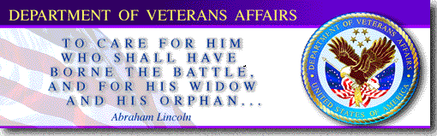
VA Optometric Residency Programs
The Department of Veterans Affairs (VA) has the largest optometric clinical training program in the United States. Nationwide, there are over 170 ACOE accredited post-graduate residency and more than 1100 externship positions available annually for clinical training. Former VA residents are among the most successful and nationally recognized individuals within the profession.
In today’s changing health care environment, it is important to plan for the future. All current indicators suggest that the demand for optometrists with residency training will continue to rise. Already, many of the best jobs require post-graduate residency certification.
Regardless of ultimate career goals, a VA residency can be an excellent “stepping stone.” The opportunity to acquire an outstanding position within a practice or managed care organization is enhanced by having completed a VA residency. Prior VA residents are also given preference for VA staff positions. Many others have obtained faculty appointments at a School or College of Optometry due to their VA residency credentials.

Unique Benefits of a VA Residency
- An outstanding 12 month (July 1 - June 30) clinical patient care experience serving a challenging and rewarding Veteran population
- A stimulating interdisciplinary environment where the resident learns to coordinate primary optometric eye care with other health care services to maximize patient care outcomes and learning experiences
- Research and academic opportunities mentored by experienced clinicians and researchers who are among the most published optometrists worldwide
- Vacation, national holidays, and sick days along with authorized absence for approved continuing education
- Health & life insurance plans available
- Competitive annual salary

Each VA residency program is unique as experiences and opportunities are different at each site. More specific residency program information can be obtained by contacting the individual sites.

Residency Training
All residents receive training in primary eye care, serving as part of an interdisciplinary team working to provide high quality patient care. With a primarily geriatric patient population, ocular disease management is a significant portion of the training experience. Residents augment their training through various medical service rotations, grand rounds, and/or other professional development activities.

Low Vision Rehabilitation
In addition to the above mentioned advanced competence areas, certain programs offer some training in low vision care. This experience typically includes exposure to a professional team of highly qualified providers with unique skills for care of visually impaired Veterans.

Eligibility Criteria
Applicants must be U.S. citizens and have received a Doctor of Optometry degree from an ACOE accredited School or College of Optometry by July 1 of the residency year. Prior to residency completion, the applicant is required to obtain state licensure.

Application
Transcripts, NBEO scores, letters of recommendation, and on-site interviews are factors considered for selection to a VA residency program. All applications are submitted through the Optometry Residency Matching Service, Inc. (ORMS) at:
http://www.optometryresident.org


VA RESIDENCY PROGRAM SITES
Alabama | Birmingham VAMC †† | patti.fuhr@va.gov
 | Tuscaloosa VAMC | nathan.whitaker@va.gov
Arizona | Southern Arizona VA HCS Tucson†† | gregory.wolfe@va.gov
Arkansas | Fayetteville VAMC | kelli.shaon@va.gov
California | VA Central California HCS Fresno | deana.lum2@va.gov
 | GREATER LOS ANGELES HCS
 | ● Los Angeles ACC †† | chang.kim@va.gov
 | ● Sepulveda ACC/Nursing Home | steven.ferrucci@va.gov
 | ● West Los Angeles HCC†† | pauline.ilsen@va.gov
 | San Diego VAMC †† | dawn.pewitt@va.gov
 | San Francisco VAMC | bernard.dolan@va.gov
 | Veterans Affairs Palo Alto HCS†† | david.yang@va.gov
Connecticut | VA CONNECTICUT HCS
 | ● Newington Campus | sharon.bisighini@va.gov
 | ● West Haven Campus †† | nancy.shenouda-awad@va.gov
Delaware | Wilmington VAMC | brian.mahoney@va.gov
Florida | Bay Pines VAMC | joseph.miller3@va.gov
 | Daytona Beach OPC | dianne.kowing@va.gov
 | Gainesville VAMC | susannah.marcus@va.gov
 | Lake City VAMC †† | wendy.mcgonigal@va.gov
 | Miami VAMC | william.prunty@va.gov
 | Orlando VAMC | john.spalding@va.gov
 | Tallahassee VAOPC | joni.scott-weideman@va.gov
Illinois | Jesse Brown VAMC†† | thomas.stelmack@va.gov
 | Hines VAH †† | joan.stelmack@va.gov
 | Marion VAMC | linda.lucas2@va.gov
 | VA Illiana HCS | stephen.boyer@va.gov
Indiana | Northern Indiana HCS - Fort Wayne Division | sara.schamerloh@va.gov
Kansas | Wichita MAMROC †† | michelle.dent2@va.gov
Kentucky | Lexington VAMC †† | michelle.lynch@va.gov
Maine | Togus VAMROC | james.smith20@va.gov
Maryland | VA MARYLAND HCS
 | ● Baltimore Division †† | anthony.litwak@va.gov
 | ● Perry Point Division | amy.quan@va.gov
Massachusetts | Bedford VAMC | donee.wong@va.gov
 | VA BOSTON HCS
 | ● Brockton Division | kevin.toolin@va.gov
 | ● Brockton/Worcester Division | kevin.toolin@va.gov
 | ● Jamaica Plain Division | tak.chau@va.gov
 | ● Jamaica Plain Rehab Div †† | nyssa.connell@va.gov
 | ● West Roxbury Division | lisa.fanciullo@va.gov
Michigan | Battle Creek VAMC †† | michael.vandeveer@va.gov
 | Detroit VAMC †† | phillip.elston@va.gov
 | Grand Rapids VAOPC | douglas.coon@va.gov
Missouri | Kansas City VAMC †† | timothy.harkins@va.gov
 | Mt. Vernon OPC | bethany.whitesell@va.gov
 | St. Louis VAMC †† | steven.grondalski@va.gov
Nevada | Las Vegas VAMC †† | lane.fujimoto@va.gov
 | Reno VAMC | marla.plecha@va.gov
New Hampshire | Manchester VAMC | nadia.zalatimo@va.gov
New Jersey | VA New Jersey HCS†† | malinda.cafiero@va.gov  cathy.marques@va.gov
New Mexico | Albuquerque VAMC†† | michael.sullivan-mee@va.gov
New York | Brooklyn Campus - NY Harbor HCS†† | evan.canellos@va.gov
 | Hudson Valley HCS†† | nancy.wong@va.gov
 | Northport VAMC †† | michael.mcgovern@va.gov
North Carolina | Salisbury VAMC †† | jeffrey.joy1@va.gov
Ohio | Chillicothe VAMC | brian.montgomery@va.gov
 | Cincinnati VAMC†† | kelly.thompson4@va.gov
 | Cleveland VAMC†† | stacia.yaniglos@va.gov
 | Columbus OPC | brett.irvin@va.gov
 | Dayton VAMC†† | gregory.kiracofe@va.gov
Oklahoma | Muskogee VAMC | angela.charlton@va.gov
Oregon | Portland VAMC†† | weon.jun@va.gov
 | Roseburg VAMC | bryan.deck@va.gov
 | VA Southern Oregon RC&C | mark.ostermeier@va.gov
Pennsylvania | Lebanon VAMC | kevin.wolford@va.gov
 |  | daniel.petley@va.gov
 | Philadelphia VAMC†† | marilyn.verghese@va.gov
 | Wilkes-Barre VAMC | joseph.reck@va.gov
Rhode Island | Providence VAMC | claire.messina@va.gov
South Carolina | Dorn Veterans Hospital†† | william.denton@va.gov
 | Charleston VAMC | stephen.morse@va.gov

Tennessee | Memphis VAMC†† | james.williamson4@va.gov
 | James H. Quillen VAMC | loren.bennett@va.gov
Texas | Amarillo VAMC | david.trout@va.gov
Utah | Salt Lake City VAMC†† | harald.olafsson@va.gov
Vermont | White River Junction VAMC†† | dorothy.hitchoth@va.gov
Virginia | Hampton VAMC†† | gay.tokumaru@va.gov
 | Salem VAMC | scott.slagle@va.gov
Washington | VA Puget Sound HCS - American Lake Division†† | jeffery.hiett@va.gov
 | Jonathan M. Wainwright Memorial VAMC | barbara.hetrick@va.gov
 | Spokane VAMC†† | thomas.riley1@va.gov
West Virginia | Huntington VAMC †† | brian.colander@va.gov

†† Offers some low vision experience – contact program for specifics.

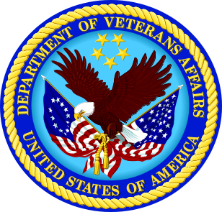

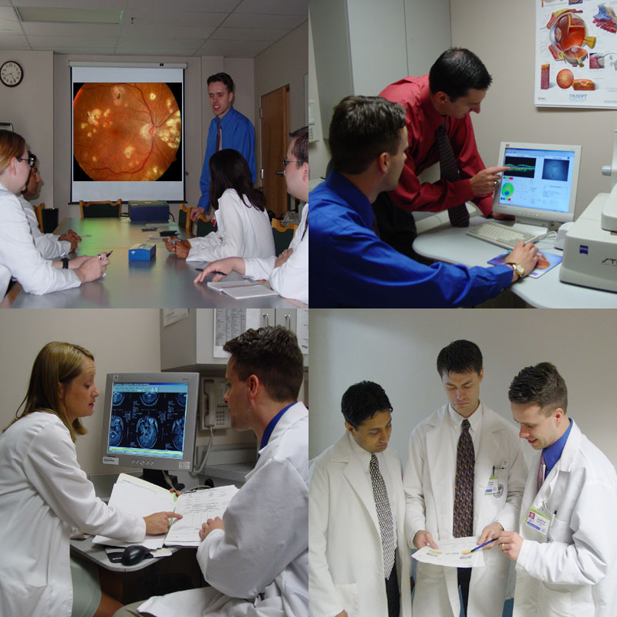

VA Optometric
Residency Programs

VA Office of Academic Affiliations
& VA Optometric Service

Contact Persons:
Dr. John Townsend in VA Optometric Service at:
John.Townsend@va.gov or
(410) 779-1576

Dr. Debbie Hettler in
VA Office of Academic Affiliations at:
Debbie.Hettler@va.gov or
(202) 461-9499

Residency Program details may be viewed at:
www.va.gov/optometry/ or www.va.gov/oaa/

