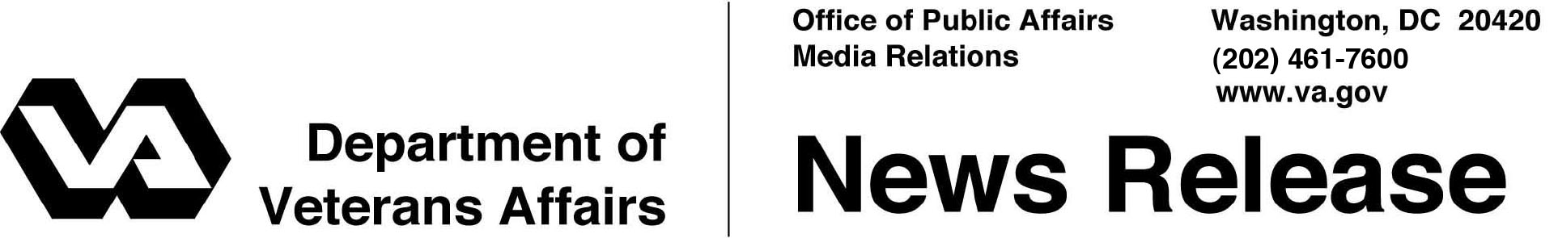

FOR IMMEDIATE RELEASE

November 30, 2012

**42 VA Employees Earn Health Care Analytics Certificates**

***Graduates Gain* *New Skills to Improve Performance and Decision-Making***

WASHINGTON – Department of Veterans Affairs employees were recently certified in health care analytics for the first time through a VA program aimed at creating a culture to identify patterns in data and translate it into improvements for Veteran health care.

“This certification program provides a highly effective, tool to train VA employees in skills that will continue to make VA a data- and performance-driven organization. Ultimately, this will lead to improved services for Veterans,” said Secretary of Veterans Affairs Eric K. Shinseki. “By training VA employees at all levels on how to evaluate our performance, we are getting a true picture of where we need to focus our energies to create meaningful improvements in our operations.”

The 42 graduates are the first to have completed the Healthcare Analytics Certificate Program. The program helps develop expert knowledge and skill in performing complex data analysis, translating information into knowledge, leading teams in identifying relevant data, and coaching and mentoring others in the use of data.

Nearly 500 other employees are enrolled in one or more of the program’s four courses, each of which lasts 10 weeks and typically requires six hours of class time and homework per week. These courses focus on health care data analysis, systems improvement, data mining and project analysis. Graduates from the program have expressed their satisfaction with both the information and skills they have learned, and the program’s return on investment.

“There are many advanced analytic skills and techniques that I learned that I incorporate into my every day work and projects,” one graduate said. “Veterans benefit because I am able to help others locate data more quickly and really focus on the true question, ensuring that outcomes match what is intended for specific projects at the outset.”

The certificate program is a training opportunity associated with VA’s Health Informatics Initiative, which helps to build a sustainable, collaborative relationship between VA’s health care system and the Office of Information and Technology, further transitioning VA to a patient-centered model of care. The initiative is building VA health informatics capacity and workforce to support rapid product development and delivery methods.

The program was developed in conjunction with the VA Nebraska-Western Iowa Health Care System and the Midwest Mountain Veterans Engineering Resource Center (VERC) through its affiliation with the University of Nebraska Lincoln Department of Industrial and Management Systems Engineering.

###