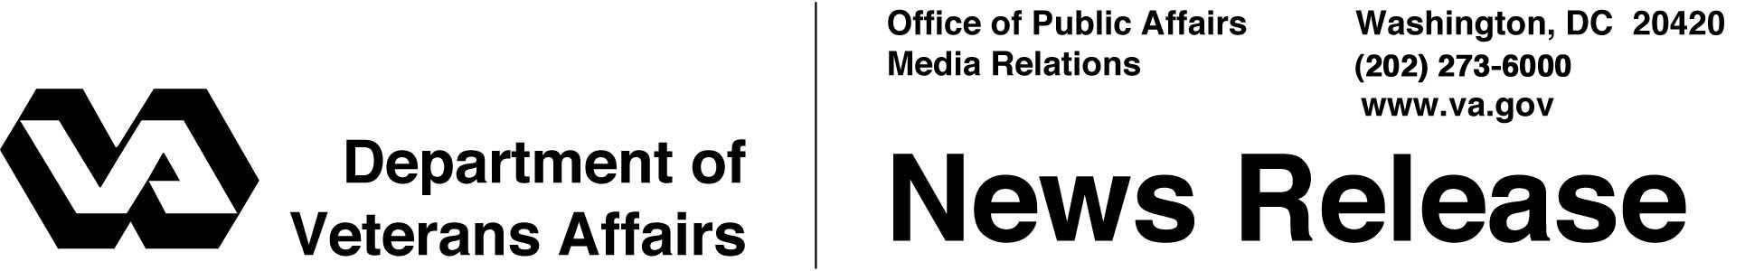

FOR IMMEDIATE RELEASE
October 18, 2007

VA Announces 46 Grants for Homeless Programs
Department Marks 20 Years Serving Homeless Veterans
WASHINGTON – As the Department of Veterans Affairs (VA) marks the 20th anniversary of its homeless program, VA has awarded 46 grants worth over $16 million to public and private non-profit groups to assist homeless veterans.
“For the last 20 years, VA has worked with its community partners to lift veterans out of homelessness,” said Gordon H. Mansfield, Acting Secretary of Veterans Affairs. “We are making progress by expanding treatment, rehabilitation and safe transitional housing for our homeless veterans, though more remains to be done.”
Based on VA’s national estimates, progress is being made for homeless veterans. The number of homeless veterans on any night has decreased 20 percent during the last six years, and veterans as a percent of the adult homeless population has decreased 10 percent.
This latest round of grants creates 950 beds for homeless veterans, bringing to more than 12,000 the number of VA-funded community-based beds provided by public and community non-profit and faith-based organizations in 34 states and the District of Columbia.
VA has the largest integrated network of homeless assistance programs in the country. It is the only federal agency providing substantial one-on-one contact with the homeless. In many cities and rural areas, VA social workers and other clinicians conduct extensive outreach programs, clinical assessments, medical treatment, alcohol and drug abuse counseling and employment assistance.
More information about VA’s homeless programs is available on the Internet at http://www.va.gov/homeless.
# # #

Attached is a list of Homeless Grants for 2007

VA’s Homeless Grants, 2007

State | City | Recipient | Amount
Ariz. | Tucson | Old Pueblo Community Foundation | $202,130
 | Tucson | Esperanza En Escalante | 21,430
Calif. | Bell | The Salvation Army, a California Corporation | 500,000
 | Oakland | Volunteers of America Bay Area | 586,857
 | Oceanside | North County Interfaith Council | 1,120,000
Fla. | New Port Richey | Steps to Recovery, Inc. | 143,975
 | Pensacola | Volunteers of America of Florida | 736,848
 | Punta Gorda | Volunteers of America of Florida | 666,848
 | St. Petersburg | The House of Hope | 1,575,470
Iowa | Ottumwa | Ottumwa Community Outreach Ministry, Inc. | 195,000
Ill. | Chicago | Volunteers of America of Illinois, Inc. | 1,000,000
 | Chicago | Featherfist | 416,250
 | Hebron | Transitional Living Services | 18,320
Ind. | Indianapolis | HVAF of Indiana, Inc. | 822,250
Kan. | Kansas City | The Salvation Army, an Illinois Corporation | 14,949
La. | Hammond | Quad Area Community Action Agency, Inc. | 591,500
 | Houma | Start Corporation | 424,033
 | New Orleans | Volunteers of America of Greater New Orleans, Inc. | 291,850
 | Opelousas | Lafayette Catholic Service Centers, Inc. | 56,430
Mass. | New Bedford | Southeastern Massachusetts Veterans Housing Program, Inc. | 19,039
 | Worcester | Massachusetts Veterans, Inc. | 552,500
 | Worchester | Massachusetts Veterans Inc. | 455,000
Mich. | Ann Arbor | Michigan Ability Partners | 201,501
 | Lansing | Volunteers of America of Michigan, Inc. | 259,265
Miss. | Hattiesburg | Region XII Commission on Mental Health & Retardation | 12,119
N.C. | Asheville | Asheville Buncombe Community Christian Ministry, Inc. | 1,600,000
 | Dallas | Lutheran Family Services in the Carolinas | 51,669

N.J. | Jersey City | The Doe Fund, Inc. | 526,500
 | Winslow | New Jersey Department of Military & Veterans Affairs | 500,000
N.M. | Gallup | Community Area Resource Enterprises (CARE 66) | 311,039
N.Y | Albany | Albany Housing Coalition | 11,700
 | Yonkers | Westhab, Inc. | 400,000
Ohio | Cincinnati | Volunteers of America, Ohio River | 910,000
 | Dayton | Spirit of Peace Community Development Corp | 115,000
Penn. | Coastesville | Philadelphia Veterans Multi-Services | 21,658
 | Philadelphia | Fresh Start Foundation | 18,200
S.C. | Columbia | Lutheran Family Services | 130,897
 | North Charleston | Volunteers of America of the Carolinas | 800,000
Tenn. | Lewisburg | Buffalo Valley | 67,210
 | Memphis | Alpha Omega Veterans Services | 24,700
 | Memphis | Cocaine & Alcohol Awareness Program | 17,728
 | Nashville | Next Stages | 25,681
Wash. | Spokane | Volunteers of America of Eastern Washington | 12,720
Wisc. | King | Center for Veterans Issues | 15,431
 | Milwaukee | Center for Veterans Issues | 18,781
 | Union Grove | Center for Veterans Issues | 18,781

