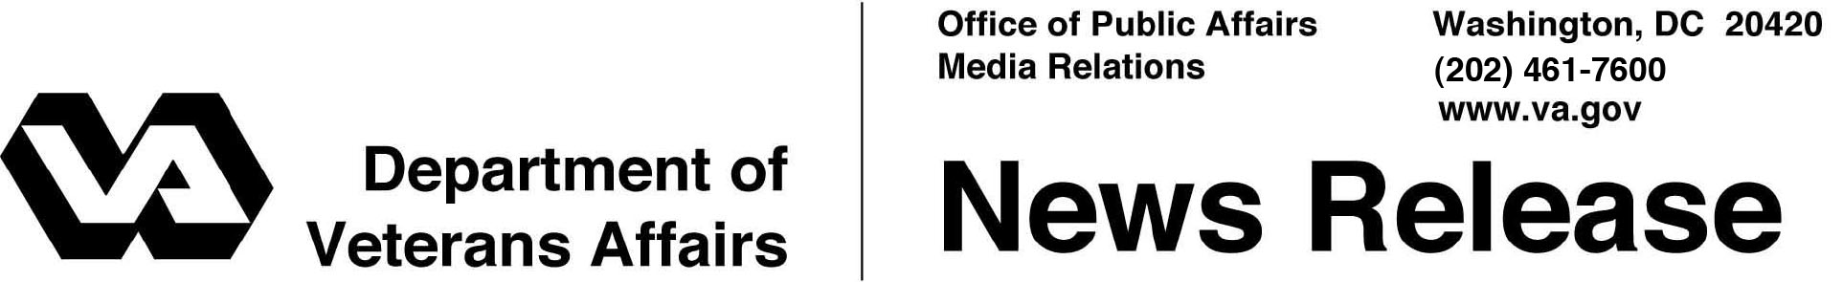

FOR IMMEDIATE RELEASE
September 19, 2013

VA Announces Award of Patient-Centered Community Care Contracts
Contracts Provide Expanded Access to Community-based Care
WASHINGTON -- The Department of Veterans Affairs announced today that Veterans will have greater access to quality health care through a new initiative: Patient-Centered Community Care (PCCC).
“PCCC is an innovative solution that helps VA medical centers continue to provide quality care efficiently,” said Secretary of Veterans Affairs Eric K. Shinseki. “This will be a valuable option for VA medical centers to use to expand our Veterans’ access to care.”
Under PCCC, VA medical centers will have the ability to purchase non-VA medical care for Veterans through contracted medical providers when they cannot readily provide the needed care due to geographic inaccessibility or limited capacity. Eligible Veterans will have access to inpatient specialty care, outpatient specialty care, mental health care, limited emergency care, and limited newborn care for enrolled female Veterans following the birth of a child.
“PCCC provides a regional contracting vehicle for VA to work with local community providers to give Veterans access to high quality care,” said Dr. Robert Petzel, VA’s Under Secretary for Health. “It will also help VA in our continued efforts to ensure timely and accessible services are provided to Veterans for non-VA medical care.”
In total, VA has awarded two contracts under PCCC, one to Health Net Federal Services LLC and another to TriWest Healthcare Alliance Corp. These companies will set up networks in six regions covering the entire country. VA expects to have these regional contract networks available to its medical centers by the spring of 2014. The awarded contracts, estimated at $9.4 billion, include one base year and four option years.
PCCC is part of the overall Non-VA Medical Care Program. It will provide all VA facilities with an additional option to purchase non-VA medical care when required Veteran care services are unavailable within the VA medical facility or when the Veterans benefit from receiving the needed care nearer to their homes.
Among the many benefits to the Veterans and VA under these new contracts, VA will enjoy standardized health care quality metrics, timely return of medical documentation, cost avoidance with fixed rates for services across the board, guaranteed access to care, and enhanced tracking and reporting of non-VA medical care expenditures over traditional non-VA medical care services.
For additional information, please visit: https://www.fbo.gov/index?s=opportunity&mode=form&id=3dde670a20dee9c5a6b38d8ca53642e1&tab=core&_cview=0

# # #

