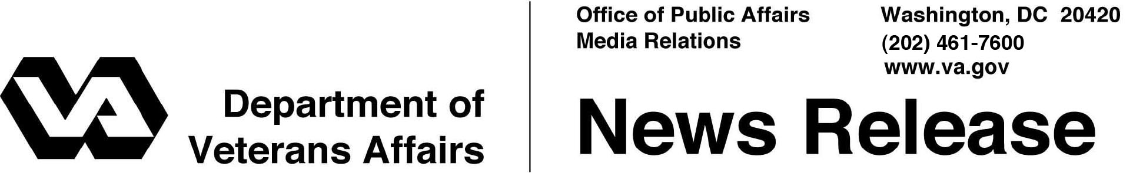

FOR IMMEDIATE RELEASE

August 10, 2012

**Post-9/11 GI Bill Celebrates Start of Fourth Year**

*773,000 Veterans and Their Family Members Benefit From Program*

WASHINGTON– August marks the third anniversary of the Post-9/11 GI Bill, and since it was implemented Aug. 1, 2009, the Department of Veterans Affairs has provided educational benefits to 773,000 Veterans and their family members.

“This is one of the most important programs helping our Iraq and Afghanistan Veterans reach their educational goals,” said Secretary of Veterans Affairs Eric K. Shinseki. “We’re proud this important benefit is making such a big difference in the lives of so many Veterans.”

The Post-9/11 GI Bill pays tuition and fees on behalf of Veterans or eligible dependents directly to the school in which they are enrolled. Eligible participants also receive a monthly housing allowance and up to $1000 annually for books and supplies. The program also allows eligible Servicemembers to transfer their benefits to their spouses and/or children.

The program provides a wide range of educational options, including undergraduate and [graduate degrees](http://www.gibill.va.gov/resources/education_resources/programs/ihl.html), [vocational/technical training](http://www.gibill.va.gov/resources/education_resources/programs/ncd.html), [on-the-job training](http://www.gibill.va.gov/resources/education_resources/programs/on_the_job_apprenticeship_training.html), [flight training](http://www.gibill.va.gov/resources/education_resources/programs/flight_training.html), [correspondence training](http://www.gibill.va.gov/resources/education_resources/programs/correspondence_training.html), [licensing](http://www.gibill.va.gov/resources/education_resources/programs/licensing_and_certification.html) and [national testing programs,](http://www.gibill.va.gov/resources/education_resources/programs/national_testing_program.html) [entrepreneurship training](http://www.gibill.va.gov/resources/education_resources/programs/entrepreneurship_training.html), and [tutorial assistance](http://www.gibill.va.gov/resources/education_resources/programs/tutorial_assistance_program.html). All training programs must be approved for GI Bill benefits.

“For over 68 years, GI Bill programs have shaped and changed the lives of Servicemembers, Veterans, their families and survivors by helping them reach their educational goals,” said Allison A. Hickey, Under Secretary for Benefits. “Benefits provided under the Post-9/11 GI Bill will continue to shape and change the lives of Veterans by helping them build a stronger foundation for their careers.”

The Post-9/11 GI Bill is the most extensive educational assistance program since the original GI Bill was signed into law in 1944. Since its inception, VA has paid more than $20 billion in benefits to Veterans and their family members.

For the 2012-2013 academic year, 1,770 colleges and universities are supplementing Post-9/11 GI Bill benefits by participating in the Yellow Ribbon Program. Under the Yellow Ribbon Program, degree-granting institutions make additional funds available for a Veteran’s educational program without an additional charge to their GI Bill entitlement. To make up the difference for those students whose tuition and fees exceed what the Post-9/11 GI Bill covers, institutions can voluntarily enter into a Yellow Ribbon Agreement with VA to designate an additional amount of funding, and VA will match that amount.

VA is seeking legal authority to trademark the term *GI Bill*. President Obama signed an executive order on April 26, directing VA and the Department of Defense to undertake a number of measures to “stop deceptive and misleading” promotional efforts that target the GI Bill educational benefits of Servicemembers, Veterans, and eligible family members and survivors. In June, the attorneys general of several states gave VA the rights to the *GIBill.com* website after the original owners agreed to give up the internet site to settle a lawsuit by the states.

For more information on the Post-9/11 GI Bill and other Veteran education programs, visit <http://www.gibill.va.gov>.

# # #