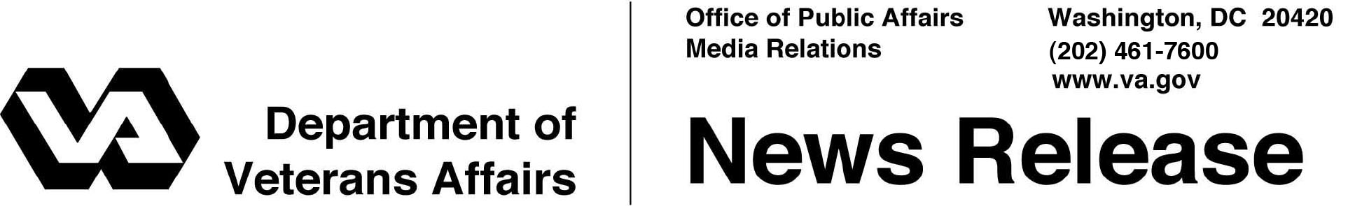

FOR IMMEDIATE RELEASE
November 5, 2013

VA Meets President’s Mental Health Executive Order Hiring Goal
More than 800 Veterans Hired as Mental Health Peer Specialists and Peer Apprentices
WASHINGTON – The Department of Veterans Affairs has hired 815 Peer Specialists and Peer Apprentices, exceeding the hiring goal set in President Obama’s Aug. 31, 2012 Executive Order aimed at improving access to mental health services for Veterans, service members and military families.
On June 3, VA announced the department met another goal established by the Executive Order by hiring 1,600 additional mental health professionals.
“We have made strong progress to expand Veterans’ access to quality mental health services, but we must continue to increase access,” said Secretary of Veterans Affairs Eric K. Shinseki. “These newly hired employees, Veterans themselves, are uniquely equipped to guide fellow Veterans through difficult issues.”
Peer Specialists and Peer Support Apprentices are a unique cadre of people joining VA’s mental health care teams. They are Veterans who have successfully dealt with their own mental health recovery for a minimum of one year. Peer Specialists are trained and certified, while Peer Support Apprentices are undergoing training and certification to become Peer Specialists. An additional component from the Executive Order mandated that all training for these peer counselors would be complete by the end of the year. VA remains on track to meet that requirement.
“We are proud to have exceeded the hiring goal established by the President in his Executive Order,” said Under Secretary for Health, Dr. Robert A. Petzel. “We are well on the way to have all of these new hires trained by the end of the calendar year.”

- More -

Mental Health Peers – 2/2/2/2

Specialists and apprentices are working at every VA medical center throughout the country as well as at Community-Based Outpatient Clinics with over 10,000 enrollees. As the Nation’s largest integrated health care system, VA cares for more than 6.3 million Veterans annually, and has seen an increase in the amount of service men and women who are dealing with mental health issues. VA’s push to hire Veterans who can provide peer support is a key part of a greater effort aimed at increasing access to mental health care services for the nation’s Veterans by hiring thousands of new mental health professionals.
Earlier this year, VA announced a 50 percent increase in staffing for the Veterans Crisis Line (1-800-273-8255), which has been credited with rescuing more than 26,000 actively suicidal Veterans.
This year, VA held Mental Health Summits at 151 VA medical centers across the country to further engage community partners, Veteran Service Organizations, health care providers and local governments, and to address the broad mental health needs of Veterans and their families.
To learn more about current VA Peer to Peer job opportunities visit: http://www.vacareers.va.gov/peer-to-peer/. Veterans and their families interested in learning more about the mental health services provided by VA can go to www.mentalhealth.va.gov.

# # #

