VA Optometric Residency Programs
The Department of Veterans Affairs (VA) has the largest optometric clinical training program in the United States. Nationwide, there are over 215 ACOE accredited post-graduate residency and about 1,400 externship positions available annually for clinical training. Former VA residents are among the most successful and nationally recognized individuals within the profession.
In today’s changing health care environment, it is important to plan for the future. All current indicators suggest that the demand for optometrists with residency training will continue to rise. Already, many of the best jobs require post-graduate optometric residency certification.
Regardless of ultimate career goals, a VA residency can be an excellent “stepping stone.” The opportunity to acquire an outstanding position within a practice or health care network is enhanced by having completed a VA residency.
Prior VA residents are also given preference for VA staff positions. Many others have obtained faculty appointments at a School or College of Optometry due to their VA optometric residency credentials.

Unique Benefits of a

VA Residency
- An outstanding 12 month (July 1 - June 30) clinical patient care experience serving a challenging and rewarding Veteran population
- A stimulating interdisciplinary environment where the resident learns to coordinate primary optometric eye care services with other health care providers to maximize patient care outcomes and learning experiences
- Research and academic opportunities mentored by experienced clinicians and researchers who are among the most published optometrists worldwide
- Vacation, national holidays, and sick days along with authorized absence for approved continuing education
- Competitive annual salary with pay adjustment for high cost areas
- Health insurance plans

Each VA residency program is unique as experiences and opportunities are different at each site. More specific residency program information can be obtained by contacting the individual sites.

Residency Training
All residents receive training in primary eye care, serving as part of an interdisciplinary health care team working to provide high quality patient care. With a primarily geriatric patient population, the management of ocular disease is a significant portion of the training experience. Residents augment their training through various medical service rotations, grand rounds, and/or other professional development activities.

Low Vision Rehabilitation
In addition to the above mentioned advanced competence areas, certain programs offer substantial training in low vision care. This experience typically includes exposure to a professional team of highly qualified providers with unique skills for care of visually impaired Veterans.

Eligibility Criteria
Applicants must be U.S. citizens and have received a Doctor of Optometry degree from an ACOE accredited School or College of Optometry by July 1 of the residency year. Prior to residency completion, the applicant is required to obtain State licensure.

Application
Transcripts, NBEO scores, letters of recommendation, and on-site interviews are factors considered for selection to a VA residency program. All applications are submitted through the Optometry Residency Match (ORMatch) at:
http://www.natmatch.com/ormatch.html
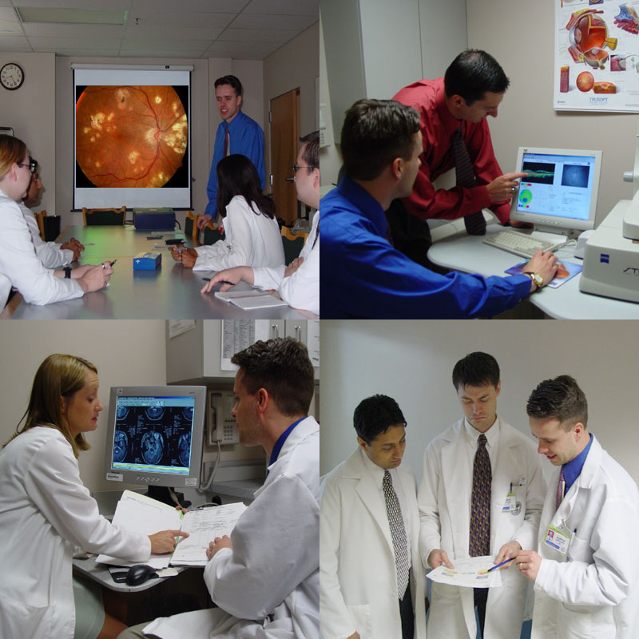

VA RESIDENCY PROGRAM SITES
Alabama | Birmingham VAMC †† | bethany.martinez@va.gov
 | Tuscaloosa VAMC | lisa.schifanella@va.gov
Arizona | Phoenix VA HCS | logan.powers@va.gov
 | Southern Arizona VA HCS Tucson†† | danielle.weiler@va.gov
Arkansas | Fayetteville VAMC | emily.peterson@va.gov
California | VA Central California HCS Fresno | deana.lum2@va.gov  claire.henry@va.gov
 | GREATER LOS ANGELES HCS
 | ● Los Angeles ACC †† | diana.wu@va.gov
 | ● Sepulveda ACC/Nursing Home | steven.ferrucci@va.gov
 |  | brenda.yeh@va.gov
 | ● West Los Angeles HCC†† | pauline.ilsen@va.gov
 | Long Beach VA HCS BRC†† | edward.chu@va.gov
 | San Diego VAMC †† | katherine.wang@va.gov
 | San Francisco VAMC | andrew.mick@va.gov
 | VA Palo Alto HCS†† | david.yang@va.gov
 |  | lee.vien@va.gov
Connecticut | VA CONNECTICUT HCS
 | ● Newington Campus | nicole.roy@va.gov
 |  | michael.kelleman@va.gov
 | ● West Haven Campus †† | nancy.shenouda-awad@va.gov  theresa.zerilli@va.gov
Delaware | Wilmington VAMC | rajni.acharya@va.gov
Florida | BAY PINES VAHCS
 | ● Bay Pines VAMC | candace.greenough@va.gov
 | ● Bradenton VA CBOC | katherine.dunatov@va.gov
 | Gainesville VAMC | susannah.marcus@va.gov
 | Jacksonville OPC | roxanne.senechal@va.gov
 | Miami VAMC | kasey.zann@va.gov
 | Orlando VAMC | nirmani.karunathilake@va.gov
 |  | beth.norris@va.gov
 | Tallahassee VAOPC | brandon.sanders2@va.gov
 | Tampa | chung.to@va.gov
Illinois | Jesse Brown VAMC and Edward Hines, Jr. VAH BRC†† | jennifer.brown1befc6@va.gov
 | VA Illiana HCS | guadalupe.mejia@va.gov
 | James A. Lovell Federal HCC | shelly.kim@va.gov
Indiana | Brownsburg VA Clinic | sarah.zender@va.gov
 | Northern Indiana HCS - Fort Wayne Division | aaron.case@va.gov
 | Northern Indiana HCS – Jackie Walorski VA Clinic | christopher.bugajski@va.gov
Kansas | Wichita Robert J. Dole VAMC †† | michelle.dent2@va.gov
Kentucky | Lexington VAMC †† | ashley.rone@va.gov
 |  | tara.foltz@va.gov
Maine | VA Maine Health Care System | laura.dowd@va.gov
 |  | kyla.duchin@va.gov
Maryland | VA MARYLAND HCS
 | ● Baltimore Division †† | adam.leposa@va.gov
 | ● Perry Point Division | michael.belhumeur@va.gov
Massachusetts | Bedford VAMC | paul.colburn@va.gov
 | VA BOSTON HCS
 | ● Brockton Division | kevin.toolin@va.gov
 | ● Jamaica Plain Division | tak.chau@va.gov
 | ● Jamaica Plain Rehab Div †† | jennifer.gustafson@va.gov
 | ● Lowell VA CBOC | emily.carell@va.gov
 | ● West Roxbury Division | joseph.kane@va.gov
Michigan | Battle Creek VAMC †† | carla.gilbertsonkuiken@va.gov
 | Detroit VAMC †† | jaime.zadoff@va.gov
 | VA Wyoming HC Center | jordan.kuipers2@va.gov
Missouri | Kansas City VAMC †† | kendra.null@va.gov
 | St. Louis VAMC †† | allison.schafers@va.gov
 | Springfield CBOC | hilary.price@va.gov
Nevada | Las Vegas VAMC †† | lane.fujimoto@va.gov
 | Reno VAMC | joan.browne@va.gov
New Hampshire | Manchester VAMC | nadia.zalatimo@va.gov
New Jersey | VA New Jersey HCS†† (East Orange and Lyons) | malinda.cafiero@va.gov
New Mexico | Albuquerque VAMC | stacy.washington1@va.gov
New York | VA Hudson Valley HCS†† (Montrose and Castle Point) | jean.jung@va.gov
 | NY Harbor HCS†† (Brooklyn and St. Albans) | michelle.d’amura@va.gov
 | Northport VAMC †† | shephali.patel@va.gov

North | Salisbury VAMC †† | jeffrey.joy1@va.gov
Carolina | Greenville VA HCC | armstrong.keodara@va.gov
Ohio | Chillicothe VAMC | daniel.grangaard2@va.gov
 | Cincinnati VAMC†† | matthew.horton3@va.gov
 | Cleveland VAMC†† | rachael.canania@va.gov
 | Columbus OPC | brett.irvin@va.gov
 | Dayton VAMC†† | dalya.qaisi@va.gov
Oklahoma | Muskogee VAMC | melissa.turner4@va.gov
 |  | francis.mai@va.gov
Oregon | VA Portland Health Care System†† (Portland/Vancouver Division) | weon.jun@va.gov
 | ● Salem CBOC | vincent.chan1@va.gov
 | VA Southern Oregon RC&C | aaron.severson@va.gov
Pennsylvania | Erie | delia.landy@va.gov
 | Lebanon VAMC†† | kevin.wolford@va.gov
 |  | daniel.petley@va.gov
 | Wilkes-Barre VAMC | jennifer.price@va.gov
Rhode Island | Providence VAMC | amanda.hunter2@va.gov
 |  | fatima.raposo@va.gov
South | Charleston VAMC†† | kelly.singleton2@va.gov
Carolina | Dorn Veterans Hospital†† | anthony.vanalstine@va.gov
 | Greenville VAOPC | monica.jezior2@va.gov
Tennessee | James H. Quillen VAMC | loren.bennett@va.gov
 | Memphis VAMC†† | james.williamson4@va.gov
Texas | Amarillo VAMC | david.trout@va.gov
 | Houston VAHCS - Michael E. DeBakey VAMC†† | bhagya.segu1@va.gov
 | Waco-Doris Miller VAMC | erika.jones10@va.gov
 | South Texas VHCS - Audie L. Murphy VA Hospital†† | gregg.wentworth@va.gov
 | VA Texas Valley Coastal Bend HCS - Harlingen | michael.wingard@va.gov
Utah | Salt Lake City VAMC†† | duane.tanner@va.gov
Vermont | White River Junction VAMC†† | richard.frick@va.gov
Virginia | Salem VAMC†† | alicia.greene3@va.gov
Washington | VA Puget Sound HCS - American Lake Division†† | yangdi.chen2@va.gov
 | Spokane VAMC†† | len.koh@va.gov
 | Walla Walla - Jonathan M. Wainwright Memorial VAMC | jonathan.haley@va.gov
West Virginia | Huntington VAMC †† | jacqueline.hallauer@va.gov

†† Offers some low vision experience – contact program for specifics.



VA Optometric
Residency Programs

VA Office of Academic Affiliations
& VA Optometric Service

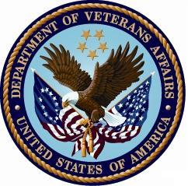

Veterans Health Administration
Optometry Service National Program
Office
Phone: 410-637-4754

Residency Program details may be viewed at:
www.va.gov/optometry/ or www.va.gov/oaa/

