**HELP GUIDE - Submitting Financial Conflict of Interest Disclosures**

ORD has released a new directive (VHA Directive 1200.13) regarding financial conflicts of interest in research. As a result, we must change the VAPORHCS procedures for submission and review of financial conflict of interest (COI) disclosures.

# What is NOT Changing:

* **Who must submit COI disclosures:**

Anyone in an “investigator” role (e.g., principal investigator (including repository director), co-investigator, sub-investigator) must submit COI disclosures at initial review (or when they are first added to a study) and yearly thereafter.

* **When new (potential) COIs should be reported:**

As soon as they are known/anticipated

* **What counts as a COI:**

The questions on the COI disclosure form have not changed, nor have the criteria used to assess potential conflicts.

# What IS Changing:

* **Which studies must provide annual COI disclosures:**

**ALL** - This includes studies that undergo no other annual reviews and have not been previously asked to submit annual COI disclosures (e.g., IRB-exempt studies, animal studies). It also includes studies overseen by the joint VAPORHCS-OHSU IRB, the VA Central IRB, and commercial IRBs (e.g., Advarra).

* **How COI disclosures are submitted:**

**In VAIRRS/IRBNet** - ORD has converted the COI disclosure PDF to a “smart form” in IRBNet, and they are requiring that all VAs use it.

* This includes studies overseen by the joint VAPORHCS-OHSU IRB. VA investigators on these studies must submit annual COI disclosures in IRBNet, NOT eIRB.
* **When annual COI disclosures are due:**

**Annual COI review is now separate from other annual reviews.**

🡪 You are no longer required to submit COIs with IRB (or other) continuing reviews.

**COI submission deadline for all studies: November 1, every year**

Reminders will be sent at the beginning of each fiscal year (Oct 1). **COI disclosures completed before October 1 of a given year will NOT satisfy the annual COI disclosure requirement for that year.** New disclosures will be required in October.

**Rationale:** VHA Directive 1200.13 separates annual COI review from other annual reviews, and we believe a single deadline for all annual COI disclosures will minimize burden on VAPORHCS researchers. The IRBNet "My COI" tab will allow investigators to complete all their COI disclosures in one place without navigating to each project. PIs and study coordinators will not need to track study-specific deadlines for COI review.

# What You Need To Do:

## One-time tasks:

1. Any VAPORHCS investigator who does not already have an IRBNet account must register for an account and affiliate themselves with VAPORHCS. Instructions are below.
2. PIs and/or study coordinators must ensure that each of their projects in IRBNet is “shared” with every co-/sub-investigator on the project at VAPORHCS. Instructions are below.

**Going forward, 1 & 2 must be completed before a new investigator is added to a study so that they may submit a COI disclosure at the same time as the personnel change.**

## Annual tasks:

1. Researchers must use the **My COI** tab in IRBNet to **complete an annual COI disclosure** for each VAPORHCS project for which they are an investigator. Instructions are below.

**NOTE: Completed COI disclosures are not accessible to reviewers until they are submitted as described in step 4 below.**

1. For each study, the PI or a study coordinator must **create an IRBNet package, link all VAPORHCS investigators’ COI disclosures to that package, and submit the package** to the VA Portland Conflict of Interest workspace. Instructions are below.

**Annual COI disclosures for all VAPORHCS investigators on a study must be submitted to the VA Portland Conflict of Interest IRBNet workspace by November 1.**

**Important Info:**

* Annual COI submissions must NOT be combined with other submissions (e.g., amendments, continuing reviews). Packages submitted to the VAPORHCS COI workspace are not accessible to IRB, IACUC, SRS, or RDC reviewers.
* COI disclosure packages do NOT need to be signed. By submitting an annual COI disclosure package, you attest that it contains COI disclosures from all investigators on the study.
* If a COI disclosure in your submission indicates a potential COI that has not been previously reviewed, please add the current version of your study’s protocol to the package. OGC Ethics requires a protocol when reviewing potential COIs, but they do not have access to documents in other IRBNet packages.

## New studies, new COIs, and new investigators:

### New Study:

COI disclosures must be submitted in a separate IRBNet package from the new project submission to a research oversight committee (IRB, IACUC, SRS, RDC).

**If the PI has a potential conflict to disclose, submit a package containing (at least) the PI's COI disclosure as early as possible.** The project cannot receive RDC approval and begin until OGC Ethics has reviewed the potential conflict. Review by OGC Ethics can take many months.

* This may require that you create the "project" in IRBNet months before you are ready to submit to any research oversight committees.

**If the PI has no potential conflict to disclose, submit the COI package at the same time as other initial review package(s).**

* Any co-/sub-investigators with a potential COI cannot be added to the study until that COI has been reviewed by OGC Ethics. If you need a co-/sub-investigator with a potential COI to begin work on the study immediately, please submit their COI disclosure as early as possible.

### Investigator with New (Potential) COI:

**Do NOT wait until October**. Potential COIs are sent to OGC Ethics for review. It is in your interest to have OGC Ethics determine if they are actual COIs before you inadvertently break federal COI laws.

**Submit a package containing only the disclosure with the potential COI.**

* There is no need to ask other investigators on the study to submit COI disclosures until the next annual review.

### New Investigator Being Added to Existing Study:

**Submit a package containing only the new investigator's COI disclosure.**

* The COI disclosure cannot be included in the personnel change package because COI disclosures must be submitted to a different workspace/"board" in IRBNet.
* There is no need to ask other investigators on the study to submit COI disclosures until the next annual review.

# Special Considerations for Multi-Site Studies

* **Only investigators affiliated with VAPORHCS must submit COI disclosures to the VA Portland Conflict of Interest workspace in IRBNet.**

Investigators at other sites are subject to the COI review requirements at their sites. Investigators at other VAs are required to submit their COI disclosures to their own VA's COI IRBNet workspace. They have separate IRBNet "projects" for the study at their sites, so you do not need to share the VAPORHCS IRBNet project with them.

* **The November 1 deadline is for VAPORHCS investigators only.**

Other sites (including VAs) may have different deadlines for COI disclosures. You are not required to coordinate VAPORHCS COI submissions with COI submissions at other sites.

* **For VA Central IRB studies, where Portland is the lead site,** **VAPORHCS investigators should complete COI disclosures for the PI/SC IRBNet project.**

You are not required to also complete COI disclosures for the LSI IRBNet project.

# FAQs

**Q:** I’m a study coordinator trying to share a project with a co-investigator. They say they have a VAIRRS/IRBNet account. Why do they not appear when I search for their name?

**A:** The co-investigator likely didn’t select VAPORHCS as an affiliation when they created their IRBNet account. Have them log in to IRBNet and click on **User Profile** in the upper right corner. That will take them to a page with an option to **Add an Additional Affiliation**.

**Q:** I’m an investigator trying to complete my COI disclosures. Why are some of my studies missing from the dropdown list in my My COI page?

**A:** Most likely, the project has not been “shared” with you in IRBNet. Please contact the PI or study coordinator to correct this. If this does not solve the problem, see below.

**Q:** I completed all my COI disclosures, but some still say "Incomplete" in the list on my My COI page. What should I do?

**A:** You likely did not click Save and Exit on the last screen (see below). Click on the pencil icon next to each incomplete disclosure to complete this last step.

**Q:** My answers to the COI questions are the same for all of my studies. May I complete one COI disclosure and submit it for all of my studies?

**A: No** - This would be convenient, but IRBNet does not allow it.

**Q:** If I completed a COI disclosure last year, and nothing has changed, do I need to complete a new one this year?

**A:** **Yes** - We have received explicit instructions from ORD that we must collect new COI disclosures every year, even if nothing has changed. The disclosures are dated in IRBNet, and we expect that this requirement will be enforced.

**Q:** I submitted COI disclosures for a new study in August. Now it’s October 1, and I’m being told I need to submit my annual COI disclosures for the same study. Do I really have to resubmit already? It’s only been two months!

**A: Yes** - We realize this is inconvenient the first year, but it allows you to submit all of your annual COI disclosures at once going forward. The alternative is study-specific deadlines for annual COI review in addition to (and different from) the study-specific annual subcommittee review deadlines you likely already have for many of your studies.

**Q:** It’s May, and I’m considering an investment/consulting gig/other opportunity that might change my answers to the COI disclosure questions for some of my studies. Should I wait until October to complete a new COI disclosure in IRBNet?

**A:** **No** - Potential conflicts should be disclosed immediately so that OGC Ethics may review them and determine if they are actual conflicts before you inadvertently break federal COI law. Please complete new COI disclosures for all affected studies and submit them to the VA Portland Conflict of Interest workspace as soon as possible.

**Q:** Am I an investigator?

**A:** It is the PI’s responsibility to determine which study personnel meet the definition of “investigator”:

*The* ***Principal Investigator (PI)*** *is a qualified person who directs a research study or program. The PI oversees scientific, technical, and day-to-day management of the research. If a study is conducted by a team of individuals, the PI is the responsible leader of that team.*

* 1. *A* ***sub-investigator*** *or* ***co-investigator*** *is a qualified person designated by the PI or LSI to perform critical research procedures and/or to make important research-related decisions. Both terms are interchangeable but are key personnel on a research study or program.*
  2. *(From VHA Directive 1200.05)*

**Q:** Are “responsible clinicians” on a study required to submit annual COI disclosures (as in the past)?

**A:** The new COI directive (1200.13) says “investigators” are required to submit annual COI disclosures. PIs are responsible for reviewing the definition of “investigator” and determining if each responsible clinician on their study is fulfilling an investigator role.

**Q:** Must OHSU investigators working on a study overseen by the joint VAPORHCS-OHSU IRB submit COI disclosures in IRBNet?

**A:** **Yes** - **IF** they meet the definition of a VA investigator on the study:

* 1. *A* ***VA investigator*** *is any individual who conducts research while acting under a VA appointment, including full and part-time employees, without compensation (WOC) employees, or individuals appointed or detailed to VA under the Intergovernmental Personnel Act (IPA) of 1970 (5 U.S.C. 3371 et seq.). (From VHA Directive 1200.05)*

**Q:** For a multi-site study, must investigators at other sites submit COI disclosures to the VA Portland Conflict of Interest workspace?

**A: No** - see Special Considerations for Multi-Site Studies above

Rare Exceptions: For older studies, if you have previously included COI disclosures for non-VAPORHCS investigators in your continuing reviews, please continue to include these individuals in your annual COI disclosure submissions at VAPORHCS.

**Q:** I’m not technically an “investigator,” but I think I may have a financial conflict of interest with a study I’m working on. Should I use the My COI tab in IRBNet to submit a COI disclosure?

**A:** **No** - All potential COIs must be reported, but OGC Ethics has requested that only VA investigators submit COI disclosures in IRBNet. Study team members who are not investigators but believe they may have a financial conflict of interest should consult with an OGC Deputy Ethics Official directly by emailing OGCPacificEthics@va.gov.

**Q:** Who is the “sponsor” of my study?

**A:** For investigational drug and device studies conducted under an IND or IDE, the sponsor is whoever applied to the FDA for the IND or IDE (usually, a pharmaceutical/medical device company or the PI). Other studies may put “N/A.” Do not list the funding source as the sponsor unless the organization funding the study also holds the IND/IDE for the study.

**Q:** I've followed all the directions, and IRBNet isn't doing what it's supposed to do. What should I do?

**A:** IRBNet Support has provided the following general tips for unexpected problems:

* Restart and update your browser, and either perform a hard-refresh by pressing Ctrl + F5 or clear your cache: [http://www.wikihow.com/Clear-Your-Browser's-Cache](https://gcc02.safelinks.protection.outlook.com/?url=http%3A%2F%2Fwww.wikihow.com%2FClear-Your-Browser%27s-Cache&data=05%7C02%7C%7C3eefb3abdc814a68828c08dce4b1543b%7Ce95f1b23abaf45ee821db7ab251ab3bf%7C0%7C0%7C638636697474766784%7CUnknown%7CTWFpbGZsb3d8eyJWIjoiMC4wLjAwMDAiLCJQIjoiV2luMzIiLCJBTiI6Ik1haWwiLCJXVCI6Mn0%3D%7C0%7C%7C%7C&sdata=L0tKGu%2FUa37bnIrbHb0o4hDPDUQpKopZhAgfpMSWBPw%3D&reserved=0).
* Try a different browser. (Preliminary reports suggest that Chrome works better than Edge.)

**Q:** If I have questions that are not answered here, who should I ask?

**A:** The VAPORHCS Conflict of Interest Administrators are Rachel Johnson (Rachel.Johnson3@va.gov) and Katie Floyd (Katie.Floyd@va.gov).

# Registering For An Account In IRBNet

**PLEASE NOTE:** Do NOT use the back arrow in your web browser during this process.

1. On the IRBNet GovCloud homepage ([gov.irbnet.org](https://gcc02.safelinks.protection.outlook.com/?url=http%3A%2F%2Fgov.irbnet.org%2F&data=04%7C01%7C%7C54bea70f079340f31bd708d90b278c23%7Ce95f1b23abaf45ee821db7ab251ab3bf%7C0%7C0%7C637553086749259535%7CUnknown%7CTWFpbGZsb3d8eyJWIjoiMC4wLjAwMDAiLCJQIjoiV2luMzIiLCJBTiI6Ik1haWwiLCJXVCI6Mn0%3D%7C1000&sdata=CJj1LBAZsOVcj0rnn9rqwz6nfcRoh1TK7bOsEGhkxQs%3D&reserved=0)), select **Register Now**.

***Be sure you are on the GOV page, not the general IRBNet homepage.***

1. Enter your information (all fields are required), and select **VA Portland Health Care System, Portland, OR** from the list next to **Your Research Institution or Organization.**

**NOTE: A VA email address is NOT required, but please use your VA email address if you consistently check it and keep it active.**

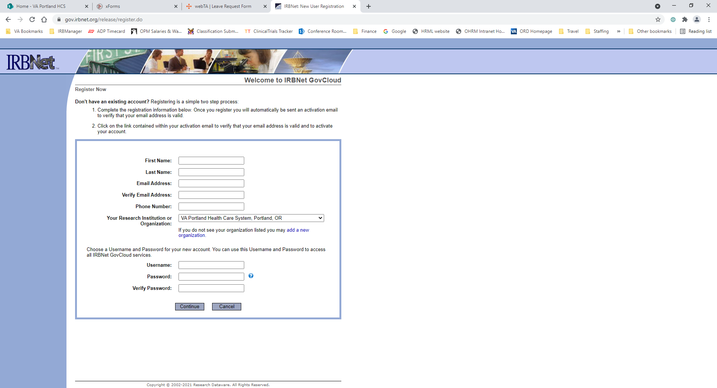

1. Read and accept the Terms of Use.
2. Enter a recovery email (required) and a recovery phone number (not required)
3. A pop-up will appear prompting you to enter the verification code that was just emailed to the main (not recovery) address you provided.
4. Once you enter the verification code, you will have successfully registered, and you will be taken to a blank workspace.

# Sharing A Project In IRBNet

**Who may share a project:** Anyone with full access to the project (see #3 below)

1. Within the project you want to share, select **Share this Project** (in the left column), then **Share**.



1. On the next screen, ensure **Research Institutions** is checked, and select **VA Portland Health Care System, Portland, OR** as the organization. (It should be highlighted in the list by default.)

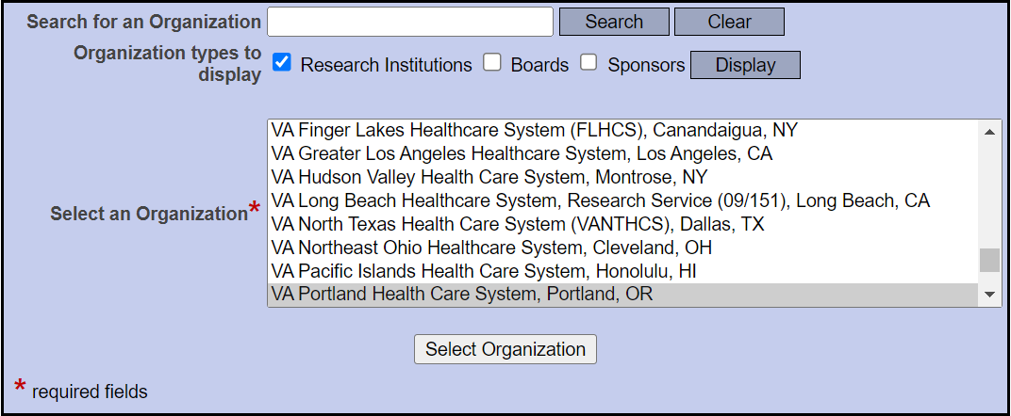

1. On the next screen, use the **Search for User** box to find the investigator with whom you want to share the study. Select **Full** as the access type to ensure that they can submit COI disclosures.

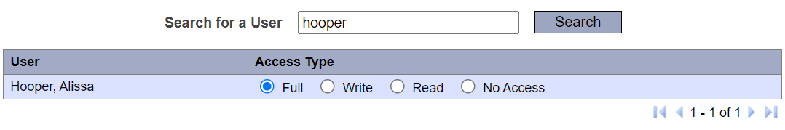

Click **Save** at the bottom of the page to share the project.

# Completing COI Disclosures in IRBNet

1. Log in to IRBNet and select **My COI** (in the left column), then **Create an Initial, Interim, or Annual Disclosure**.



1. The next page has three steps:

**Step 1:** From the dropdown menu, select the project for which you want to complete a COI disclosure.

**NOTE:** The dropdown list will display all projects that have been shared with you in IRBNet. Please submit COI disclosures only for projects on which you are an investigator.

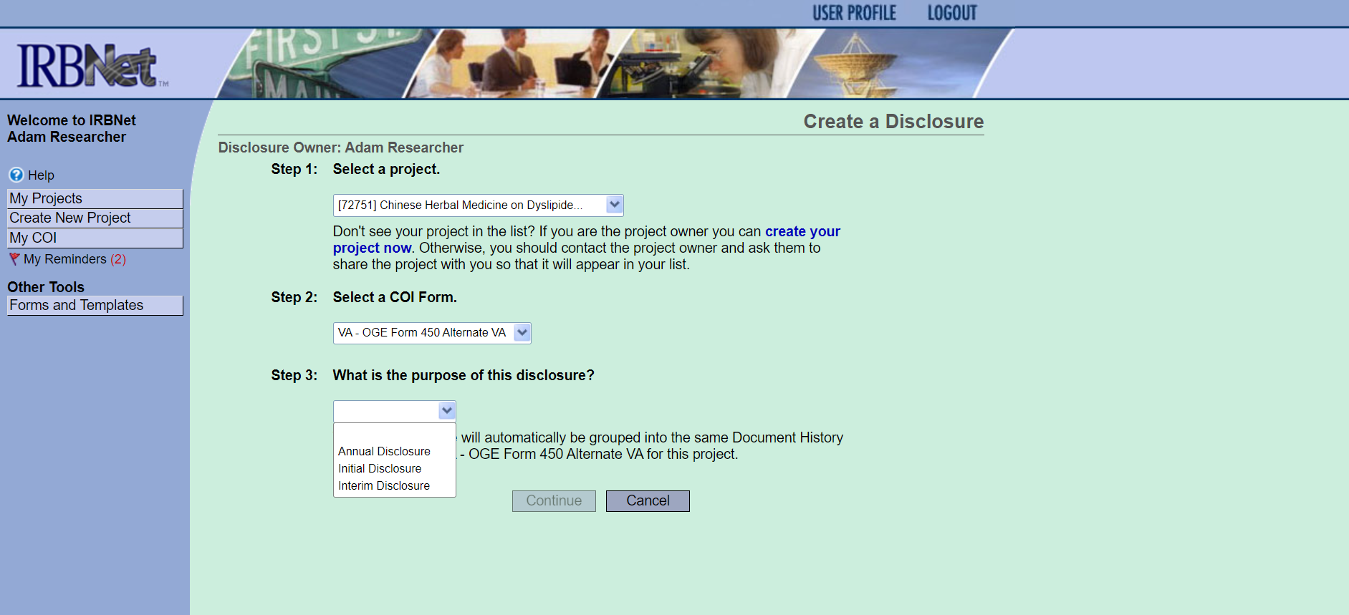

**Step 2:** Select VA - OGE Form 450 Alternate VA. (This is the only option.)



**Step 3:** Select the appropriate disclosure type.

**Initial** for your first COI disclosure for a study

**Annual** for disclosures submitted as part of the annual COI review in October

**Interim** for all other COI disclosures (e.g., you have a new potential conflict to disclose)



1. The next pages will ask the same questions as the PDF COI disclosure form you are used to. **Answer all required questions.**
2. You will see the page below when your COI disclosure is almost complete. **Be sure to click Save and Exit to complete the disclosure.**

When you have completed a COI disclosure, you will be taken back to your **My COI** page. (If you do not see the page below, the COI disclosure you are working on is not yet complete.)

A list of completed COI disclosures will appear at the bottom of the page, and you may use the **Create an Initial, Interim, or Annual Disclosure** option at the top to complete disclosures for additional studies.

**IMPORTANT: Your COI disclosures are not submitted for review until they have been linked to a package that is submitted to the VA Portland Conflict of Interest IRBNet workspace (see below).**

# Submitting COI Disclosure Packages in IRBNet

1. Create a package within your project as you would for an IRB, IACUC, SRS, or RDC submission. Select the package from the **Project Overview** tab and go to the **Designer** page. Then, select **Link / Un-link COI Disclosures** at the bottom of the page.

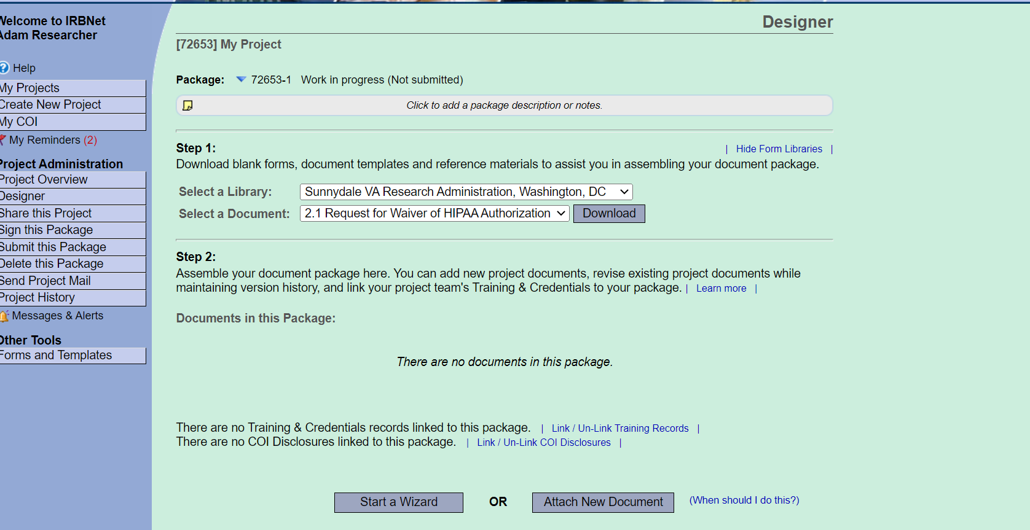

1. The next page will list the completed disclosures for every study team member with access to the project. Click the **Link** boxes next to the COI forms you want to submit and click **Save**.

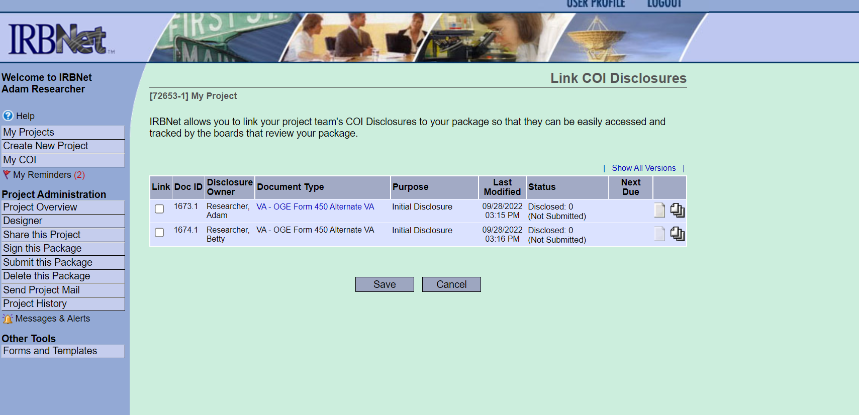

**NOTE:** If any of the COI forms in the package disclose a potential COI that has not previously been reviewed, please add the current version of your study’s protocol to the package.

1. After all required COI forms are linked to the package, click **Submit this Package** in the lefthand column under **Project Administration**.

For **Select a Board**, select **VA Portland Conflict of Interest, Portland, OR** and click **Continue**.

**Do NOT submit COI disclosures to VA Portland Intake.** To protect confidentiality, COI disclosures should be submitted to a different workspace than other IRBNet submissions.

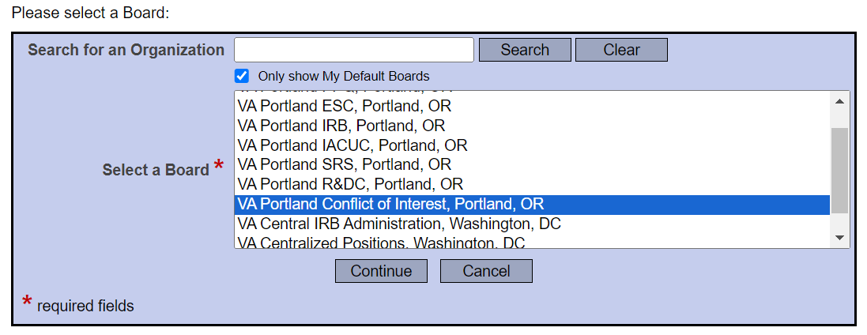

For the **Submission Type**, select **Disclosure**, and click **Submit**.

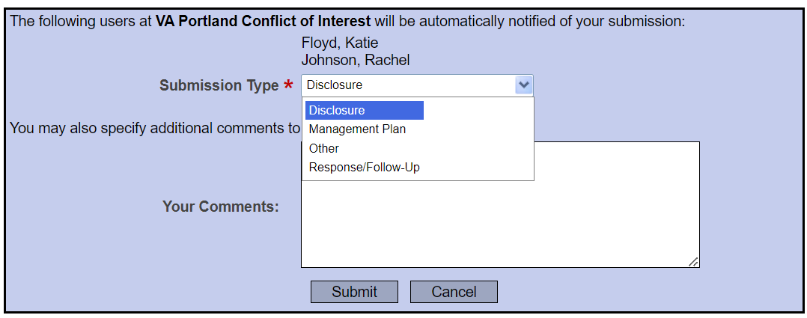

**NOTE:** If **Disclosure** is not an option for **Submission Type**, you are submitting to the wrong "Board." Go back and ensure **VA Portland Conflict of Interest, Portland, OR** is selected as the Board.

# After Submission

## The COI Review Process:

* COI disclosures that indicate no COI or report a COI that has been previously reviewed by OGC Ethics will be reviewed by the VAPORHCS Conflict of Interest Administrators.
* Potential COIs that have not previously been reviewed by OGC Ethics will be sent to OGC Ethics. No action is required from the investigator unless an OGC Deputy Ethics Official requests changes or more information.

## Monitoring the Status of COI Review:

Most COI disclosures will require no action from investigators after submission. Investigators will receive an email from IRBNet when each COI disclosure has been "certified" (approved).

**If changes or more information are needed, investigators will be notified by email from the IRBNet messaging system.** Investigators are responsible for managing their spam filters to ensure they receive IRBNet messages.

### Checking COI Review Status in IRBNet

Under **Project Overview**, there is a list of users with whom a project has been shared. The icons in the COI column indicate the status of their COI disclosures.

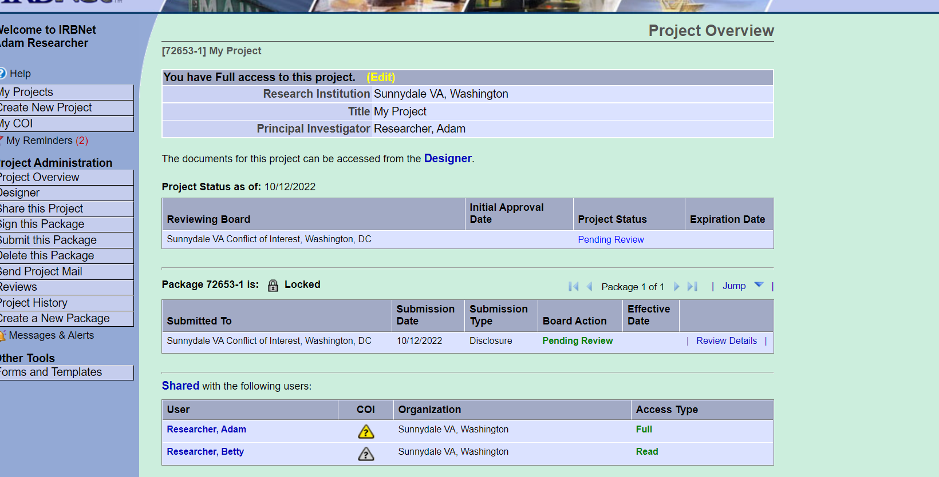

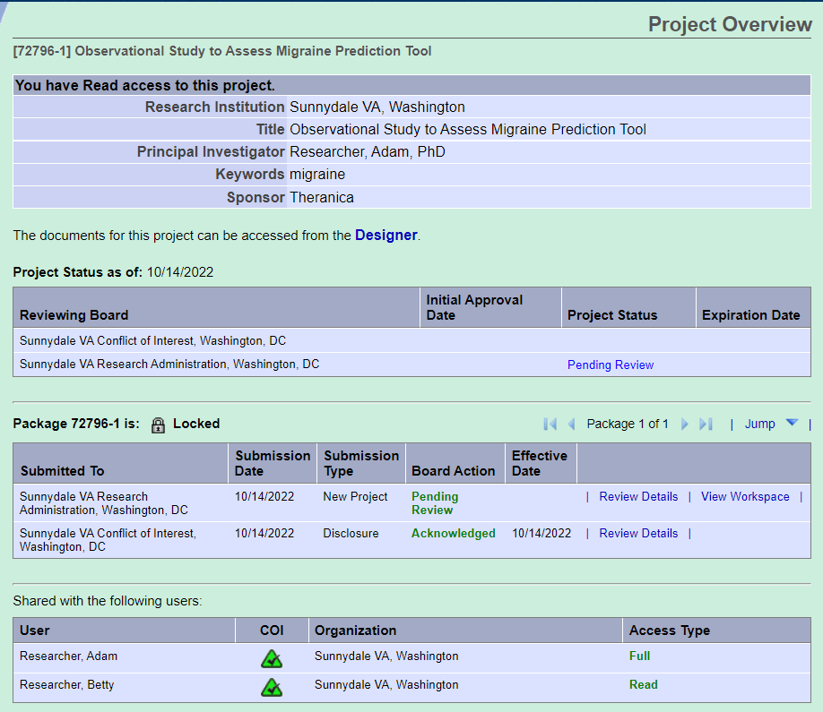

Yellow - a COI disclosure has been submitted but not yet reviewed.

Grey - no COI disclosure has been submitted.

Green - the individual's COI disclosure has been reviewed and approved.