**HELP GUIDE - Submitting a New Non-Exempt Human Subjects Research Project to the VAPORHCS IRB**

**The VAPORHCS IRB forms are meant to work together and prompt you for all information and forms required for your submission. Please read through all instructions and take advantage of all the provided links to policies, definitions, and other forms when applicable. This will help ensure that you include all required elements and reduce time to IRB approval.**

# STEP #0: For PIs New to Human Subjects Research at VAPORHCS

If this is your first human subjects study at VAPORHCS, you will need to make sure A - C below are complete before you submit your study to a VAPORHCS research oversight committee.

1. **Apply for a VAPORHCS research appointment**. Instructions may be found [here](https://www.va.gov/PORTLANDRESEARCH/piservices/hiring/appointmentrequirements.asp).

*If you have no existing (paid or WOC) appointment at VAPORHCS, the process of obtaining one can be quite lengthy. If you have a (paid or WOC) appointment at VAPORHCS in a service other than R&D, the process of obtaining a VAPORHCS research appointment is much quicker.* ***Questions about research appts should be sent to VHAPOR-ResearchWOC@va.gov.***

1. **Complete VAPORHCS human subjects training**. Instructions may be found [here](https://www.va.gov/PORTLANDRESEARCH/documents/irb/citi-instructions.doc).

*As noted in the linked instructions, you must complete the VAPORHCS-specific CITI human subjects training. OHSU CITI human subjects training is not sufficient.*

1. **Register for an account in IRBNet.**

The VA version of IRBNet is called VAIRRS. It is the electronic protocol management system you will use to submit your project to VAPORHCS research oversight committees. It is also where you will find many of the forms you will need to submit.

**PLEASE NOTE:** Do NOT use the back arrow in your web browser during this process.

1. On the IRBNet GovCloud homepage ([gov.irbnet.org](https://gcc02.safelinks.protection.outlook.com/?url=http%3A%2F%2Fgov.irbnet.org%2F&data=04%7C01%7C%7C54bea70f079340f31bd708d90b278c23%7Ce95f1b23abaf45ee821db7ab251ab3bf%7C0%7C0%7C637553086749259535%7CUnknown%7CTWFpbGZsb3d8eyJWIjoiMC4wLjAwMDAiLCJQIjoiV2luMzIiLCJBTiI6Ik1haWwiLCJXVCI6Mn0%3D%7C1000&sdata=CJj1LBAZsOVcj0rnn9rqwz6nfcRoh1TK7bOsEGhkxQs%3D&reserved=0)), select **Register Now**.

*Be sure you are on the GOV page, not the general IRBNet homepage.*

1. Enter your information into the fields (they are all required) and ensure you select **VA Portland Health Care System, Portland, OR** by scrolling through the list.

**NOTE: The PI's email address must be their VA email address.**

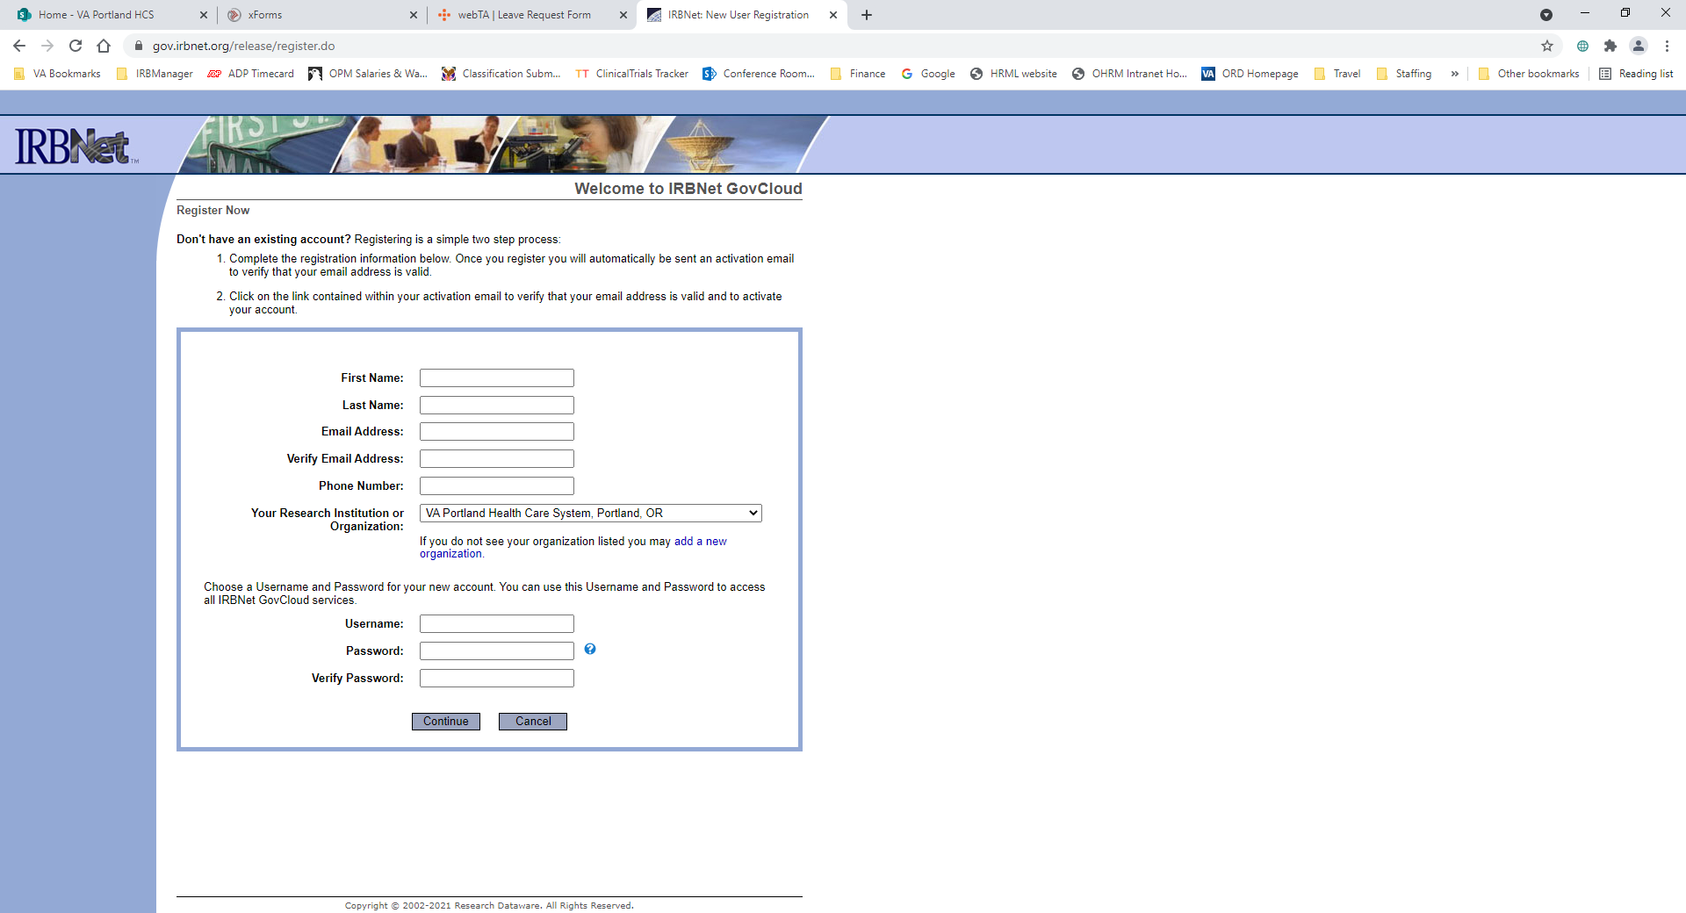

1. Read and accept the Terms of Use.
2. Enter a recovery email (required) and a recovery phone number (not required)
3. A pop-up will appear prompting you to enter the verification code that was just emailed to the main (not recovery) address you provided.
4. Once you enter the verification code, you will have successfully registered, and you will be taken to a blank workspace.

# STEP #1: Proposed Project Questionnaire (PPQ) Submission and Sign-off

* **Complete a Proposed Project Questionnaire (PPQ)**

The PPQ is located at: <https://www.va.gov/PORTLANDRESEARCH/documents/irb/ppq.docx>

* + The VA PPQ provides basic information necessary for the VA Research Office to evaluate and route the project to the appropriate oversight committees. This form must be completed by a VA PI when submitting a research project that uses VA resources (i.e., VA time, VA patients, VA space, and/or VA equipment).
  + The instructions at the beginning of the PPQ prompt for additional documents (an abstract, conflict of interest form, and protocol draft or grant application).
* **Email your completed PPQ and all supporting documents to** [**Research.Grants@va.gov**](mailto:Research.Grants@va.gov).
* After you receive notice that your PPQ has been signed, proceed to **Step #2.**

**EXCEPTION: If the PI or any other investigator on the study has a potential financial conflict of interest to disclose, complete Steps #2 and #3 as soon as possible. Do NOT wait for the PPQ to be signed.**

Potential COIs must be reviewed by OGC Ethics before the project can begin. Review by OGC Ethics can take many months.

# STEP #2: Creating your Initial Review/New Project in VAIRRS

* Log into the VAIRRS/IRBNet system ([[gov.irbnet.org](https://gcc02.safelinks.protection.outlook.com/?url=http%3A%2F%2Fgov.irbnet.org%2F&data=04%7C01%7C%7C54bea70f079340f31bd708d90b278c23%7Ce95f1b23abaf45ee821db7ab251ab3bf%7C0%7C0%7C637553086749259535%7CUnknown%7CTWFpbGZsb3d8eyJWIjoiMC4wLjAwMDAiLCJQIjoiV2luMzIiLCJBTiI6Ik1haWwiLCJXVCI6Mn0%3D%7C1000&sdata=CJj1LBAZsOVcj0rnn9rqwz6nfcRoh1TK7bOsEGhkxQs%3D&reserved=0)](https://gcc02.safelinks.protection.outlook.com/?url=http%3A%2F%2Fgov.irbnet.org%2F&data=04%7C01%7C%7C54bea70f079340f31bd708d90b278c23%7Ce95f1b23abaf45ee821db7ab251ab3bf%7C0%7C0%7C637553086749259535%7CUnknown%7CTWFpbGZsb3d8eyJWIjoiMC4wLjAwMDAiLCJQIjoiV2luMzIiLCJBTiI6Ik1haWwiLCJXVCI6Mn0%3D%7C1000&sdata=CJj1LBAZsOVcj0rnn9rqwz6nfcRoh1TK7bOsEGhkxQs%3D&reserved=0)). *This will allow you to access the templates and forms needed to complete your Initial Review/New Project package.*
* To start your New Project submission, click on "**Create New Project"** located on the left-hand side of your Submission Manager workspace page. ***NOTE: Do NOT click "Create A New Package"***

# STEP #3: Submitting Required COI Disclosures in VAIRRS

**Each investigator (principal, co-, sub-) on your study must submit a financial conflict of interest (COI) disclosure before the project may begin. These disclosures must be completed in VAIRRS and must be submitted in a separate package from your IRB submission.**

**Basic Steps:**

1. **Ensure each of your co-/sub-investigators has a VAIRRS/IRBNet account. (Unless a person is a new investigator at VAPORHCS, they likely already have an account.)**
2. **"Share" the project you created in Step 2 with each of your investigators.**
3. **Have each of your investigators use the My COI tab in VAIRRS to complete a COI disclosure for your project.**
4. **Create a package, link your investigators' COI disclosures, and submit the package to the VA Portland Conflict of Interest VAIRRS workspace.**

***For detailed guidance on how to complete these steps, please consult the HELP GUIDE_Submitting COI Disclosures document in the VA Portland IRB - Documents for Researchers VAIRRS library (see NOTE at the top of Step #4 below).***

# STEP #4: Completing your Initial Review/New Project Submission in VAIRRS

**NOTE: Most forms required for IRB submissions can be located by navigating** in the VAIRRS system to **Forms and Templates (under Other Tools on left-hand side of the package)**; selecting **VA Portland IRB - Documents for Researchers** **(from the Select a Library drop-down menu).**

* **Create a VAPORHCS Protocol using the VAPORHCS Protocol Template**
* The protocol template prompts for the information the IRB needs in order to verify that your proposed project is in compliance with all applicable federal, state, and VA requirements. Please read the directions carefully and ensure that you have addressed all applicable prompts.
* **If the protocol you would like to propose was written by a third party (i.e., the sponsor, the coordinating center, etc.),** please use the protocol template to create a local protocol addendum that makes clear which study activities will occur at VAPORHCS and addresses all applicable prompts for those study activities.

***NOTE:*** *Sponsor's protocols typically contain a lot of information that the IRB does not need to review. A well-constructed local protocol addendum will significantly expedite IRB review of your project by making the information the VAPORHCS IRB needs easy to find. (Please note that VAPORHCS has an all-volunteer IRB made up primarily of VA clinicians and staff who have little (if any) protected time for their IRB work.)*

* Complete the **Initial Review Questionnaire (IRQ)**

***NOTE:*** *Follow the Checklist for Submission section and instructions throughout the form carefully. The IRQ includes specific prompts for other required forms, guidance documents and how to locate them.*

* To upload the **VAPORHCS Local Protocol Addendum, Initial Review Questionnaire (IRQ)**, and **all supporting documents**, click the **Attach New Document** button at the bottom of the page (of the New Project submission you are working on).

# STEP #5: Required “Wizards”

* All new projects submitted to the VAPORHCS IRB must include a **Project Cover Sheet, VA IRB Information Sheet**, and **Study Team Tracking Sheet**. VAIRRS includes a **wizard** for each that is used to complete them within the system.
* To locate and complete the required wizards, click the **Start a Wizard** button at the bottom of the page of the New Project submission you are working on, and select the wizard you need to complete.

***NOTE:*** *For additional guidance, consult the* ***000-WIZARDS GENERAL GUIDANCE & UPDATES*** *and/or the specific* ***0-Wizard Guide*** *documents**located in the* ***VA Portland IRB – Documents for Researchers VAIRRS library.***

# STEP #6: How to Submit Your Completed New Project Package:

* Once the submission materials are complete, **the PI must sign the package in VAIRRS.** No other study staff is required to sign the package. **Study staff may submit the package (see instructions below) on the PI's behalf, but they may NOT sign on the PI's behalf.** 
  + PIs can access additional instructions for how to sign a package by navigating in VAIRRS to **Forms and Templates** (under **Other Tools** on left-hand side of CR package) and selecting **VA Portland IRB - Documents for Researchers** from the **Select a Library** drop-down menu, and selecting **0-HELP GUIDE_Signing A Package** from the documents list.
* **Submit** the package by navigating to **Project Administration** on the left-hand side of the package and clicking on **Submit this Package.**

# Review Process for Non-Exempt Human Subjects Studies:

* + 1. **Review by the VAPORHCS Information Systems Security Officer (ISSO)**

When this step is complete, the ISSO will sign the ERDSP and upload it to VAIRRS/IRBNet. You will receive an email notification from VAIRRS/IRBNet stating that your project has been forwarded to the VAPORHCS IRB.

* + 1. **Pre-Review by an IRB Analyst**

An IRB Analyst will review the submission and send you a list of changes needed before IRB review. The goal of this step is to minimize the number of changes requested by Privacy Officer (PO) and IRB reviewers, as those changes must be re-reviewed by PO and/or IRB reviewers once they are made.

* + 1. **Review by the VAPORHCS Privacy Officer**
    2. **IRB Review**

When this step is complete, you will receive an email notification from VAIRRS/IRBNet stating that the IRB has approved the study. An approval letter and study documents stamped with the IRB approval date will be published in VAIRRS/IRBNet. However, please note that **the study may not begin until the R&D Committee has also reviewed and approved it.**

* + 1. **R&D Committee Review**

When this step is complete, you will be notified that you may begin the study.

# Making Required Revisions:

If any of the above reviewers require changes, you will be notified by email that your submission has been "unlocked" for revisions. Once you have made those changes, you will need to **mark revisions complete** to re-lock the package. This will notify the IRB analysts that the project is ready to be sent back to the reviewer who requested the changes.

Additional instructions are available in the **0-HELP GUIDE_STUDY-TEAMS_Minor Revisions-Finding Approval-Ltr-Docs** and **0-VAIRRS FAQ-For Study Teams** help guides in the **VA Portland IRB - Documents for Researchers** VAIRRS library.

# Additional Resources and Guidance:

PI resources can be found at the following links:

<https://www.va.gov/PORTLANDRESEARCH/piservices/index.asp>

[http://www.portland.va.gov/Research/hrpp/index.asp?tab=3](https://www.va.gov/PORTLANDRESEARCH/hrpp/index.asp?tab=3)

<https://www.research.va.gov/resources/policies/human_research.cfm>

<https://www.va.gov/PORTLANDRESEARCH/piservices/rd_forms.asp>

**QUESTIONS?**

Email the IRB Inbox at [pvamc-irb@va.gov](mailto:pvamc-irb@va.gov)