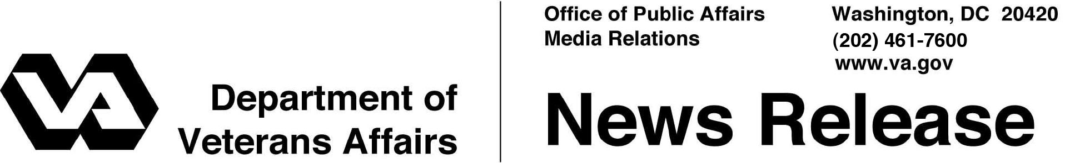

FOR IMMEDIATE RELEASE
Dec. 7, 2009

Shinseki Says VA’s Home Loan Program a “Continued Success”
Veterans More Likely to Avoid Foreclosure with VA-Backed Loan
WASHINGTON – Despite problems in the nation’s housing market, mortgage loans backed by the Department of Veterans Affairs (VA) had a lower foreclosure rate than any other type of home loan in the industry, as of the end of the last fiscal year.
“The dedication of VA’s loan professionals, the support of our partners in the mortgage industry and most importantly, the hard work and sacrifice of our Veterans have made this possible,” said Secretary of Veterans Affairs Eric K. Shinseki. “VA is making good on its promise to help Veterans buy homes, and Veterans are achieving their dreams.”
Currently, about 1.3 million active home loans were obtained using VA’s Home Loan Guaranty Program. The program makes home ownership more affordable for Veterans, active-duty members, and some surviving spouses by protecting lenders from loss if the borrower fails to repay the loan.
More than 90 percent of VA-guaranteed loans are made without a downpayment. Despite this, VA has the lowest serious delinquency rate in the industry, according to the Mortgage Bankers Association. Furthermore, VA’s percentage of loans in foreclosure is the lowest of all measured loan types—lower even than prime loans, which require high credit scores and a 20 percent downpayment by the borrower.
Much of the program’s strength stems from the efforts of VA employees and loan servicers nationwide, whose primary mission is to help Veterans stay in their homes, avoid foreclosure and protect their credit lines from the consequences of a foreclosure, Shinseki said.
Depending on the situation, VA’s loan specialists can intervene on a Veteran’s behalf to help pursue home-retention options such as repayment plans, loan modifications and forbearance. Additionally, under certain circumstances, VA can refund a loan, which involves purchasing the loan from the mortgage company and modifying the terms so the Veteran can afford the new mortgage payment.
Home Loans 2/2/2/2

Since 1944, when home-loan guarantees were offered under the original GI Bill, through the fiscal year that ended Sept. 30, VA has guaranteed more than 18.7 million home loans worth $1.04 trillion.
To obtain more information about the VA Home Loan Guaranty Program, Veterans can call VA at 1-877-827-3702. Information can also be obtained at http://www.homeloans.va.gov.

# # #

