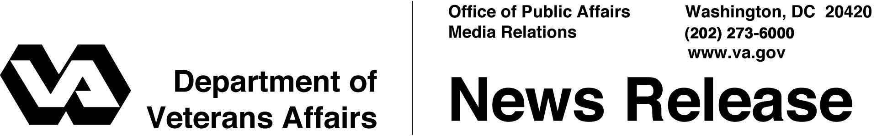

FOR IMMEDIATE RELEASE
June 13, 2007
Nicholson Praises SBA’s Patriot Express Loans
Vets a “Great Resource” for Business, Secretary Says
WASHINGTON -- With nearly a quarter of newly discharged veterans considering starting their own businesses, Secretary of Veterans Affairs Jim Nicholson praised a new Small Business Administration venture to make business ownership easier for all veterans.
The Small Business Administration (SBA) has unveiled a program called “Patriot Express” that offers a wide variety of assistance to veterans interested in setting up or expanding their own small businesses.
“America’s veterans are a great resource for the private sector,” Nicholson said. “I commend Administrator Steve Preston of the Small Business Administration for his initiative in helping veterans transition back into the private sector.”
Assistance under the new SBA program for veterans ranges from help writing a business plan and managing a business, to obtaining financing and learning how to export goods. Participants may also qualify for loans between 2.25 percent and 4.75 percent over the prime interest rate.
Patriot Express is open to veterans, reservists and National Guard members, current spouses of eligible personnel, the surviving spouses of service members who die on active duty, or spouses of veterans who die from a service-connected disability.
Expanding veterans’ eligibility to SBA’s Patriot Express program was a key recommendation of a presidential task force on the needs of returning veterans that Nicholson chaired. Nicholson delivered the panel’s report to the White House on April 23.
More information about the SBA program is available at http://www.sba.gov/patriotexpress.

# # #

