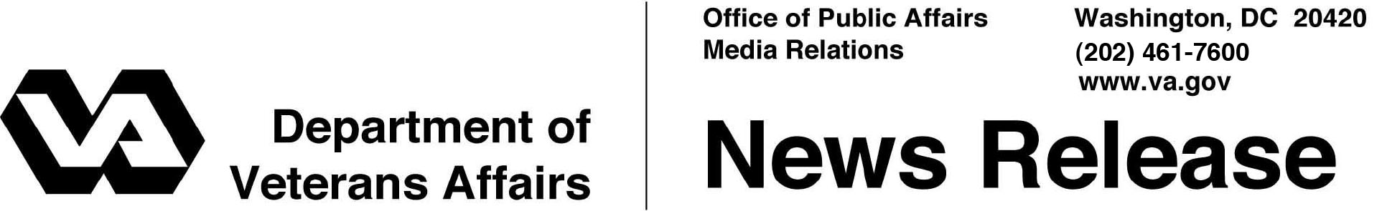

FOR IMMEDIATE RELEASE
October 24, 2008

Enhanced VA Mortgage Options Now Available for Veterans

Of Potential Benefit to Those in Financial Distress
WASHINGTON -- Veterans with conventional home loans now have new options for refinancing to a Department of Veterans Affairs (VA) guaranteed home loan. These new options are available as a result of the Veterans’ Benefits Improvement Act of 2008, which the President signed into law on October 10, 2008.
“These changes will allow VA to assist a substantial number of veterans with subprime mortgages refinance into a safer, more affordable, VA guaranteed loan,” said Secretary of Veterans Affairs Dr. James B. Peake. “Veterans in financial distress due to high rate subprime mortgages are potentially the greatest beneficiaries.”
VA has never guaranteed subprime loans. However, as a result of the new law VA can now help many more veterans who currently have subprime loans.
The new law makes changes to VA’s home loan refinancing program. Veterans who wish to refinance their subprime or conventional mortgage may now do so for up to 100 percent of the value of the property. These types of loans were previously limited to 90 percent of the value.
Additionally, Congress raised VA’s maximum loan amount for these types of refinancing loans. Previously, these refinancing loans were capped at $144,000. With the new legislation, such loans may be made up to $729,750 depending on where the property is located.
Increasing the loan-to-value ratio and raising the maximum loan amount will allow more qualified veterans to refinance through VA, allowing for savings on interest costs or even potentially avoiding foreclosure.

- More -

Enhanced VA Mortgage Options 2/2/2/2

Originally set to expire at the end of this month, VA’s authority to guaranty Adjustable Rate Mortgages (ARMs) and Hybrid ARMs was also extended under this new law through September 30, 2012. Unlike conventional ARMs and hybrid ARMs, VA limits interest rate increases on these loans from year to year, as well as over the life of the loans.
Since 1944, when home loan guaranties were offered with the original GI Bill, VA has guaranteed more than 18 million home loans worth over $911 billion. This year, about 180,000 veterans, active duty servicemembers, and survivors received loans valued at about $36 billion.
For more information, or to obtain help from a VA Loan Specialist, veterans may call VA at 1-877-827-3702 or visit www.homeloans.va.gov.

# # #

