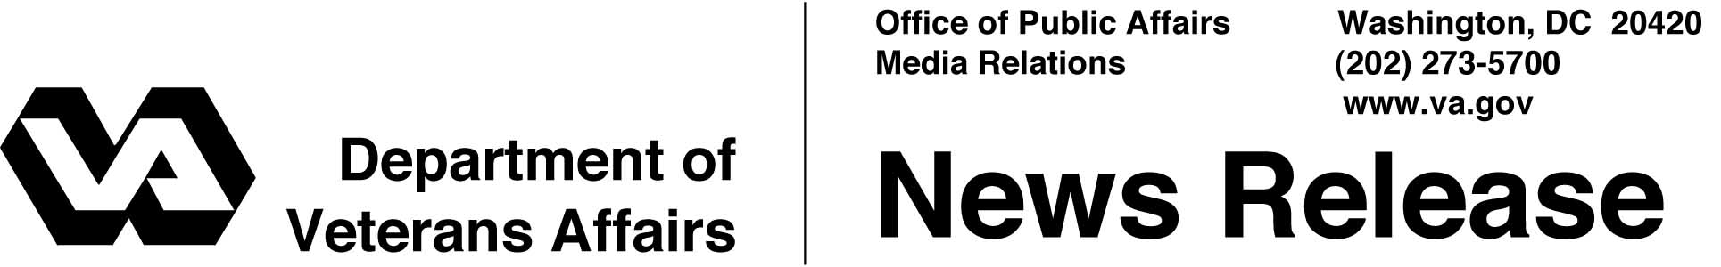

FOR IMMEDIATE RELEASE
July 11, 2002

VA Receives Top Award From Pharmaceutical Association
WASHINGTON -- Innovation comes in many forms. For a Department of Veterans Affairs (VA) nurse in Topeka, Kan., it sprang from the most unexpected of places, a rental car company. Her idea resulted in the birth of a cutting-edge program that recently received the American Pharmaceutical Association Foundation's Pinnacle Award in the health system category.
Her inspiration evolved into Bar Code Medication Administration (BCMA), a program designed to eliminate a host of problems like poor handwriting and lost paper prescriptions. According to the Department of Health and Human Services, medication errors in the nation's hospitals can be cut by more than two-thirds if doctors enter prescriptions into a computer rather than scribbling on paper.
"Innovations in information technology have been a key component of the profound changes in VA health care," said Dr. Frances Murphy, deputy under secretary for health, who accepted the award on behalf of VA. "Bar code medication administration was piloted at the Topeka VA Medical Center in 1995. Today, it is in every VA facility and hailed throughout the medical community."
Bar coding works like this. Before dispensing medications at a VA hospital, a nurse scans a patient's wristband with a hand-held device similar to price scanners used in stores (or rental car companies), and then scans a label on the medicine to make sure the right patient is getting the right medicine in the right dose and at the right time.
A significant advantage is that a real-time system gives everyone in the medication loop, from physician to the pharmacist to the nurse, instant updates. If the physician cancels or changes a drug order mid-shift, the system catches the change and prevents administration of the wrong dose.

-More-
Pinnacle Award 2-2-2-2

Almost five years ago, VA realized that medical errors were a major problem that needed to be confronted with aggressive action, according to Murphy. VA established its National Center for Patient Safety in 1998, more than a year before the Institute of Medicine's report, "To Err is Human," raised public awareness of the extent of the safety problems in U.S. health care.
"There is a whole range of errors that can take place in the administration of medication -- the wrong time, the wrong dose, the wrong patient," said Dr. Murphy. "If the error is not identified it may continue and cause serious harm. It was to eradicate just such mistakes that VA installed computerized software and equipment. Patient safety and quality of care are our highest priorities at VA."
The results cannot be ignored. Between 1993 and 1999, the Topeka VA medical center saw a 74-percent improvement in errors caused by the wrong medication being administered, a 57-percent improvement in errors caused by the incorrect doses being administered, a 91-percent improvement in wrong-patient errors and an almost 92-percent improvement in wrong-time errors.
In presenting the Pinnacle Award to VA, Dr. Kenneth Kizer, former under secretary for health at VA and currently the president and CEO of the National Quality Forum, said, "This initiative [bar code administration] meets and exceeds the American Pharmaceutical Association's standards and is a model for health care improvement that every institution in the country should seek to replicate."
The Pinnacle Award comes to VA in no small measure because of a VA nurse's foresight and passion more than ten years ago. "Along with thousands of other VA employees, she raised VA's standards and made VA a benchmark in the world of health care," said Murphy.

# # #

