Blind Rehabilitation (BR)

ANRV 5.1*9 GUI Version 5.1.6

Release Notes
May 2024
Document Version 1.0
Department of Veterans Affairs (VA)
Office of Information and Technology (OI&T)

Revision History
Date | Version | Description | Author
05/2024 | 1.0 | Release Notes for 5.1*9 (5.1.6) | Booz Allen Hamilton

Table of Contents
1 Purpose 1
1.1 General Updates 1
1.1.1 Print Letters 1
1.1.2 Print Reports 4
1.1.3 Print VIST Roster Sorts Reports 4
1.1.4 VIST Roster Summary Report 4
1.1.5 BR Patient 6
2 JAWS Supported Versions 7

List of Figures
Figure 1 - Select Patients Method 2
Figure 2 - Remove names from the patient list 2
Figure 3 - Select Patient Criteria - Patient Mailing Labels 3
Figure 4 - Select Patient Criteria for Print Letters 3
Figure 5 - Microsoft Accessibility Check 4
Figure 6 - Microsoft Read Aloud 4
Figure 7 - ICD10 with some ICD9 codes 5
Figure 8 - non-BRC VIST Referrals Summary 5
Figure 9 - Tracked By field 6
Figure 10 - Supported JAWS Versions 7

Purpose
The Blind Rehabilitation (BR) team has made significant updates to the BR application. This document will summarize the updates made for release 5.1.6 and provide brief instructional text for specific updates.

General Updates
The 5.1.6 release includes improvements to reports in the Print VIST Roster Sorts menu and the Print Reports menu. Among the improvements are the screen reading order when using JAWS (Job Access With Speech), Data Only downloads for the less complex reports, and updates to the VIST Roster Summary Report. The reports that have rows that are unable to be displayed in a single row have been reformatted, so they are easier to read.
Release 5.1.6 also includes updates to the Letters and Labels Menu. The Enter/Edit Letters allows a user to edit and Print Existing Letters. The Select Patients Method will retain your Saved Patient List upon log off.
The application has been updated to use ICD10 codes rather than ICD9 codes. The VIST Roster Summary report was updated to include ICD10 codes for the Primary and Secondary Cause of Vision Loss sections. Some ICD9 codes are still listed and have a * preceding it if it is still in use by a patient on the roster.

Print Letters
The Print Letters tab has been corrected to allow letters to be printed using the institutions roster list or a trimmed roster list that will persist upon log off.
Figure 1 - Select Patients Method
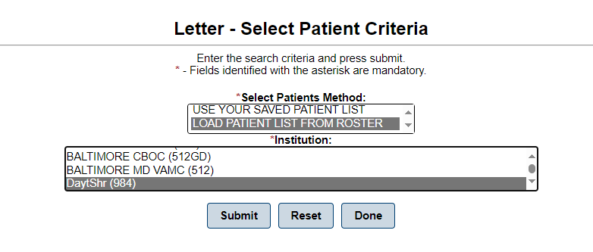

If the user selects the Load Patient list from Roster, it will load the roster for the institution(s) you have highlighted. A user can begin to edit the list by clicking the Remove button on the row adjacent to the patient’s address. This will become your saved patient list after you click the Continue button.
Figure 2 - Remove names from the patient list
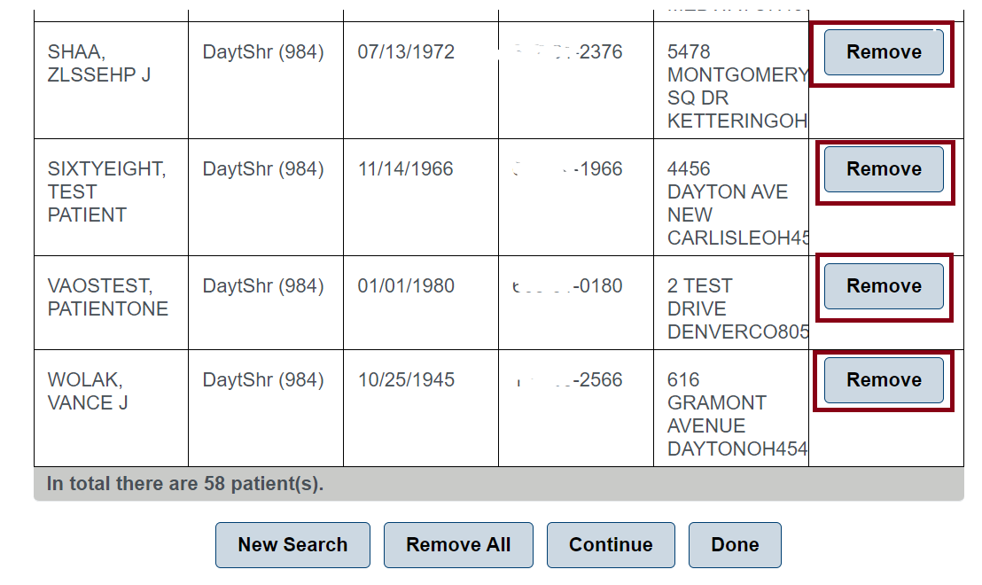
The USE CURRENT LIST AND MANUALLY EDIT button will be available if the end user had previously created a unique list by Print Letters – Search Criteria or Print Patient Mailing Labels – Select Patient Criteria. The USE CURRENT LIST AND MANUALLY EDIT - Select Patients Method will not display if prior search criteria were not done. The end user may choose USE CURRENT LIST AND MANUALLY EDIT option; this will become your Saved Patient List. The Saved Patient list persists upon logout.
Figure 3 - Select Patient Criteria - Patient Mailing Labels
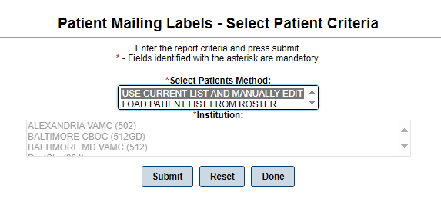

The USE BR PATIENT ALREADY SELECTED method will be available if you had executed a BR Patient Search during this log in session. If you had not done any BR patient searches, you will not see it in the Select Patients Method box. Likewise, you will not see the USE YOUR SAVED PATIENT LIST if you have never selected Letters or Mailing Labels to print. If you choose the USE BR PATIENT ALREADY SELECTED option, or the LOAD PATIENT LIST FROM ROSTER, this will become your Saved Patient List. The Saved Patient list persists upon logout.
Figure 4 - Select Patient Criteria for Print Letters
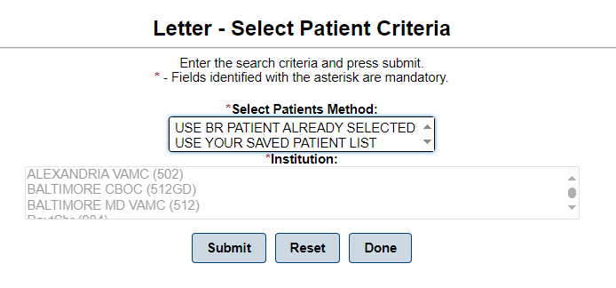

Print Reports
Reports under the Print Reports tab have been updated to correct the screen reading order when using applications such as JAWS or ZoomText. The reports have also been updated for exported reports in Excel and Word so that they pass the Microsoft Accessibility check.
There is an issue with exporting reports to Word when JAWS is running. This occurs for reports that are larger than 12 pages. Alternate screen reading tools should be used when exporting large reports to Word such as ZoomText or the built in Read Aloud Feature under the Review tab. This issue with JAWS and large Word reports will be fixed in a future release.
Figure 5 - Microsoft Accessibility Check
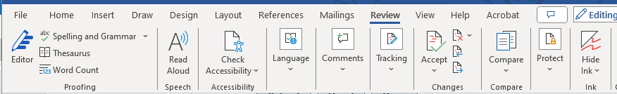

Print VIST Roster Sorts Reports
Reports under the Print VIST Roster Sorts Reports tab has been updated to correct the screen reading order when using applications such as JAWS or ZoomText. The reports have also been updated for exported reports in Excel and Word so that they pass the Microsoft Accessibility check.
There is an issue with exporting large reports to Word when JAWS is running. This occurs for reports that are larger than 12 pages. Alternate screen reading tools should be used when exporting reports to Word such as ZoomText or the built in Read Aloud Feature under the Review tab. This issue with JAWS and large Word reports will be fixed in a future release.

Figure 6 - Microsoft Read Aloud

VIST Roster Summary Report
The VIST Roster Summary Report and VIST Roster Summary Report (by VISN) have been updated to include ICD10 codes. If a patient is still using an ICD9 code on the roster, their ICD9 code will appear in the report and will be marked with an *. This applies to both Primary and Secondary Cause of Vision Loss.

Figure 7 - ICD10 with some ICD9 codes
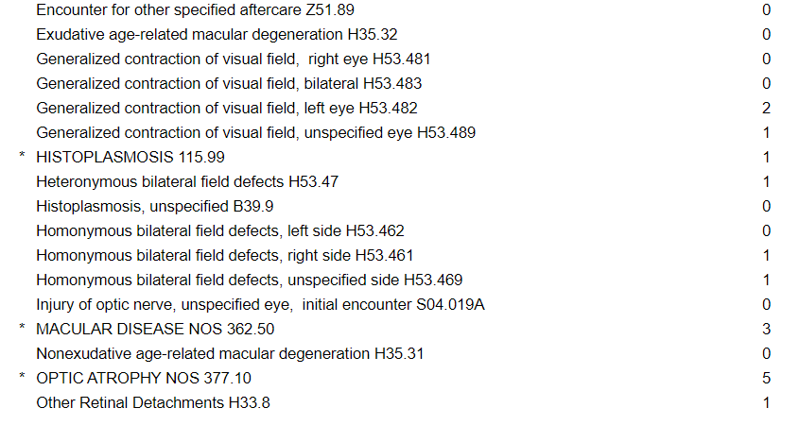
The VIST Referrals Applications section have been updated to provide statistics on referrals. For BRC type referrals the quantity of Submitted, Admitted, and Discharged referrals is tracked. For non-BRC type referrals the number of Submitted and Completed referrals is provided for the given reporting period. Vision Therapy type referrals are now included in the report.

Figure 8 - non-BRC VIST Referrals Summary
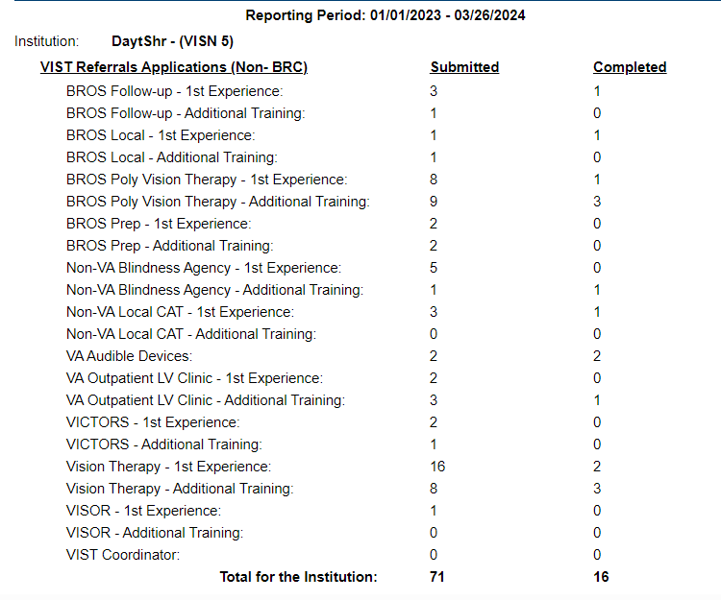

The VIST Coordinator Encounters and VIST Referrals (VA – Fee for Service) sections have been removed from the VIST Roster Summary Report.

BR Patient
The Enter New Blind Patient has been corrected to make a new staff member’s name available in the Tracked By field. Previously, the application would have to be restarted before new staff names could be selected from this drop-down list.
Figure 9 - Tracked By field
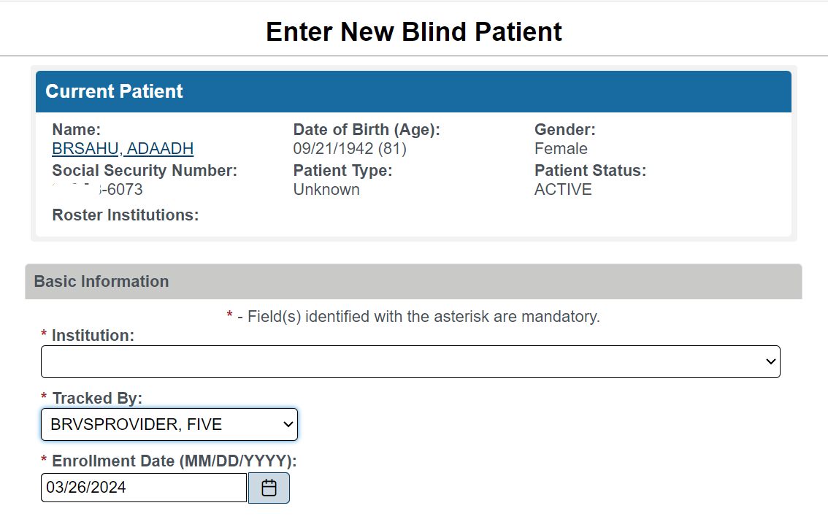

JAWS Supported Versions
The supported JAWS versions can be found at the following link: Job Access With Speech (JAWS) (va.gov) 9 depicts the supported JAWS versions in a table format.
Figure 10 - Supported JAWS Versions
