

Update _2_0_198A

Clinical Reminders

VA-MH HRS PATIENT RECORD FLAG TEMPLATE UPDATE

Install Guide

**January 2024**

Product Development

Office of Information Technology

Department of Veterans Affairs

Table of Contents

Introduction 1

Install Details 2

Install Example 3

Post Installation 7

## Introduction

**Description of changes:**

1. With publication of VHA Directive 1166, Patient Record Flags, on November 8, 2023, all reference to “Category I” patient record flags has been retired. Therefore, all reference to “Category I” is being removed from the High Risk for Suicide Patient Record Flag (HRS-PRF) (**reminder dialog VA-MH HRS PRF CATEGORY I - HIGH RISK FOR SUICIDE)** progress notes. In addition the template content has been updated as follows:

* The version number is now 2.1
* Reference to management of missed and cancelled appointments has been streamlined and simplified to include a requirement to follow outreach procedures as per policy.
* Reference to mental health appointments has been modified from “provided with” to “offered.”
* Reference to receipt of caring communications has been modified to acknowledge changes made by the nationally standardized High Risk Flag Caring Letters (HRF CL).

For references and resources related to the High Risk for Suicide Patient Record Flag, please see REDACTED

2. The Suicide Prevention Consult for High Risk Flag Placement Progress Note Template (reminder dialog VA-MH HRF PLACEMENT CONSULT) was updated to version 2.1 and to remove the words “Category 1”.

UPDATE_2_0_198A contains 1 Reminder Exchange entry:

**UPDATE_2_0_****198A VA-MH HRS PATIENT RECORD FLAG UPDATE**

**The exchange file contains the following components:**

**TIU TEMPLATE FIELD**

VA-WORDR

**HEALTH FACTORS**

VA-REMINDER UPDATES [C]

VA-UPDATE_2_0_198A

VA-HRS PRF CONSULT [C]

VA-HRS PRF CONSULT ACTIVATE FLAG NO

VA-HRS PRF CONSULT FLAG IN PLACE

VA-HRS PRF CONSULT ACTIVATE FLAG YES

VA-HIGH RISK FOR SUICIDE [C]

VA-HRS PRF ASSIGNED SPC

VA-HRS PRF CONTINUED

VA-HRS PRF ACTIVATED

VA-HRS PRF NEXT REVIEW DATE

VA-HRS PRF RECEIVING FACILITY

VA-HRS PRF TRANSFER DATE

VA-HRS PRF TRANSFERRING FACILITY

VA-HRS PRF TRANSFERRED

VA-HRS PRF CARING COMM NO DIED

VA-HRS PRF CARING COMM NO IFSM

VA-HRS PRF CARING COMM NO CORR

VA-HRS PRF CARING COMM YES

VA-HRS PRF STRESS

VA-HRS PRF COPING MEDICAL

VA-HRS PRF COPING MH

VA-HRS PRF COPING PD

VA-HRS PRF LETHAL MEANS NO

VA-HRS PRF MAINTAIN SAFETY

VA-HRS PRF SUICIDE PLAN NO

VA-HRS PRF SUICIDAL INTENT ADMIT NO

VA-HRS PRF INPAT NO

VA-HRS PRF RECENT SDV NO

VA-HRS PRF MH ENGAGE NO

VA-HRS PRF MH ENGAGE YES

VA-HRS PRF INACTIVATE CLIN REVIEW

VA-HRS PRF DECEASED

VA-HRS PRF IFSM SAFETY PLAN

VA-HRS PRF IFSM CARE COORD

VA-HRS PRF IFSM COMM REFERRAL

VA-HRS PRF INELIG FORMER SERV MEM

VA-HRS PRF INACTIVATED

**REMINDER SPONSOR**

OFFICE OF MH AND SUICIDE PREVENTION

**REMINDER TERM**

VA-REMINDER UPDATE_2_0_198A

**REMINDER DIALOG**

VA-MH HRF PLACEMENT CONSULT

VA-MH HRS PRF CATEGORY I - HIGH RISK FOR SUICIDE

## Install Details

This update is being distributed as a web host file. The address for the host file is: **https://REDACTED /UPDATE_2_0_198A.PRD**

The file will be installed using Reminder Exchange, programmer access is not required.

Installation:

=============

This update can be loaded with users on the system. Installation will take less than 5 minutes.

## Install Example

To Load the Web Host File. Navigate to Reminder exchange in Vista


Screen shot of the Reminder Exchange terminal window with LWH for "Load Web Host File" entered and a URL for PRD file downloads filled in (that is only active from inside the VA firewall)

At the **Select Action:** prompt, enter **LWH** for Load Web Host File

At the **Input the url for the .prd file:** prompt, type the following web address:

**https://REDACTED /UPDATE_2_0_198A.PRD**

You should see a message at the top of your screen that the file successfully loaded.

Search and locate an entry titled **UPDATE_2_0_198A VA-MH HRS PATIENT RECORD FLAG** in reminder exchange.

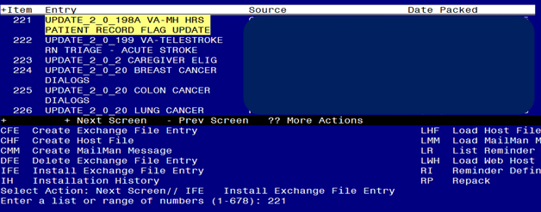

At the **Select Action** prompt, enter **IFE** for Install Exchange File Entry

Enter the number that corresponds with your entry UPDATE_2_0_198A VA-MH HRS PATIENT RECORD FLAG UPDATE *(in this example it is entry 221. It will vary by site).* The date of the exchange file should be 12/05/2023.

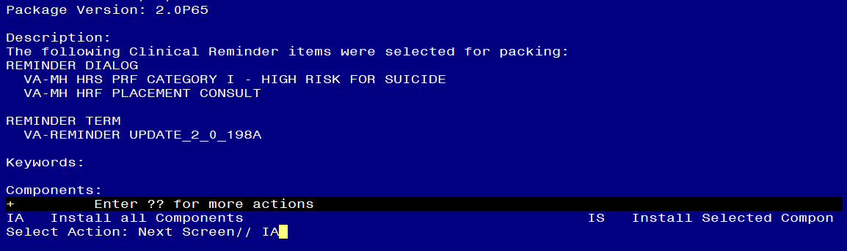

At the **Select Action** prompt, type **IA** for Install all Components and hit enter.

Select Action: Next Screen// IA Install all Components

You will see several prompts, for all new entries you will choose **I to Install**

For components that already exists but the packed component is different, choose **O to Overwrite.**

**You will be promped to install the FIRST reminder dialog component (VA-MH HRF PLACEMENT CONSULT).** You will choose to install all even though some components may have an X to indicate that they exist.

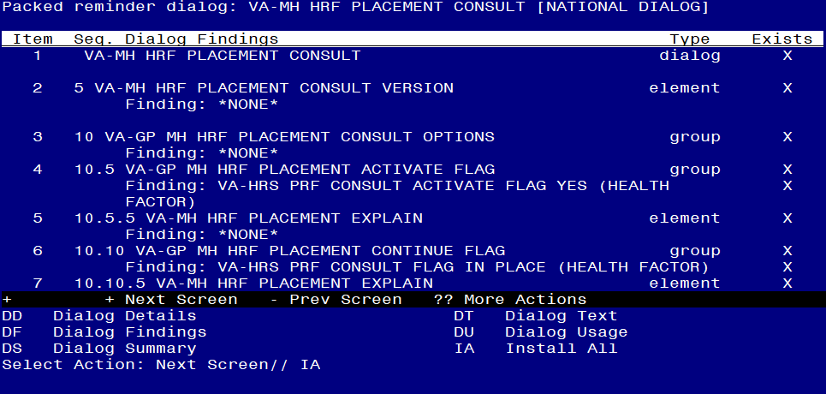

At the **Select Action** prompt, type **IA** to install the dialog: **VA-MH HRF PLACEMENT CONSULT**

Select Action: Next Screen// IA Install All

Install reminder dialog and all components with no further changes: Y// Yes

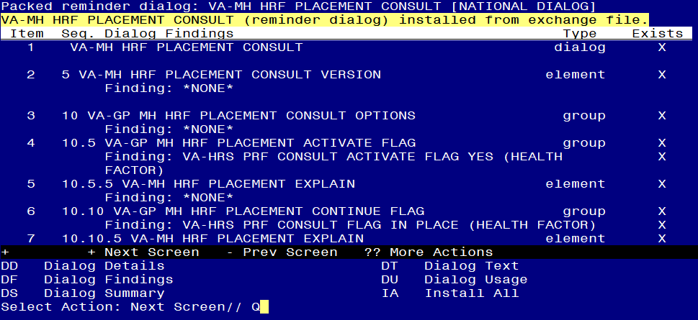

After completing this dialog install, you will type Q.

**You will be promped to install the NEXT reminder dialog component (VA-MH HRS PRF CATEGORY I - HIGH RISK FOR SUICIDE).** You will choose to install all even though some components may have an X to indicate that they exist.

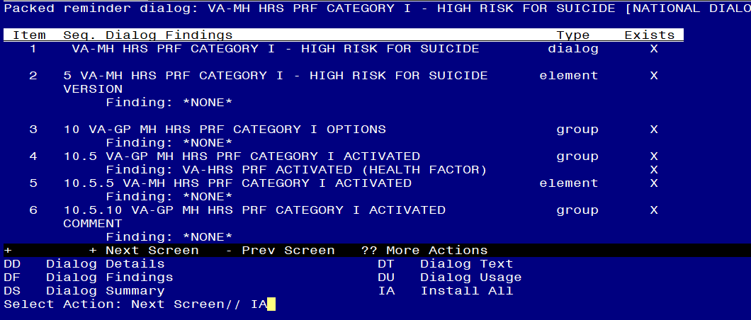

At the **Select Action** prompt, type **IA** to install the dialog: **VA-MH HRS PRF CATEGORY I - HIGH RISK FOR SUICIDE**

Select Action: Next Screen// IA Install All

Install reminder dialog and all components with no further changes: Y// Yes

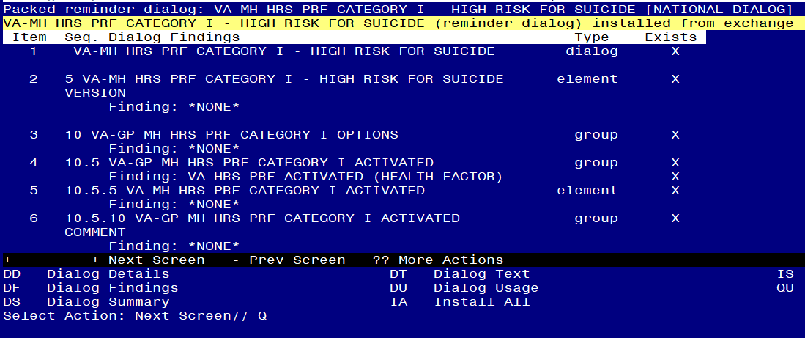

After completing this dialog install, you will type Q.

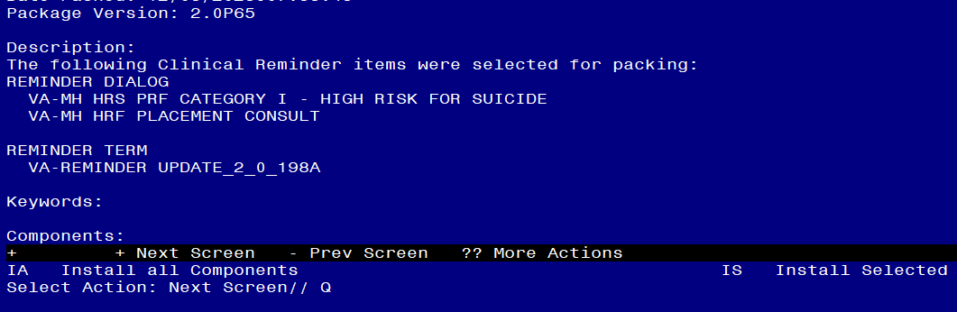

You will then be returned to this screen. At the **Select Action** prompt, type **Q.**

Install complete.

## Post Installation

1. **In CPRS open the note titled** **SUICIDE PREVENTION HIGH RISK FLAG CONSULT RESPONSE** (reminder dialog VA-MH HRF PLACEMENT CONSULT) and confirm the version displays as 2.1.

**Note: it may be easier to confirm/review the dialog text in VistA based on the rules surrounding this note. You can use the menu REMINDER DIALOG MANAGEMENT, then REMINDER DIALOGS, change view to Reminder Dialogs, search for the dialog name VA-MH HRF PLACEMENT CONSULT, open and use the DT Dialog Text option to verify “Version 2.1” displays on the first element.**

1. **In CPRS open the note titled** PATIENT RECORD FLAG CATEGORY I - HIGH RISK FOR SUICIDE (reminder dialog VA-MH HRS PRF CATEGORY I - HIGH RISK FOR SUICIDE) and confirm the version displays as 2.1.

**Note: it may be easier to confirm/review the dialog text in VistA based on the rules surrounding this note. You can use the menu REMINDER DIALOG MANAGEMENT, then REMINDER DIALOGS, change view to Reminder Dialogs, search for the dialog VA-MH HRS PRF CATEGORY I - HIGH RISK FOR SUICIDE (you may want to do a partial name search), open the dialog and use the DT Dialog Text option to verify “Version 2.1” displays on the first element.**