

Update_2_0_240A

Clinical Reminders

VA-PAVE TEMPLATE UPDATE

Install Guide

**March 2024**

Product Development

Office of Information Technology

Department of Veterans Affairs

**Table of Contents**

Introduction 1

Pre-Install 3

Install Details 4

Install Example 4

Post Installation 7

## Introduction

The updates to this template are to improve usability based on feedback from the field and meet EPRP (Dmg 61) VVC performance measures criteria.

Changes to PAVE Foot Check

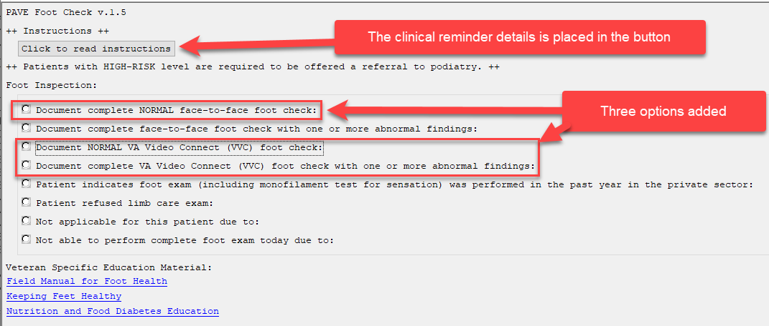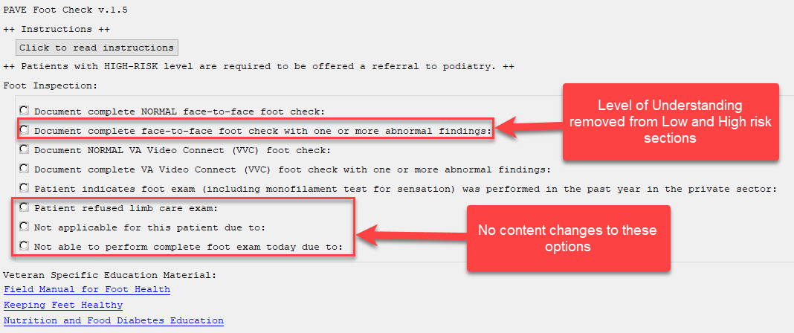

There are no changes to the reminder definition or logic.

**UPDATE_2_0_240 contains 1 Reminder Exchange entry:**

UPDATE_2_0_240 VA-PAVE TEMPLATE UPDATE

**The exchange file contains the following components:**

**REMINDER GENERAL FINDINGS**

VIEW PROGRESS NOTE TEXT

**TIU TEMPLATE FIELD**

VA-DIABETES NUTRITION AND FOOD

VA-DIABETES:KEEPING FEET HEALTHY

VA-FIELD MANUAL FOR FOOT HEALTH

VA-WORD

OTHER NON-VA

OTHER TEXT

VA-PAVE RESOURCES

VA-PAVE LOW RISK DESCRIPTION

VA-PAVE HIGH RISK DESCRIPTION

**EDUCATION TOPICS**

VA-DIABETIC FOOT CARE COUNSELING

**EXAM**

VA-DIABETIC FOOT CHECK

**HEALTH FACTORS**

VA-REMINDER UPDATES [C]

VA-UPDATE_2_0_240A

VA-PAVE PACT FOOT CHECK [C]

VA-PAVE PACT VVC SENSORY REVIEWED

VA-PAVE PACT VVC PERIPHERAL ARTERY DISEASE REVIEWED

VA-PAVE PODIATRY FOOT EXAM [C]

VA-PAVE FOOT LEVEL 1 EDUCATION

VA-PAVE PACT FOOT LEVEL LOW RISK

VA-PAVE PACT VISUAL FOOT CHECK NORMAL

VA-PAVE PACT VVC FOOT CHECK

VA-PAVE FOOT LEVEL 3 EDUCATION

VA-PAVE PACT PATIENT ESTABLISHED WITH POD/VASC

VA-PAVE PACT PT SEEN BY OUTSIDE FOOT SPECIALIST

VA-PAVE PACT VVC PT HAS ULCER

VA-PAVE PACT VVC PT HAS NO ULCER

VA-PAVE PACT FOOT LEVEL HIGH RISK

VA-PAVE PACT VISUAL FOOT CHECK ABNORMAL

VA-PAVE PACT VVC UNABLE TO PERFORM VISUAL EXAM

VA-PAVE PACT VVC PT DECLINES VISUAL FOOT CHECK

VA-PAVE PACT SENSORY FOOT CHECK NORMAL

VA-PAVE PACT PEDAL PULSES FOOT CHECK NORMAL

VA-PAVE RECEIVES BEHAVIORAL HEALTH AND REFUSE PRIMARY CARE

VA-PAVE BILATERAL FOOT AMPUTATION

VA-PAVE INCORRECT DIAGNOSIS [C]

VA-PAVE INCORRECT NEUROPATHY DIAGNOSIS

VA-PAVE INCORRECT VASCULAR DIAGNOSIS

VA-PAVE INCORRECT RENAL DIAGNOSIS

VA-PAVE INCORRECT DIABETES DIAGNOSIS

REMINDER FACTORS [C]

LIFE EXPECTANCY <6 MONTHS

VA-PAVE PACT PATIENT REFUSED FOOT CHECK

VA-PAVE PACT FOOT CHECK DONE ELSEWHERE

VA-PAVE PACT SENSORY FOOT CHECK ABNORMAL

VA-PAVE PACT PEDAL PULSES FOOT CHECK ABNORMAL

**REMINDER TERM**

VA-REMINDER UPDATE_2_0_240

**REMINDER DIALOG**

VA-PACT PAVE FOOT CHECK

## Pre-Install

1. **Review the dialog text of the following element and identify what local DATA OBJECT is used for** PATIENT ADDRESS, you will need to add it back post install.
   1. Using the menu Reminder Dialog Management, Reminder Dialogs, change your view to Element.
   2. Inquire/Print information for the following element: VAL-TH VVC TELEPHONE TRIAGE PATIENT LOCATION HOME
2. **Review the dialog text of the following element and identify what local DATA OBJECT** is used for PATIENT PHONE NUMBER, you will need to add it back post install.
   1. Using the menu Reminder Dialog Management, Reminder Dialogs, change your view to Element.
   2. Inquire/Print information for the following element: VAL-TH VVC TELEPHONE TRIAGE CONTACT PHONE OBJECT
3. **Review the following elements and if you previously added a quick order as an additional finding**, you will need to add them back post install:
   1. Using the menu Reminder Dialog Management, Reminder Dialogs, change your view to group
   2. Inquire/Print information for the following group:
      1. VAL-PACT PAVE FOOT REFERRAL TO PODIATRY LEVEL 1 REVISED
   3. Facilities also had the option with the initial install to add additional orders or enable the below elements.
   4. Change your view to element view and Inquire/Print information for the following elements:
      1. VAL-PACT PAVE PODIATRY CONSULT 2
      2. VAL-PACT PAVE PODIATRY CONSULT 3
      3. VAL-PACT PAVE PODIATRY CONSULT 4

You can also create an exchange file to back up all of the items listed and install that exchange file backup after this install if you would like.

## Install Details

This update is being distributed as a web host file. The address for the host file is: **https://REDACTED/UPDATE_2_0_240A.PRD**

The file will be installed using Reminder Exchange, programmer access is not required.

Installation:

=============

This update can be loaded with users on the system. Installation will take less than 5 minutes.

## Install Example

To Load the Web Host File. Navigate to Reminder exchange in Vista

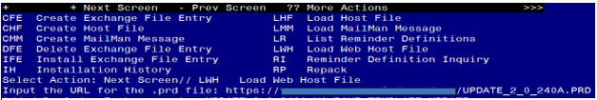

At the **Select Action:** prompt, enter **LWH** for Load Web Host File

At the **Input the url for the .prd file:** prompt, type the following web address:

**https://REDACTED/UPDATE_2_0_240A.PRD**

You should see a message at the top of your screen that the file successfully loaded.

Search for and locate the reminder exchange entry titled UPDATE_2_0_240A VA-PAVE TEMPLATE UPDATE. 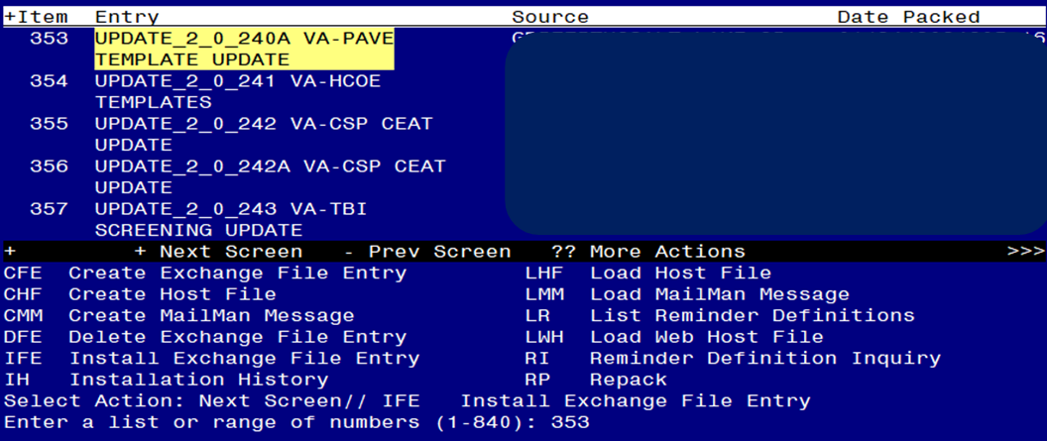

At the **Select Action** prompt, enter **IFE** for Install Exchange File Entry

Enter the number that corresponds with your entry titled **UPDATE_2_0_240A VA-PAVE REMINDER AND TEMPLATE**  *(in this example it is entry 353, it will vary by site)* The date on the exchange file should be 02/21/2024.

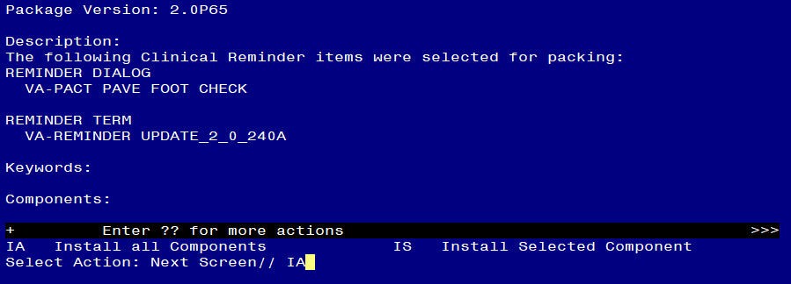

At the **Select Action** prompt, type **IA** for Install all Components and hit enter.

Select Action: Next Screen// IA Install all Components

During the installation, you will see several prompts:

Install all new components

Overwrite any existing components that you are prompted to overwrite

**You will be promped to install the reminder dialog component:**

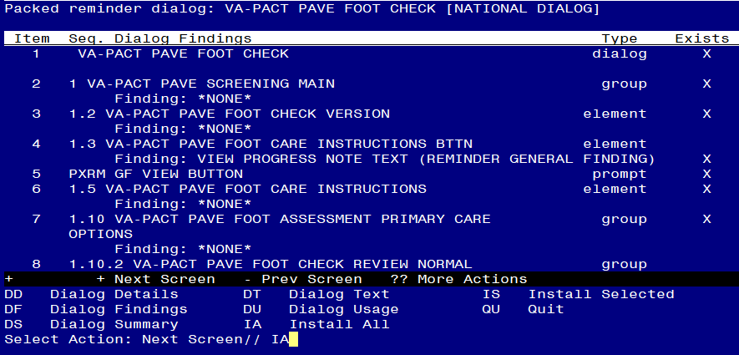At the **Select Action** prompt, type **IA** to install the dialog – **VA-PODIATRY PAVE FOOT EXAM**

Select Action: Next Screen// IA Install All

Install reminder dialog and all components with no further changes: Y// ES


Screen shot of the last of the list of elements, groups and dialogs that needed to be installed with a Q for quit entered at the "Select Action:" prompt because they now all exist.

When the dialog has completed installation, you will then be returned to this screen. At the **Select Action** prompt, type **Q.**

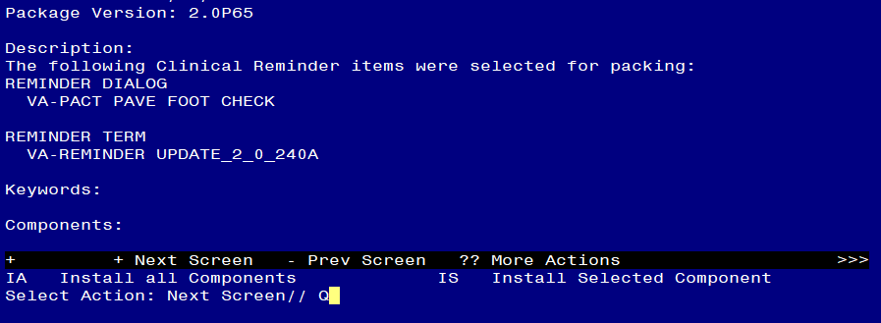

You will be returned to this screen. Type Q to quit.

Install Completed

## Post Installation

1. **In CPRS, Open reminder PAVE Foot Check (reminder dialog VA-PACT PAVE FOOT CHECK) confirm display is version 2.2.**
2. A**dd Order to the reminder dialog – review your pre-install inquiry and add back any order as an additional finding.** 
   1. Add your local quick order for a referral to Podiatry for a PAVE evaluation as an additional finding to the reminder dialog group: VAL-PACT PAVE FOOT REFERRAL TO PODIATRY LEVEL 1 REVISED
   2. If your site would like to have more than one consult type for PAVE, there are three additional elements under the refer to podiatry section that are installed as disabled. You can enable one or more of these elements and add orders as additional findings if needed, you can also edit the dialog text to provide any additional information if needed. .
      1. VAL-PACT PAVE PODIATRY CONSULT 2
      2. VAL-PACT PAVE PODIATRY CONSULT 3
      3. VAL-PACT PAVE PODIATRY CONSULT 4
3. **Add your local DATA OBJECT** FOR PATIENT ADDRESS to the following element: VAL-TH VVC TELEPHONE TRIAGE PATIENT LOCATION HOME
   1. Using the menu Reminder Dialog Management, Reminder Dialogs, change your view to Element.
   2. Search for and edit the following element: VAL-TH VVC TELEPHONE TRIAGE PATIENT LOCATION HOME
4. **Add your local DATA OBJECT** FOR PATIENT PHONE NUMBER to the following element: VAL-TH VVC TELEPHONE TRIAGE CONTACT PHONE OBJECT.
   1. Using the menu Reminder Dialog Management, Reminder Dialogs, change your view to Element.
   2. Search for and edit the following element: VAL-TH VVC TELEPHONE TRIAGE CONTACT PHONE OBJECT
5. (Optional) **Add a local DATA OBJECT** for Podiatry Clinic Visit to the following element: VAL-PACT PAVE FOOT PODIATRY/VASCULAR LAST SEEN.
   1. Using the menu Reminder Dialog Management, Reminder Dialogs, change your view to Element.
   2. Search for and edit the following element: VAL-PACT PAVE FOOT PODIATRY/VASCULAR LAST SEEN
      1. Instructions for how to create this object are located here:REDACTED