

Update_2_0_286A  
  
Clinical Reminders

VA-LOW VISION VISUAL FUNCTIONING QUESTIONNAIRE UPDATE

Install Guide

**February 2023**

Product Development

Office of Information Technology

Department of Veterans Affairs

Table of Contents

Introduction 1

Install Details 4

Install Example 4

Post Installation 6

## Introduction

Blind Rehabilitation Service (BRS) implemented a standardized functional outcome measure (Visual Functioning Questionnaire (VFQ) to be used by all BRS programs in 2022.

This update incorporates changes based on recommendations from the field.

* The instructions are now in a button improving accessibility
* Two questions were added
  + Program Administering
  + Episode of care

Before:

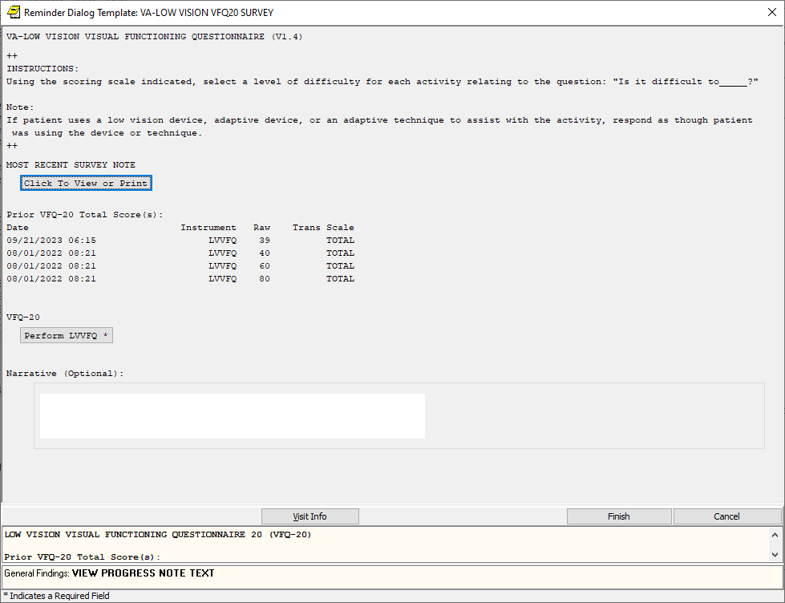

After:

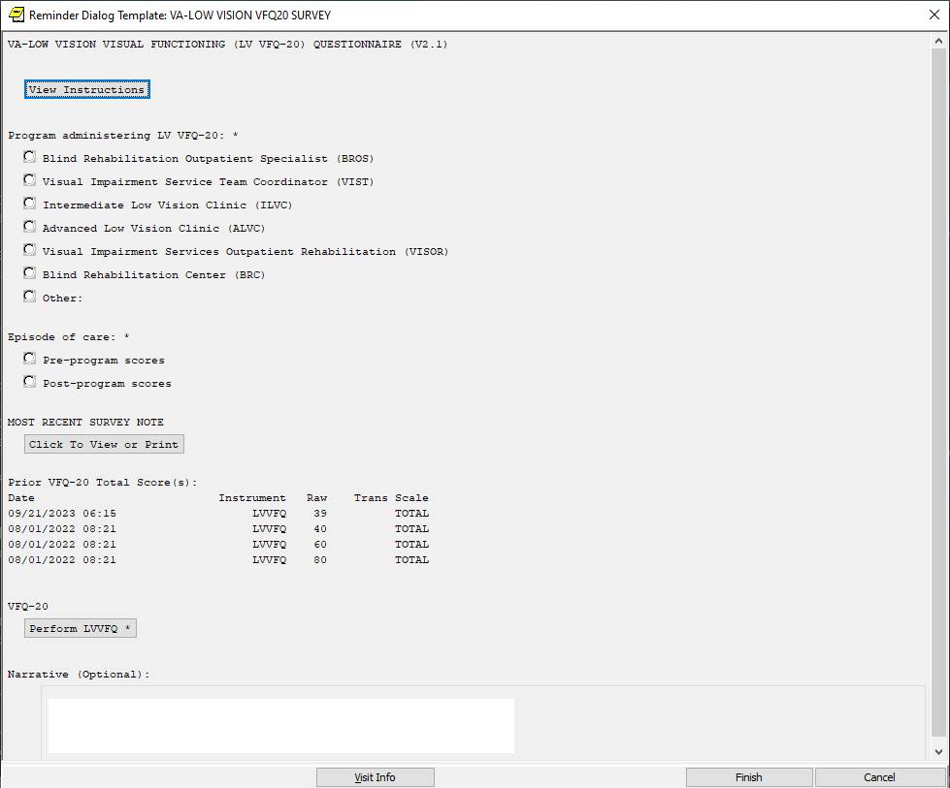

Instructions button:

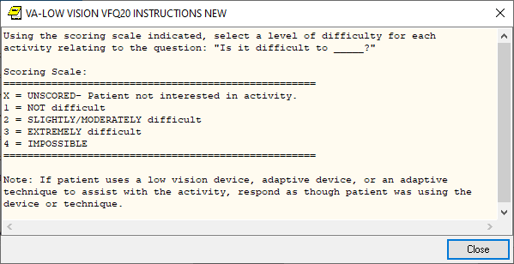

UPDATE_2_0_286A contains 1 Reminder Exchange entry:

**UPDATE_2_0_286A VA-LOW VISION VFQ UPDATE**

**The exchange file contains the following components:**

**REMINDER GENERAL FINDINGS**

VIEW PROGRESS NOTE TEXT

**TIU TEMPLATE FIELD**

WP 4/60

**HEALTH FACTORS**

VA-REMINDER UPDATES [C]

VA-UPDATE_2_0_286A

VA-LOW VISION-VFQ 20 [C]

VA-LOW VISION-VFQ EPISODE OF CARE POST-PROGRAM

VA-LOW VISION-VFQ EPISODE OF CARE PRE-PROGRAM

VA-LOW VISION-VFQ ADMINISTERED BY OTHER

VA-LOW VISION-VFQ ADMINISTERED BY BRC

VA-LOW VISION-VFQ ADMINISTERED BY VISOR

VA-LOW VISION-VFQ ADMINISTERED BY ALVC

VA-LOW VISION-VFQ ADMINISTERED BY ILVC

VA-LOW VISION-VFQ ADMINISTERED BY VIST

VA-LOW VISION-VFQ ADMINISTERED BY BROS

**REMINDER SPONSOR**

BLIND REHAB SERVICE

**REMINDER TERM**

VA-REMINDER UPDATE_2_0_286A

**HEALTH SUMMARY TYPE**

VA-VFQ20

VA-LOW VISION LAST NOTE

**HEALTH SUMARY OBJECTS**

VA-VFQ20 (TIU)

VA-LOW VISION VFQ TOTAL

**TIU DOCUMENT DEFINITION**

VA-VFQ20

VA-BRS VFQ LAST NOTE

**REMINDER DIALOG**

VA-LOW VISION VFQ20 SURVEY

## Install Details

This update is being distributed as a web host file. The address for the host file is: https://REDACTED/UPDATE_2_0_286A.PRD

The file will be installed using Reminder Exchange, programmer access is not required.

Installation:

=============

This update can be loaded with users on the system. Installation will take less than 5 minutes.

## Install Example

Go to Reminder exchange in Vista.

To Load the exchange file, use LWH. The URL is

https://REDACTED /UPDATE_2_0_286A.PRD

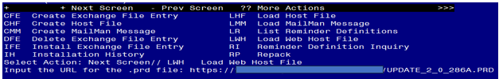

You will see a message indicating the file was loaded successfully.

Search and locate an entry titled UPDATE_2_0_286A VA-LOW VISION VFQ UPDATE in reminder exchange.

Screen shot of the terminal window with IFE for the Select Action for Install Exchange File Entry found In the document text indicating the correct name of the Reminder Exchange File entry and the number of that entry entered at the "Enter a list or range of numbers" Prompt.  This number varies by site.  You can search for the text name of the entry by entering SL at the prompt and then enter the number when you find it.


At the **Select Action** prompt, enter **IFE** for Install Exchange File Entry

Enter the number that corresponds with your entry titled UPDATE_2_0_286A VA-LOW VFQ UPDATE *(in this example it is entry 369, it will vary by site)* that is dated 02/08/2024.


Screen shot of a list of the items that were selected by the reminder developers for packing to include with the selected reminder exchange item.  For the Select Action for Install Exchange File IA for Install All is entered.

At the **Select Action** prompt, type **IA** for Install all Components and hit enter.

**For all new entries in any category you will choose I to Install**

**Skip any items in any category you are prompted to overwrite**

You will then be prompted to install the dialog component.

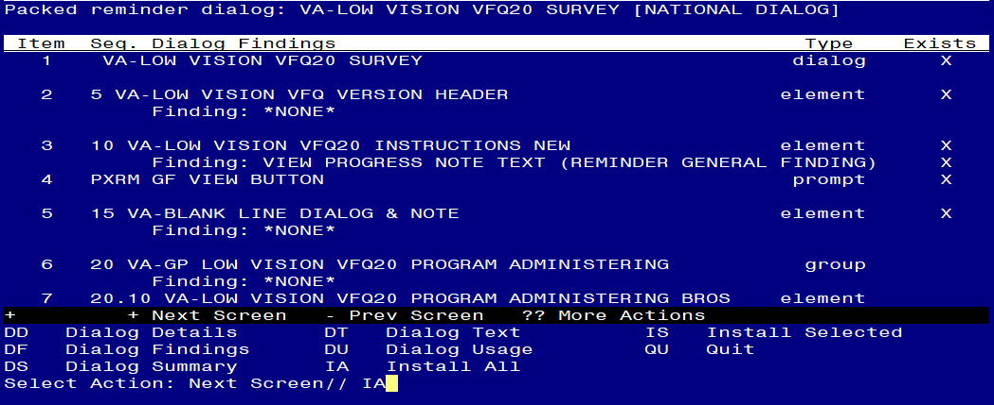

At the **Select Action** prompt, type **IA** to install the dialog – **VA-LOW VISION VFQ20 SURVEY**

Install reminder dialog and all components with no further changes: Y//ES

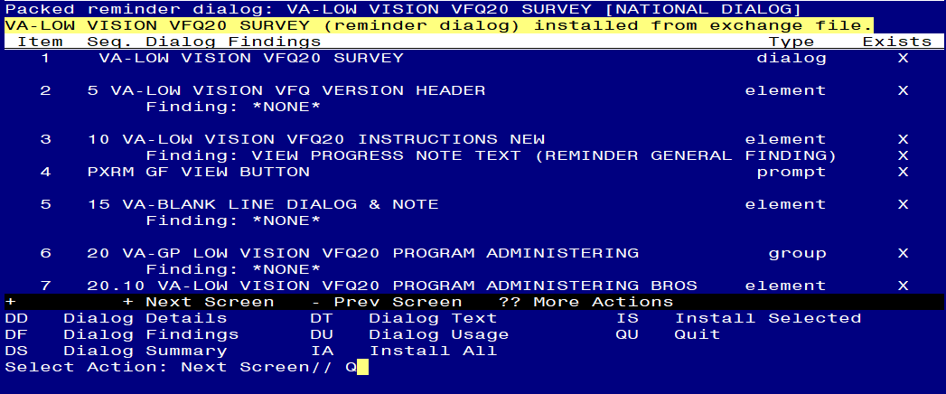

When the dialog has completed installation, you will then be returned to this screen. At the **Select Action** prompt, type **Q.**

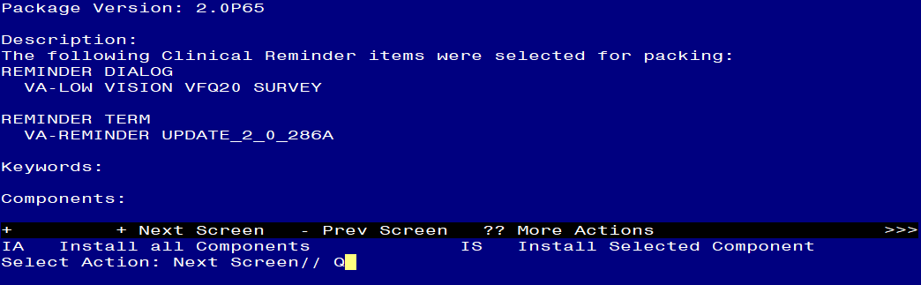

You will then be returned to this screen. At the **Select Action** prompt, type **Q.**

Install complete.

## Post Installation

1. **Open the note titled** BRS VFQ-20 VISUAL FUNCTIONING QUESTIONNAIRE (reminder dialog name VA-LOW VISION VFQ20 SURVEY) and confirm that the version now displays as 2.1.