

**Update _2_0_307E**

Clinical Reminders

TOXIC EXPOSURE SCREEN REMINDER UPDATE

Install Guide

**January 2024**

Product Development

Office of Information Technology

Department of Veterans Affairs

Table of Contents

Introduction 1

Install Details 6

Install Example 7

Post Installation 11

## Introduction

This update contains the following changes to the existing Toxic Exposure Screening and Toxic Exposure Screening Follow-up Clinical Reminder Dialogs:

The following changes were made:

1. The **TOXIC EXPOSURE SCREENING reminde**r dialog was updated:
   1. Version is now 5.2
   2. An unable to screen option was ADDED and can be used to document outreach attempts
      1. This option WILL NOT resolve the reminder

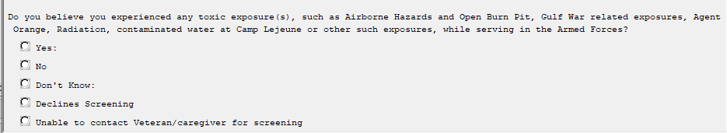

New option expanded:

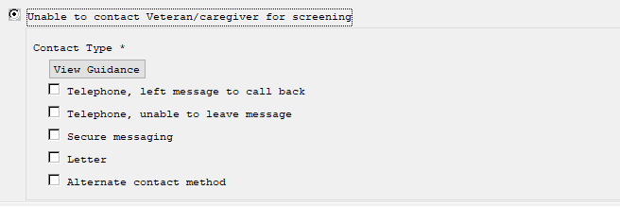

View Guidance Button:

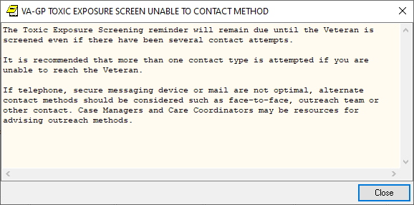

1. The **TOXIC EXPOSURE SCREENING FOLLOW-UP reminder** dialog was updated:
2. Version is now 5.2
3. Specific instructions on how to add to the problem list were added

– note this only appears if the patient answered yes to an exposure concern on the screening and does not display in the note:

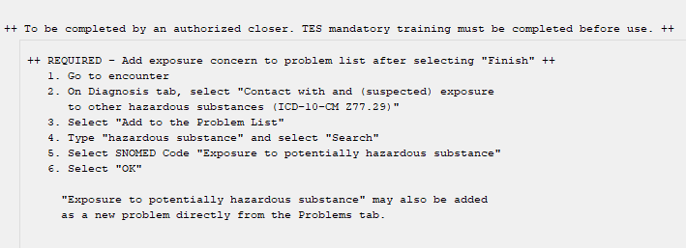

1. Updated existing “Unable to contact…” option
   1. Added “View Guidance” button
   2. Added alternate contact method as an additional option to first and second contact attempts

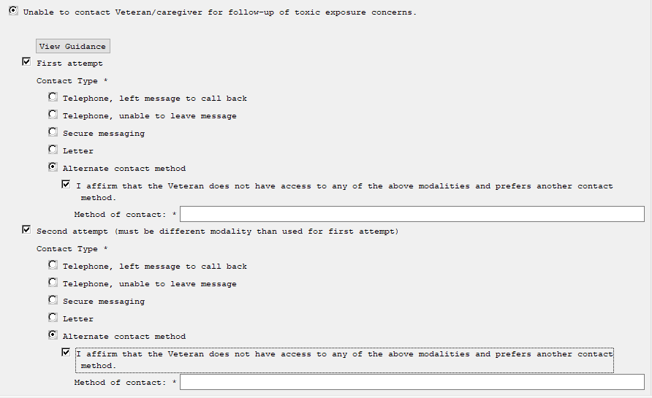

View Guidance Button:

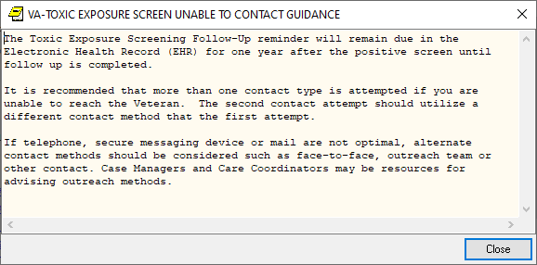

There are no changes to the logic or functionality of the reminder definitions.

UPDATE_2_0_307E contains 1 Reminder Exchange entry:

UPDATE_2_0_307E TOXIC EXPOSURE SCREEN REMINDER UPDATE

**The exchange file contains the following components:**

**REMINDER GENERAL FINDINGS**

VIEW PROGRESS NOTE TEXT

**TIU TEMPLATE FIELD**

VA-TOXIC CONTACT

VA-TES OMB DATE

VA-TES OMB NUM

VA-ENV EXP VBA

VA-ENV EXP OTHER

VA-WORD

VA-TOX EXP VSO

VA-ENV EXP SYMP RA

VA-ENV EXP SYMP GW2

VA-ENV EXP SYMP GW

VA-ENV EXP SYMP CL

VA-ENV EXP SYMP AH

VA-ENV EXP SYMP AO

**HEALTH FACTORS**

VA-REMINDER UPDATES [C]

VA-UPDATE_2_0_307E

VA-TOXIC EXPOSURE SCREEN [C]

VA-TOX EXP SCRN UNABLE TO CONTACT ALTERNATE

CONTACT METHOD

VA-TOX EXP SCRN UNABLE TO CONTACT LETTER

VA-TOX EXP SCRN UNABLE TO CONTACT SECURE MESSAGE

VA-TOX EXP SCRN UNABLE TO CONTACT TELEPHONE NO MESSAGE LEFT

VA-TOX EXP SCRN UNABLE TO CONTACT TELEPHONE LEFT MESSAGE

VA-TOX EXP SCRN UNABLE TO CONTACT

VA-TOX EXP SCRN VETERAN CONCERN TOXIC EXP NO MED CONCERNS

VA-TOX EXP SCRN VETERAN CONCERN TOXIC EXP MED CONCERNS

VA-TOX EXP SCRN FOLLOW UP NO CONNECTIONS GIVEN

VA-TOX EXP SCRN FOLLOW UP CONSULT TO SOCIAL WORK

VA-TOX EXP SCRN FOLLOW UP CONSULT TO TES NAVIGATOR

VA-TOX EXP SCRN FOLLOW UP CONSULT TO REGISTRY PROGRAM

VA-TOX EXP SCRN FOLLOW UP CONNECTED WITH VSO

VA-TOX EXP SCRN FOLLOW UP CONNECTED WITH VBA

VA-TOX EXP SCRN VETERAN CONCERN TOXIC EXP REGISTRY QUESTIONS

VA-TOX EXP SCRN VETERAN CONCERN TOXIC EXP VA ENROLL QUESTIONS

VA-TOX EXP SCRN VETERAN CONCERN TOXIC EXP BENEFIT QUESTIONS

VA-TOX EXP SCRN VETERAN CONCERN TOXIC EXP NO QUESTIONS

VA-TOX EXP SCRN VETERAN CONCERN DOESNT KNOW

VA-TOX EXP SCRN VETERAN CONCERN DECLINED

VA-TOX EXP SCRN VETERAN CONCERN EDUCATION PROVIDED OTHER

VA-TOX EXP SCRN VETERAN CONCERN OTHER EXPOSURE

VA-TOX EXP SCRN VETERAN CONCERN EDUCATION PROVIDED RADIATION

VA-TOX EXP SCRN VETERAN CONCERN RADIATION EXPOSURE

VA-TOX EXP SCRN VETERAN CONCERN EDUCATION PROVIDED GULF WAR

VA-TOX EXP SCRN VETERAN CONCERN GULF WAR EXPOSURE

VA-TOX EXP SCRN VETERAN CONCERN EDUCATION PROVIDED CL

VA-TOX EXP SCRN VETERAN CONCERN CAMP LEJEUNE EXPOSURE

VA-TOX EXP SCRN VETERAN CONCERN EDUCATION PROVIDED AHBP

VA-TOX EXP SCRN VETERAN CONCERN AIRBORNE HAZARD BURN PIT

VA-TOX EXP SCRN VETERAN CONCERN EDUCATION PROVIDED AO

VA-TOX EXP SCRN VETERAN CONCERN AGENT ORANGE

VA-TOX EXP SCRN VETERAN CONCERN NONE

VA-TOX EXP SCRN FOLLOW UP AUTHORIZED CLOSER NOTIFIED

VA-TOX EXP SCRN VETERAN CONCERN TOXIC EXP MED QUESTIONS

VA-TOX EXP SCRN VETERAN CONCERN TOXIC EXP DECLINE FOLLOWUP

VA-TOX EXP SCRN VETERAB CONCERN TOXIC EXP FOLLOW ALT CONT 2 ATT

VA-TOX EXP SCRN VETERAN CONCERN TOXIC EXP FOLLOW LETTER 2 ATT

VA-TOX EXP SCRN VETERAN CONCERN TOXIC EXP FOLLOW VETTEXT 2 ATT

VA-TOX EXP SCRN VETERAN CONCERN TOXIC EXP FOLLOW SECUR MSG 2 ATT

VA-TOX EXP SCRN VETERAN CONCERN TOXIC EXP FOLL PHONE NO MSG 2ATT

VA-TOX EXP SCRN VETERAN CONCERN TOXIC EXP FOLLOW PHONE MSG 2 ATT

VA-TOX EXP SCRN VETERAN CONCERN TOXIC EXP 2ND ATTEMPT FOLLOWUP

VA-TOX EXP SCRN VETERAN CONCERN TOXIC EXP FOLLOW ALT CONTACT

VA-TOX EXP SCRN VETERAN CONCERN TOXIC EXP FOLLOW LETTER

VA-TOX EXP SCRN VETERAN CONCERN TOXIC EXP FOLLOW VETTEXT

VA-TOX EXP SCRN VETERAN CONCERN TOXIC EXP FOLLOW SECURE MESSAGE

VA-TOX EXP SCRN VETERAN CONCERN TOXIC EXP FOLLOW PHONE NO MSG

VA-TOX EXP SCRN VETERAN CONCERN TOXIC EXP FOLLOW PHONE LEFT MSG

VA-TOX EXP SCRN VETERAN CONCERN TOXIC EXP FIRST ATTEMPT FOLLOWUP

VA-TOX EXP SCRN VETERAN CONCERN TOXIC EXP UNABLE CONTACT FOLLOW

VA-TOX EXP SCRN VETERAN CONCERN TOXIC EXP PRESUMP COND QUESTIONS

**REMINDER TAXONOMY**

VA-TOXIC EXPOSURE

**REMINDER TERM**

VA-REMINDER UPDATE_2_0_307E

VA-USER CLASS FOR TES FOLLOWUP

VA-TOXIC EXPOSURE

**HEALTH SUMMARY TYPE:**

VA-TOXIC EXP QUESTIONS

VA-TOXIC EXPOSURE

**HEALTH SUMMARY OBJECTS**

VA-TOXIC EXP QUESTIONS (TIU)

VA-TOXIC EXPOSURE (TIU)

**TIU DOCUMENT DEFINITION:**

VA-TOXIC EXP QUESTIONS

VA-TOXIC EXPOSURE

**REMINDER DIALOG**

VA-TOXIC EXPOSURE SCREENING PROVIDER FOLLOW UP

VA-TOXIC EXPOSURE

## Install Details

This update is being distributed as a web host file. The address for the host file is: https://REDACTED /UPDATE_2_0_307E.PRD

The file will be installed using Reminder Exchange, programmer access is not required.

Installation:

=============

This update can be loaded with users on the system. Installation will take less than 5 minutes.

## Pre-Install

Any local modifications to template fields or to the dialog will be overwritten. Please make note of your local modifications prior to re-entering them in the post-install.

Inquire/print the following reminder dialog elements to identify if you have any orders added as an additional finding and/or if you have changed the reminder dialog text (you can also create an exchange file to back them up and install that exchange file backup after this install if you would like):

VAL-TOXIC EXPOSURE SCREENING LOCAL CONTACT INFO

VAL-TOXIC EXPOSURE SCREENING REGISTRY EXAM CONSULT

VAL-TOXIC EXPOSURE SCREENING REGISTRY EXAM TES NAV

VAL-TOXIC EXPOSURE SCREENING REGISTRY EXAM SOCIAL WORK

You will add these orders back and update the dialog text in the post install.

You can also review the template field VA-TOX EXP VSO, this should not be overwritten in the install but it would be good to know what you have in that field if you accidentally overwrite during the install.

## Install Example

To Load the exchange file, in VistA, using the Reminder Exchange menu, use LWH. The URL is https://REDACTED /UPDATE_2_0_307E.PRD

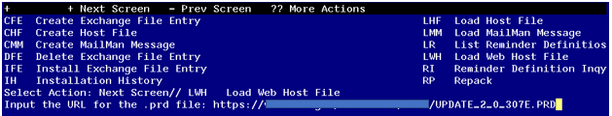

You should see a message that the file was loaded successfully.

Search and locate an entry titled UPDATE_2_0_307E TOXIC EXPOSURE SCREEN REMINDER UPDATE in reminder exchange.

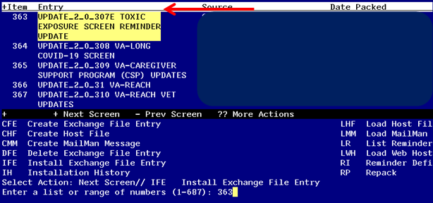

At the **Select Action** prompt, enter **IFE** for Install Exchange File Entry

Enter the number that corresponds with your entry titled UPDATE_2_0_307E TOXIC EXPOSURE SCREEN REMINDER *(in this example it is entry 363, it will vary by site)* that is dated 01/17/2024. 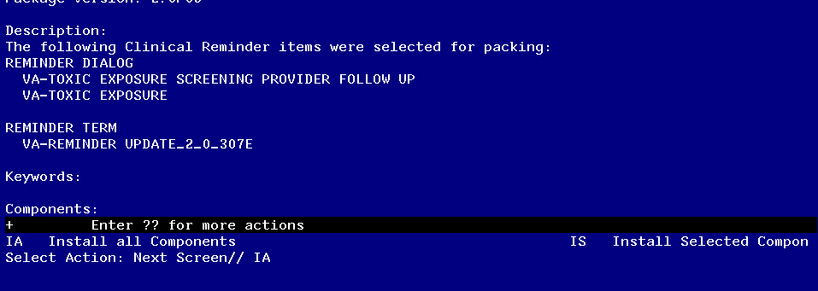

At the **Select Action** prompt, type **IA** for **Install all Components** and hit enter.

Any items that are NEW in any of the below categories, you should INSTALL.

SKIP any items that you are prompted to overwrite.

You will then be prompted to install the first Dialog component.

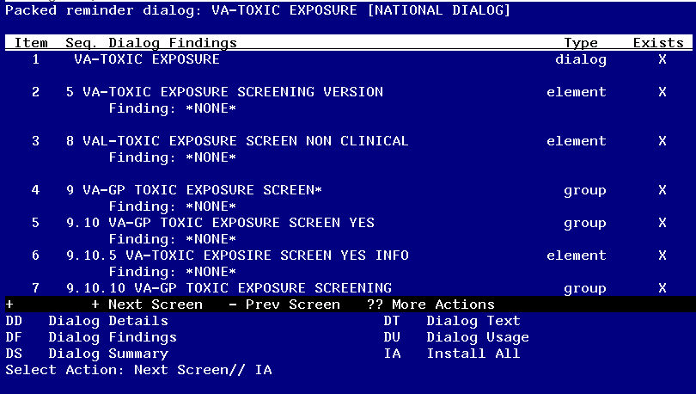

At the **Select Action** prompt, type **IA** to install the dialog – **VA-TOXIC EXPOSURE SCREEN**

Install reminder dialog and all components with no further changes: Y// ES

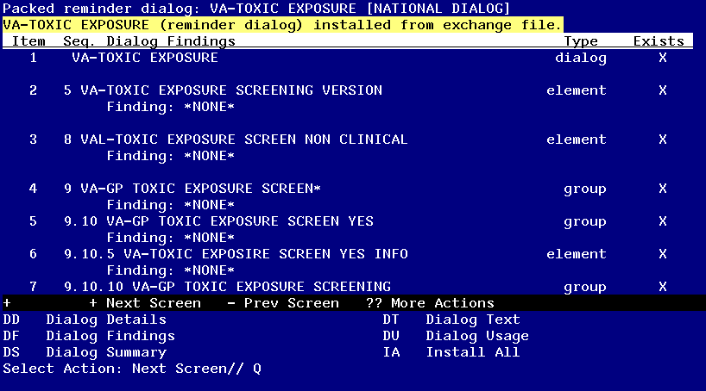

When the dialog has completed installation, you will then be returned to this screen. At the **Select Action** prompt, type **Q.**

You will then be prompted to install the next Dialog component.

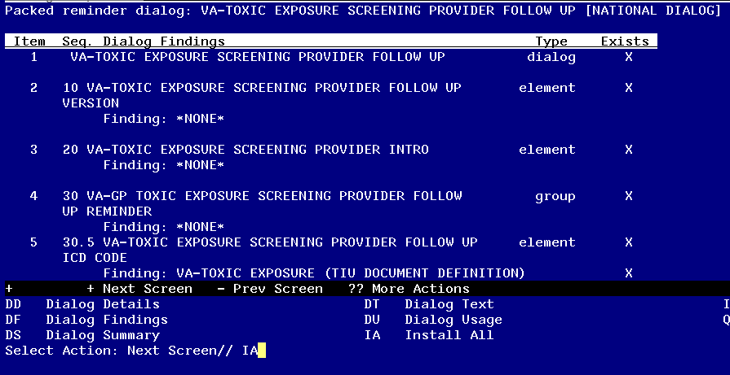

At the **Select Action** prompt, type **IA** to install the dialog – **VA-TOXIC EXPOSURE SCREENING PROVIDER FOLLOW UP**

Install reminder dialog and all components with no further changes: Y// ES....

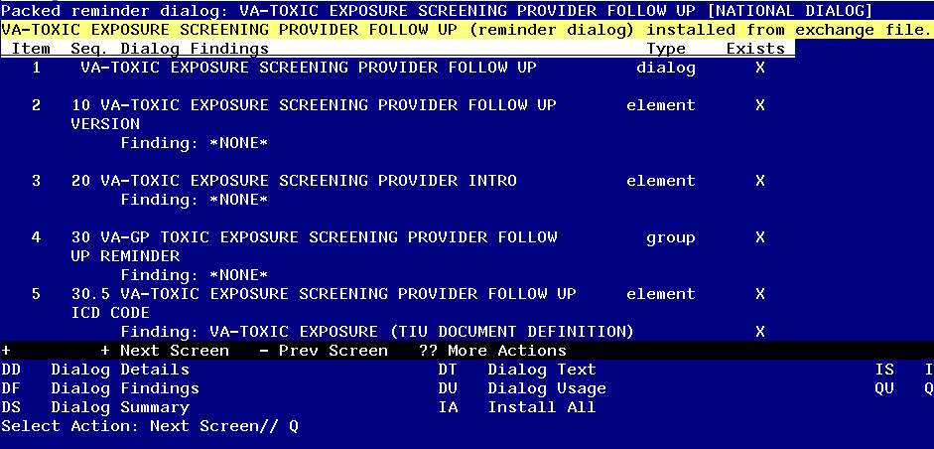

When the dialog has completed installation, you will then be returned to this screen. At the **Select Action** prompt, type **Q.**

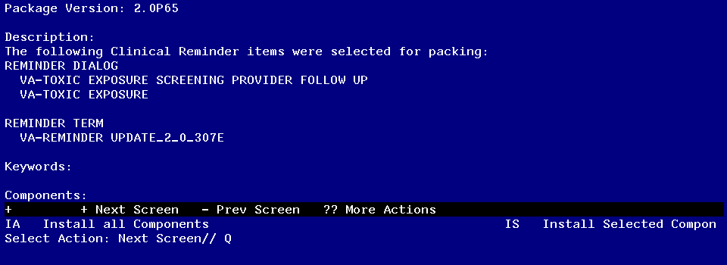

You will then be returned to this screen. At the **Select Action** prompt, type **Q.**

Install complete.

## Post Installation

1. **Using your pre-install inquiry, update the dialog text and findings:**

In Vista, using the menu, Reminder Dialog Management, Reminder Dialogs, change your view to Element view. Search for and find the element VAL-TOXIC EXPOSURE SCREENING LOCAL CONTACT INFO. Edit the DIALOG/PROGRESS NOTE TEXT and replace the lines with “xxxxxxx” with the text for local contacts you identified in the pre-install.

Add consult/referrals to follow up reminder if you previously attached a consult to these items. Review your pre-install inquiry and edit the additional findings and dialog text to match.

To add a quick order, in Vista, using the menu, Reminder Dialog Management, Reminder Dialogs, change your view to Element view. Search for and find the appropriate element and add your quick order as an Additional Finding – DO NOT CHANGE OR REMOVE THE HEALTH FACTOR IN THE FINDING FIELD.

* + 1. VAL-TOXIC EXPOSURE SCREENING REGISTRY EXAM CONSULT – represents a Consult/Referral to Registry Program
    2. VAL-TOXIC EXPOSURE SCREENING REGISTRY EXAM SOCIAL WORK – represents a Consult/Referral to Social Work
    3. VAL-TOXIC EXPOSURE SCREENING REGISTRY EXAM TES NAV – represents a Consult/Referral to TES Navigator

1. In CPRS, open the reminder Toxic Exposure Screening and confirm the version displays as 5.2. Confirm your local information added in step 1 is also correct.
2. In CPRS, open the reminder Toxic Exposure Screening Follow-up and confirm the version displays as 5.2. Confirm your local information added in step 1 is also correct.
3. Review template field VA-TOX EXP VSO and confirm the correct information displays.