

Update _2_0_355A

Clinical Reminders

VA-MENTAL HEALTH TEMPLATE UPDATE

Install Guide

**July 2024**

Product Development

Office of Information Technology

Department of Veterans Affairs

Table of Contents

Introduction 1

Pre-Install 6

Install Details 7

Install Example 7

Post Installation 11

Introduction

The MH FLOW Discharge template content is being added as an option to both the MHTC BHIP CC ASSIGNMENT and MTHC BHIP CC NEEDS ASSESSMENT AND INTERVENTION to help streamline documentation for Veterans who are ready to step down care to Primary Care or to graduate from mental health care.

Currently, both an unassignment note and a FLOW discharge note would be required to discharge a Veteran from the BHIP program.

With the addition of the MH FLOW Discharge note into the MHTC BHIP CC ASSIGNMENT and MTHC BHIP CC NEEDS ASSESSMENT AND INTERVENTION the MHTC Care Coordinator has the option to complete both of these actions in one note.

No changes to the existing content of either template were made.

UPDATE_2_0_355A contains 1 Reminder Exchange entry:

**UPDATE_2_0_****355A VA-MENTAL HEALTH TEMPLATE UPDATE**

**The exchange file contains the following components:**

**TIU TEMPLATE FIELD**

VA-WORDR

VA-DATE ONLY R

VA-OTHER TEXT

VA-WP 65/3

VA-ADDITIONAL COMMENTS

VA-WORD

VA-MH TREATMENT COORDINATOR VETERAN AND/OR FAMILY

VA-BLANK SP

VA-DATE ONLY

VA-DATE DEFAULT TODAY

VA-BLANK IN PN TEXT

VA-MOBILE

VA-STORM LINK

**HEALTH FACTORS**

VA-REMINDER UPDATES [C]

VA-UPDATE_2_0_355A

VA-MH DISCHARGE FLOW [C]

VA-MH FLOW DC REASON VETERAN PERSUING COMMUNITY MH CARE

VA-MH FLOW DC REASON VETERAN PREFER OTHER

VA-MH FLOW DC REASON VETERAN MOVING

VA-MH FLOW DC REASON VETERAN NOT INTERESTED

VA-MH FLOW DC REASON VETERAN PREFER

VA-MH FLOW DC REASON LACK OF ENGAGEMENT

VA-MH FLOW DC REASON POOR ADHERE MED

VA-MH FLOW DC REASON INCONSISTENT ATTENDANCE

VA-MH FLOW DC REASON UNABLE TO ENGAGE

VA-MH FLOW DC REASON COMPLETED PHARMACOTHERAPY

VA-MH FLOW DC REASON COMPLETED PSYCHOTHERAPY

VA-MH FLOW DC OTHER

VA-MH FLOW DC OCC ED FUNCTIONING

VA-MH FLOW DC BEHAVIOR

VA-MH FLOW DC INTERPERSONAL FUNCTION

VA-MH FLOW DC QUALITY OF LIFE

VA-MH FLOW DC SELF REPORT MH MEASURE

VA-MH FLOW DC REASON COMPLETED TREATMENT

VA-MH FLOW DC REASON MED STABLE

VA-MHTC CCI [C]

VA-MH-BHIP-TRANS-OTHER

VA-MH-BHIP-TRANS-VRS

VA-MH-BHIP-TRANS-FAMILY

VA-MH-BHIP-TRANS-PRRC

VA-MH-BHIP-TRANS-ICMHR

VA-MH-BHIP-TRANS-PCT

VA-MH-BHIP-TRANS-SUD

VA-MH TX ASSIGNMENT [C]

VA-MH-BHIP-VET OTHER

VA-MH-BHIP-VET DISCHARGE

VA-MH-BHIP-VET NEW FACILITY

VA-MH-BHIP-VET CITC

VA-MH-BHIP-VET PREFER UN

VA-MH-BHIP-UNASSIGN

VA-MHTC PCMM NOTES

VA-MH-BHIP-REASS-OTH

VA-MH-BHIP-REASS-REQUEST

VA-MH-BHIP-REASS-TEAM

VA-MH-BHIP-REASS-TRANS

MENTAL HEALTH [C]

MENTAL HEALTH TREATMENT COORDINATOR

VA-MH-BHIP-REASSIGN

VA-MH-BHIP-INITIAL ASSIGN

VA-MH-BHIP-INT-OTHGEN-OG

VA-MH-BHIP-INT-OTHGEN-FU

VA-MH-BHIP-INT-OTHGEN-TODAY

VA-MH-BHIP-FU-MODALITY

VA-MH-BHIP-FU-FREQUENCY

VA-MH-BHIP-INT-COMRESOURCES-OG

VA-MH-BHIP-INT-COMRESOURCES-FU

VA-MH-BHIP-INT-COMRESOURCES-TODAY

VA-MH-BHIP-INT-WH-OG

VA-MH-BHIP-INT-WH-FU

VA-MH-BHIP-INT-WH-TODAY

VA-MH-BHIP-INT-MMOBILE-OG

VA-MH-BHIP-INT-MMOBILE-FU

VA-MH-BHIP-INT-MMOBILE-TODAY

VA-MH-BHIP-INT-SELF-OG

VA-MH-BHIP-INT-SELF-FU

VA-MH-BHIP-INT-SELF-TODAY

VA-MH-BHIP-INT-PEER-OG

VA-MH-BHIP-INT-PEER-FU

VA-MH-BHIP-INT-PEER-TODAY

VA-MH-BHIP-INT-SUBMITCONS-OG

VA-MH-BHIP-INT-SUBMITCONS-FU

VA-MH-BHIP-INT-SUBMITCONS-TODAY

VA-MH-BHIP-INT-SUBMITCONS

VA-MH-BHIP-INT-EDSERVICE-OG

VA-MH-BHIP-INT-EDSERVICE-FU

VA-MH-BHIP-INT-EDSERVICE-TODAY

VA-MH-BHIP-INT-REVIEWSTORM-OG

VA-MH-BHIP-INT-REVIEWSTORM-FU

VA-MH-BHIP-INT-REVIEWSTORM-TODAY

VA-MH-BHIP-INT-NALOX-OG

VA-MH-BHIP-INT-NALOX-FU

VA-MH-BHIP-INT-NALOX-TODAY

VA-MH-BHIP-INT-EDREFILL-OG

VA-MH-BHIP-INT-EDREFILL-FU

VA-MH-BHIP-INT-EDREFILL-TODAY

VA-MH-BHIP-INT-MEDREFILL-OG

VA-MH-BHIP-INT-MEDREFILL-FU

VA-MH-BHIP-INT-MEDREFILL-TODAY

VA-MH-BHIP-INT-EDMEDAD-OG

VA-MH-BHIP-INT-EDMEDAD-FU

VA-MH-BHIP-INT-EDMEDAD-TODAY

VA-MH-BHIP-INT-CONSHRF-OG

VA-MH-BHIP-INT-CONSHRF-FU

VA-MH-BHIP-INT-CONSHRF-TODAY

VA-MH-BHIP-INT-HRF-OG

VA-MH-BHIP-INT-HRF-FU

VA-MH-BHIP-INT-HRF-TODAY

VA-MH-BHIP-INT-DCFU-OG

VA-MH-BHIP-INT-DCFU-FU

VA-MH-BHIP-INT-DCFU-TODAY

VA-MH-BHIP-INT-PDENEEDS-OG

VA-MH-BHIP-INT-PDENEEDS-FU

VA-MH-BHIP-INT-PDENEEDS-TODAY

VA-MH-BHIP-INT-COR-SPC-OG

VA-MH-BHIP-INT-COR-SPC-FU

VA-MH-BHIP-INT-COR-SPC-TODAY

VA-MH-BHIP-INT-SP2-OG

VA-MH-BHIP-INT-SP2-FU

VA-MH-BHIP-INT-SP2-TODAY

VA-MH-BHIP-INT-GUNLOCK-OG

VA-MH-BHIP-INT-GUNLOCK-FU

VA-MH-BHIP-INT-GUNLOCK-TODAY

VA-MH-BHIP-INT-LMA-OG

VA-MH-BHIP-INT-LMA-FU

VA-MH-BHIP-INT-LMA-TODAY

VA-MH-BHIP-INT-SAFEPLAN-OG

VA-MH-BHIP-INT-SAFEPLAN-FU

VA-MH-BHIP-INT-SAFEPLAN-TODAY

VA-MH-BHIP-INT-CSRE-OG

VA-MH-BHIP-INT-CSRE-FU

VA-MH-BHIP-INT-CSRE-TODAY

VA-MH-BHIP-INT-CONSULTEAM-OG

VA-MH-BHIP-INT-CONSULTEAM-FU

VA-MH-BHIP-INT-CONSULTEAM-TODAY

VA-MH-BHIP-INT-COPROVIDER-OG

VA-MH-BHIP-INT-COPROVIDER-FU

VA-MH-BHIP-INT-COPROVIDER-TODAY

VA-MH-BHIP-INT-CASEREV-OG

VA-MH-BHIP-INT-CASEREV-FU

VA-MH-BHIP-INT-CASEREV-TODAY

VA-MH-BHIP-INT-OTHGEN

VA-MH-BHIP-FOLLOWUP-CC-SIGNIFICANT CHANGES

VA-MH-BHIP-INT-OTHGEN-NA

VA-MH-BHIP-INT-COMRESOURCES-NA

VA-MH-BHIP-INT-WH-NA

VA-MH-BHIP-INT-MMOBILE-NA

VA-MH-BHIP-INT-SELF-NA

VA-MH-BHIP-INT-PEER-NA

VA-MH-BHIP-INT-SUBMITCONS-NA

VA-MH-BHIP-INT-EDSERVICE-NA

VA-MH-BHIP-INT-REVIEWSTORM-NA

VA-MH-BHIP-INT-NALOX-NA

VA-MH-BHIP-INT-EDREFILL-NA

VA-MH-BHIP-INT-MEDREFILL-NA

VA-MH-BHIP-INT-EDMEDAD-NA

VA-MH-BHIP-INT-CONSHRF-NA

VA-MH-BHIP-INT-HRF-NA

VA-MH-BHIP-INT-DCFU-NA

VA-MH-BHIP-INT-PDENEEDS-NA

VA-MH-BHIP-INT-COR-SPC-NA

VA-MH-BHIP-INT-SP2-NA

VA-MH-BHIP-INT-GUNLOCK-NA

VA-MH-BHIP-INT-LMA-NA

VA-MH-BHIP-INT-SAFEPLAN-NA

VA-MH-BHIP-INT-CSRE-NA

VA-MH-BHIP-INT-CONSULTEAM-NA

VA-MH-BHIP-INT-COPROVIDER-NA

VA-MH-BHIP-INT-CASEREV-NA

VA-MH-BHIP-FOLLOWUP-CC-PLAN

VA-MH-BHIP-INITIAL-CC-PLAN

**REMINDER SPONSOR**

VHA OFFICE OF MENTAL HEALTH AND SUICIDE PREVENTION

OFFICE OF MH AND SUICIDE PREVENTION

OFFICE OF MENTAL HEALTH SERVICES

**REMINDER TERM**

VA-REMINDER UPDATE_2_0_355A

**REMINDER DEFINITION**

VA-BL MH PCMM MHTC

VA-BL MHTC OTHER FU

VA-BL MHTC REFERRALS COMMUNITY FU

VA-BL MHTC REFERRALS WH FU

VA-BL MHTC REFERRALS MOBILE FU

VA-BL MHTC REFERRALS SELF FU

VA-BL MHTC REFERRALS PEER FU

VA-BL MHTC REFERRALS SUBMIT FU

VA-BL MHTC REFERRALS AVAILABLE FU

VA-BL MHTC MMI STORM FU

VA-BL MHTC MMI OVERDOSE FU

VA-BL MHTC MMI CONTACT FU

VA-BL MHTC MMI REFILL FU

VA-BL MHTC MMI ADHERENCE FU

VA-BL MHTC SRR ECONSULT FU

VA-BL MHTC SRR HRF FU

VA-BL MHTC SRR SBOB FU

VA-BL MHTC SRR DC FU

VA-BL MHTC SRR SPC FU

VA-BL MHTC SRR OFFER EB FU

VA-BL MHTC SRR GUNLOCK FU

VA-BL MHTC SRR LETHAL FU

VA-BL MHTC SRR NEW PLAN FU

VA-BL MHTC SRR NEW CSRE FU

VA-BL MHTC GI CONSULT FU

VA-BL MHTC GI COORDINATE FU

VA-BL MHTC GI CCR FU

**HEALTH SUMMARY TYPE**

VA-MH TREATMENT COORDINATOR

VA-MHTC OTHER INTERVENTION

VA-MHTC CONSULT ORDER

**HEALTH SUMMARY OBJECT**

VA-MH TREATMENT COORDINATOR (TIU)

VA-MHTC OTHER INTERVENTION (TIU)

VA-MHTC CONSULT ORDER (TIU)

**TIU DOCUMENT DEFINITION**

VA-MH TREATMENT COORDINATOR

VA-MHTC OTHER INTERVENTION

VA-MHTC CONSULT ORDER

**REMINDER DIALOG**

VA-MHTC CARE COORDINATION INTERVENTION

VA-MH TREATMENT COORDINATOR ASSIGNMENT

Pre-Install

1. **Review dialog text in the following reminder dialog components and save for reference post install.**

In VistA, Reminder Dialog Management, Reminder Dialogs, change view to Group, choose the option Inquiry/Print for reminder dialog groups:

**VAL-GP MH DISCHARGE NEXT PCP**

In VistA, Reminder Dialog Management, Reminder Dialogs, change view to Element, choose the option Inquiry/Print for reminder dialog elements:

**VAL-MHTC VVC HOME ADDRESS**

**VAL-MHTC VVC PHONE**

**2. The following elements may have quick orders as finding,** you will add the orders back in the post install steps:

In VistA, Reminder Dialog Management, Reminder Dialogs, change view to Element, choose the option Inquiry/Print for reminder dialog elements:

**VA-MHTC SRR ECONSULT TODAY**

**VA-MHTC REFERRALS SUBMIT TODAY**

**VA-MHTC REFERRALS PEER TODAY**

**VA-MHTC REFERRALS WH TODAY**

**VA-MHTC SRR OFFER EB TODAY**

Install Details

This update is being distributed as a web host file. The address for the host file is: https://REDACTED /UPDATE_2_0_355A.PRD

The file will be installed using Reminder Exchange, programmer access is not required.

Installation:

This update can be loaded with users on the system. Installation will take less than 5 minutes.   
Install Example

Go to Reminder exchange in Vista.

To Load the exchange file, use LWH. The URL is https://Redacted /UPDATE_2_0_355A.PRD

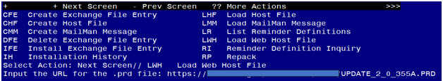

You will see a message indicating the file was loaded successfully.

Search and locate an entry titled UPDATE_2_0_355A VA-MENTAL HEALTH TEMPLATE UPDATE in reminder exchange.

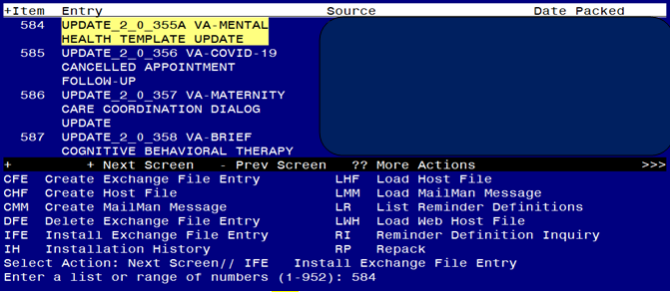

At the **Select Action** prompt, enter **IFE** for Install Exchange File Entry

Enter the number that corresponds with your entry titled UPDATE_2_0_355A VA-MENTAL HEALTH TEMPLATE UPDATE *(in this example it is entry 584, it will vary by site)* that is dated 06/13/2024.

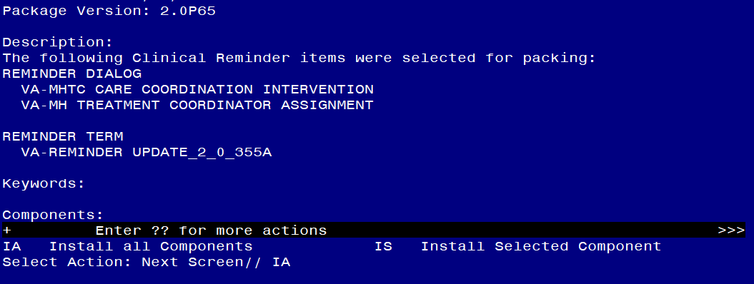

At the **Select Action** prompt, type **IA** for Install all Components and hit enter.

**For all new entries in any category you will choose I to Install**

**SKIP any items in any category you are prompted to overwrite.**

You will then be prompted to install the first dialog component.

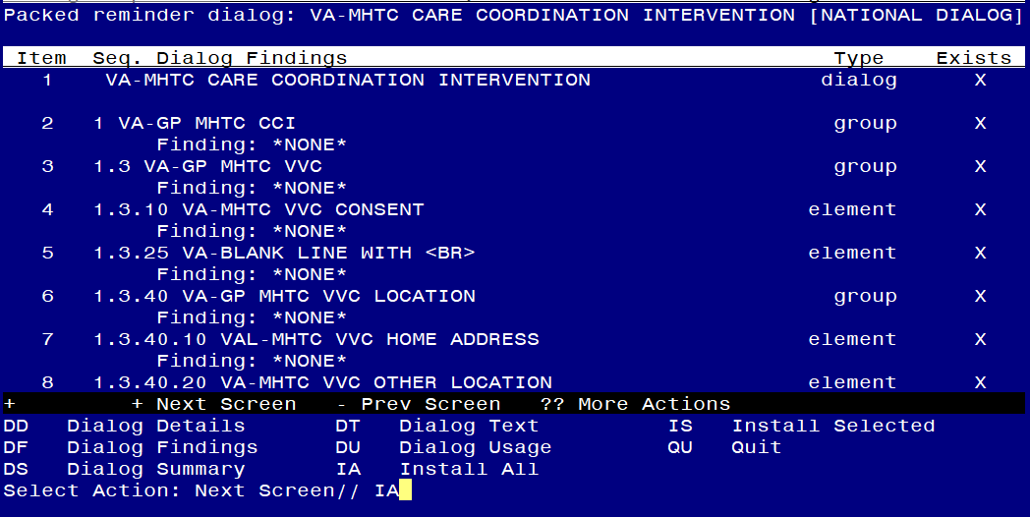

At the **Select Action** prompt, type **IA** to install the dialog – **VA-MHTC CARE COORDINATION INTERVENTION.**

Install reminder dialog and all components with no further changes: Y//ES

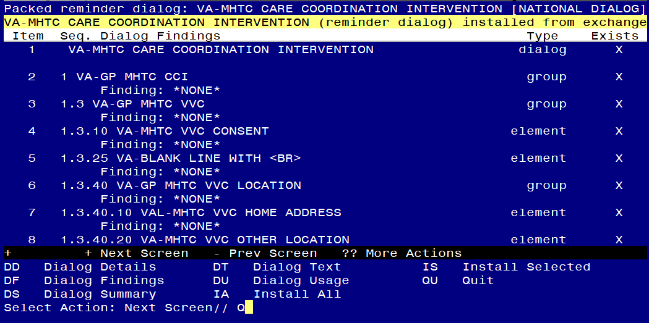

When the dialog has completed installation, you will then be returned to this screen. At the **Select Action** prompt, type **Q.**

You will then be prompted to install the next dialog component.

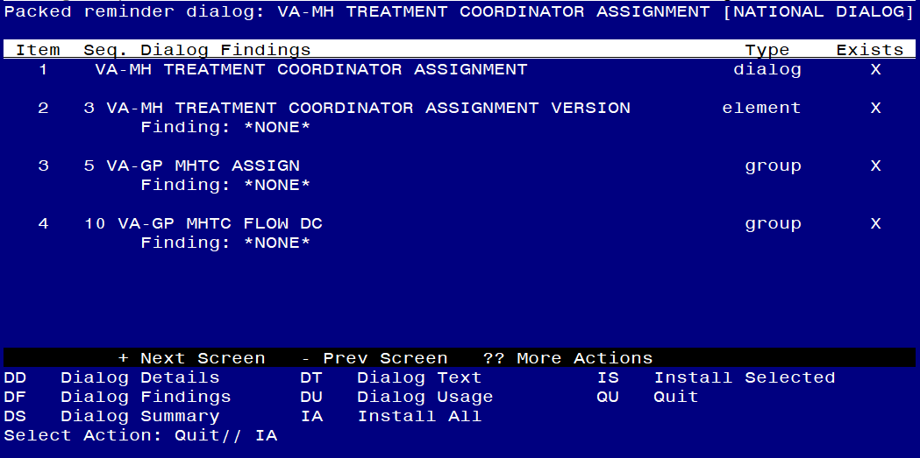

At the **Select Action** prompt, type **IA** to install the dialog – **VA-MH TREATMENT COORDINATOR ASSIGNMENT**

Install reminder dialog and all components with no further changes: Y//ES

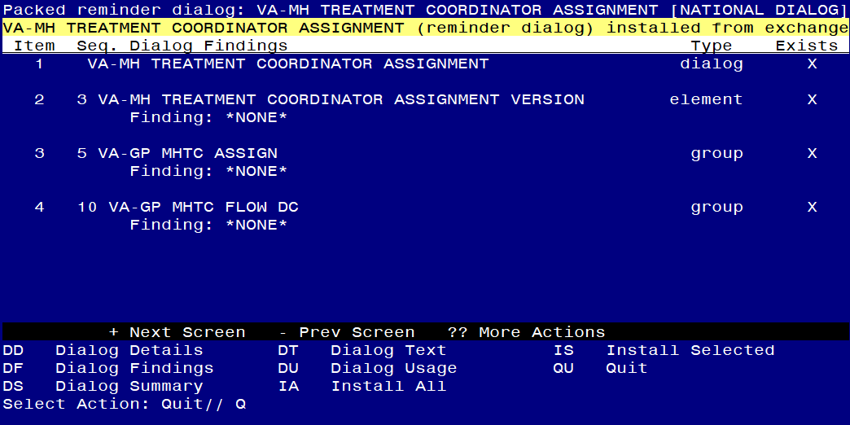

When the dialog has completed installation, you will then be returned to this screen. At the **Select Action** prompt, type **Q.**

You will then be prompted to install the next dialog component.

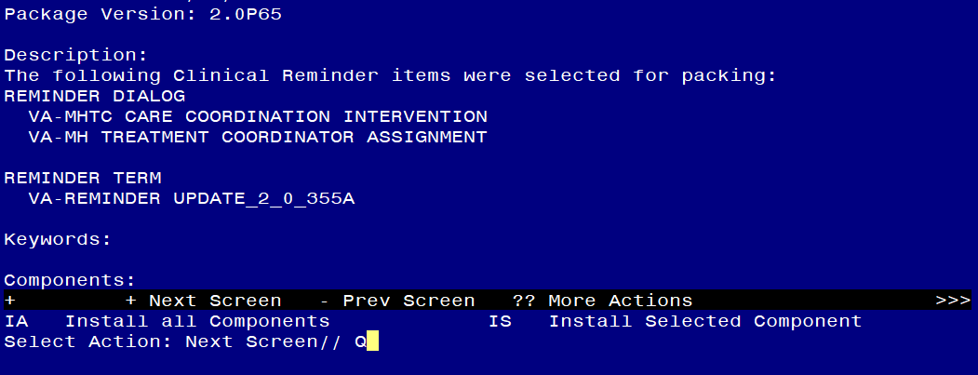

You will then be returned to this screen. At the **Select Action** prompt, type **Q.**

Install complete.

Post Installation

1. **Insert local objects into the dialog text.**
2. Using the pre-install inquiry, replace the text “INSERT OBJECT HERE” with your local objects for Primary care Provider and PACT Team. In VistA, Reminder Dialog Management, Reminder Dialogs, change view to Group, search list and navigate to reminder dialog group **VAL-GP MH DISCHARGE NEXT PCP**, and edit the group header dialog text.
3. Using the pre-install inquiry, replace the text “**INSERT PATIENT ADDRESS OBJECT**” with your local object. In VistA, Reminder Dialog Management, Reminder Dialogs, change view to Elements, search list and navigate to reminder dialog element **VAL-MHTC VVC HOME ADDRESS**, and edit the dialog text.
4. Using the pre-install inquiry, replace the text “**INSERT PATIENT PHONE OBJECT**” with your local object. In VistA, Reminder Dialog Management, Reminder Dialogs, change view to Elements, search list and navigate to reminder dialog element **VAL-MHTC VVC PHONE**, and edit the dialog text.
5. In CPRS, open the note titled MHTC BHIP CC ASSIGNMENT (reminder dialog VA-MH TREATMENT COORDINATOR ASSIGNMENT) and confirm the version number is 2.0.
6. In CPRS, open the note titled MHTC BHIP CC NEEDS ASSESSMENT AND INTERVENTION PLAN (reminder dialog VA-MHTC CARE COORDINATION INTERVENTION) and confirm the version number is 4.0.
7. Add local finding to the following elements as applicable for your site:

**Using the VistA menu reminder Dialog manager, Reminder Dialogs, change your view to element view.**

1. VA-MHTC SRR ECONSULT TODAY - add local suicide risk flag e-consult order
2. VA-MHTC REFERRALS SUBMIT TODAY - add mh consult menu
3. VA-MHTC REFERRALS PEER TODAY – add consult for peer support services
4. VA-MHTC REFERRALS WH TODAY – add menu/consult for whole health services
5. VA-MHTC SRR OFFER EB TODAY - add national suicide prevention telehealth consult