

Update _2_0_390A

Clinical Reminders

INFLUENZA REMINDER UPDATE 2024

Install Guide

**August 2024**

Product Development

Office of Information Technology

Department of Veterans Affairs

Table of Contents

Introduction 1

Pre-Install 3

Install Details 3

Install Example 4

Post Installation 8

## Introduction

**DO NOT INSTALL THIS INTO YOUR PRODUCTION ACCOUNT UNTIL YOUR SITE HAS YOUR FLU FORMULATIONS FOR 2024-2025 FLU SEASON AND YOU ARE READY TO ADMINISTER. YOU WILL NEED TO COORDINATE WITH YOUR FLU COMMITTEE AND POSSIBLY PHARMACY**

UPDATE 390A Influenza Reminder Update for 2024-25 influenza season contains the following updates.

1. Updated start date to 7/30/24
2. Updated stop date to 5/20/25
3. Added new vaccine formulations
4. Added not indicated finding
5. Added FF(2) (Refusal)
6. Removed FF(11)
7. Removed FF(12)
8. Added contraindicated logic
9. Changed resolution logic to include new finding items

Refusal logic has changed to look for 2 active refusals this flu season on separate encounters. We are no longer looking for the 2 refusals to be within 30 days of each other. An active refusal means that the documented refusal has not expired (date given on VIMM form for “Choose reschedule date”)

Screenshot to show the Choose Reschedule Date field entry


UPDATE_2_0_390 contains 1 Reminder Exchange entry:

**UPDATE_2_0_390A FLU REMINDER 2024-2025**

**The exchange file contains the following components:**

REMINDER GENERAL FINDINGS

1 VIEW PROGRESS NOTE TEXT

TIU TEMPLATE FIELD

2 BLANK TEXT FIELD FOR DIALOGS

3 IM SCRIBE

4 IM INFLUENZA VACCINE POST SEASON MESSAGE

5 IM INFLUENZA VACCINE REMINDER DIALOG HEADER

6 VA-LOCATIONS

7 IM PHARMACY PHONE NUMBERS

8 CDC FLU VACCINE AND EGG ALLERGIES

9 CDC ADVERSE REACTIONS GUIDELINES

10 CDC SUMMARY OF RECOMMENDATIONS

11 CDC FLU VACCINE RECOMMENDATIONS

12 NCP INFLUENZA IMMUNIZATION GUIDANCE

IMMUNIZATION

INFLUENZA, UNSPECIFIED FORMULATION

INFLUENZA, HIGH-DOSE, QUADRIVALENT, PF

INFLUENZA, SPLIT VIRUS, QUADRIVALENT, PRESERVATIVE

INFLUENZA, SPLIT VIRUS, QUADRIVALENT, PF

INFLUENZA, HIGH-DOSE, TRIVALENT, PF

INFLUENZA, MDCK, QUADRIVALENT, PRESERVATIVE

INFLUENZA, RECOMBINANT, QUADRIVALENT, PF

INFLUENZA, MDCK, QUADRIVALENT, PF

INFLUENZA, ADJUVANTED, TRIVALENT, PF

INFLUENZA, INTRADERMAL, QUADRIVALENT,

PRESERVATIVE FREE

INFLUENZA, RECOMBINANT, TRIVALENT, PF

INFLUENZA, MDCK, TRIVALENT, PF

INFLUENZA NASAL, UNSPECIFIED FORMULATION

INFLUENZA, LIVE, QUADRIVALENT, INTRANASAL

INFLUENZA, SEASONAL, INTRADERMAL, PRESERVATIVE

FREE

INFLUENZA, SPLIT VIRUS, TRIVALENT, PRESERVATIVE

INFLUENZA, SPLIT VIRUS, TRIVALENT, PF

INFLUENZA, MDCK, TRIVALENT, PRESERVATIVE

INFLUENZA, ADJUVANTED, QUADRIVALENT, PF

INFLUENZA, LIVE, TRIVALENT, INTRANASAL

HEALTH FACTORS

13 VA-REMINDER UPDATES [C]

14 VA-UPDATE_2_0_390A

15 IMMUNIZATION [C]

16 VA-INFLUENZA IMM NONE CURRENT SEASON

17 VA-INFLUENZA IMM NOT INDICATED

18 VA-INFLUENZA IMM REFUSED

19 VA-INFLUENZA IMM PRECAUTION

20 VA-INFLUENZA IMM PERM CONTRAINDICATION

21 VA-FLU EDUCATION VIRTUAL/TELEHEALTH VST

22 VA-INFLUENZA IMM SEASON CONTRAINDICATION

REMINDER SPONSOR

23 VA NATIONAL CENTER FOR HEALTH PROMOTION AND

DISEASE PREVENTION (NCP)

24 NATIONAL CENTER FOR HEALTH PROMOTION AND DISEASE

PREVENTION (NCP)

REMINDER COMPUTED FINDINGS

VA-FILEMAN DATE

VA-REMINDER DEFINITION

VA-ASU USER CLASS

VA-AGE

VA-IMMUNIZATION AND LOCATION LOT INFO

REMINDER TAXONOMY

25 VA-IMMUNIZATION ICD10 CODE

REMINDER TERM

26 VA-REMINDER UPDATE_2_0_390A

27 VA-INFLUENZA IMM SEASON STOP DATE

28 VA-INFLUENZA IMM NOT DONE THIS SEASON

29 VA-INFLUENZA IMM CONTRAINDICATION

30 VA-INFLUENZA IMM SEASON START DATE

31 VA-INFLUENZA IMM SEASONAL VACCINE FORMULATIONS

32 VA-BL INFLUENZA DONE

33 VA-INFLUENZA ADMIN SUPPRESSION

34 VA-IM NO DOSES AVAIL FLU 140

35 VA-IM NO DOSES AVAIL FLU 111

36 VA-IM NO DOSES AVAIL FLU 141

37 VA-IM NO DOSES AVAIL FLU 320

38 VA-IM NO DOSES AVAIL FLU 155

39 VA-IM NO DOSES AVAIL FLU 135

40 VA-INFLUENZA HIGH DOSE SUPPRESS OPTION

41 VA-IM NO DOSES AVAIL FLU 168

42 VA-IM NO DOSES AVAIL FLU 153

43 VA-INFLUENZA ORDER SUPPRESSION

REMINDER DEFINITION

44 VA-INFLUENZA SEASONAL IMMUNIZATION

HEALTH SUMMARY COMPONENT

PCE IMMUNIZATIONS SELECTED

HEALTH SUMMARY TYPE

45 VA-OBJ FLU VACCINE DATE

HEALTH SUMMARY OBJECTS

46 VA-FLU VACCINE DATE (TIU)

TIU DOCUMENT DEFINITION

47 VA-FLU VACCINE DATE

REMINDER DIALOG

48 VA-INFLUENZA IMMUNIZATION

## Pre-Install

Using the menu Reminder Dialog Manager, reminder Dialog, change view to group view, review the reminder dialog group VAL-OI IM INFLUENZA OUTPT and identify any quick order added as a finding or additional finding.

## Install Details

**DO NOT INSTALL THIS INTO YOUR PRODUCTION ACCOUNT UNTIL YOUR SITE HAS YOUR FLU FORMULATIONS FOR 2024-2025 FLU SEASON AND YOU ARE READY TO ADMINISTER. YOU WILL NEED TO COORDINATE WITH YOUR FLU COMMITTEE AND POSSIBLY PHARMACY**

This update is being distributed as a web host file. The address for the host file is: https://REDACTED /UPDATE_2_0_390A.PRD

The file will be installed using Reminder Exchange, programmer access is not required.

Installation:

=============

This update can be loaded with users on the system. Installation will take less than 30 minutes.

## Install Example

To Load the exchange file, use LWH. The URL is https://Redacted /UPDATE_2_0_390A.PRD

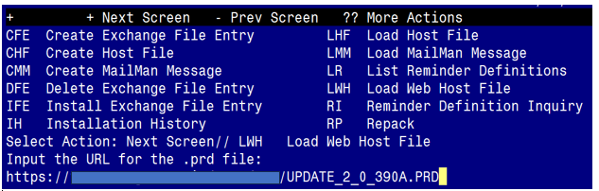

You should see a message that the file was loaded successfully.

Search and locate an entry titled UPDATE_2_0_390A FLU REMINDER 2024-2025 in reminder exchange.

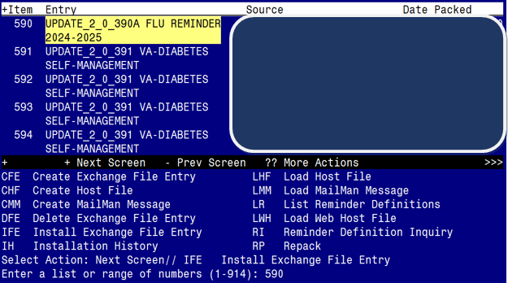

At the **Select Action** prompt, enter **IFE** for Install Exchange File Entry

Enter the number that corresponds with your entry titled UPDATE_2_0_390A FLU REMINDER 2024-2025 *(in this example it is entry 590, it will vary by site)* that is dated 08/08/2024.

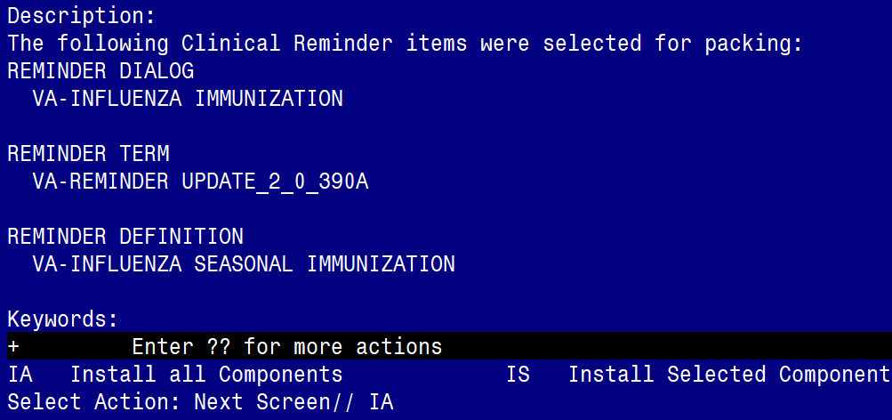

At the **Select Action** prompt, type **IA** for Install all Components and hit enter.

**For all new entries you will choose I to Install**

**For any TIU TEMPLATE FIELD that exist but are different, use OVERWRITE action**

**For HEALTH FACTORS that exist but are different use OVERWRITE action**

**For any REMINDER TERM that exist but are different, use the SKIP action except for the following 4 terms. For these four terms use OVERWRITE action**

VA-INFLUENZA IMM SEASON START DATE

VA-INFLUENZA IMM SEASON STOP DATE

VA-INFLUENZA IMM CONTRAINDICATION

VA-BL INFLUENZA DONE

**For any reminder definition that that exists but is different, use OVERWRITE action**

**For any** HEALTH SUMMARY TYPE that exist but are different, **use the SKIP action**

**++ In your test account, if you get prompted that any formulations do not exist, you can choose D to delete. You should not get that error in production where the immunization file should be up to date. ++**

**You will be promped to install the reminder dialog component: Many sites have made local edits to the influenza dialog and this will install will override all your local modifications**

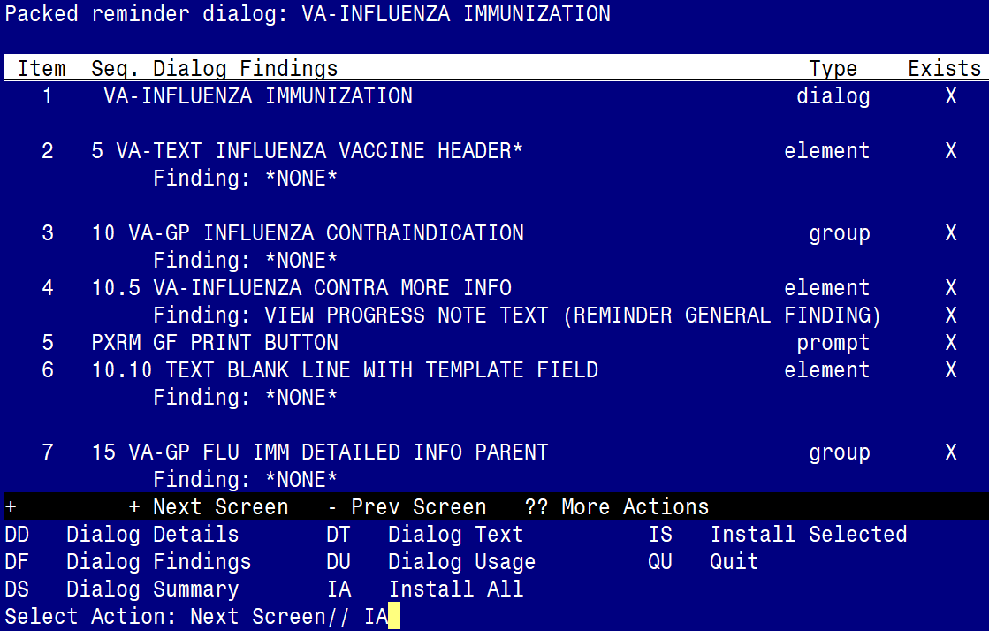

At the **Select Action** prompt, type **IA** to install all items.. If you have made local changes, this will overwrite all your changes!!

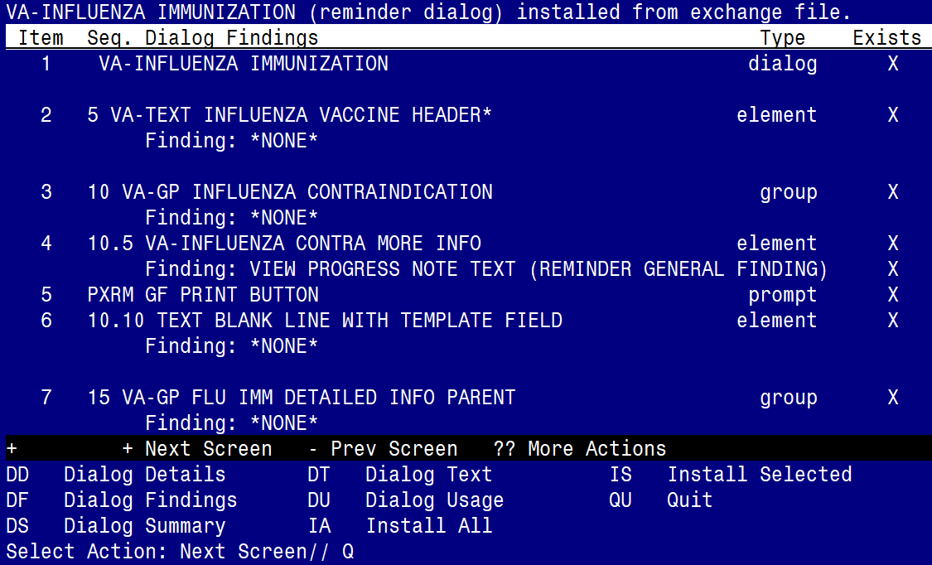

When the dialog has completed installation, you will then be returned to this screen. At the **Select Action** prompt, type **Q.**

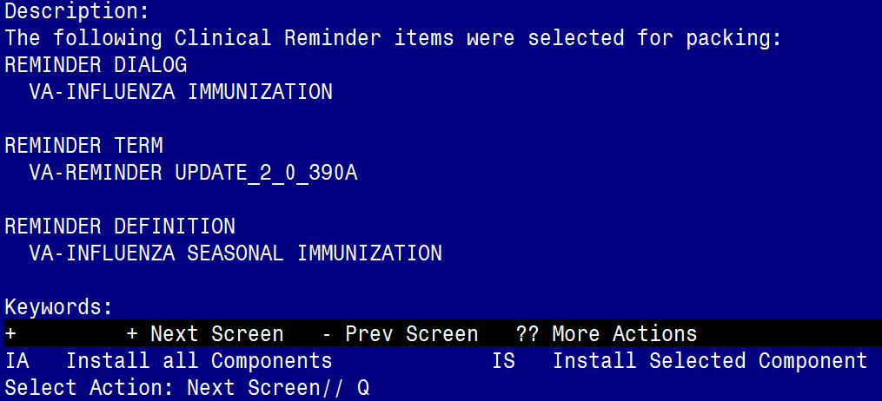

**Type Q to exit the dialog installation**

## Post Installation

1. Using the pre-install inquiry, add the appropriate immunization quick orders as a FINDING ITEM on the reminder dialog group VAL-OI IM INFLUENZA OUTPT. (You may not have had an order on this group, it is a local site decision on whether or not to add one, if you are not sure, review with your Pharmacy AdPac.

The finding item should be your local order or ordering menu for seasonal influenza.

1. If you want to suppress the ordering option in the dialog or the administration option in the INFLUENZA dialog, then follow the instructions in the following reminder terms. If you did not overwrite these terms during installation, they should work the same as in previous seasons.
   1. VA-INFLUENZA ORDER SUPPRESSION
   2. VA-INFLUENZA ADMIN SUPPRESSION

To suppress the dialog element for specific user classes: VA-ASU USER CLASS Enter the user class that should NOT see the dialog element. If more than one user class is needed, add additional findings of the CF VA-ASU USER CLASS for each one as needed.

To suppress the dialog element for all users: VA-AGE change the < sign to a > sign in the CF for patient age.

To suppress for specific user classes, in the above Terms configure the VA-ASU USER CLASS computed finding and DELETE the VA-AGE finding. NOTE: If the Age finding is not deleted, the user class settings will not work.

Other Local Options

1. Season Start Date: There is a reminder term, VA-INFLUENZA IMM SEASON START DATE, for the season start date. This is the date before which any vaccination will be ignored for this current season. The reminder is exported with a date of 7/30/2024. You should not need to change this date for the 2024-2025 flu season.
2. Season Stop Date: There is a reminder term to indicate the date that a facility chooses to stop giving vaccine, VA-INFLUENZA IMM SEASON STOP DATE. Each spring, when flu season is over based on community incidence, the facility chooses to stop giving vaccine. After this date has passed as defined in this reminder term, the reminder logic changes to turn off if the vaccine was refused during the season or if someone records that the patient did not get vaccine during the season. The dialog also changes to a post-season version once this date has passed.  
   The term is exported with a default of 5/20/2025 which will need to be updated by each site in the spring of 2025 when a decision is made to stop giving vaccine.
3. Dialog Text: much of the informational text and all of the administration options in the reminder dialog are local. You can edit the information text to add flu clinic hours or other local information. You can add or remove any of the flu vaccination options – the 3 formulary vaccine formulations are included by default but the group that contains them is local.
4. High dose suppression: if you want to completely suppress the option to document high dose vaccine on some group of patients, you can do that by making the condition in the reminder term shown below true for those patients. The reminder dialog is exported with a default age of 18 - for patients under the age of 18, the option to document high dose is suppressed.   
     
   PLEASE be careful with this option -if a nurse administers high dose vaccine and then opens the dialog and the option is not there, they are likely to record the vaccine incorrectly.

VA-INFLUENZA HIGH DOSE SUPPRESS OPTION

-------------------------------------------

Class: NATIONAL

Sponsor: VA National Center for Health Promotion and Disease Prevention (NCP)

Description:

Enter any condition or reminder definition that defines a population for

whom the option to see the High Dose flu vaccine administration option will

be suppressed.

If this term is true, then that option will be suppressed.

Findings:

Finding Item: VA-AGE (FI(1)=CF(27))

Finding Type: REMINDER COMPUTED FINDING

Condition: I V<18

1. Adding non-formulary formulations: The group for administering vaccine, VAL-GP IM INFLUENZA ADMIN OPTIONS, is local. There are several formulations that have dialog groups available but not viewable because the groups are installed as disabled. There is also an additional local option that you can use and edit the text if your site purchases something other than the options provided. If your site wants to use one of the hidden options, you can remove the disable from the dialog group in Vista.

The reminder dialog will install with these CVX codes enabled, your site can disable one or more of these if you do not provide that formulation :

140 - Fluarix – syringe

141 - Fluzone - multidose vial

135 - Fluzone – syringe (High Dose)

Screenshot of the reminder dialog with the default formulations as it was sent out with the exchange file.


These additional CVX codes are available but disabled in the dialog and can be enabled if appropriate for your site, please work with your local Pharmacy to make sure you have the appropriate CVX codes enabled:

111 – FluMist (this option has an additional VIS sheet link)

153 - Flucelvax – syringe

155 - Flublok – syringe

320 - Flucelvax – multidose vial

168 - Fluad – syringe

1. Update the reminder term VA-INFLUENZA IMM NOT DONE THIS SEASON and change the beginning date and time to the date your site starts giving the flu vaccine.

The reason you use that date is because prior to that date, users may have documented that the vaccine was not available which added the health factor. The health factor should only be recognized as a resolution if entered after your site starts giving vaccine.

Using the VistA menu Reminder Term Management, TE Add/Edit Reminder Term, edit the reminder term: VA-INFLUENZA IMM NOT DONE THIS SEASON

Select Reminder Term: **VA-INFLUENZA IMM NOT DONE THIS SEASON**      NATIONAL

        ...OK? Yes//   (Yes)

Choose from:

HF VA-INFLUENZA IMM NONE CURRENT SEASON                         Finding #   1

Select Finding: **`1** VA-INFLUENZA IMM NONE CURRENT SEASON

Editing Finding Number: 1

FINDING ITEM: VA-INFLUENZA IMM NONE CURRENT SEASON

        //

BEGINNING DATE/TIME: T-6M// **3240903  <<<<enter the date here, this date represents 09/03/2024, you would use the date appropriate for your site**

ENDING DATE/TIME:

OCCURRENCE COUNT: 1//

WITHIN CATEGORY RANK: 0//

INCLUDE VISIT DATA:

CONDITION:

CONDITION CASE SENSITIVE: NO//   NO

USE STATUS/COND IN SEARCH:

 Choose from:

 HF VA-INFLUENZA IMM NONE CURRENT SEASON                         Finding #   1

Select Finding: **<<<< Hit Enter here to finalize the edit**

Install complete.