

Update _2_0_391

Clinical Reminders

VA-DIABETES SELF-MANAGEMENT

Install Guide

**May 2024**

Product Development

Office of Information Technology

Department of Veterans Affairs

Table of Contents

Introduction 1

Install Details 4

Install Example 4

Post Installation 10

## Introduction

In November of 2019, VA and DOD jointly obtained recognition status from the American Diabetes Association (ADA) for its Virtual Diabetes Self-Management Training (DSMT)/Diabetes Self-Management Education and Support (DSMES) program (#006585).

In an effort to standardize and expand the program, numerous resources were developed, including power points, patient handbooks, a facilitator guide, implementation toolkit, CPRS template and a power BI Dashboard. The Power BI Dashboard will extract health factor data from the CDW.

Sites that are interested in offering the DSMES template must register for training. This training is a 6-hour virtual DSMES Train the Facilitator program that is offered approximately 4 times per year. To register for the training, you may contact Jamie Olsen or Mary Julius. You will then be sent a link for a Teams form to be completed. **Please do not make these templates available until someone at your site that has completed the training!**

**If you are not sure if someone at your site has completed the training, please reach out to REDACTED**

UPDATE_2_0_391 contains 1 Reminder Exchange entry:

UPDATE_2_0_391 VA-DIABETES SELF-MANAGEMENT

**The exchange file contains the following components:**

REMINDER GENERAL FINDINGS

1 VIEW PROGRESS NOTE TEXT

TIU TEMPLATE FIELD

2 TEXT (1-10 CHAR) REQ

3 WP 2

4 VCL LINK

5 WORD 2 LINES RQ

6 WORD PROCESSING (NOT REQUIRED)

7 ED BOX 50 REQ

8 WORD 2 LINES

9 TEXT (1-30 CHAR) REQ

HEALTH FACTORS

10 VA-REMINDER UPDATES [C]

11 VA-UPDATE_2_0_391

12 DIABETES [C]

13 VA-DSME SMART TAKING MEDICATIONS

14 VA-DSME SMART REDUCING RISKS

15 VA-DSME SMART PROBLEM SOLVING

16 VA-DSME SMART MONITORING

17 VA-DSME SMART HEALTHY EATING

18 VA-DSME SMART HEALTHY COPING

19 VA-DSME SMART BEING ACTIVE

20 VA-DSME MODULE 3

21 VA-DSME MODULE 8

22 VA-DSME MODULE 7

23 VA-DSME MODULE 6

24 VA-DSME MODULE 5

25 VA-DSME MODULE 4

26 VA-DSME MODULE 2

27 VA-DSME MODULE 1

28 VA-DSME REDUCING RISKS SMART GOAL DISCONTINUED

29 VA-DSME REDUCING RISKS SMART GOAL DIGRESSION FROM

GOAL

30 VA-DSME REDUCING RISKS SMART GOAL SOME PROGRESS

31 VA-DSME REDUCING RISKS SMART GOAL NOT ACHIEVED

32 VA-DSME REDUCING RISKS SMART GOAL ACHIEVED

33 VA-DSME HEALTHY COPING SMART GOAL DISCONTINUED

34 VA-DSME HEALTHY COPING SMART GOAL DIGRESSION FROM

GOAL

35 VA-DSME HEALTHY COPING SMART GOAL SOME PROGRESS

36 VA-DSME HEALTHY COPING SMART GOAL NOT ACHIEVED

37 VA-DSME HEALTHY COPING SMART GOAL ACHIEVED

38 VA-DSME PROBLEM SOLVING SMART GOAL DISCONTINUED

39 VA-DSME PROBLEM SOLVING SMART GOAL DIGRESSION

FROM GOAL

40 VA-DSME PROBLEM SOLVING SMART GOAL SOME PROGRESS

41 VA-DSME PROBLEM SOLVING SMART GOAL NOT ACHIEVED

42 VA-DSME PROBLEM SOLVING SMART GOAL ACHIEVED

43 VA-DSME TAKING MEDS SMART GOAL DISCONTINUED

44 VA-DSME TAKING MEDS SMART GOAL DIGRESSION FROM

GOAL

45 VA-DSME TAKING MEDS SMART GOAL SOME PROGRESS

46 VA-DSME TAKING MEDS SMART GOAL NOT ACHIEVED

47 VA-DSME TAKING MEDS SMART GOAL ACHIEVED

48 VA-DSME MONITORING SMART GOAL DISCONTINUED

49 VA-DSME MONITORING SMART GOAL DIGRESSION FROM GOAL

50 VA-DSME MONITORING SMART GOAL SOME PROGRESS

51 VA-DSME MONITORING SMART GOAL NOT ACHIEVED

52 VA-DSME MONITORING SMART GOAL ACHIEVED

53 VA-DSME HEALTHY EATING SMART GOAL DISCONTINUED

54 VA-DSME HEALTHY EATING SMART GOAL DIGRESSION FROM

GOAL

55 VA-DSME HEALTHY EATING SMART GOAL SOME PROGRESS

56 VA-DSME HEALTHY EATING SMART GOAL NOT ACHIEVED

57 VA-DSME HEALTHY EATING SMART GOAL ACHIEVED

58 VA-DSME BEING ACTIVE SMART GOAL DISCONTINUED

59 VA-DSME BEING ACTIVE SMART GOAL DIGRESSION FROM

GOAL

60 VA-DSME BEING ACTIVE SMART GOAL SOME PROGRESS

61 VA-DSME BEING ACTIVE SMART GOAL NOT ACHIEVED

62 VA-DSME BEING ACTIVE SMART GOAL ACHIEVED

63 VA-DSME TYPE OTHER

64 VA-DSME TYPE GDM

65 VA-DSME TYPE 2

66 VA-DSME TYPE 1

67 VA-DSME TYPE PRE-DIABETES

68 HOMELESSNESS SCREENING [C]

69 VA-MONEY TO BUY FOOD-YES CURRENT CONCERN

70 VA-FOOD 12MO ACTUALLY RAN OUT SOMETIMES

71 VA-FOOD 12MO ACTUALLY RAN OUT OFTEN

72 VA-FOOD 12MO WORRY RUN OUT SOMETIMES

73 VA-FOOD 12MO WORRY RUN OUT OFTEN

74 VA-HOMELESSNESS FOOD SHORTAGE YES

75 VA-MONEY TO BUY FOOD-NO CURRENT CONCERN

76 VA-FOOD 12MO ACTUALLY RAN OUT NEVER

77 VA-FOOD 12MO WORRY RUN OUT NEVER

78 VA-HOMELESSNESS FOOD SHORTAGE NO

79 VA-DSME DDS2 POSITIVE

80 VA-DSME DDS2 NEGATIVE

REMINDER SPONSOR

81 OFFICE OF NUTRITION AND FOOD SERVICES

REMINDER TERM

82 VA-REMINDER UPDATE_2_0_391

83 VA-HOMELESSNESS FOOD SHORTAGE YES

84 VA-HOMELESSNESS FOOD SHORTAGE NO

REMINDER DEFINITION

85 VA-DSME SMART GOALS HS OBJECT

86 VA-BL DIABETES SELF-MANAGEMENT FOOD INSECURITY

HEALTH SUMMARY COMPONENT

CLINICAL REMINDERS FINDINGS

CLINICAL REMINDERS LAST DONE

HEALTH SUMMARY TYPE

87 VA-DSME SMART GOALS

88 REMINDERS LAST DONE

HEALTH SUMMARY OBJECTS

89 VA-DSME SMART GOALS (TIU)

90 REMINDERS LAST DONE (TIU)

TIU DOCUMENT DEFINITION

91 VA-DSME SMART GOALS

PATIENT SEX

PATIENT RACE

PATIENT AGE

92 REMINDERS LAST DONE

REMINDER DIALOG

93 VA-DIABETES SELF-MANAGEMENT EDUCATION NOTE

## Install Details

This update is being distributed as a web host file. The address for the host file is: https://REDACTED/UPDATE_2_0_391.PRD

The file will be installed using Reminder Exchange, programmer access is not required.

Installation:

=============

This update can be loaded with users on the system. Installation will take less than 10 minutes.

## Install Example

**Step 1 – (must be completed first) Load the Mental Health Instruments**

You will first load the instruments using the INSTRUMENT EXCHANGE Menu (YTQ INSTRUMENT EXCHANGE) in Vista. If you do not have access to this menu, you will need to go through your facility process to request a new Vista menu. The new instrument you will load is DDS2

**THIS IS NOT REMINDER EXCHANGE**

Use this url for install REDACTED/CR_DDS2_B1.JSON

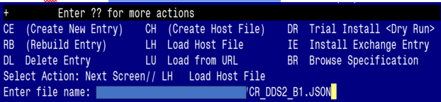

This will load: CR-DDS2 v1

created on: 09/01/2023@10:55:38

source: MELDRUM@CAMP MASTER

Description ---

(no description)

Do you want to continue? Yes// YES

CR-DDS2 v1 loaded.

Press return to continue...

Once the DDS2 is loaded, you will need to install

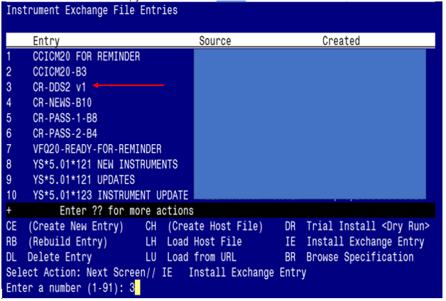

Find entry named “CR-DDS2 v1” and then select IE. In this instance, you would select number 3 to install. When prompted to Use verbose mode, you will choose YES

**Step 2 –**Install the reminder exchange file

To Load the exchange file, use LWH.

The URL is https://REDACTED /UPDATE_2_0_391.PRD

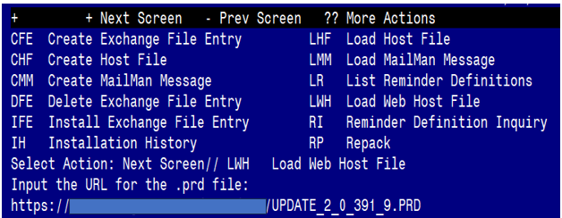

You should see a message that the file was loaded successfully.

Terminal window screen shot of the message displaying the URL of the file that was successfully loaded.  Part of the URL has been redacted as it is a VA only internal web site URL as shown in the text unless redacted for use outside of the VA.

Search and locate an entry titled UPDATE_2_0_391 VA-DIABETES SELF-MANAGEMENT in reminder exchange.

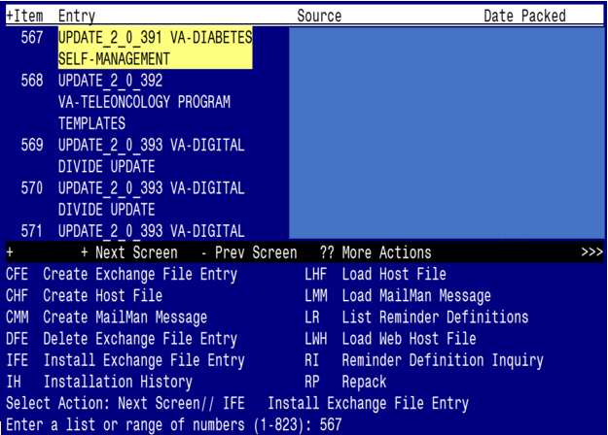

At the **Select Action** prompt, enter **IFE** for Install Exchange File Entry

Enter the number that corresponds with your entry titled UPDATE_2_0_391 VA-DIABETES SELF-MANAGEMENT *(in this example it is entry 567, it will vary by site)* that is dated 4/26/2024

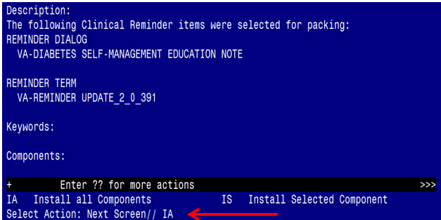 Select IA to install all components and hit enter

**Once this is done, you will be able to use action IA** for Install all Components and hit enter.

**For all new entries in any category you will choose I to Install**

**For Health Factors that exist, but are different you will OVERWRITE**

**For Reminder Terms that exist, but are different, you will Merge**

**For Health Summary type (if presented), you will SKIP**

You will be prompted to install the VA-DIABETES SELF-MANAGEMENT EDUCATION NOTE Dialog component. You will choose IA to install this component

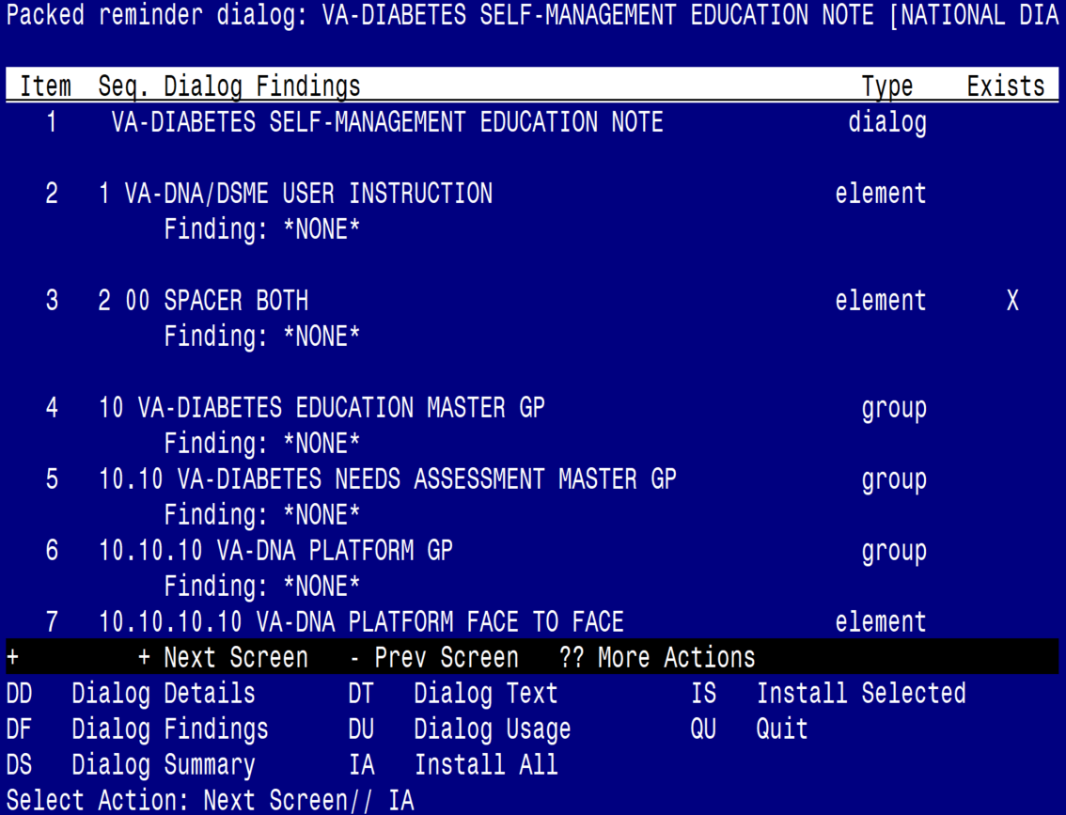

At the **Select Action** prompt, type IA to install dialog VA-DIABETES SELF-MANAGEMENT EDUCATION NOTE

All dialog components for VA-DIABETES SELF-MANAGEMENT EDUCATION NOTE are new.

Install reminder dialog and all components with no further changes: Y//YES

Once the dialog is installed, you will choose Q to quit

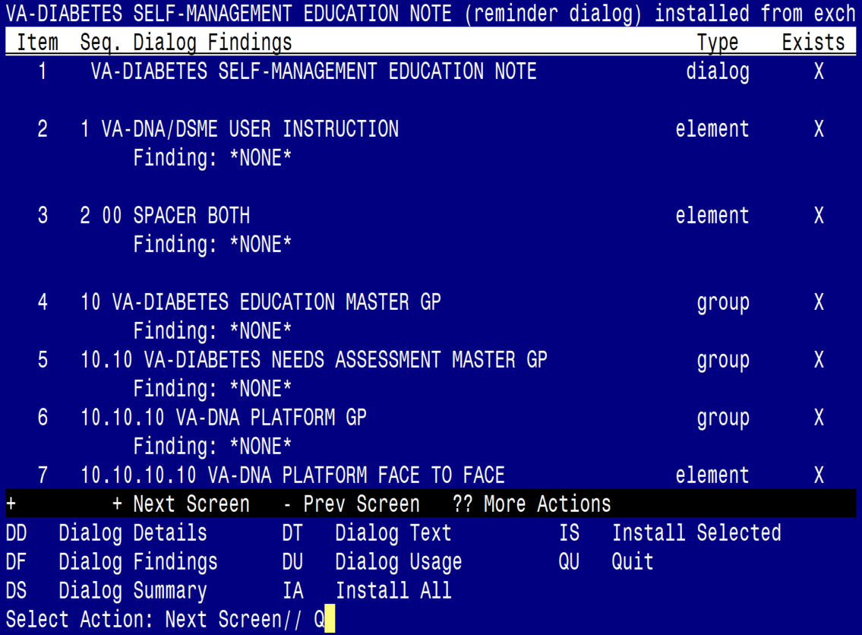

At the **Select Action** prompt, type Q to quit

You will then be brought back to this screen. Choose Q to quit and Install is complete

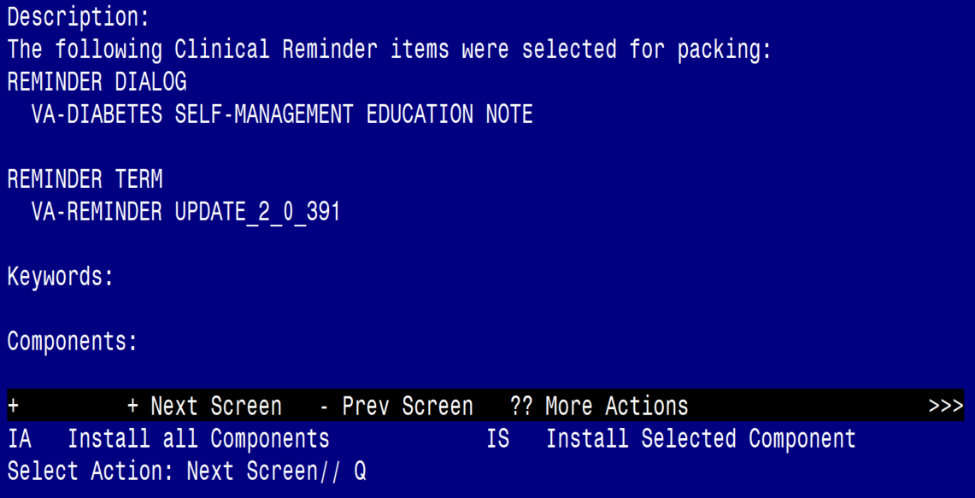

Install complete.

## Post Installation

Sites that are interested in offering the DSMES template must register for training. This training is a 6-hour virtual DSMES Train the Facilitator program that is offered approximately 4 times per year. To register for the training, you may contact Jamie Olsen or Mary Julius. Then you will be sent a link for a Teams form to complete. **Please do not make these templates available until you have someone at your site that has completed the training!**

1. Dialog element VAL-DSME SLEEP RELATED CONCERNS REFERRAL YES, you may map a quick order for a consult to sleep clinic. The element is also local so you may also change the text on that element to meet your site’s needs or DISABLE if you don’t offer this service.
2. Dialog element VAL-DNA RISK TOBACCO RESOURCES CONSULT, you may map a quick order for a consult to tobacco cessation clinic, if your site has one. The element is also local so you may also change the text on that element to meet your site’s needs or DISABLE if you don’t offer this service.
3. Dialog element VAL-DNA DDS2 POS BEHAVIORAL HEALTH PROVIDER YES is local and you may change the text based on processes your site uses for alerting a provider about a possible intervention. Quick orders may be mapped if needed.
4. Dialog element VAL-DNA DDS2 POS WHOLE HEALTH CLASS YES is local and is already mapped to the national Return To Clinic quick order. You may edit this and the text on the dialog element if needed to meet your site’s needs

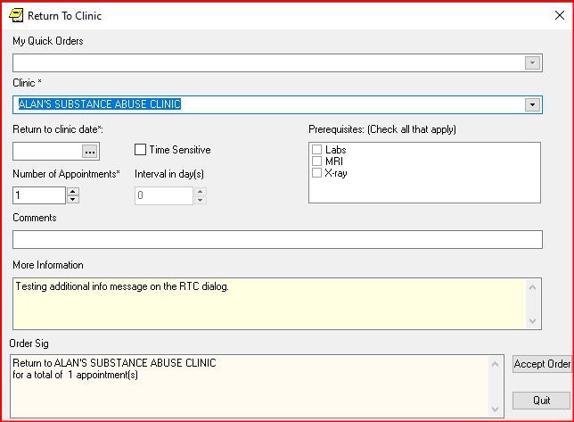

1. Dialog element VAL-DSME PATIENT/FAMILY RESPONSE REFERRAL DIETICIAN is local and may have a quick order for a consult to dietetics. Text of the element may also be changed to meet your site’s needs or DISABLE if you don’t offer this service.
2. Dialog element VAL-DSME PATIENT/FAMILY RESPONSE REFERRAL PHARMACY is local and may have a quick order for a consult to Pharmacy. Text of the element may also be changed to meet your site’s needs or DISABLE if you don’t offer this service.
3. Dialog element VAL-DSME PATIENT/FAMILY RESPONSE REFERRAL OTHER is local. Text of the element may also be changed to meet your site’s needs or DISABLE if you don’t offer this service.
4. Dialog element VAL-DNA CR RESULTS SUMMARY has a Health Summary Object named REMINDERS LAST DONE. The Health Summary Type is REMINDERS LAST DONE. This contains a Health Summary Component of CLD. You may map clinical reminder definitions to this if needed. Examples may be reminders that have to do with diabetes. The element is also local, so you may disable this if you do not want to display this information.
5. Dialog elements VAL-DNA DIABETES LABS and VAL-DNA DIABETES MEDS are local, and you may add your local objects to these elements for display of labs and medications. If your site doesn’t have a local object, you may DISABLE these elements for your site. If you do have an object or plan to create one, contact someone in endocrinology for a list of the appropriate labs to display. The group that these elements are part of is also local and is named VAL-DNA LAB AND MEDICINE OBJECTS Screen shot of the LAB AND INFORMATION object elements showing the following:
   LAB AND MEDICINE INFORMATION
     VIEW DIABETES LABS
     VIEW DISBETES MEDICATIONS
6. Create Note Titles:
7. Document Definitions (Manager) 🡪Create Document Definitions 🡪Next Level 🡪Progress Notes 🡪Next Level 🡪Enter document class where the progress note title should go 🡪Title  
   For DIABETES SELF-MANAGEMENT TRAINING [C], this should be in Document Class named Consult or Consults depending on how your site named the Class

Create the following note title:

**DIABETES SELF-MANAGEMENT TRAINING**. The VHA Enterprise Standard Title should be DIABETOLOGY NOTE

Create second note title:

**DIABETES SELF-MANAGEMENT TRAINING [C].** The VHA Enterprise Standard Title should be DIABETOLOGY CONSULT 🡪This will go in Consult document class

1. **Make the Dialog template available to be attached to a Personal or Shared template and attach the dialog to a progress note title (LINK feature in this menu for steps 2 and 3).**

Select Reminder Managers Menu Option: **CP** CPRS Reminder Configuration

CA Add/Edit Reminder Categories

CL CPRS Lookup Categories

CS CPRS Cover Sheet Reminder List

MH Mental Health Dialogs Active

PN Progress Note Headers

RA Reminder GUI Resolution Active

TIU TIU Template Reminder Dialog Parameter

DEVL Evaluate Coversheet List on Dialog Finish

DL Default Outside Location

PT Position Reminder Text at Cursor

LINK Link Reminder Dialog to Template

TEST CPRS Coversheet Time Test

NP New Reminder Parameters

GEC GEC Status Check Active

WH WH Print Now Active

Select CPRS Reminder Configuration Option: **TIU** TIU Template Reminder Dialog Parameter

Reminder Dialogs allowed as Templates may be set for the following:

1 User USR [choose from NEW PERSON]

3 Service SRV [choose from SERVICE/SECTION]

4 Division DIV [SALT LAKE CITY]

5 System SYS [NATREM.FO-SLC.MED.VA.GOV]

Enter selection: **5** Choose *the appropriate number for your site. Your site may do this by System or other levels. The example below uses SYSTEM level.*

Setting Reminder Dialogs allowed as Templates for System: NATREM.FO-SLC.MED.VA.GOV

Select Display Sequence:

388 VA-COVID-19 TELEPHONE FOLLOW-UP

389 VA-SRA-CONSULT RESPONSE (D)

*When you type a question mark above, you will see the list of #’s (with dialogs) that are already taken. Choose a number* ***NOT*** *on this list. For this example, 391 is not present so I will use 391.*

Select Display Sequence: **391**

Are you adding 391 as a new Display Sequence? Yes// **YES**

Display Sequence: 391// <Enter> 391

Clinical Reminder Dialog: **VA-DIABETES SELF-MANAGEMENT EDUCATION NOTE** reminder dialog NATIONAL

...OK? Yes// <Enter> (Yes)

1. **Associate the reminder dialog with the note title in CPRS. The reminder dialog should be associated with the two newly created note titles, not put in shared templates folder.**

In CPRS, open the Template Editor, expand Document Titles, select the appropriate folder (if applicable), then click New Template (top right-hand corner).

