

Update _2_0_401

Clinical Reminder Dialog

VA-SCI/D CENTER ANNUAL EVALUATION OUTREACH

Install Guide

**December 2023**

Product Development

Office of Information Technology

Department of Veterans Affairs

Table of Contents

Introduction 1

Install Details 2

Install Example 3

Post Installation 6

## Introduction

Per Memorandum 1176(2), Annual Comprehensive Preventive Health Evaluations must be offered to all Veterans with Spinal Cord Injury and Disorder (SCI/D) and performed at SCI/D Centers by a multidisciplinary team trained in SCI/D care. Every effort must be made to educate Veterans with SCI/D about the importance of the SCI/D Comprehensive Preventive Health Evaluation and the advantages to have the evaluation at the SCI/D Center.

If the Veteran refuses or is unable to travel, clear documentation that the annual evaluation was offered and refused must be entered into the medical record and the designated Chief, SCI/D Center must be notified.

The SCI/D Center Annual Evaluation Outreach template will ensure that all SCI/D Veterans are offered an Annual Evaluation in compliance with the 1176 memorandum. Education on the importance of receiving an Annual Evaluation at the SCI/D Center will be documented, along with any reasons for refusal. Health factors embedded within this template provide the ability to track and analyze the data collected.

**The exchange file contains the following components:**

**TIU TEMPLATE FIELD**

TEXT (1-50 CHAR) REQ

**HEALTH FACTORS**

VA-REMINDER UPDATES [C]

VA-SCI/D AE CLINIC CANCELLED

VA-SCI/D AE DECL-DISTANCE

VA-SCI/D AE DECL-DOES NOT QUALIFY TRAVEL ASSIST

VA-SCI/D AE DECL-FY

VA-SCI/D AE DECL-HOSPITALIZED

VA-SCI/D AE DECL-ILL

VA-SCI/D AE DECLINED

VA-SCI/D AE DECL-NON-VA PCP

VA-SCI/D AE DECL-OTHER

VA-SCI/D AE DECL-PAIN

VA-SCI/D AE DECL-PT FEELS NOT NEEDED

VA-SCI/D AE DECL-RESPONSIBILITIES

VA-SCI/D AE DECL-SCHEDULED/COMPLETED

VA-SCI/D AE DECL-VA SCI/D SPOKE SITE

VA-SCI/D AE DECL-VENT

VA-SCI/D AE DECL-WOUNDS

VA-SCI/D AE EDUCATION

VA-SCI/D AE FC NO BED

VA-SCI/D AE FC NOT APPROPRIATE

VA-SCI/D AE FC OTHER

VA-SCI/D AE FIRST CALL

VA-SCI/D AE FIRST LEFT VM

VA-SCI/D AE FIRST NO VM

VA-SCI/D AE HYBRID SPOKE CVT SCH ALERTED

VA-SCI/D AE HYBRID SPOKE OUTPT SCH ALERTED

VA-SCI/D AE HYBRID INPT ADM SCH

VA-SCI/D AE HYBRID INPT ADM SCH ALERTED

VA-SCI/D AE HYBRID OTHER

VA-SCI/D AE HYBRID OUTPT SCH ALERTED

VA-SCI/D AE HYBRID OUTPT SCHEDULED

VA-SCI/D AE HYBRID VVC SCH ALERTED

VA-SCI/D AE HYBRID VVC SCHEDULED

VA-SCI/D AE INPT ADM SCH

VA-SCI/D AE INPT ADM SCH ALERT

VA-SCI/D AE LETTER SENT MHV

VA-SCI/D AE LETTER SENT USPS

VA-SCI/D AE LODGING CAREGIVER

VA-SCI/D AE LODGING VET

VA-SCI/D AE LODGING VET/CG

VA-SCI/D AE NO SHOW

VA-SCI/D AE NO SHOW DECLINED RESCHEDULE

VA-SCI/D AE NO SHOW NO VM

VA-SCI/D AE NO SHOW REASON

VA-SCI/D AE NO SHOW RESCHEDULED COMMENTS

VA-SCI/D AE OUTPT F2F SCH ALERTED

VA-SCI/D AE OUTPT F2F SCH/DATE

VA-SCI/D AE OUTPT VVC SCH ALERTED

VA-SCI/D AE OUTPT VVC SCH/DATE

VA-SCI/D AE OUTREACH

VA-SCI/D AE OUTREACH [C]

VA-SCI/D AE SECOND CALL

VA-SCI/D AE SECOND LEFT VM

VA-SCI/D AE SECOND NO VM

VA-SCI/D AE THIRD CALL

VA-SCI/D AE THIRD LEFT VM

**REMINDER SPONSOR**

OFFICE OF SPINAL CORD INJURIES AND DISORDERS (SCI/D)

**REMINDER DIALOG**

VA-SCI/D CENTER ANNUAL EVALUATION OUTREACH NOTE

**REMINDER TERM**

VA-REMINDER UPDATE_2_0_401

## Pre-Installation

1. Coordinate with local SCI/D Hub staff and identify the following local quick orders for mapping to elements in the post-installation steps.
   1. Lodging consult order
   2. Return to clinic order (RTC) for Spinal Cord Injury or generic RTC order
   3. Return to clinic order (RTC) for VA Video Connect or generic RTC order
   4. Return to clinic order (RTC) for Hybrid VA Video Connect or generic RTC order
   5. Return to clinic order (RTC) for Hybrid Outpatient Clinic or generic RTC order
   6. IFC Consult for SCI/D Hybrid Spoke, if available
   7. IFC Consult for Hybrid Spoke Clinical Video Telehealth (CVT), if available
   8. Consult order for VA Special Mode Transportation

## Installation

Install Details

This update is being distributed as a web host file. The address for the host file is: **https://REDACTED /UPDATE_2_0_401.PRD**

This update can be loaded with users on the system. Installation will take less than 5 minutes.

## Install Example

To Load the Web Host File. Navigate to Reminder exchange in Vista

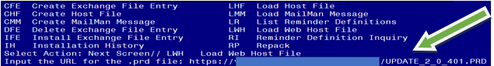

At the **Select Action:** prompt, enter **LWH** for Load Web Host File

At the **Input the URL for the .prd file:** prompt, type the following web address:

**https://REDACTED /UPDATE_2_0_401.PRD**

You should see a message at the top of your screen that the file successfully loaded.

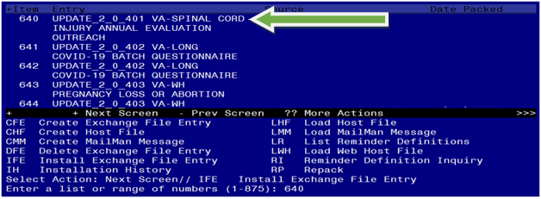

Search and locate an entry titled **UPDATE_2_0_401 VA-SPINAL CORD INJURY ANNUAL EVALUATION OUTREACH** in reminder exchange.

At the **Select Action** prompt, enter **IFE** for Install Exchange File Entry

Enter the number that corresponds with your entry UPDATE_2_0_401 VA-SPINAL CORD INJURY ANNUAL EVALUATION OUTREACH.

*(In this example it is entry 640. It will vary by site).* The date of the exchange file should be 12/20/2023.

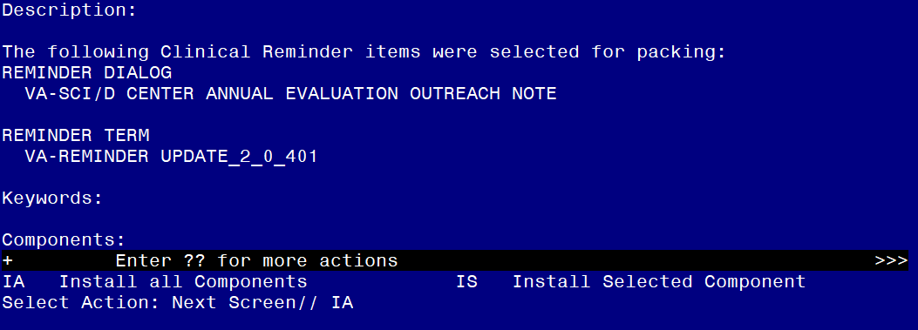

At the **Select Action** prompt, type **IA** for Install all Components and hit enter.

Select Action: Next Screen// **IA**  Install all Components

You will see several prompts, for all new entries you will choose **I to Install**

For any components that already exists but the packed component is different, choose **O to Overwrite.**

**You will be promped to install the reminder dialog component (VA-SCI/D CENTER ANNUAL EVALUATION OUTREACH NOTE).** You will choose to install all even though some components may have an X to indicate that they exist.

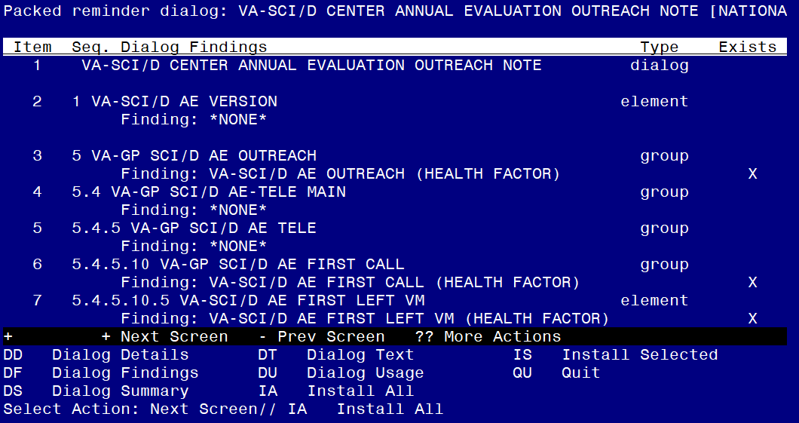

At the **Select Action** prompt, type **IA** to install the dialog.

Install reminder dialog and all components with no further changes: **Yes**

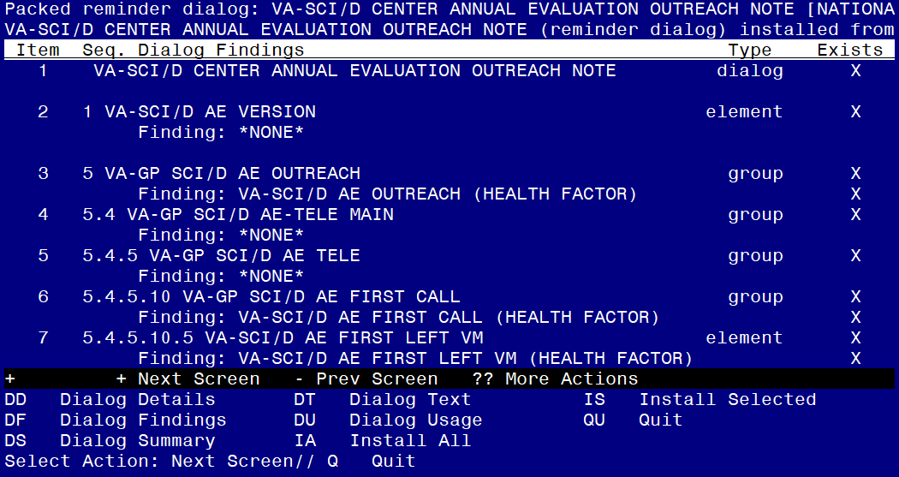

After completing this dialog install, you will type **Q**.

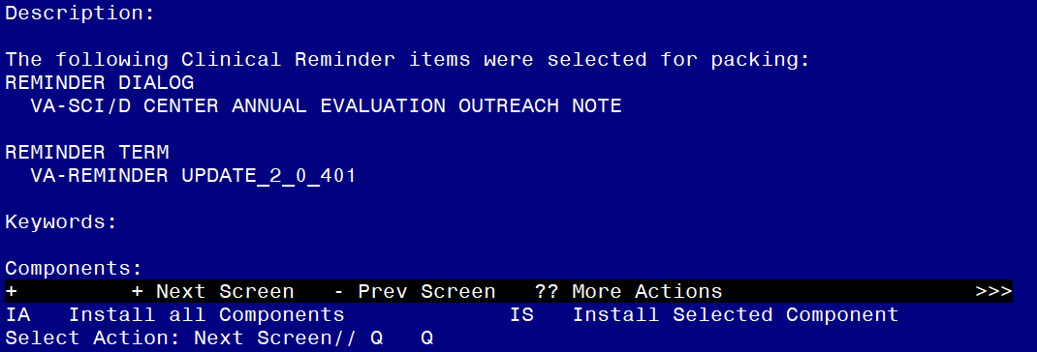

You will then be returned to this screen. At the **Select Action** prompt, type **Q.**

Install complete.

## Post Installation

1. **Make the Dialog template available to be attached to a Personal or Shared template or to be able to attach the dialog to a progress note title.**

Select Reminder Managers Menu <TEST ACCOUNT> Option: **CP** CPRS Reminder Configuration

CA Add/Edit Reminder Categories

CL CPRS Lookup Categories

CS CPRS Cover Sheet Reminder List

MH Mental Health Dialogs Active

PN Progress Note Headers

RA Reminder GUI Resolution Active

TIU TIU Template Reminder Dialog Parameter

DEVL Evaluate Coversheet List on Dialog Finish

DL Default Outside Location

PT Position Reminder Text at Cursor

LINK Link Reminder Dialog to Template

TEST CPRS Coversheet Time Test

NP New Reminder Parameters

GEC GEC Status Check Active

WH WH Print Now Active

Select CPRS Reminder Configuration <TEST ACCOUNT> Option: **TIU** TIU Template Reminder Dialog Parameter

Reminder Dialogs allowed as Templates may be set for the following:

1 User USR [choose from NEW PERSON]

3 Service SRV [choose from SERVICE/SECTION]

4 Division DIV [SALT LAKE CITY]

5 System SYS [NATREM.FO-SLC.MED.VA.GOV]

Enter selection: **5** *Choose the appropriate number for your site. Your site may do this by System or other levels. The example below uses SYSTEM level.*

Setting Reminder Dialogs allowed as Templates for System: NATREM.FO-SLC.MED.VA.GOV

Select Display Sequence: **?**

388 VA-COVID-19 TELEPHONE FOLLOW-UP

389 VA-SRA-CONSULT RESPONSE (D)

*When you type a question mark above, you will see the list of #’s (with dialogs) that are already taken. Choose a number* ***NOT*** *on this list. For this example, 390 and 391 are not present so those numbers can be used.*

Select Display Sequence: **390**

Are you adding 390 as a new Display Sequence? Yes// **YES**

Display Sequence: 390// **<Enter>**

Clinical Reminder Dialog: **VA-SCI/D CENTER ANNUAL EVALUATION OUTREACH NOTE**

reminder dialog NATIONAL

...OK? Yes// **Yes**

1. **Map lodging consult to following group.**

Name: **VA-GP SCI/D AE LODGING VET/CG - CONSULT ORDER**

FINDING ITEM: Enter “Q.”, then name of consult quick order.

1. **Map return to clinic order (RTC) for Spinal Cord Injury or appropriate RTC order to following elements.**
2. Name: **VA-GP SCI/D AE OUTPT F2F-RTC ORDER**

FINDING ITEM: Enter “Q.”, then name of RTC order.

1. Name: **VA-SCI/D AE VC RTC**

FINDING ITEM: Enter “Q.”, then name of RTC order.

1. Name: **VA-SCI/D AE CC RTC ORDER**

FINDING ITEM: Enter “Q.”, then name of RTC order.

1. **Map return to clinic order (RTC) for VA Video Connect or appropriate RTC order to following element.**

Name: **VA-GP SCI/D AE VVC-RTC ORDER**

FINDING ITEM: Enter “Q.”, then name of RTC order.

1. **Map return to clinic order (RTC) for Hybrid VA Video Connect or appropriate RTC order to following element.**

Name: **VA-SCI/D AE HYBRID VVC-RTC ORDER**

FINDING ITEM: Enter “Q.”, then name of RTC order.

1. **Map return to clinic order (RTC) for Hybrid Outpatient Clinic or appropriate RTC order to following element.**

Name: **VA-GP SCI/D AE OUTPT CLINIC-RTC ORDER**

FINDING ITEM:

1. **Map IFC Consult for Hybrid Spoke to following element.**

The following element is released disabled. Enable the element and map the quick order if available locally. If this IFC doesn’t exist locally, then skip this step.

Name: **VAL-SCI/D AE HYBRID SPOKE-IFC ORDER**

DISABLE: DISABLE AND DO NOT SEND MESSAGE//

FINDING ITEM:

1. **Map IFC Consult for Hybrid Spoke Clinical Video Telehealth (CVT) to following element.**

The following element is released disabled. Enable the element and map the quick order if available locally. If this IFC doesn’t exist locally, then skip this step.

Name: **VAL-SCI/D AE HYBRID SPOKE CVT-IFC ORDER**

DISABLE: DISABLE AND DO NOT SEND MESSAGE// FINDING ITEM:

1. **Map consult order for VA Special Mode Transportation to following element.**

Name: **VA-SCI/D AE TRANSPORTATION-SMT CONSULT ORDER**

FINDING ITEM:

1. **Create note title and map to reminder dialog.**

The note title to create to associate with this template is:

Title: **SCI/D CENTER ANNUAL EVALUATION OUTREACH**

Std. Title: **SPINAL CORD INJURY NOTE**

Dialog: **VA-SCI/D CENTER ANNUAL EVALUATION OUTREACH NOTE**

***Note:*** *Comprehensive information on Creating new Document Classes and Titles can be found beginning on page 54 of the TIU/ASU Implementation Guide at the following link:* [*http://www.va.gov/vdl/documents/Clinical/CPRS-Text_Integration_Utility_(TIU)/tiuim.pdf*](http://www.va.gov/vdl/documents/Clinical/CPRS-Text_Integration_Utility_(TIU)/tiuim.pdf)

1. **Associate the reminder dialog with the note title in CPRS**

In CPRS, open the Template Editor, expand Document Titles, select the appropriate folder (if applicable), then click New Template (top right-hand corner).

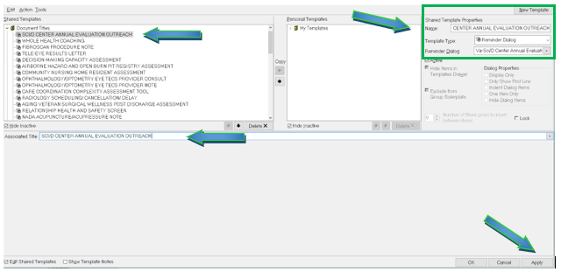

Type in the following information:

Name: **SCI/D CENTER ANNUAL EVALUATION OUTREACH**

Template Type: **Reminder Dialog**

Reminder Dialog: **VA-SCI/D CENTER ANNUAL EVALUATION OUTREACH NOTE**

Next, type in the Associated Title name –– then click Apply.