

Update _2_0_403

Clinical Reminders

VA-WH PREGNANCY LOSS OR ABORTION

Install Guide

**November 2023**

Product Development

Office of Information Technology

Department of Veterans Affairs

Table of Contents

Introduction 1

Install Details 2

Install Example 3

Post Installation 6

## Introduction

As per 38CFR Part 17 RIN 2900-AR57 the Veteran’s Health Administration has amended its medical regulations to:

1. Remove the exclusion on abortion counseling.
2. Establish exceptions to the exclusion on abortions for Veterans who receive care at the VA and CHAMPVA (Civilian Health and Medical Program of the Department of Veterans Affairs) beneficiaries.

This new documentation template was created to support this change.

Users of the template will be those who provide treatment for early pregnancy loss or abortion, using medication or a procedure, including those who are referring patients to the community for that care.

UPDATE_2_0_403 contains 1 Reminder Exchange entry:

**UPDATE_2_0_****403 VA-WH PREGNANCY LOSS OR ABORTION**

**The exchange file contains the following components:**

**REMINDER GENERAL FINDINGS**

TICKLER REMINDER COMMENT

TICKLER REMINDER

VIEW PROGRESS NOTE TEXT

**TIU TEMPLATE FIELD**

VA-BLANK

VA-DATE ONLY R

VA-WH EDD CALC

VA-PREG WORKFLOW

VA-POSPREGSOP

**HEALTH FACTORS**

VA-REMINDER UPDATES [C]

VA-UPDATE_2_0_403

VA-WH PREGNANCY LOSS TERMINATION [C]

VA-WH PREG LOSS PLAN REFER COMMUNITY

VA-WH PREG LOSS PLAN PROCEDURE VA CRH

VA-WH PREG LOSS PLAN PROCEDURE VA IFC

VA-WH PREG LOSS PLAN PROCEDURE VA FACILITY

VA-WH PREG LOSS PLAN MEDICATION VA CRH

VA-WH PREG LOSS PLAN MEDICATION VA IFC

VA-WH PREG LOSS PLAN MEDICATION VA FACILITY

VA-WOMENS HEALTH [C]

VA-WH GESTATIONAL AGE UNKNOWN

VA-WH GESTATIONAL AGE DAYS

VA-WH GESTATIONAL AGE WEEKS

VA-WH ABORT PLAN REFER COMMUNITY

VA-WH ABORT PLAN PROCEDURE VA CRH

VA-WH ABORT PLAN PROCEDURE VA IFC

VA-WH ABORT PLAN PROCEDURE VA FACILITY

VA-WH ABORT PLAN MEDICATION VA CRH

VA-WH ABORT PLAN MEDICATION VA IFC

VA-WH ABORT PLAN MEDICATION VA FACILITY

VA-WH ABORT ELIGIBILITY RAPE INCEST

VA-WH ABORT ELIGIBILITY LIFE HEALTH

**REMINDER TAXONOMY**

VA-PREGNANCY LOSS DX CODES

VA-PREGNANCY TERM DX CODES

**REMINDER TERM**

VA-REMINDER UPDATE_2_0_403

**REMINDER DIALOG**

VA-WH PREGNANCY LOSS OR ABORTION

## Install Details

This update is being distributed as a web host file. The address for the host file is: https://REDACTED /UPDATE_2_0_403.PRD

The file will be installed using Reminder Exchange, programmer access is not required.

Installation:

=============

This update can be loaded with users on the system. Installation will take less than 5 minutes.

## Install Example

Go to Reminder exchange in Vista.

To Load the exchange file, use LWH. The URL is

https://REDACTED /UPDATE_2_0_403.PRD

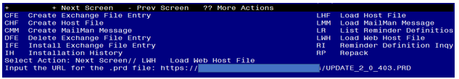

You will see a message indicating the file was loaded successfully.

Search and locate an entry titled UPDATE_2_0_403 VA-WH PREGNANCY LOSS OR ABORTION in reminder exchange.

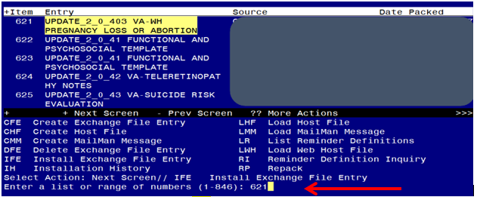

At the **Select Action** prompt, enter **IFE** for Install Exchange File Entry

Enter the number that corresponds with your entry titled UPDATE_2_0_403 VA-WH PREGNANCY LOSS OR ABORTION *(in this example it is entry 621, it will vary by site)* that is dated 11/22/2023.

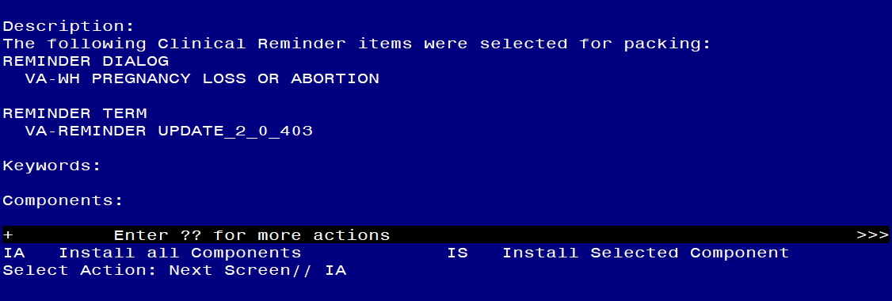

At the **Select Action** prompt, type **IA** for Install all Components and hit enter.

**For all new entries in any category you will choose I to Install**

**SKIP any items in any category you are prompted to overwrite.**

You will then be prompted to install the dialog component.

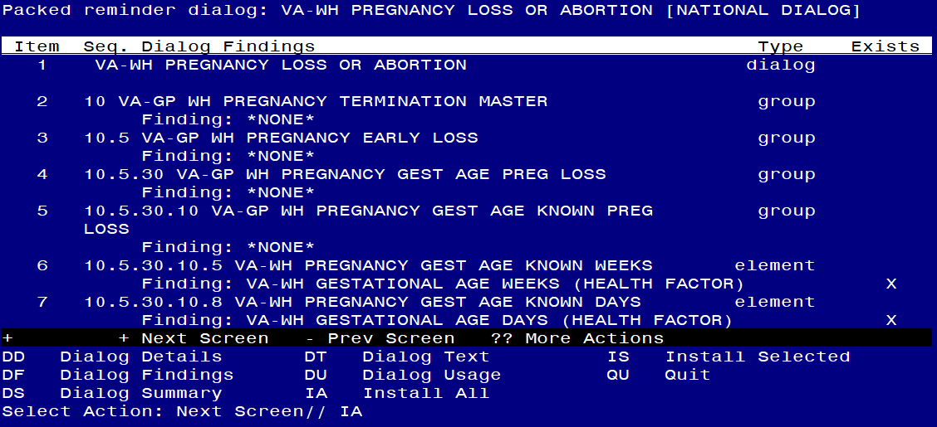

At the **Select Action** prompt, type **IA** to install the dialog – **VA-WH PREGNANCY LOSS OR ABORTION**

Install reminder dialog and all components with no further changes: Y//ES

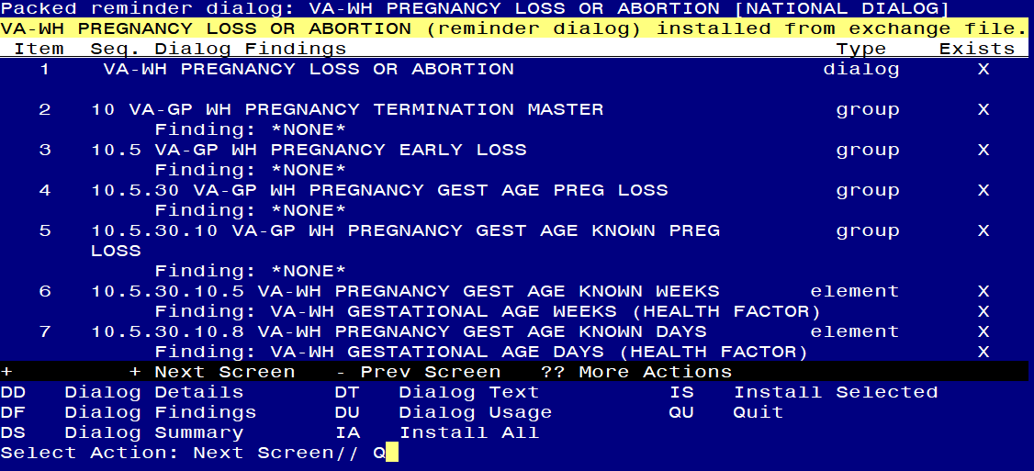

When the dialog has completed installation, you will then be returned to this screen. At the **Select Action** prompt, type **Q.**

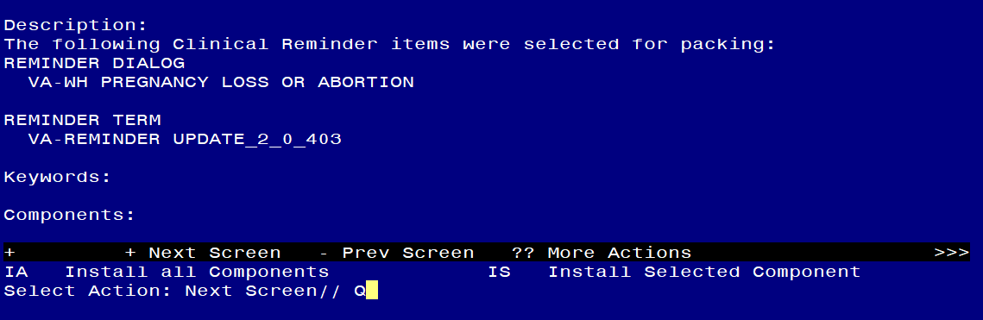

You will then be returned to this screen. At the **Select Action** prompt, type **Q.**

Install complete.

## Post Installation

1. **Make the Dialog templates available to be attached to a Personal or Shared templates or to be able to attach the dialog to a progress note title.**

Select Reminder Managers Menu <TEST ACCOUNT> Option: **CP** CPRS Reminder Configuration

CA Add/Edit Reminder Categories

CL CPRS Lookup Categories

CS CPRS Cover Sheet Reminder List

MH Mental Health Dialogs Active

PN Progress Note Headers

RA Reminder GUI Resolution Active

TIU TIU Template Reminder Dialog Parameter

DEVL Evaluate Coversheet List on Dialog Finish

DL Default Outside Location

PT Position Reminder Text at Cursor

LINK Link Reminder Dialog to Template

TEST CPRS Coversheet Time Test

NP New Reminder Parameters

GEC GEC Status Check Active

WH WH Print Now Active

Select CPRS Reminder Configuration <TEST ACCOUNT> Option: **TIU** TIU Template Reminder Dialog Parameter

Reminder Dialogs allowed as Templates may be set for the following:

1 User USR [choose from NEW PERSON]

3 Service SRV [choose from SERVICE/SECTION]

4 Division DIV [SALT LAKE CITY]

5 System SYS [NATREM.FO-SLC.MED.VA.GOV]

Enter selection: **5** *Choose the appropriate number for your site. Your site may do this by System or other levels. The example below uses SYSTEM level.*

Setting Reminder Dialogs allowed as Templates for System: NATREM.FO-SLC.MED.VA.GOV

Select Display Sequence: **?**

403 VA-COVID-19 TELEPHONE FOLLOW-UP

389 VA-SRA-CONSULT RESPONSE (D)

*When you type a question mark above, you will see the list of #’s (with dialogs) that are already taken. Choose a number* ***NOT*** *on this list. For this example, 390 is not present so I will use 390.*

Select Display Sequence: **390**

Are you adding 390 as a new Display Sequence? Yes// **YES**

Display Sequence: 390// <Enter> 390

Clinical Reminder Dialog: **VA-WH PREGNANCY LOSS OR ABORTION** reminder dialog NATIONAL

...OK? Yes// <Enter> (Yes)

1. **Add the template to your shared template folder.** This template is designed to be incorporated into any provider or nurse note (note title may vary site to site).

It should be added to the shared template folder so that it can be incorporated into an existing note by the user.

In CPRS, open the Template Editor, expand Shared Templates, select the appropriate folder (if applicable), then click New Template (top right-hand corner).

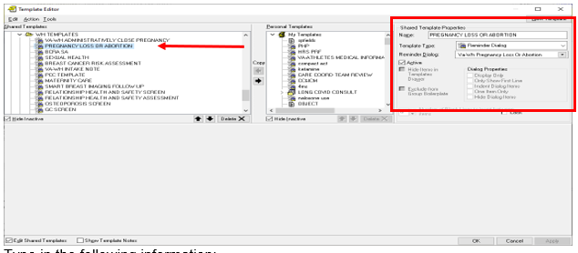

Type in the following information:

Name: **PREGNANCY LOSS OR ABORTION**

Template Type: **Reminder Dialog**

Reminder Dialog: **VA-WH PREGNANCY LOSS OR ABORTION**

–– then click Apply.

1. **Add quick orders to the dialog**. Using the VistA menu Reminder Dialog Manager, Dialog Manager, change view to elements, search for and edit the following elements, you will add your quick order as **a finding item**:

* VA-WH PREGNANCY GEST AGE UNKNOWN ORDER ULTRASOUND – add your local quick order for transvaginal ultrasound.
* VA-WH PREGNANCY GEST AGE UNKNOWN ORDER ULTRASOUND ABORTION – add your local quick order for transvaginal ultrasound.
* VA-WH PREGNANCY TERM ADD ORDER CONTRACEPTION – add your local quick order for emergency contraception.
* VA-WH PREGNANCY TERM ADD ORDER SOCIAL WORK – add your local quick order for social work consult or referral.
* VA-WH PREGNANCY TERM ADD ORDER MH CONSULT – add your local quick order for a mental health consult or referral
* VA-WH PREGNANCY TERM ADD ORDER RTC – add your local return to clinic order
* VA-WH PREGNANCY LOSS PLAN REFER – add your local community care consult for pregnancy loss.
* VA-WH PREGNANCY TERM PLAN REFER– add your local community care consult for abortion.
* VA-GP WH PREGNANCY LOSS PLAN MED MANAGE – add your local quick order or menu for pregnancy loss medications (Mifepristone and Misoprostol).
* VA-GP WH PREGNANCY TERM PLAN MED ABORTION – add your local quick order or menu for pregnancy loss medications (Mifepristone and Misoprostol)

1. **Add additional local follow up items to the plan section (OPTIONAL)**. Using the VistA menu Reminder Dialog Manager, Dialog Manager, change view to group, search for and edit the following groups, you can add **locally created elements** to the items available in the follow up portion of the plan sections by adding your local elements or groups at the sequence prompt. The groups listed are a class of local and can be locally modified. Consult your local Women’s Health providers to see if they would like any additional items added. Your site may choose to not make any edits to these sections:

* VAL-GP WH PREGNANCY TERM PLAN FOLLOW UP
* VAL-GP PREGNANCY LOSS PLAN FOLLOWUP

***NOTE****: If there are any questions or problems during the installation, please notify your local IT support to log a national help desk ticket or contact the VA Service Desk and have them submit a national ticket to:*

*Category: Affected Service*

*Affected Service: VistA - Clinical Reminders*