

Update_2_0_405

Clinical Reminders

VA-ACORN TEMPLATE

Install Guide

**January 2024**

Product Development

Office of Information Technology

Department of Veterans Affairs

**Table of Contents**

Introduction 1

Install Details 5

Install Example 5

Post Installation 9

## Introduction

The ACORN screener is used to identify unmet social needs among Veterans in VHA clinical settings. The nine social need domains are: housing instability (clinical reminder), food insecurity (clinical reminder), utilities, transportation, legal needs, social isolation/loneliness, employment, education, and digital needs. Veterans who screen positive are offered relevant services and resources to address their needs.

This template is co-sponsored by the National Social Work Program, Care Management and Social Work Service and the Office of Health Equity. The primary users of this template are care team members (e.g., nurses, peer support specialists, social workers) and use of the template is required by any VA medical centers who have already implemented ACORN.

**UPDATE_2_0_405 contains 1 Reminder Exchange entry:**

UPDATE_2_0_405 VA-ACORN TEMPLATE

**The exchange file contains the following components:**

**REMINDER GENERAL FINDINGS**

VIEW PROGRESS NOTE TEXT

**TIU TEMPLATE FIELD**

ACORN SCREENING TOOL LINK

GEN WORD PROCESSING LARGE

VA-ACORN SHAREPOINT

**HEALTH FACTORS**

VA-REMINDER UPDATES [C]

VA-UPDATE_2_0_405

VA-ACORN [C]

VA-SDOH ACORN SCREENING NOT DONE

VA-SDOH ACORN HELP LEARNING TO USE DEVICES - DECLINE

VA-SDOH ACORN HELP LEARNING TO USE DEVICES - NO DEVICE

VA-SDOH ACORN HELP LEARNING TO USE DEVICES - NO

VA-SDOH ACORN HELP LEARNING TO USE DEVICES - YES

VA-SDOH ACORN OTHER ADMINISTERED

VA-SDOH ACORN STAFF ADMINISTERED

VA-SDOH ACORN SELF ADMINISTERED

VA-SDOH ACORN RESPONSES PROVIDED BY OTHER

VA-SDOH ACORN RESPONSES PROVIDED BY CAREGIVER

VA-SDOH ACORN RESPONSES PROVIDED BY VETERAN

VA-SDOH ACORN NOTES

VA-SDOH ACORN DISPO OTHER

VA-SDOH ACORN SOCIAL WORK INTERVENTION TODAY

VA-SDOH ACORN COMMUNICATION WITH CARE TEAM

VA-SDOH ACORN FOLLOW UP PLANNED

VA-SDOH ACORN DIGITAL DIVIDE CONSULT

VA-SDOH ACORN DIGITAL DIVIDE WARM HAND OFF

VA-SDOH ACORN DIGITAL DIVIDE CONNECTION

VA-SDOH ACORN DIETITIAN CONSULT

VA-SDOH ACORN DIETITIAN WARM HAND OFF

VA-SDOH ACORN DIETITIAN CONNECTION

VA-SDOH ACORN MH CONSULT

VA-SDOH ACORN MH WARM HAND OFF

VA-SDOH ACORN MH CONNECTION

VA-SDOH ACORN PCMHI OR PCBH CONSULT

VA-SDOH ACORN PCMHI OR PCBH WARM HAND OFF

VA-SDOH ACORN PCMHI OR PCBH CONNECTION

VA-SDOH ACORN SW CONSULT

VA-SDOH ACORN SW WARM HAND OFF

VA-SDOH ACORN SW CONNECTION

VA-SDOH ACORN RESOURCES GIVEN - CHILDCARE

VA-SDOH ACORN RESOURCES GIVEN - DIGITAL DIVIDE

VA-SDOH ACORN RESOURCES GIVEN - OTHER

VA-SDOH ACORN RESOURCES GIVEN - FOOD

VA-SDOH ACORN RESOURCES GIVEN - EDUCATION

VA-SDOH ACORN RESOURCES GIVEN - EMPLOYMENT

VA-SDOH ACORN RESOURCES GIVEN- LONELINESS ISOLATION

VA-SDOH ACORN RESOURCES GIVEN - LEGAL

VA-SDOH ACORN RESOURCES GIVEN - TRANSPORTATION

VA-SDOH ACORN RESOURCES GIVEN - UTILITIES

VA-SDOH ACORN RESOURCES GIVEN - HOUSING

VA-SDOH ACORN RESOURCE GUIDES GIVEN

VA-SDOH ACORN PROVIDED RESOURCES

VA-SDOH ACORN ALREADY RECEIVING SERVICES

VA-SDOH ACORN DECLINES ASSISTANCE

VA-SDOH ACORN DISPO - NO NEEDS

VA-SDOH ACORN DISPO - NO RESOURCES OR REFERRALS GIVEN

VA-SDOH ACORN ACCESS TO RELIABLE INTERNET - DECLINE

VA-SDOH ACORN ACCESS TO RELIABLE INTERNET - DO NOT WANT

VA-SDOH ACORN ACCESS TO RELIABLE INTERNET - NO

VA-SDOH ACORN ACCESS TO RELIABLE INTERNET - YES

VA-SDOH ACORN ACCESS TO LANDLINE - YES

VA-SDOH ACORN ACCESS TO PHONE OR COMPUTER - DECLINE

VA-SDOH ACORN ACCESS TO PHONE OR COMPUTER - NO

VA-SDOH ACORN ACCESS TO COMPUTER - YES

VA-SDOH ACORN ACCCESS TO SMARTPHONE - YES

VA-SDOH ACORN ACCESS TO SIMPLE CELL PHONE - YES

VA-SDOH ACORN WANT MORE INFO ABOUT EDUCATION RESOURCES - DECLINE

VA-SDOH ACORN WANT MORE INFO ABOUT EDUCATION RESOURCES - NO

VA-SDOH ACORN WANT MORE INFO ABOUT EDUCATION RESOURCES - YES

VA-SDOH ACORN HELP FINDING OR KEEPING WORK - DECLINE

VA-SDOH ACORN FINDING WORK - DON'T NEED HELP

VA-SDOH ACORN HELP KEEPING WORK - YES

VA-SDOH ACORN HELP FINDING WORK - YES

VA-SDOH ACORN FEELING LONELY OR ISOLATED - DECLINE

VA-SDOH ACORN FEELING LONELY OR ISOLATED - NEVER

VA-SDOH ACORN FEELING LONELY OR ISOLATED - SOMETIMES

VA-SDOH ACORN FEELING LONELY OR ISOLATED - OFTEN

VA-SDOH ACORN LEGAL MATTERS - DECLINE

VA-SDOH ACORN LEGAL MATTERS - NO

VA-SDOH ACORN LEGAL MATTERS - YES

VA-SDOH ACORN ISSUES FROM LACK OF TRANSPORTATION - DECLINE

VA-SDOH ACORN ISSUES FROM LACK OF TRANSPORTATION - NEVER

VA-SDOH ACORN NEED UPCOMING APPOINTMENT TRANSPORTATION - DECLINE

VA-SDOH ACORN NEED UPCOMING APPOINTMENT TRANSPORTATION - NO

VA-SDOH ACORN NEED UPCOMING APPOINTMENT TRANSPORTATION - YES

VA-SDOH ACORN ISSUES FROM LACK OF TRANSPORTATION - SOMETIMES

VA-SDOH ACORN ISSUES FROM LACK OF TRANSPORTATION - OFTEN

VA-SDOH ACORN TROUBLE PAYING UTILITIES - NA

VA-SDOH ACORN TROUBLE PAYING UTILITIES - DECLINE

VA-SDOH ACORN TROUBLE PAYING UTILITIES - NEVER

VA-SDOH ACORN UTILITIES THREATEN TO SHUT OFF - NA

VA-SDOH ACORN UTILITIES THREATEN TO SHUT OFF - DECLINE

VA-SDOH ACORN UTILITIES ALREADY SHUT OFF

VA-SDOH ACORN UTILITIES THREATEN TO SHUT OFF - NO

VA-SDOH ACORN UTILITIES THREATEN TO SHUT OFF - YES

VA-SDOH ACORN TROUBLE PAYING UTILITIES - SOMETIMES

VA-SDOH ACORN TROUBLE PAYING UTILITIES - OFTEN

VA-SDOH ACORN NEED HELP GETTING FOOD THIS WEEK - DECLINE

VA-SDOH ACORN NEED HELP GETTING FOOD THIS WEEK - NO

VA-SDOH ACORN NEED HELP GETTING FOOD THIS WEEK - YES

VA-SDOH ACORN CURRENTLY WITHOUT A PLACE TO STAY - DECLINE

VA-SDOH ACORN CURRENTLY WITHOUT A PLACE TO STAY - NO

VA-SDOH ACORN CURRENTLY WITHOUT A PLACE TO STAY - YES

VA-SDOH ACORN VETERAN AGREES TO SCREENING

HOMELESSNESS SCREENING [C]

VA-MONEY TO BUY FOOD-YES CURRENT CONCERN

VA-FOOD 12MO ACTUALLY RAN OUT SOMETIMES

VA-FOOD 12MO ACTUALLY RAN OUT OFTEN

VA-FOOD 12MO WORRY RUN OUT SOMETIMES

VA-FOOD 12MO WORRY RUN OUT OFTEN

POSITIVE - HAS WORRIES ABOUT HOUSING

POSITIVE - HAS NO STABLE HOUSING

**REMINDER SPONSOR**

OFFICE OF SOCIAL WORK

**REMINDER TAXONOMY**

VA-TX ACORN Z56.9

VA-TX ACORN Z65.8

VA-TX ACORN Z65.3

VA-TX ACORN Z59.82

VA-TX ACORN Z59.12

VA-TX ACORN Z59.87

VA-TX ACORN Z59.41

VA-TX ACORN Z58.811

VA-TX ACORN Z59.00

**REMINDER TERM**

VA-REMINDER UPDATE_2_0_405

**HEALTH SUMMARY COMPONENT**

PCE HEALTH FACTORS SELECTED

**HEALTH SUMMARY TYPE**

VA-ACORN HS WARM HAND OFFS

VA-ACORN HS POSITIVE RESULTS

VA-ACORN HS PRIOR SCREEN

**HEALTH SUMMARY OBJECTS**

VA-ACORN HO WARM HANDOFFS

VA-ACORN HO POS RESULTS

VA-ACORN HO PRIOR SCREEN

**TIU DOCUMENT DEFINTION**

VA-ACORN WARM HANDOFFS

VA-ACORN POS RESULTS

VA-ACORN PRIOR SCREEN

**REMINDER DIALOG**

VA-ACORN SDOH SCREENER

## Install Details

This update is being distributed as a web host file. The address for the host file is: **https://REDACTED /UPDATE_2_0_405.PRD**

The file will be installed using Reminder Exchange, programmer access is not required.

Installation:

=============

This update can be loaded with users on the system. Installation will take less than 30 minutes.

## Install Example

To Load the Web Host File. Navigate to Reminder exchange in Vista

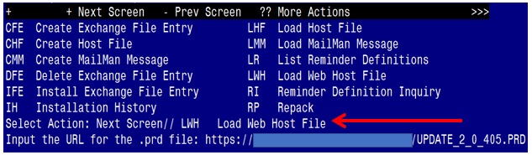

At the **Select Action:** prompt, enter **LWH** for Load Web Host File

At the **Input the url for the .prd file:** prompt, type the following web address:

**https://REDACTED /UPDATE_2_0_405.PRD**

You should see a message at the top of your screen that the file successfully loaded.

Terminal window screen shot of the message displaying the URL of the file that was successfully loaded.  Part of the URL has been redacted as it is a VA only internal web site URL as shown in the text unless redacted for use outside of the VA.

Search for and locate the reminder exchange entry titled UPDATE_2_0_405 VA-ACORN TEMPLATE.

(*see screenshot on the next page*)

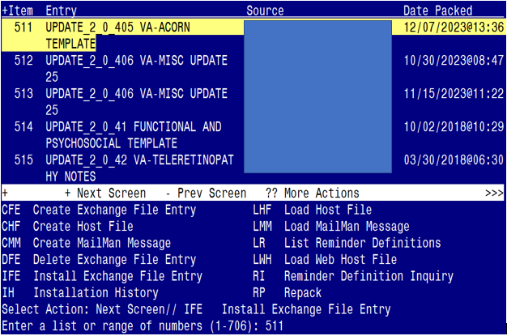

At the **Select Action** prompt, enter **IFE** for Install Exchange File Entry

Enter the number that corresponds with your entry titled **UPDATE_2_0_405 VA-ACORN TEMPLATE** *(in this example it is entry 511, it will vary by site).* The exchange file date is 12/07/2023@13:36.

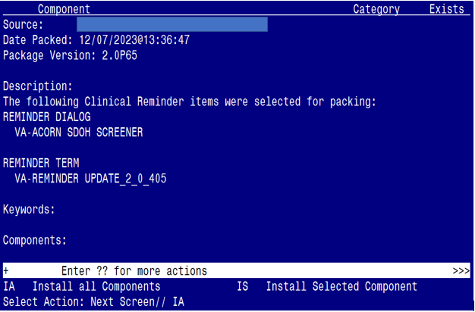

At the **Select Action** prompt, type **IA** for Install all Components and hit enter.

Select Action: Next Screen// IA Install all Components

**You will see several prompts:**

* For all new components, you will choose **I to Install**
* For any existing components, you will choose **S to Skip**

**You will be promped to install the dialog component:**

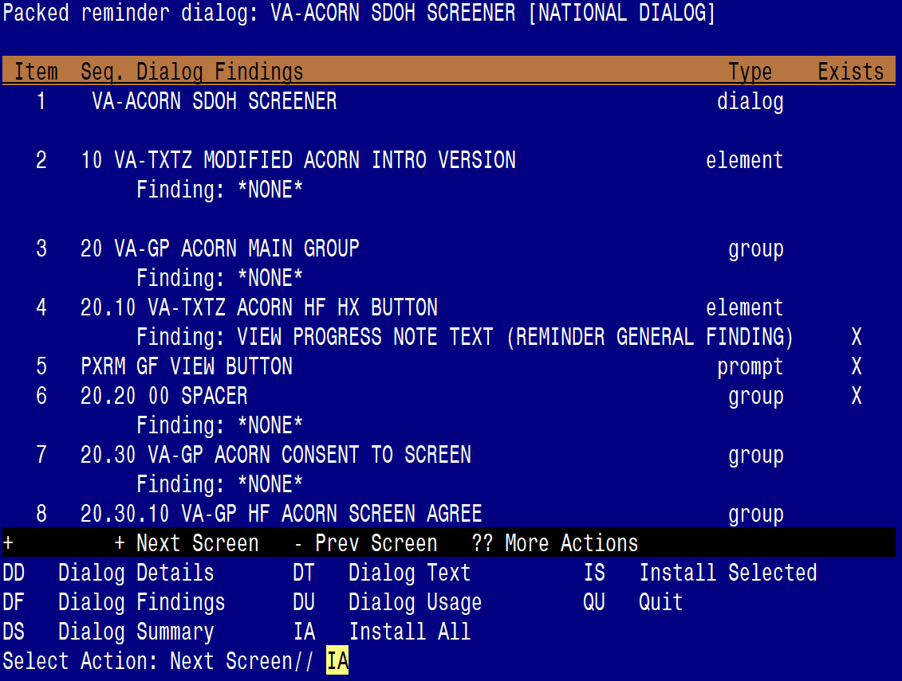

At the **Select Action** prompt, type **IA** to install the dialog – **VA-ACORN SDOH SCREENER**

Select Action: Next Screen// IA Install All

Install reminder dialog and all components with no further changes: Y// ES

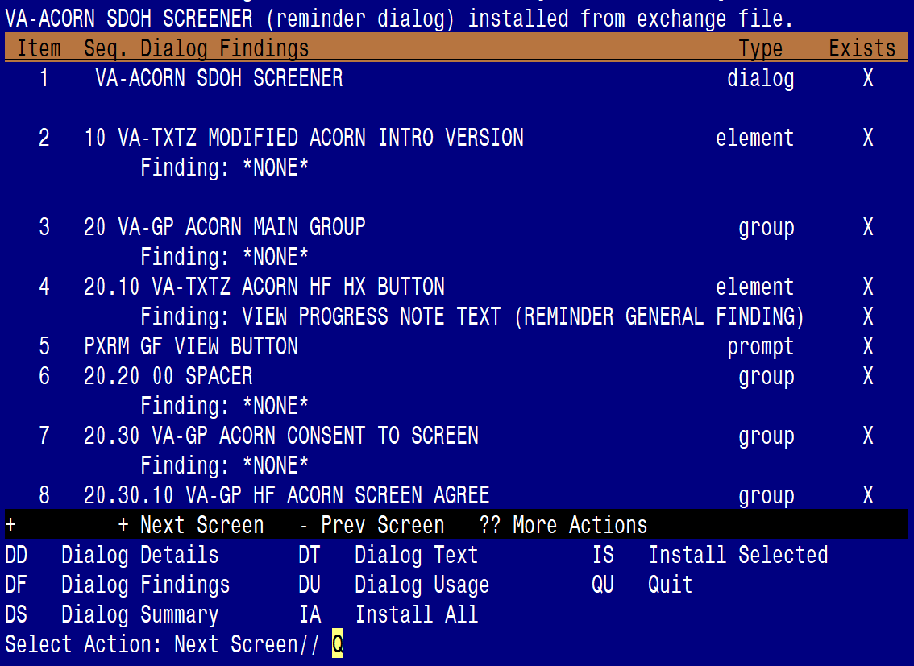

When the dialog has completed installation, you will then be returned to this screen. At the **Select Action** prompt, type **Q.**

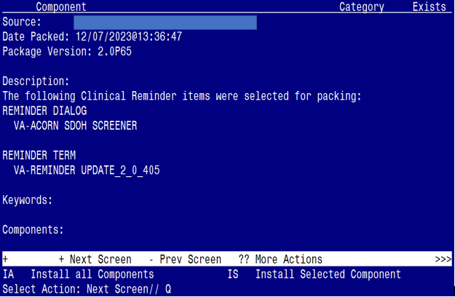

You will be returned to this screen. Type Q to quit.

Install Completed

## Post Installation (complete these steps ONLY if your site is a current ACORN site)

1. **Make the dialogs available to be attached to progress note titles.**

From the Reminders Manager Menu:

Select Reminder Managers Menu Option: **CP** CPRS Reminder Configuration

CA Add/Edit Reminder Categories

CL CPRS Lookup Categories

CS CPRS Cover Sheet Reminder List

MH Mental Health Dialogs Active

PN Progress Note Headers

RA Reminder GUI Resolution Active

TIU TIU Template Reminder Dialog Parameter

DL Default Outside Location

PT Position Reminder Text at Cursor

Select CPRS Reminder Configuration Option: **TIU** TIU Template Reminder Dialog Parameter

Reminder Dialogs allowed as Templates may be set for the following:

1 User USR [choose from NEW PERSON]

3 Service SRV [choose from SERVICE/SECTION]

4 Division DIV [choose from INSTITUTION]

5 System SYS [NATREM.FO-SLC.MED.VA.GOV]

Enter selection*:* 5  *Choose the appropriate number for your site. Your site may do this by System or other levels. The example below uses SYSTEM level*

Setting Reminder Dialogs allowed as Templates for System:

Select Display Sequence: **?**

148 VA-VETERANS CHOICE NOTE

149 VA-TBI SCREENING

*When you type a question mark above, you will see the list of #’s (with dialogs) that are already taken. Choose a number* ***NOT*** *on this list. For this example, looking above I see the number 150 is not present, so I will use 150.*

Select Display Sequence: **150**

Are you adding 150 as a new Display Sequence? Yes// **Y** YES

Display Sequence: 150// <Enter> 150

Clinical Reminder Dialog**: type in the name of the dialog**

**VA-ACORN SDOH SCREENER** then **<enter>**

reminder dialog NATIONAL

OK? Yes// <Enter> (Yes)

1. **Associate the new reminder dialog with a shared template in CPRS**

To do this, go to Template Editor, then Shared Templates, select the appropriate folder (if applicable), and choose New Template (top right-hand corner).

Type in the following information:

Name: **ACORN SDOH SCREENER NOTE**

Template Type: Reminder Dialog

Reminder Dialog: **VA-ACORN SDOH SCREENER**

Next, select Apply.

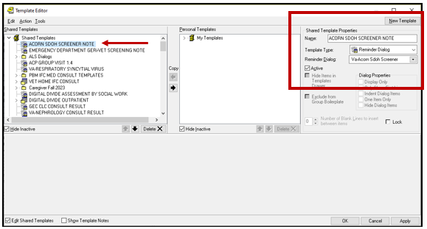

1. **Setup of specific a Note title.**

**(If your site is a current ACORN site and already has a ACORN note title linked to a dialog template, you do not need to create the new note title listed below. Instead you can skip to step #4 and associate the new ACORN dialog to that existing note title and disable/deactivate your current ACORN dialog).**

If your site does not have an existing ACORN note title, you will need to create the note title as follows:

**ACORN SDOH SCREENER NOTE**

You can place it in the same category as your other social work notes.

*The note title above is to be mapped to the following VHA Enterprise Standard Title:* **SOCIAL WORK NOTE**

Note: Comprehensive information on Creating Document Definitions can be found beginning on page 47 of the [TIU/ASU Implementation Guide](http://www.va.gov/vdl/documents/Clinical/CPRS-Text_Integration_Utility_(TIU)/tiuim.pdf)

1. **Associate the new reminder dialog with the note title in CPRS**

To do this, go to Template Editor, then Document Titles, select the appropriate folder (if applicable), and choose New Template (top right-hand corner).

Type in the following information:

Name: **ACORN SDOH SCREENER NOTE**

Template Type: Reminder Dialog

Reminder Dialog: **VA-ACORN SDOH SCREENER**

Next, type in the Associated Title, which in this case is **ACORN SDOH SCREENER NOTE** and hit Apply.

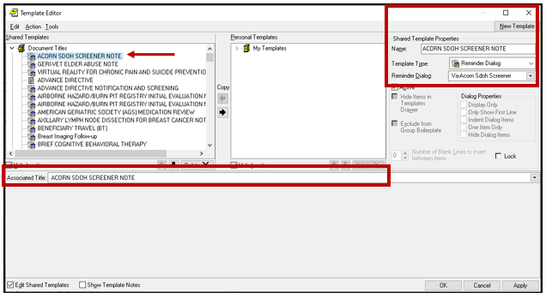

1. Embed the **Homelessness and Food Insecurity Screen** dialog into the **VAL-GP ACORN HOMELESS FOOD INSEC CR MAIN** group:
2. In VISTA, navigate to the Reminder Dialog Management. Select Reminder Dialogs (DI), then Change View (CV) to Dialog Group View

1. Locate the group titled: VAL-GP ACORN HOMELESS FOOD INSEC CR MAIN

1. Add a one sequence number and the group titled: VA-GP HOMELESSNESS SCREEN AND FOOD INSECURITY

NAME: **VAL-GP ACORN HOMELESS FOOD INSEC CR MAIN**

DISABLE: **<enter>**

CLASS: LOCAL/**<enter>**/

SPONSOR: **<enter>**

REVIEW DATE: **<enter>**

RESOLUTION TYPE: **<enter>**

ORDERABLE ITEM: **<enter>**

FINDING ITEM: **<enter>**

Additional findings: **<enter>**none

Select ADDITIONAL FINDING: **<enter>**

GROUP CAPTION: **<enter>**

PUT A BOX AROUND THE GROUP: **<enter>**

SHARE COMMON PROMPTS: **<enter>**

MULTIPLE SELECTION:NO SELECTION REQUIRED// **<enter>**

HIDE/SHOW GROUP: **<enter>**

GROUP HEADER DIALOG TEXT:

Edit? NO// **<enter>**

GROUP HEADER ALTERNATE P/N TEXT:

Edit? NO// **<enter>**

EXCLUDE FROM PROGRESS NOTE: YES// **<enter>**

SUPPRESS CHECKBOX: SUPPRESS// **<enter>**

NUMBER OF INDENTS: **<enter>**

INDENT PROGRESS NOTE TEXT: **enter>**

Select SEQUENCE: **10**

DIALOG ELEMENT: **VA-GP HOMELESSNESS SCREEN AND FOOD INSECURITY**

...OK? Yes// **Yes**

EXCLUDE FROM PN TEXT: **<enter>**

Select SEQUENCE:

Select BRANCHING LOGIC SEQUENCE: **<enter>**

Checking reminder dialog for errors

NO ERRORS FOUND

Input your edit comments.

Edit? NO//**<enter>**

1. (Optional Action) Add consult quick orders as an **additional finding** to the elements below:

ELEMENT: VA-TXTZ HF/OI ACORN DISPO SW

Additional Findings: << add your consult quick order here>>

*(note: the quick order should be for a social work consult)*

**(note: to determine which social work consult to use for this action step, connect with your local Social Work Chief or Executive)**

ELEMENT: VA-TXTZ HF/OI ACORN DISPO PCBH

Additional Findings: << add your consult quick order here>>

*(note: the quick order should be for a primary care behavioral health consult)*

**(note: to determine which PCBH or PCMHI consult to use for this action step, connect with your local head of PCBH or PCMHI)**

ELEMENT: VA-TXTZ HF/OI ACORN DISPO MH

Additional Findings: << add your consult quick order here>>

*(note: the quick order should be for a mental health consult)*

**(note: to determine which Mental Health consult to use for this action step, connect with your local head of Mental Health (e.g., Mental Health Chief))**

ELEMENT: VA-TXTZ HF/OI ACORN DISPO DIETITIAN

Additional Findings: << add your consult quick order here>>

*(note: the quick order should be for a dietitian consult)*

**(note: to determine which Dietitian consult to use for this action step, connect with your local Nutrition and Food Services or lead Dietitian)**

ELEMENT: VA-TXTZ HF/OI ACORN DISPO DD CONSULT

Additional Findings: << add your consult quick order here>>

*(note: the quick order should be for a digital divide consult)*

**(note: to determine which consult to use for the Digital Divide, connect with your local Social Work Chief or Executive)**