

Update\_2\_0\_408

Clinical Reminders

VA-PGX (PHASER) CLOPIDOGREL/PREVIOUS RESULTS CROC UPDATE

Install Guide

**February 2024**

Product Development

Office of Information Technology

Department of Veterans Affairs

Table of Contents

[Introduction 1](#_Toc158812994)

[Pre-Install 2](#_Toc158812995)

[Install Details 2](#_Toc158812996)

[Install Example 2](#_Toc158812997)

[Post Installation 6](#_Toc158812998)

## Introduction

Reminder Update 408 distributes 2 reminder order checks to evaluate pharmacogenomic influence on prescribing for clopidogrel plus 4 reminder order checks to alert providers to already available pharmacogenomic test results should they attempt to order another pharmacogenomic test panel. Below are the Reminder Order check groups that are distributed. These groups also contain the corresponding Reminder Order check rules. These   
order checks complement the existing portfolio of PHASER pharmacogenomic order checks   
previously distributed.

PHASER VA Provider information and Site Deployment Materials:  [PHASER-SharePoint](https://dvagov.sharepoint.com/sites/VHAPGx) (only accessible within the VA firewall). PHASER public website:  [www.cancer.va.gov/phaser.asp](http://www.cancer.va.gov/phaser.asp)

**UPDATE\_2\_0\_408 contains 1 Reminder Exchange entry:**

UPDATE\_2\_0\_408 VA-PGX (PHASER) CLOPIDOGREL/PREVIOUS RESULTS CROC

**The exchange file contains the following components:**

REMINDER SPONSOR

1 VHA PHARMACY BENEFITS MANAGEMENT

2 VHA ONCOLOGY

HEALTH FACTORS

3 VA-PGX GENE TESTING [C]

4 VA-PGX 16 GENE PANEL

5 VA-PGX 11 GENE PANEL

6 VA-PGX 8 GENE PANEL

7 VA-PGX 18 GENE PANEL

8 VA-PGX 15 GENE PANEL

9 VA-PGX CYP3A5 POOR METABOLIZER

10 VA-PGX CYP3A5 NORMAL METABOLIZER

11 VA-PGX CYP3A5 INTERMED METABOLIZER

12 VA-PGX CYP2C19 UNINFORMATIVE

13 VA-PGX CYP2C19 POOR METABOLIZER

14 VA-PGX CYP2C19 NORMAL METABOLIZER

15 VA-PGX CYP2C19 RAPID METABOLIZER

16 VA-PGX CYP2C19 ULTRARAPID METABOLIZER

17 VA-PGX CYP2C19 INTERMED METABOLIZER

18 VA-REMINDER UPDATES [C]

19 VA-UPDATE\_2\_0\_408

20 VA-PGX TESTING ACCEPTED

REMINDER TERM

21 VA-PGX CYP2C19 NOT INTERMEDIATE

22 VA-PGX CYP2C19 INTERMED METABOLIZER

23 VA-PGX CYP2C19 NOT POOR

24 VA-PGX CYP2C19 POOR METABOLIZER

25 VA-REMINDER UPDATE\_2\_0\_408

REMINDER DEFINITION

26 VA-PGX PREVIOUS 16 GENE PANEL

27 VA-PGX PREVIOUS 11 GENE PANEL

28 VA-PGX PREVIOUS 8 GENE PANEL

29 VA-PGX PREVIOUS 18 GENE PANEL

30 VA-PGX CYP2C19IM MOST RECENT

31 VA-PGX CYP2C19PM MOST RECENT

REMINDER ORDER CHECK RULES

32 VA-PGX PREVIOUS 16 GENE PANEL (R)

33 VA-PGX PREVIOUS 11 GENE PANEL (R)

34 VA-PGX PREVIOUS 8 GENE PANEL (R)

35 VA-PGX PREVIOUS 18 GENE PANEL (R)

36 VA-PGX CLOPIDOGREL CYP2C19IM (R)

37 VA-PGX CLOPIDOGREL CYP2C19PM (R)

REMINDER ORDER CHECK ITEMS GROUP

38 VA-PGX PREVIOUS 16 GENE PANEL (G)

39 VA-PGX PREVIOUS 11 GENE PANEL (G)

40 VA-PGX PREVIOUS 8 GENE PANEL (G)

41 VA-PGX PREVIOUS 18 GENE PANEL (G)

42 VA-PGX CLOPIDOGREL CYP2C19IM (G)

43 VA-PGX CLOPIDOGREL CYP2C19PM (G)

REMINDER DIALOG

44 VA-EL PHASER CONSENT ONLY PT AGREES

## Pre-Install

None

## Install Details

This update is being distributed as a web host file. The address for the host file is: **https://REDACTED /UPDATE\_2\_0\_408.PRD**

The file will be installed using Reminder Exchange, programmer access is not required.

Installation:

=============

This update can be loaded with users on the system. Installation will take less than 5 minutes.

## Install Example

If your site is unable to use LWH functionality, use VistA mail to install the exchange file.

To Load the Web Host File. Navigate to Reminder exchange in Vista

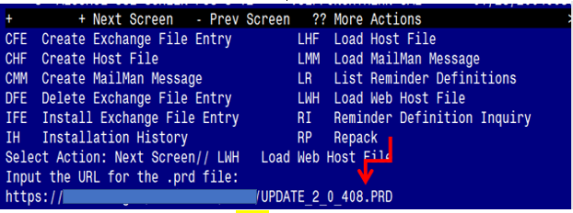

At the **Select Action:** prompt, enter **LWH** for Load Web Host File

At the **Input the url for the .prd file:** prompt, type the following web address:

**https://REDACTED /UPDATE\_2\_0\_408.PRD**

**Terminal window screen shot of the message displaying the URL of the file that was successfully loaded.  Part of the URL has been redacted as it is a VA only internal web site URL as shown in the text unless redacted for use outside of the VA.**

You should see a message at the top of your screen that the file successfully loaded

Search for and locate a reminder exchange entry named **UPDATE\_2\_0\_408 VA-PGX (PHASER) CLOPIDOGREL/PREVIOUS RESULTS CROC**

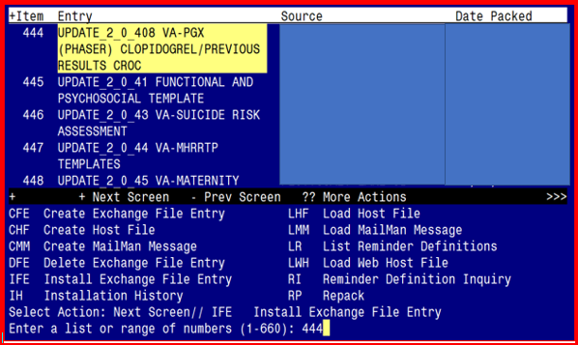

At the **Select Action** prompt, enter **IFE** for Install Exchange File Entry

Enter the number that corresponds with your entry titled **UPDATE\_2\_0\_408 VA-PGX (PHASER) CLOPIDOGREL/PREVIOUS RESULTS CROC** *(in this example it is entry 444, it will vary by site).* The Date Packed should read 01/25/2024.

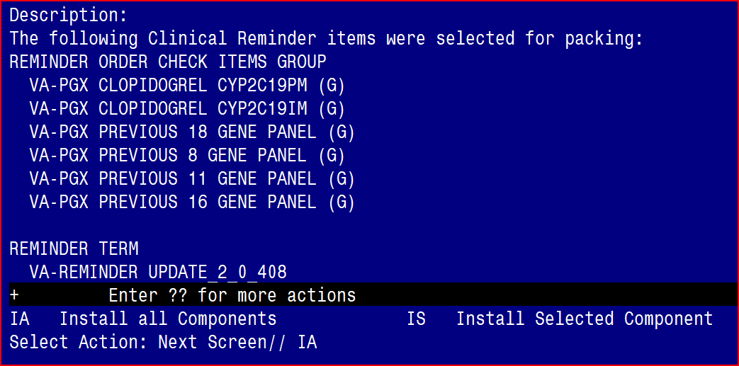

At the **Select Action** prompt, type **IA** for Install all Components and hit enter.

Select Action: Next Screen// IA   Install all Components

During the installation, you will see several prompts:

You will Install (I) all new components

Overwrite (O) any other existing components

Once you have installed the Order Check Groups and Rules, you will be prompted to install the dialog element VA-EL PHASER CONSENT ONLY PT AGREES. You do not need to install this piece and may type Q to quit this part of the install.

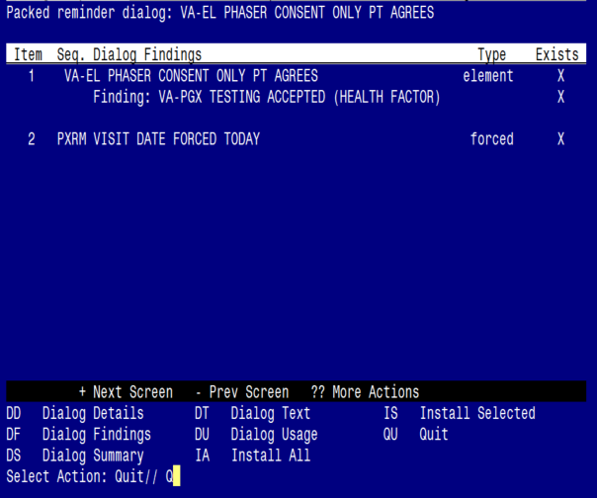

Type Q to quit the dialog install

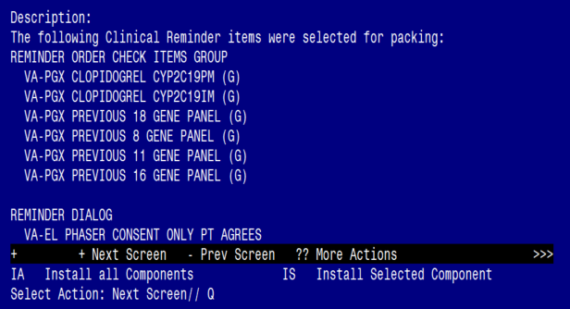

Install is complete and you may type “Q” to Quit

**Note: If your site is NOT a participating PHASER site, you do not need to proceed to the Post Install steps. No further action is needed. Go to VA PHASER SITE LISTING REDACTED to check your site’s PHASER participation status.**

## Post Installation

1. For the 4 new Reminder Order Check Groups, the PHASER Panel orderable item(s) will need to be added to the below Order Check Item List. When entering the Orderable Items, if your standard is to have your station number as a prefix, then use that to search. If you do not know the name of your Orderable Item, please contact your LIM to obtain the name.

VA-PGX PREVIOUS 18 GENE PANEL (G)

VA-PGX PREVIOUS 8 GENE PANEL (G)

VA-PGX PREVIOUS 11 GENE PANEL (G)

VA-PGX PREVIOUS 16 GENE PANEL (G)

Example of how to add the Orderable Item(s)

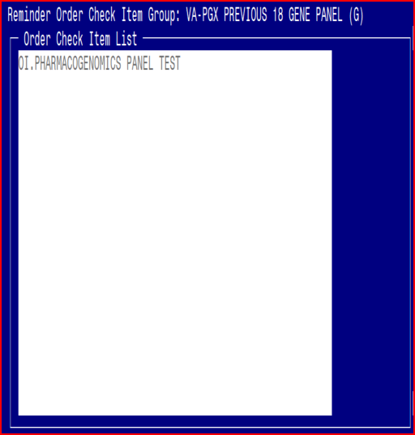

Are you adding 'PHARMACOGENOMICS PANEL TEST' as a new ORDER CHECK ITEMS? No// Y

1. Once all Orderable Items have been added to the new Reminder Order Check groups, you will need to change the STATUS from INAC to PROD for all 6 Reminder Order Check Rules

VA-PGX CLOPIDOGREL CYP2C19PM (R)

VA-PGX CLOPIDOGREL CYP2C19IM (R)

VA-PGX PREVIOUS 18 GENE PANEL (R)

VA-PGX PREVIOUS 8 GENE PANEL (R)

VA-PGX PREVIOUS 11 GENE PANEL (R)

VA-PGX PREVIOUS 16 GENE PANEL (R)

Screen shot showing 
RULE NAME: VA_PGX PREVIOUS 18 GENE PANEL (R)
DISPLAY NAME: Pharmagogenomics Warning - PGx 18-Gene Panel Results Available
Status: INAC