

Update _2_0_411

Clinical Reminders

VA-NEPHROLOGY CKD CONSULT RESULT

Install Guide

**March 2024**

Product Development

Office of Information Technology

Department of Veterans Affairs

Table of Contents

Introduction 1

Pre-Installation: 3

Installation: 3

Install Example 3

Post Installation 6

## Introduction

This update contains one new template developed to standardize Nephrology CKD Consult responses, improve communication to Primary Care teams regarding CKD etiology, make specific recommendations, and clarify patient co-management responsibilities.

A collaboration between the offices of Kidney Medicine and Primary Care, this template aligns with VA Directive 1053 Chronic Kidney Disease Prevention, Early Recognition and Management.

The Template is intended for use by all VA Nephrology/Kidney Medicine Physicians in order to complete a Consult Request for CKD. ​

UPDATE_2_0_411 contains 1 Reminder Exchange entry named **UPDATE_2_0_411 VA-NEPHROLOGY CKD CONSULT RESULT**

**The exchange file contains the following components:**

**TIU TEMPLATE FIELD**

VA-NEPH OTHER LABS

VA-NEPH VACCINE GUIDELINES

VA-WORD

OTHER NON-VA

OTHER TEXT

VA- CKD KFRE

**HEALTH FACTORS**

VA-REMINDER UPDATES [C]

VA-UPDATE_2_0_411

VA-NEPHROLOGY CONSULT RESULT [C]

VA-NEPHROLOGY CKD RTC ORDER

VA-NEPHROLOGY CKD CONSULT COMP OPT ANEMIA

VA-NEPHROLOGY CHRONIC KIDNEY DISEASE [C]

VA-NEPHROLOGY CKD CONSULT COMP OPT MINERAL/BONE

VA-NEPHROLOGY CKD CONSULT OTHER CONSULT TYPE

VA-NEPHROLOGY CKD CONSULT CONTROL BP/BG

VA-NEPHROLOGY CKD CONSULT AVOID NEPHROTOXINS

VA-NEPHROLOGY CKD CONSULT EDUCATE PT

VA-NEPHROLOGY CKD CONSULT LAB MONITOR KIDNEY FUNCT

VA-NEPHROLOGY CKD CONSULT MAX MEDS

VA-NEPHROLOGY CKD CONSULT PLAN

VA-NEPHROLOGY CKD CONSULT VVC

VA-NEPHROLOGY CKD CONSULT CVT

VA-NEPHROLOGY CKD CONSULT E-CONSULT

VA-NEPHROLOGY CKD CONSULT FACE TO FACE

VA-NEPHROLOGY CKD CONSULT TYPE

VA-NEPHROLOGY CKD CONSULT ROS GENERAL

VA-NEPHROLOGY CKD CONSULT ROS CV

VA-NEPHROLOGY CKD CONSULT ROS SKIN

VA-NEPHROLOGY CKD CONSULT ROS PSYCH

VA-NEPHROLOGY CKD CONSULT ROS MS

VA-NEPHROLOGY CKD CONSULT ROS NEURO

VA-NEPHROLOGY CKD CONSULT ROS GU

VA-NEPHROLOGY CKD CONSULT ROS EYE

VA-NEPHROLOGY CKD CONSULT ROS OTHER

VA-NEPHROLOGY CKD CONSULT ROS GI

VA-NEPHROLOGY CKD CONSULT ROS RESP

VA-NEPHROLOGY CKD CONSULT ROS ENT

VA-NEPHROLOGY CKD CONSULT SUBJECTIVE/OBJECTIVE

VA-NEPHROLOGY CKD ALBUMINURIA CATEGORIES [C]

VA-NEPHROLOGY CKD ALBUMINURIA A3 (>300MG/G)

VA-NEPHROLOGY CKD ALBUMINURIA A2 (30-300MG/G)

VA-NEPHROLOGY CKD ALBUMINURIA A1 (< 30MG/G)

VA-NEPHROLOGY CKD STAGE [C]

VA-NEPHROLOGY CKD GFR G5 <15

VA-NEPHROLOGY CKD GFR G4 15-29

VA-NEPHROLOGY CKD GFR G3B 30-44

VA-NEPHROLOGY CKD GFR G3A 45-59

VA-NEPHROLOGY CKD GFR G2 60-90

VA-NEPHROLOGY CKD GFR G1 >90

VA-NEPHROLOGY KIDNEY FAILURE RISK EQUATION 5Y SCORE

VA-NEPHROLOGY KIDNEY FAILURE RISK EQUATION 2Y SCORE

VA-NEPHROLOGY CKD CONSULT ASSESSMENT

VA-NEPHROLOGY CKD CONSULT RESULT NOTE

**REMINDER SPONSOR**

OFFICE OF SPECIALTY CARE SERVICES

**REMINDER TERM**

VA-REMINDER UPDATE_2_0_411

VAL-BL NEPH URINE ALBUMIN CREATININE RATIO (TRM)

**REMINDER DIALOG**

VA-NEPHROLOGY CONSULT RESULTS NOTE

This update is being distributed as a web host file. The address for the host file is: https://REDACTED UPDATE_2_0_411_5.PRD

The file will be installed using Reminder Exchange, programmer access is not required.

## Pre-Installation:

1. Using the VISTA menu, **Reminder Dialog Management, Reminder Dialogs**, find the elements/group below. Do an inquiry/print for the following two reminder dialog elements and group. The information will be needed for the post install.

* Element: VAL-TH VVC TELEPHONE TRIAGE CONTACT PHONE OBJECT
* Element: VAL-TH VVC TELEPHONE TRIAGE PATIENT LOCATION HOME
* Group: VAL-GP CKD LAB ORDER OPTIONS

1. Using the VISTA menu, **Reminder Term Management, Inquire about Reminder Term**, Find Term VA-KIDNEY HEALTH EVALUATION UACR LAB TEST. Print or screen capture finding information to use during post install.

## Installation:

This update can be loaded with users on the system. Installation will take less than 5 minutes.

## Install Example

Go to Reminder exchange in Vista.

To Load the exchange file, use LWH. The URL is: https://REDACTED /UPDATE_2_0_411_5.PRD

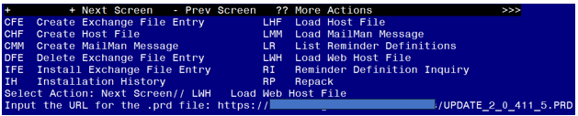

You should receive a message that the file was successfully loaded into your reminder exchange file.

Search and locate exchange file name **UPDATE_2_0_411 VA-NEPHROLOGY CKD CONSULT RESULT**

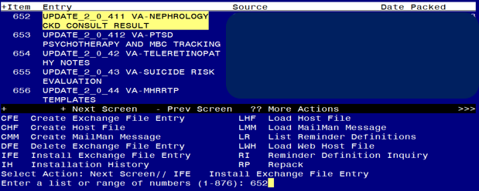

At the **Select Action** prompt, enter **IFE** for Install Exchange File Entry

Enter the number that corresponds with your entry titled **UPDATE_2_0_411 VA-NEPHROLOGY CONSULT RESULTS NOTE**

*(in this example it is entry 652, it will vary by site)* that is dated 03/01/2024.)

Screen shot of a list of the items that were selected by the reminder developers for packing to include with the selected reminder exchange item.  For the Select Action for Install Exchange File IA for Install All is entered.


At the **Select Action** prompt, type **IA** for Install all Components and hit enter.

**For all new entries in any category, you will choose I to Install**

**If you are prompted to overwrite any items, choose S to Skip.**

You will then be prompted to install the dialog component.

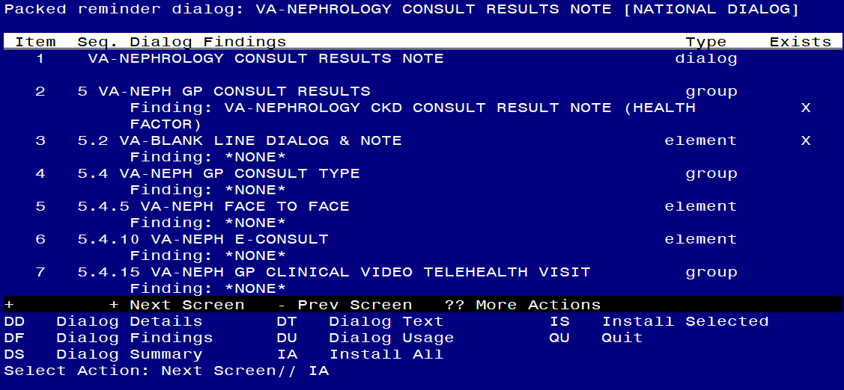

Select IA to install all. This will install the reminder dialog **VA-NEPHROLOGY CONSULT RESULTS NOTE**

Install reminder dialog and all components with no further changes: Y//Y

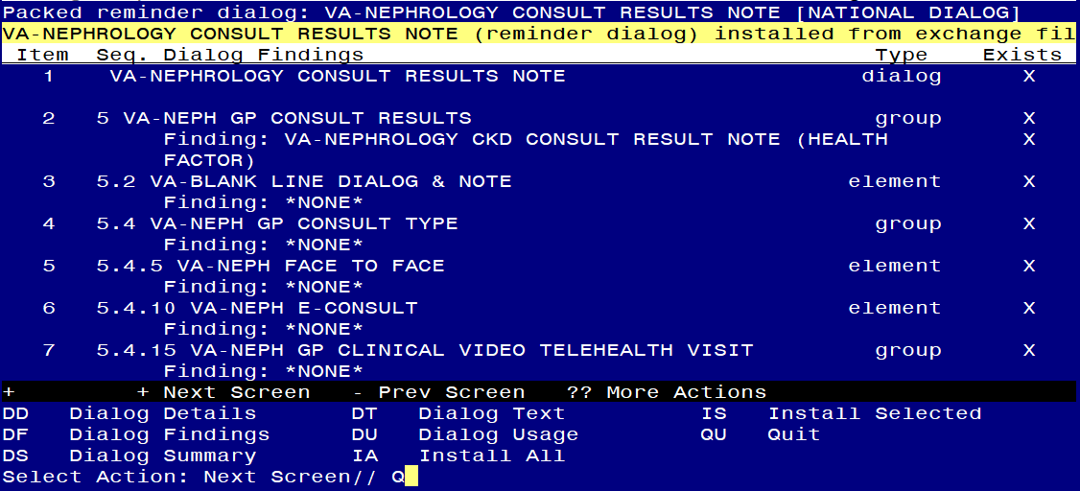

After install, select Q for quit.

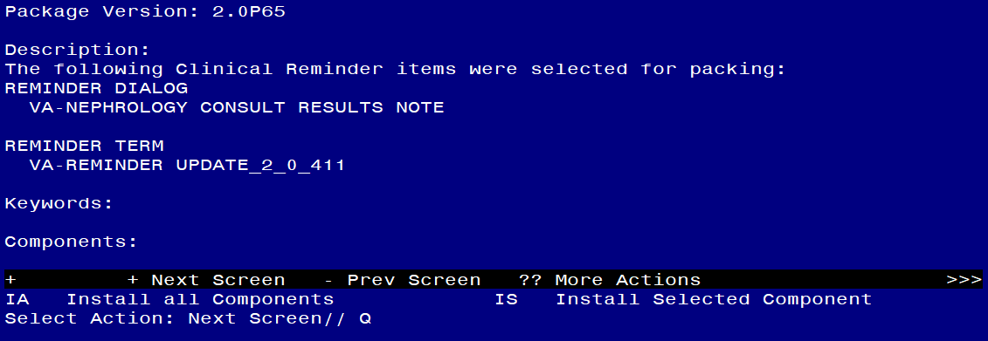

Select Q for quit to exit the install

## Post Installation

1. **Setup of Note Title.**

The suggested note title to create to associate with this template is:

**NEPHROLOGY CKD CONSULT RESULT**

VHA Enterprise Standard Title: **NEPHROLOGY CONSULT**

**You can add this to the document class where consult notes are stored.**

***Note:*** *Comprehensive information on Creating new Document Classes and Titles can be found beginning on page 54 of the TIU/ASU Implementation Guide at the following link:* [*http://www.va.gov/vdl/documents/Clinical/CPRS-Text_Integration_Utility_(TIU)/tiuim.pdf*](http://www.va.gov/vdl/documents/Clinical/CPRS-Text_Integration_Utility_(TIU)/tiuim.pdf)

1. **Make the Dialog template available to be attached to a Personal or Shared template or to be able to attach the dialog to a progress note title. (You can use the LINK feature in this menu for steps 2 and 3 if you choose to)**

Select Reminder Managers Menu <TEST ACCOUNT> Option:

**CP** CPRS Reminder Configuration

CA Add/Edit Reminder Categories

CL CPRS Lookup Categories

CS CPRS Cover Sheet Reminder List

MH Mental Health Dialogs Active

PN Progress Note Headers

RA Reminder GUI Resolution Active

TIU TIU Template Reminder Dialog Parameter

DEVL Evaluate Coversheet List on Dialog Finish

DL Default Outside Location

PT Position Reminder Text at Cursor

LINK Link Reminder Dialog to Template

TEST CPRS Coversheet Time Test

NP New Reminder Parameters

GEC GEC Status Check Active

WH WH Print Now Active

Select CPRS Reminder Configuration <TEST ACCOUNT> Option:

**TIU** TIU Template Reminder Dialog Parameter

Reminder Dialogs allowed as Templates may be set for the following:

1 User USR [choose from NEW PERSON]

3 Service SRV [choose from SERVICE/SECTION]

4 Division DIV [SALT LAKE CITY]

5 System SYS [NATREM.FO-SLC.MED.VA.GOV]

Enter selection: **5** Choose *the appropriate number for your site. Your site may do this by System or other levels. The example below uses SYSTEM level.*

Setting Reminder Dialogs allowed as Templates for System:

NATREM.FO-SLC.MED.VA.GOV

Select Display Sequence:

388 VA-COVID-19 TELEPHONE FOLLOW-UP

389 VA-SRA-CONSULT RESPONSE (D)

*When you type a question mark above, you will see the list of #’s (with dialogs) that are already taken. Choose a number* ***NOT*** *on this list. For this example, 391 is not present so I will use 391.*

Select Display Sequence: **391**

Are you adding 391 as a new Display Sequence? Yes// **YES**

Display Sequence: 391// <Enter> 391

Clinical Reminder Dialog**: VA-NEPHROLOGY CONSULT RESULTS NOTE**

reminder dialog NATIONAL ...OK? Yes// <Enter> (Yes)

1. **Connect the template to your note title.**

* In CPRS, open the Template Editor, expand Document Titles, select the appropriate folder (if applicable), then click New Template (top right-hand corner).

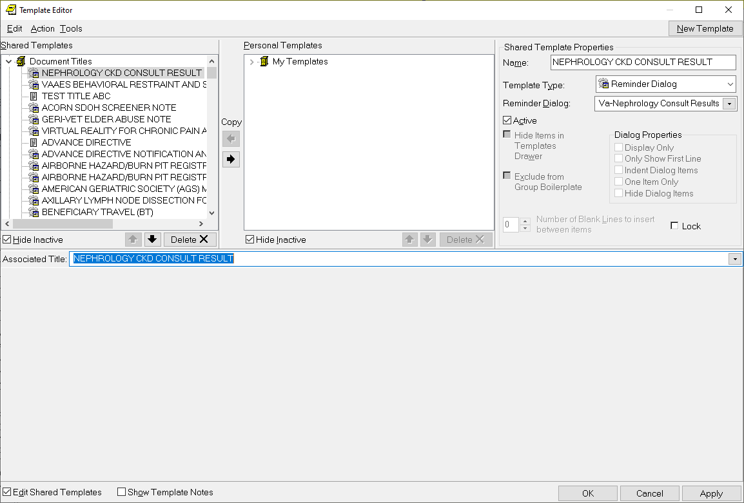

1. Type in the following information:

Name: **NEPHROLOGY CKD CONSULT RESULT**

Template Type: **Reminder Dialog**

Reminder Dialog: **VA-NEPHROLOGY CONSULT RESULTS NOTE**

Associated Title: **NEPHROLOGY CONSULT RESULT**

- then click Apply.

1. **Add your local DATA OBJECT** FOR PATIENT ADDRESS to the following element: VAL-TH VVC TELEPHONE TRIAGE PATIENT LOCATION HOME

Using the menu Reminder Dialog Management, Reminder Dialogs, change your view to Element.

Search for and edit the dialog text of the following element: VAL-TH VVC TELEPHONE TRIAGE PATIENT LOCATION HOME

1. **Add your local DATA OBJECT** FOR PATIENT PHONE NUMBER to the following element: VAL-TH VVC TELEPHONE TRIAGE CONTACT PHONE OBJECT

Using the menu Reminder Dialog Management, Reminder Dialogs, change your view to Element. Search for and edit the dialog text of the following element:

VAL-TH VVC TELEPHONE TRIAGE CONTACT PHONE OBJECT

1. **Use Group from Pre-Install** to add your local TIU Health Summary Objects for eGFR & uACR (for 1 occurrence within 1Y in the element):

VAL-NEPH EGFR AND UACR DATA OBJECTS

VAL-NEPH GP CKD STAGING OPTIONS

1. **Add your local TIU Health Summary Object** for problem list to the element: VAL-NEPH PROBLEM LIST OBJECTS
2. **Add your local TIU Health Summary Object** for Blood Pressure (for 3 occurrences within 1Y in the element):

VAL-NEPH BLOOD PRESSURE DATA OBJECT

1. **Add your local TIU Health Summary Object** for HgBA1C for 1 occurrence within 1Y in the element:

VAL-NEPH HEMOGLOBIN A1C DATA OBJECT

1. **Add your local TIU Health Summary Object** Essential Med List Review (EMLR) **OR** local data objects that meet EPRP criteria in the element:

VAL-NEPH MEDICATION AND ALLERGY OBJECTS

1. **Add your local TIU Health Summary Objects** for BMP or CMP, CBC & urinalysis (for 1 occurrence within 1 Y), & uACR, Cystatin C, HgBA1C (for 3 occurrences within 1Y) in the element:

VAL-NEPH LAB OBJECTS

1. **Add your local Return to Clinic order** as an additional finding on the reminder dialog element: VAL-NEPH RTC DATE ORDER TXT.
2. **Add LAB Test to reminder term:** VAL-BL NEPH URINE ALBUMIN CREATININE RATIO (TRM)
3. Use term VA-KIDNEY HEALTH EVALUATION UACR LAB TEST from Pre-Install to add LAB TESTS that represent uACR to the reminder term VAL-BL NEPH URINE ALBUMIN CREATININE RATIO (TRM). The findings that you add should be LT type findings. Ex: LT.UACR. You do not need to add a status or info in any other fields.
4. Add beginning date, ending date and occurrence count to finding.

BEGINNING DATE/TIME: **T-1Y**

ENDING DATE/TIME: **N**

OCCURRENCE COUNT: **1**

How-to documents for creating health summary objects are available at REDACTED.