

Update_2_0_417

Clinical Reminders

VA-MISC Update 26

Install Guide

**February 2024**

Product Development

Office of Information Technology

Department of Veterans Affairs

**Table of Contents**

Introduction 1

Pre-Installation 6

Install Details 7

Install Example 7

Post Installation 21

## Introduction

This update contains minor spelling corrections and other changes/edits to existing clinical reminder content, a full list of the changes can be found here:

**Redacted URL - Document is MISC_UPDATE_26_CHANGES**

**UPDATE_2_0_417 contains 1 Reminder Exchange entry:**

UPDATE_2_0_417 VA-MISC UPDATE 26

**The exchange file contains the following components:**

**REMINDER GENERAL FINDINGS**

VIEW PROGRESS NOTE TEXT

**TIU TEMPLATE FIELDS**

WP 2/50

VA-ONC CLINICAL TRIAL

VA-ONC OFF REASON TXT

VA-ONC TREATMENT REASON

TEXT NO LIMIT

NUMBER 1-50

CKD GUIDELINES

VA- CKD KFRE

TEXT (1-60 CHAR)

VA-OSP HRF RISK STRAT TOOL

VA-OSP CSRE GUIDE LINK

**HEALTH FACTORS**

VA-REMINDER UPDATES [C]

VA-UPDATE_2_0_417

VA-ONC KID STAGE IV CLINICAL PATHWAY [C]

VA-ONC KID STAGE IV PROG AFTER INTER FAVOR PEMBRO+AXIT

VA-ONC KID STAGE IV NOT CAND INTER IN/POOR OFF PATH RSN

VA-ONC KID STAGE IV PROGRESS AFTER 1ST LINE OFF PATH RSN

VA-ONC KID STAGE IV PROGRESS AFTER 1ST LINE OFF PATH TX

VA-ONC KID STAGE IV PROGRESS AFTER 1ST LINE CABOZANTINIB

VA-ONC KID STAGE IV PROGRESS AFTER 1ST LINE CLINICAL TRIAL

VA-ONC KID STAGE IV NO PROG AFTER INTER OFF PATH RSN

VA-ONC KID STAGE IV NO PROG AFTER INTER OFF PATH TX

VA-ONC KID STAGE IV NO PROG AFTER INTER SURVEILLANCE

VA-ONC KID STAGE IV NO PROG AFTER INTER CLINICAL TRIAL

VA-ONC KID STAGE IV PROG AFTER INTER IN/POOR OFF PATH TX

VA-ONC KID STAGE IV PROG AFTER INTER IN/POOR IPI+NIVO

VA-ONC KID STAGE IV PROG AFTER INTER IN/POOR CLINICAL TRIAL

VA-ONC KID STAGE IV PROG AFTER INTER FAVOR OFF PATH RSN

VA-ONC KID STAGE IV PROG AFTER INTER FAVOR OFF PATH TX

VA-ONC KID STAGE IV PROG AFTER INTERFAVOR PEMBRO+AXIT

VA-ONC KID STAGE IV PROG AFTER INTER FAVOR CLINICAL TRIAL

VA-ONC KID STAGE IV PROG AFTER INTER IN/POOR OFF PATH RSN

VA-ONC KID STAGE IV NOT CAND INTER IN/POOR OFF PATH TX

VA-ONC KID STAGE IV NOT CAND INTER IN/POOR IPI+NIVO

VA-ONC KID STAGE IV NOT CAND INTER IN/POOR CLINICAL TRIAL

VA-ONC KID STAGE IV NOT CAND INTER FAVOR OFF PATH RSN

VA-ONC KID STAGE IV NOT CAND INTER FAVOR OFF PATH TX

VA-ONC KID STAGE IV NOT CAND INTER FAVOR PEMBRO+AXIT

VA-ONC KID STAGE IV NOT CAND INTER FAVOR CLINICAL TRIAL

VA-ONC KID STAGE IV CAND INTER OFF PATH RSN

VA-ONC KID STAGE IV CAND INTER OFF PATH TX

VA-ONC KID STAGE IV CAND INTER METASTASIS DIRECTED TX

VA-ONC KID STAGE IV CAND INTER CYTO NEPHRECTOMY

VA-ONC KID STAGE IV CAND INTER CLINICAL TRIAL

VA-ONC KID STAGE III CLINICAL PATHWAY [C]

VA-ONC KID STAGE III S/P SURG OFF PATH RSN

VA-ONC KID STAGE III S/P SURG OFF PATH TX

VA-ONC KID STAGE III S/P SURG ADJ PEMBRO W SURV

VA-ONC KID STAGE III S/P SURG CLINICAL TRIAL

VA-ONC KID STAGE III SURG OFF PATH RSN

VA-ONC KID STAGE III SURG OFF PATH TX

VA-ONC KID STAGE III SURG RADICAL NEPHRECTOMY

VA-ONC KID STAGE III SURG CLINICAL TRIAL

VA-ONC KID STAGE II CLINICAL PATHWAY [C]

VA-ONC KID STAGE II NO ADJ PEMBRO OFF PATH RSN

VA-ONC KID STAGE II NO ADJ PEMBRO OFF PATH TX

VA-ONC KID STAGE II NO ADJ PEMBRO SURVEILLANCE

VA-ONC KID STAGE II NO ADJ PEMBRO CLINICAL TRIAL

VA-ONC KID STAGE II CAND ADJ PEMBRO OFF PATH RSN

VA-ONC KID STAGE II CAND ADJ PEMBRO OFF PATH TX

VA-ONC KID STAGE II CAND ADJ PEMBRO

VA-ONC KID STAGE II CAND ADJ PEMBRO CLINICAL TRIAL

VA-ONC KID STAGE II SURGERY OFF PATH RSN

VA-ONC KID STAGE II SURGERY OFF PATH TX

VA-ONC KID STAGE II SURGERY RADICAL NEPHRECTOMY

VA-ONC KID STAGE II SURGERY PARTIAL NEPHRECTOMY

VA-ONC KID STAGE II SURGERY CLINICAL TRIAL

VA-ONC KID STAGE I CLINICAL PATHWAY [C]

VA-ONC KID STAGE I T1B OFF PATH RSN

VA-ONC KID STAGE I T1B OFF PATH TX

VA-ONC KID STAGE I T1B ABLATIVE PROCEDURES W SURV

VA-ONC KID STAGE I T1B ACTIVE SURVEILLANCE

VA-ONC KID STAGE I T1B RADICAL NEPHRECTOMY W SURV

VA-ONC KID STAGE I T1B PARTIAL NEPHRECTOMY W SURV

VA-ONC KID STAGE I T1B CLINICAL TRIAL

VA-ONC KID STAGE I T1A OFF PATH RSN

VA-ONC KID STAGE I T1A OFF PATH TX

VA-ONC KID STAGE I T1A RENAL BIOPSY W SURV

VA-ONC KID STAGE I T1A ABLATIVE PROCEDURES W SURV

VA-ONC KID STAGE I T1A RADICAL NEPHRECTOMY W SURV

VA-ONC KID STAGE I T1A PARTIAL NEPHRECTOMY W SURV

VA-ONC KID STAGE I T1A ACTIVE SURVEILLANCE

VA-ONC KID STAGE I T1A CLINICAL TRIAL

VA-OSP TH DISCHARGE [C]

VA-OSP TH DC REASON OTHER

VA-OSP TH DC REASON CRISIS

VA-OSP TH DC REASON UNABLE TO REACH

VA-OSP TH DC REASON NOT GOOD FIT OTHER

VA-OSP TH DC REASON INTERFERING SYMPTOMS NEED ADDRESSING

VA-OSP TH DC REASON NOT GOOD FIT AT THIS TIME

VA-OSP TH DC REASON REQUESTED TO END OTHER

VA-OSP TH DC REASON UNABLE TO ATTEND OTHER PRIORITIES

VA-OSP TH DC REASON FEELS NO LONGER NEED TREATMENT

VA-OSP TH DC REASON UNCOMFORTABLE DISCUSSING SUICIDE

VA-OSP TH DC REASON REQUESTED TO END TREATMENT

VA-OSP TH DC SPI NUMBER SESSIONS

VA-OSP TH DC SPI UNPLANNED

VA-OSP TH DC DBT INTAKE ONLY

VA-OSP TH DC DBT NUMBER MONTHS

VA-OSP TH DC DBT NUMBER IND SESSIONS

VA-OSP TH DC DBT PARTIAL PROTOCOL

VA-OSP TH DC DBT FULL PROTOCOL

VA-OSP TH DC DBT UNPLANNED

VA-OSP TH DC PST-CP INTAKE ONLY

VA-OSP TH DC PST-SP NUMBER SESSIONS

VA-OSP TH DC PST-SP PARTIAL PROTOCOL

VA-OSP TH DC PST-SP FULL PROTOCOL

VA-OSP TH DC PST-SP UNPLANNED

VA-OSP TH DC CBT-SP INTAKE ONLY

VA-OSP TH DC CBT-SP NUMBER SESSIONS

VA-OSP TH DC CBT-SP PARTIAL PROTOCOL COMPLETED

VA-OSP TH DC CBT-SP FULL PROTOCOL COMPLETED

VA-OSP TH DC CBT-SP UNPLANNED

VA-OSP TH DC SPI PLANNED

VA-OSP TH DC DBT AGREED EARLY TERMINATION

VA-OSP TH DC DBT PLANNED

VA-OSP TH DC PST-SP AGREED EARLY TERMINATION

VA-OSP TH DC PST-SP PLANNED

VA-OSP TH DC CBT-SP AGREED EARLY TERMINATION

VA-OSP TH DC CBT-SP PLANNED

VA-ONC LUNG NSCLC IIA/IIB CLINICAL PATHWAY [C]

VA-ONC LUNG NSCLC IIA/IIB R1/R2 NO RRS SQU CLIN TRIAL

VA-ONC LUNG NSCLC IIA/IIB R1/R2 NO RRS SQU OFF PATH RSN

VA-ONC LUNG NSCLC IIA/IIB R1/R2 NO RRS SQU OFF PATH TX

VA-ONC LUNG NSCLC IIA/IIB R1/R2 NO RRS SQU CIS+DOC+RAD ONC

VA-ONC LUNG NSCLC IIA/IIB R1/R2 NSQ NO EXON OFF PATH RSN

VA-ONC LUNG NSCLC IIA/IIB R1/R2 NSQ NO EXON OFF PATH TX

VA-ONC LUNG NSCLC IIA/IIB R1/R2 NSQ NO EXON CLIN TRIAL

VA-ONC LUNG NSCLC IIA/IIB R1/R2 NSQ NO EXON SURV

VA-ONC LUNG NSCLC IIA/IIB R1/R2 NSQ EXON OFF PATH RSN

VA-ONC LUNG NSCLC IIA/IIB R1/R2 NSQ EXON OFF PATH TX

VA-ONC LUNG NSCLC IIA/IIB R1/R2 NSQ EXON CLIN TRIAL

VA-ONC LUNG NSCLC IIA/IIB R1/R2 NSQ EXON OSIM

VA-ONC LUNG NSCLC IIA/IIB R1/R2 NO RRS NSQ OFF PATH RSN

VA-ONC LUNG NSCLC IIA/IIB R1/R2 NO RRS NSQ OFF PATH TX

VA-ONC LUNG NSCLC IIA/IIB R1/R2 NO RRS NSQ CIS+PEME

VA-ONC LUNG NSCLC IIA/IIB R1/R2 NO RRS NSQ CLIN TRIAL

VA-ONC LUNG NSCLC IIA/IIB R1/R2 RRS CLIN TRIAL

VA-ONC LUNG NSCLC IIA/IIB R1/R2 RRS OFF PATH RSN

VA-ONC LUNG NSCLC IIA/IIB R1/R2 RRS OFF PATH TX

VA-ONC LUNG NSCLC IIA/IIB R1/R2 RRS RERESECT

VA-ONC LUNG NSCLC IIA/IIB R0 SQU CIS+DOCE+SURV

VA-ONC LUNG NSCLC IIA/IIB R0 SQU OFF PATH RSN

VA-ONC LUNG NSCLC IIA/IIB R0 SQU OFF PATH TX

VA-ONC LUNG NSCLC IIA/IIB R0 SQU CLIN TRIAL

VA-ONC LUNG NSCLC IIA/IIB R0 NSQ NO EXON OFF PATH RSN

VA-ONC LUNG NSCLC IIA/IIB R0 NSQ NO EXON OFF PATH TX

VA-ONC LUNG NSCLC IIA/IIB R0 NSQ NO EXON CLIN TRIAL

VA-ONC LUNG NSCLC IIA/IIB R0 NSQ NO EXON SURV

VA-ONC LUNG NSCLC IIA/IIB R0 NSQ EXON OFF PATH RSN

VA-ONC LUNG NSCLC IIA/IIB R0 NSQ EXON OFF PATH TX

VA-ONC LUNG NSCLC IIA/IIB R0 NSQ EXON CLIN TRIAL

VA-ONC LUNG NSCLC IIA/IIB R0 NSQ EXON OSIM

VA-ONC LUNG NSCLC IIA/IIB R0 NSQ OFF PATH RSN

VA-ONC LUNG NSCLC IIA/IIB R0 NSQ OFF PATH TX

VA-ONC LUNG NSCLC IIA/IIB R0 NSQ CIS+PEME

VA-ONC LUNG NSCLC IIA/IIB R0 NSQ CLIN TRIAL

VA-ONC LUNG NSCLC IIA/IIB POST RESECT SQU CLINICAL TRIAL

VA-ONC LUNG NSCLC IIA/IIB POST RESECT SQU CIS+DOC+REF RAD ONC

VA-ONC LUNG NSCLC IIA/IIB POST RESECT SQU OFF PATH RSN

VA-ONC LUNG NSCLC IIA/IIB POST RESECT SQU OFF PATH TX

VA-ONC LUNG NSCLC IIA/IIB POST RESECT NSQ NO EXON OFF PATH RSN

VA-ONC LUNG NSCLC IIA/IIB POST RESECT NSQ NO EXON OFF PATH TX

VA-ONC LUNG NSCLC IIA/IIB POST RESECT NSQ NO EXON SURV

VA-ONC LUNG NSCLC IIA/IIB POST RESECT NSQ NO EXON CLIN TRIAL

VA-ONC LUNG NSCLC IIA/IIB POST RESECT NSQ EXON OFF PATH RSN

VA-ONC LUNG NSCLC IIA/IIB POST RESECT NSQ EXON OFF PATH TX

VA-ONC LUNG NSCLC IIA/IIB POST RESECT NSQ EXON OSIM

VA-ONC LUNG NSCLC IIA/IIB POST RESECT NSQ EXON CLIN TRIAL

VA-ONC LUNG NSCLC IIA/IIB POST RESECT NSQ CIS+PEME

VA-ONC LUNG NSCLC IIA/IIB POST RESECT NSQ OFF PATH RSN

VA-ONC LUNG NSCLC IIA/IIB POST RESECT NSQ OFF PATH TX

VA-ONC LUNG NSCLC IIA/IIB POST RESECT NSQ CLINICAL TRIAL

VA-ONC LUNG NSCLC IIA/IIB NO SURG CLIN TRIAL

VA-ONC LUNG NSCLC IIA/IIB NO SURG OFF PATH TX

VA-ONC LUNG NSCLC IIA/IIB NO SURG OFF PATH RSN

VA-ONC LUNG NSCLC IIA/IIB NO SURG REF ONC/RAD ONC

VA-ONC LUNG NSCLC IIA/IIB SURG CLINICAL TRIAL

VA-ONC LUNG NSCLC IIA/IIB SURG OFF PATH RSN

VA-ONC LUNG NSCLC IIA/IIB SURG OFF PATH TX

VA-ONC LUNG NSCLC IIA/IIB SURG RESECTION

VA-ONCOLOGY PATHWAYS [C]

VA-ONC LUNG NSCLC IIA/IIB CLINICAL PATHWAY

VA-ONC LUNG NSCLC STAGE IA/IB PATHWAY[C]

VA-ONC LUNG NSCLC IB SURG OFF PATH RSN

VA-ONC LUNG NSCLC IB SURG OFF PATH TX

VA-ONC LUNG NSCLC IB SURG SUBLOBAR RESECTION

VA-ONC LUNG NSCLC IB SURG SEGMENTECTOMY

VA-ONC LUNG NSCLC IB SURG LOBECTOMY

VA-ONC LUNG NSCLC IB SURG CLIN TRIAL

VA-ONC LUNG NSCLC IA SURG OFF PATH RSN

VA-ONC LUNG NSCLC IA SURG OFF PATH TX

VA-ONC LUNG NSCLC IA SURG CLIN TRIAL

VA-ONC LUNG NSCLC IA SURG RESECTION

VA-VAAES NEURO AVPU [C]

VA-VAAES NEURO AVPU ALERT

VA-MOVE WEIGHT MANAGEMENT [C]

VA-MOVE ASSESSMENT-GRP

VA-SUICIDE RISK ASSESSMENT [C]

VA-SUICIDE ACTION NO ALERT SPC

VA-SUICIDE ACTION ALERT SPC

VA-SUICIDE RISK UNABLE COMPLETE-OTHER PLAN

VA-SUICIDE RISK UNABLE COMPLETE-PLAN REFER EXISTING MH PROVIDER

VA-SUICIDE RISK UNABLE COMPLETE-PLAN REFER MH

VA-SUICIDE RISK UNABLE COMPLETE-PLAN COMPLETE CSRE

VA-SUICIDE RISK UNABLE COMPLETE-VETERAN NOT HIGH ACUTE RISK

VA-SUICIDE RISK UNABLE COMPLETE-OTHER EVIDENCE PATIENT IS HIRSK

VA-SUICIDE RISK UNABLE COMPLETE-WELFARE CHECK

VA-SUICIDE RISK UNABLE COMPLETE-CONTACT VA POLICE

VA-SUICIDE RISK UNABLE COMPLETE-INITIATE LOCAL EVAL PROCESS

VA-SUICIDE RISK UNABLE COMPLETE-VETERAN AT HIGH ACUTE RISK

VA-SUICIDE RISK UNABLE TO COMPLETE-OTHER REASON

VA-SUICIDE RISK UNABLE TO COMPLETE-VETERAN UNABLE TO PARTICIPATE

VA-SUICIDE RISK UNABLE TO COMPLETE-VETERAN LEFT AMA

VA-SUICIDE RISK UNABLE TO COMPLETE-VETERAN DECLINE WARM HANDOFF

VA-SUICIDE RISK UNABLE TO COMPLETE

**REMINDER SPONSORS**

VHA OFFICE OF MENTAL HEALTH AND SUICIDE PREVENTION

OFFICE OF TELEHEALTH SERVICES STORE AND FORWARD TELEHEALTH

NATIONAL CENTER FOR HEALTH PROMOTION AND DISEASE PREVENTION (NCP)

**REMINDER TERMS**

VA-REMINDER UPDATE_2_0_417

**HEALTH SUMMARY COMPONENTS**

PCE HEALTH FACTORS SELECTED

**HEALTH SUMMARY TYPES**

VA-ONCOLOGY PATHWAYS KIDNEY

**HEALTH SUMMARY OBJECTS**

VA-ONCOLOGY PATHWAYS KIDNEY (TIU)

**TIU DOCUMENT DEFINTIONS**

VA-ONCOLOGY PATHWAYS KIDNEY

**REMINDER DIALOGS**

VA-GP MISC UPDATE 26

## Pre-Installation

1. From the **Reminder Dialog Management** menu, Inquire/Print (INQ) and capture/save the following ELEMENTS:

ELEMENT: VAL-SUICIDE ACTION ALERT SPC YES

(*Identify any order that you have mapped as a finding time or additional finding. Re-mapping steps of this order are outlined in the post-Installation steps.*)

1. From the **Reminder Dialog Management** menu, Inquire/Print (INQ) and capture/save the following ELEMENT:

ELEMENT: VAL-TXT TELE-EYE RESULT LETTER-LOCAL INFO

(*Identify the scheduling phone number that you have listed in the dialog text. You will need to add it back in the post-Installation steps.*)

1. Check the **Reminder Exchange** Install History (IH) and ensure your facility has installed the following (previously released) Updates:
   * UPDATE_2_0_293 VA-TECHNOLOGY BASED EYE CARE SERVICES (TECS)
   * UPDATE_2_0_362 VA-AES DIALOG UPDATES
   * UPDATE_2_0_370 VA-TELERETINOPATHY REMINDER AND DIALOG
   * UPDATE_2_0_372 VA-TELESTROKE REMINDER DIALOGS
   * UPDATE_2_0_383 VA-HTN REMINDER UPDATE
   * UPDATE_2_0_385 VA-MISCELLANEOUS UPDATE 24
   * UPDATE_2_0_406 VA-MISCELLANEOUS UPDATE 25

## Install Details

This update is being distributed as a web host file. The address for the host file is: **https://REDACTED /UPDATE_2_0_417.PRD**

The file will be installed using Reminder Exchange, programmer access is not required.

Installation:

=============

This update can be loaded with users on the system. Installation will take less than 30 minutes.

## Install Example

To Load the Web Host File. Navigate to Reminder exchange in Vista

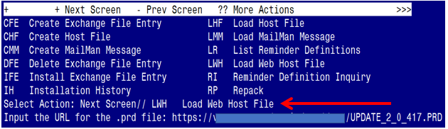

At the **Select Action:** prompt, enter **LWH** for Load Web Host File

At the **Input the url for the .prd file:** prompt, type the following web address:

**https://REDACTED /UPDATE_2_0_417.PRD**

You should see a message at the top of your screen that the file successfully loaded.

Terminal window screen shot of the message displaying the URL of the file that was successfully loaded.  Part of the URL has been redacted as it is a VA only internal web site URL as shown in the text unless redacted for use outside of the VA.

Search for and locate the reminder exchange entry titled UPDATE_2_0_417 VA-MISC UPDATE 26.

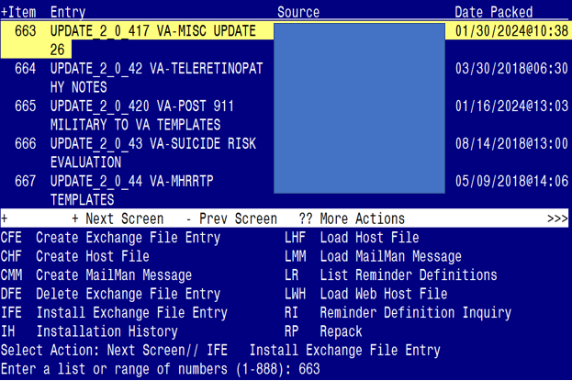

At the **Select Action** prompt, enter **IFE** for Install Exchange File Entry

Enter the number that corresponds with your entry titled **UPDATE_2_0_417 VA-MISC UPDATE 26** *(in this example it is entry 663, it will vary by site).* The exchange file date is 01/30/2024@10:38.

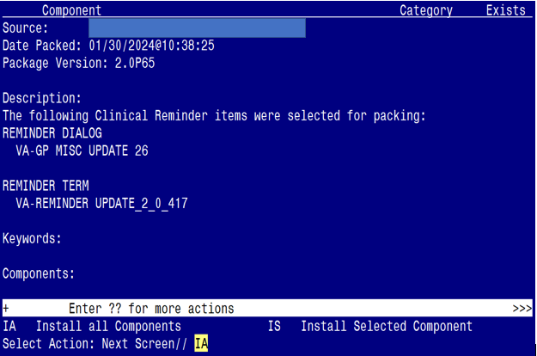

At the **Select Action** prompt, type **IA** for Install all Components and hit enter.

Select Action: Next Screen// IA Install all Components

**You will see several prompts for components. The individual components for which you may (or may not) be prompted are listed below, along with the response you should provide.**

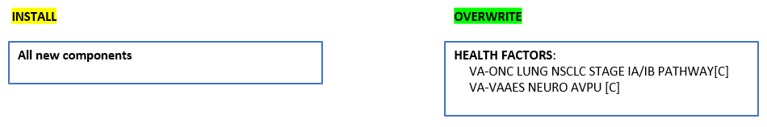

(*The components outlined above are also listed out individually starting on the next page.)*

**Any component NOT listed should be skipped.**

TIU TEMPLATE FIELD entry **CKD GUIDELINES** is NEW,

what do you want to do?

Select one of the following:

C Create a new entry by copying to a new name

I Install

Q Quit the install

S Skip, do not install this entry

Enter response: I// Install

TIU TEMPLATE FIELD entry **VA-OSP HRF RISK STRAT TOOL** is NEW,

what do you want to do?

Select one of the following:

C Create a new entry by copying to a new name

I Install

Q Quit the install

S Skip, do not install this entry

Enter response: I// Install

HEALTH FACTORS entry **VA-UPDATE_2_0_417** is NEW,

what do you want to do?

Select one of the following:

C Create a new entry by copying to a new name

I Install

Q Quit the install

S Skip, do not install this entry

Enter response: I// Install

HEALTH FACTORS entry **VA-OSP TH DC DBT INTAKE ONLY** is NEW,

what do you want to do?

Select one of the following:

C Create a new entry by copying to a new name

I Install

Q Quit the install

S Skip, do not install this entry

Enter response: I// Install

HEALTH FACTORS entry **VA-OSP TH DC PST-CP INTAKE ONLY** is NEW,

what do you want to do?

Select one of the following:

C Create a new entry by copying to a new name

I Install

Q Quit the install

S Skip, do not install this entry

Enter response: I// Install

HEALTH FACTORS entry **VA-OSP TH DC CBT-SP INTAKE ONLY** is NEW,

what do you want to do?

Select one of the following:

C Create a new entry by copying to a new name

I Install

Q Quit the install

S Skip, do not install this entry

Enter response: I// Install

HEALTH FACTORS entry **VA-ONC LUNG NSCLC IIA/IIB R1/R2 NSQ NO EXON OFF PATH RSN** is NEW, what do you want to do?

Select one of the following:

C Create a new entry by copying to a new name

I Install

Q Quit the install

S Skip, do not install this entry

Enter response: I// Install

HEALTH FACTORS entry **VA-ONC LUNG NSCLC IIA/IIB R1/R2 NSQ NO EXON OFF PATH TX** is NEW, what do you want to do?

Select one of the following:

C Create a new entry by copying to a new name

I Install

Q Quit the install

S Skip, do not install this entry

Enter response: I// Install

HEALTH FACTORS entry **VA-ONC LUNG NSCLC IIA/IIB R1/R2 NSQ NO EXON CLIN TRIAL** is NEW, what do you want to do?

Select one of the following:

C Create a new entry by copying to a new name

I Install

Q Quit the install

S Skip, do not install this entry

Enter response: I// Install

HEALTH FACTORS entry **VA-ONC LUNG NSCLC IIA/IIB R1/R2 NSQ NO EXON SURV** is NEW,

what do you want to do?

Select one of the following:

C Create a new entry by copying to a new name

I Install

Q Quit the install

S Skip, do not install this entry

Enter response: I// Install

HEALTH FACTORS entry **VA-ONC LUNG NSCLC IIA/IIB R1/R2 NSQ EXON OFF PATH RSN** is NEW, what do you want to do?

Select one of the following:

C Create a new entry by copying to a new name

I Install

Q Quit the install

S Skip, do not install this entry

Enter response: I// Install

HEALTH FACTORS entry **VA-ONC LUNG NSCLC IIA/IIB R1/R2 NSQ EXON OFF PATH TX** is NEW, what do you want to do?

Select one of the following:

C Create a new entry by copying to a new name

I Install

Q Quit the install

S Skip, do not install this entry

Enter response: I// Install

HEALTH FACTORS entry **VA-ONC LUNG NSCLC IIA/IIB R1/R2 NSQ EXON CLIN TRIAL** is NEW, what do you want to do?

Select one of the following:

C Create a new entry by copying to a new name

I Install

Q Quit the install

S Skip, do not install this entry

Enter response: I// Install

HEALTH FACTORS entry **VA-ONC LUNG NSCLC IIA/IIB R1/R2 NSQ EXON OSIM** is NEW,

what do you want to do?

Select one of the following:

C Create a new entry by copying to a new name

I Install

Q Quit the install

S Skip, do not install this entry

Enter response: I// Install

HEALTH FACTORS entry **VA-ONC LUNG NSCLC IIA/IIB R1/R2 NO RRS NSQ CIS+PEME** is NEW, what do you want to do?

Select one of the following:

C Create a new entry by copying to a new name

I Install

Q Quit the install

S Skip, do not install this entry

Enter response: I// Install

HEALTH FACTORS entry **VA-ONC LUNG NSCLC IIA/IIB POST RESECT NSQ NO EXON OFF PATH RSN** is NEW, what do you want to do?

Select one of the following:

C Create a new entry by copying to a new name

I Install

Q Quit the install

S Skip, do not install this entry

Enter response: I// Install

HEALTH FACTORS entry **VA-ONC LUNG NSCLC IIA/IIB POST RESECT NSQ NO EXON OFF PATH TX** is NEW, what do you want to do?

Select one of the following:

C Create a new entry by copying to a new name

I Install

Q Quit the install

S Skip, do not install this entry

Enter response: I// Install

HEALTH FACTORS entry **VA-ONC LUNG NSCLC IIA/IIB POST RESECT NSQ NO EXON SURV** is NEW, what do you want to do?

Select one of the following:

C Create a new entry by copying to a new name

I Install

Q Quit the install

S Skip, do not install this entry

Enter response: I// Install

HEALTH FACTORS entry **VA-ONC LUNG NSCLC IIA/IIB POST RESECT NSQ NO EXON CLIN TRIAL** is NEW, what do you want to do?

Select one of the following:

C Create a new entry by copying to a new name

I Install

Q Quit the install

S Skip, do not install this entry

Enter response: I// Install

HEALTH FACTORS entry **VA-ONC LUNG NSCLC IIA/IIB POST RESECT NSQ EXON OFF PATH RSN** is NEW, what do you want to do?

Select one of the following:

C Create a new entry by copying to a new name

I Install

Q Quit the install

S Skip, do not install this entry

Enter response: I// Install

HEALTH FACTORS entry **VA-ONC LUNG NSCLC IIA/IIB POST RESECT NSQ EXON OFF PATH TX** is NEW, what do you want to do?

Select one of the following:

C Create a new entry by copying to a new name

I Install

Q Quit the install

S Skip, do not install this entry

Enter response: I// Install

HEALTH FACTORS entry **VA-ONC LUNG NSCLC IIA/IIB POST RESECT NSQ EXON OSIM** is NEW, what do you want to do?

Select one of the following:

C Create a new entry by copying to a new name

I Install

Q Quit the install

S Skip, do not install this entry

Enter response: I// Install

HEALTH FACTORS entry **VA-ONC LUNG NSCLC IIA/IIB POST RESECT NSQ EXON CLIN TRIAL** is NEW, what do you want to do?

Select one of the following:

C Create a new entry by copying to a new name

I Install

Q Quit the install

S Skip, do not install this entry

Enter response: I// Install

HEALTH FACTORS entry **VA-ONC LUNG NSCLC IIA/IIB POST RESECT NSQ CIS+PEME** is NEW, what do you want to do?

Select one of the following:

C Create a new entry by copying to a new name

I Install

Q Quit the install

S Skip, do not install this entry

Enter response: I// Install

HEALTH FACTORS entry named **VA-ONC LUNG NSCLC STAGE IA/IB PATHWAY[C]**

already exists but the packed component is different, what do you

want to do?

Select one of the following:

C Create a new entry by copying to a new name

O Overwrite the current entry

U Update

Q Quit the install

S Skip, do not install this entry

Enter response: O// Overwrite the current entry

Are you sure you want to overwrite? N// Y

HEALTH FACTORS entry **VA-ONC LUNG NSCLC IB SURG OFF PATH RSN** is NEW,

what do you want to do?

Select one of the following:

C Create a new entry by copying to a new name

I Install

Q Quit the install

S Skip, do not install this entry

Enter response: I// Install

HEALTH FACTORS entry **VA-ONC LUNG NSCLC IB SURG OFF PATH TX** is NEW,

what do you want to do?

Select one of the following:

C Create a new entry by copying to a new name

I Install

Q Quit the install

S Skip, do not install this entry

Enter response: I// Install

HEALTH FACTORS entry **VA-ONC LUNG NSCLC IB SURG SUBLOBAR RESECTION** is NEW,

what do you want to do?

Select one of the following:

C Create a new entry by copying to a new name

I Install

Q Quit the install

S Skip, do not install this entry

Enter response: I// Install

HEALTH FACTORS entry **VA-ONC LUNG NSCLC IB SURG SEGMENTECTOMY** is NEW,

what do you want to do?

Select one of the following:

C Create a new entry by copying to a new name

I Install

Q Quit the install

S Skip, do not install this entry

Enter response: I// Install

HEALTH FACTORS entry **VA-ONC LUNG NSCLC IB SURG LOBECTOMY** is NEW,

what do you want to do?

Select one of the following:

C Create a new entry by copying to a new name

I Install

Q Quit the install

S Skip, do not install this entry

Enter response: I// Install

HEALTH FACTORS entry **VA-ONC LUNG NSCLC IB SURG CLIN TRIAL** is NEW,

what do you want to do?

Select one of the following:

C Create a new entry by copying to a new name

I Install

Q Quit the install

S Skip, do not install this entry

Enter response: I// Install

HEALTH FACTORS entry **VA-ONC LUNG NSCLC IA SURG OFF PATH RSN** is NEW,

what do you want to do?

Select one of the following:

C Create a new entry by copying to a new name

I Install

Q Quit the install

S Skip, do not install this entry

Enter response: I// Install

HEALTH FACTORS entry **VA-ONC LUNG NSCLC IA SURG OFF PATH TX** is NEW,

what do you want to do?

Select one of the following:

C Create a new entry by copying to a new name

I Install

Q Quit the install

S Skip, do not install this entry

Enter response: I// Install

HEALTH FACTORS entry **VA-ONC LUNG NSCLC IA SURG CLIN TRIAL** is NEW,

what do you want to do?

Select one of the following:

C Create a new entry by copying to a new name

I Install

Q Quit the install

S Skip, do not install this entry

Enter response: I// Install

HEALTH FACTORS entry **VA-ONC LUNG NSCLC IA SURG RESECTION** is NEW,

what do you want to do?

Select one of the following:

C Create a new entry by copying to a new name

I Install

Q Quit the install

S Skip, do not install this entry

Enter response: I// Install

HEALTH FACTORS entry named **VA-VAAES NEURO AVPU [C]** already exists but

the packed component is different, what do you want to do?

Select one of the following:

C Create a new entry by copying to a new name

O Overwrite the current entry

U Update

Q Quit the install

S Skip, do not install this entry

Enter response: O// Overwrite the current entry

Are you sure you want to overwrite? N// y YES

REMINDER TERM entry **VA-REMINDER UPDATE_2_0_417** is NEW,

what do you want to do?

Select one of the following:

C Create a new entry by copying to a new name

I Install

Q Quit the install

S Skip, do not install this entry

Enter response: I// Install

HEALTH SUMMARY TYPE entry **VA-ONCOLOGY PATHWAYS KIDNEY** is NEW,

what do you want to do?

Select one of the following:

C Create a new entry by copying to a new name

I Install

Q Quit the install

S Skip, do not install this entry

Enter response: I// Install

HEALTH SUMMARY OBJECTS entry **VA-ONCOLOGY PATHWAYS KIDNEY (TIU)** is NEW,

what do you want to do?

Select one of the following:

C Create a new entry by copying to a new name

I Install

Q Quit the install

S Skip, do not install this entry

Enter response: I// Install

TIU DOCUMENT DEFINITION entry **VA-ONCOLOGY PATHWAYS KIDNEY** is NEW,

what do you want to do?

Select one of the following:

C Create a new entry by copying to a new name

I Install

Q Quit the install

S Skip, do not install this entry

Enter response: I// Install

**You will be prompted to install the dialog component:**

Regarding the VA-VP MISC UPDAET 26 (NATIONAL DOALOG):
Screen shot of the terminal window showing a list of elements, groups and dialogs with the text with IA for "Install All" entered at the "Select Action:" Prompt.  The correct entry is described in the text.

At the **Select Action** prompt, type **IA** to install the dialog – **VA-GP MISC UPDATE 26**

Select Action: Next Screen// IA Install All

Install reminder dialog and all components with no further changes: Y// ES

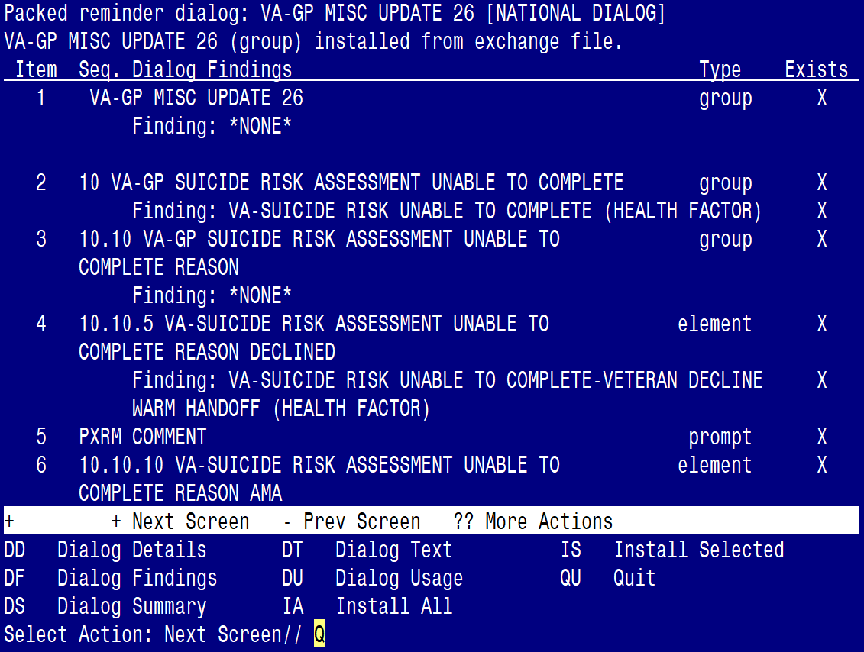

When the dialog has completed installation, you will then be returned to this screen. At the **Select Action** prompt, type **Q.**

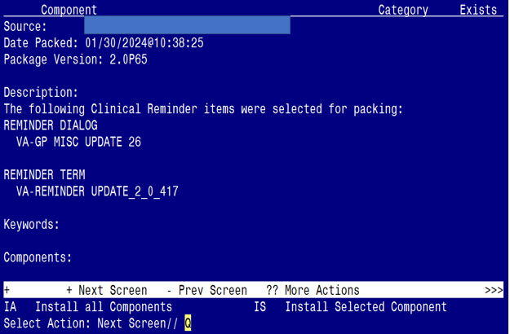

You will be returned to this screen. Type Q to quit.

Install Completed

## Post Installation

1. Refer to the Inquire/Print (INQ) you saved during the Pre-Installation steps for the following ELEMENTS:

> Map the quick order identified in the pre-installation step to the element’s additional finding.

Element: **VAL-SUICIDE ACTION ALERT SPC YES**

DISABLE:

CLASS: LOCAL//

FINDING ITEM: HF.VA-SUICIDE ACTION ALERT SPC

Additional findings:

Select ADDITIONAL FINDING: Enter “Q.”, then name of local consult quick order

1. Refer to the Inquire/Print (INQ) you saved during the Pre-Installation steps for the following ELEMENT:

Enter the phone number (XXX-XXX-XXXX) identified in the pre-installation step to the element’s dialog text.

Element: **VAL-TXT TELE-EYE RESULT LETTER-LOCAL INFO**

DISABLE:

CLASS: LOCAL//

FINDING ITEM:

Additional findings:

DIALOG/PROGRESS NOTE TEXT:

\\If a VA eye care appointment has been recommended, please call to

schedule at least 30-60 days in advance of the recommended return date:

XXX-XXX-XXXX

\\If you have already been contacted by the scheduling team and/or have an appointment scheduled, no action is necessary.