

Update _2_0_418

Clinical Reminders

VA-CAREGIVER SUPPORT PROGRAM (CSP) DIALOG UPDATES

Install Guide

**April 2024**

Product Development

Office of Information Technology

Department of Veterans Affairs

Table of Contents

Introduction 1

Pre-Installation Steps 17

Install Details 17

Install Example 18

Post Installation 26

## Introduction

In support of the MISSION Act, the Caregiver Support Program (CSP) has updated the CSP Approval, Denial and Discharge or Revocation Notes, CSP PCAFC Veterans Functional Assessment Instrument and CSP PGCSS Veteran Intake dialog templates with options based on new regulations, removed redundancies, and added missing elements. These updates are related to the MISSION Act Final Rule and Caregiver Support Program expansion.

The CSP and Geriatric and Extended Care teams created a new Community Care-GEC CSP PCAFC Respite Consult and Community Care-GEC CSP PCAFC Respite Note to track and monitor respite requests for caregivers enrolled in the Program of Comprehensive Assistance for Family Caregivers.

CSP Templates/Dialogues

* CSP Approval Note (PCAFC/PGCSS)- Updated options in the referral/resource section and in the information provided section; updated validation rules on required fields
* CSP Discharge Note (PCAFC/PGCSS)- Updated options in the referral/resource section; updated validation rules on required fields
* CSP Denial Note (PCAFC/PGCSS)- Updated options in the referral/resource section and in the information provided section; updated validation rules on required fields
* CSP PCAFC Veterans Functional Assessment Instrument (VFAI) –response template attached to consult—Updated verbiage on multiple instructional sections to clarify steps for clinical assessors to improve standardization and regulation compliance (instructions should be in boiler plate only; not populate in progress note); updated verbiage and options under multiple ADLs/IADLs to clarify the response; improved organization of ADL/IADL sections for ease of use and readability.
* CSP PGCSS Veteran Intake- Added the ability to document up to 3 approved General Caregivers for one Veteran in the template; updated verbiage to include more than one General Caregiver (when applicable)
* GEC CSP PCAFC Respite Note- **New progress note** built to support the GEC CSP PCAFC Respite Consult. This progress note is a separate note to be completed by CSP staff to assist the PCP and GEC with ordering and processing the caregiver’s request for respite services.

CSP Consult/TXML

* GEC CSP PCAFC Respite Consult- New consult built to support the CSP’s and (Geriatric and Extended Care) GEC’s needs to track respite requests specific to PCAFC enrolled Family Caregivers. This consult will be submitted by the Veteran’s assigned Primary Care Provider (PCP). Once the consult is submitted, it will be routed to the local CSP team for completion. The CSP team will then forward the consult to the local GEC department to review/process/schedule the respite services.

UPDATE_2_0_418 contains 1 Reminder Exchange entry:

**UPDATE_2_0_418 VA-CSP DIALOG UPDATES**

**The exchange file contains the following components:**

**TIU TEMPLATE FIELD**

DATE (*)

OTHER NON-VA

OTHER TEXT

TEXT (1-40 CHAR) REQ

TEXT (1-70) REQUIRED

VA*CG BLANK SPACE2

VA*CG W-P2LINES(REQ)

VA-BRANCH OF SERVICE

VA-CSP EDIT 30

VA-CSP RELATIONSHIP

VA-CSP WP 2 LINES R

VA-CSP WP 3L IND 2

VA-CSP WP 4 LINES R

VA-WORD

WORD PROCESSING FIELD

YES OR NO

YES / NO

EDIT 20+

**HEALTH FACTORS**

PGCSS AGREE RECEIVE SERVICES YES

PGCSS CG ADDRESS

PGCSS CG EMAIL

PGCSS CG NAME

PGCSS CG PHONE

PGCSS CG RELATION BROTHER

PGCSS CG RELATION DAUGHTER

PGCSS CG RELATION FATHER

PGCSS CG RELATION FRIEND/NEIGHBOR

PGCSS CG RELATION MOTHER

PGCSS CG RELATION OTHER

PGCSS CG RELATION SIG OTHER

PGCSS CG RELATION SISTER

PGCSS CG RELATION SON

PGCSS CG RELATION SPOUSE

PGCSS CONTACT FACILITY

PGCSS CONTACT IN HOME

PGCSS CONTACT TELEPHONE

PGCSS CONTACT VIDEO

PGCSS LIVES WITH CG NO

PGCSS LIVES WITH CG YES

PGCSS RECEIVING CARE FROM OTHER NO

PGCSS RECEIVING CARE FROM OTHER YES

PROGRAM OF GENERAL CG SUPPORT SERVICES [C]

VA-CSP APPROVAL APPEAL INFO PROVIDED

VA-CSP APPROVAL ASSIST WITH ADL

VA-CSP APPROVAL ASSIST WITH INS AND SUP

VA-CSP APPROVAL ASSIST WITH SUP AND PROT

VA-CSP APPROVAL DATE

VA-CSP APPROVAL DATE LETTER MAILED

VA-CSP APPROVAL INFO CHAMP VA

VA-CSP APPROVAL INFO DC AND REVOCATION

VA-CSP APPROVAL INFO GEN CAREGIVER

VA-CSP APPROVAL INFO OTHER

VA-CSP APPROVAL INFO RESOURCES

VA-CSP APPROVAL INFO ROI

VA-CSP APPROVAL INFO ROLES

VA-CSP APPROVAL INFO STIPEND

VA-CSP APPROVAL KEY CONTACT INFO PROVIDED

VA-CSP APPROVAL LEVEL 1

VA-CSP APPROVAL LEVEL 2

VA-CSP APPROVAL NON-VA ACP FORMS PROVIDED

VA-CSP APPROVAL NOTIFICATION DATE

VA-CSP APPROVAL PCAFC APPEAL FAQS PROVIDED

VA-CSP APPROVAL PRIVACY PRACTICES INFO PROVIDED

VA-CSP APPROVAL VA FORM 10-305 PROVIDED

VA-CSP APPROVED COMP ASSISTANCE

VA-CSP APPROVED GENERAL CG SERVICES

VA-CSP CAREGIVER APPROVAL [C]

VA-CSP CAREGIVER DENIAL [C]

VA-CSP CAREGIVER DISCHARGE [C]

VA-CSP DENIAL AP NOT COMPLETE WI 90D

VA-CSP DENIAL CAREGIVER DECEASED

VA-CSP DENIAL CG NOT 18

VA-CSP DENIAL CG NOT CAPABLE

VA-CSP DENIAL COMMUNICATION DATE

VA-CSP DENIAL DATE

VA-CSP DENIAL DEATH VETERAN OR CG

VA-CSP DENIAL ENROLLING PCAFC

VA-CSP DENIAL GENERAL CAREGIVER INFO PROVIDED

VA-CSP DENIAL KEY CONTACT INFO PROVIDED

VA-CSP DENIAL LETTER SENT

VA-CSP DENIAL NO ADL NEED

VA-CSP DENIAL NO LONGER INTERESTED

VA-CSP DENIAL NO PC TEAM

VA-CSP DENIAL NO SC DISABILITY

VA-CSP DENIAL NOT A VETERAN OR SM

VA-CSP DENIAL NOT ENROLLED VA

VA-CSP DENIAL NOT FAMILY

VA-CSP DENIAL NOT IN BEST INTEREST

VA-CSP DENIAL NOT LIVING IN US

VA-CSP DENIAL NOT NEEDED OR OTHER

VA-CSP DENIAL NOT RECEIVING CARE

VA-CSP DENIAL NOT RECEIVING SERVICES

VA-CSP DENIAL OTHER INFO PROVIDED

VA-CSP DENIAL OTHER REASON

VA-CSP DENIAL PCAFC APPEAL FAQS PROVIDED

VA-CSP DENIAL PCAFC ELIG FACT SHEET

VA-CSP DENIAL REASON DOESNT LIVE IN STATE

VA-CSP DENIAL VA FORM 10-305 PROVIDED

VA-CSP DENIAL VA/COMMUNITY INFO PROVIDED

VA-CSP DENIAL VETERAN DECEASED

VA-CSP DENIAL WITHDREW APPLICATION

VA-CSP DENIED COMP ASSISTANCE

VA-CSP DENIED GENERAL CAREGIVER SERVICES

VA-CSP DISCHARGE BASED ON CG ASSESS

VA-CSP DISCHARGE CAREGIVER DECEASED

VA-CSP DISCHARGE CAREGIVER REQUEST

VA-CSP DISCHARGE CAREGIVER REQUEST IPV

VA-CSP DISCHARGE CEAT DETERMINE

VA-CSP DISCHARGE CG INSTITUTIONALIZED

VA-CSP DISCHARGE CG NOT CAPABLE

VA-CSP DISCHARGE CG UNWILLING

VA-CSP DISCHARGE DATE

VA-CSP DISCHARGE ENROLLED PCAFC

VA-CSP DISCHARGE FACT SHEET PROVIDED

VA-CSP DISCHARGE FRAUD

VA-CSP DISCHARGE GENERAL CAREGIVER INFO

VA-CSP DISCHARGE KEY CONTACT INFO PROVIDED

VA-CSP DISCHARGE LETTER SENT DATE

VA-CSP DISCHARGE NEGLECT OR ABUSE

VA-CSP DISCHARGE NO ADL NEED

VA-CSP DISCHARGE NO CONTACT

VA-CSP DISCHARGE NO PC TEAM

VA-CSP DISCHARGE NO REASSESSMENT

VA-CSP DISCHARGE NO SC DISABILITY

VA-CSP DISCHARGE NO WELLNESS CONTACTS

VA-CSP DISCHARGE NOT ENROLLED VA

VA-CSP DISCHARGE NOT FAMILY

VA-CSP DISCHARGE NOT IN BEST INTEREST

VA-CSP DISCHARGE NOT LIVING IN STATE

VA-CSP DISCHARGE NOT LIVING IN US

VA-CSP DISCHARGE NOT RECEIVING CARE

VA-CSP DISCHARGE NOTIFICATION DATE

VA-CSP DISCHARGE OTHER INFO PROVIDED

VA-CSP DISCHARGE OTHER REASON

VA-CSP DISCHARGE OTHERS PROVIDING

VA-CSP DISCHARGE PCAFC APPEAL FAQS PROVIDED

VA-CSP DISCHARGE PCAFC ELIG FACT SHEET

VA-CSP DISCHARGE PERSONAL SAFETY

VA-CSP DISCHARGE VA ERROR

VA-CSP DISCHARGE VA FORM 10-305 PROVIDED

VA-CSP DISCHARGE VA/COMMUNITY INFO PROVIDED

VA-CSP DISCHARGE VET INSTITUTIONALIZED

VA-CSP DISCHARGE VETERAN DECEASED

VA-CSP DISCHARGE VETERAN OR CG REQUEST

VA-CSP DISCHARGE VETERAN REQUEST

VA-CSP DISCHARGED COMP ASSISTANCE

VA-CSP DISCHARGED GENERAL CG SERVICES

VA-CSP GENERAL CAREGIVER APPROVED

VA-CSP GENERAL CAREGIVER DENIED

VA-CSP GENERAL CAREGIVER DISCHARGED

VA-CSP PCAFC RESPITE [C]

VA-CSP PCAFC RESPITE CLIN APROP NO

VA-CSP PCAFC RESPITE CLIN APROP YES

VA-CSP PCAFC RESPITE REQ ACUTE CARE

VA-CSP PCAFC RESPITE REQ ADHC

VA-CSP PCAFC RESPITE REQ CLC

VA-CSP PCAFC RESPITE REQ CNH

VA-CSP PCAFC RESPITE REQ INSTIT NO

VA-CSP PCAFC RESPITE REQ INSTIT YES

VA-CSP PCAFC RESPITE REQ NON INSTIT NO

VA-CSP PCAFC RESPITE REQ NON INSTIT YES

VA-CSP PCAFC RESPITE REQ NON SKILL HOME

VA-CSP PCAFC RESPITE REQ SKILL HOME

VA-CSP PGCSS CG ADDL1 ADDRESS

VA-CSP PGCSS CG ADDL1 EMAIL

VA-CSP PGCSS CG ADDL1 NAME

VA-CSP PGCSS CG ADDL1 PHONE

VA-CSP PGCSS CG ADDL1 RELATION BROTHER

VA-CSP PGCSS CG ADDL1 RELATION DAUGHTER

VA-CSP PGCSS CG ADDL1 RELATION FATHER

VA-CSP PGCSS CG ADDL1 RELATION FRIEND/NEIGHBOR

VA-CSP PGCSS CG ADDL1 RELATION MOTHER

VA-CSP PGCSS CG ADDL1 RELATION OTHER

VA-CSP PGCSS CG ADDL1 RELATION SIG OTHER

VA-CSP PGCSS CG ADDL1 RELATION SISTER

VA-CSP PGCSS CG ADDL1 RELATION SON

VA-CSP PGCSS CG ADDL1 RELATION SPOUSE

VA-CSP PGCSS CG ADDL2 ADDRESS

VA-CSP PGCSS CG ADDL2 EMAIL

VA-CSP PGCSS CG ADDL2 NAME

VA-CSP PGCSS CG ADDL2 PHONE

VA-CSP PGCSS CG ADDL2 RELATION BROTHER

VA-CSP PGCSS CG ADDL2 RELATION DAUGHTER

VA-CSP PGCSS CG ADDL2 RELATION FATHER

VA-CSP PGCSS CG ADDL2 RELATION FRIEND/NEIGHBOR

VA-CSP PGCSS CG ADDL2 RELATION MOTHER

VA-CSP PGCSS CG ADDL2 RELATION OTHER

VA-CSP PGCSS CG ADDL2 RELATION SIG OTHER

VA-CSP PGCSS CG ADDL2 RELATION SISTER

VA-CSP PGCSS CG ADDL2 RELATION SON

VA-CSP PGCSS CG ADDL2 RELATION SPOUSE

VA-CSP PGCSS INFO OTHER PROVIDED

VA-CSP PGCSS INFO VA/COMM RES PROVIDED

VA-CSP PGCSS LIVES WITH CG ADDL1 NO

VA-CSP PGCSS LIVES WITH CG ADDL1 YES

VA-CSP PGCSS LIVES WITH CG ADDL2 NO

VA-CSP PGCSS LIVES WITH CG ADDL2 YES

VA-CSP PGCSS VET CURR ENR VA CARE NO

VA-CSP PGCSS VET CURR ENR VA CARE YES

VA-CSP PGCSS VET HAS COMM PCP NO

VA-CSP PGCSS VET HAS COMM PCP YES

VA-CSP PGCSS VET HAS VA PCP NO

VA-CSP PGCSS VET HAS VA PCP YES

VA-CSP PRIMARY CAREGIVER APPROVED

VA-CSP PRIMARY CAREGIVER DENIED

VA-CSP PRIMARY CAREGIVER DISCHARGED

VA-CSP SECONDARY CAREGIVER 2 APPROVED

VA-CSP SECONDARY CAREGIVER 2 DENIED

VA-CSP SECONDARY CAREGIVER 2 DISCHARGED

VA-CSP SECONDARY CAREGIVER APPROVED

VA-CSP SECONDARY CAREGIVER DENIED

VA-CSP SECONDARY CAREGIVER DISCHARGED

VA-CSP VET FUNCTIONAL ASSESS INSTRUMENT [C]

VA-CSP VETERAN APPROVED

VA-CSP VETERAN DENIED

VA-CSP VETERAN DISCHARGED

VA-CSP VFAI ADL BATHE DEP

VA-CSP VFAI ADL BATHE IND

VA-CSP VFAI ADL BATHE MAX

VA-CSP VFAI ADL BATHE MOD

VA-CSP VFAI ADL BATHE NOTAPP

VA-CSP VFAI ADL BATHE NOTATT

VA-CSP VFAI ADL BATHE REFUSED

VA-CSP VFAI ADL BATHE SET-UP

VA-CSP VFAI ADL BATHE SOMETIMES ASSIST REQ

VA-CSP VFAI ADL BATHE SUP

VA-CSP VFAI ADL CHAIR TRNSFR DEP

VA-CSP VFAI ADL CHAIR TRNSFR IND

VA-CSP VFAI ADL CHAIR TRNSFR MAX

VA-CSP VFAI ADL CHAIR TRNSFR MOD

VA-CSP VFAI ADL CHAIR TRNSFR NOTAPP

VA-CSP VFAI ADL CHAIR TRNSFR NOTATT

VA-CSP VFAI ADL CHAIR TRNSFR REFUSED

VA-CSP VFAI ADL CHAIR TRNSFR SET-UP

VA-CSP VFAI ADL CHAIR TRNSFR SOMETIMES ASSIST REQ

VA-CSP VFAI ADL CHAIR TRNSFR SUP

VA-CSP VFAI ADL DRESS LOWER DEP

VA-CSP VFAI ADL DRESS LOWER IND

VA-CSP VFAI ADL DRESS LOWER MAX

VA-CSP VFAI ADL DRESS LOWER MOD

VA-CSP VFAI ADL DRESS LOWER NOTAPP

VA-CSP VFAI ADL DRESS LOWER NOTATT

VA-CSP VFAI ADL DRESS LOWER REFUSED

VA-CSP VFAI ADL DRESS LOWER SET-UP

VA-CSP VFAI ADL DRESS LOWER SOMETIMES ASSIST REQ

VA-CSP VFAI ADL DRESS LOWER SUP

VA-CSP VFAI ADL DRESS TOP DEP

VA-CSP VFAI ADL DRESS TOP IND

VA-CSP VFAI ADL DRESS TOP MAX

VA-CSP VFAI ADL DRESS TOP MOD

VA-CSP VFAI ADL DRESS TOP NOTAPP

VA-CSP VFAI ADL DRESS TOP NOTATT

VA-CSP VFAI ADL DRESS TOP REFUSED

VA-CSP VFAI ADL DRESS TOP SET-UP

VA-CSP VFAI ADL DRESS TOP SOMETIMES ASSIST REQ

VA-CSP VFAI ADL DRESS TOP SUP

VA-CSP VFAI ADL EAT DEP

VA-CSP VFAI ADL EAT IND

VA-CSP VFAI ADL EAT MAX

VA-CSP VFAI ADL EAT MOD

VA-CSP VFAI ADL EAT NOTAPP

VA-CSP VFAI ADL EAT NOTATT

VA-CSP VFAI ADL EAT REFUSED

VA-CSP VFAI ADL EAT SET-UP

VA-CSP VFAI ADL EAT SOMETIMES ASSIST REQ

VA-CSP VFAI ADL EAT SUP

VA-CSP VFAI ADL FOOTWEAR DEP

VA-CSP VFAI ADL FOOTWEAR IND

VA-CSP VFAI ADL FOOTWEAR MAX

VA-CSP VFAI ADL FOOTWEAR MOD

VA-CSP VFAI ADL FOOTWEAR NOTAPP

VA-CSP VFAI ADL FOOTWEAR NOTATT

VA-CSP VFAI ADL FOOTWEAR REFUSED

VA-CSP VFAI ADL FOOTWEAR SET-UP

VA-CSP VFAI ADL FOOTWEAR SOMETIMES ASSIST REQ

VA-CSP VFAI ADL FOOTWEAR SUP

VA-CSP VFAI ADL LYING TO SIT DEP

VA-CSP VFAI ADL LYING TO SIT IND

VA-CSP VFAI ADL LYING TO SIT MAX

VA-CSP VFAI ADL LYING TO SIT MOD

VA-CSP VFAI ADL LYING TO SIT NOTAPP

VA-CSP VFAI ADL LYING TO SIT NOTATT

VA-CSP VFAI ADL LYING TO SIT REFUSED

VA-CSP VFAI ADL LYING TO SIT SET-UP

VA-CSP VFAI ADL LYING TO SIT SOMETIMES ASSIST REQ

VA-CSP VFAI ADL LYING TO SIT SUP

VA-CSP VFAI ADL MBLTY ROLL DEP

VA-CSP VFAI ADL MBLTY ROLL IND

VA-CSP VFAI ADL MBLTY ROLL MAX

VA-CSP VFAI ADL MBLTY ROLL MOD

VA-CSP VFAI ADL MBLTY ROLL NOTAPP

VA-CSP VFAI ADL MBLTY ROLL NOTATT

VA-CSP VFAI ADL MBLTY ROLL REFUSED

VA-CSP VFAI ADL MBLTY ROLL SET-UP

VA-CSP VFAI ADL MBLTY ROLL SOMETIMES ASSIST REQ

VA-CSP VFAI ADL MBLTY ROLL SUP

VA-CSP VFAI ADL ORAL DEP

VA-CSP VFAI ADL ORAL IND

VA-CSP VFAI ADL ORAL MAX

VA-CSP VFAI ADL ORAL MOD

VA-CSP VFAI ADL ORAL NOTAPP

VA-CSP VFAI ADL ORAL NOTATT

VA-CSP VFAI ADL ORAL REFUSED

VA-CSP VFAI ADL ORAL SET-UP

VA-CSP VFAI ADL ORAL SOMETIMES ASSIST REQ

VA-CSP VFAI ADL ORAL SUP

VA-CSP VFAI ADL PROSTHETICS DEP

VA-CSP VFAI ADL PROSTHETICS IND

VA-CSP VFAI ADL PROSTHETICS MAX

VA-CSP VFAI ADL PROSTHETICS MOD

VA-CSP VFAI ADL PROSTHETICS NOTAPP

VA-CSP VFAI ADL PROSTHETICS NOTATT

VA-CSP VFAI ADL PROSTHETICS REFUSED

VA-CSP VFAI ADL PROSTHETICS SET-UP

VA-CSP VFAI ADL PROSTHETICS SOMETIMES ASSIST REQ

VA-CSP VFAI ADL PROSTHETICS SUP

VA-CSP VFAI ADL SIT TO LYING DEP

VA-CSP VFAI ADL SIT TO LYING IND

VA-CSP VFAI ADL SIT TO LYING MAX

VA-CSP VFAI ADL SIT TO LYING MOD

VA-CSP VFAI ADL SIT TO LYING NOTAPP

VA-CSP VFAI ADL SIT TO LYING NOTATT

VA-CSP VFAI ADL SIT TO LYING REFUSED

VA-CSP VFAI ADL SIT TO LYING SET-UP

VA-CSP VFAI ADL SIT TO LYING SOMETIMES ASSIST REQ

VA-CSP VFAI ADL SIT TO LYING SUP

VA-CSP VFAI ADL SIT TO STAND DEP

VA-CSP VFAI ADL SIT TO STAND IND

VA-CSP VFAI ADL SIT TO STAND MAX

VA-CSP VFAI ADL SIT TO STAND MOD

VA-CSP VFAI ADL SIT TO STAND NOTAPP

VA-CSP VFAI ADL SIT TO STAND NOTATT

VA-CSP VFAI ADL SIT TO STAND REFUSED

VA-CSP VFAI ADL SIT TO STAND SET-UP

VA-CSP VFAI ADL SIT TO STAND SOMETIMES ASSIST REQ

VA-CSP VFAI ADL SIT TO STAND SUP

VA-CSP VFAI ADL TOILET TRNSFR DEP

VA-CSP VFAI ADL TOILET TRNSFR IND

VA-CSP VFAI ADL TOILET TRNSFR MAX

VA-CSP VFAI ADL TOILET TRNSFR MOD

VA-CSP VFAI ADL TOILET TRNSFR NOTAPP

VA-CSP VFAI ADL TOILET TRNSFR NOTATT

VA-CSP VFAI ADL TOILET TRNSFR REFUSED

VA-CSP VFAI ADL TOILET TRNSFR SET-UP

VA-CSP VFAI ADL TOILET TRNSFR SOMETIMES ASSIST

VA-CSP VFAI ADL TOILET TRNSFR SUP

VA-CSP VFAI ADL TOILETING DEP

VA-CSP VFAI ADL TOILETING IND

VA-CSP VFAI ADL TOILETING MAX

VA-CSP VFAI ADL TOILETING MOD

VA-CSP VFAI ADL TOILETING NOTAPP

VA-CSP VFAI ADL TOILETING NOTATT

VA-CSP VFAI ADL TOILETING REFUSED

VA-CSP VFAI ADL TOILETING SET-UP

VA-CSP VFAI ADL TOILETING SOMETIMES ASSIST REQ

VA-CSP VFAI ADL TOILETING SUP

VA-CSP VFAI ADL WASH DEP

VA-CSP VFAI ADL WASH IND

VA-CSP VFAI ADL WASH MAX

VA-CSP VFAI ADL WASH MOD

VA-CSP VFAI ADL WASH NOTAPP

VA-CSP VFAI ADL WASH NOTATT

VA-CSP VFAI ADL WASH REFUSED

VA-CSP VFAI ADL WASH SET-UP

VA-CSP VFAI ADL WASH SOMETIMES ASSIST REQ

VA-CSP VFAI ADL WASH SUP

VA-CSP VFAI AGITX BHVRMGMT PHYSRESISTS

VA-CSP VFAI AGITX BHVRMGMT RESISTS

VA-CSP VFAI AGITX CUES

VA-CSP VFAI AGITX FREQ 1XWEEK

VA-CSP VFAI AGITX FREQ 2XWEEK

VA-CSP VFAI AGITX FREQ 3XWEEK

VA-CSP VFAI AGITX FREQ 4MOREWEEK

VA-CSP VFAI AGITX FREQ DAILY

VA-CSP VFAI AGITX FREQ LESSWEEKLY

VA-CSP VFAI AGITX NOINTERVENTION

VA-CSP VFAI AGITX REDIRECTION

VA-CSP VFAI AGITYPE EASILYAGITATED

VA-CSP VFAI AGITYPE EASILYANGERED

VA-CSP VFAI AGITYPE EASILYFRUSTRATED

VA-CSP VFAI AGITYPE OTHER

VA-CSP VFAI ATRISK NEGLECTABUSE NO

VA-CSP VFAI ATRISK NEGLECTABUSE YES

VA-CSP VFAI DELTX BHVRMGMT PHYSRESISTS

VA-CSP VFAI DELTX BHVRMGMT RESISTS

VA-CSP VFAI DELTX CUES

VA-CSP VFAI DELTX FREQ 1XWEEK

VA-CSP VFAI DELTX FREQ 2XWEEK

VA-CSP VFAI DELTX FREQ 3XWEEK

VA-CSP VFAI DELTX FREQ 4MOREWEEK

VA-CSP VFAI DELTX FREQ DAILY

VA-CSP VFAI DELTX FREQ LESSWEEKLY

VA-CSP VFAI DELTX NOINTERVENTION

VA-CSP VFAI DELTX REDIRECTION

VA-CSP VFAI DELTYPE CATATONIC

VA-CSP VFAI DELTYPE DELUSIONS

VA-CSP VFAI DELTYPE DISORGANIZEDSPEECH

VA-CSP VFAI DELTYPE HALLUCINATIONS

VA-CSP VFAI DELTYPE OTHER

VA-CSP VFAI DELTYPE THOUGHTDISORDER

VA-CSP VFAI IMPTX BHVRMGMT PHYSRESISTS

VA-CSP VFAI IMPTX BHVRMGMT RESISTS

VA-CSP VFAI IMPTX CUES

VA-CSP VFAI IMPTX FREQ 1XWEEK

VA-CSP VFAI IMPTX FREQ 2XWEEK

VA-CSP VFAI IMPTX FREQ 3XWEEK

VA-CSP VFAI IMPTX FREQ 4MOREWEEK

VA-CSP VFAI IMPTX FREQ DAILY

VA-CSP VFAI IMPTX FREQ LESSWEEKLY

VA-CSP VFAI IMPTX NOINTERVENTION

VA-CSP VFAI IMPTX REDIRECTION

VA-CSP VFAI IMPTYPE DISREGARD

VA-CSP VFAI IMPTYPE EASILYINFLUENCE

VA-CSP VFAI IMPTYPE FINANCIAL

VA-CSP VFAI IMPTYPE HIGHRISKBEHAVIORS

VA-CSP VFAI IMPTYPE OTHER

VA-CSP VFAI IMPTYPE THOUGHTLESS

VA-CSP VFAI INSTR CONTNEEDS NO

VA-CSP VFAI INSTR CONTNEEDS YES

VA-CSP VFAI INSTR NEEDS NO

VA-CSP VFAI INSTR NEEDS YES

VA-CSP VFAI MANUALWC 150FT DEP

VA-CSP VFAI MANUALWC 150FT IND

VA-CSP VFAI MANUALWC 150FT MAX

VA-CSP VFAI MANUALWC 150FT MOD

VA-CSP VFAI MANUALWC 150FT NOTAPP

VA-CSP VFAI MANUALWC 150FT NOTATT

VA-CSP VFAI MANUALWC 150FT REFUSED

VA-CSP VFAI MANUALWC 150FT SET-UP

VA-CSP VFAI MANUALWC 150FT SOMETIMES ASSIST REQ

VA-CSP VFAI MANUALWC 150FT SUP

VA-CSP VFAI MANUALWC 15MIN DEP

VA-CSP VFAI MANUALWC 15MIN IND

VA-CSP VFAI MANUALWC 15MIN MAX

VA-CSP VFAI MANUALWC 15MIN MOD

VA-CSP VFAI MANUALWC 15MIN NOTAPP

VA-CSP VFAI MANUALWC 15MIN NOTATT

VA-CSP VFAI MANUALWC 15MIN REFUSED

VA-CSP VFAI MANUALWC 15MIN SET-UP

VA-CSP VFAI MANUALWC 15MIN SOMETIMES ASSIST REQ

VA-CSP VFAI MANUALWC 15MIN SUP

VA-CSP VFAI MANUALWC 50FT DEP

VA-CSP VFAI MANUALWC 50FT IND

VA-CSP VFAI MANUALWC 50FT MAX

VA-CSP VFAI MANUALWC 50FT MOD

VA-CSP VFAI MANUALWC 50FT NOTAPP

VA-CSP VFAI MANUALWC 50FT NOTATT

VA-CSP VFAI MANUALWC 50FT REFUSED

VA-CSP VFAI MANUALWC 50FT SET-UP

VA-CSP VFAI MANUALWC 50FT SOMETIMES ASSIST REQ

VA-CSP VFAI MANUALWC 50FT SUP

VA-CSP VFAI MANUALWC CROSSSTREET DEP

VA-CSP VFAI MANUALWC CROSSSTREET IND

VA-CSP VFAI MANUALWC CROSSSTREET MAX

VA-CSP VFAI MANUALWC CROSSSTREET MOD

VA-CSP VFAI MANUALWC CROSSSTREET NOTAPP

VA-CSP VFAI MANUALWC CROSSSTREET NOTATT

VA-CSP VFAI MANUALWC CROSSSTREET REFUSED

VA-CSP VFAI MANUALWC CROSSSTREET SET-UP

VA-CSP VFAI MANUALWC CROSSSTREET SOMETIMES

VA-CSP VFAI MANUALWC CROSSSTREET SUP

VA-CSP VFAI MEDMNGMNT ADMINISTRATION

VA-CSP VFAI MEDMNGMNT NO

VA-CSP VFAI MEDMNGMNT NOANS

VA-CSP VFAI MEDMNGMNT NOHELP

VA-CSP VFAI MEDMNGMNT REMINDERS

VA-CSP VFAI MEDMNGMNT SET-UP

VA-CSP VFAI MEDMNGMNT YES

VA-CSP VFAI MOBILITY MANWHLCHR

VA-CSP VFAI MOBILITY MOTWHLCHR

VA-CSP VFAI MOBILITY NOWLK NOWHLCHR

VA-CSP VFAI MOBILITY WALKS

VA-CSP VFAI MOTORWC 150FT DEP

VA-CSP VFAI MOTORWC 150FT IND

VA-CSP VFAI MOTORWC 150FT MAX

VA-CSP VFAI MOTORWC 150FT MOD

VA-CSP VFAI MOTORWC 150FT NOTAPP

VA-CSP VFAI MOTORWC 150FT NOTATT

VA-CSP VFAI MOTORWC 150FT REFUSED

VA-CSP VFAI MOTORWC 150FT SET-UP

VA-CSP VFAI MOTORWC 150FT SOMETIMES ASSIST REQ

VA-CSP VFAI MOTORWC 150FT SUP

VA-CSP VFAI MOTORWC 15MIN DEP

VA-CSP VFAI MOTORWC 15MIN IND

VA-CSP VFAI MOTORWC 15MIN MAX

VA-CSP VFAI MOTORWC 15MIN MOD

VA-CSP VFAI MOTORWC 15MIN NOTAPP

VA-CSP VFAI MOTORWC 15MIN NOTATT

VA-CSP VFAI MOTORWC 15MIN REFUSED

VA-CSP VFAI MOTORWC 15MIN SET-UP

VA-CSP VFAI MOTORWC 15MIN SOMETIMES ASSIST REQ

VA-CSP VFAI MOTORWC 15MIN SUP

VA-CSP VFAI MOTORWC 50FT DEP

VA-CSP VFAI MOTORWC 50FT IND

VA-CSP VFAI MOTORWC 50FT MAX

VA-CSP VFAI MOTORWC 50FT MOD

VA-CSP VFAI MOTORWC 50FT NOTAPP

VA-CSP VFAI MOTORWC 50FT NOTATT

VA-CSP VFAI MOTORWC 50FT REFUSED

VA-CSP VFAI MOTORWC 50FT SET-UP

VA-CSP VFAI MOTORWC 50FT SOMETIMES ASSIST REQ

VA-CSP VFAI MOTORWC 50FT SUP

VA-CSP VFAI MOTORWC CROSSSTREET DEP

VA-CSP VFAI MOTORWC CROSSSTREET IND

VA-CSP VFAI MOTORWC CROSSSTREET MAX

VA-CSP VFAI MOTORWC CROSSSTREET MOD

VA-CSP VFAI MOTORWC CROSSSTREET NOTAPP

VA-CSP VFAI MOTORWC CROSSSTREET NOTATT

VA-CSP VFAI MOTORWC CROSSSTREET REFUSED

VA-CSP VFAI MOTORWC CROSSSTREET SET-UP

VA-CSP VFAI MOTORWC CROSSSTREET SOMETIMES

VA-CSP VFAI MOTORWC CROSSSTREET SUP

VA-CSP VFAI REQSUP AWAYHOME CONSTANT

VA-CSP VFAI REQSUP AWAYHOME INTENSE

VA-CSP VFAI REQSUP AWAYHOME NOHELP

VA-CSP VFAI REQSUP AWAYHOME SOMEHELP

VA-CSP VFAI REQSUP STAYHOME ALONE1HR

VA-CSP VFAI REQSUP STAYHOME ALONEMOSTDAY

VA-CSP VFAI REQSUP STAYHOME ALWAYS

VA-CSP VFAI REQSUP STAYHOME DAILYCHK-IN

VA-CSP VFAI REQSUP STAYHOME NOCHK-INS

VA-CSP VFAI REQSUP STAYHOME NOWANDTHEN

VA-CSP VFAI RISKSELF-NEGLECT NO

VA-CSP VFAI RISKSELF-NEGLECT YES

VA-CSP VFAI SAFETY AGITATION NO

VA-CSP VFAI SAFETY AGITATION NOTAPP

VA-CSP VFAI SAFETY AGITATION YES

VA-CSP VFAI SAFETY DELUSIONS NO

VA-CSP VFAI SAFETY DELUSIONS NOTAPP

VA-CSP VFAI SAFETY DELUSIONS YES

VA-CSP VFAI SAFETY IMPULSIVITY NO

VA-CSP VFAI SAFETY IMPULSIVITY NOTAPP

VA-CSP VFAI SAFETY IMPULSIVITY YES

VA-CSP VFAI SAFETY WANDERING NO

VA-CSP VFAI SAFETY WANDERING NOTAPP

VA-CSP VFAI SAFETY WANDERING YES

VA-CSP VFAI SELF-DIR HLTHSAFETY NO

VA-CSP VFAI SELF-DIR HLTHSAFETY YES

VA-CSP VFAI SELF-DIR IDNEEDS NO

VA-CSP VFAI SELF-DIR IDNEEDS YES

VA-CSP VFAI SELF-PRES IND

VA-CSP VFAI SELF-PRES MENTALLYPHYSUNABLE

VA-CSP VFAI SELF-PRES MENTALLYUNABLE

VA-CSP VFAI SELF-PRES MIN

VA-CSP VFAI SELF-PRES PHYSUNABLE

VA-CSP VFAI VETRISKFACTOR ALCOHOL

VA-CSP VFAI VETRISKFACTOR BEHAVIORS

VA-CSP VFAI VETRISKFACTOR DEHYDRATION

VA-CSP VFAI VETRISKFACTOR HYGIENE

VA-CSP VFAI VETRISKFACTOR IMPAIRMENT

VA-CSP VFAI VETRISKFACTOR LIVINGCOND

VA-CSP VFAI VETRISKFACTOR NOTAPP

VA-CSP VFAI VETRISKFACTOR OTHER

VA-CSP VFAI VETRISKFACTOR UNABLEMNGMEDS

VA-CSP VFAI WALKS 12STEPS DEP

VA-CSP VFAI WALKS 12STEPS IND

VA-CSP VFAI WALKS 12STEPS MAX

VA-CSP VFAI WALKS 12STEPS MOD

VA-CSP VFAI WALKS 12STEPS NOTAPP

VA-CSP VFAI WALKS 12STEPS NOTATT

VA-CSP VFAI WALKS 12STEPS REFUSED

VA-CSP VFAI WALKS 12STEPS SET-UP

VA-CSP VFAI WALKS 12STEPS SOMETIMES ASSIST REQ

VA-CSP VFAI WALKS 12STEPS SUP

VA-CSP VFAI WALKS 4STEPS DEP

VA-CSP VFAI WALKS 4STEPS IND

VA-CSP VFAI WALKS 4STEPS MAX

VA-CSP VFAI WALKS 4STEPS MOD

VA-CSP VFAI WALKS 4STEPS NOTAPP

VA-CSP VFAI WALKS 4STEPS NOTATT

VA-CSP VFAI WALKS 4STEPS REFUSED

VA-CSP VFAI WALKS 4STEPS SET-UP

VA-CSP VFAI WALKS 4STEPS SOMETIMES ASSIST REQ

VA-CSP VFAI WALKS 4STEPS SUP

VA-CSP VFAI WALKS CARRYBOTHHANDS DEP

VA-CSP VFAI WALKS CARRYBOTHHANDS IND

VA-CSP VFAI WALKS CARRYBOTHHANDS MAX

VA-CSP VFAI WALKS CARRYBOTHHANDS MOD

VA-CSP VFAI WALKS CARRYBOTHHANDS NOTAPP

VA-CSP VFAI WALKS CARRYBOTHHANDS NOTATT

VA-CSP VFAI WALKS CARRYBOTHHANDS REFUSED

VA-CSP VFAI WALKS CARRYBOTHHANDS SET-UP

VA-CSP VFAI WALKS CARRYBOTHHANDS SOMETIMES

VA-CSP VFAI WALKS CARRYBOTHHANDS SUP

VA-CSP VFAI WALKS CROSSSTREET DEP

VA-CSP VFAI WALKS CROSSSTREET IND

VA-CSP VFAI WALKS CROSSSTREET MAX

VA-CSP VFAI WALKS CROSSSTREET MOD

VA-CSP VFAI WALKS CROSSSTREET NOTAPP

VA-CSP VFAI WALKS CROSSSTREET NOTATT

VA-CSP VFAI WALKS CROSSSTREET REFUSED

VA-CSP VFAI WALKS CROSSSTREET SET-UP

VA-CSP VFAI WALKS CROSSSTREET SOMETIMES ASSIST

VA-CSP VFAI WALKS CROSSSTREET SUP

VA-CSP VFAI WALKS CURB DEP

VA-CSP VFAI WALKS CURB IND

VA-CSP VFAI WALKS CURB MAX

VA-CSP VFAI WALKS CURB MOD

VA-CSP VFAI WALKS CURB NOTAPP

VA-CSP VFAI WALKS CURB NOTATT

VA-CSP VFAI WALKS CURB REFUSED

VA-CSP VFAI WALKS CURB SET-UP

VA-CSP VFAI WALKS CURB SOMETIMES ASSIST REQ

VA-CSP VFAI WALKS CURB SUP

VA-CSP VFAI WALKS PICKUPOBJECT DEP

VA-CSP VFAI WALKS PICKUPOBJECT IND

VA-CSP VFAI WALKS PICKUPOBJECT MAX

VA-CSP VFAI WALKS PICKUPOBJECT MOD

VA-CSP VFAI WALKS PICKUPOBJECT NOTAPP

VA-CSP VFAI WALKS PICKUPOBJECT NOTATT

VA-CSP VFAI WALKS PICKUPOBJECT REFUSED

VA-CSP VFAI WALKS PICKUPOBJECT SET-UP

VA-CSP VFAI WALKS PICKUPOBJECT SOMETIMES ASSIST

VA-CSP VFAI WALKS PICKUPOBJECT SUP

VA-CSP VFAI WALKS WALK10FT DEP

VA-CSP VFAI WALKS WALK10FT IND

VA-CSP VFAI WALKS WALK10FT MAX

VA-CSP VFAI WALKS WALK10FT MOD

VA-CSP VFAI WALKS WALK10FT NOTAPP

VA-CSP VFAI WALKS WALK10FT NOTATT

VA-CSP VFAI WALKS WALK10FT REFUSED

VA-CSP VFAI WALKS WALK10FT SET-UP

VA-CSP VFAI WALKS WALK10FT SOMETIMES ASSIST REQ

VA-CSP VFAI WALKS WALK10FT SUP

VA-CSP VFAI WALKS WALK10FTUNEVEN DEP

VA-CSP VFAI WALKS WALK10FTUNEVEN IND

VA-CSP VFAI WALKS WALK10FTUNEVEN MAX

VA-CSP VFAI WALKS WALK10FTUNEVEN MOD

VA-CSP VFAI WALKS WALK10FTUNEVEN NOTAPP

VA-CSP VFAI WALKS WALK10FTUNEVEN NOTATT

VA-CSP VFAI WALKS WALK10FTUNEVEN REFUSED

VA-CSP VFAI WALKS WALK10FTUNEVEN SET-UP

VA-CSP VFAI WALKS WALK10FTUNEVEN SOMETIMES

VA-CSP VFAI WALKS WALK10FTUNEVEN SUP

VA-CSP VFAI WALKS WALK150FT DEP

VA-CSP VFAI WALKS WALK150FT IND

VA-CSP VFAI WALKS WALK150FT MAX

VA-CSP VFAI WALKS WALK150FT MOD

VA-CSP VFAI WALKS WALK150FT NOTAPP

VA-CSP VFAI WALKS WALK150FT NOTATT

VA-CSP VFAI WALKS WALK150FT REFUSED

VA-CSP VFAI WALKS WALK150FT SET-UP

VA-CSP VFAI WALKS WALK150FT SOMETIMES ASSIST REQ

VA-CSP VFAI WALKS WALK150FT SUP

VA-CSP VFAI WALKS WALK50FT DEP

VA-CSP VFAI WALKS WALK50FT IND

VA-CSP VFAI WALKS WALK50FT MAX

VA-CSP VFAI WALKS WALK50FT MOD

VA-CSP VFAI WALKS WALK50FT NOTAPP

VA-CSP VFAI WALKS WALK50FT NOTATT

VA-CSP VFAI WALKS WALK50FT REFUSED

VA-CSP VFAI WALKS WALK50FT SET-UP

VA-CSP VFAI WALKS WALK50FT SOMETIMES ASSIST REQ

VA-CSP VFAI WALKS WALK50FT SUP

VA-CSP VFAI WALKS WALKINDOORS DEP

VA-CSP VFAI WALKS WALKINDOORS IND

VA-CSP VFAI WALKS WALKINDOORS MAX

VA-CSP VFAI WALKS WALKINDOORS MOD

VA-CSP VFAI WALKS WALKINDOORS NOTAPP

VA-CSP VFAI WALKS WALKINDOORS NOTATT

VA-CSP VFAI WALKS WALKINDOORS REFUSED

VA-CSP VFAI WALKS WALKINDOORS SET-UP

VA-CSP VFAI WALKS WALKINDOORS SOMETIMES ASSIST

VA-CSP VFAI WALKS WALKINDOORS SUP

VA-CSP VFAI WALKS WALKS15MIN DEP

VA-CSP VFAI WALKS WALKS15MIN IND

VA-CSP VFAI WALKS WALKS15MIN MAX

VA-CSP VFAI WALKS WALKS15MIN MOD

VA-CSP VFAI WALKS WALKS15MIN NOTAPP

VA-CSP VFAI WALKS WALKS15MIN NOTATT

VA-CSP VFAI WALKS WALKS15MIN REFUSED

VA-CSP VFAI WALKS WALKS15MIN SET-UP

VA-CSP VFAI WALKS WALKS15MIN SOMETIMES ASSIST

VA-CSP VFAI WALKS WALKS15MIN SUP

VA-CSP VFAI WANTX BHVRMGMT PHYSRESISTS

VA-CSP VFAI WANTX BHVRMGMT RESISTS

VA-CSP VFAI WANTX CUES

VA-CSP VFAI WANTX FREQ 1XWEEK

VA-CSP VFAI WANTX FREQ 2XWEEK

VA-CSP VFAI WANTX FREQ 3XWEEK

VA-CSP VFAI WANTX FREQ 4MOREWEEK

VA-CSP VFAI WANTX FREQ DAILY

VA-CSP VFAI WANTX FREQ LESSWEEKLY

VA-CSP VFAI WANTX NOINTERVENTION

VA-CSP VFAI WANTX REDIRECTION

VA-CSP VFAI WANTYPE LEAVES AREA/HOME

VA-CSP VFAI WANTYPE WANDERS AWAY COMM

VA-REMINDER UPDATES [C]

VA-UPDATE_2_0_418

**REMINDER SPONSOR**

CAREGIVER SUPPORT PROGRAM

**REMINDER TERM**

VA-REMINDER UPDATE_2_0_418

**REMINDER DIALOG**

VA-CSP PROGRAM APPROVAL

VA-CSP PROGRAM DENIAL

VA-CSP PROGRAM DISCHARGE

VA-CSP VETERAN FUNCTIONAL ASSESSMENT INSTRUMENT

VA-PGCSS VETERAN INTAKE

VA-CSP PCAFC RESPITE NOTE

**TIU OBJECTS**

PATIENT NAME

PATIENT DATE OF BIRTH

PATIENT SSN

SERVICE DISABILITIES

## Pre-Installation Steps

1. Identify TIU objects to display patient address and patient phone number.

## Install Details

This update is being distributed as a web host file. The address for the host file is: **https://REDACTED /UPDATE_2_0_418.PRD**

The file will be installed using Reminder Exchange, programmer access is not required.

Installation:

=============

This update can be loaded with users on the system. Installation will take less than 45 minutes.

## Install Example

To Load the Web Host File. Navigate to Reminder exchange in Vista

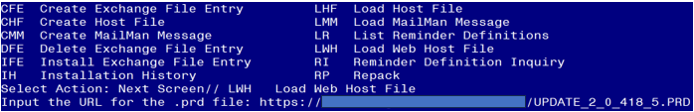

At the **Select Action:** prompt, enter **LWH** for Load Web Host File

At the **Input the url for the .prd file:** prompt, type the following web address:

**https://REDACTED /UPDATE_2_0_418.PRD**

You should see a message at the top of your screen that the file successfully loaded.

Search and locate an entry titled **UPDATE_2_0_418 VA-CSP DIALOG UPDATES** in reminder exchange.

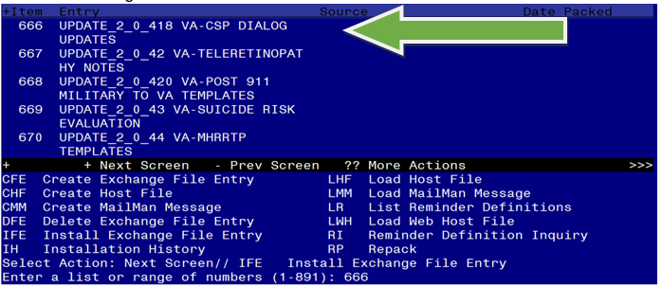

At the **Select Action** prompt, enter **IFE** for Install Exchange File Entry

Enter the number that corresponds with your entry UPDATE_2_0_418 VA-CSP DIALOG UPDATES *(in this example it is entry 666. It will vary by site).* The date of the exchange file should be 04/18/2024.

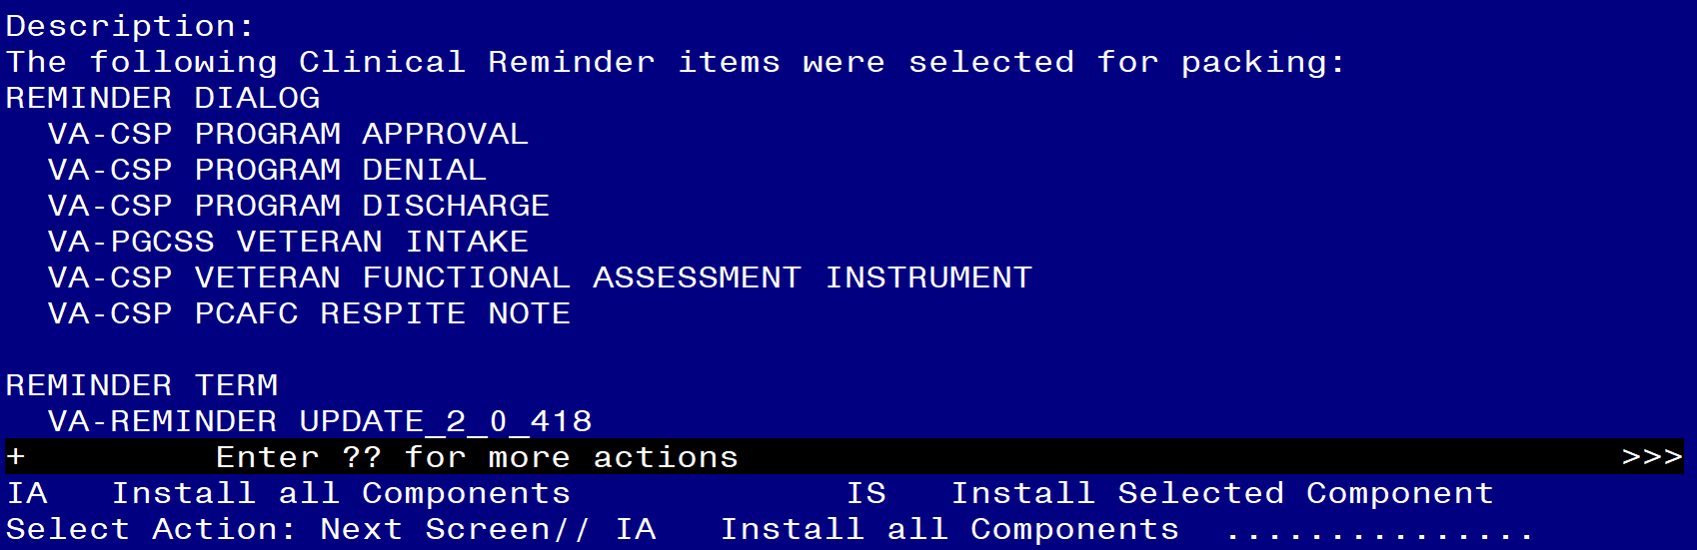

At the **Select Action** prompt, type **IA** for Install all Components and hit enter.

Select Action: Next Screen// IA Install all Components

You will see several prompts, for all new entries you will choose **I to Install**

For components that already exists but the packed component is different, choose **O to Overwrite.**

**You will be prompted to install the FIRST reminder dialog component (VA-CSP PCAFC RESPITE NOTE).** You will choose to install all even though some components may have an X to indicate that they exist.

Regarding theVA-CSP PCAFC RESPITE NOTE: 
Screen shot of the terminal window showing a list of elements, groups and dialogs with the text with IA for "Install All" entered at the "Select Action:" Prompt.  The correct entry is described in the text.

At the **Select Action** prompt, type **IA** to install the dialog: **VA-CSP PCAFC RESPITE NOTE**

Select Action: Next Screen// IA Install All

Install reminder dialog and all components with no further changes: Y// Yes

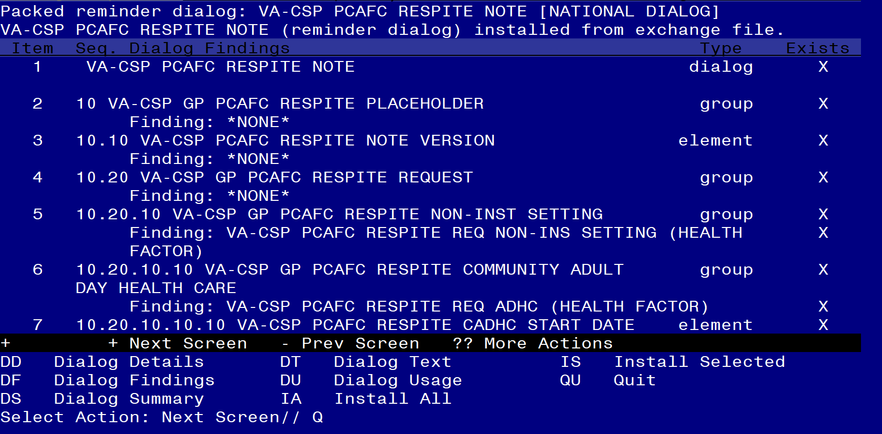

After completing this dialog install, you will type Q.

**You will be prompted to install the next reminder dialog component (VA-CSP VETERAN FUNCTIONAL ASSESSMENT INSTRUMENT).** You will choose to install all even though some components may have an X to indicate that they exist.

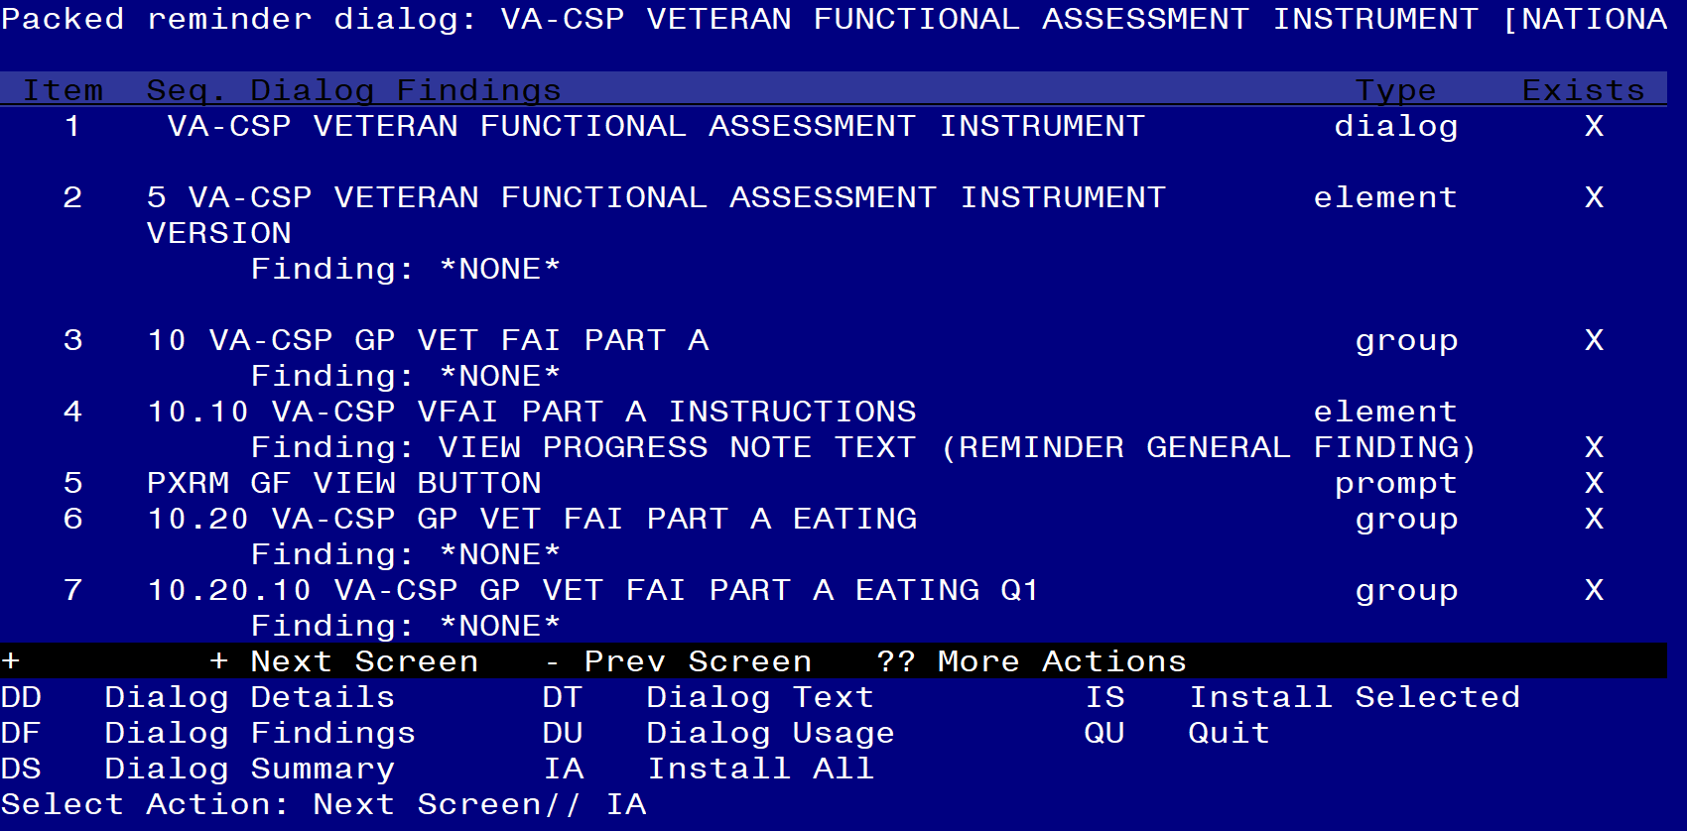

At the **Select Action** prompt, type **IA** to install the dialog: **VA-CSP VETERAN FUNCTIONAL ASSESSMENT INSTRUMENT**

Select Action: Next Screen// IA Install All

Install reminder dialog and all components with no further changes: Y// Yes

Regarding the VA-CSP VETERAN FUNCTIONAL ASSESSMENT INSTRUMENT: Screen shot of the last of the list of elements, groups and dialogs that needed to be installed with a Q for quit entered at the "Select Action:" prompt because they now all exist.  



After completing this dialog install, you will type Q.

**You will be prompted to install the next reminder dialog component (****VA-PGCSS VETERAN INTAKE).** You will choose to install all even though some components may have an X to indicate that they exist.

Regarding the VA-PGCSS VETERAN INTAKE National Dialog:  Screen shot of the terminal window showing a list of elements, groups and dialogs with the text with IA for "Install All" entered at the "Select Action:" Prompt.  The correct entry is described in the text.


At the **Select Action** prompt, type **IA** to install the dialog: **VA-PGCSS VETERAN INTAKE**

Select Action: Next Screen// IA Install All

Install reminder dialog and all components with no further changes: Y// Yes

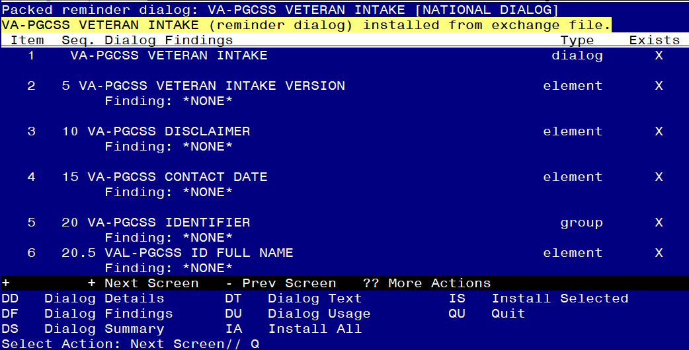

After completing this dialog install, you will type Q.

**You will be prompted to install the next reminder dialog component (VA-CSP PROGRAM DISCHARGE).** You will choose to install all even though some components may have an X to indicate that they exist.

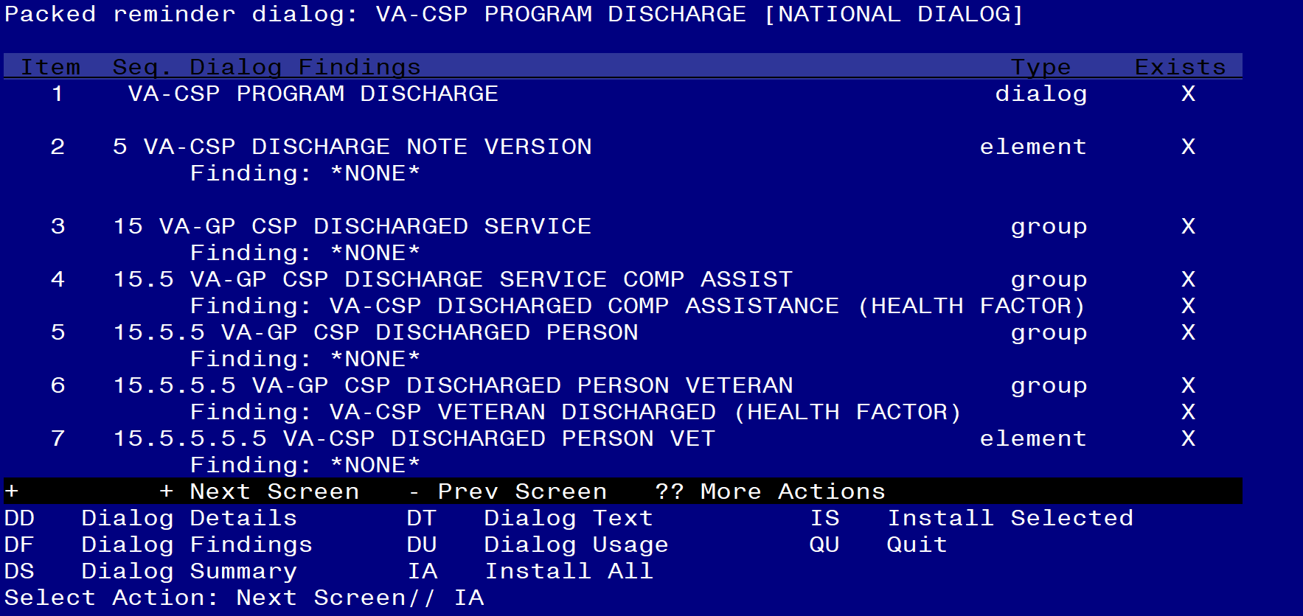

At the **Select Action** prompt, type **IA** to install the dialog: **VA-CSP PROGRAM DISCHARGE**

Select Action: Next Screen// IA Install All

Install reminder dialog and all components with no further changes: Y// Yes

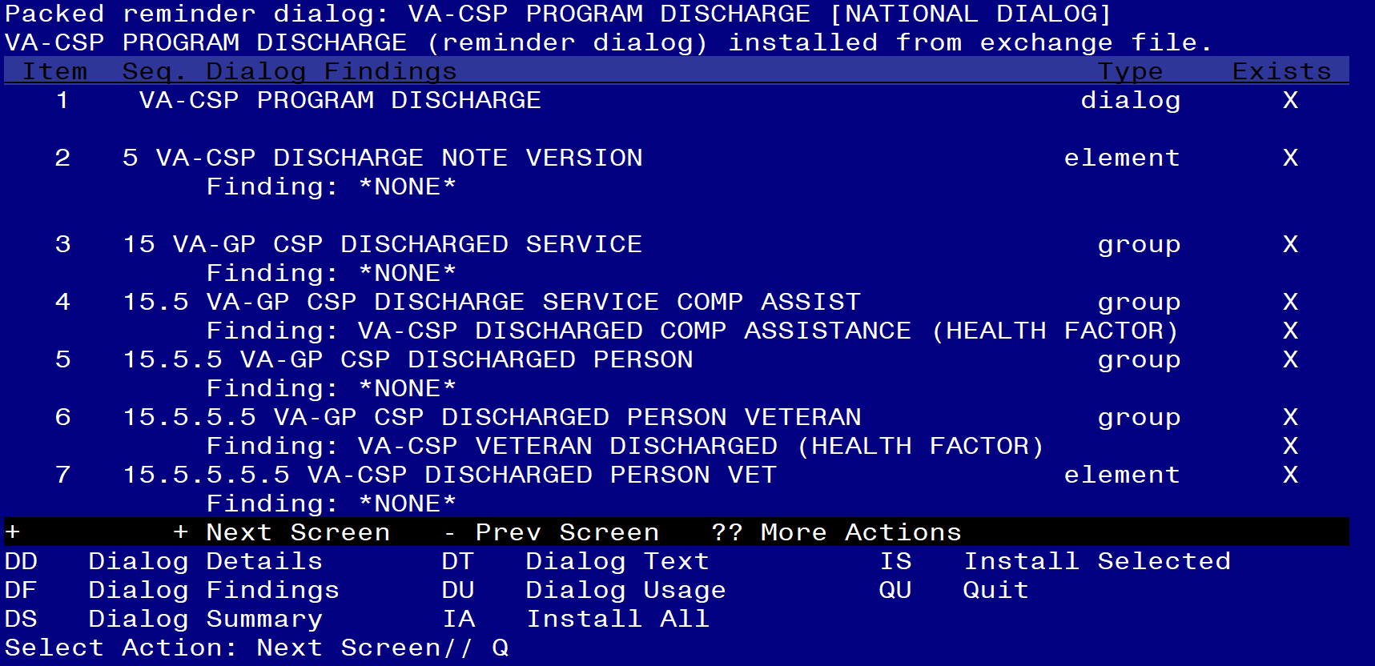

After completing this dialog install, you will type Q.

**You will be prompted to install the next reminder dialog component (VA-CSP PROGRAM DENIAL).** You will choose to install all even though some components may have an X to indicate that they exist.

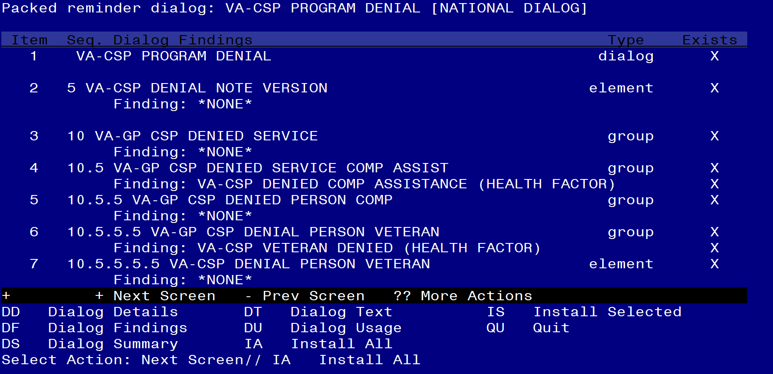

At the **Select Action** prompt, type **IA** to install the dialog: **VA-CSP PROGRAM DENIAL**

Select Action: Next Screen// IA Install All

Install reminder dialog and all components with no further changes: Y// Yes

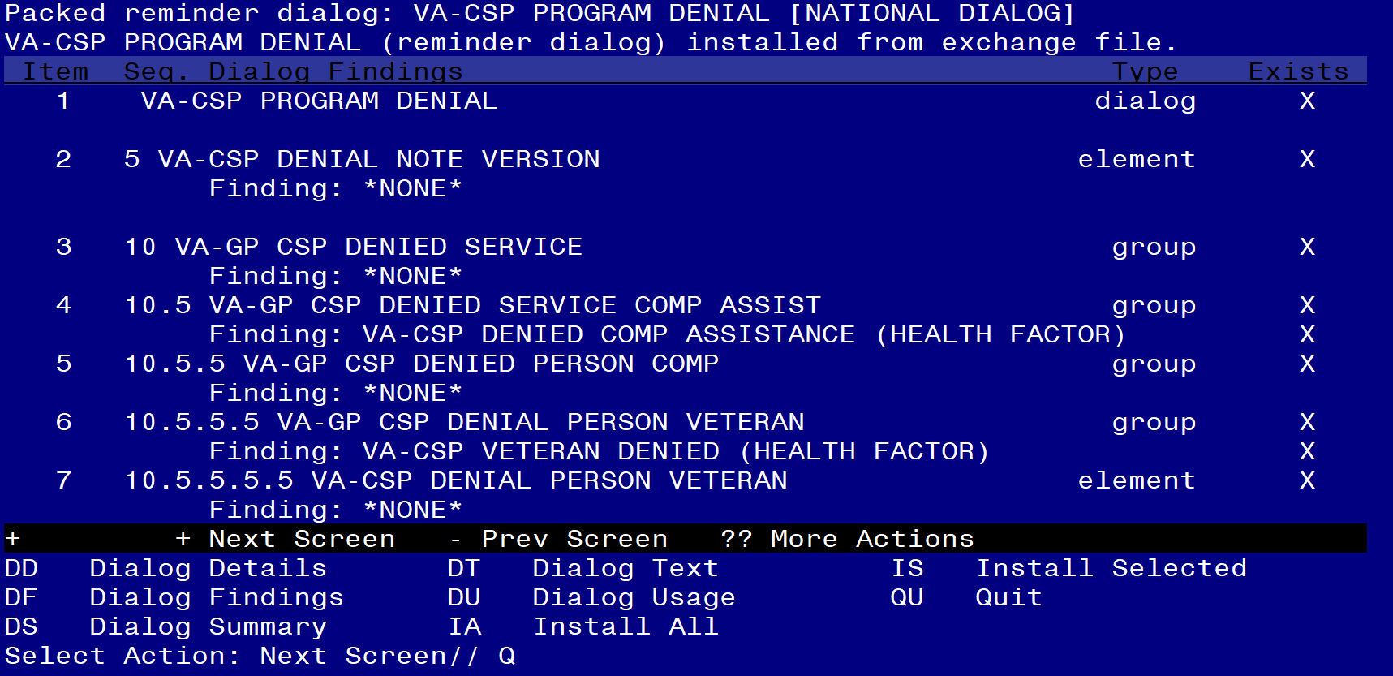

After completing this dialog install, you will type Q.

**You will be prompted to install the next reminder dialog component (VA-CSP PROGRAM APPROVAL).** You will choose to install all even though some components may have an X to indicate that they exist.

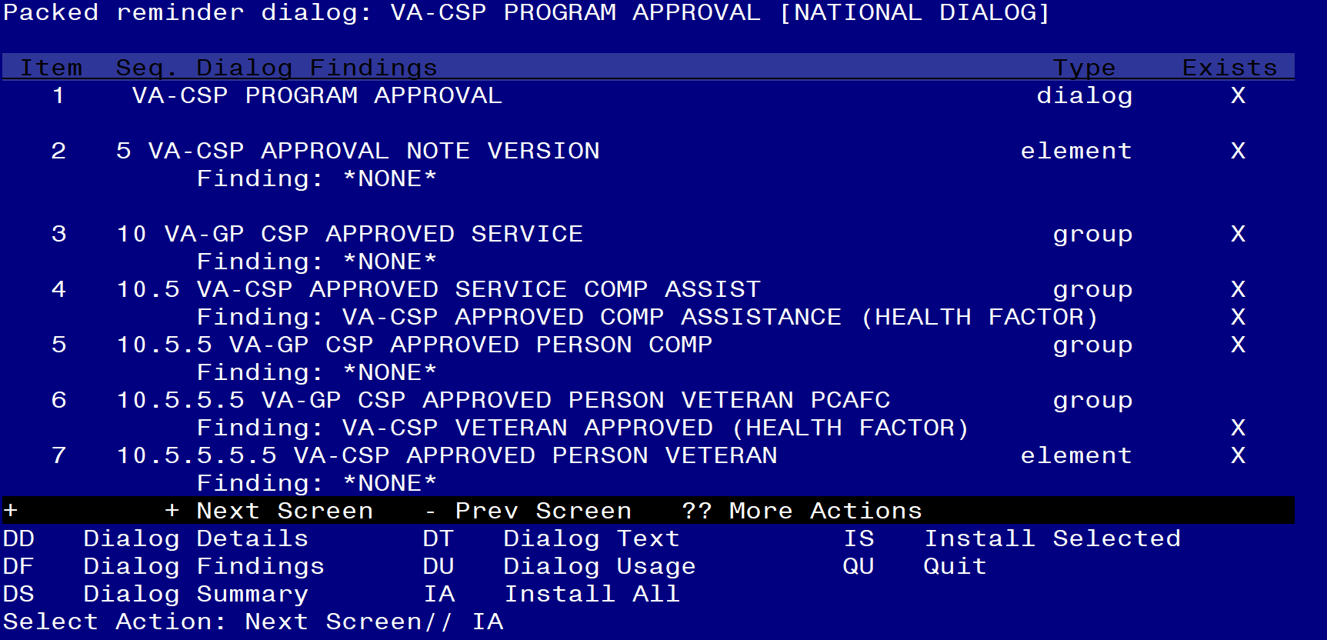

At the **Select Action** prompt, type **IA** to install the dialog: **VA-CSP PROGRAM APPROVAL**

Select Action: Next Screen// IA Install All

Install reminder dialog and all components with no further changes: Y// Yes

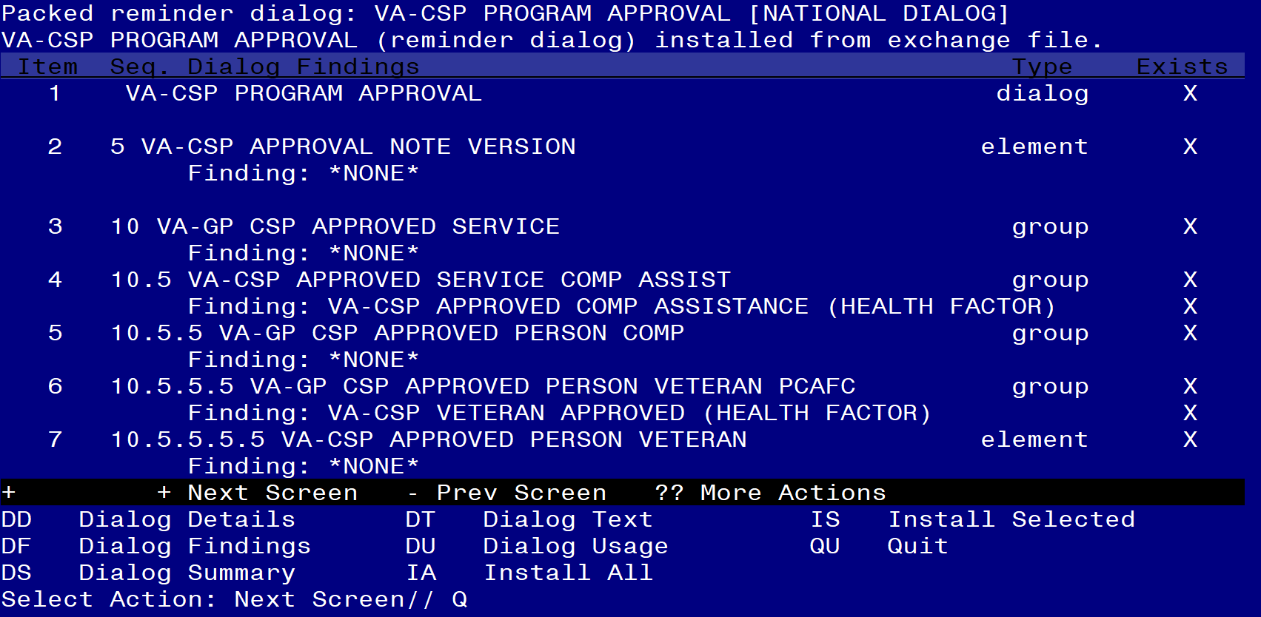

After completing this dialog install, you will type Q.

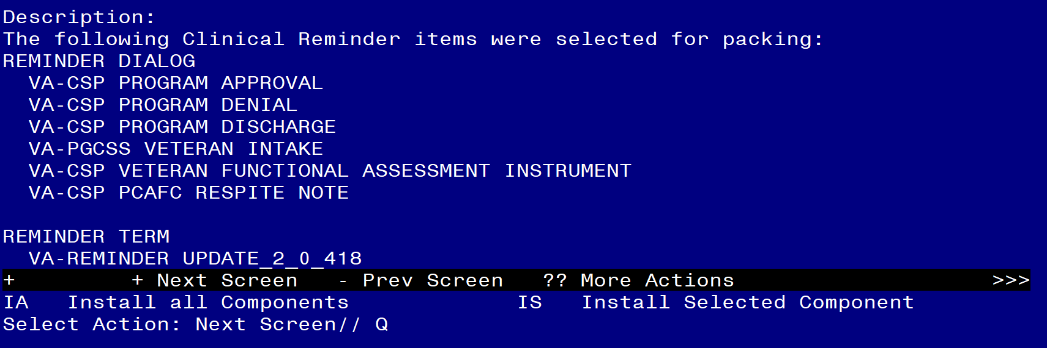

You will then be returned to this screen. At the **Select Action** prompt, type **Q.**

Install complete.

## Post Installation

**Note: This is an update to existing national dialogs, so steps 1-3 likely have already been completed for all dialogs, except the new VA-CSP PCAFC RESPITE NOTE. Confirm the other note titles below are active and linked to the appropriate Reminder Dialogs.**

1. **Make the Dialog template available to be attached to a Personal or Shared template or to be able to attach the dialog to a progress note title.**

Select Reminder Managers Menu <TEST ACCOUNT> Option: **CP** CPRS Reminder Configuration

CA Add/Edit Reminder Categories

CL CPRS Lookup Categories

CS CPRS Cover Sheet Reminder List

MH Mental Health Dialogs Active

PN Progress Note Headers

RA Reminder GUI Resolution Active

TIU TIU Template Reminder Dialog Parameter

DEVL Evaluate Coversheet List on Dialog Finish

DL Default Outside Location

PT Position Reminder Text at Cursor

LINK Link Reminder Dialog to Template

TEST CPRS Coversheet Time Test

NP New Reminder Parameters

GEC GEC Status Check Active

WH WH Print Now Active

Select CPRS Reminder Configuration <TEST ACCOUNT> Option: **TIU** TIU Template Reminder Dialog Parameter

Reminder Dialogs allowed as Templates may be set for the following:

1 User USR [choose from NEW PERSON]

3 Service SRV [choose from SERVICE/SECTION]

4 Division DIV [SALT LAKE CITY]

5 System SYS [NATREM.FO-SLC.MED.VA.GOV]

Enter selection: **5** *Choose the appropriate number for your site. Your site may do this by System or other levels. The example below uses SYSTEM level.*

Setting Reminder Dialogs allowed as Templates for System: NATREM.FO-SLC.MED.VA.GOV

Select Display Sequence: **?**

149 VA-COVID-19 TELEPHONE FOLLOW-UP

160 VA-SRA-CONSULT RESPONSE (D)

*When you type a question mark above, you will see the list of #’s (with dialogs) that are already taken. Choose a number* ***NOT*** *on this list. For this example, 150 is not present so I will use 150.*

Select Display Sequence: **150**

Are you adding 150 as a new Display Sequence? Yes// **Y** YES

Display Sequence: 150// <Enter>

Clinical Reminder Dialog**:VA-CSP PROGRAM DISCHARGE** then **<enter>**

OK? Yes// <Enter>

Select Display Sequence: **151**

Are you adding 151 as a new Display Sequence? Yes// **Y** YES

Display Sequence: 151// <Enter>

Clinical Reminder Dialog**:VA-CSP PROGRAM APPROVAL** then **<enter>**

OK? Yes// <Enter>

Select Display Sequence: **152**

Are you adding 152 as a new Display Sequence? Yes// **Y** YES

Display Sequence: 152// <Enter>

Clinical Reminder Dialog**: VA-CSP PROGRAM DENIAL** then **<enter>**

OK? Yes// <Enter>

Select Display Sequence: **153**

Are you adding 152 as a new Display Sequence? Yes// **Y** YES

Display Sequence: 152// <Enter>

Clinical Reminder Dialog**:VA-PGCSS VETERAN INTAKE** then **<enter>**

OK? Yes// <Enter> (Yes)

Select Display Sequence: **154**

Are you adding 154 as a new Display Sequence? Yes// **Y** YES

Display Sequence: 154// <Enter>

Clinical Reminder Dialog**:** **VA-CSP VETERAN FUNCTIONAL ASSESSMENT INSTRUMENT** then **<enter>**

OK? Yes// <Enter>

Select Display Sequence: **155**

Are you adding 155 as a new Display Sequence? Yes// **Y** YES

Display Sequence: 155// <Enter>

Clinical Reminder Dialog**:** **VA-CSP PCAFC RESPITE NOTE**

then **<enter>**

OK? Yes// <Enter>

1. **Add appropriate TIU objects for patient address and phone number to the VAL-CSP PCAFC VETERAN NAME/SSN dialog element.**

NAME: VAL-CSP PCAFC VETERAN NAME/SSN

DISABLE:

CLASS: LOCAL//

SPONSOR:

REVIEW DATE:

RESOLUTION TYPE:

ORDERABLE ITEM:

FINDING ITEM:

Additional findings: none

Select ADDITIONAL FINDING:

DIALOG/PROGRESS NOTE TEXT:

Veteran address: NEED OBJECT\\

Veteran phone #: NEED OBJECT\\

Edit? NO// **YES**

==[ WRAP ]==[INSERT ]=======< DIALOG/PROGRESS NOTE TE[Press <PF1>H for help]====

Veteran address: NEED OBJECT\\

Veteran phone #: NEED OBJECT\\

Replace the red text with appropriate TIU object.

1. **Setup of Note Titles.**

The note titles to create to associate with this template are:

**CSP APPROVAL NOTE**

**CSP DENIAL NOTE**

**CSP DISCHARGE/REVOCATION NOTE**

**CSP PGCSS VETERAN INTAKE**

**CSP PCAFC VETERAN FUNCTIONAL ASSESSMENT INSTRUMENT CONSULT**

**CSP PCAFC RESPITE NOTE**

VHA Enterprise Standard Title: **CAREGIVER CERTIFICATE**

You can add these to your document class where caregiver notes are located.

***Note:*** *Comprehensive information on Creating new Document Classes and Titles can be found beginning on page 54 of the TIU/ASU Implementation Guide at the following link:* [*http://www.va.gov/vdl/documents/Clinical/CPRS-Text_Integration_Utility_(TIU)/tiuim.pdf*](http://www.va.gov/vdl/documents/Clinical/CPRS-Text_Integration_Utility_(TIU)/tiuim.pdf)

1. **Associate the reminder dialogs with the note title in CPRS**
2. Type in the following information:

Name: **CSP APPROVAL NOTE**

Template Type: Reminder Dialog

Reminder Dialog: **VA-CSP PROGRAM APPROVAL**

Next, type in the Associated Title, which in this case is **CSP APPROVAL NOTE** and hit Apply.

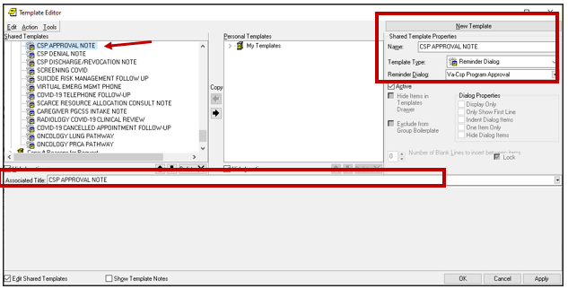

1. Name: **CSP DISCHARGE/REVOCATION NOTE**

Template Type: Reminder Dialog

Reminder Dialog: **VA-CSP PROGRAM DISCHARGE**

Associated Title: **CSP DISCHARGE/REVOCATION NOTE**

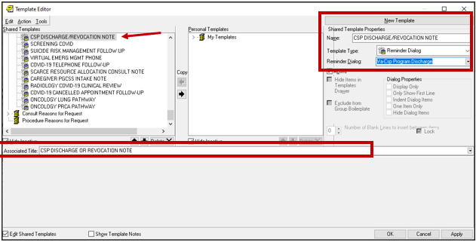

1. Name: **CSP DENIAL NOTE**

Template Type: Reminder Dialog

Reminder Dialog: **VA-CSP PROGRAM DENIAL**

Associated Title: **CSP DENIAL NOTE**

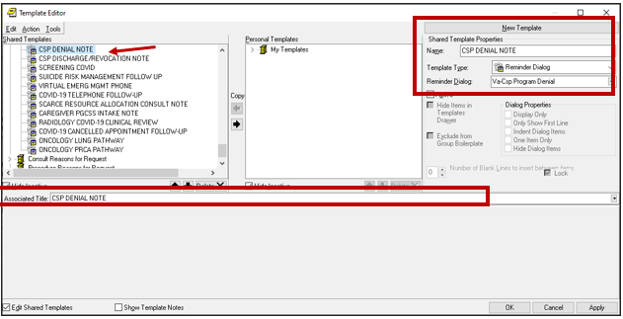

1. Name: **CSP PGCSS VETERAN INTAKE**

Template Type: Reminder Dialog

Reminder Dialog: **VA-PGCSS VETERAN INTAKE**

Associated Title: **CSP PGCSS VETERAN INTAKE**

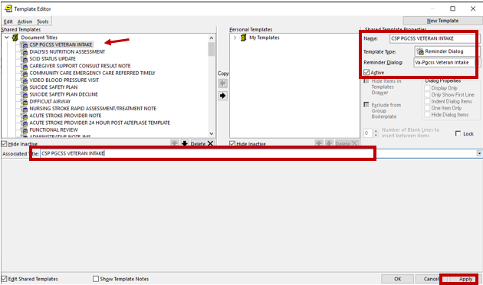

1. Name: **CSP PCAFC VETERAN FUNCTIONAL ASSESSMENT INSTRUMENT CONSULT**

Template Type: Reminder Dialog

Reminder Dialog: **VA-CSP VETERAN FUNCTIONAL ASSESSMENT INSTRUMENT**

Associated Title: **CSP PCAFC VETERAN FUNCTIONAL ASSESSMENT INSTRUMENT CONSULT**

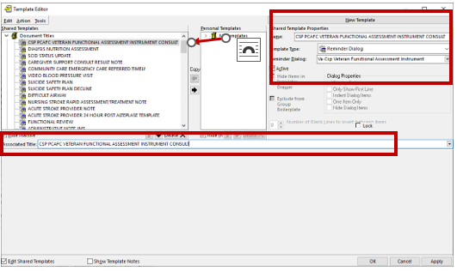

1. Name: **CSP PCAFC RESPITE NOTE**

Template Type: Reminder Dialog

Reminder Dialog: **VA-CSP PCAFC RESPITE NOTE**

Associated Title: **CSP PCAFC RESPITE NOTE**

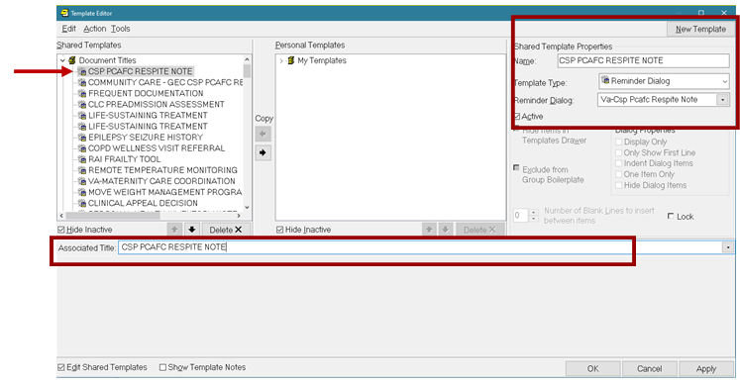

1. **Complete the Community Care – GEC CSP PCAFC Respite Consult creation guide. It is located in the same folder as this installation guide:** Update 418 location inside the VA is redacted.