

Update_2_0_427

Clinical Reminders

VA-SURVIVORS ASSISTANCE AND MEMORIAL SUPPORT TEMPLATES

Install Guide

June 2024

Product Development

Office of Information Technology

Department of Veterans Affairs

Table of Contents

Introduction 1

Install Details 3

Install Example 4

Post Installation 10

## Introduction

VHA is establishing a Survivors Assistance and Memorial Support (SAMS) Program to provide personalized, supportive services to families, caregivers, and survivors at the end of a Veteran's life and ensure Veterans without identified family receive dignified burials to honor their service.

After a Veteran dies while receiving VA care (in a VA facility or while on VA authorized care at a non-VA facility) the decedent affairs clerk contacts the legal next-of-kin within 24 hours to facilitate administrative tasks.

These tasks include:

* Selecting a funeral home.
* Requesting an autopsy.
* Obtaining a copy of the death certificate and adding it to the Veteran’s electronic health record.
* Acquiring additional benefits information to be documented in the Veteran’s electronic health record.

Staff will use the Survivors Assistance and Memorial Support (SAMS) Program templates to document these interactions. The SAMS templates’ function is to standardize and improve the documentation of these interactions.

The measures of success for these three templates are:

* Their adoption across all VA facilities.
* The monitoring quality of data gathered when VA staff:
  + Offer standardized bereavement materials to survivors.
  + Use the required process to determine that a Veteran's remains are unclaimed, and then processing (and documenting) the required steps for handling unclaimed remains.

UPDATE_2_0_427 contains 1 Reminder Exchange entry:

**UPDATE_2_0_427 VA-SURVIVORS ASSISTANCE AND MEMORIAL SUPPORT**

**The exchange file contains the following components:**

**TIU TEMPLATE FIELDS**

VA-WORD

VA-BLANK SP

VA-SAMS LOCATION

VA-DATE ONLY

VA-OTHER TEXT

VA-*

VA-BLANK IN PN TEXT

VA-DATE TIME

VA-EDIT 20/240

**HEALTH FACTORS**

VA-REMINDER UPDATES [C]

VA-UPDATE_2_0_427

VA-SURVIVOR ASSISTANCE AND MEMORIAL SUPPORT (SAMS) [C]

VA-SAMS CHAPLAIN REQUESTED

VA-SAMS FU CONTACT

VA-SAMS INITIAL CONTACT

VA-SAMS CONTACT

VA-SAMS CONTACT THIRD ATTEMPT

VA-SAMS CONTACT SECOND ATTEMPT

VA-SAMS CONTACT FIRST ATTEMPT

VA-SAMS ROLE OTHER

VA-SAMS ROLE FRIEND

VA-SAMS ROLE FAMILY

VA-SAMS ROLE NOK

VA-SAMS MODALITY TELEHEALTH

VA-SAMS MODALITY TELEPHONE

VA-SAMS MODALITY IN PERSON

VA-SAMS CONTACT SAMS SPECIALIST

VA-SAMS CONTACT CLINICAL

VA-SAMS DEATH CERT RECEIVED

VA-SAMS DEATH HUMANITARIAN

VA-SAMS DEATH EXTERNAL

VA-SAMS DEATH AUTHORIZED CARE

VA-SAMS DEATH INPATIENT

VA-SAMS DEATH VA ED

VA-SAMS DEATH CERT TEMPLATE

VA-SAMS ORGAN DONATION NOT ON FILE

VA-SAMS ORGAN DONATION ON FILE

VA-SAMS DEATH CERT REQUESTED

VA-SAMS CITC MANAGER AWARE

VA-SAMS UNCLAIMED RELEASED

VA-SAMS NOK VERBAL CONSENT

VA-SAMS UNCLAIMED UNRELEASED

VA-SAMS FORM 27-2008

VA-SAMS BURIAL FLAG

VA-SAMS UNCLAIMED NATIONAL CEMETERY

VA-SAMS FUNERAL PENDING

VA-SAMS MILITARY DC HONORS NO

VA-SAMS MILITARY DC UNAVAILABLE

VA-SAMS MILITARY DC NOK

VA-SAMS MILITARY DC FUNERAL HOME

VA-SAMS FUNERAL HOME NOTIFICATION

VA-SAMS DISPOSITION GREEN

VA-SAMS DISPOSITION SEA

VA-SAMS DISPOSITION CREMATION

VA-SAMS DISPOSITION BURIAL

VA-SAMS 523 COMPLETED

VA-SAMS AUTOPSY REQUESTED

VA-SAMS DEATH/DISCHARGE NOTE RECEIVED

VA-SAMS CORONOR CASE

VA-SAMS NVA CONTACT

VA-SAMS COD NOT OBTAINED

VA-SAMS COD UNKNOWN

VA-SAMS COD OTHER

VA-SAMS COD HOMICIDE

VA-SAMS COD SUICIDE

VA-SAMS COD ACCIDENTAL

VA-SAMS COD NATURAL

VA-SAMS REMAINS UNCLAIMED

VA-SAMS REMAINS CLAIMED

VA-SAMS CONTACT CERTIFIED LETTER

**REMINDER SPONSORS**

OFFICE OF SOCIAL WORK

**REMINDER TERMS**

VA-REMINDER UPDATE_2_0_427

VA-SAMS EXTERNAL

VA-SAMS VA AUTHORIZED CARE

VA-SAMS CITC

VA-SAMS FUNERAL HOME

VA-SAMS INPATIENT

VA-SAMS COD

VA-SAMS REMAINS UNCLAIMED

**HEALTH SUMMARY COMPONENTS**

PCE HEALTH FACTORS SELECTED

**HEALTH SUMMARY TYPES**

VA-SAMS CONTACT

**HEALTH SUMMARY OBJECTS**

VA-SAMS CONTACT (TIU)

**TIU DOCUMENT DEFINTIONS**

PATIENT DATE OF DEATH

VA-SAMS CONTACT

**REMINDER DIALOGS**

VA-SAMS SURVIVOR CONTACT CLINICAL

VA-SAMS DEATH CERTIFICATE

VA-SAMS SURVIVOR CONTACT SAMS SPECIALIST

## Install Details

This update is being distributed as a web host file. The address for the host file is: **https://REDACTED /UPDATE_2_0_427.PRD**

The file will be installed using Reminder Exchange, programmer access is not required.

Installation:

=============

This update can be loaded with users on the system. Installation will take less than 30 minutes.

## Install Example

To Load the Web Host File. Navigate to Reminder exchange in Vista

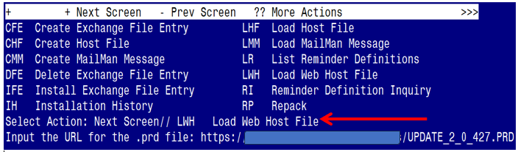

At the **Select Action:** prompt, enter **LWH** for Load Web Host File

At the **Input the url for the .prd file:** prompt, type the following web address:

https://REDACTED/UPDATE_2_0_247.PRD

You should see a message at the top of your screen that the file successfully loaded.

Terminal window screen shot of the message displaying the URL of the file that was successfully loaded.  Part of the URL has been redacted as it is a VA only internal web site URL as shown in the text unless redacted for use outside of the VA.

Search reminder exchange and locate an entry titled:

**UPDATE_2_0_427 VA-SURVIVORS ASSISTANCE AND MEMORIAL SUPPORT**

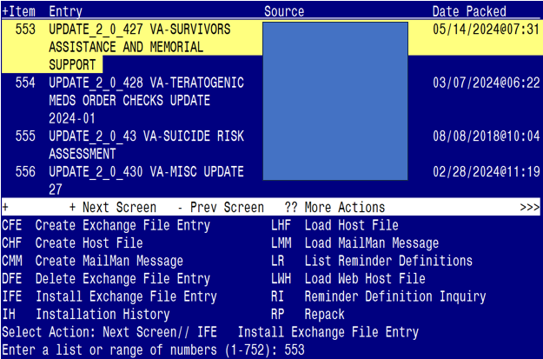

At the **Select Action** prompt, enter **IFE** for Install Exchange File Entry

Enter the number that corresponds with your entry:

UPDATE_2_0_427 VA-SURVIVORS ASSISTANCE AND MEMORIAL SUPPORT

*(In this example it is entry 553. It will vary by site).* The date of the exchange file should be 05/14/2024@07:31.

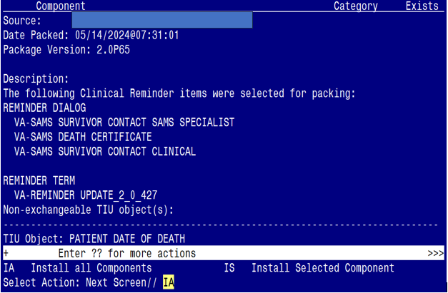

At the **Select Action** prompt, type **IA** for Install all Components and hit enter.

Select Action: Next Screen// IA Install all Components

You will see several prompts:

For all new entries you will choose **I to Install**

For entries that already exist but the packed component is different, choose O to Overwrite

**You will be promped to install the 1st reminder dialog component**

**(VA-SAMS SURVIVOR CONTACT CLINICAL)**

You will install all even though some components may have an X to indicate that they exist.

Regarding VA-SAMS SURVIVOR CONTACT CLINICAL:
Screen shot of the terminal window showing a list of elements, groups and dialogs with the text with IA for "Install All" entered at the "Select Action:" Prompt.  The correct entry is described in the text.

At the **Select Action** prompt, type **IA** to install the dialog:

**VA-SAMS SURVIVOR CONTACT CLINICAL**

Select Action: Next Screen// IA Install All

Install reminder dialog and all components with no further changes: Y// Yes

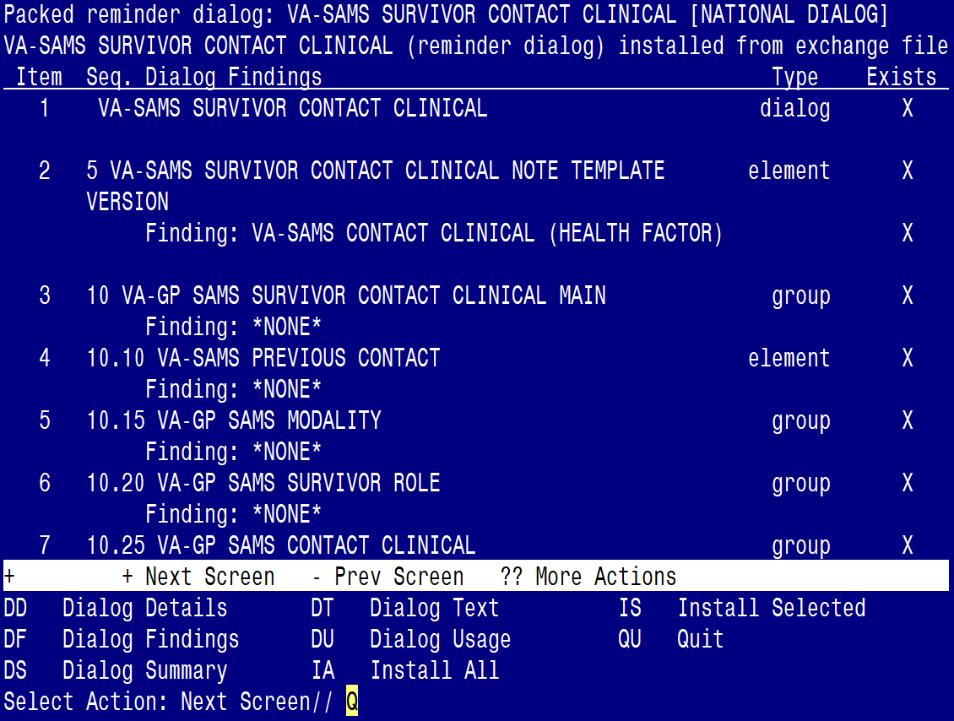

After completing this dialog install, you will type Q.

**You will be promped to install the 2nd reminder dialog component**

**(VA-SAMS DEATH CERTIFICATE)**

You will install all even though some components may have an X to indicate that they exist.

Regarding VA-SAMS DEATH CERTIFICATE:  Screen shot of the terminal window showing a list of elements, groups and dialogs with the text with IA for "Install All" entered at the "Select Action:" Prompt.  The correct entry is described in the text.


At the **Select Action** prompt, type **IA** to install the dialog:

**VA-SAMS DEATH CERTIFICATE**

Select Action: Next Screen// IA Install All

Install reminder dialog and all components with no further changes: Y// Yes

Regarding VA-SAMS DEATH CERTIFICATE:
Screen shot of the last of the list of elements, groups and dialogs that needed to be installed with a Q for quit entered at the "Select Action:" prompt because they now all exist.  

After completing this dialog install, you will type Q.

**You will be promped to install the 3rd reminder dialog component**

**(VA-SAMS SURVIVOR CONTACT SAMS SPECIALIST)**

You will install all even though some components may have an X to indicate that they exist.

Regarding VA-SAMS SURVIVOR CONTACT SAMS SPECIALIST:
Screen shot of the terminal window showing a list of elements, groups and dialogs with the text with IA for "Install All" entered at the "Select Action:" Prompt.  The correct entry is described in the text.

At the **Select Action** prompt, type **IA** to install the dialog:

**VA-SAMS SURVIVOR CONTACT SAMS SPECIALIST**

Select Action: Next Screen// IA Install All

Install reminder dialog and all components with no further changes: Y// Yes

Regarding VA-SAMS SURVIVOR CONTACT SAMS SPECIALIST:
Screen shot of the last of the list of elements, groups and dialogs that needed to be installed with a Q for quit entered at the "Select Action:" prompt because they now all exist.  

After completing this dialog install, you will type Q.

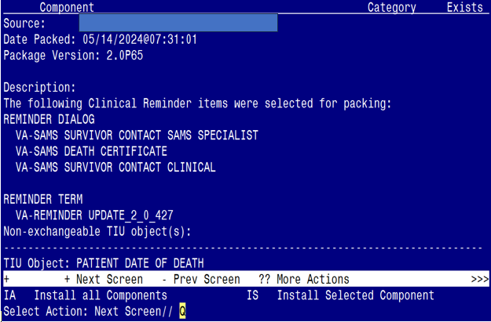

You will then be returned to this screen. At the **Select Action** prompt, type **Q.**

Install complete.

## Post Installation

1. **Make the dialogs available to be attached to Personal or Shared templates and/or to be able to attach to progress note titles.**

From the Reminders Manager Menu:

Select Reminder Managers Menu Option: **CP** CPRS Reminder Configuration

CA Add/Edit Reminder Categories

CL CPRS Lookup Categories

CS CPRS Cover Sheet Reminder List

MH Mental Health Dialogs Active

PN Progress Note Headers

RA Reminder GUI Resolution Active

TIU TIU Template Reminder Dialog Parameter

DL Default Outside Location

PT Position Reminder Text at Cursor

Select CPRS Reminder Configuration Option: **TIU** Template Reminder Dialog Parameter

Reminder Dialogs allowed as Templates may be set for the following:

1 User USR [choose from NEW PERSON]

3 Service SRV [choose from SERVICE/SECTION]

4 Division DIV [choose from INSTITUTION]

5 System SYS [NATREM.FO-SLC.MED.VA.GOV]

Enter selection*:* 5  *Choose the appropriate number for your site. Your site may do this by System or other levels. The example below uses SYSTEM level*

Setting Reminder Dialogs allowed as Templates for System:

Select Display Sequence: **?**

148 VA-VETERANS CHOICE NOTE

149 VA-TBI SCREENING

*When you type a question mark above, you will see the list of #’s (with dialogs) that are already taken. Choose a number* ***NOT*** *on this list. For this example, looking above I see the number 150 is not present, so I will use 150.*

Select Display Sequence: **150**

Are you adding 150 as a new Display Sequence? Yes// **Y** YES

Display Sequence: 150// <Enter> 150

Clinical Reminder Dialog**: VA-SAMS DEATH CERTIFICATE** then **<enter>**

reminder dialog NATIONAL

OK? Yes// <Enter> (Yes)

Select Display Sequence: **151**

Are you adding 151 as a new Display Sequence? Yes// **Y** YES

Display Sequence: 151// <Enter> 151

Clinical Reminder Dialog**: VA-SAMS SURVIVOR CONTACT CLINICAL** then **<enter>**

reminder dialog NATIONAL

OK? Yes// <Enter> (Yes)

Select Display Sequence: **152**

Are you adding 153 as a new Display Sequence? Yes// **Y** YES

Display Sequence: 153// <Enter> 152

Clinical Reminder Dialog**: VA-SAMS SURVIVOR CONTACT SAMS SPECIALIST** then **<enter>**

reminder dialog NATIONAL

OK? Yes// <Enter> (Yes)

1. **Setup of specific Note titles.**

You will need to create three new note titles for these templates, as follows:

**SAMS DEATH CERTIFICATE**

**SAMS SURVIVOR CONTACT CLINICAL**

**SAMS SURVIVOR CONTACT SAMS SPECIALIST**

*All the note titles above are to be mapped to the following VHA Enterprise Standard Title:* **SOCIAL WORK NOTE**

Note: Comprehensive information on Creating Document Definitions can be found beginning on page 47 of the [TIU/ASU Implementation Guide](http://www.va.gov/vdl/documents/Clinical/CPRS-Text_Integration_Utility_(TIU)/tiuim.pdf)

1. **Associate the new reminder dialogs with the note titles in CPRS**

To do this, go to Template Editor, then Document Titles, select the appropriate folder (if applicable), and choose New Template (top right-hand corner).

1. Type in the following information:

Name: **SAMS DEATH CERTIFICATE**

Template Type: Reminder Dialog

Reminder Dialog: **VA-SAMS DEATH CERTIFICATE**

Next, type in the Associated Title, which in this case is **SAMS DEATH CERTIFICATE** and click Apply.

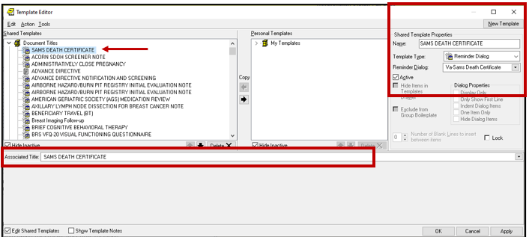

1. Name: **SAMS SURVIVOR CONTACT CLINICAL**

Template Type: Reminder Dialog

Reminder Dialog: **VA-SAMS SURVIVOR CONTACT CLINICAL**

Associated Title: **SAMS SURVIVOR CONTACT CLINICAL**

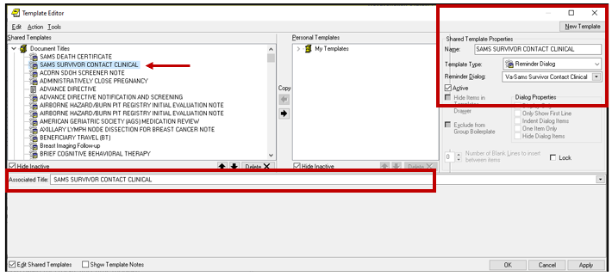

1. Name: **SAMS SURVIVOR CONTACT SAMS SPECIALIST**

Template Type: Reminder Dialog

Reminder Dialog: **VA-SAMS SURVIVOR CONTACT SAMS SPECIALIST**

Associated Title: **SAMS SURVIVOR CONTACT SAMS SPECIALIST**

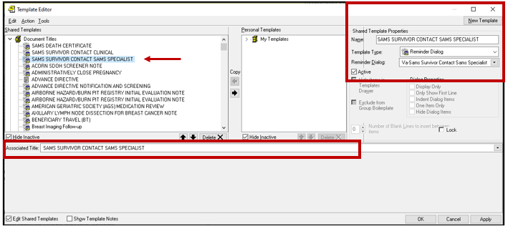

1. **Associate the new three (3) reminder dialogs with a shared template in CPRS**

To do this, go to Template Editor, then Shared Templates, select the appropriate folder (if applicable), and choose New Template (top right-hand corner).

1. Type in the following information:

Name: **SAMS DEATH CERTIFICATE**

Template Type: Reminder Dialog

Reminder Dialog: **VA-SAMS DEATH CERTIFICATE**

Next, select Apply.

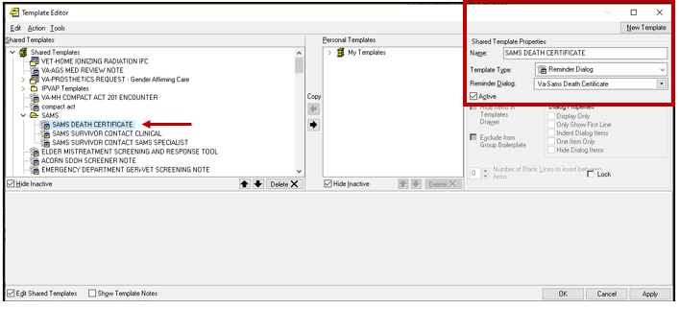

1. Type in the following information:

Name: **SAMS SURVIVOR CONTACT CLINICAL**

Template Type: Reminder Dialog

Reminder Dialog: **VA-SAMS SURVIVOR CONTACT CLINICAL**

Next, select Apply.

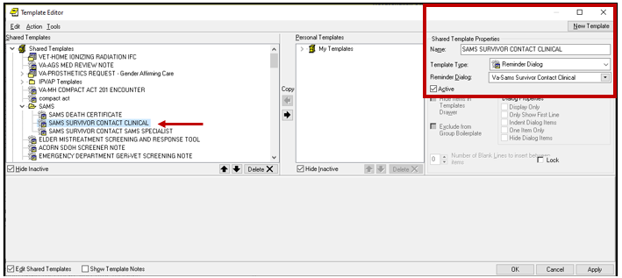

1. Type in the following information:

Name: **SAMS SURVIVOR CONTACT SAMS SPECIALIST**

Template Type: Reminder Dialog

Reminder Dialog: **VA-SAMS SURVIVOR CONTACT SAMS SPECIALIST**

Next, select Apply.

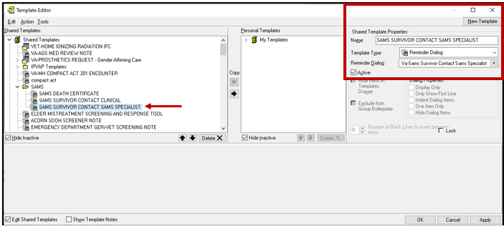

*<< continue to the next page >>*

1. In CPRS, go to 'Edit Template Fields' and enter your facility name in the ITEMS box for following template field: **VA-SAMS LOCATION**

*(note: for integrated sites, you can change the 'type' to combo box and enter your facility names in the 'Items' field)*

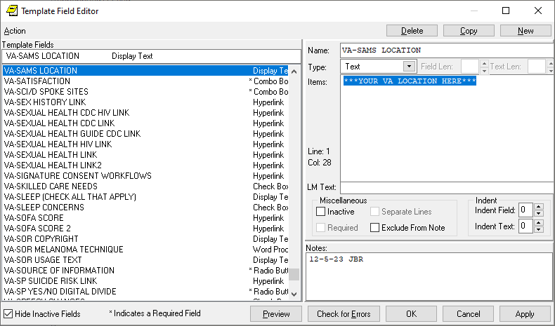

1. Confirm the PATIENT DATE OF DEATH object is included in the Element: VAL-SAMS DATE OF DEATH. If not, add your site's object for Patient Date of Death

Element: **VAL-SAMS DATE OF DEATH**

DIALOG/PROGRESS NOTE TEXT:

|PATIENT DATE OF DEATH|