

Update_2_0_430

Clinical Reminders

VA-MISC Update 27

Install Guide

**April 2024**

Product Development

Office of Information Technology

Department of Veterans Affairs

**Table of Contents**

Introduction 1

Pre-Installation 5

Install Details 6

Install Example 6

Post Installation 27

## Introduction

This update contains minor spelling corrections and other changes/edits to existing clinical reminder content, a full list of the changes can be found here:

**REDACTED LINK**

**UPDATE_2_0_430 contains 1 Reminder Exchange entry:**

UPDATE_2_0_430 VA-MISC UPDATE 27

**The exchange file contains the following components:**

**ROUTINES**

PXRMASU

PXRMPDEM

**MH TESTS AND SURVEYS**

FAST

CDR

GDS DEMENTIA

**REMINDER GENERAL FINDINGS**

VIEW PROGRESS NOTE TEXT

**TIU TEMPLATE FIELDS**

VA-WELLBEING SIGNS LINK

VA-BLANK

NUM REQ

GEN WORD PROCESSING

VA-SAH IA HEAD INJURY TEXT

YES -OR- NO

VA-SAH IA CURRENT MH TX

YES/NO/NA

TEXT (1-20 CHAR)

TEXT (6 CHAR)

TEXT (1-20 CHAR) REQ

VA-NALOXONE PATIENT GUIDE

VA-DATE ONLY R

VA-TEXT (1-50 CHAR)R

VA-ONC OFF REASON TXT

DATE & TIME (REQ)

VANOD PU DESCRIPTIONS

VA-VAAES PREVENTION AND TREATMENT OF PI E-VERSION

VA VANOD ACTIVITIES FOR PRESSURE INJURY IN CLC

VA VANOD FLOW FOR SPINAL CORD

VA VANOD FLOW FOR INPATIENT MENTAL HEALTH

VA VANOD FLOW FOR HBPC PRESSURE INJURIES

VA VANOD FLOW FOR ACUTE PRESSURE INJURIES

VA-WHOLE HEALTH LIBRARY

**HEALTH FACTORS**

VA-M2VA CARE PLAN [C]

VA-M2VA PAIN CARE PATHWAY MOTIVATIONAL INTERVENTION ADDICTION

VA-M2VA PAIN CARE PATHWAY MOTIVATIONAL INTERVENTION PAIN CARE

VA-REMINDER UPDATES [C]

VA-UPDATE_2_0_430

REMINDER FACTORS [C]

LIFE EXPECTANCY <6 MONTHS

VA LIFE EXPECTANCY [C]

VA LIMITED LIFE EXPECTANCY

WH MAMMOGRAM [C]

WH BILATERAL MASTECTOMY

VA-WH BREAST CANCER RISK ASSESSMENT [C]

VA-WH BCRA N/A MALE, NO ESTROGEN 5 YEARS

VA-WH BCRA SERVICE ACT AREA NO

LIFE EXPECTANCY < 1 YEAR

LIFE EXPECTANCY < 6 MONTHS

MENTAL HEALTH [C]

SEVERE CHRONIC COGNITIVE IMPAIRMENT

HOMELESSNESS SCREENING [C]

VA-FOOD ALREADY RECEIVING ASSISTANCE

REFERRED TO DIETICIAN FOOD

REFERRED TO SOCIAL WORK FOOD

NO REFERRALS REQUESTED FOOD

VA-FOOD 12MO ACTUALLY RAN OUT OFTEN

VA-IPVAP/SAH [C]

VA-IPVAP/SAH LEG NOT JUSTICE INVOLVED

VA-IPVAP/SAH LEG JUSTICE INVOLVED

SKIN ASSESSMENT [C]

VA-VAAES SKIN INSPECTION PU/PI NEW

VAAES PI PERI WOUND ERYTHEMA NON-BLANCH

PI PERI WOUND INTACT

PI PERI WOUND USUAL FOR ETHNICITY

PI PERI WOUND SKIN TEMP

PI PERI WOUND FLUCTUANCE

PI PERI WOUND INDURATION

PI PERI WOUND CREPITUS

PI PERI WOUND MACERATION

PI PERI WOUND ERYTHEMA

VA-VAAES PI STAGE 2 #1 WOUND BED TISSUE TYPE - HYPER-PIGMENTATION

VA-VAAES PI STAGE 2 #1 WOUND BED TISSUE TYPE - OTHER

VA-VAAES PI STAGE 2 #1 WOUND BED TISSUE TYPE - RUPTURED BLISTER

VA-VAAES PI STAGE 2 #1 WOUND BED TISSUE TYPE - INTACT BLISTER

VA-VAAES PI STAGE 2 #1 WOUND BED TISSUE TYPE - RED

VA-VAAES PI STAGE 2 #1 WOUND BED TISSUE TYPE - PINK

VA-VAAES PI STAGE 2 #1 WOUND BED TISSUE TYPE - HYPO-PIGMENTATION

VA-VAAES PI STAGE 2 #5 WOUND BED TISSUE TYPE - HYPER-PIGMENTATION

VA-VAAES PI STAGE 2 #5 WOUND BED TISSUE TYPE - OTHER

VA-VAAES PI STAGE 2 #5 WOUND BED TISSUE TYPE - RUPTURED BLISTER

VA-VAAES PI STAGE 2 #5 WOUND BED TISSUE TYPE - INTACT BLISTER

VA-VAAES PI STAGE 2 #5 WOUND BED TISSUE TYPE - RED

VA-VAAES PI STAGE 2 #5 WOUND BED TISSUE TYPE - PINK

VA-VAAES PI STAGE 2 #5 WOUND BED TISSUE TYPE - HYPO-PIGMENTATION

SKIN HIGH RISK FACTORS [C]

MED DEVICE PI STAGE 2 FIFTH

DRAINAGE APPEARANCE VISCOUS

DRAINAGE APPEARANCE SERO-PURULENT

DRAINAGE APPEARANCE PURULENT

DRAINAGE APPEARANCE SANGUINEOUS

DRAINAGE APPEARANCE SEROSANGUINEOUS

DRAINAGE APPEARANCE SEROUS

VA-VAAES DRAINAGE COLOR RED

VA-VAAES DRAINAGE COLOR AMBER

DRAINAGE COLOR GREEN

DRAINAGE COLOR TAN

DRAINAGE COLOR COLORLESS

DRAINAGE AMOUNT SCANT

DRAINAGE AMOUNT HEAVY

DRAINAGE AMOUNT MODERATE

DRAINAGE AMOUNT SMALL

WOUND DRAINAGE

DRAINAGE AMOUNT NONE

PRESSURE ULCER STAGE [C]

STAGE II #5

VA-VAAES PI STAGE 2 #4 WOUND BED TISSUE TYPE - HYPER-PIGMENTATION

VA-VAAES PI STAGE 2 #4 WOUND BED TISSUE TYPE - OTHER

VA-VAAES PI STAGE 2 #4 WOUND BED TISSUE TYPE - RUPTURED BLISTER

VA-VAAES PI STAGE 2 #4 WOUND BED TISSUE TYPE - INTACT BLISTER

VA-VAAES PI STAGE 2 #4 WOUND BED TISSUE TYPE - RED

VA-VAAES PI STAGE 2 #4 WOUND BED TISSUE TYPE - PINK

VA-VAAES PI STAGE 2 #4 WOUND BED TISSUE TYPE - HYPO-PIGMENTATION

MED DEVICE PI STAGE 2 FOURTH

STAGE II #4

VA-VAAES PI STAGE 2 #3 WOUND BED TISSUE TYPE - HYPER-PIGMENTATION

VA-VAAES PI STAGE 2 #3 WOUND BED TISSUE TYPE - OTHER

VA-VAAES PI STAGE 2 #3 WOUND BED TISSUE TYPE - RUPTURED BLISTER

VA-VAAES PI STAGE 2 #3 WOUND BED TISSUE TYPE - INTACT BLISTER

VA-VAAES PI STAGE 2 #3 WOUND BED TISSUE TYPE - RED

VA-VAAES PI STAGE 2 #3 WOUND BED TISSUE TYPE - PINK

VA-VAAES PI STAGE 2 #3 WOUND BED TISSUE TYPE - HYPO-PIGMENTATION

MED DEVICE PI STAGE 2 THIRD

STAGE II #3

VA-VAAES PI STAGE 2 #2 WOUND BED TISSUE TYPE - HYPER-PIGMENTATION

VA-VAAES PI STAGE 2 #2 WOUND BED TISSUE TYPE - OTHER

VA-VAAES PI STAGE 2 #2 WOUND BED TISSUE TYPE - RUPTURED BLISTER

VA-VAAES PI STAGE 2 #2 WOUND BED TISSUE TYPE - INTACT BLISTER

VA-VAAES PI STAGE 2 #2 WOUND BED TISSUE TYPE - RED

VA-VAAES PI STAGE 2 #2 WOUND BED TISSUE TYPE - PINK

VA-VAAES PI STAGE 2 #2 WOUND BED TISSUE TYPE - HYPO-PIGMENTATION

MED DEVICE PI STAGE 2 SECOND

STAGE II #2

MED DEVICE PI STAGE 2

STAGE II

VA-SUICIDE RISK ASSESSMENT [C]

VA-SUICIDE ACTION IMPLEMENT APT TRACKING REMIND

VA-NALOXONE [C]

VA-NALOXONE PATIENT GUIDE

VA-COMMON CARRIER NO ACCESS [C]

VA-COMMON CARRIER NO ACCESS TO POV

VA-COMMON CARRIER ACCESS TO POV

LIFE EXPECTANCY < 5 YEARS

VA-ONC PRCA CSPC M1 PATHWAY [C]

VA-ONC PRCA CSPC M1 LV NO ABI OFF PATH RSN

VA-VAAES LINE [C]

VA-VAAES LINE ASSESS PERI #3 D/C

VA-VAAES PERIPHERAL IV 3 D/C

VA-VAAES LINE ASSESS PERI #3 INSERT

VA-VAAES PERIPHERAL IV 3 INSERT

VA-VAAES LINE ASSESS PERI #2 D/C

VA-VAAES PERIPHERAL IV 2 D/C

VA-VAAES LINE ASSESS PERI #2 INSERT

VA-VAAES PERIPHERAL IV 2 INSERT

VA-VAAES LINE ASSESS PERI #1 D/C

VA-VAAES PERIPHERAL IV 1 D/C

VA-VAAES LINE ASSESS PERI #1 INSERT

VA-VAAES PERIPHERAL IV 1 INSERT

**REMINDER SPONSORS**

VA POST 9/11 TRANSITION AND CASE MANAGEMENT

NATIONAL CENTER FOR HEALTH PROMOTION AND DISEASE PREVENTION (NCP)

MENTAL HEALTH AND BEHAVIORAL SCIENCE STRATEGIC GROUP

MENTAL HEALTH SERVICES

HOMELESSNESS OFFICE

NATIONAL CLINICAL PRACTICE GUIDELINE COUNCIL

OFFICE OF NURSING SERVICE

OFFICE OF TELEHEALTH SERVICES STORE AND FORWARD TELEHEALTH

**REMINDER COMPUTED FINDINGS**

VA-ASU USER CLASS

VA-IS INPATIENT

**REMINDER TAXONOMY**

VA-TERMINAL CANCER PATIENTS

**REMINDER TERMS**

VA-M2VA PAIN CARE PATHWAY MOTIVATIONAL INTERVENTION

VA-REMINDER UPDATE_2_0_430

VA-WH BCRA NOT INDICATED

VA-COGNITIVE IMPAIRMENT

VA-USER CLASS FOR COGNITIVE IMPAIRMENT

VA-VAAES IV LINE#3 DC

VA-VAAES IV LINE#3

VA-VAAES IV LINE#2 DC

VA-VAAES IV LINE#2

VA-VAAES IV LINE#1 DC

VA-VAAES IV LINE#1

**REMINDER DEFINITIONS**

VA-BL NSG PIV #3 INSERT

VA-BL NSG PIV #2 INSERT

VA-BL NSG PIV #1 INSERT

**REMINDER DIALOGS**

VA-GP MISC UPDATE 27

## Pre-Installation

1. From the **Reminder Dialog Management** menu, Inquire/Print (INQ) and capture/save the following two (2) ELEMENTS :

ELEMENT: VAL-OI SOCIAL WORK REFERRAL

ELEMENT: VAL-OI DIETARY REFERRAL

(*Post-install, you will re-map orders that you have mapped as an additional finding)*

1. Check the **Reminder Exchange** Install History (IH) and ensure your facility has installed the following (previously released) Updates:
   * UPDATE_2_0_229A VA-MILITARY SEXUAL TRAUMA SCREENING REMINDER
   * UPDATE_2_0_374 VA-COMMON CARRIER POV ACCESS
   * UPDATE_2_0_404 VA-WHS WELL-BEING SIGNS TEMPLATE UPDATE
   * UPDATE_2_0_417 VA-MISCELLANEOUS UPDATE 26
   * UPDATE_2_0_419 VA-MATERNITY CARE COORDINATION DIALOG UPDATE

## Install Details

This update is being distributed as a web host file. The address for the host file is: **https://REDACTED /UPDATE_2_0_430.PRD**

The file will be installed using Reminder Exchange, programmer access is not required.

Installation:

=============

This update can be loaded with users on the system. Installation will take less than 30 minutes.

## Install Example

To Load the Web Host File. Navigate to Reminder exchange in Vista

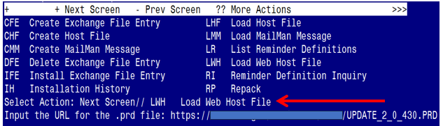

At the **Select Action:** prompt, enter **LWH** for Load Web Host File

At the **Input the url for the .prd file:** prompt, type the following web address:

**https://REDACTED /UPDATE_2_0_430.PRD**

You should see a message at the top of your screen that the file successfully loaded.

Terminal window screen shot of the message displaying the URL of the file that was successfully loaded.  Part of the URL has been redacted as it is a VA only internal web site URL as shown in the text unless redacted for use outside of the VA.

Search for and locate the reminder exchange entry titled UPDATE_2_0_430 VA-MISC UPDATE 27.

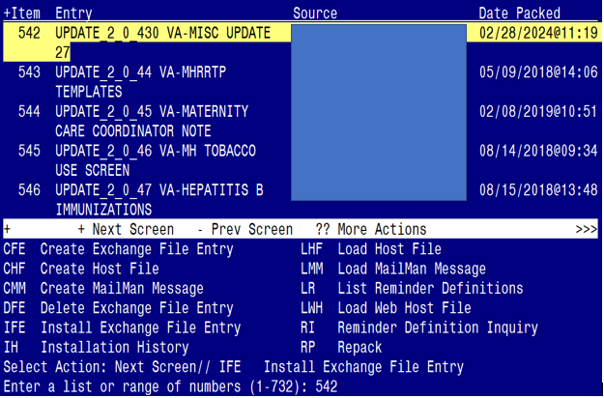

At the **Select Action** prompt, enter **IFE** for Install Exchange File Entry

Enter the number that corresponds with your entry titled **UPDATE_2_0_430 VA-MISC UPDATE 27** *(in this example it is entry 542, it will vary by site).* The exchange file date is 02/28/2024@11:19.

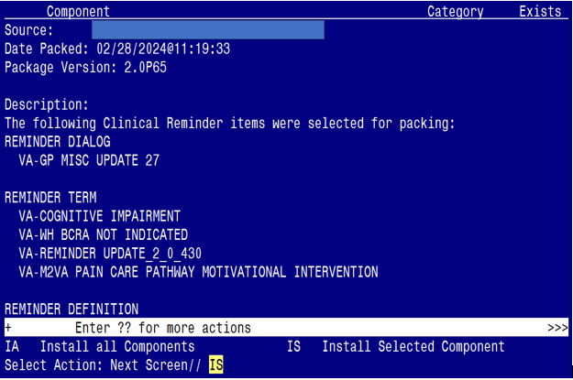

***There is a new reminder sponsor associated with this install. You will need to do an IS to selectively install reminder sponsor **VA POST 9/11 TRANSITION AND CASE MANAGEMENT.** If you don’t install this first, you will receive errors when installing the health factors. Please complete this next step prior to continuing! ***

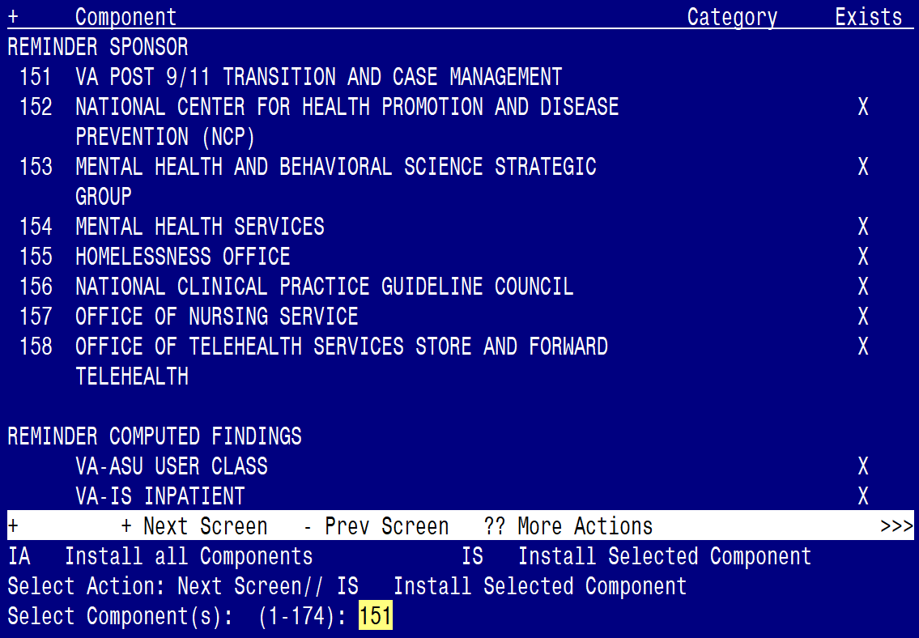

At the **Select Action** prompt, type **IS** for Install Selected Component and hit enter.

At the Select Component, type 152 and hit enter

Select Action: Quit// IS Install Selected Component

Select Component(s): (1-175): 151

REMINDER SPONSOR entry VA POST 9/11 TRANSITION AND CASE MANAGEMENT is NEW,

what do you want to do?

Select one of the following:

C Create a new entry by copying to a new name

I Install

Q Quit the install

S Skip, do not install this entry

Enter response: I// Install

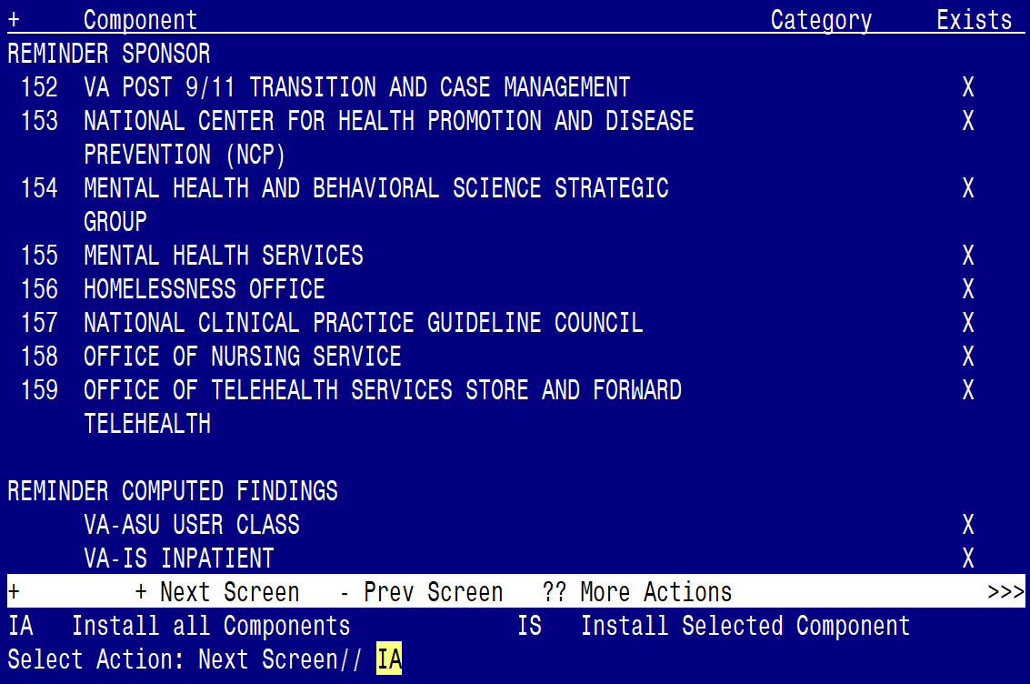

At the **Select Action** prompt, type **IA** for Install all Components and hit enter.

Select Action: Next Screen// IA Install all Components

**You will see several prompts for components. The individual components for which you may (or may not) be prompted are listed below, along with the response you should provide.**

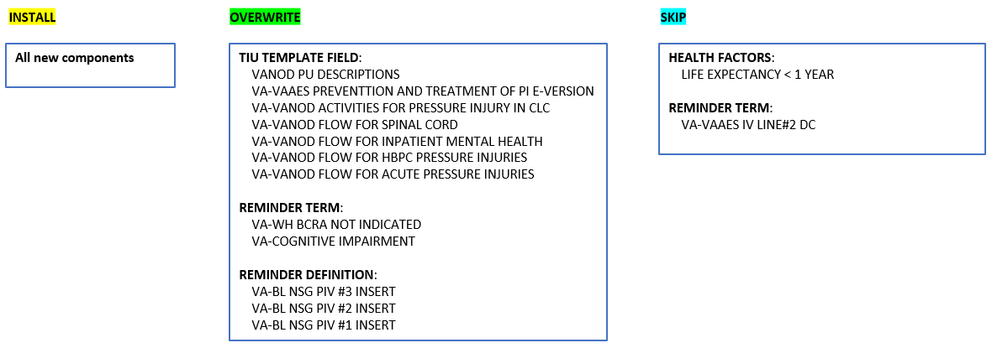

(*The components outlined above are also listed out individually starting on the next page.)*

**Any component NOT listed should be skipped.**

TIU TEMPLATE FIELD entry **VA-WELLBEING SIGNS LINK** is NEW,

what do you want to do?

Select one of the following:

C Create a new entry by copying to a new name

I Install

Q Quit the install

S Skip, do not install this entry

Enter response: I// Install

TIU TEMPLATE FIELD entry named **VANOD PU DESCRIPTIONS** already exists

but the packed component is different, what do you want to do?

Select one of the following:

C Create a new entry by copying to a new name

O Overwrite the current entry

U Update

Q Quit the install

S Skip, do not install this entry

Enter response: O// Overwrite the current entry

Are you sure you want to overwrite? N// YES

TIU TEMPLATE FIELD entry named **VA-VAAES PREVENTION AND TREATMENT OF**

**PI E-VERSION** already exists but the packed component is different,

what do you want to do?

Select one of the following:

C Create a new entry by copying to a new name

O Overwrite the current entry

U Update

Q Quit the install

S Skip, do not install this entry

Enter response: O// Overwrite the current entry

Are you sure you want to overwrite? N// YES

TIU TEMPLATE FIELD entry named **VA VANOD ACTIVITIES FOR PRESSURE**

**INJURY IN CLC** already exists but the packed component is different,

what do you want to do?

Select one of the following:

C Create a new entry by copying to a new name

O Overwrite the current entry

U Update

Q Quit the install

S Skip, do not install this entry

Enter response: O// Overwrite the current entry

Are you sure you want to overwrite? N// YES

TIU TEMPLATE FIELD entry named **VA VANOD FLOW FOR SPINAL CORD** already

exists but the packed component is different, what do you want to do?

Select one of the following:

C Create a new entry by copying to a new name

O Overwrite the current entry

U Update

Q Quit the install

S Skip, do not install this entry

Enter response: O// Overwrite the current entry

Are you sure you want to overwrite? N// YES

TIU TEMPLATE FIELD entry named **VA VANOD FLOW FOR INPATIENT MENTAL**

**HEALTH** already exists but the packed component is different, what do

you want to do?

Select one of the following:

C Create a new entry by copying to a new name

O Overwrite the current entry

U Update

Q Quit the install

S Skip, do not install this entry

Enter response: O// Overwrite the current entry

Are you sure you want to overwrite? N// YES

TIU TEMPLATE FIELD entry named **VA VANOD FLOW FOR HBPC PRESSURE**

**INJURIES** already exists but the packed component is different, what

do you want to do?

Select one of the following:

C Create a new entry by copying to a new name

O Overwrite the current entry

U Update

Q Quit the install

S Skip, do not install this entry

Enter response: O// Overwrite the current entry

Are you sure you want to overwrite? N// YES

TIU TEMPLATE FIELD entry named **VA VANOD FLOW FOR ACUTE PRESSURE**

**INJURIES** already exists but the packed component is different, what

do you want to do?

Select one of the following:

C Create a new entry by copying to a new name

O Overwrite the current entry

U Update

Q Quit the install

S Skip, do not install this entry

Enter response: O// Overwrite the current entry

Are you sure you want to overwrite? N// YES

TIU TEMPLATE FIELD entry **VA-WHOLE HEALTH LIBRARY** is NEW,

what do you want to do?

Select one of the following:

C Create a new entry by copying to a new name

I Install

Q Quit the install

S Skip, do not install this entry

Enter response: I// Install

HEALTH FACTORS entry **VA-M2VA CARE PLAN [C]** is NEW,

what do you want to do?

Select one of the following:

C Create a new entry by copying to a new name

I Install

Q Quit the install

S Skip, do not install this entry

Enter response: I// Install

HEALTH FACTORS entry **VA-M2VA PAIN CARE PATHWAY MOTIVATIONAL INTERVENTION ADDICTION** is NEW, what do you want to do?

Select one of the following:

C Create a new entry by copying to a new name

I Install

Q Quit the install

S Skip, do not install this entry

Enter response: I// Install

HEALTH FACTORS entry **VA-M2VA PAIN CARE PATHWAY MOTIVATIONAL INTERVENTION PAIN CARE** is NEW, what do you want to do?

Select one of the following:

C Create a new entry by copying to a new name

I Install

Q Quit the install

S Skip, do not install this entry

Enter response: I// Install

HEALTH FACTORS entry **VA-UPDATE_2_0_430** is NEW,

what do you want to do?

Select one of the following:

C Create a new entry by copying to a new name

I Install

Q Quit the install

S Skip, do not install this entry

Enter response: I// Install

HEALTH FACTORS entry named **LIFE EXPECTANCY < 1 YEAR** already exists

but the packed component is different, what do you want to do?

Select one of the following:

C Create a new entry by copying to a new name

O Overwrite the current entry

U Update

Q Quit the install

S Skip, do not install this entry

Enter response: O// Skip, do not install this entry

HEALTH FACTORS entry **VA-VAAES PI STAGE 2 #1 WOUND BED TISSUE TYPE -HYPER-PIGMENTATION** is NEW, what do you want to do?

Select one of the following:

C Create a new entry by copying to a new name

I Install

Q Quit the install

S Skip, do not install this entry

Enter response: I// Install

HEALTH FACTORS entry **VA-VAAES PI STAGE 2 #1 WOUND BED TISSUE TYPE - OTHER** is NEW, what do you want to do?

Select one of the following:

C Create a new entry by copying to a new name

I Install

Q Quit the install

S Skip, do not install this entry

Enter response: I// Install

HEALTH FACTORS entry **VA-VAAES PI STAGE 2 #1 WOUND BED TISSUE TYPE - RUPTURED BLISTER** is NEW, what do you want to do?

Select one of the following:

C Create a new entry by copying to a new name

I Install

Q Quit the install

S Skip, do not install this entry

Enter response: I// Install

HEALTH FACTORS entry **VA-VAAES PI STAGE 2 #1 WOUND BED TISSUE TYPE - INTACT BLISTER** is NEW, what do you want to do?

Select one of the following:

C Create a new entry by copying to a new name

I Install

Q Quit the install

S Skip, do not install this entry

Enter response: I// Install

HEALTH FACTORS entry **VA-VAAES PI STAGE 2 #1 WOUND BED TISSUE TYPE - RED** is NEW, what do you want to do?

Select one of the following:

C Create a new entry by copying to a new name

I Install

Q Quit the install

S Skip, do not install this entry

Enter response: I// Install

HEALTH FACTORS entry **VA-VAAES PI STAGE 2 #1 WOUND BED TISSUE TYPE - PINK** is NEW, what do you want to do?

Select one of the following:

C Create a new entry by copying to a new name

I Install

Q Quit the install

S Skip, do not install this entry

Enter response: I// Install

HEALTH FACTORS entry **VA-VAAES PI STAGE 2 #1 WOUND BED TISSUE TYPE - HYPO-PIGMENTATION** is NEW, what do you want to do?

Select one of the following:

C Create a new entry by copying to a new name

I Install

Q Quit the install

S Skip, do not install this entry

Enter response: I// Install

HEALTH FACTORS entry **VA-VAAES PI STAGE 2 #5 WOUND BED TISSUE TYPE -HYPER-PIGMENTATION** is NEW, what do you want to do?

Select one of the following:

C Create a new entry by copying to a new name

I Install

Q Quit the install

S Skip, do not install this entry

Enter response: I// Install

HEALTH FACTORS entry **VA-VAAES PI STAGE 2 #5 WOUND BED TISSUE TYPE - OTHER** is NEW, what do you want to do?

Select one of the following:

C Create a new entry by copying to a new name

I Install

Q Quit the install

S Skip, do not install this entry

Enter response: I// Install

HEALTH FACTORS entry **VA-VAAES PI STAGE 2 #5 WOUND BED TISSUE TYPE - RUPTURED BLISTER** is NEW, what do you want to do?

Select one of the following:

C Create a new entry by copying to a new name

I Install

Q Quit the install

S Skip, do not install this entry

Enter response: I// Install

HEALTH FACTORS entry **VA-VAAES PI STAGE 2 #5 WOUND BED TISSUE TYPE - INTACT BLISTER** is NEW, what do you want to do?

Select one of the following:

C Create a new entry by copying to a new name

I Install

Q Quit the install

S Skip, do not install this entry

Enter response: I// Install

HEALTH FACTORS entry **VA-VAAES PI STAGE 2 #5 WOUND BED TISSUE TYPE - RED** is NEW, what do you want to do?

Select one of the following:

C Create a new entry by copying to a new name

I Install

Q Quit the install

S Skip, do not install this entry

Enter response: I// Install

HEALTH FACTORS entry **VA-VAAES PI STAGE 2 #5 WOUND BED TISSUE TYPE - PINK** is NEW, what do you want to do?

Select one of the following:

C Create a new entry by copying to a new name

I Install

Q Quit the install

S Skip, do not install this entry

Enter response: I// Install

HEALTH FACTORS entry **VA-VAAES PI STAGE 2 #5 WOUND BED TISSUE TYPE - HYPO-PIGMENTATION** is NEW, what do you want to do?

Select one of the following:

C Create a new entry by copying to a new name

I Install

Q Quit the install

S Skip, do not install this entry

Enter response: I// Install

HEALTH FACTORS entry **VA-VAAES PI STAGE 2 #4 WOUND BED TISSUE TYPE -HYPER-PIGMENTATION** is NEW, what do you want to do?

Select one of the following:

C Create a new entry by copying to a new name

I Install

Q Quit the install

S Skip, do not install this entry

Enter response: I// Install

HEALTH FACTORS entry **VA-VAAES PI STAGE 2 #4 WOUND BED TISSUE TYPE - OTHER** is NEW, what do you want to do?

Select one of the following:

C Create a new entry by copying to a new name

I Install

Q Quit the install

S Skip, do not install this entry

Enter response: I// Install

HEALTH FACTORS entry **VA-VAAES PI STAGE 2 #4 WOUND BED TISSUE TYPE - RUPTURED BLISTER** is NEW, what do you want to do?

Select one of the following:

C Create a new entry by copying to a new name

I Install

Q Quit the install

S Skip, do not install this entry

Enter response: I// Install

HEALTH FACTORS entry **VA-VAAES PI STAGE 2 #4 WOUND BED TISSUE TYPE - INTACT BLISTER** is NEW, what do you want to do?

Select one of the following:

C Create a new entry by copying to a new name

I Install

Q Quit the install

S Skip, do not install this entry

Enter response: I// Install

HEALTH FACTORS entry **VA-VAAES PI STAGE 2 #4 WOUND BED TISSUE TYPE - RED** is NEW, what do you want to do?

Select one of the following:

C Create a new entry by copying to a new name

I Install

Q Quit the install

S Skip, do not install this entry

Enter response: I// Install

HEALTH FACTORS entry **VA-VAAES PI STAGE 2 #4 WOUND BED TISSUE TYPE - PINK** is NEW, what do you want to do?

Select one of the following:

C Create a new entry by copying to a new name

I Install

Q Quit the install

S Skip, do not install this entry

Enter response: I// Install

HEALTH FACTORS entry **VA-VAAES PI STAGE 2 #4 WOUND BED TISSUE TYPE - HYPO-PIGMENTATION** is NEW, what do you want to do?

Select one of the following:

C Create a new entry by copying to a new name

I Install

Q Quit the install

S Skip, do not install this entry

Enter response: I// Install

HEALTH FACTORS entry **VA-VAAES PI STAGE 2 #3 WOUND BED TISSUE TYPE -HYPER-PIGMENTATION** is NEW, what do you want to do?

Select one of the following:

C Create a new entry by copying to a new name

I Install

Q Quit the install

S Skip, do not install this entry

Enter response: I// Install

HEALTH FACTORS entry **VA-VAAES PI STAGE 2 #3 WOUND BED TISSUE TYPE - OTHER** is NEW, what do you want to do?

Select one of the following:

C Create a new entry by copying to a new name

I Install

Q Quit the install

S Skip, do not install this entry

Enter response: I// Install

HEALTH FACTORS entry **VA-VAAES PI STAGE 2 #3 WOUND BED TISSUE TYPE - RUPTURED BLISTER** is NEW, what do you want to do?

Select one of the following:

C Create a new entry by copying to a new name

I Install

Q Quit the install

S Skip, do not install this entry

Enter response: I// Install

HEALTH FACTORS entry **VA-VAAES PI STAGE 2 #3 WOUND BED TISSUE TYPE - INTACT BLISTER** is NEW, what do you want to do?

Select one of the following:

C Create a new entry by copying to a new name

I Install

Q Quit the install

S Skip, do not install this entry

Enter response: I// Install

HEALTH FACTORS entry **VA-VAAES PI STAGE 2 #3 WOUND BED TISSUE TYPE - RED** is NEW, what do you want to do?

Select one of the following:

C Create a new entry by copying to a new name

I Install

Q Quit the install

S Skip, do not install this entry

Enter response: I// Install

HEALTH FACTORS entry **VA-VAAES PI STAGE 2 #3 WOUND BED TISSUE TYPE - PINK** is NEW, what do you want to do?

Select one of the following:

C Create a new entry by copying to a new name

I Install

Q Quit the install

S Skip, do not install this entry

Enter response: I// Install

HEALTH FACTORS entry **VA-VAAES PI STAGE 2 #3 WOUND BED TISSUE TYPE - HYPO-PIGMENTATION** is NEW, what do you want to do?

Select one of the following:

C Create a new entry by copying to a new name

I Install

Q Quit the install

S Skip, do not install this entry

Enter response: I// Install

HEALTH FACTORS entry **VA-VAAES PI STAGE 2 #2 WOUND BED TISSUE TYPE -HYPER-PIGMENTATION** is NEW, what do you want to do?

Select one of the following:

C Create a new entry by copying to a new name

I Install

Q Quit the install

S Skip, do not install this entry

Enter response: I// Install

HEALTH FACTORS entry **VA-VAAES PI STAGE 2 #2 WOUND BED TISSUE TYPE - OTHER** is NEW, what do you want to do?

Select one of the following:

C Create a new entry by copying to a new name

I Install

Q Quit the install

S Skip, do not install this entry

Enter response: I// Install

HEALTH FACTORS entry **VA-VAAES PI STAGE 2 #2 WOUND BED TISSUE TYPE - RUPTURED BLISTER** is NEW, what do you want to do?

Select one of the following:

C Create a new entry by copying to a new name

I Install

Q Quit the install

S Skip, do not install this entry

Enter response: I// Install

HEALTH FACTORS entry **VA-VAAES PI STAGE 2 #2 WOUND BED TISSUE TYPE - INTACT BLISTER** is NEW, what do you want to do?

Select one of the following:

C Create a new entry by copying to a new name

I Install

Q Quit the install

S Skip, do not install this entry

Enter response: I// Install

HEALTH FACTORS entry **VA-VAAES PI STAGE 2 #2 WOUND BED TISSUE TYPE - RED** is NEW, what do you want to do?

Select one of the following:

C Create a new entry by copying to a new name

I Install

Q Quit the install

S Skip, do not install this entry

Enter response: I// Install

HEALTH FACTORS entry **VA-VAAES PI STAGE 2 #2 WOUND BED TISSUE TYPE - PINK** is NEW, what do you want to do?

Select one of the following:

C Create a new entry by copying to a new name

I Install

Q Quit the install

S Skip, do not install this entry

Enter response: I// Install

HEALTH FACTORS entry **VA-VAAES PI STAGE 2 #2 WOUND BED TISSUE TYPE - HYPO-PIGMENTATION** is NEW, what do you want to do?

Select one of the following:

C Create a new entry by copying to a new name

I Install

Q Quit the install

S Skip, do not install this entry

Enter response: I// Install

HEALTH FACTORS entry **VA-SUICIDE ACTION IMPLEMENT APT TRACKING REMIND** is NEW,

what do you want to do?

Select one of the following:

C Create a new entry by copying to a new name

I Install

Q Quit the install

S Skip, do not install this entry

Enter response: I// Install

HEALTH FACTORS entry **VA-NALOXONE PATIENT GUIDE** is NEW,

what do you want to do?

Select one of the following:

C Create a new entry by copying to a new name

I Install

Q Quit the install

S Skip, do not install this entry

Enter response: I// Install

REMINDER TERM entry **VA-M2VA PAIN CARE PATHWAY MOTIVATIONAL INTERVENTION** is NEW, what do you want to do?

Select one of the following:

C Create a new entry by copying to a new name

I Install

Q Quit the install

S Skip, do not install this entry

Enter response: I// Install

REMINDER TERM entry **VA-REMINDER UPDATE_2_0_430** is NEW,

what do you want to do?

Select one of the following:

C Create a new entry by copying to a new name

I Install

Q Quit the install

S Skip, do not install this entry

Enter response: I// Install

REMINDER TERM entry named **VA-WH BCRA NOT INDICATED** already exists but

the packed component is different, what do you want to do?

Select one of the following:

C Create a new entry by copying to a new name

M Merge findings

O Overwrite the current entry

U Update

Q Quit the install

S Skip, do not install this entry

Enter response: O// Overwrite the current entry

Are you sure you want to overwrite? N// YES

REMINDER TERM entry named **VA-COGNITIVE IMPAIRMENT** already exists but

the packed component is different, what do you want to do?

Select one of the following:

C Create a new entry by copying to a new name

M Merge findings

O Overwrite the current entry

U Update

Q Quit the install

S Skip, do not install this entry

Enter response: O// Overwrite the current entry

Are you sure you want to overwrite? N// YES

REMINDER TERM entry named **VA-VAAES IV LINE#2 DC** already exists but

the packed component is different, what do you want to do?

Select one of the following:

C Create a new entry by copying to a new name

M Merge findings

O Overwrite the current entry

U Update

Q Quit the install

S Skip, do not install this entry

Enter response: O// Skip, do not install this entry

REMINDER DEFINITION entry named **VA-BL NSG PIV #3 INSERT** already exists

but the packed component is different, what do you want to do?

Select one of the following:

C Create a new entry by copying to a new name

O Overwrite the current entry

U Update

Q Quit the install

S Skip, do not install this entry

Enter response: O// Overwrite the current entry

Are you sure you want to overwrite? N// YES

REMINDER DEFINITION entry named **VA-BL NSG PIV #2 INSERT** already exists

but the packed component is different, what do you want to do?

Select one of the following:

C Create a new entry by copying to a new name

O Overwrite the current entry

U Update

Q Quit the install

S Skip, do not install this entry

Enter response: O// Overwrite the current entry

Are you sure you want to overwrite? N// YES

REMINDER DEFINITION entry named **VA-BL NSG PIV #1 INSERT** already exists

but the packed component is different, what do you want to do?

Select one of the following:

C Create a new entry by copying to a new name

O Overwrite the current entry

U Update

Q Quit the install

S Skip, do not install this entry

Enter response: O// Overwrite the current entry

Are you sure you want to overwrite? N// YES

**You will be promped to install the dialog component:**

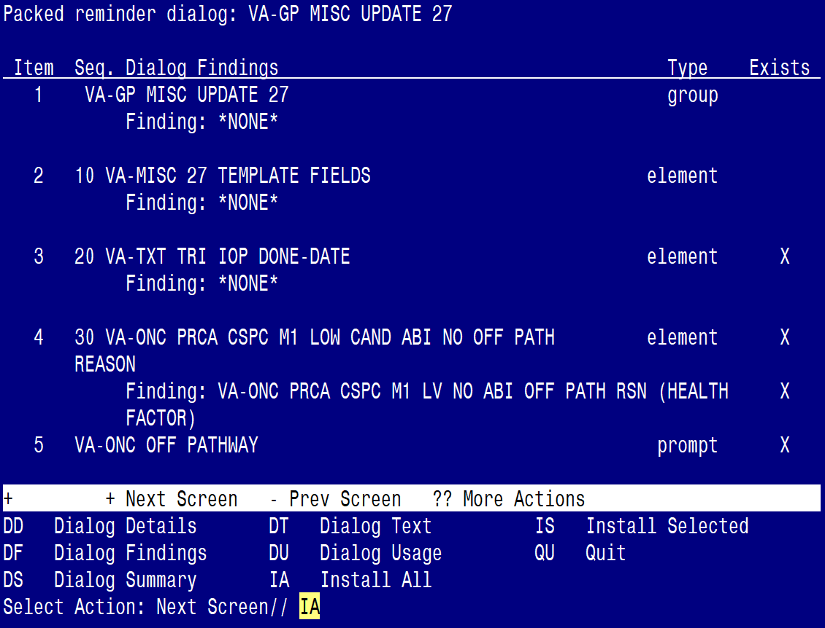

At the **Select Action** prompt, type **IA** to install the dialog – **VA-GP MISC UPDATE 27**

Select Action: Next Screen// IA Install All

Install reminder dialog and all components with no further changes: Y// ES

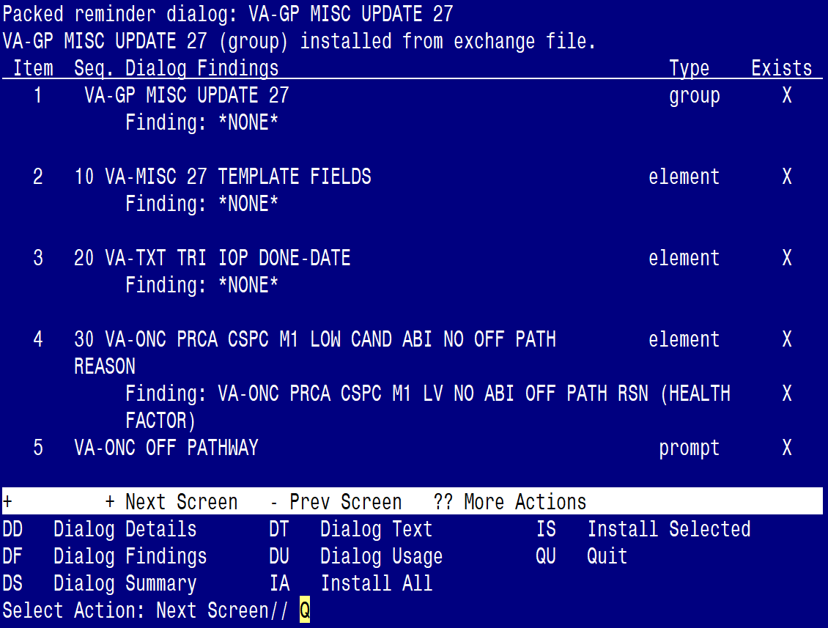

When the dialog has completed installation, you will then be returned to this screen. At the **Select Action** prompt, type **Q.**

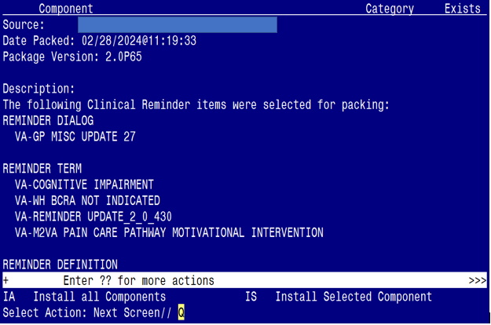

You will be returned to this screen. Type Q to quit.

Install Completed

## Post Installation

1. Refer to the Inquire/Print (INQ) you saved during the Pre-Installation steps for the following two (2) ELEMENTS:

*(Map the quick orders identified in the pre-installation step to the element’s additional finding)*

Element: **VAL-OI SOCIAL WORK REFERRAL**

FINDING ITEM:

Additional findings:

Select ADDITIONAL FINDING: Enter “Q.”, then name of local consult quick order

Element: **VAL-OI DIETARY REFERRAL**

FINDING ITEM:

Additional findings:

Select ADDITIONAL FINDING: Enter “Q.”, then name of local consult quick order

1. Locate the group: **VAL-GP MCC ALCOHOL USE SCREEN CR MAIN**
   1. In VISTA, navigate to the Reminder Dialog Management. Select Reminder Dialogs (DI), then Change View (CV) to Dialog Group View
   2. Locate the group titled: VAL-GP MCC ALCOHOL USE SCREEN CR MAIN
   3. Replace the group in Sequence 10 to be: VA-ALCOHOL SCREENING VERSION
   4. Remove/Delete Sequence 20: VAL-GP ALC SCREEN AUDC

*(note: leave the other sequences as-is)*

NAME: **VAL-GP MCC ALCOHOL USE SCREEN CR MAIN**

DISABLE: **<enter>**

CLASS: LOCAL// **<enter>**

SPONSOR: **<enter>**

REVIEW DATE: **<enter>**

RESOLUTION TYPE: **<enter>**

ORDERABLE ITEM: **<enter>**

FINDING ITEM: **<enter>**

Additional findings: **<enter>**none

Select ADDITIONAL FINDING: **<enter>**

GROUP CAPTION: **<enter>**

PUT A BOX AROUND THE GROUP: **<enter>**

SHARE COMMON PROMPTS: **<enter>**

MULTIPLE SELECTION: **<enter>**

HIDE/SHOW GROUP: **<enter>**

GROUP HEADER DIALOG TEXT:

Edit? NO// **<enter>**

GROUP HEADER ALTERNATE P/N TEXT:

Edit? NO// **<enter>**

EXCLUDE FROM PROGRESS NOTE: YES// **<enter>**

SUPPRESS CHECKBOX: **<enter>**

NUMBER OF INDENTS: **<enter>**

INDENT PROGRESS NOTE TEXT: <**enter>**

Select SEQUENCE: **10**

DIALOG ELEMENT: **VA-TEXT ALCOHOL MISUSE SCREEN INSTRUCTIONS *<< Replace***

// VA-ALCOHOL SCREENING VERSION ***<< with***

...OK? Yes//

EXCLUDE FROM PN TEXT: **<enter>**

Select SEQUENCE: **20** VAL-GP ALC SCREEN AUDC

SEQUENCE: 20// **@**

SURE YOU WANT TO DELETE THE ENTIRE '20' SEQUENCE? **Y**

Select SEQUENCE: **<enter>**

Select BRANCHING LOGIC SEQUENCE: **<enter>**

Checking reminder dialog for errors

NO ERRORS FOUND

Input your edit comments.

Edit? NO//**<enter>**

The group VAL-GP MCC ALCOHOL USE SCREEN CR MAIN will now have the following sequences when you complete this step:

10 VA-ALCOHOL SCREENING VERSION

30 TEXT BLANK LINE WITH TEMPLATE FIELD

40 VA-TEXT SUD CPG URL

50 TEXT BLANK LINE WITH TEMPLATE FIELD