

Update_2_0_444

Clinical Reminders

VA-Community Care Template Update

Install Guide

**May 2024**

Product Development

Office of Information Technology

Department of Veterans Affairs

**Table of Contents**

Introduction 1

Install Details 5

Pre-Install 5

Post Installation 9

## Introduction

The Community Care-Emer Self Presenting Care Coord Plan Note and Community Care-Care Coordination Plan Note are being updated to address the completion of the Suicidal Behavior and Overdose Report (SBOR) note for reported overdose or suicide events.  This update will align with Appendix F, Overdose Reporting and Response per VHA Directive **1160.04 VHA PROGRAMS FOR VETERANS WITH SUBSTANCE USE DISORDERS**.

Additional health factors were also added to these notes.

Both templates were updated to be Version 3.2.

The Office of Community Care will provide training for staff using the updated templates.

**UPDATE_2_0_444 contains 1 Reminder Exchange entry:**

UPDATE_2_0_444 VA-COMMUNITY CARE TEMPLATE UPDATE

**The exchange file contains the following components:**

**REMINDER GEERAL FINDINGS**

VIEW PROGRESS NOTE TEXT

**TIU TEMPLATE FIELD**

DATE & TIME (REQ)

WORD 2 LINES1 REQ

WP 2/74

DATE & TIME

ENTER DATE/TIME

OTHER

DATE (*)

GEN WORD PROCESSING

WORD PROCESSING - 2 LINES

TEXT NOTES:

TEXT (1-30 CHAR) REQ

TEXT (1-50 CHAR)

TEXT (1-60 CHAR)R

SELECT ONE

TEXT (1-20 CHAR)

TEXT 30 CHAR (REQ)

TEXT (1-30 CHAR)

TEXT (1-60 CHAR)REQUIRED

GEN TEXT BOX 20 SPACES

GEN BED TYPE

GEN TEXT BOX 25

GEN TEXT BOX 50

WP 1 LINE REQ1

CC CARE COORD PLAN INSTRUCTIONS

WP 1 LINE REQ

TEXT (1-40 CHAR)

RB CC APPT TBD

DATE

NVCC VA/NON VA

GEN TEXT 5 SPACES

GEN TEXT BOX 2 SP

TEXT (1-40 CHAR) REQ

TEXT VA-NVCC OTHER CLINIC

TEXT (1-20 CHAR) REQ

TEXT (1-20 CHAR REQ)

OPTIONAL TEXT

TEXT VENDOR REASON TO CONTACT

DATE (REQ)

TEXT VENDOR NAME

TEXT (1-60 CHARACTERS) REQ

TEXT ENTER DM MGMT

TEXT ENTER CM MGMT

DATE

ENTER PROVIDER

RB CARE COORD CSR LOC

TEXT LEAD COORDINATOR

ANTICIPATED LOS

NUMBER 0-45

TEXT ENTER PROVIDER CONTACT INFO

TEXT CCPN CONT STAY REVIEW INFO

DOD WORKSHEET METHOD/CONTACT

GEN NOT APPLICABLE

WP 1 LINE

OPTIONAL COMMENT-DISPLAY ONLY

WP 2/74REQ

VA CC COORD NOTE FINISH

TEXT CC TRANSFER FORMS INFO

CC-TEXT TRANSFER INSTRUCTIONS 2

RB YES/NO

VA-CC TEXT REFUSAL FOR TRANFER INFO

CC-TEXT TRANSFER INSTRUCTIONS

NON VA CARE LEVEL OF CARE

GEN TEXT BOX 50 REQUIRED

NVCC ADMISSION ROUTE

VA-OSP CRISTAL

**HEALTH FACTORS**

VA-REMINDER UPDATES [C]

VA-UPDATE_2_0_444

COMMUNITY CARE [C]

VA-CCET OVERDOSE EVENT YES SBOR TO BE COMPLETED

VA-CCET OVERDOSE EVENT YES SBOR COMPLETED

VA-CCPN OVERDOSE/SUICIDE EVENT YES

CCPN CARE COORD EPISODE OF CARE COMPLETE

CCPN CARE COORD VETERAN HANDOFF

CCET SELF PRESENTING DISCH DISP DEATH

VA-CCET SELF PRESENTING DISCH DISP OTHER

CCET SELF PRESENTING DISCH DISP SKILLED NRS FACILITY

CCET SELF PRESENTING DISCH DISP LTAC

CCET SELF PRESENTED DISCH DISP ACUTE REHAB

CCET SELF PRESENTING DISCH DISP FAMILY/OTHER PERSON

CCET SELF PRESENTING DISCH DISP CNH

CCPN CARE COORD DISCH DISP HOME

CCPN CARE COORD DISCHARGE DATE

CCPN CARE COORD DISCH DISP

CCPN CARE COORD TRANSFER OTHER CMF

CCPN CARE COORD TRANSFER TO VA

CCPN CARE COORD TRANSFER

CCPN REFERRAL HOSPITAL INITIAL NOTE

CCPN CARE COORD ADMIT DATE

VA REF ADMIT YES

CCPN CARE COORD APPT MGMT

CCPN CAREGIVER AGENCY

CCPN CAREGIVER INDIVIDUAL

CCPN LOC URGENT

CCPN LOC COMPLEX/CHRONIC

CCPN LOC MODERATE

CCPN LOC BASIC

CCPN CARE COORD FOLLOW UP

CCPN CARE COORD PROVIDER CONTACT

CCPN CARE COORD PATIENT CONTACT

CCPN CARE COORD DISCH PLAN

CCPN CARE COORD DISEASE MGMT

CCPN CARE COORD CONT STAY REVIEW

CCPN CARE COORD CASE MGMT

VA-CCET OVERDOSE EVENT NO

CCET SUICIDE PREVENTION COORD NOTIFIED

COM CARE HOSPITAL NOTE [C]

ADMIN NOT ELIGIBLE FOR 38 U.S.C. 1703

CCET COMPACT ACT

VA-CCET SELF PRESENTING EOC COMPLETE

VA-CCET SELF PRESENTING VETERAN HANDOFF

VA-CCET SELF PRESENTING PROVIDER CONTACT

CCET SUICIDAL BEH SELF PRESENTED

CCET CAREGIVER AGENCY SELF PRESENTED

CCET CAREGIVER INDIVIDUAL SELF PRESENTED

CCET CAREGIVER QUESTION SELF PRESENTED

CCET BEHAVIORAL HEALTH COORD NOTIFIED

CCET HOMICIDAL BEH SELF PRESENTED

CCET TRANS SELF PRESENTED OTHER CMF

VA-COVID-19 [C]

VA-COVID-19 OUTSIDE PCR SPEC COLLECTED

VA-COVID-19 PCR LAB OUTSIDE NEGATIVE

VA-COVID-19 PCR LAB OUTSIDE POSITIVE

CCET TRANS SELF PRESENTED TO VA

CCET TRANSFER SELF PRESENTED

CCET ADMIT DATE SELF PRESENTED

CCET ADMITTED SELF PRESENTED

CCET SELF PRESENTING DISCH DISP HOME

CCET DISCHARGE DATE SELF PRESENTED

CCET DISCH DISP SELF PRESENTED

VA-CCET SELF PRESENTING PATIENT CONTACT

CCET APPOINT MGMT SELF PRESENTED

CCET DISCH PLAN SELF PRESENTED

CCET CONT STAY REVIEW SELF PRESENTED

VA-CCPN VERSION 3.2

VA-CCET VERSION 3.2

**REMINDER SPONSOR**

VHA OFFICE OF COMMUNITY CARE

**REMINDER TERM**

VA-REMINDER UPDATE_2_0_444

**HEALTH SUMMARY TYPE**

VA-CSRE LAST 24 HOURS

VA-SBOR LAST 24H

**HEALTH SUMMARY OBJECTS**

VA-CSRE LAST 24HRS (TIU)

VA-SBOR LAST 24HRS (TIU)

**TIU DOCUMENT DEFINITION**

VA-CSRE LAST 24HRS

VA-SBOR LAST 24HRS

**REMINDER DIALOG**

VA-COMMUNITY CARE UPDATE 444

## Install Details

This update is being distributed as a web host file. The address for the host file is: **https://REDACTED /UPDATE_2_0_444.PRD**

The file will be installed using Reminder Exchange, programmer access is not required.

Installation:

=============

This update can be loaded with users on the system. Installation will take less than 5 minutes. Completing the post install could take longer depending on if your facility has made local modifications to these templates.

## Pre-Install

Prior to installing this update, use the action INQ (Inquiry/Print) to print and save the existing reminder dialog for the following items. This will ensure the local modifications to these items are easier to complete when you complete the Post-Install steps***. Local modifications are optional, your facility may have no modifications.***

**REMINDER DIALOG ELEMENTS:**

VAL-EL OPTIONAL LOCAL INFORMATION

VAL-EL NON VA FACILITY INTAKE S/I SUICIDE COOR NAME

VAL-EL CC REFERRAL HOSPITAL CCPN

**REMINDER DIALOG GROUPS:**

VAL-GP COMMUNITY CARE COORD ADMIT SAME

VAL-GP COMMUNITY CARE COORD DC DISP ER

VAL-GP COMMUNITY CARE COORD EOC EMER WORD PROC

VAL-GP COMMUNITY CARE COORD EOC WORD PROCESSING

VAL-GP COMMUNITY CARE COORD INFO FACILITY

VAL-GP COMMUNITY CARE COORD VETERAN HANDOFF EMER

VAL-GP COMMUNITY CARE COORD VET HANDOFF INFO

VAL-GP COMMUNITY CARE COORD PLAN VA FACILITY FOLLOW UP

VAL-GP COMMUNITY CARE COORD TRAN FACILITY

VAL-GP DATE ADMITTED

VAL-GP DATE OF DISCHARGE CCET

VAL-GP NVCC CCCI ADMITTED YES ER

VAL-GP NVCC CCCI ADMITTED YES QUESTIONS (G)

## Install Example

To Load the Web Host File. Navigate to Reminder exchange in Vista

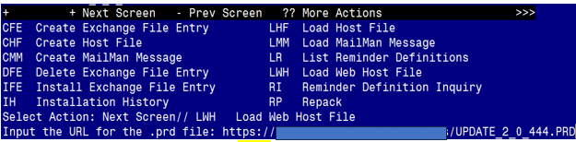

At the **Select Action:** prompt, enter **LWH** for Load Web Host File

At the **Input the url for the .prd file:** prompt, type the following web address:

**https://REDACTED/UPDATE_2_0_444.PRD**

You should see a message at the top of your screen that the file successfully loaded.

Search and locate an entry titled **444 VA-COMMUNITY CARE TEMPLATE UPDATE** in reminder exchange.

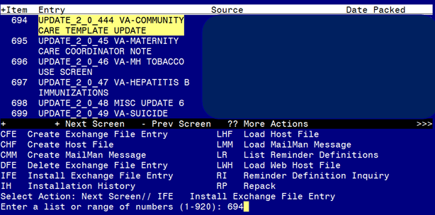

At the **Select Action** prompt, enter **IFE** for Install Exchange File Entry

Enter the number that corresponds with your entry titled **UPDATE_2_0_444 VA-COMMUNITY CARE TEMPLATE UPDATE** *(in this example it is entry 694*

*, it will vary by site, the date packed should be 05/08/2024)*

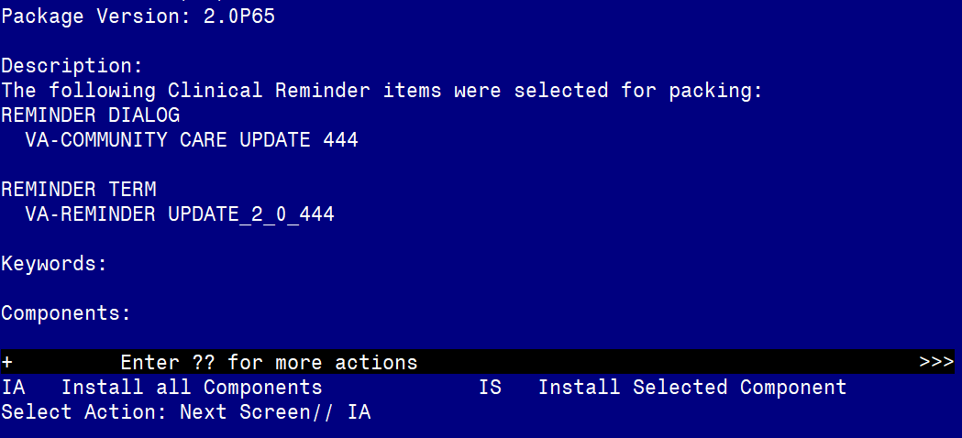

At the **Select Action** prompt, type **IA** for Install all Components and hit enter.

Select Action: Next Screen// IA Install all Components

During the installation, you will see several prompts:

Install all new components

If you are prompted to OVERWRITE any existing components select S for Skip.

**You will be promped to install the dialog component:**

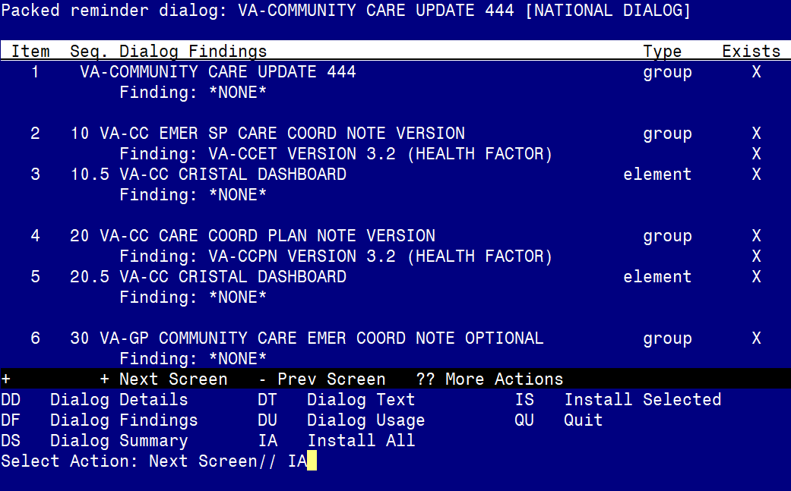

At the **Select Action** prompt, type **IA** to install the dialog – **VA-COMMUNITY CARE UPDATE 444**

Select Action: Next Screen// IA Install All

Install reminder dialog and all components with no further changes: Y// ES

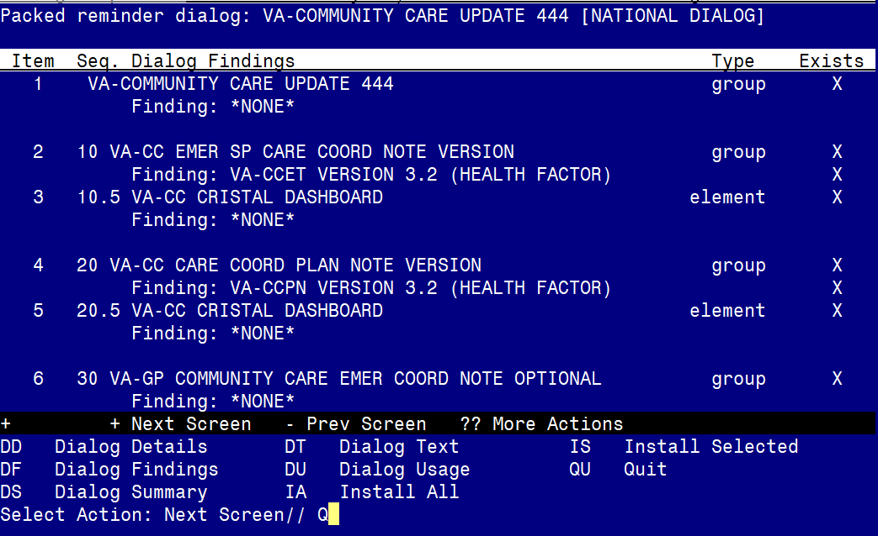

When the dialog has completed installation, you will then be returned to this screen. At the **Select Action** prompt, type **Q.**

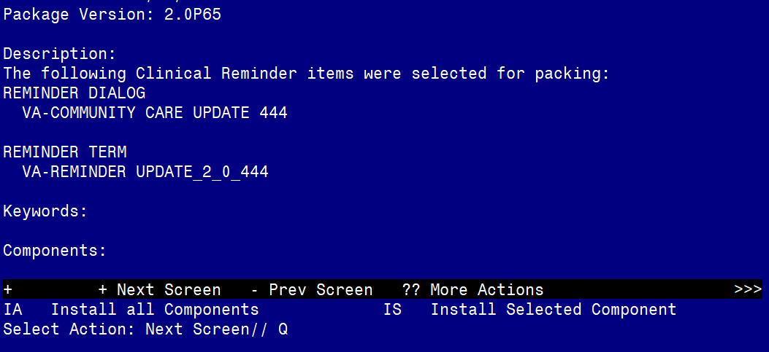

You will be returned to this screen. Type Q to quit.

Install Completed

## Post Installation

1. Add the health summary type component SPN for select progress note and for selection, your local note title named SUICIDE RISK EVALUATION COMPREHENSIVE to the health summary type CSRE LAST 24.

In VistA, using the health summary coordinator menu, Build Health Summary Type Menu, Create/Modify Health Summary Type, edit the following health summary type:

Select Build Health Summary Type Menu <TEST ACCOUNT> Option: **1** Create/Modify Health Summary Type

Select Health Summary Type: **VA-CSRE LAST 24 HOURS**

WARNING: You are about to edit a Health Summary Type that is being used by a Health Summary Object. Changing the structure of this Health SummaryType will alter how the Object will display.

Do want to continue? NO// **Y** YES

NAME: VA-CSRE LAST 24 HOURS Replace **<<enter>>**

TITLE: CRSE Last 24 Hours// **<<enter>>**

SUPPRESS PRINT OF COMPONENTS WITHOUT DATA: **<<enter>>**

SUPPRESS SENSITIVE PRINT DATA: **<<enter>>**

LOCK: **<<enter>>**

OWNER: **<<enter>>**

Do you wish to copy COMPONENTS from an existing Health Summary Type? YES// **NO**

Select COMPONENT: **SPN** PROGRESS NOTES SELECTED SPN

SUMMARY ORDER: 5// 5

OCCURRENCE LIMIT:

TIME LIMIT:**1D**

HEADER NAME: Selected Prog Notes//

No selection items chosen.

Select new items one at a time in the sequence you want them displayed.

You may select any number of items.

Select SELECTION ITEM: **SUICIDE RISK EVALUATION - COMPREHENSIVE**

Searching for a TIU DOCUMENT DEFINITION, (pointed-to by SELECTION ITEM)

Searching for a TIU DOCUMENT DEFINITION

SUICIDE EISK EVALUATION - COMPREHENSIVE TITLE

Std Title: SUICIDE PREVENTION NOTE

...OK? Yes// **<<enter>>** (Yes)

Select SELECTION ITEM: **<<enter>>**

Select COMPONENT: **<<enter>>**

Do you wish to review the Summary Type structure before continuing? NO//

Please hold on while I resequence the summary order.

1. Add the health summary type component SPN for select progress note and for selection, your local note title named SUICIDE BEHAVIOR AND OVERDOSE REPORT to the health summary type SBOR LAST 24H.

In VistA, using the health summary coordinator menu, Build Health Summary Type Menu, Create/Modify Health Summary Type, edit the following health summary type:

Select Build Health Summary Type Menu <TEST ACCOUNT> Option: **1** Create/Modify Health Summary Type

Select Health Summary Type: **VA-Sbor Last 24h**

WARNING: You are about to edit a Health Summary Type that is being used by a Health Summary Object. Changing the structure of this Health SummaryType will alter how the Object will display.

Do want to continue? NO// **Y** YES

NAME: VA-Sbor last 24hours Replace **<<enter>>**

TITLE: SBOR Last 24 Hours// **<<enter>>**

SUPPRESS PRINT OF COMPONENTS WITHOUT DATA: **<<enter>>**

SUPPRESS SENSITIVE PRINT DATA: **<<enter>>**

LOCK: **<<enter>>**

OWNER: **<<enter>>**

Do you wish to copy COMPONENTS from an existing Health Summary Type? YES// **NO**

Select COMPONENT: **SPN** PROGRESS NOTES SELECTED SPN

SUMMARY ORDER: 5// 5

OCCURRENCE LIMIT:

TIME LIMIT: **1D**

HEADER NAME: Selected Prog Notes//

No selection items chosen.

Select new items one at a time in the sequence you want them displayed.

You may select any number of items.

Select SELECTION ITEM: **SUICIDE BEHAVIOR AND OVERDOSE REPORT**

Searching for a TIU DOCUMENT DEFINITION, (pointed-to by SELECTION ITEM)

Searching for a TIU DOCUMENT DEFINITION

SUICIDE BEHAVIOR AND OVERDOSE REPORT TITLE

Std Title: SUICIDE PREVENTION NOTE

...OK? Yes// **<<enter>>** (Yes)

Select SELECTION ITEM: **<<enter>>**

Select COMPONENT: **<<enter>>**

Do you wish to review the Summary Type structure before continuing? NO//

Please hold on while I resequence the summary order.

1. Open and close CPRS.
2. **Please confirm your site is using the below reminder dialogs and note titles:**

DOCUMENT DEFINITION:  COMMUNITY CARE-CARE COORDINATION PLAN NOTE

REMINDER DIALOG NAME: VA-COMMUNITY CARE-CARE COORD PLAN NOTE

DOCUMENT DEFINITION:  COMMUNITY CARE-EMER SELF PRESENTING CARE COORD PLAN NOTE

REMINDER DIALOG NAME: VA-COMMUNITY CARE-EMER SP CARE COORD PLAN NOTE

1. Open the note titled COMMUNITY CARE-CARE COORDINATION PLAN NOTE reminder dialog VA-COMMUNITY CARE-CARE COORD PLAN NOTE and confirm the version is 3.2.
2. Open the note titled COMMUNITY CARE-EMER SELF PRESENTING CARE COORD PLAN NOTE reminder dialog VA-COMMUNITY CARE-EMER SP CARE and confirm the version is 3.2.
3. Refer to your saved Inquiry from the pre-installation steps, and add back any local modifications to the following items.  ***Local modifications are optional, your facility may have no modifications.***

**REMINDER DIALOG ELEMENTS:**

VAL-EL OPTIONAL LOCAL INFORMATION

VAL-EL NON VA FACILITY INTAKE S/I SUICIDE COOR NAME

VAL-EL CC REFERRAL HOSPITAL CCPN

**REMINDER DIALOG GROUPS:**

VAL-GP COMMUNITY CARE COORD ADMIT SAME

VAL-GP COMMUNITY CARE COORD DC DISP ER

VAL-GP COMMUNITY CARE COORD EOC EMER WORD PROC

VAL-GP COMMUNITY CARE COORD EOC WORD PROCESSING

VAL-GP COMMUNITY CARE COORD INFO FACILITY

VAL-GP COMMUNITY CARE COORD VETERAN HANDOFF EMER

VAL-GP COMMUNITY CARE COORD VET HANDOFF INFO

VAL-GP COMMUNITY CARE COORD PLAN VA FACILITY FOLLOW UP

VAL-GP COMMUNITY CARE COORD TRAN FACILITY

VAL-GP DATE ADMITTED

VAL-GP DATE OF DISCHARGE CCET

VAL-GP NVCC CCCI ADMITTED YES ER

VAL-GP NVCC CCCI ADMITTED YES QUESTIONS (G)