

Update _2_0_446

Clinical Reminders

BENZODIAZAPINE AND OPIOID REMINDER ORDER CHECKS UPDATE

Install Guide

June 2024

Product Development

Office of Information Technology

Department of Veterans Affairs

Table of Contents

Introduction 1

Pre Install 1

Install Details 2

Install Example 2

Post-Installation 5

## Introduction

DESCRIPTION:

Prescriptions from ANYTIME in the past were causing the order checks to fire because the reminder definitions that control the CROCs were a status of N/A due to both Benzo and Opioid findings being true.  Changes were made to both reminder definitions that control the operation of the Reminder Order Checks. The Benzodiazepine and Opioid term findings were changed to have a Beginning date/time of T-6M for OUTPATIENT and INPATIENT meds only. New findings were added for NON-VA Benzodiazepine and Opioid prescriptions. These NON-VA med findings have no Beginning date/time entries. The rationale for no Beginning date/time is they don’t update over time, the system doesn’t know if an entry from 18 months ago still represents current therapy or not.

UPDATE_2_0_446 contains 1 Reminder Exchange entry:

UPDATE_2_0_446 VA-BENZODIAZEPINE/OPIOID ORDER CHECKS UPDATE

HEALTH FACTORS

1 VA-REMINDER UPDATES [C]

2 VA-UPDATE_2_0_446

REMINDER TERM

3 VA-OPIOID DRUG CLASS (CN101) (TERM) NON-VA

4 VA-OPIOID DRUG CLASS (CN101) (TERM)

5 VA-BENZODIAZEPINE DRUG CLASS (CN302) (TERM)

6 VA-BENZODIAZEPINE DRUG CLASS (CN302) (TERM) NON-VA

7 VA-REMINDER UPDATE_2_0_446

REMINDER DEFINITION

8 VA-BENZODIAZEPINE (CN302) BUT NOT OPIOID (CN101)

9 VA-OPIOID (CN101) BUT NOT BENZODIAZEPINE (CN302)

REMINDER ORDER CHECK RULES

10 VA-BENZODIAZEPINE DRUG CLASS (CN302) (RULE)

11 VA-OPIOID DRUG CLASS (CN101) (RULE)

REMINDER ORDER CHECK ITEMS GROUP

12 VA-OPIOID DRUG CLASS (CN101) (GROUP)

13 VA-BENZODIAZEPINE DRUG CLASS (CN302) (GROUP)

## Pre Install

1. Check reminder term VA-BENZODIAZEPINE DRUG CLASS (CN302) (TERM) to see if your site has mapped any other items besides DRUG CLASS CN302. If so, make a note of this so that you can add this back during post install.
2. Check reminder term VA-OPIOID DRUG CLASS (CN101) (TERM) to see if your site has mapped any other items besides DRUG CLASS CN101. If so, make a note of this so that you can add this back during post install.

## Install Details

This update is being distributed as a web host file.

The file will be installed using Reminder Exchange, programmer access is not required.

This update can be loaded with users on the system. Installation will take less than 5 minutes

## Install Example

To Load the Web Host File. Navigate to Reminder exchange in Vista

At the **Select Action:** prompt, enter **LWH** for Load Web Host File

**Copy and pasted the below text.**

**https://REDACTED/UPDATE_2_0_446.PRD**

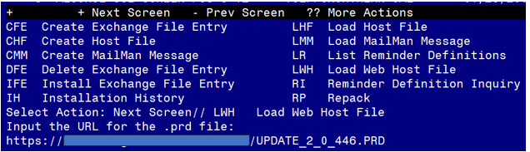

You should see a message that the exchange file was successfully loaded

Terminal window screen shot of the message displaying the URL of the file that was successfully loaded.  Part of the URL has been redacted as it is a VA only internal web site URL as shown in the text unless redacted for use outside of the VA.

In reminder exchange, search list for UPDATE_2_0_446

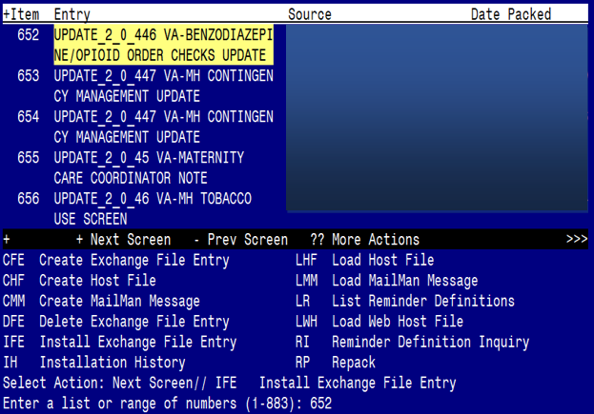

At the **Select Action** prompt, enter **IFE** for Install Exchange File Entry

Enter the number that corresponds with your entry **UPDATE_2_0_446 VA-BENZODIAZEPINE/OPIOID ORDER CHECKS UPDATE.**  *(in this example it is entry 652 it will vary by site, the date on the file should be 05/08/2024).*

The following instructions apply to all sites

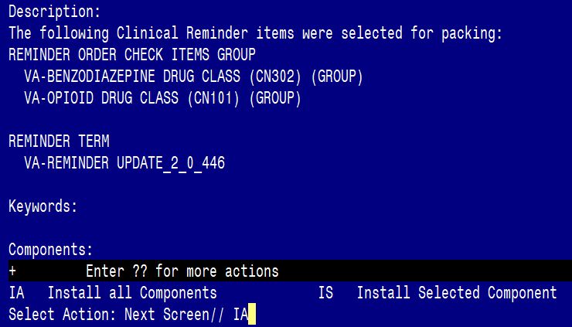

At the **Select Action** prompt, type **IA** for **Install all Components** and hit enter.

Any items that are NEW in any of the below categories, you should INSTALL

OVERWRITE any REMINDER DEFINITIONS that you are prompted to overwrite.

OVERWRITE any REMINDER ORDER CHECK RULES that you are prompted to overwrite.

OVERWRITE any REMINDER ORDER CHECK GROUPS that you are prompted to overwrite.

OVERWRITE any HEALTH FACTORS that exist but are different

.

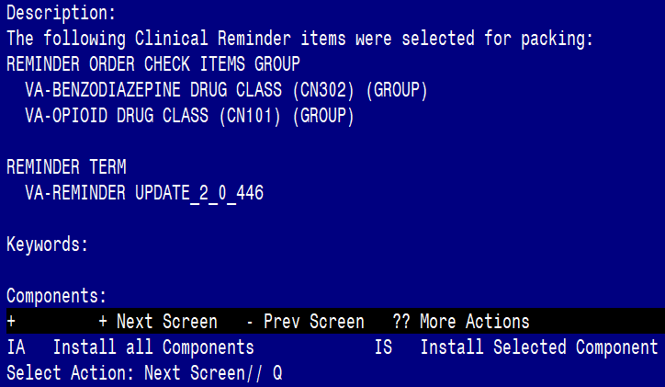

You will then be returned to this screen. At the **Select Action** prompt, type **Q.**

Install complete.

## Post-Installation

1. If you had made note of any additional items in Pre-Install items 1 and 2, add these items back to the following two terms…
   1. VA-BENZODIAZEPINE DRUG CLASS (CN302) (TERM)
   2. VA-OPIOID DRUG CLASS (CN101) (TERM)
2. Ensure that VA-OPIOID DRUG CLASS (CN101) Order check rule is PRODUCTION. The install will revert them back to INACTIVE.
3. Ensure that VA-BENZODIAZEPINE DRUG CLASS (CN302) Order check rule is PRODUCTION> The install will revert them back to INACTIVE.