

Update _2_0_447

Clinical Reminders

VA-MH CONTINGENCY MANAGEMENT UPDATE

Install Guide

**June 2024**

Product Development

Office of Information Technology

Department of Veterans Affairs

Table of Contents

Introduction 1

Install Details 4

Install Example 4

Post-Installation 8

## Introduction

DESCRIPTION:

Contingency Management (CM) is an evidence-based treatment for substance use disorder (SUD) that incentivizes recovery behaviors such as abstinence from substances verified by toxicology testing with rapidly available results. CM is recommended by the VA/Department of Defense Clinical Practice Guideline for Management of SUD and mandated by VHA Directive 1160.04 to be available to Veterans being treated for SUD in VA intensive outpatient SUD programs. Furthermore, the White House’s 2022 National Drug Control Strategy calls for expansion of access to CM. VA has reporting responsibilities on its implementation of the NDCS, including expanded access to CM, to the White House.

In 2018, VA disseminated a note template for documenting the provision of CM. The template carries the note title “Addiction Treatment Contingency Management Note,” and it includes items that generate health factor data for national monitoring of the implementation of CM, e.g., number of Veterans with SUD who receive CM, fidelity to the empirically tested CM protocol, and CM clinical outcomes like retention in treatment and abstinence.

At the time of the dissemination of the original CM note template, VA’s implementation was primarily focused on incentivizing abstinence verified by urine drug testing with rapidly available results, i.e., rapid, point-of-care (POC) testing administered in the clinic by treatment providers under each facility’s Lab oversight or Lab-administered testing with stat results. However, CM implementation was limited to those VA facilities where one of these testing options is available. To facilitate broader implementation of CM to Veterans with SUD who can benefit from it, an additional toxicology testing option is being made available – patient self-testing.

With patient self-testing, the patient administers and interprets the test and shares the result with the CM provider. Because the testing is conducted entirely by the patient, self-testing is not subject to oversight by each VA facility’s Pathology and Laboratory Medicine Service. Additionally, whereas VA policy mandates confirmatory testing of disputed results from provider-administered POC testing, patient self-testing is not subject to that requirement. However, regulations do prohibit recording of patient self-testing results in the healthcare record in the same way that Lab-administered testing results or provider-administered POC testing results are recorded, i.e., recording results as positive or negative for a substance. Consequently, the advent of patient self-testing as a toxicology testing option necessitated modifications to the original CM note template to accommodate these considerations, e.g., how test results are recorded and handling disputed test results.

Additional developments in both the science of CM and VA’s implementation of CM have necessitated additional modifications to the original note template. Alternatives to toxicology testing of urine samples permit application of CM to incentivize other abstinence behaviors such as tobacco smoking cessation verified by testing for the presence of carbon monoxide in breath samples. An emerging application of CM incentivizes abstinence from alcohol verified by the level of phosphatidylethanol (PEth) in samples of blood collected via finger-stick. Additionally, VA’s implementation of CM is being expanded to make it available in remote clinical encounters via telehealth. Because toxicology testing of urine samples is not practical in a video telehealth clinical encounter, patient self-testing of oral fluid (conducted under the visual observation by the CM provider) is available as a toxicology testing option in such clinical encounters.

Furthermore, VA’s implementation of CM has expanded to incentivize other recovery behaviors such as therapy attendance and medication adherence. To accommodate these expansions of the applications of CM, additional templates specific to each recovery behavior are either under development or being considered for development. Consequently, the note title accompanying the original CM note template must be changed to specify its exclusive use in documenting the provision of CM to incentivize abstinence. The new note title to accompany this template is “ABSTINENCE CONTINGENCY MANAGEMENT NOTE.” Details are specified later in this installation guide.

The original version of Contingency Management was released with UPDATE_2_0_32 in January of 2018.

UPDATE_2_0_447 contains 1 Reminder Exchange entry:

UPDATE_2_0_447 VA-MH CONTINGENCY MANAGEMENT UPDATE

TIU TEMPLATE FIELD

1 WP 10/70

2 VA-EDIT BOX 30/80

3 WP-2LINES

4 NUMBER 0-12

HEALTH FACTORS

5 VA-REMINDER UPDATES [C]

6 VA-UPDATE_2_0_447

7 MH CONTINGENCY MANAGEMENT [C]

8 VA-MH CM NO-SHOW

9 VA-MH CM REMOTE ENCOUNTER

10 VA-MH CM IN PERSON ENCOUNTER

11 VA-MH CM SUBSTRATE OTHER

12 VA-MH CM SUBSTRATE BLOOD

13 VA-MH CM SUBSTRATE BREATH

14 VA-MH CM SUBSTRATE ORAL FLUID

15 VA-MH CM SUBSTRATE URINE

16 VA-MH CM EVAL TYPE SELF

17 VA-MH CM EVAL TYPE POC

18 VA-MH CM EVAL TYPE LAB

19 VA-MH CM FINAL SESSION COMPLETED

20 VA-MH CM PRIZE DRAW 8+

21 VA-MH CM PRIZE DRAW 7

22 VA-MH CM PRIZE DRAW 6

23 VA-MH CM PRIZE DRAW 5

24 VA-MH CM PRIZE DRAW 4

25 VA-MH CM PRIZE DRAW 3

26 VA-MH CM PRIZE DRAW 1

27 VA-MH CM PRIZE DRAW 2

28 VA-MH CM PRIZE REMINDER SLIP-YES

29 VA-MH CM PRIZE REMINDER SLIP-NO

30 VA-MH CM PRIZE DRAW-NO

31 VA-MH CM UDAS COLLECTED-NO

32 VA-MH CM EVAL NOT PASSED NOT-TARGET

33 VA-MH CM EVAL PASSED NOT-TARGET

34 VA-MH CM EVAL NOT PASSED TARGET

35 VA-MH CM EVAL PASSED TARGET

36 VA-MH CM EVAL DISPUTED NO CONFIRMATION NEEDED

37 VA-MH CM EVAL DISPUTED

38 VA-MH CM UDAS COLLECTED-YES

39 VA-MH CM SELF REPORT ABST-NO OTHER

40 VA-MH CM SELF REPORT ABST-NO SEDATIVE

41 VA-MH CM SELF REPORT ABST-NO CANNABIS

42 VA-MH CM SELF REPORT ABST-NO ALCOHOL

43 VA-MH CM SELF REPORT ABST-NO OPIOID

44 VA-MH CM SELF REPORT ABST-NO STIMULANT

45 VA-MH CM SELF REPORT ABST-NO HALLUCINOGE

46 VA-MH CM SELF REPORT ABST-NO

47 VA-MH CM SELF REPORT ABST-YES

48 VA-MH CM TARGET SUBSTANCE TOBACCO

49 VA-MH CM TARGET SUBSTANCE OTHER

50 VA-MH CM TARGET SUBSTANCE CANNABIS

51 VA-MH CM TARGET SUBSTANCE ALCOHOL

52 VA-MH CM TARGET SUBSTANCE OPIOID

53 VA-MH CM TARGET SUBSTANCE SEDATIVE

54 VA-MH CM TARGET SUBSTANCE STIMULANT

55 VA-MH CM TARGET SUBSTANCE HALLUCINOGEN

56 VA-MH CM SESSION PREVIOUS MISSED-NO

57 VA-MH CM SESSION PREVIOUS MISSED-NOT EXC

58 VA-MH CM SESSION PREVIOUS MISSED-EXC

59 VA-MH CM SESSION PREVIOUS MISSED-YES

60 VA-MH CM SESSION NUMBER 31-36+

61 VA-MH CM SESSION NUMBER 21-30

62 VA-MH CM SESSION NUMBER 11-20

63 VA-MH CM SESSION NUMBER 1-10

64 CM TEMPLATES

65 MH EVIDENCED BASED PSYCHOTHER TEMPLATES [C]

66 MH EBP TEMPLATE

REMINDER SPONSOR

67 MENTAL HEALTH SERVICES

68 OFFICE OF MENTAL HEALTH SERVICES

REMINDER TERM

69 VA-REMINDER UPDATE_2_0_447

REMINDER DIALOG

70 VA-MH CONTINGENCY MANAGEMENT

## Install Details

This update is being distributed as a web host file.

The file will be installed using Reminder Exchange, programmer access is not required.

This update can be loaded with users on the system. Installation will take less than 10 minutes

## Install Example

To Load the Web Host File. Navigate to Reminder exchange in Vista

At the **Select Action:** prompt, enter **LWH** for Load Web Host File

**Copy and pasted the below text.**

**https://REDACTED /UPDATE_2_0_447.PRD**

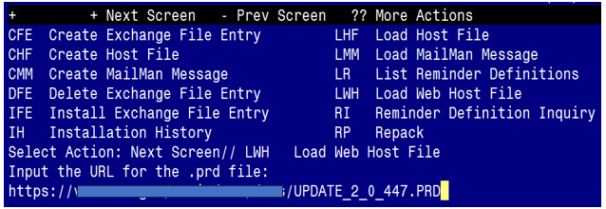

You should see a message that the exchange file was successfully loaded

In reminder exchange, search list for UPDATE_2_0_447

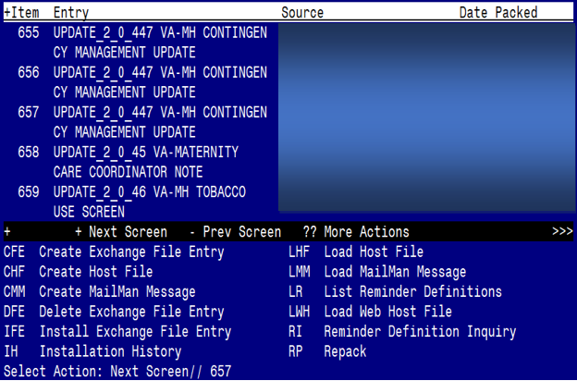

At the **Select Action** prompt, enter **IFE** for Install Exchange File Entry

Enter the number that corresponds with your entry **UPDATE_2_0_447 VA-MH CONTINGENCY MANAGEMENT UPDATE.**  *(in this example it is entry 657 it will vary by site, the date on the file should be 06/24/2024).*

The following instructions apply to all sites

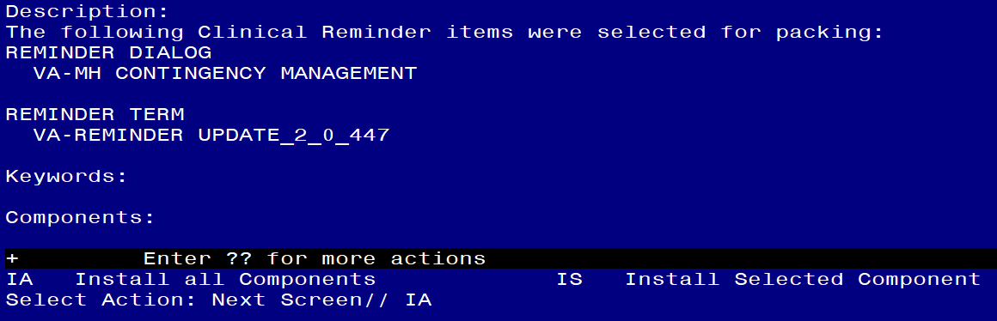

At the **Select Action** prompt, type **IA** for **Install all Components** and hit enter.

Any items that are NEW in any of the below categories, you should INSTALL

OVERWRITE any TIU TEMPLATE FIELDS that you are prompted to overwrite

SKIP any HEALTH FACTORS if you are prompted to overwrite

SKIP any REMINDER SPONSORS if you are prompted to overwrite

OVERWRITE any REMINDER TERMS that you are prompted to overwrite

You will then be prompted to install the dialog component. You will choose IA to install all even though some items will already have an X to indicate they exist. .

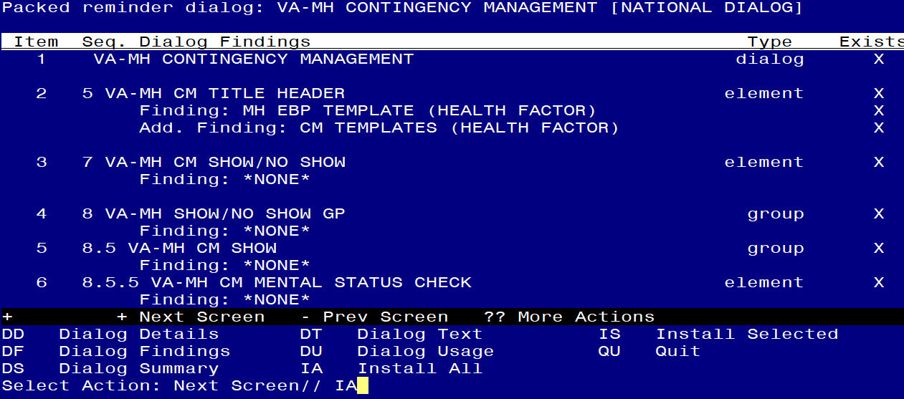

At the **Select Action** prompt, type **IA** to install the dialog –**VA-MH CONTINGENCY MANAGEMENT**

**
Screen shot of the last of the list of elements, groups and dialogs that needed to be installed with a Q for quit entered at the "Select Action:" prompt because they now all exist. **

You will then be returned to this screen. At the **Select Action** prompt, type **Q.**

.

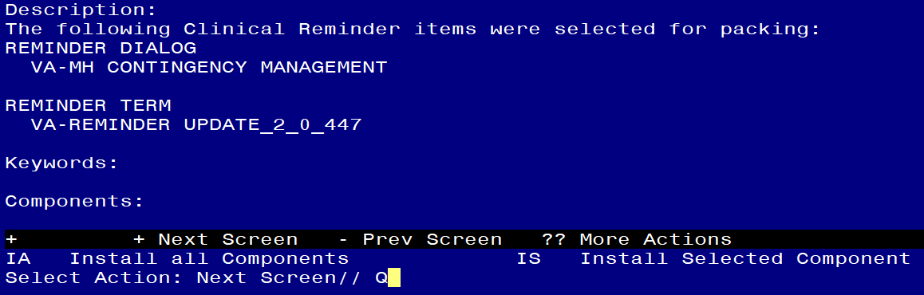

You will then be returned to this screen. At the **Select Action** prompt, type **Q.**

Install complete.

## Post-Installation

This is an update to the existing reminder dialog VA-MH CONTINGENCY MANAGEMENT. The current note title you were instructed to use when this was originally released ([UPDATE_2_0_32](https://dvagov.sharepoint.com/:b:/r/sites/VHANCR/Install%20Guides/Update_2_0_32_IG.pdf?csf=1&web=1)) was ADDICTION TREATMENT CONTINGENCY MANAGEMENT NOTE. The program office is requesting that sites create a new TIU title named ABSTINENCE CONTINGENCY MANAGEMENT NOTE. You will need to Inactivate note title named ADDICTION TREATMENT CONTINGENCY MANAGEMENT NOTE and unlink the reminder dialog from it. Once you create the new TIU title, you will link the updated reminder dialog from this install to that TIU title.

1. **This step should already be done, but check to make sure the reminder dialog VA-MH CONTINGENCY MANAGEMENT** is set as a sequence. If it is not, you will need to continue with step 1 - **Make the Dialog able to be attached to a Personal or Shared template or to be able to attach the dialog to a progress note title.**

From the Reminders Manager Menu:

Select Reminder Managers Menu Option: **CP** CPRS Reminder Configuration

CA Add/Edit Reminder Categories

CL CPRS Lookup Categories

CS CPRS Cover Sheet Reminder List

MH Mental Health Dialogs Active

PN Progress Note Headers

RA Reminder GUI Resolution Active

TIU TIU Template Reminder Dialog Parameter

DL Default Outside Location

PT Position Reminder Text at Cursor

Select CPRS Reminder Configuration Option: **TIU** TIU Template Reminder Dialog Parameter

Reminder Dialogs allowed as Templates may be set for the following:

1 User USR [choose from NEW PERSON]

3 Service SRV [choose from SERVICE/SECTION]

4 Division DIV [choose from INSTITUTION]

5 System SYS [NATREM.FO-SLC.MED.VA.GOV]

Enter selection*:* 5  *Choose the appropriate number for your site. Your site may do this by System or other levels. The example below uses SYSTEM level*

Setting Reminder Dialogs allowed as Templates for System:

Select Display Sequence: **?**

148 VA-VETERANS CHOICE NOTE

149 VA-TBI SCREENING

*When you type a question mark above, you will see the list of #’s (with dialogs) that are already taken. Choose a number* ***NOT*** *on this list. For this example, looking above I see the number 150 is not present, so I will use 150.*

Select Display Sequence: **150**

Are you adding 150 as a new Display Sequence? Yes// **Y** YES

Display Sequence: 150// <Enter> 150

Clinical Reminder Dialog**: type in the name of the dialog**

**VA-MH CONTINGENCY MANAGEMENT** then **<enter>** reminder dialog NATIONAL

OK? Yes// <Enter> (Yes)

1. **Setup of Note title**

You will need to create a new note title for the dialog included in this update to be attached to.

The new note title that needs to be created is:

**ABSTINENCE CONTINGENCY MANAGEMENT NOTE**

This note title should be mapped to the following VHA Enterprise Standard Title:**SATP NOTE**

Comprehensive information on Creating Document Definitions can be found beginning on page 47 of the [TIU/ASU Implementation Guide](http://www.va.gov/vdl/documents/Clinical/CPRS-Text_Integration_Utility_(TIU)/tiuim.pdf)

1. **Associate the reminder dialog with the note title in CPRS.**

To do this, go to Template Editor, then Document Titles, select the appropriate folder (if applicable), and choose New Template (top right-hand corner).

1. Type in the following information:

Name: **ABSTINENCE CONTINGENCY MANAGEMENT NOTE**

Template Type: Reminder Dialog

Reminder Dialog: **VA-MH CONTINGENCY MANAGEMENT**


Screen shot of the CPRS Template Editor showing that the Document Titles list is shown with the Document Title selected on the upper left.  On the upper right, Name of the Reminder Dialog is entered.  In the center, the Associated title is entered.  The proper entries are all described in the text preceding this screen shot.

Next, type in the Associated Title, which in this case is **ABSTINENCE CONTINGENCY MANAGEMENT NOTE**, and hit Apply:


Screen shot of the CPRS Template Editor showing that the Document Titles list is shown with the Document Title selected on the upper left.  On the upper right, Name of the Reminder Dialog is entered.  In the center, the Associated title is entered.  The proper entries are all described in the text preceding this screen shot.

Install complete.

1. Ensure version is 2.4 on top of dialog

No other post installation needed