

Update _2_0_464

Clinical Reminders

VA-WH BREAST CANCER RISK ASSESSMENT UPDATE

Install Guide

**July 2024**

Product Development

Office of Information Technology

Department of Veterans Affairs

Table of Contents

Introduction 1

Install Example 2

Post Installation 5

## Introduction

This update adds several health factors to several options in the VA-WH BREAST CANCER RISK ASSESSMENT reminder dialog. This dialog was originally released in Clinical Reminder Update 316 and revised in Clinical Reminder Update 316A and Clinical Reminder Update 371.

UPDATE_2_0_464 contains 1 Reminder Exchange entry named **UPDATE_2_0_464 VA-WH BREAST CANCER RISK ASSESSMENT UPDATE**

**The exchange file contains the following components:**

This contains several reminder dialog elements.

**The exchange file contains the following components:**

**HEALTH FACTORS**

VA-REMINDER UPDATES [C]

VA-UPDATE_2_0_464

VA-WH BREAST CANCER RISK ASSESSMENT [C]

VA-WH BCRA FHRA PT DECLINES DETAILED-RISK ASSMNT REFERRAL

VA-WH BCRA FHRA NEGATIVE

VA-WH BCRA FHRA DEFERRED OR UNKNOWN

VA-WH BCRA PT DECLINES SCREENING MAMMOGRAM

VA-WH BCRA FHRA NATL TELEONC HIGH RISK BREAST CLINIC IFC ORDERED

VA-WH BCRA FHRA REFER DETAILED RISK ASSMNT/GENETIC

COUNSELING

VA-WH BCRA WAIT FOR RISK EVALUATION RECOMMENDATIONS

VA-WH BCRA PT DECLINES DETAILED-RISK EVAL

**REMINDER SPONSORS**

OFFICE OF HEALTHCARE INNOVATION AND LEARNING

**REMINDER TERMS**

VA-REMINDER UPDATE_2_0_464

## Pre-Installation:

1. Identify order dialog mapped to the VAL-WH BCRA PH RISK ASSMNT POSITIVE TELEONC element. Also, note if the element is disabled. This was an optional step in Update 316A, so an order may not be mapped.
2. Identify order dialog mapped to the VAL-WH BCRA FH RISK ASSMNT REFER TELEONC element. Also, note if the element is disabled. This was an optional step in Update 316A, so an order may not be mapped.
3. Identify order dialog mapped to the VAL-WH BCRA PH RISK ASSMNT POSITIVE LOCAL REFER element. Also, copy text in the DIALOG/PROGRESS NOTE TEXT field.
4. Identify order dialog mapped to the VAL-WH BCRA FH RISK ASSMNT REFER LOCAL element. Also, copy text in the DIALOG/PROGRESS NOTE TEXT field.

## Installation:

This update can be loaded with users on the system. Installation will take less than 5 minutes.

This update is being distributed as a web host file. The address for the host file is: https://REDACTED /UPDATE_2_0_464.PRD

The file will be installed using Reminder Exchange, programmer access is not required.

## Install Example

Go to Reminder exchange in Vista.

To Load the exchange file, use LWH. The URL is: **https://REDACTED /UPDATE_2_0_464.PRD**

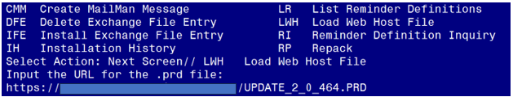

You should receive a message that the file was successfully loaded into your reminder exchange file.

Search and locate exchange file name **UPDATE_2_0_464 VA-WH BREAST CANCER RISK ASSESSMENT UPDATE**

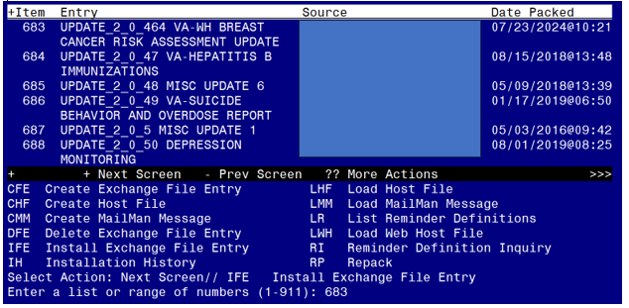

At the **Select Action** prompt, enter **IFE** for Install Exchange File Entry

Enter the number that corresponds with your entry titled **UPDATE_2_0_464 VA-BREAST CANCER RISK ASSESSMENT UPDATE** *(in this example it is entry 683, it will vary by site)* that is dated 7/23/2024.)

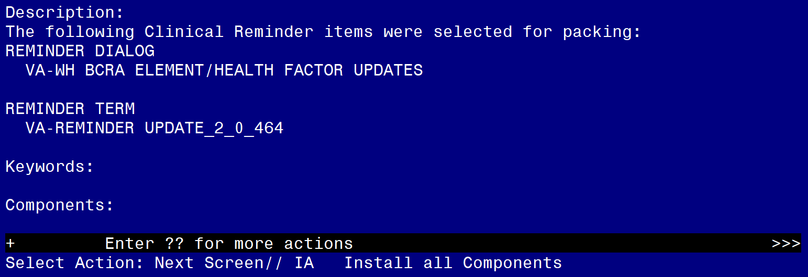

At the **Select Action** prompt, type **IA** for Install all Components and hit enter.

**For all new entries in any category, you will choose I to Install**

**If you are prompted to overwrite any items, choose S to Skip.**

You will then be prompted to install the dialog component.

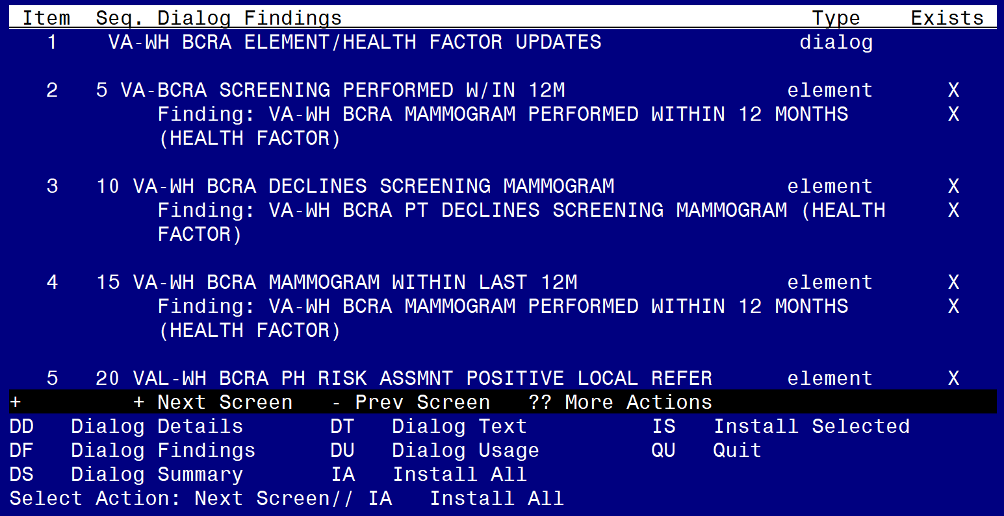

Select IA to install all. This will install the reminder dialog **VA-WH BCRA ELEMENT/HEALTH FACTOR UPDATES**

Install reminder dialog and all components with no further changes: Y//Y

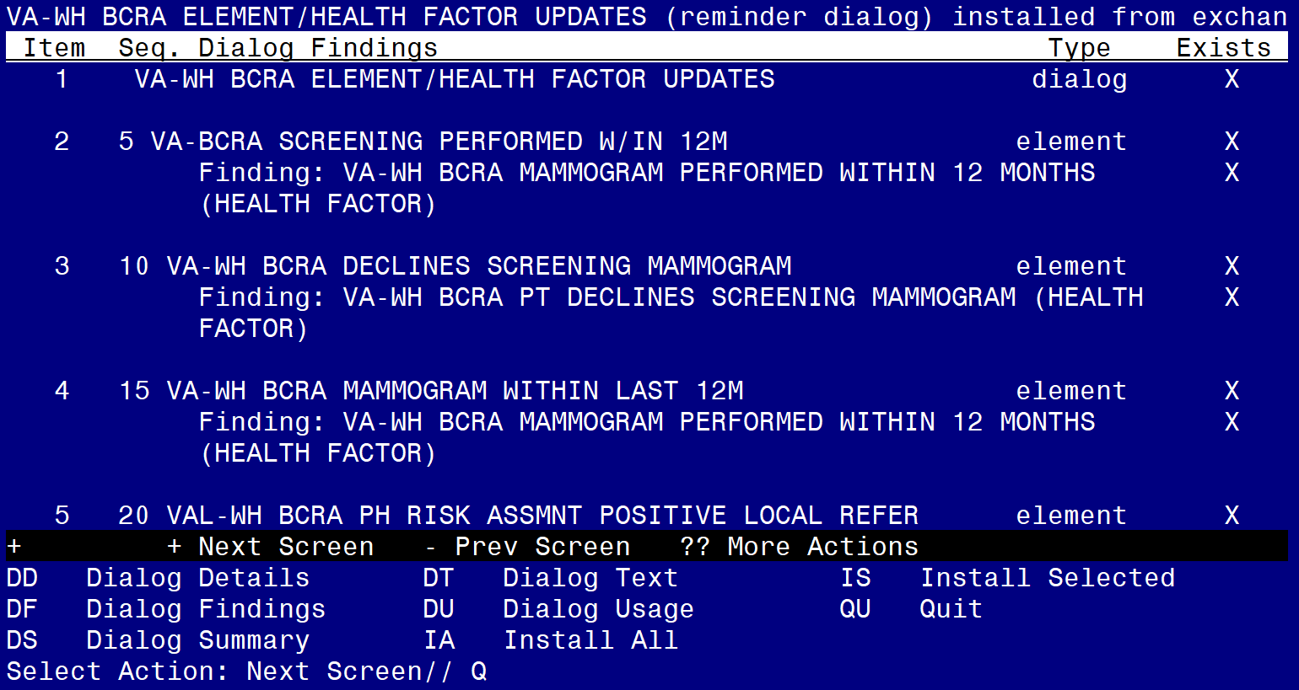

After install, select Q for quit.

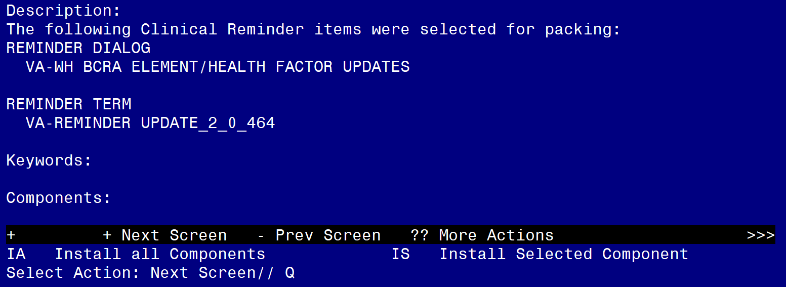

Select Q for quit to exit the install

## Post Installation

1. **As identified during pre-installation, map the local order for an interfacility consult to national TeleOncology (High Risk Breast Clinic) to the following two elements, if available. Disable these elements if the interfacility consult is not available at your site.**
   1. Navigate to the reminder dialog element menu in VistA and locate the elements.

NAME: VAL-WH BCRA PH RISK ASSMNT POSITIVE TELEONC

Replace

DISABLE: **Enter “2” to disable this option if the consult to national**

**TeleOncology (High Risk Breast Clinic) is not available.**

CLASS: LOCAL//

SPONSOR:

REVIEW DATE:

RESOLUTION TYPE:

ORDERABLE ITEM:

FINDING ITEM: HF VA-WH BCRA FHRA NATL TELEONC HIGH RISK BREAST CLINIC IFC

ORDERED

Additional findings: none

Select ADDITIONAL FINDING: **Enter “Q.”, then name of local quick order for the consult to**

**national TeleOncology (High Risk Breast Clinic), if available.**

NAME: VAL-WH BCRA FH RISK ASSMNT REFER TELEONC

Replace

DISABLE: **Enter “2” to disable this option if the consult to national**

**TeleOncology (High Risk Breast Clinic) is not available.**

CLASS: LOCAL//

SPONSOR:

REVIEW DATE:

RESOLUTION TYPE:

ORDERABLE ITEM:

FINDING ITEM: HF VA-WH BCRA FHRA NATL TELEONC HIGH RISK BREAST CLINIC IFC

ORDERED

Select ADDITIONAL FINDING: **Enter “Q.”, then name of local quick order for the consult to**

**national TeleOncology (High Risk Breast Clinic), if available.**

1. **As identified during pre-installation, map the local order for a consult to Women’s Health for detailed risk assessment. If a consult doesn’t exist, coordinate with Women’s Health to change text in element to match local process.**
   1. Navigate to the reminder dialog element menu in VistA and locate the elements.

NAME: VAL-WH BCRA PH RISK ASSMNT POSITIVE LOCAL REFER

DISABLE:

CLASS: LOCAL//

SPONSOR:

REVIEW DATE:

RESOLUTION TYPE:

ORDERABLE ITEM:

FINDING ITEM: HF VA-WH BCRA FHRA REFER DETAILED RISK ASSMNT/GENETIC

COUNSELING

Additional findings: none

Select ADDITIONAL FINDING: **Enter “Q.”, then name of local quick order for the consult to**

**Women’s Health.**

DIALOG/PROGRESS NOTE TEXT:

Positive - Referred for local detailed risk assessment

Edit? NO// YES **Enter “Yes” if dialog text needs to be revised.**

==[ WRAP ]==[INSERT ]===< DIALOG/PROGRESS NOTE TE[Press <PF1>H for help]====

Positive - Referred for local detailed risk assessment

**The text above can be revised, as needed.**

<=======T=======T=======T=======T=======T=======T=======T=======T=======T>===

NAME: VAL-WH BCRA FH RISK ASSMNT REFER LOCAL

DISABLE:

CLASS: LOCAL//

SPONSOR:

REVIEW DATE:

RESOLUTION TYPE:

ORDERABLE ITEM:

FINDING ITEM: HF VA-WH BCRA FHRA REFER DETAILED RISK ASSMNT/GENETIC

COUNSELING

Additional findings: none

Select ADDITIONAL FINDING: **Enter “Q.”, then name of local quick order for the consult to**

**Women’s Health.**

DIALOG/PROGRESS NOTE TEXT:

Score of 2 or more- Referred for local/in person detailed risk assessment

and genetic counseling

Edit? NO// YES **Enter “Yes” if dialog text needs to be revised.**

==[ WRAP ]==[INSERT ]===< DIALOG/PROGRESS NOTE TE[Press <PF1>H for help]====

Score of 2 or more- Referred for local/in person detailed risk assessment

and genetic counseling

**The text above can be revised, as needed.**

<=======T=======T=======T=======T=======T=======T=======T=======T=======T>===