VistA Blood Establishment Computer Software (VBECS) Version 2.3.4

Technical Manual-Security Guide Version 2.0

October 2023

Department of Veterans Affairs
Enterprise Project Management Office

Table of Contents

Introduction 1
VBECS Versioning 1
Related Manuals and Reference Materials 2
How This Technical Manual-Security Guide Is Organized 3
Terms 3
Figures and Tables 3
Appendices 3
Customer Support 3
VBECS Hardware 4
Required Peripherals 4
Printers 5
Report Printer 5
Label Printer 6
Scanners 6
Configuring Scanners 6
Scanner Testing 7
Optional Peripherals – Automated Instruments 8
Remote Desktop 9
Remote Desktop Shortcuts 9
Remote Desktop Logon Warnings 10
Remote Desktop Credentials 11
Remote Desktop Logon Troubleshooting 13
Remote Desktop Sessions 15
Session Time Limits 16
Session Disconnect vs Sign Out 17
Unexpected Remote Desktop Disconnections 19
Remote Desktop Credentials – Lock Screen 20
Remote Desktop Appearance and Zooming 21
Remote Desktop Navigation 21
Remote Desktop Zooming 22
Exported Reports Network Share 23
VBECS Server Maintenance 25
What to Expect During Server Maintenance 28
PRODUCTION Maintenance 28
TEST Maintenance 28
Anti-Virus Software and Virus Protection 28
VistA Maintenance Operations 29
Set Up VBECS Outbound Logical Links 29
Set Up the VBECS Inbound Logical Link 31
Start VistA HL7 Logical Links 32
Monitor VBECS HL7 Logical Links 33
Configure VBECS VistALink Links 34
Workload Data Transmission 35
Troubleshooting 36
Error on VBECS or VBECS Admin Launch 36
VBECS Application Interfaces 36
Scanner Problems 40
Database 41
Backups 41
Recovery 41
Database Record Locks 41
Security 43
VBECS Active Directory (AD) Groups 43
Glossary 47
Appendices 48
Appendix A: Verify VBECS HL7 Interface Protocols 48
Set Up VBECS Protocol Definitions 48
Patient Update Events 49
Patient Merge Events 56
Order Update Events 59
Order Update Events (continued) 62
Appendix B: Laboratory Test File (#60) 65
Index 68
Revision History 70

Introduction
The main purpose of the VistA Blood Establishment Computer Software (VBECS) is to automate the daily processing of blood inventory and patient transfusions in a hospital transfusion service.
Unauthorized access or misuse of this system and/or its data is a federal crime. Use of all data, printed or electronic, must be in accordance with VA policy on security and privacy.

Do not change the system! The U.S. Food and Drug Administration classifies this software as a medical device. Unauthorized modifications will render this device an adulterated medical device under Section 501 of the Medical Device Amendments to the Federal Food, Drug, and Cosmetic Act. Acquiring and implementing this software through the Freedom of Information Act requires the implementer to assume total responsibility for the software and become a registered manufacturer of a medical device, subject to FDA regulations. Adding to or updating VBECS software without permission is prohibited.

VBECS Versioning
The VBECS version (see Figure 1) is derived by combining a three part version number from the VBECS application software (e.g., 2.3.4) with the revision letter of the VBECS database. The VBECS version can be found under the Help>About menu option in VBECS or selecting Help from the VBECS Admin main menu.

The 3-part version number (e.g., 2.3.4) is incremented for application code changes, such as:
- Changes to any VBECS visual element or behavior (e.g., new menu options, larger font size)
- Windows operating system or virtualization upgrade.
- New features or changes to existing functionality.
When the 3-part version number is incremented, the revision letter resets to “A”.

The revision letter (i.e., A-Z) is incremented for database-only changes, such as:
- Blood products added to or changed from VBECS’s available product list
- Changes to any core VBECS data (e.g., available facilities, new printer driver)
- Database query logic changes or performance improvements.

All VBECS documentation will contain the 3-part version number and when applicable, include the revision letter.

Modifications to environmental settings can be made without affecting the VBECS version. Environment changes affect the underlying hardware or remote desktop experience, such as:
- Changing server RAM, CPU or hard drive capacity
- Changing the VBECS desktop wallpaper
- Changing Remote Desktop session limits
Figure 1: Example of VBECS Versioning
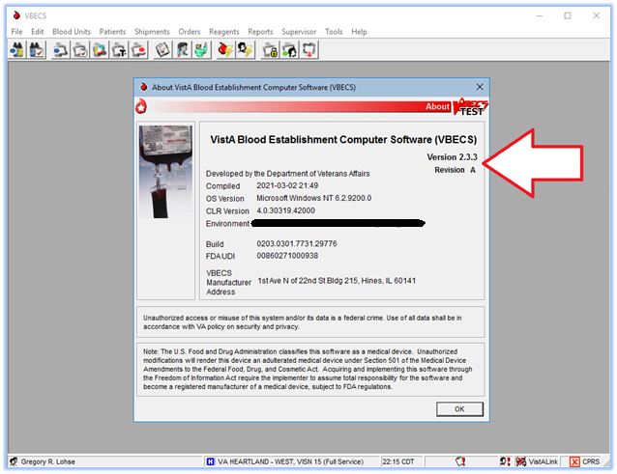

Related Manuals and Reference Materials
- CPRS-VBECS Interface (OR*3.0*212) Release Notes April 2009
- Duplicate Record Merge: Patient Merge Technical Manual Version 7.3 April 1998 Revised December 2010
- Health Product Support Release of Products and Patches Guide V2.3 Updated: February 2014
- REDACTED
- Kernel Systems Manual Version 8.0, Chapter 1: Sign-On Security/User Interface, pp. 13–20
- PIMS V. 5.3 Technical Manual
- VBECS – <instrument> Configuration and Setup Guide
- VBECS 2.3.4 Admin User Guide
- VBECS 2.3.4 User Guide
- VistALink Version 1.5 Developer-System Manager Manual, Chapter 6: Security Management, pp. 34–35

How This Technical Manual-Security Guide Is Organized
Outlined text is used throughout this guide to highlight warnings, limitations, and cautions:
Warnings, limitations, cautions

Terms
In many instances, a user may scan a barcode or enter data manually (by typing). The term “enter” is used throughout this guide to mean “enter manually.”

See the Glossary for definitions of other terms and acronyms used in this guide.

Figures and Tables
If you refer to figures and tables from the Technical Manual-Security Guide in your local policy and procedure documents, you may wish to use their titles only, without figure or table numbers: as the technical manual-security guide is updated, those numbers may change.

Appendices
The appendices contain reference materials.

Customer Support
Contact your Local/Regional Office of Information Technology (OIT) or Laboratory Information Manager (LIM) if you encounter VistA or CPRS connection problems and for training support before contacting the Service Desk (SD).
Please ensure local/regional VistA Support contact information is available at all times.
If you experience an FDA reportable adverse event (patient death or serious injury) that VBECS may have caused or contributed to, contact the Service Desk directly to enter a ticket for Blood Bank software support.
If the problem remains unresolved after local VistA triage, call the Service Desk (below) and specify the Affected Service be set as VBECS (VistA - Blood Establishment Computer Software)

Service Desk Contact
Call the Service Desk REDACTED
Refer to REDACTED the VBECS SharePoint site for up-to-date information about contacting the Service Desk.
For troubleshooting error messages in VBECS similar to Contact Your System Administrator, contact the Service Desk.

VBECS Hardware
Each blood bank will have separate PRODUCTION and TEST instances of VBECS. The term “instance” is used to represent all system components needed to make VBECS work. Some multidivisional sites will share a VBECS instance, but VBECS does not have a consolidated database or data shared between all VBECS instances.

A VBECS instance requires:
- Application (App) server
- SQL database (hosted on a Microsoft SQL Server cluster)
- VistA
- Additional Required Peripherals (see Table 1)

The VBECS team is responsible for providing and maintaining the App and SQL Servers, which run as virtualized hardware in the Microsoft Azure Government (MAG) VA Enterprise Cloud (VAEC). The System Schematic diagram (Figure 2) describes the major system components of a VBECS instance:
- Application Server (App Server): A Windows Server 2016 virtual machine and remote desktop session host.
  - A Production instance has two App servers, with one server always powered-on and a redundant identical server in a passive (powered-off) state. A second server provides decreased downtime during maintenance or system failure.
  - A Test instance only has one App server (always powered-on).
- SQL Server Cluster: Comprised of three Windows Server 2016 virtual machines, clustered using Microsoft Windows Failover Clustering software. This essentially results in three copies of every VBECS database for redundancy and maximum uptime.
- User Workstations: Users access the VBECS application using Remote Desktop Services.

Required Peripherals
The following table lists the additional hardware required to complete a fully functional VBECS instance. This hardware can be shared between TEST and PRODUCTION instances. Obtaining and maintaining this hardware is the responsibility of each blood bank.
Table 1: Additional Required Peripherals
Barcode Scanner | - Windows compatible  - Scanner must be capable of interpreting Code 39, ISBT 128, and PDF-417 barcodes  - (optional) Scanner is capable of interpreting 2-D barcodes.
Report Printer | - Windows compatible  - Laser quality  - Capable of printing on at least 8.5” x 11” paper
Label Printer | - Thermal transfer  - ZPL and ZPLII language supported  - 300 DPI print head must print on 4" x 4" label stock
User Workstation | - Display should be set to at least 1024 x 768 resolution. *Resolutions smaller than this value will not be able to fit all VBECS screens in the remote desktop window without scrolling.  - Speaker(s) to hear VBECS audio alerts  - Personal Identity Verification (PIV) card reader
Figure 2: System Schematic

Printers
If you need assistance setting up, configuring, or troubleshooting your printers; contact your hardware vendor.

Report Printer
The VBECS team recommends Lexmark and HP printers, however any Windows compatible printer should work with VBECS. Refer to the VBECS Admin User Guide for details on adding a new printer. Since PRODUCTION and TEST are separate instances, any printer changes will need to be made on both VBECS app servers.

Changing the IP address for your VBECS Report Printer
Refer to the VBECS Admin User Guide for more details and example screen prompts. You will need to repeat these steps in both your TEST and PRODUCTION instance.
- Connect to your VBECS server, and launch VBECS Admin.
- Select the Edit Printer option (VistA is not required).
- Remove the existing VBECS printer.
- Define a new VBECS printer, giving it the same name and driver but enter the new IP address.
- Print a test page to ensure it is setup properly.

Label Printer
You may use any brand of label printer that meets the requirements listed in Table 1. Many label printers come with a standard 203 DPI print head and must be upgraded to a 300 DPI print head. If you purchased a new printer and tags are printing too big to fit on a label, the most likely cause is due to it having an incompatible print head.

Upgrading a Label Printer Print Head
If you have a label printer with a 203 DPI print head, it may be possible and more cost effective to upgrade it to 300 DPI rather than buying a new printer. However, the print head is just one of the needed components. Please contact a vendor for a print head upgrade kit. These kits include the additional gears and parts that are required in order for the printer to get the full DPI from the print head.

Changing the IP address for your Label Printer
If the IP address on your label printer changes, you’ll need to update the IP address in the Edit Division menu option of the VBECS Admin software. All users will need to close the VBECS software first before you can make this change. You will need to update the IP address in both your TEST and PRODUCTION instance.

Refer to the VBECS Admin User Guide for more details and example screen prompts.

Network and Port Requirements
Due to VA firewall rules, VBECS can only communicate with printers over port 9100. Make sure your label printer is configured on this port.

If any VBECS printer is on a protected VLAN, open a ticket with your local biomed team to permit traffic to your local VLAN from the VBECS Azure networks on TCP port 9100.

Scanners
The VBECS team recommends Honeywell scanners, however other brands may suffice as long as they meet the requirements listed in Table 1. Most scanners should be able to scan barcodes from a computer display. However, if you experience issues, it could mean the barcode is too small or large; try zooming in/out of the document.

Configuring Scanners
For VBECS to properly render barcode scans, the scanner needs to send all barcode data prefixed with a tilde (~) and appended with a TAB key. Configuring a scanner for use in VBECS is done by scanning special barcodes that instruct the scanner to send the tilde and TAB keys. If you have a new scanner or an existing scanner no longer works properly in VBECS, scan one of the configuration barcodes below and then proceed to the Scanner Testing section.

If you’re experiencing scanner issues after trying out the configuration barcodes below, contact Customer Support.

Honeywell 4600
Scan Figure 3 to configure a Honeywell 4600 scanner and then validate it using the barcodes below. This configuration barcode may also work for other models.
Figure 3: Configuration Barcode for Honeywell 4600 (VBECS Settings)

Honeywell Xenon 1900 Series
Scan Figure 4 followed by Figure 5 to configure a Honeywell Xenon 1900 scanner. This approach may also work for other Xenon models.
Figure 4: Configuration Barcode for Honeywell Xenon 1900 Part 1 (Reset Scanner Defaults)
Figure 5: Configuration Barcode for Honeywell Xenon 1900 Part 2 (VBECS Settings)

Scanner Testing
A scanner that is configured for use in VBECS needs to add a tilde (~) prefix and a TAB suffix to all scans. To test your scanner, print this page or try scanning off the screen.
First, open Notepad on your workstation and click inside the blank document (the cursor should now be blinking in the whitespace).
- Test 1: Scan Figure 6. The text should read “~123456789” followed by a TAB.
- Test 2: Scan Figure 7. The text should read “~123456789” followed by a TAB.
- Test 3: Scan Figure 8. The text should read “~Testing” followed by a TAB.
- Test 4: Scan Figure 9. The text should read “~123456789” followed by a TAB.
If any of the tests failed, your scanner is not configured properly. Try using a different configuration barcode above or contact Customer Support.

Figure 6: Code39 (Codabar) Test Barcode
Figure 7: ISBT 128 Test Barcode

Figure 8: PDF 417 Test Barcode
Figure 9: 2-D Data Matrix Test Barcode

Optional Peripherals – Automated Instruments
VBECS currently supports Echo, Erytra, ProVue and Vision instruments. These instruments perform testing on a specimen and send the test results and interpretations to a server running Data Innovations (DI) Instrument Manager (IM) software. The IM software wraps those results and interpretations into HL7 messages which are then sent to your VBECS app server. Consult the VBECS SharePoint Web site for documentation on configuring an instrument/IM for use with VBECS.

For your IM server to successfully send test results to your VBECS Azure app server, the network pathway needs to be open between VBECS and IM server. This requires two separate firewall changes:
- National BPE change:
Provide the VBECS team with all of your IM server IP addresses so that they can create a ticket to have communication opened between the VBECS Azure networks and your IM server(s).
- Local ACL modification:
File a ticket with your local biomed team requesting an ACL modification to permit bidirectional traffic between your DI server(s) and the VBECS Azure networks.

Firewall changes can take up to two weeks to complete, so if your existing IM server is relocating or being re-IP’d, contact the VBECS team as soon as possible.

Remote Desktop
In simplest terms, Remote Desktop is Microsoft’s client software that allows a user at one computer to connect to another computer. The VBECS software runs on a virtualized application (app) server, which is only accessible using the Remote Desktop client.

Remote Desktop Shortcuts
The VBECS team has published Remote Desktop shortcuts for each VBECS instance. Each shortcut contains all the required configuration values to access the VBECS VAEC servers. Shortcuts can be found on the VBECS SharePoint page:
REDACTED

The VBECS VAEC servers are addressed by DHCP (not static IP address), and therefore rely on DNS entries to correctly route network connections to the proper server.
- PRODUCTION shortcuts are configured to connect to a VBECS load balancer DNS entry. This load balancer uses logic to determine which of the two PRODUCTION app servers are active and correctly routes incoming connections to that server.
- TEST shortcuts are configured to connect to a DNS entry which redirects to the single TEST app server.
In either instance, if the server’s DHCP IP address changes, the DNS entry will continue to correctly route all network connections.
Do not modify the VBECS remote desktop shortcuts unless instructed to do so by the VBECS Team.
Do not create your own VBECS remote desktop shortcut, unless it is an exact copy of the one provided by the VBECS Team.
Refer to the PIV Exemption information under REDACTED.
A video tutorial for downloading remote desktop shortcuts can be found by clicking REDACTED.
Download Instructions (Figure 10):
- Navigate to and select your blood bank’s remote desktop entry for either TEST or PRODUCTION.
- Click Download.
- Click Save As (some browsers may not present this option).
Figure 10 : Downloading Remote Desktop Shortcuts
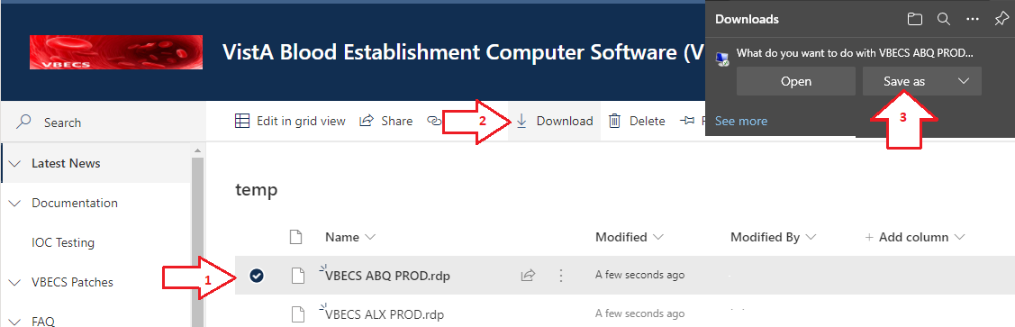
- Save the icon to your Desktop (or path of your choosing).
To make a remote desktop shortcut available for all users of a workstation, it’s recommended place the shortcut in the C:\Users\Public\Desktop folder on every lab workstation. However, this path is a protected system folder and only accessible to system administrators. Contact your local desktop IT support for assistance.

Remote Desktop Logon Warnings
The first time you connect to remote computer you may see the messages from Figure 11 and Figure 12. Check the box next to “Don’t ask me again for connections to this computer”.
Figure 11: Example of an Ignorable Remote Desktop Warning
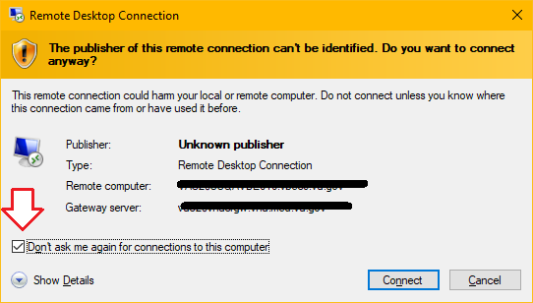
Figure 12: Example of Another Ignorable Remote Desktop Warning
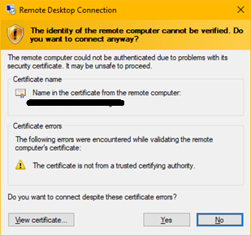

Remote Desktop Credentials
When starting a remote desktop connection to the VBECS server, watch the PIN/Password field (Figure 13):
- If you are connecting with your PIV, the field must read PIN. If the field reads Password, you have the wrong credential selected.
- If you’re connecting with your Windows ID and password, the field must read Password. If the field reads PIN, you have the wrong credential selected.

To select a different credential, click the More choices link, which will expand the window and show you all available credentials. PIV credentials will have the (smart card icon) and Windows credentials will have the (Windows user icon). If your Windows ID is not visible, select the “Use a different account” option. Do not check the Remember me box.
Figure 13: Example of Remote Desktop Credential Selection
E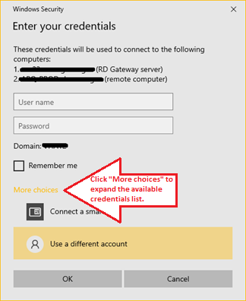

Remote Desktop Logon Troubleshooting
This section contains a list of several correctable errors you could receive while establishing your remote desktop connect to a VBECS app server.

The VAEC servers require that all users connecting to the server have AES 256-bit encryption enabled on their Active Directory user account. As of the writing of this document, the VA has not yet mandated this field be set on all accounts, so if you see the error displayed in Figure 14 contact Customer Support to request the AES 256-bit encryption option be set on your account.
Figure 14: Example of Missing Active Directory Encryption Alert
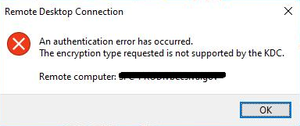

Each VBECS app server grants remote desktop permission to two VBECS user groups (see VBECS Active Directory (AD) Groups). If you receive the error displayed in Figure 15, then you most likely do not belong to one of your blood bank’s VBECS user groups. If you’ve verified you belong to the proper group, contact Customer Support.
Figure 15: Example of Missing Active Directory Group Membership Alert
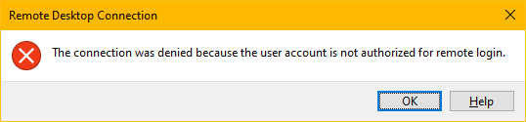

If you receive the error displayed in Figure 16, the Remote Desktop client was unable to contact the server you’re trying to reach. There are a variety of possible causes this could occur, including:
- infrastructure disruption (brief or severe)
- server is rebooting (maintenance-related or unexpectedly)
- incorrect/corrupted Remote Desktop shortcut

In most cases, waiting a minute or two before trying again resolves the issue. To rule out a corrupted shortcut, replace your existing copy with a fresh one. If you are still receiving this error after trying these corrective measures, please contact Customer Support.
Figure 16: Example of Unreachable Server Alert
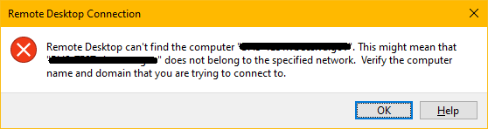

If your connection attempt fails (Figure 17) while displaying “Estimating connection quality”, one underlying cause may be network latency between your workstation and the VBECS server (other workstations may work fine). Rebooting your workstation may resolve the issue; otherwise, move to another workstation (if you can) while the underlying issue resolves on its own. You may also contact Customer Support for further troubleshooting.
Figure 17: Example of Remote Desktop Timeout Alert

Remote Desktop Sessions
Connecting to a computer with Remote Desktop creates a session on the remote computer. Each VBECS user is allowed one session per VBECS instance. Trying to start a second session will simply reconnect you to your first session. You can switch workstations without losing your session. A session terminates when the user clicks the Sign Out desktop shortcut, or when a session times out (see next section).

Session example 1:
- From workstation A, you open a remote desktop connection to the VBECS app server.
- You start using VBECS.
- You move to workstation B without closing your remote desktop window on workstation A.
- From workstation B you open a remote desktop connection to VBECS.
- You’ll see VBECS exactly where you left off on workstation A, but if you returned to workstation A you’d see the message from Figure 18. You can click OK to dismiss it.

Session example 2:
- From workstation A you open a remote desktop connection to the VBECS app server.
- You start using VBECS.
- You minimize the remote desktop window.
- From workstation A you open a new remote desktop connection to VBECS.
- You’ll see VBECS exactly where you left off in the minimized window, but you’d also see the message from Figure 18. You can click OK to dismiss it.
Figure 18: Example of a Single Session Reminder Alert
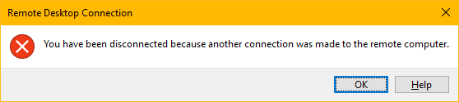

Since VBECS PRODUCTION and TEST are different instances, you can have a remote desktop window open to each at the same time. The sessions are independent and do not affect each other.

Session Time Limits
After starting a remote desktop session, it will remain “active” as long as it continues to receive user input (mouse movement, keystrokes, barcode scans, etc.). Once user input stops, the session becomes idle. After a session has been idle for 60 minutes, the message in Figure 19 is displayed in the remote desktop window. Pressing any key or clicking OK will reset the idle timer.
Figure 19: Example of Remote Desktop Idle Time Limit Alert
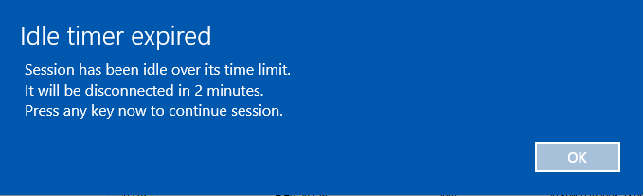

Failure to respond to the Idle timer expired message, will disconnect your session and display the message in Figure 20. You can reconnect to a disconnected session from any workstation and resume your work in VBECS where you left off. However, a disconnected session that is not reconnected within 60 minutes is terminated; all programs are closed, all unsaved work is lost, and the user is signed out of the server. No messages are displayed when a disconnected session is terminated.

Figure 20: Example of Remote Desktop Disconnected Alert

Session Disconnect vs Sign Out
When you are finished using VBECS or need to move to another workstation, you have two options: Sign Out or Disconnect.

Disconnecting from a Remote Desktop session closes the client connection; your running applications on the server remain running and no work is lost. Disconnected sessions can be reconnected-to from any workstation until the disconnected session times-out (see Section: Session Time Limits).

Signing out of a Remote Desktop session attempts to terminate the session and close all running applications.

If you click Sign Out with VBECS running but have no unsaved changes, the session will terminate. However, if you click Sign Out with VBECS running and unsaved changes, the server will protect you against data loss by presenting Figure 21.

If you have not responded within 30 seconds, the message will disappear and the sign out process is automatically canceled.
Figure 21: Example of Sign Out Preventing VBECS Data Loss
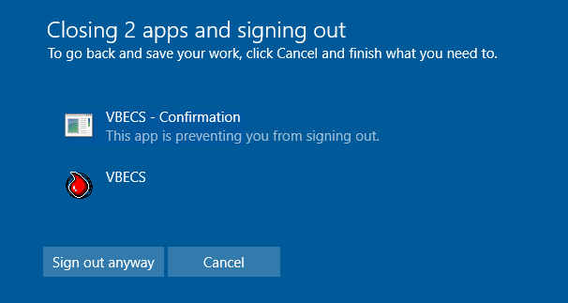

Do not click the Sign out anyway button. Clicking this button causes Windows to forcibly close VBECS, which fails to properly release your record locks. See Section: Database Record Locks..

To Sign out, click the Sign Out shortcut available on each app server desktop (Figure 22).

To Disconnect, click the X in the remote desktop window (Figure 22 and Figure 23).
Figure 22: Example of Remote Desktop in Windowed-Mode
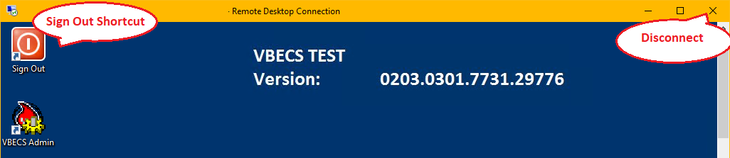
Figure 23: Example of Remote Desktop in Full Screen Mode
Removing your PIV card from the workstation will not disconnect your session.

The VBECS team recommends using the Sign Out shortcut when you are not expecting to need VBECS for over an hour OR at the end of your shift.

Unexpected Remote Desktop Disconnections
In addition to being able to manually disconnect your Remote Desktop session, it is possible that your session will disconnect for other reasons – typically network related. If this happens, you will have 60 minutes to reconnect to your session or it will terminate.

Depending on the severity of the cause, your connection may try to re-establish itself for you. When this happens, you’ll see a message similar to Figure 24. Allow the reconnections to try. If all attempts fail, try manually reconnecting using the VBECS Remote Desktop shortcut. If you’re still unable to connect, contact Customer Support.
Figure 24: Example of a Disconnected Session Automatically Retrying to Connect
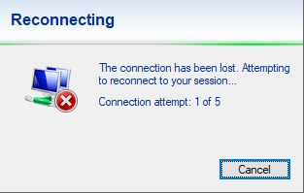

When an unexpected disconnection is more severe in nature, you’ll see a message similar to Figure 25. Try reconnecting again with your VBECS remote desktop shortcut. Try reconnecting using the VBECS Remote Desktop shortcut. If you’re unable to connect, contact Customer Support.
Figure 25: Example of an Unexpected Disconnected Session Alert
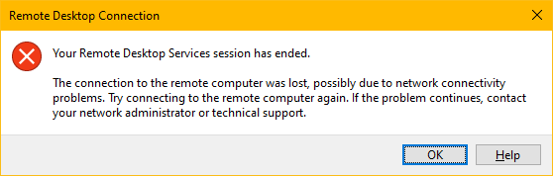

Remote Desktop Credentials – Lock Screen
Similar to the credential nuance mentioned with Remote Desktop login, if you find yourself at the VBECS server’s lock screen (Figure 26), ensure you select the right credentials to login. Here, accounts are represented by icons:
- - the smart card icon. Click this icon to login with your PIV credentials.
- - the Windows user icon. Click this icon to login with your Windows ID and password.
If you don’t see any of these icons, click the Sign-in options link.
Figure 26: Example of Remote Desktop Lock Screen
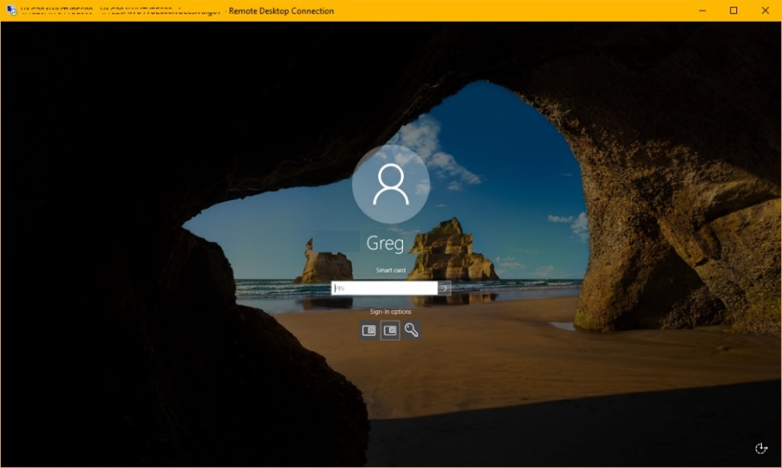

Remote Desktop Appearance and Zooming
Windows includes a feature (Figure 27) allowing you to increase the scale (magnification) of your workstation display. Windows may recommend (and set) this value larger than 100%, which causes your fonts and apps to get larger and are easier to read. However, VBECS fonts are not affected by this setting. What is affected are VBECS report on-screen previews; report fields may no longer line up correctly. Printed reports may be affected by this setting. Exported reports are unaffected by this setting.
Figure 27: Example of Windows Scale Setting That Affects VBECS Report Previews
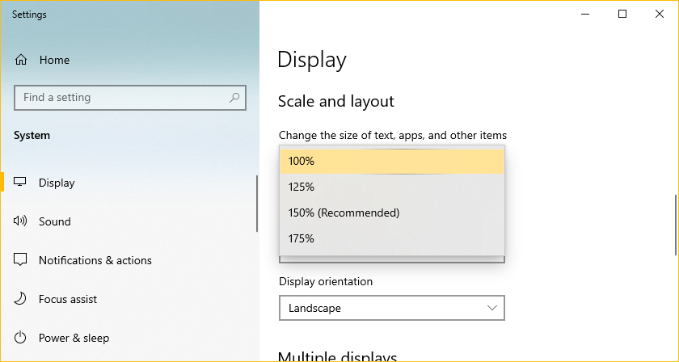

Remote Desktop Navigation
Most Windows functionality has been hidden from VBECS users to protect system integrity. However, if VBECS ever freezes or you cannot see the Sign Out desktop shortcut, you can try clicking the “Show Desktop” button, located in the lower-right corner of the Windows taskbar. Figure 28 shows a magnified representation of where to click.
Figure 28: Example of the Show Desktop Button

Remote Desktop Zooming
VBECS fonts are a fixed size but you can magnify use the Remote Desktop Zoom feature to make the fonts appear larger. Remote Desktop zooming is only enabled when the window is not in full-screen mode. To disable full-screen mode, double click anywhere on the remote desktop title bar. Once in non-full-screen mode, right-click on the title bar to show the remote desktop options and select Zoom and then a factor of your liking (Figure 29). To return to full screen mode you will first need to revert the Zoom back to 100%. Changing the zoom on a remote desktop window has no effect on VBECS report previews.
Figure 29: Example Setting Remote Desktop Zooming
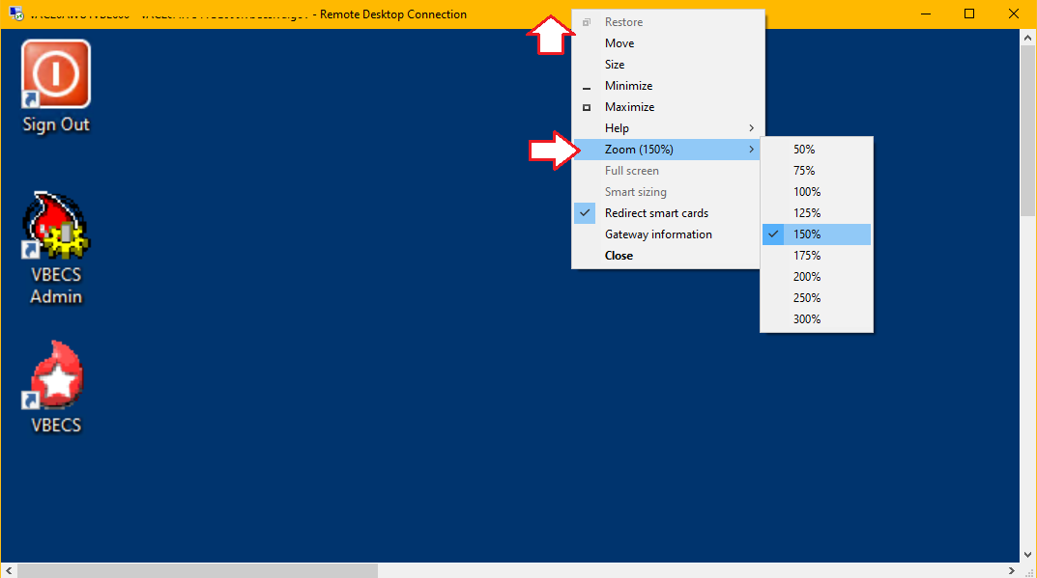

Exported Reports Network Share
For increased security, the VBECS application server blocks user access to the file system. As a result, exported reports are only accessible through network share. Each VBECS instance has its own network share, which means that TEST and PRODUCTION reports are saved to different locations. Only users with permission to VBECS Admin have the ability to create and delete folder on the network share, all other users have read-only access.

The VBECS Team has created shortcuts for each VBECS instance that can be saved on workstations for quick access to the exported report network share. These shortcuts can be found on the VBECS SharePoint page:
REDACTED

A video tutorial for downloading report share shortcuts can be found by clicking REDACTED.
Download Instructions (Figure 30):
- Navigate to and select your blood bank’s report share entry for either TEST or PRODUCTION.
- Click Download.
- Click Save As (some browsers may not present this option).
Figure 30 : Example of Downloading the Report Share Shortcut (using Microsoft Edge)
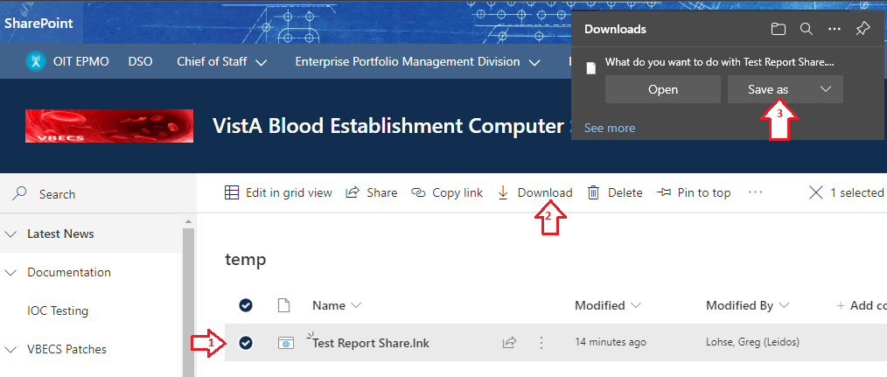

- A “Save As” window opens (Figure 31).
- Select your Desktop (or path of your choosing).
- Set the Save as type field to All files (*.*)
- In the File name field, replace “download” with “lnk”.
- Click Save.
Figure 31 : Example of Saving the Report Share Shortcut to the Desktop
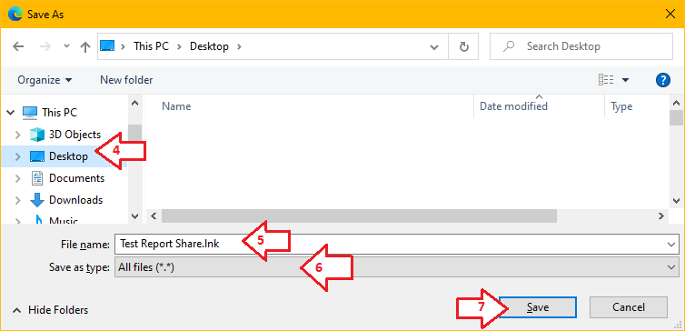
To make a report share shortcut available for all users of a workstation, it’s recommended place the shortcut in the C:\Users\Public\Desktop folder on every lab workstation. However, this path is a protected system folder and only accessible to system administrators. Contact your local desktop IT support for assistance.

VBECS Server Maintenance
The VBECS servers must be updated regularly with security and software updates to enhance security and meet VA compliance. All software updates or changes affecting the VBECS servers are first tested by the VBECS team before being applied to blood bank test or production servers.

VBECS servers are not rebooted at a specific time but are instead rebooted at any time during a maintenance window. A maintenance window puts less stress on the Azure infrastructure which should result in faster reboot times. All VBECS servers will be rebooted twice each month. These maintenance windows take place during the weeks of the 2nd and 4th Tuesday of each month according to the schedule in Table 2. If a maintenance day falls on a VA observed holiday, the remaining maintenance schedule will shift forward one day. Refer to Table 3 to see which maintenance window applies to your VBECS instance. Additional reboots may occur for critical maintenance or security patches but connected users will always receive warning alerts (Figure 32) and minimal downtime.
Table 2: Maintenance Window Schedule
Environment | Tuesday | Wednesday | Thursday
PRODUCTION | 10AM-1PM CST  East region servers | 10AM-1PM CST  South region servers | 10AM-1PM CST  Southwest region servers
TEST | 1PM-3PM CST  East region servers | 1PM-3PM CST  South region servers | 1PM-3PM CST  Southwest region servers
Table 3: VBECS Server Regions
REDACTED

If you are unable to connect to your VBECS app server for more than 10 minutes during your server maintenance window (or ever), contact Customer Support.

What to Expect During Server Maintenance

PRODUCTION Maintenance
When your PRODUCTION server’s maintenance begins, all disconnected sessions are terminated. However, any user with an open Remote Desktop client window will see warning alerts similar to Figure 32. Seeing one of these alerts means that your passive VBECS server is already running. You should switch to it as soon as possible by signing out and back in; the load balancer will route you to the correct server.
Please do not disconnect your session; instead, use the Sign Out shortcut (see the Session Disconnect vs Sign Out section). Maintenance warning alerts will be sent at 10, 5 and 1 minute prior to the server reboot.
Figure 32: Example of Server Maintenance Alert (Production Server)
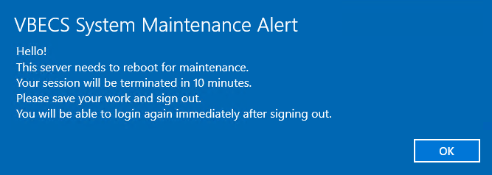

TEST Maintenance
Due to current limitations with the cloud, TEST environments will not receive warning alerts similar to Figure 32. TEST servers will reboot at some point during their maintenance window without warning, so plan accordingly. Test accounts will be completely unavailable while the server reboots; the expected downtime is between 5 and 30 minutes. Contact Customer Support if you are unable to access your TEST environment outside the maintenance window.

Anti-Virus Software and Virus Protection
Anti-virus software is required and running on all VBECS servers. The VA’s Infrastructure Operations team determines which vendor’s software to use, however the VBECS Team tests any updates on development servers before approving it for use on all VBECS servers.

VistA Maintenance Operations
Four HL7 Logical Links and one VistALink connection must be established and configured to establish proper communication with VBECS. The HL7 links are:
- OERR-VBECS
- VBECS-OERR
- VBECSPTU
- VBECSPTM

The VistALink connection configuration is the data that VistA will use to transmit data in XML format to VBECS. The following set of instructions will aid in the proper configuration of these links and ensure reliable communication between VistA and VBECS. These links must be configured during the initial installation of VBECS, and after any changes to the HL7 or VistALink configuration on VBECS. The settings should also be updated after the VistA Test account has been remirrored.

Set Up VBECS Outbound Logical Links
- At the “Select HL7 Main Menu Option:” prompt, enter Filer.
- Shut down the logical link.
- At the “Select Filer and Link Management Options Option:” prompt, enter Link Edit.
- At the “Select HL LOGICAL LINK NODE:” prompt, enter OERR-VBECS (Figure 33).
Figure 33: HL7 Logical Link Edit Menu Navigation
HL7 Main Menu
Event monitoring menu ...
Systems Link Monitor
Filer and Link Management Options ...
Message Management Options ...
Interface Developer Options ...
Site Parameter Edit

Select HL7 Main Menu Option: FILER

SM Systems Link Monitor
FM Monitor, Start, Stop Filers
LM TCP Link Manager Start/Stop
SA Stop All Messaging Background Processes
RA Restart/Start All Links and Filers
DF Default Filers Startup
SL Start/Stop Links
PI Ping (TCP Only)
ED Link Edit
ER Link Errors ...

Select Filer and Link Management Options Option: ED

Select HL LOGICAL LINK NODE: OERR-VBECS

- Enter Enabled in the AUTOSTART field (Figure 34).
- Move the cursor to the LLP TYPE field and press Enter (Figure 34).
Figure 34: HL7 Logical Link
HL7 LOGICAL LINK
-----------------------------------------------------------------------------
NODE: OERR-VBECS
INSTITUTION:
DOMAIN:
AUTOSTART: ENABLED
QUEUE SIZE: 10
LLP TYPE: TCP
______________________________________________________________________________
COMMAND: Press <PF1>H for help Insert
- In the “TCP/IP ADDRESS” field, enter the value contained from the “Computer Name” field of your VBECS remote desktop shortcut. IP addresses cannot be used.
- In the “TCP/IP PORT” field, enter VBECS standard port numbers of 21993 for TEST and 21994 for PRODUCTION.
- Set the “ACK TIMEOUT” field to 30.
- Set the “READ TIMEOUT” field to 30.
- Move the cursor to the “COMMAND:” prompt.
- Enter Close to return to the previous screen.
- At the “COMMAND:” prompt, enter Save.
- Enter Exit.
Figure 35: TCP Lower Level Parameters: OERR-VBECS
HL7 LOGICAL LINK
-----------------------------------------------------------------------------
TCP LOWER LEVEL PARAMETERS
OERR-VBECS

TCP/IP SERVICE TYPE: CLIENT (SENDER)
TCP/IP ADDRESS: <DNS from the VBECS remote desktop shortcut>
TCP/IP PORT: <21993 or 21994>

ACK TIMEOUT: 30 RE-TRANSMISION ATTEMPTS:
READ TIMEOUT: 30 EXCEED RE-TRANSMIT ACTION:
BLOCK SIZE: SAY HELO:

STARTUP NODE: PERSISTENT: NO
RETENTION: 15 UNI-DIRECTIONAL WAIT:
____________________________________________________________________________
COMMAND: Press <PF1>H for help Insert
- Repeat Steps 3 through 14 substituting “VBECSPTM” and “VBECSPTU” for “OERR-VBECS” when prompted for the logical link name to change the IP address and port numbers for the VBECSPTM and VBECSPTU logical links.

Set Up the VBECS Inbound Logical Link
- At the “Select HL7 Main Menu Option:” prompt, enter Filer.
- At the “Select Filer and Link Management Options Option:” prompt, enter Link Edit.
- At the “Select HL LOGICAL LINK NODE:” prompt, enter VBECS-OERR (as shown for OERR-VBECS in Figure 33).
- Enter Enabled in the AUTOSTART field (Figure 36).
- Move the cursor to the LLP TYPE field and press Enter (Figure 36).
Figure 36: HL7 Logical Link
HL7 LOGICAL LINK
-----------------------------------------------------------------------------
NODE: VBECS-OERR
INSTITUTION:
DOMAIN:
AUTOSTART: ENABLED
QUEUE SIZE: 10
LLP TYPE: TCP
_____________________________________________________________________________
COMMAND: Press <PF1>H for help Insert
- Blank out the “TCP/IP ADDRESS” field.
- In the “TCP/IP PORT” field, enter the correct (unique) port number for your VistA. Unique port numbers are in the format 1mn93 for TEST and 1mn94 for PRODUCTION, where “mn” is the site specific “magic number”. Regional support should be contacted for the correct port numbers.
- Set the “ACK TIMEOUT” field to 30.
- Set the “READ TIMEOUT” field to 30.
- Set the “RE-TRANSMISSION ATTEMPTS” field to 10.
- Set the “EXCEED RE-TRANSMIT ACTION” field to restart.
- Move the cursor to the “COMMAND:” prompt.
- Enter Close to return to the previous screen.
- At the “COMMAND:” prompt, enter Save.
- Enter Exit.
Figure 37: TCP Lower Level Parameters: VBECS-OERR
HL7 LOGICAL LINK
-----------------------------------------------------------------------------
TCP LOWER LEVEL PARAMETERS
VBECS-OERR

TCP/IP SERVICE TYPE: SINGLE LISTENER
TCP/IP ADDRESS:
TCP/IP PORT: <1mn93 OR 1mn94>

ACK TIMEOUT: 30 RE-TRANSMISION ATTEMPTS: 10
READ TIMEOUT: 30 EXCEED RE-TRANSMIT ACTION: restart
BLOCK SIZE: SAY HELO:

STARTUP NODE: PERSISTENT: NO
RETENTION: UNI-DIRECTIONAL WAIT:
____________________________________________________________________________
COMMAND: Press <PF1>H for help Insert

Start VistA HL7 Logical Links
- Before data can be transmitted over the VBECS logical links, edit the link definitions as described above.
- To turn on the new VBECS logical links, select Start/Stop Links [HL START].
- Start the “OERR-VBECS” logical link.
- Start the “VBECS-OERR” logical link.
- Start the “VBECSPTM” logical link.
- Start the “VBECSPTU” logical link.
- Ensure that the VistA HL7 Link Manager is running; VBECS messaging cannot occur without it.
- To check the status of the Link Manager (and, if necessary, restart it), access the HL START/STOP LINK MANAGER menu option.

Monitor VBECS HL7 Logical Links
Once two-way communication has been established, you can monitor the links.

- Use the “System Link Monitor” to view the status of the VBECS Logical Links.
- From the “HL7 Main Menu”, select System Link Monitor (Figure 38).
Figure 38: HL7 System Link Monitor Menu Navigation
HL7 Main Menu
Event monitoring menu ...
Systems Link Monitor
Filer and Link Management Options ...
Message Management Options ...
Interface Developer Options ...
Site Parameter Edit

Select HL7 Main Menu Option: System Link Monitor
- When a list of VistA HL7 links defined at your site appears, press V at the “Select a Command:” prompt (Figure 39).
- At the “Select LINK MONITOR VIEWS:” prompt, enter VBECS (Figure 39).
Figure 39: System Link Monitor
SYSTEM LINK MONITOR for <your site name>

MESSAGES DEVICE
NODE RECEIVED PROCESSED TO SEND SENT TYPE STATE

LA7V 657 4 4 MM Halting
LL15VISN 105 105 394 105 NC Shutdown
MPIVA 0 0 322 0 NC Shutdown
NPTF 0 0 25 0 MM Halting
OERR-VBE 34 34 1019 1018 NC Idle
PSOTPBAA 28 28 52 28 NC Shutdown
VABAC 0 0 1 0 NC Shutdown
VAFAV 0 0 2 0 NC Shutdown
VAFHM 0 0 3 0 NC Shutdown
VAFRE 0 0 4 0 NC Shutdown

Incoming filers running => 1 TaskMan running
Outgoing filers running => 1 Link Manager running
Monitor OVERDUE
Select a Command:
(N)EXT (B)ACKUP (A)LL LINKS (S)CREENED (V)IEWS (Q)UIT (?) HELP: V

Select LINK MONITOR VIEWS: VBECS
- A screen similar to Figure 40 appears.
Figure 40: System Link Monitor
SYSTEM LINK MONITOR for <your site name>

MESSAGES DEVICE
NODE RECEIVED PROCESSED TO SEND SENT TYPE STATE

OERR-VBECS 0 0 0 0 NC Idle
VBECS-OERR 0 0 0 0 SS Idle
VBECSPTM 0 0 0 0 NC Enabled
VBECSPTU 0 0 0 0 NC Enabled

Incoming filers running => 1 TaskMan running
Outgoing filers running => 1 Link Manager Running
Monitor OVERDUE
Select a Command:
(N)EXT (B)ACKUP (A)LL LINKS (S)CREENED (V)IEWS (Q)UIT (?) HELP:
- To exit the “System Link Monitor”, at the “Select a Command:” prompt, enter Q to quit.
- Refer to Appendix A: Verify VBECS HL7 Interface Protocols if errors are noted and the configuration of the HL7 links is in question.

The volume of HL7 traffic over these links depends on the number of daily CPRS Blood Bank orders and updates to the VistA clinical information at your site. These can be significant at large sites. Monitor the links closely the first few days after the installation and purge the HL7 log data (as appropriate) in accordance with your standard HL7 monitoring and purging procedures.

Configure VBECS VistALink Links
- Use the “Edit Parameter Values” option on the “GENERAL PARAMETER TOOLS” menu to edit the values for the VistALink connection to VBECS.
- At the “Select Instance:” prompt, enter LISTENER IP ADDRESS.
- At the “Value:” prompt, enter the value of the “Computer Name” field from the appropriate VBECS remote desktop shortcut. IP addresses cannot be used.
- At the “Select Instance:” prompt, enter LISTENER PORT NUMBER.
- At the “Value:” prompt, enter the VBECS VistALink listener port number: 21991 for TEST and 21992 for PRODUCTION.
- Press Enter to exit the option.
Figure 41: VistALink Configuration
Select OPTION NAME: GENERAL PARAMETER TOOLS XPAR MENU TOOLS General Parameter Tools

LV List Values for a Selected Parameter
LE List Values for a Selected Entity
LP List Values for a Selected Package
LT List Values for a Selected Template
EP Edit Parameter Values
ET Edit Parameter Values with Template
EK Edit Parameter Definition Keyword

Select General Parameter Tools Option: EP Edit Parameter Values
--- Edit Parameter Values

Select PARAMETER DEFINITION NAME: VBECS VISTALINK

---------------- Setting VBECS VISTALINK for Package: VBECS
Select Instance: LISTENER IP ADDRESS

Instance: LISTENER IP ADDRESS// LISTENER IP ADDRESS
Value: <IP address>// <”Computer Name” field value from the VBECS remote desktop shortcut>
Select Instance: LISTENER PORT NUMBER

Instance: LISTENER PORT NUMBER Replace LISTENER PORT NUMBER
Value: 8000// <21991 or 21992>
Select Instance:

Workload Data Transmission
VBECS workload data is recorded in VBECS when records that qualify as Workload Events are saved in VBECS. This data is extracted from VBECS to the VistA Laboratory workload recording system by way of a VistA scheduled task named LR TASK NIGHT (NIGHTLY CLEANUP).

If VistA is not receiving VBECS workload, ensure the task is scheduled correctly in VistA.

This task is scheduled using the SCHEDULE/UNSCHEDULE OPTIONS (XUTM SCHEDULE) option.
Set the “QUEUED TO RUN AT WHAT TIME:” entry to just after midnight.
Set the “RESCHEDULING FREQUENCY:” to “1D”, which indicates that the task should repeat daily.

Troubleshooting

Error on VBECS or VBECS Admin Launch
If you see the message depicted in Figure 42 it means that your VBECS environment is corrupted and your VBECS software version does not match the version expected in your VBECS database. This should never happen, so contact Customer Support immediately.

Figure 42: Example of Critical Software Mismatch Error
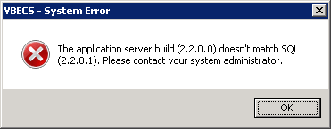

VBECS Application Interfaces
When the HL7 Listener service encounters an error parsing an HL7 message it generates an event description like the following:
VBECS Patient Update HL7 Parser: Error processing HL7 message:
Missing or invalid content in HL7 message:
ERR^MSH~1~12~203~

Upon troubleshooting an email message regarding an HL7 message, contact Customer Support. Due to PII and HIPAA constraints, patient information will not be sent over unencrypted email and the support personnel will need to manually retrieve this information from your VBECS server. Table 4 describes the possible error codes and problem descriptions.

Table 4: Troubleshooting Rejected VBECS HL7 Messages
Error Code | Description of Problem
100 | Segment Sequence Error
101 | Required Field Missing
102 | Data Type Error
103 | Table Value Not Found
200 | Unsupported Message Type
201 | Unsupported Event Code
202 | Unsupported Processing ID
203 | Unsupported Version Id
204 | Unknown Key Identifier
205 | Duplicate Key Identifier
206 | Application Record Locked
207 | Application Internal Error
208 | Conflicting Processing Id

Table 5: Troubleshooting VBECS Application Interfaces
Source | Description of Problem | Possible Cause | Solution
VBECS: Order Alerts and Pending Order List | New orders or cancellations of existing orders in CPRS are not showing up in VBECS. | The OERR-VBECS HL7 Logical Link is not running on the VistA system. | Start the OERR-VBECS HL7 Logical Link.
 |  | The VBECS HL7 Listener Windows service is not running or is hung on your VBECS app server. | Contact Customer Support to restart the VBECS HL7 Listener Windows service on your VBECS app server.
 |  | Network connectivity issue | Contact Customer Support to troubleshoot possible network service disruptions or firewall issues.
 |  | The HL7 message is missing patient name or one or more name components length(s) exceed(s) the VBECS maximum supported value. | VBECS responds to the new order request with an application reject (AR) acknowledgement message indicating Patient Name(s) not found in HL7 Message or Patient's Name(s) field size(s) exceed(s) VBECS maximum supported value. Rejected patient order messages due to invalid patient name message content are recorded on the Windows Event Log (Finding Application Log Entries from Email Alerts) and an email message containing the MSH segment of the rejected HL7 message.
VBECS Admin: Edit Division | New orders are not showing up in VBECS. | Order mappings to institutions within a division’s configuration are not setup properly. | Map the missing CBOC facilities in the Edit Divisions menu option for VBECS Admin.
VBECS: Patient Update Alerts | VistA patient updates are not showing up in VBECS. | The Taskman scheduled option VAFC BATCH UPDATE is not scheduled to run or has not reached the time limit in the schedule. | Schedule the VAFC BATCH UPDATE option to run at the desired frequency (the recommended frequency is every 10 minutes) or use the option “One-time Option Queue” in the Taskman Management Options to start the task.
 |  | The VBECSPTU HL7 Logical Link is not running on the VistA system. | Start the VBECSPTU HL7 Logical Link.
 |  | The VBECS HL7 Listener Windows service is not running or is hung on your VBECS app server. | Contact Customer Support to restart the VBECS HL7 Listener Windows service on your VBECS app server.
 |  | Network connectivity issue | Contact Customer Support to troubleshoot possible network service disruptions or firewall issues.
 |  | The HL7 message is missing the patient’s name or one or more of the patient’s name component length(s) exceed the VBECS maximum supported length. | Contact Customer Support to help identify which patient name component is causing the problem.
VBECS: Patient Merge Alerts | VistA Patient Merge events are not showing up in VBECS. | The VBECSPTM HL7 Logical Link is not running on the VistA system. | Start the VBECSPTM HL7 Logical Link.
 |  | The VBECS HL7 Listener Windows service is not running or is hung on your VBECS app server. | Contact to restart the VBECS HL7 Listener Windows service on your VBECS app server.
 |  | Network connectivity issue | Contact Customer Support to troubleshoot possible network service disruptions or firewall issues.
 |  | The HL7 message is missing the patient’s name or one or more of the patient’s name component length(s) exceed the VBECS maximum supported length. | Contact Customer Support to help identify which patient name component is causing the problem.
VistA: HL7 System Link Monitor | The VistA HL7 System Link Monitor shows more MESSAGES TO SEND than MESSAGES SENT for the OERR-VBECS Logical Link and is hung in an “Open” state. | The VBECS HL7 Listener Windows service is not running or is hung on your VBECS app server. | Contact Customer Support to restart the VBECS HL7 Listener Windows service on your VBECS app server.
 | The VistA HL7 System Link Monitor shows more MESSAGES TO SEND than MESSAGES SENT for the VBECSPTU Logical Link and is hung in an “Open” state.
 |  | Network connectivity issue | Contact Customer Support to troubleshoot possible network service disruptions or firewall issues.
 | The VistA HL7 System Link Monitor shows more MESSAGES TO SEND than MESSAGES SENT for the VBECSPTM Logical Link and is hung in an “Open” state.
CPRS: Orders Tab | CPRS does not display the correct status of a blood bank order after it was updated in VBECS. | The VBECS HL7 Dispatcher Windows service is not running or is hung on your VBECS app server. | Contact Customer Support to restart the VBECS HL7 Dispatcher Windows service on your VBECS app server.
 |  | The VBECS-OERR HL7 Logical Link is not running. | Start the VBECS-OERR HL7 Logical Link.
 |  | Network connectivity issue | Contact Customer Support to troubleshoot possible network service disruptions or firewall issues.
CPRS: Blood Bank Order Dialog | CPRS displays “Not able to open port” message in Patient Information screen in Blood Bank Order Dialog. | The VBECS VistALink Listener Windows service is not running or is hung on your VBECS app server. | Contact Customer Support to restart the VBECS VistALink Listener Windows service on your VBECS app server.
 |  | Network connectivity issue | Contact Customer Support to troubleshoot possible network service disruptions or firewall issues.
CPRS: Reports Tab, Blood Bank Report | CPRS displays “---- BLOOD BANK REPORT IS UNAVAILABLE----“ | The VBECS VistALink Listener Windows service is not running or is hung on your VBECS app server. | Contact Customer Support to restart the VBECS VistALink Listener Windows service on your VBECS app server.
 |  | Network connectivity issue | Contact Customer Support to troubleshoot possible network service disruptions or firewall issues.
 |  | Incorrect PARAMTERS field settings in VistA (File #8989.5) | Verify the PARAMETERS file is set correctly. Refer to the Configure VBECS VistALink Links section.
CPRS: Blood Bank Order Dialog: Signing an Order | CPRS displays an “Error Saving Order” dialog screen with the text “The error, One or more orders to the VBECS system failed and are queued for later delivery.” | A severe error occurred in the VBECS HL7 Listener Windows service, which failed to respond to CPRS properly. | Contact Customer Support to review the logs of the VBECS HL7 Listener Windows service on your VBECS app server.
 |  | Network connectivity issue | Contact Customer Support to troubleshoot possible network service disruptions or firewall issues.
 |  | If the IP address is not from the local VistA system, a rogue HL7 system is sending messages to the VBECS server. | Contact IRM to identify the location of the server with which the IP address is associated. Notify the site that the message is coming from the problem so that the messages can be routed to the correct location.
- Automated Instrument | VBECS is not receiving messages sent from the instrument. | The VBECS HL7 Dispatcher Windows service is not running or is hung on your VBECS app server. | Contact Customer Support to restart the VBECS HL7 Dispatcher Windows service on your VBECS app server.
 |  | Network connectivity issue | Contact Customer Support to troubleshoot possible network service disruptions or firewall issues.
 |  | The Automated Instrument interface is not enabled. | Enable the Automated Instrument interface in the Edit Interfaces menu option of VBECS Admin.

Scanner Problems
After scanning a barcode, a ` (backtick character) character appears at the start of the output.

Probable Cause
The Caps Lock is on.

Solution
Turn the Caps Lock off.

After scanning a barcode, characters appear in the output that do not match the label being scanned. Often, these bad characters are not alphanumeric.

Probable Cause
Network latency can cause data to become corrupted.

Solution
If the issue doesn’t improve over time, you can try to add a delay to the characters sent by the scanner. Consult your scanner vendor or documentation to increase the intercharacter delay. Start with a small delay and gradually increase until the scanner is correctly rendering the data.

Database

Backups
VBECS databases are backed up daily using Microsoft’s Azure Backup Service. This backup takes place at 4:00 AM (CST) and the data is saved to geo-redundant storage, which means it that three copies are made in both the primary and secondary storage regions to protect against drive failure. Backups are retained for 32 days.

Recovery
VBECS does not delete user-entered data. When a user invalidates or inactivates a record the record contains a status field which can be used to filter it from reports, but the record remains in the database. This is done to preserve the medical record for audit and protect against user error.
In the event of a catastrophic failure, a VBECS database can be recovered from a backup files, however all data entered after the backup file date, would need to be manually re-entered.

Database Record Locks
VBECS implements two record locking strategies for maximum protection against data editing collisions: optimistic and pessimistic. Neither locking strategy prevent reports or other read-only queries from running against the locked record.

Optimistic locking is controlled by the database. It prevents records from being updated if those records were changed since the record was retrieved for editing. This is less user friendly since a user isn’t notified of a problem until they try saving their changes. This is VBECS’s safety net in case Pessimistic locking logic fails.

Optimistic Locking Example (without Pessimistic locking in place):
User A selects a record for editing.
User B selects the same record for editing and makes their change quickly and saves.
User A makes their changes and receives an error indicating the record has already changed. They need to re-select the record and repeat their edits.

Pessimistic locking is controlled by VBECS application code and prevents a user from opening a record for edit if another user already has the same record open for edit.

Pessimistic Locking Example:
User A selects a record for editing. At this point VBECS locks the record.
User B attempts to select the same record for editing. VBECS displays an alert indicating that User A already has the record locked and prevents them from editing the record.

As long as a user is working on the data they have locked, the lock will stay active. However, if they switch to a different menu option or leave their workstation, their lock becomes inactive and an inactivity countdown begins.

The countdown value is defined by the Lock Inactivity Timeout field of the Edit Divisions menu in the VBECS Admin software (refer to the VBECS Admin User Guide).
If an inactive lock’s countdown reaches zero, the record lock is released.

Example: A division with a Lock Inactivity Timeout value of 10 minutes.
User A selects a record for editing. At this point VBECS locks the record.
User A stops using VBECS. The lock becomes inactive and a 10-minute inactivity countdown begins.

Option 1:
User A returns to VBECS before the countdown hits zero. The lock is again active, and the inactivity countdown stops.

Option 2:
User A returns to VBECS 11-minutes later. The lock is released, its menu option is closed, and the user needs to repeat their changes on that record. *VBECS does display a message to users when they have 60 seconds left on an inactivity countdown.

If a user Signs out of VBECS, any locks are released unless they use the “Sign out anyway” option (see Section: Session Disconnect vs Sign Out).

If a user Disconnects from VBECS, their locks remain and will begin their inactive countdown.

If VBECS has an unexpected shutdown or the user forcibly signs out of the server, record locks are not released. If this happens, there are 3 options available to release those locks:
- The user that owns the locks can restart VBECS. Starting VBECS releases any of the user’s locks it finds which weren’t released by pessimistic locking logic.
- Wait: locked records are automatically released by the database after 30 minutes.
- Contact Customer Support who can manually release the locks.

Security
VBECS contains sensitive data and performs a critical function, so it is critical to secure the system. It is important to secure the server from both users and malicious attacks from an individual who is trying to gain access to the system.

VBECS Active Directory (AD) Groups
To use the VBECS software, users must belong to the proper security groups. Each VBECS installation has two AD security groups which grant them access to their app server only:
- One group that controls access to the VBECS software
- One group that controls access to the VBECS Admin software

Remote Desktop permissions are granted to each of these groups on the appropriate app server.
Table 6 contains a list of all of the AD security groups used throughout VBECS. Lookup your Site Code or Division Number (Div#) to find your entry. The VBECS Team does not manage these groups. To have users added or removed from a group, contact Customer Support and mention your group name from Table 6.
Table 6: VBECS Active Directory Groups
REDACTED

Glossary
Acronym, Term | Definition
AD | Active Directory. A directory service used to organize and manage domain objects such as computers, users, and security groups.
CPRS | Computerized Patient Record System.
DNS | Domain Naming System. Service that resolves network-joined computer names into IP addresses.
HL7 | Health Level Seven.
LLP | Lower Layer Protocol.
MAG | Microsoft Azure Government. Name of the government subscription in the Microsoft Azure cloud.
PIV | Personal Identification Verification.
RDP | Remote Desktop Protocol.
SQL | Structured Query Language.
TCP/IP | Transmission Control Protocol/Internet Protocol.
VAEC | VA Enterprise Cloud. Term used to describe the VA computer systems contained within a commercial cloud.
VBECS | VistA Blood Establishment Computer Software.
VISN | Veterans Integrated Service Network.
XML | Extensible Markup Language.

Appendices

Appendix A: Verify VBECS HL7 Interface Protocols
This section can be used to verify the HL7 settings match initial VBECS installation values.

Set Up VBECS Protocol Definitions
- From the ‘HL7 Main” Menu, select Interface Developer Options.
- Select Protocol Edit.
Figure 43: Example of HL7 Protocol Menu Navigation
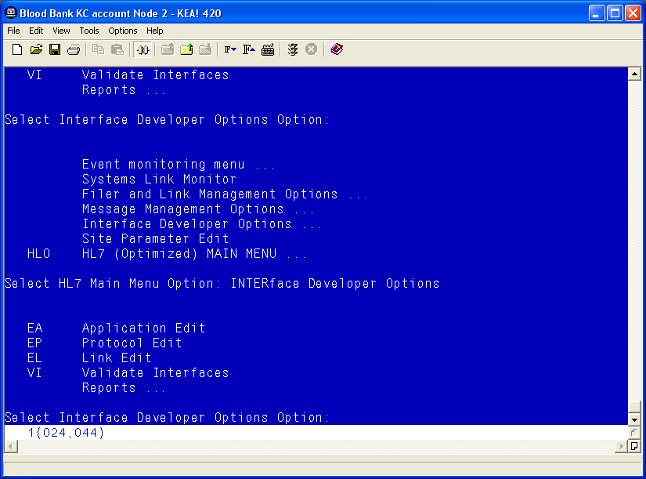

Patient Update Events

Edit VAFC ADT-A08 SERVER Protocol
- Select Edit Protocol and enter VAFC ADT-A08 SERVER.
- Move the cursor to the “TYPE” field and press Enter.
Figure 44: Example of HL7 Interface Setup
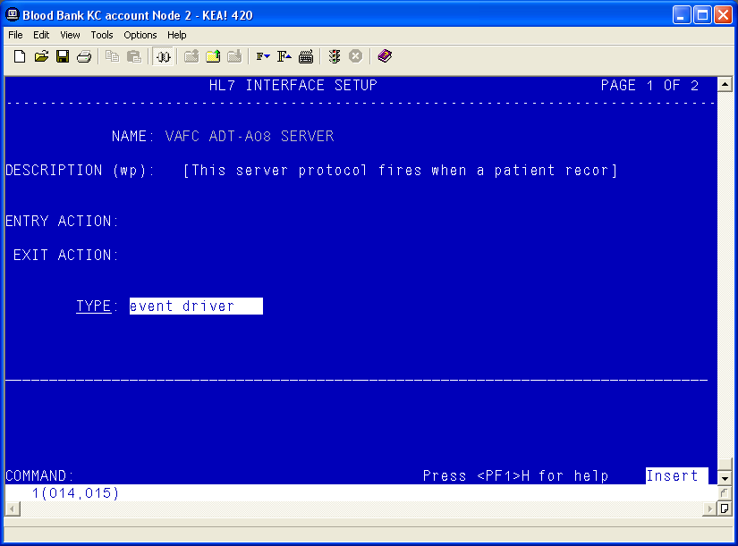
- Move the cursor to below the last entry in the “SUBSCRIBERS” section.
- Enter VBECS ADT-A08 ROUTER and press Enter.
Figure 45: Example of HL7 Event Driver
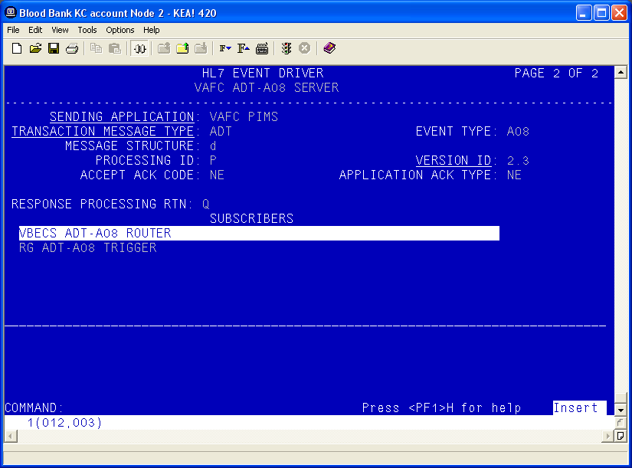
- Accept the default settings in the sub-window.
- Move the cursor to the “RECEIVING APPLICATION” prompt and verify that the entry is “VBECS ADT”.
- Press Enter.
Figure 46: Example of HL7 Subscriber: VBECS ADT-A08 Router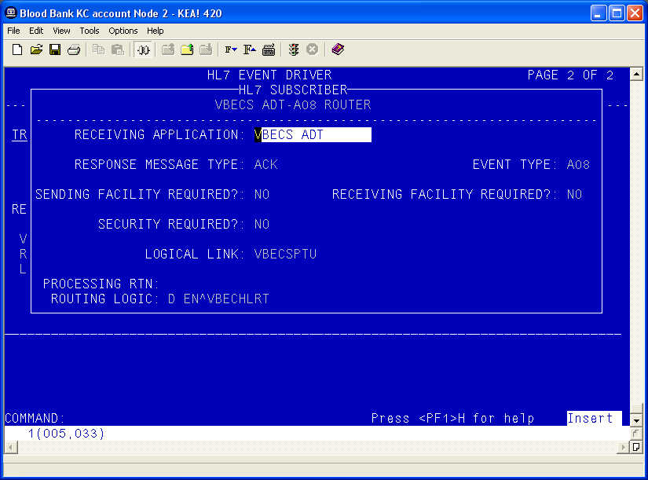
- Move the cursor to the “FACILITY NAME” prompt and enter the station number of the primary division of the site.
- Move the cursor to the “COMMAND” prompt.
- Enter Close and press Enter.
Figure 47: Example of HL7 Subscriber: VBECS ADT-A08 Router
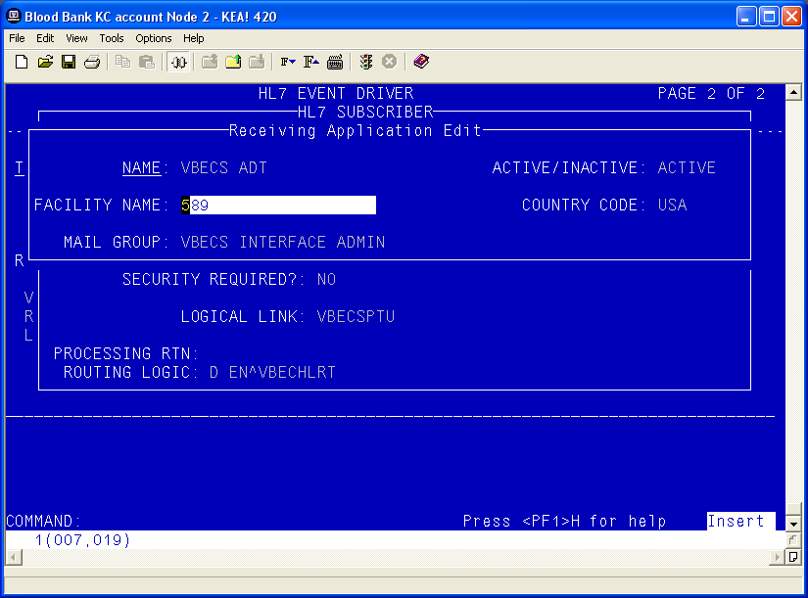
- You will return to the previous screen (Figure 47). Move the cursor to the “COMMAND” prompt.
- Enter Save and press Enter.
- Enter Exit and press Enter.

VBECS ADT-A08 CLIENT
- Select VBECS ADT-A08 CLIENT.
- Move the cursor to the “TYPE” field and press Enter.
Figure 48: Example of HL7 Interface Setup
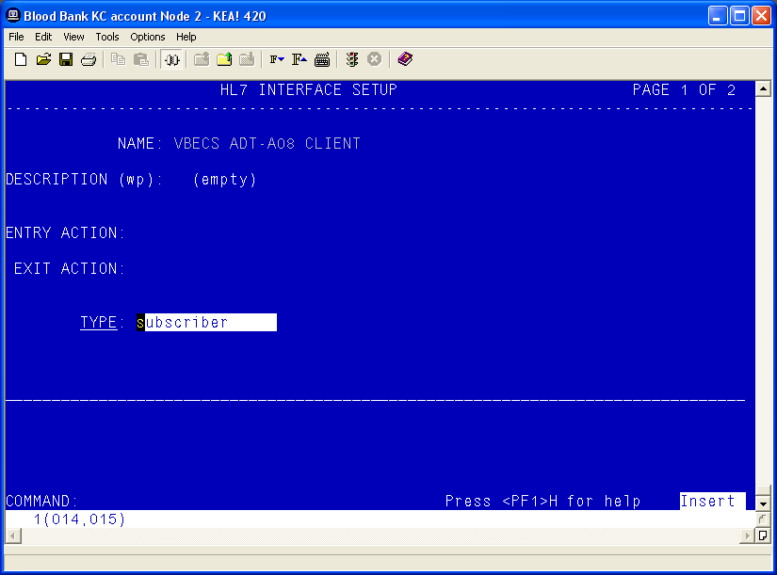
- Move the cursor to the “RECEIVING APPLICATION” prompt and verify that the entry is “VBECS ADT”.
- Press Enter.
Figure 49: Example of HL7 Subscriber: VBECS ADT-A08 Client
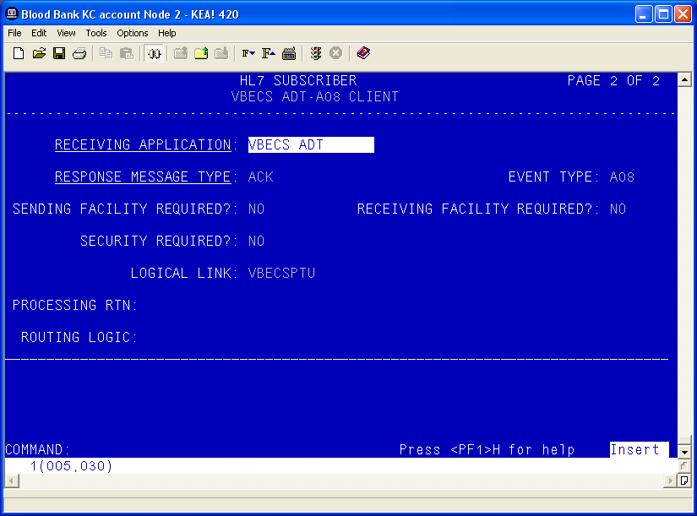
- Move the cursor to the “FACILITY NAME” prompt and enter the station number of the primary division of the site.
- Move the cursor to the “COMMAND” prompt.
- Enter Close and press Enter.
Figure 50: Example of Receiving Application Edit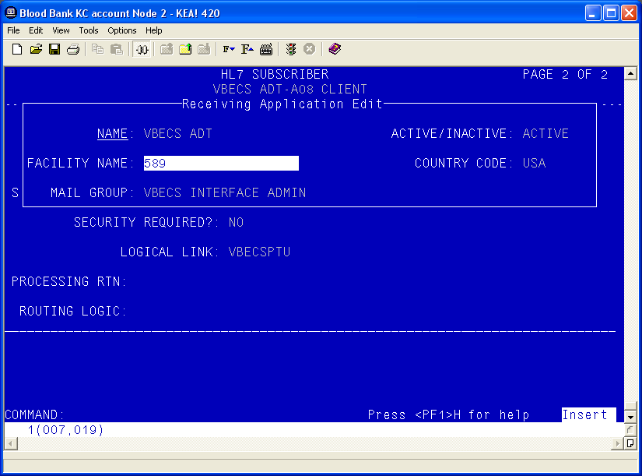
- You will return to the previous screen (Figure 50). Move the cursor to the “COMMAND” prompt.
- Enter Save and press Enter.
- Enter Exit and press Enter.

Patient Merge Events
- Select MPIF ADT-A40 SERVER.
- Move the cursor to the “TYPE” field and press Enter.
Figure 51: Example of HL7 Interface Setup
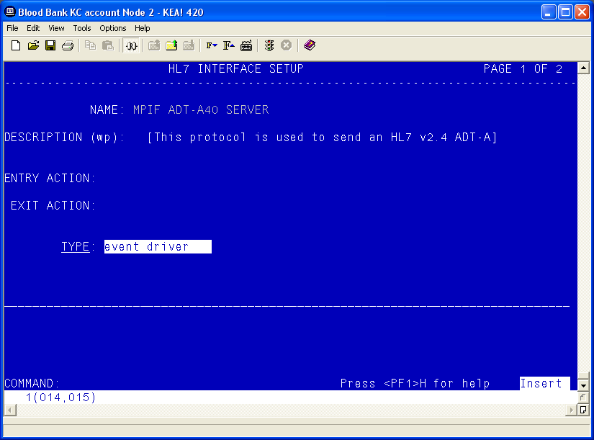
- Move the cursor to below the last entry in the “SUBSCRIBERS” section.
- Enter VBECS ADT-A40 CLIENT and press Enter.
Figure 52: Example of HL7 Event Driver: MPIF ADT-A40 Server
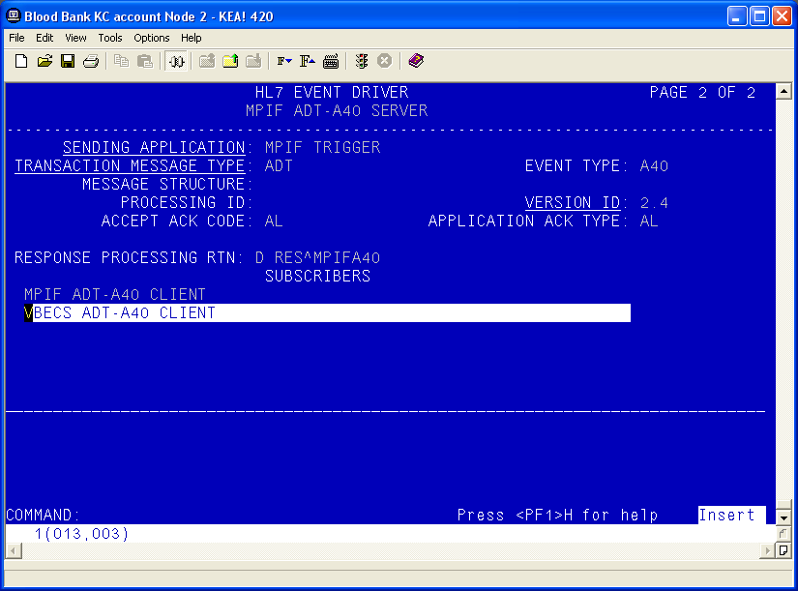
- Accept the default settings in the sub-window.
- Move the cursor to the “COMMAND” prompt.
- Enter Close and press Enter.
- You will return to the previous screen. Move the cursor to the “COMMAND” prompt.
Figure 53: Example of HL7 Subscriber: VBECS ADT-A40 Client
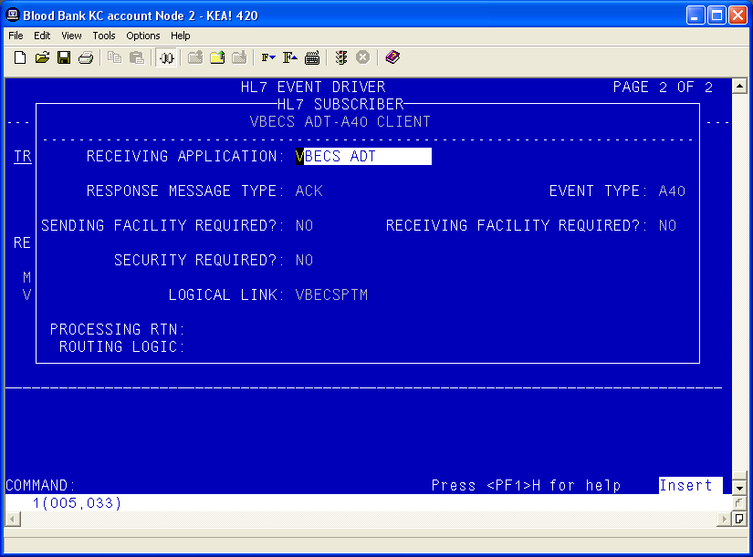
- Enter Save and press Enter.
- Enter Exit and press Enter.

Order Update Events
- Select VBECS OMG SERVER.
- Move the cursor to the “TYPE” field and press Enter.
Figure 54: Example of HL7 Order Update Setup
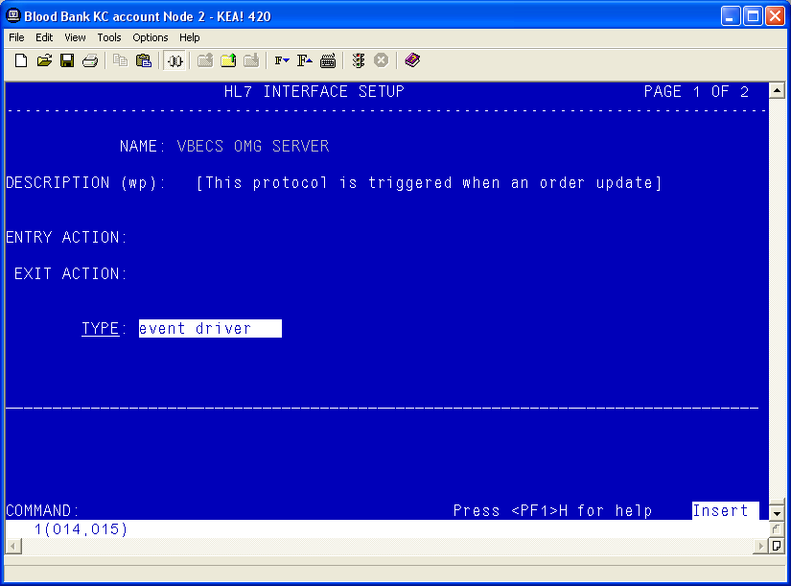
- Move the cursor to below the last entry in the “SUBSCRIBERS” section.
- Enter VBECS OMG CLIENT and press Enter.
Figure 55: Example of HL7 Event Driver: VBECS OMG Server
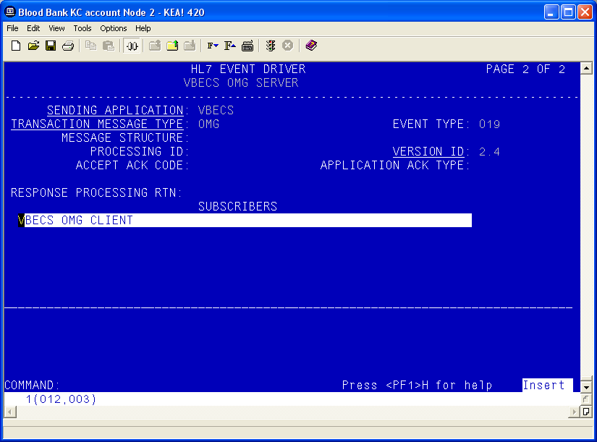
- Verify that the Receiving Application is OERR.
Figure 56: Example of HL7 Event Driver: VBECS OMG Server
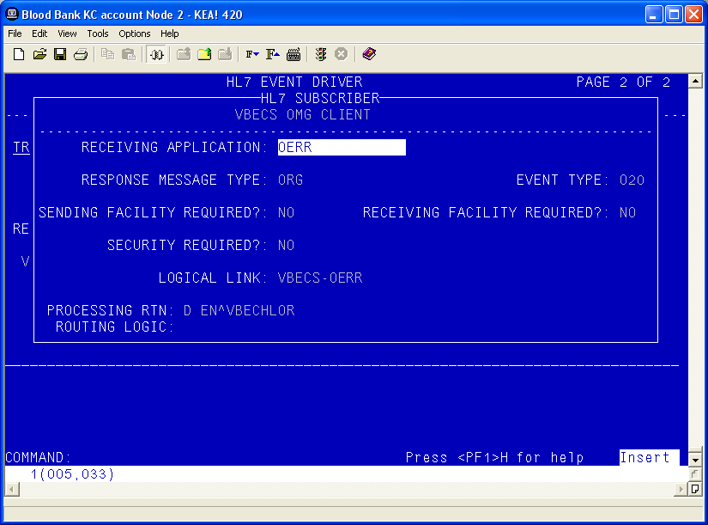
- Move the cursor to the “COMMAND” prompt.
- Enter Close and press Enter.
- Move the cursor to the “COMMAND” prompt.
- Enter Save and press Enter.
- Enter Exit and press Enter.

Order Update Events (continued)
- Select VBECS OMG CLIENT.
- Move the cursor to the “TYPE” field and press Enter.
Figure 57: Example of HL7 Interface Setup
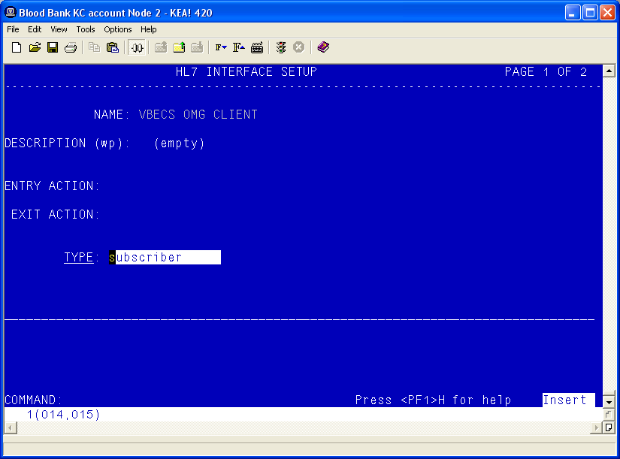
- Verify that the Receiving Application is OERR and press Enter.
Figure 58: Example of HL7 Event Driver: VBECS OMG Client
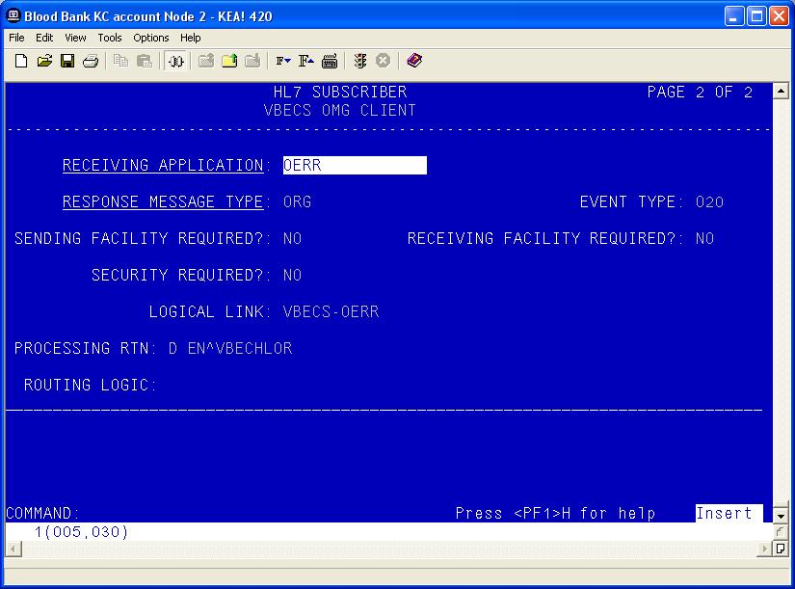
- Enter the correct Facility Name
Figure 59: Example of HL7 Subscriber: VBECS ADT-A40 Client
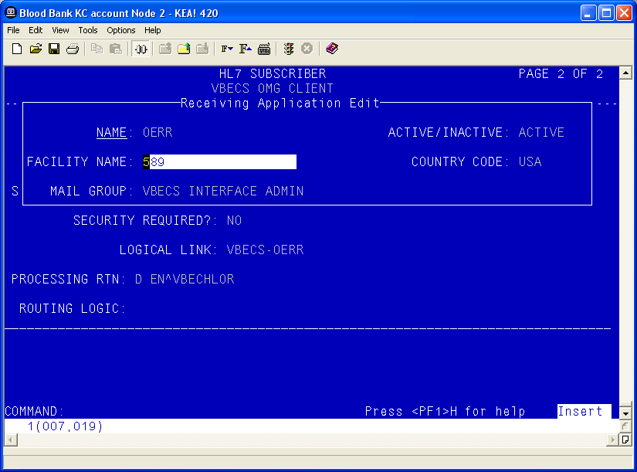
- Move the cursor to the “COMMAND” prompt.
- Enter Close and press Enter.
- Move the cursor to the “COMMAND” prompt.
- Enter Save and press Enter.
- Enter Exit and press Enter.

Appendix B: Laboratory Test File (#60)
Improper configuration of the VBECS related Laboratory tests may result in anomalies when ordering, resulting, or reporting workload for these tests. If any anomalies are noted, refer to this list for the proper configuration of these tests.
The Laboratory tests must be configured for your site. The appropriate INSTITUTION and ACCESSION AREA must be added using the “Edit cosmic tests” (LRDIECOSMIC) option. The TYPE field in Existing Blood Bank tests should be set to OUTPUT to prevent these tests from being ordered after VBECS has been installed.
Any of the diagnostic tests that will be ordered for Lab Collect (LC) must also have a LAB COLLECTION SAMPLE defined in addition to the COLLECTION SAMPLE. The LAB COLLECTION SAMPLE can be edited with the EDIT COSMIC TESTS (LRDIECOSMIC) option.

LABORATORY TEST File (#60)
NAME: ABO/RH - LAB TYPE: OUTPUT (CAN BE DISPLAYED)
SUBSCRIPT: BLOOD BANK UNIQUE COLLECTION SAMPLE: YES
HIGHEST URGENCY ALLOWED: STAT PRINT NAME: ABO RH
COLLECTION SAMPLE: BLOOD
INSTITUTION: VA HEARTLAND - WEST, VISN 15
ACCESSION AREA: BLOOD BANK
INSTITUTION: COLUMBIA, MO VAMC ACCESSION AREA: COBLOOD BANK
INSTITUTION: LEAVENWORTH VAMC ACCESSION AREA: LEBLOOD BANK
INSTITUTION: TOPEKA, KS VAMC ACCESSION AREA: TOBLOOD BANK
INSTITUTION: WICHITA VAMC ACCESSION AREA: WIBLOOD BANK
NAME: ANTIBODY SCREEN - LAB TYPE: OUTPUT (CAN BE DISPLAYED)
SUBSCRIPT: BLOOD BANK UNIQUE COLLECTION SAMPLE: YES
HIGHEST URGENCY ALLOWED: STAT PRINT NAME: AB SCRN
COLLECTION SAMPLE: BLOOD
INSTITUTION: VA HEARTLAND - WEST, VISN 15
ACCESSION AREA: BLOOD BANK
INSTITUTION: COLUMBIA, MO VAMC ACCESSION AREA: COBLOOD BANK
INSTITUTION: LEAVENWORTH VAMC ACCESSION AREA: LEBLOOD BANK
INSTITUTION: TOPEKA, KS VAMC ACCESSION AREA: TOBLOOD BANK
INSTITUTION: WICHITA VAMC ACCESSION AREA: WIBLOOD BANK
NAME: CRYOPRECIPITATE - LAB TYPE: OUTPUT (CAN BE DISPLAYED)
SUBSCRIPT: BLOOD BANK UNIQUE COLLECTION SAMPLE: YES
HIGHEST URGENCY ALLOWED: STAT PRINT NAME: CRYOPRE
COLLECTION SAMPLE: VBECS - NO SPECIMEN REQUIRED
INSTITUTION: VA HEARTLAND - WEST, VISN 15
ACCESSION AREA: BLOOD BANK
INSTITUTION: COLUMBIA, MO VAMC ACCESSION AREA: COBLOOD BANK
INSTITUTION: LEAVENWORTH VAMC ACCESSION AREA: LEBLOOD BANK
INSTITUTION: TOPEKA, KS VAMC ACCESSION AREA: TOBLOOD BANK
INSTITUTION: WICHITA VAMC ACCESSION AREA: WIBLOOD BANK
NAME: DIRECT ANTIGLOBULIN TEST - LAB TYPE: OUTPUT (CAN BE DISPLAYED)
SUBSCRIPT: BLOOD BANK UNIQUE COLLECTION SAMPLE: YES
HIGHEST URGENCY ALLOWED: STAT PRINT NAME: DAT
COLLECTION SAMPLE: BLOOD
INSTITUTION: VA HEARTLAND - WEST, VISN 15
ACCESSION AREA: BLOOD BANK
INSTITUTION: COLUMBIA, MO VAMC ACCESSION AREA: COBLOOD BANK
INSTITUTION: LEAVENWORTH VAMC ACCESSION AREA: LEBLOOD BANK
INSTITUTION: TOPEKA, KS VAMC ACCESSION AREA: TOBLOOD BANK
INSTITUTION: WICHITA VAMC ACCESSION AREA: WIBLOOD BANK
NAME: FRESH FROZEN PLASMA - LAB TYPE: OUTPUT (CAN BE DISPLAYED)
SUBSCRIPT: BLOOD BANK UNIQUE COLLECTION SAMPLE: YES
HIGHEST URGENCY ALLOWED: STAT PRINT NAME: FFP
COLLECTION SAMPLE: VBECS - NO SPECIMEN REQUIRED
INSTITUTION: VA HEARTLAND - WEST, VISN 15
ACCESSION AREA: BLOOD BANK
INSTITUTION: COLUMBIA, MO VAMC ACCESSION AREA: COBLOOD BANK
INSTITUTION: LEAVENWORTH VAMC ACCESSION AREA: LEBLOOD BANK
INSTITUTION: TOPEKA, KS VAMC ACCESSION AREA: TOBLOOD BANK
INSTITUTION: WICHITA VAMC ACCESSION AREA: WIBLOOD BANK
NAME: OTHER - LAB TYPE: OUTPUT (CAN BE DISPLAYED)
SUBSCRIPT: BLOOD BANK UNIQUE COLLECTION SAMPLE: YES
HIGHEST URGENCY ALLOWED: STAT PRINT NAME: VBOTHER
COLLECTION SAMPLE: VBECS - NO SPECIMEN REQUIRED
INSTITUTION: VA HEARTLAND - WEST, VISN 15
ACCESSION AREA: BLOOD BANK
INSTITUTION: COLUMBIA, MO VAMC ACCESSION AREA: COBLOOD BANK
INSTITUTION: LEAVENWORTH VAMC ACCESSION AREA: LEBLOOD BANK
INSTITUTION: TOPEKA, KS VAMC ACCESSION AREA: TOBLOOD BANK
INSTITUTION: WICHITA VAMC ACCESSION AREA: WIBLOOD BANK
NAME: PLATELETS - LAB TYPE: OUTPUT (CAN BE DISPLAYED)
SUBSCRIPT: BLOOD BANK UNIQUE COLLECTION SAMPLE: YES
HIGHEST URGENCY ALLOWED: STAT PRINT NAME: PLTLTS
COLLECTION SAMPLE: VBECS - NO SPECIMEN REQUIRED
INSTITUTION: VA HEARTLAND - WEST, VISN 15
ACCESSION AREA: BLOOD BANK
INSTITUTION: COLUMBIA, MO VAMC ACCESSION AREA: COBLOOD BANK
INSTITUTION: LEAVENWORTH VAMC ACCESSION AREA: LEBLOOD BANK
INSTITUTION: TOPEKA, KS VAMC ACCESSION AREA: TOBLOOD BANK
INSTITUTION: WICHITA VAMC ACCESSION AREA: WIBLOOD BANK
NAME: RED BLOOD CELLS - LAB TYPE: OUTPUT (CAN BE DISPLAYED)
SUBSCRIPT: BLOOD BANK UNIQUE COLLECTION SAMPLE: YES
HIGHEST URGENCY ALLOWED: STAT PRINT NAME: RED BLD
COLLECTION SAMPLE: VBECS - NO SPECIMEN REQUIRED
INSTITUTION: VA HEARTLAND - WEST, VISN 15
ACCESSION AREA: BLOOD BANK
INSTITUTION: COLUMBIA, MO VAMC ACCESSION AREA: COBLOOD BANK
INSTITUTION: LEAVENWORTH VAMC ACCESSION AREA: LEBLOOD BANK
INSTITUTION: TOPEKA, KS VAMC ACCESSION AREA: TOBLOOD BANK
INSTITUTION: WICHITA VAMC ACCESSION AREA: WIBLOOD BANK
NAME: TRANSFUSION REACTION WORKUP - LAB
TYPE: OUTPUT (CAN BE DISPLAYED) SUBSCRIPT: BLOOD BANK
UNIQUE COLLECTION SAMPLE: YES HIGHEST URGENCY ALLOWED: STAT
PRINT NAME: TRW
COLLECTION SAMPLE: BLOOD
INSTITUTION: VA HEARTLAND - WEST, VISN 15
ACCESSION AREA: BLOOD BANK
INSTITUTION: COLUMBIA, MO VAMC ACCESSION AREA: COBLOOD BANK
INSTITUTION: LEAVENWORTH VAMC ACCESSION AREA: LEBLOOD BANK
INSTITUTION: TOPEKA, KS VAMC ACCESSION AREA: TOBLOOD BANK
INSTITUTION: WICHITA VAMC ACCESSION AREA: WIBLOOD BANK
NAME: TYPE & SCREEN - LAB TYPE: OUTPUT (CAN BE DISPLAYED)
SUBSCRIPT: BLOOD BANK UNIQUE COLLECTION SAMPLE: YES
HIGHEST URGENCY ALLOWED: STAT PRINT NAME: T&S
COLLECTION SAMPLE: BLOOD
INSTITUTION: VA HEARTLAND - WEST, VISN 15
ACCESSION AREA: BLOOD BANK
INSTITUTION: COLUMBIA, MO VAMC ACCESSION AREA: COBLOOD BANK
INSTITUTION: LEAVENWORTH VAMC ACCESSION AREA: LEBLOOD BANK
INSTITUTION: TOPEKA, KS VAMC ACCESSION AREA: TOBLOOD BANK
INSTITUTION: WICHITA VAMC ACCESSION AREA: WIBLOOD BANK
NAME: WHOLE BLOOD - LAB TYPE: OUTPUT (CAN BE DISPLAYED)
SUBSCRIPT: BLOOD BANK UNIQUE COLLECTION SAMPLE: YES
HIGHEST URGENCY ALLOWED: STAT PRINT NAME: WB
COLLECTION SAMPLE: VBECS - NO SPECIMEN REQUIRED
INSTITUTION: VA HEARTLAND - WEST, VISN 15
ACCESSION AREA: BLOOD BANK
INSTITUTION: COLUMBIA, MO VAMC ACCESSION AREA: COBLOOD BANK
INSTITUTION: LEAVENWORTH VAMC ACCESSION AREA: LEBLOOD BANK
INSTITUTION: TOPEKA, KS VAMC ACCESSION AREA: TOBLOOD BANK
INSTITUTION: WICHITA VAMC ACCESSION AREA: WIBLOOD BANK

Index

C
Configure VBECS VistALink Links 34
Customer Support 3
D
Database 41
G
Glossary 47
H
How This Technical Manual-Security Guide Is Organized 3
I
Introduction 1
M
Monitor VBECS HL7 Logical Links 33
O
Order Update Events 59, 62
P
Patient Merge Events 56
Patient Update Events 49
Printers 5
R
Related Manuals and Reference Materials 2
Remote Desktop 9
S
Scanners 6, 40
Security 43
Service Desk 3
Set Up the VBECS Inbound Logical Link 31
Set Up VBECS Outbound Logical Links 29
Set Up VBECS Protocol Definitions 48
Start VistA HL7 Logical Links 32
V
VBECS Active Directory (AD) 13, 43
VBECS Hardware 4
VBECS Server Maintenance 25
W
Workload Data Transmission 35

Revision History
Date | Revision | Description | Author
12/30/22 | 1.0 | VBECS 2.3.4 Rev A  Modified VBECS 2.3.3 Technical Manual-Security Guide, Version 4.0 to create the VBECS 2.3.4 Technical Manual-Security Guide, Version 1.0. | BBM team
10/19/23 | 2.0 | VBECS 2.3.4 Rev B  Customer Support section: Added information on Getting Help Page.  Table 1, Label Printer row, second bullet: Changed “supported” to “language supported”.  Label Printer section, first paragraph: Revised to be more generic by not specifying Zebra printers.  Remote Desktop Shortcuts section, warning box: Added a new list item pointing the users to the PIV exemption document on the VBECS SharePoint site.  Remote Desktop Appearance and Zooming section: Revised last sentence pertaining to reports.  New User Checklist section: Removed. | BBM team
This is the last page of the VBECS 2.3.4 Technical Manual-Security Guide.

