Bed Management Solution (BMS)

Community Care Tracking List User Guide
Version 4.0
June 2024
Department of Veterans Affairs
Office of Information and Technology (OIT)

Revision History
Date | Revision | Description | Author
6/2024 | 4.2 | Updated for BMS patch version 4.2.  The following sections were updated:  Title Page – Version number  Page Footer – Version number  Note: Revision number (example: “4.2”) in this document’s Revision History table will represent the specific patch for a version of BMS. | Booz Allen Hamilton
5/2024 | 4.1 | Created for BMS patch version 4.1 | Booz Allen Hamilton

Table of Contents
1. Introduction 9
1.1. Purpose 9
1.2. Intended Audience 9
1.3. Document Orientation 9
1.3.1. Organization of the Manual 9
1.3.2. Assumptions 9
1.3.3. Coordination 10
1.3.4. Disclaimers 10
1.3.4.1 Software Disclaimer 10
1.3.4.2 Documentation Disclaimer 10
1.3.5. Documentation Conventions 11
1.3.6. References and Resources 11
1.4. Continuity of Operation 11
1.5. Microsoft Edge Settings 11
2. Getting Started 13
2.1. Community Care Tracking List 13
2.1.1. Navigating to Other VAMC Tracking Lists 15
2.2 Community Care Sites 17
2.3. Community Care Tracking List Reports 19
2.4. Exit System 20
3. Using the Software 22
3.1. Community Care Users 22
3.1.1 Community Care Tracking List Home Page 22
3.1.1.1 Adding a Veteran to the CCTL 23
3.1.1.1.1 Displaying Records on the CCTL 35
3.1.1.1.2 CCTL Column Filtering 35
3.1.1.1.3 CCTL Column Ordering 36
3.1.1.1.4 CCTL Customization 37
3.1.1.1.5 Exporting CCTL Data 41
3.1.1.1.6 CCTL Page Functions 41
3.1.1.2 Editing a Record on the CCTL 42
3.1.1.3 Removing a Record from the CCTL 50
3.1.2. Community Care Tracking List Reports 53
3.1.2.1 Date Difference Report 53
3.1.2.2 Waiting List Report 64
3.1.2.3 Favorite Facilities List Report 67
3.2 Community Care Transfer Users 71
3.2.1 Adding a CCTL Record to the Patients Pending Bed Placement List 72
3.2.2 Transfer Out Reason and Transfer Out Type Fields 77
3.3 Community Care Admins 78
3.3.1 Community Care Sites 78
3.3.1.1 Adding Community Care Site Favorites 80
3.3.1.2 Removing Community Care Site Favorites 82
3.3.2 Community Care Historical Reporting 86
3.3.2.1 Community Care Facilities 87
3.3.2.2 Community Care Favorites 93
3.3.2.3 Community Care Tracking List 96
3.4 National and Support Users 100
3.4.1 Facilities to Reactivate Report 100
3.4.1.1 National Report Type 101
3.4.1.2 Local Report Type 103

List of Figures
Figure 1 - Microsoft Edge Settings 12
Figure 2 - Community Care Tracking List 14
Figure 3 - Community Care Tracking List Link from BMS Home 14
Figure 4 - Return to Site Home Page Link 15
Figure 5 - Return to VISN Network Link Navigation from BMS Home 15
Figure 6 - Link on VISN Board to Different VAMC 16
Figure 7 - Community Care Tracking List Link of Selected VAMC 16
Figure 8 - Community Care Tracking List of Selected VAMC 17
Figure 9 - Community Care Sites Link 17
Figure 10 - Community Care Sites Page 18
Figure 11 - Community Care Facility Field Containing VAMC Site Favorites List 18
Figure 12 - Community Care Tracking List Link on Community Care Sites Page 19
Figure 13 - Community Care Tracking List Select Report Menu 19
Figure 14 - Community Care Tracking List Report Selection and Submit Button 20
Figure 15 - Date Difference Report Example Results 20
Figure 16 - Community Care Tracking List Screen Logout 21
Figure 17 - Community Care Sites Screen Logout 21
Figure 18 - Community Care User Home Page 22
Figure 19 - Community Care Tracking List Add New Patient 23
Figure 20 - Community Care Tracking List Select Patient 24
Figure 21 - Community Care Tracking List Required Fields 25
Figure 22 - Community Arrival Date 26
Figure 23 - Community Care Facility Field 26
Figure 24 - Community Care Facility General Search Option 27
Figure 25 - Community Care Facility Search 27
Figure 26 - Presenting Problem 28
Figure 27 - Admitted Field and Community Admission Date Entry 29
Figure 28 - Community Care Tracking List Add New Patient 31
Figure 29 - Community Care Tracking List Edit Complete 31
Figure 30 - Community Care Tracking List Return to Listing Link 32
Figure 31 - Community Care Tracking List Newly Added Record 32
Figure 32 - Inactive View with Removal Date and Removal Disposition Columns 33
Figure 33 - CCTL Filtered by Community Care Facility and Community Arrival 35
Figure 34 - CCTL Sorted by Community Arrival Column (Ascending) 36
Figure 35 - CCTL Column Ordering Action 37
Figure 36 - CCTL Column Ordering Result 37
Figure 37 - CCTL Save Button 37
Figure 38 - CCTL Customize Button and Hidden Columns Window 38
Figure 39 - CCTL Customize Column Addition 38
Figure 40 - CCTL Customize Column Addition Result 39
Figure 41 - CCTL Customize Column Removal 39
Figure 42 - CCTL Customize Column Removal Result 40
Figure 43 - CCTL Reset Button Results 40
Figure 44 - Export of Inactive CCTL Records in XLSX Format 41
Figure 45 - CCTL Paging and Page Size Functions 41
Figure 46 - CCTL Edit Link 42
Figure 47 - CCTL EDIT Item Screen 43
Figure 48 - CCTL Required Field Message when BDOC Reason is ‘Declined Transfer’ 43
Figure 49 - CCTL Required Field Message when BDOC Reason is ‘No Beds Available’ 44
Figure 50 - CCTL Edit Complete Screen 44
Figure 51 - CCTL Remove Link 51
Figure 52 - CCTL Removal Disposition field and Remove button 51
Figure 53 - CCTL Remove Confirmation Success Message 52
Figure 54 - CCTL Inactive Button Selected 53
Figure 55 - CCTL Reports Accessible with Community Care User Permissions 53
Figure 56 - Date Difference Report and Submit button 54
Figure 57 - Date Difference Report Regions Menu 54
Figure 58 - Date Difference Report Region Selection 54
Figure 59 - Date Difference Report VISNs Menu 55
Figure 60 - Date Difference Report VISN Selection 55
Figure 61 - Date Difference Report VA Facilities Menu 55
Figure 62 - Date Difference Report VA Facilities Selection 56
Figure 63 - Date Difference Report CC Facilities Menu 56
Figure 64 - Date Difference Report CC Facilities Selection plus Stretching Out of Drop-Down List 56
Figure 65 - Date Difference Report Arrival Date Start Calendar 57
Figure 66 - Date Difference Report Arrival Date Start Selection 57
Figure 67 - Date Difference Report Arrival Date End Menu 58
Figure 68 - Date Difference Report Arrival Date End Selection 58
Figure 69 - Date Difference Report Active on CCTL Menu 59
Figure 70 - Date Difference Report View Report Button 59
Figure 71 - Date Difference Report Results 60
Figure 72 - Date Difference Report Scroll Bars 60
Figure 73 - Date Difference Report Average Length of Stay 61
Figure 74 - Community Care Tracking List Reports Paging, Searching and Export Options 63
Figure 75 - Return to Community Care Link 63
Figure 76 - Community Care Tracking List Waiting List Report and Submit Button 64
Figure 77 - Waiting List Report Results 64
Figure 78 - Waiting List Report Scroll Bars 65
Figure 79 - Community Care Tracking List Favorite Facilities List Report 67
Figure 80 - Favorite Facilities List Report Regions Menu 68
Figure 81 - Favorite Facilities List Report Region Selection 68
Figure 82 - Favorite Facilities List Report VISNs Menu 68
Figure 83 - Favorite Facilities List Report VISN Selection 68
Figure 84 - Favorite Facilities List Report VA Facilities Menu 69
Figure 85 - Favorite Facilities List Report VA Facilities Selection 69
Figure 86 - Favorite Facilities List Report View Report Button 69
Figure 87 - Favorite Facilities List Report Results 70
Figure 88 - Favorite Facilities List Report ‘All’ Report Type Results 70
Figure 89 - CCTL Grid Add to PPBPL Link 72
Figure 90 - ADD/EDIT Patients Pending Bed Placement Screen with Copied Values 73
Figure 91 - Bed Needed By, Waiting Area and Reasons Using Community Care Edits 74
Figure 92 - ADD/EDIT Patients Pending Bed Placement Bed Type and Type of Bed/Ward Fields 74
Figure 93 - ADD/EDIT Patients Pending Bed Placement Submit Button 75
Figure 94 - ADD/EDIT Patients Pending Bed Placement Facility Parameters Configuration 75
Figure 95 - ADD/EDIT Patients Pending Bed Placement Return to Community Care 76
Figure 96 - Is On PPBPL and Date Added to PPBPL Updates 76
Figure 97 - Transfer Out Reason Edit Access 77
Figure 98 - Transfer Out Type Edit Access 77
Figure 99 - Community Care Sites Link 78
Figure 100 - Community Care Sites Configuration Screen 79
Figure 101 - Community Care Facility Drop-Down List (CCTL) 79
Figure 102 - Community Care Sites Page Search 80
Figure 103 - Community Care Sites Add Link 81
Figure 104 - Community Care Sites Favorite Addition 81
Figure 105 - CCTL Community Care Facility Menu New Favorite 82
Figure 106 - Community Care Sites Configuration Favorite Removal 83
Figure 107 - CCTL Community Care Facility Menu Removed Favorites 83
Figure 108 - CCTL Community Care Facility Menu Search Option 84
Figure 109 - CCTL Community Care Facility Search 84
Figure 110 - CCTL Community Care Facility Search Results 85
Figure 111 - CCTL Community Care Facility Search Selection 86
Figure 112 - CCTL Community Care Facility Value 86
Figure 113 - Community Care Historical Reporting 87
Figure 114 - Report Type – Community Care Facilities 87
Figure 115 - Community Care Historical Reporting Regions Selection 88
Figure 116 - Community Care Historical Reporting VISNs Menu 88
Figure 117 - Community Care Historical Reporting VISN Selection(s) 88
Figure 118 - Community Care Historical Reporting VA Facilities Menu 88
Figure 119 - Community Care Historical Reporting VA Facilities Selection(s) 89
Figure 120 - Community Care Historical Reporting CC Facilities Menu 89
Figure 121 - Community Care Historical Reporting CC Facilities Selection 89
Figure 122 - Community Care Historical Reporting From Date Calendar 90
Figure 123 - Community Care Historical Reporting To Date Calendar 90
Figure 124 - Community Care Historical Reporting View Report Button 90
Figure 125 - Community Care Facilties Report Type Results 91
Figure 126 - Report Type – Community Care Favorites 93
Figure 127 - Community Care Historical Reporting CC Facilities Selection 93
Figure 128 - Community Care Historical Reporting From Date Updated 94
Figure 129 - Community Care Favorites Report Type Results 94
Figure 130 - Report Type – Community Care Tracking List 96
Figure 131 - Community Care Historical Reporting Not Applicable Selection 96
Figure 132 - Community Care Tracking List Report Type Results 97
Figure 133 - Community Care Tracking List Report Type Scroll Bars 97
Figure 134 - Facilities to Reactivate Report and Submit Button 101
Figure 135 - Facilities to Reactivate Report Type Menu 101
Figure 136 - National Report Type and View Report Button 101
Figure 137 - Facilities to Reactivate National Report Type Results 102
Figure 138 - Click to Reactivate Link 102
Figure 139 - Facilities to Reactivate Confirmation Message 102
Figure 140 - Local Report Type Selection 103
Figure 141 - Facilities to Reactivate – Region Selection 103
Figure 142 - Facilities to Reactivate - Visn and Facility Selections 103
Figure 143 - Facilities to Reactivate Local Results 104
Figure 144 - Click to Reactivate Link 104
Figure 145 - Facilities to Reactivate Confirmation Message 104
Figure 146 - Facilities to Reactivate National Level Required Error Message 105

List of Tables
Table 1 - Documentation Symbols and Descriptions 11
Table 2 - Community Care Tracking List Fields 29
Table 3 - Community Care Tracking List Grid Columns 33
Table 4 - Community Care Tracking List Current Bed Type Values 44
Table 5 - Community Care Tracking List Transfer Out Reason Values 45
Table 6 - Community Care Tracking List Transfer Out Type Values 45
Table 7 - Community Care Tracking List Disposition Values 46
Table 8 - Community Care Tracking List BDOC Reason Values 47
Table 9 - Community Care Tracking List Signed Declined to Transfer Form Status Values 47
Table 10 - Community Care Tracking List Requested Bed Type Values 48
Table 11 - Community Care Tracking List Service Not Offered Values 48
Table 12 - Community Care Tracking List Authorization Status Values 50
Table 13 - Community Care Tracking List Removal Disposition Values 51
Table 14 - Date Difference Report Selections 61
Table 15 - Date Difference Report Report Columns 61
Table 16 - Waiting List Report Columns 65
Table 17 - Favorite Facilities List Report Selections 70
Table 18 - Favorite Facilities List Report columns 71
Table 19 - Community Care Sites Parameters 82
Table 20 - Community Care Historical Reporting – Community Care Facilities Selections 91
Table 21 - Community Care Facilities report type columns 92
Table 22 - Community Care Historical Reporting – Community Care Favorites selections 95
Table 23 - Community Care Favorites Report Type Columns 95
Table 24 - Community Care Historical Reporting – Community Care Tracking List selections 98
Table 25 - Community Care Tracking List Report Type Columns 98
Table 26 - Facilities to Reactivate Report Selections 105
Table 27 - Facilities to Reactivate report columns 105

Introduction

Purpose
This document has been designed so that Community Care-affiliated users can operate the Bed Management Solution (BMS) software effectively.

Intended Audience
This guide provides instructions on how to use Bed Management Solution (BMS) community care tracking tool to support Veterans in the community. The target audience for this manual will be clinical and administrative staff working in Veterans Affairs (VA) facilities or VISNs. This user guide assumes the identified users will have a basic computer software knowledge, however, may have no previous experience using BMS in the healthcare setting.

The user should have a basic understanding of tracking, monitoring and continuity of care for Veterans receiving care in the community including admission processes to support repatriation, to the Department of Veterans Affairs Medical Centers Healthcare system. For additional information, regarding comprehensive use of BMS as a tool to support optimization of overall patient flow for your facility, or VISN please refer to the Bed Management Solution (BMS) User Guide, the Bed Management Solution User Setup and Admin Guide, or the Bed Management Solution Technical Manual.

Document Orientation

Organization of the Manual
- Introduction – Explains BMS software and how it is used.
- Getting Started - Provides a general walkthrough of the system from initiation through exit.
- Using the Software - Categorizes information and chapter titles by function and role of the software.

Assumptions
This guide was written with the following assumed experience/skills of the audience:
- User has basic knowledge of the operating system (such as the use of commands, menu options, and navigation tools).
- User has been provided the appropriate active roles, menus, and security keys required for BMS.
For more information, refer to the BMS User Setup and Admin Guide located within the VA Software Document Library.
- User has validated access to BMS.
- User has completed any prerequisite training as applicable to their role.

Coordination
- The Clinical Applications Coordinator or Manager will send an email to the Bed Management Solution user group describing upcoming enhancements and release dates.
- The Bed Management Solution business team will continue to have enterprise calls with end users and key stakeholders at the medical center and VISN level to discuss upcoming changes and new functionality.
- OIT EPMO HSP BMS Tier 3 – T3 Sustainment Team, OIT EPMO HPS BMS Tier 2 – T2 Support Team, BMS OERHM Project Lead and the BMS Cloud Migration Project Manager will be notified of all upcoming enhancements and release dates.
For the latest information on recommended strong practices for Community Care patient tracking, refer to the BMS Community Care Tookit and other enterprise guidance for use of BMS to optimize patient flow.

Disclaimers

Software Disclaimer
This software was developed at the Department of Veterans Affairs (VA) by employees of the Federal Government in the course of their official duties. Pursuant to title 17 Section 105 of the United States Code this software is not subject to copyright protection and is in the public domain. VA assumes no responsibility whatsoever for its use by other parties, and makes no guarantees, expressed or implied, about its quality, reliability, or any other characteristic. We would appreciate acknowledgement if the software is used. This software can be redistributed and/or modified freely if any derivative works bear some notice that they are derived from it, and any modified versions bear some notice that they have been modified.

Documentation Disclaimer
The appearance of external hyperlink references in this manual does not constitute endorsement by the Department of Veterans Affairs (VA) of this Web site or the information, products, or services contained therein. The VA does not exercise any editorial control over the information you may find at these locations. Such links are provided and are consistent with the stated purpose of the VA.

Documentation Conventions
This manual uses several methods to highlight different aspects of the material.
- Various symbols are used throughout the documentation to alert the reader to special information. The following table gives a description of each of these symbols:
Table 1 - Documentation Symbols and Descriptions
Symbol | Description
 | The notepad icon emphasizes noteworthy information.
 | The warning icon indicates items of or critical importance.
 | The information icon refers the reader to additional documentation.
- Bold type indicates application elements (views, panes, links, buttons, and text boxes, for example) and key names.
- Italicized text indicates special emphasis or a particular section of a document.
- "Community Care Facility", "Community Facility" and "CC Facility" are interchangeable terms throughout this document, as are "BMS login,” "BMS User" and “User” representing VA staff. "Veteran" and "Patient" are interchangeable terms as well.

References and Resources
There is no COTS Product documentation required.

Continuity of Operation
Each facility using the BMS software application will develop a local contingency plan to be used in the event of application problems in a live environment. The facility contingency plan must identify procedures used for maintaining the functionality provided by the software in the event of a system outage.
- Contingency Planning instructions can be found HERE.

Microsoft Edge Settings
Microsoft Edge Privacy must be set to “Medium High” or lower to log in. Tools> Internet Options> Privacy Tab > Settings must be set to “Medium High” or lower.

Figure 1 - Microsoft Edge Settings
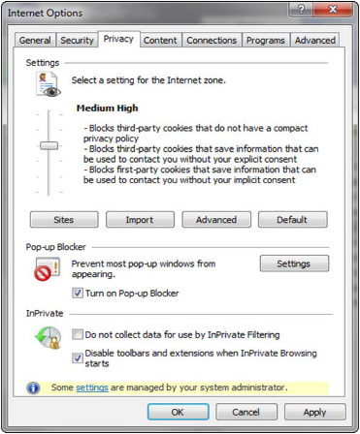

Getting Started
Bed Management Solution (BMS) includes Community Care-specific functionality for monitoring and repatriating Veterans receiving care outside of VA. Staff members can use these VAMC-specific community tracking lists to record information representing Veterans’ current status and history at nearby community facilities which are standardized within BMS. Reports are available alongside these community tracking lists to record among other things length of time from community arrival through VA admission. If the Veteran is to be repatriated back to VA, the tracking list contains a convenient function for adding the patient to the local VAMC’s Patients Pending Bed Placement List (PPBPL).
For general information on logging in to BMS, see the Getting Started chapter of the Bed Management Solution (BMS) User Guide located within the VA Software Document Library.
For the latest information on recommended best practices for Community Care patient tracking, refer to the BMS Community Care Tookit.

Community Care Tracking List
The Community Care Tracking List page displays a VAMC-specific list of veterans receiving community care. Active records display by default but Inactive and All view buttons are available to see previously entered Veteran information. Like the Patients Pending Bed Placement List (“BMS Home”), you can sort/add/remove/filter the available informational columns, as well as export to several file types. In addition, there are several CCTL-specific reports available at the top of the tracking list for analyzing patient care times, Bed Days of Care (BDOC) reasons and final dispositions—including why certain patients weren’t ultimately repatriated back to VA.

Figure 2 - Community Care Tracking List
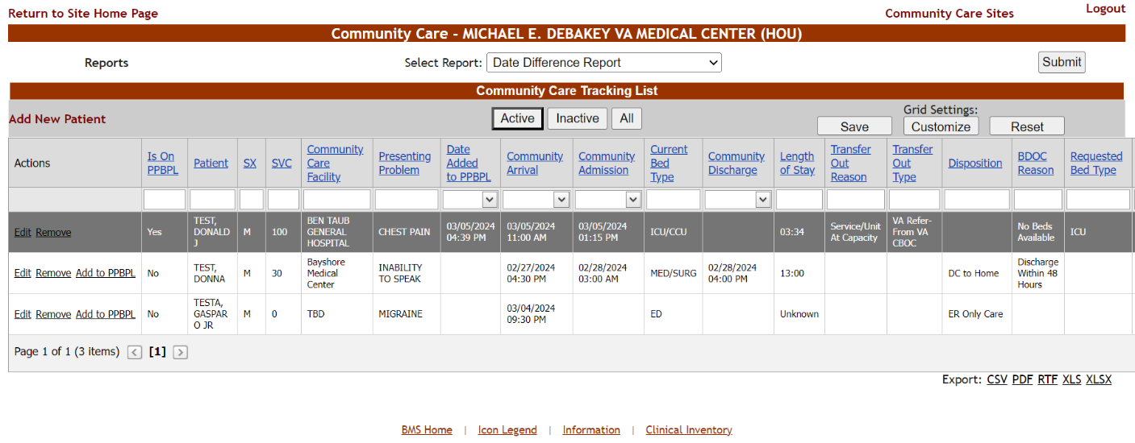

To access the Community Care Tracking List, click on the ‘Community Care Tracking List’ link from the specific VAMC’s Patients Pending Bed Placement List (PPBPL):

Figure 3 - Community Care Tracking List Link from BMS Home
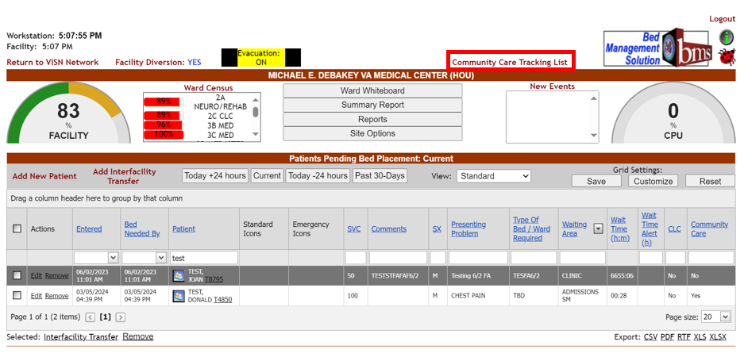
BMS logins with only a ‘Community Care User’ role or ‘Community Care Transfer User’ role, are directed to their VAMC’s CCTL immediately upon login.
From the Community Care Tracking List the user can easily return to BMS Home, using the Return to Site Home Page link:

Figure 4 - Return to Site Home Page Link

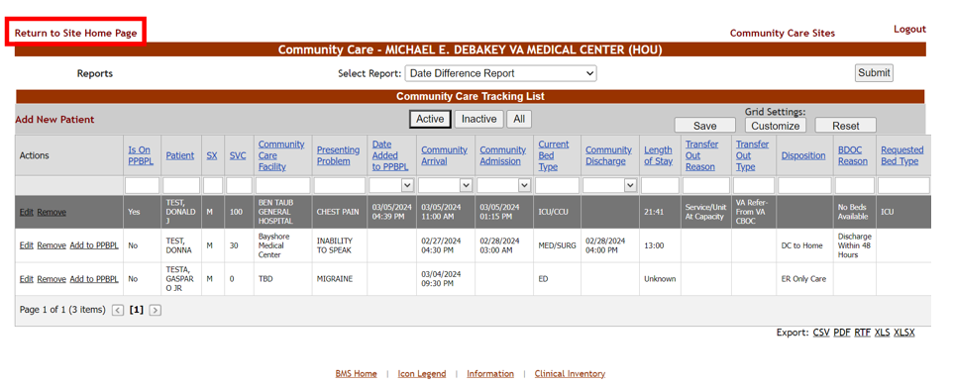
For information on BMS logins and user roles, see the Facility Administrator Users section of the BMS User Setup and Admin Guide, located within the VA Software Document Library.

Navigating to Other VAMC Tracking Lists
Since Community Care Tracking List functionality is VAMC-specific, VISN, National Users and Support Users who wish to work with other VAMC Community Care Tracking Lists must first navigate to that VAMC’s PPBPL (“BMS Home”), before clicking on the Community Care Tracking List URL.

Figure 5 - Return to VISN Network Link Navigation from BMS Home
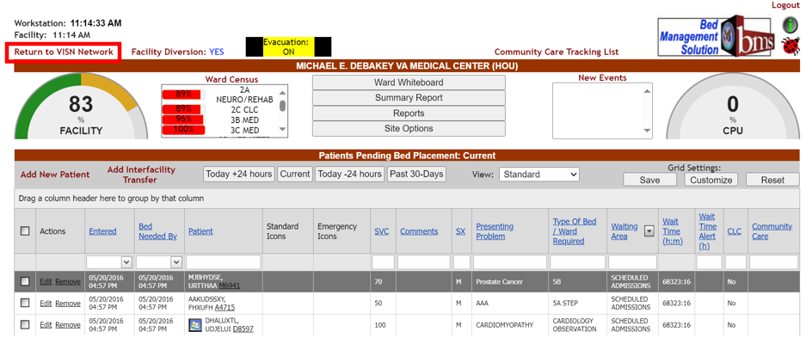

From the VISN board the user would navigate to another VAMC’s Patients Pending Bed Placement List (PPBPL), then click on the Community Care Tracking List link for that VAMC.

Figure 6 - Link on VISN Board to Different VAMC
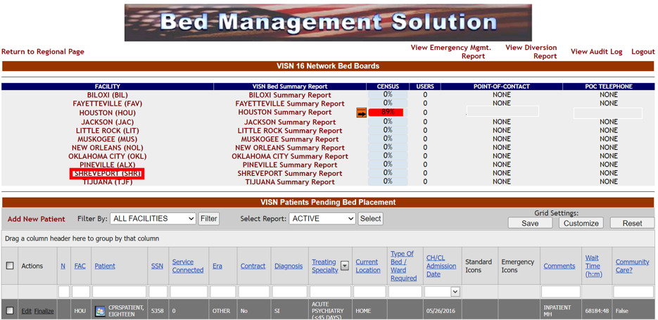

Figure 7 - Community Care Tracking List Link of Selected VAMC
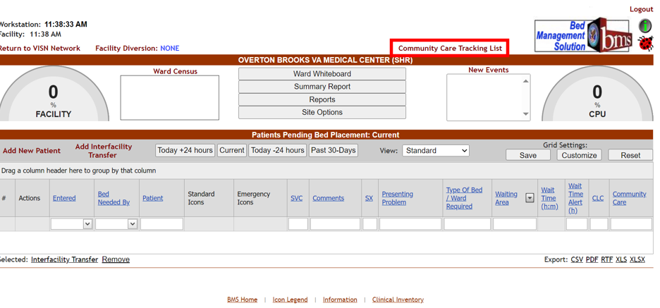

Figure 8 - Community Care Tracking List of Selected VAMC
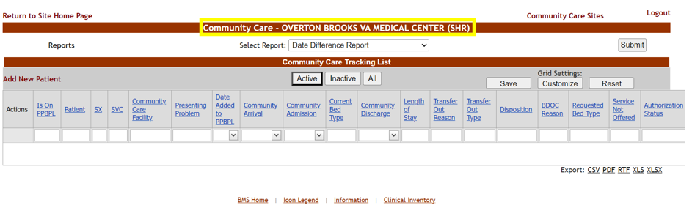

A specific Veteran can be active on more than one VAMC tracking list.

2.2 Community Care Sites
From the Community Care Tracking List page, staff with additional Community Care Admin role permissions can also navigate to a Community Care Sites page.
Figure 9 - Community Care Sites Link
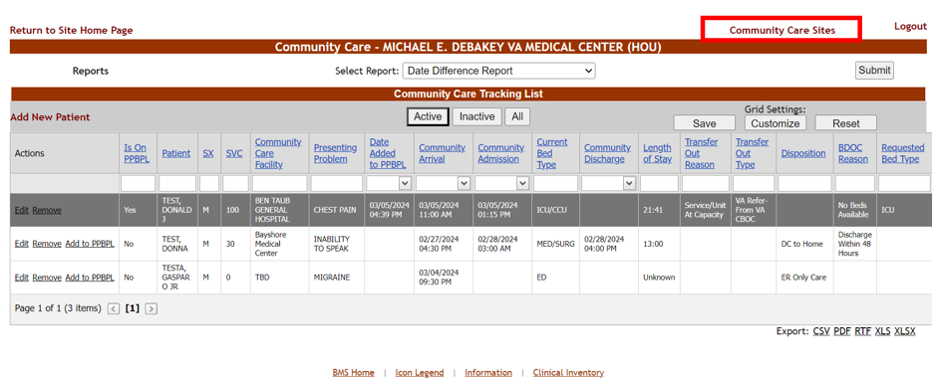

Figure 10 - Community Care Sites Page
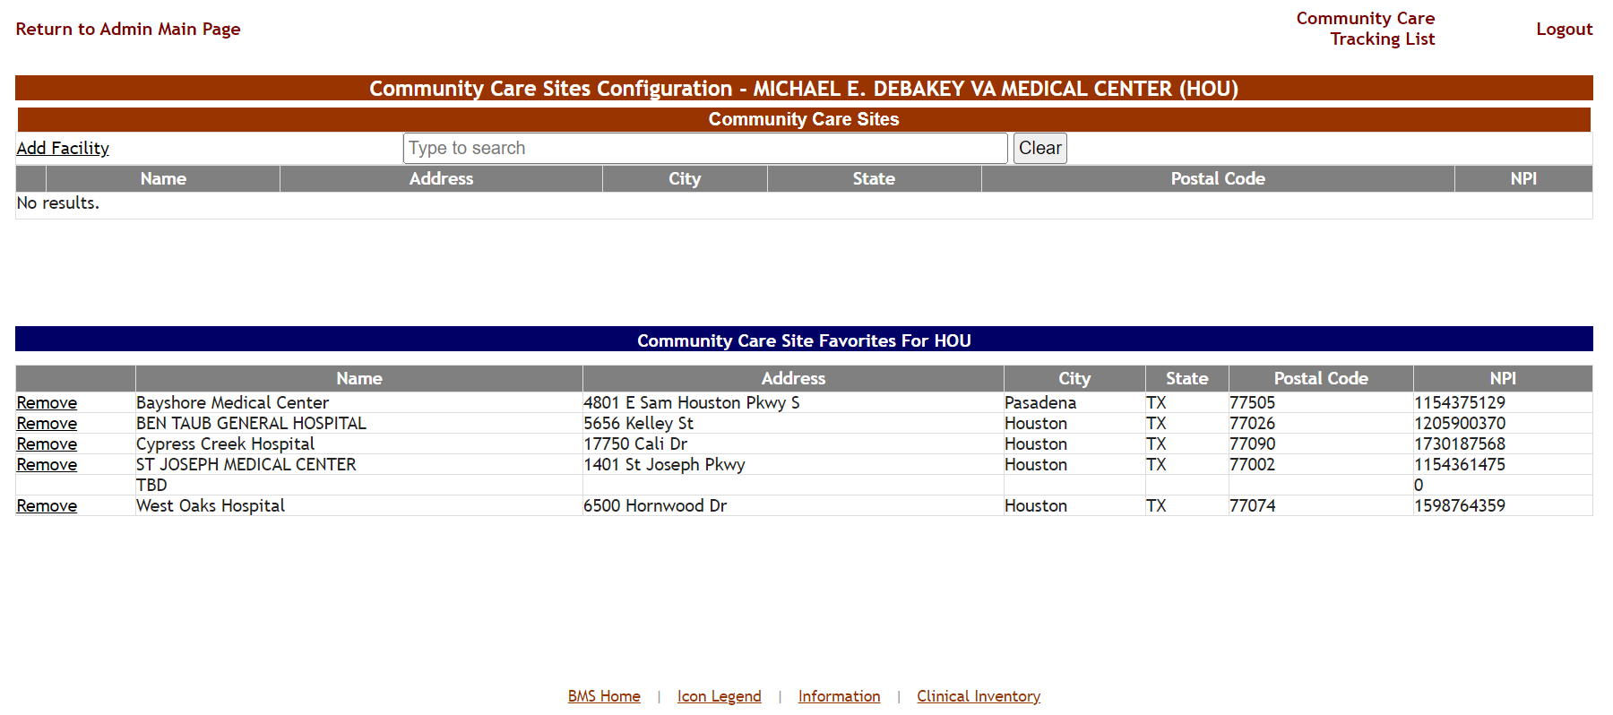

The Community Care Sites page allows staff to configure the drop-down list of “favorite” community facilities seen when staff add or edit records on the VAMC-specific tracking list.
Figure 11 - Community Care Facility Field Containing VAMC Site Favorites List

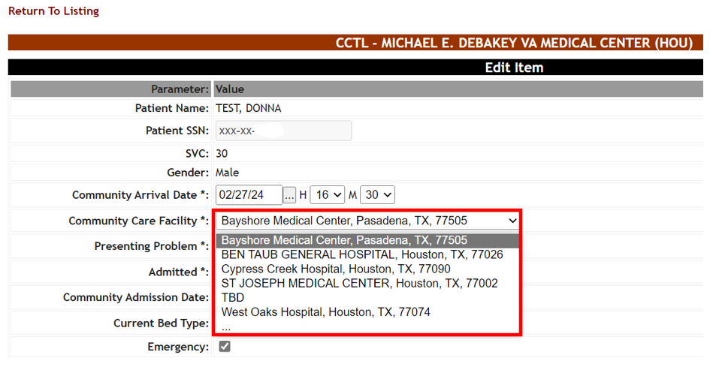

To navigate from Community Care Sites page back to the Community Care Tracking List, simply click on the Community Care Tracking List link, as in the image below:
Figure 12 - Community Care Tracking List Link on Community Care Sites Page
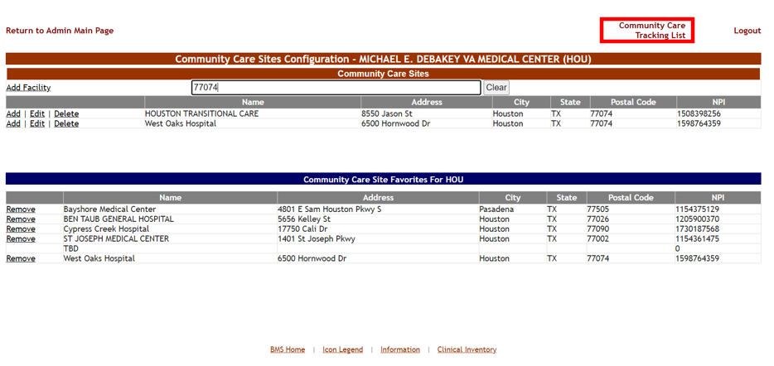
For users with an Admin User role or higher it is also possible to add/edit/remove Community Care Facility records manually.

Community Care Tracking List Reports
From the Community Care Tracking List page there are several reports which present basic patient information and datetime calculations of Veterans on a VAMC’s tracking list.
Figure 13 - Community Care Tracking List Select Report Menu
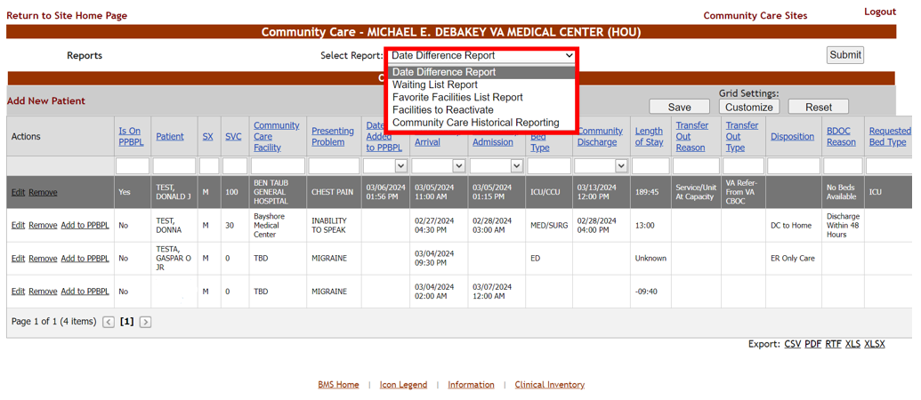
Select one of the reports, then press the Submit button to access the report selections.

Figure 14 - Community Care Tracking List Report Selection and Submit Button

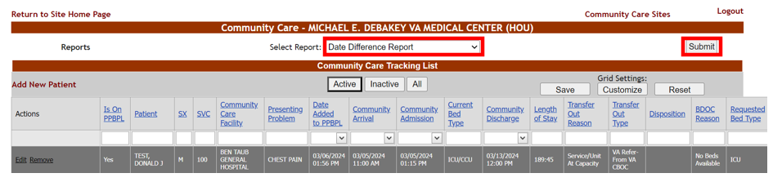

Based on your login access, you will see one or more Regions, VISNs and VA Facilities to choose from. Pressing the View Report button will run the report.
Figure 15 - Date Difference Report Example Results

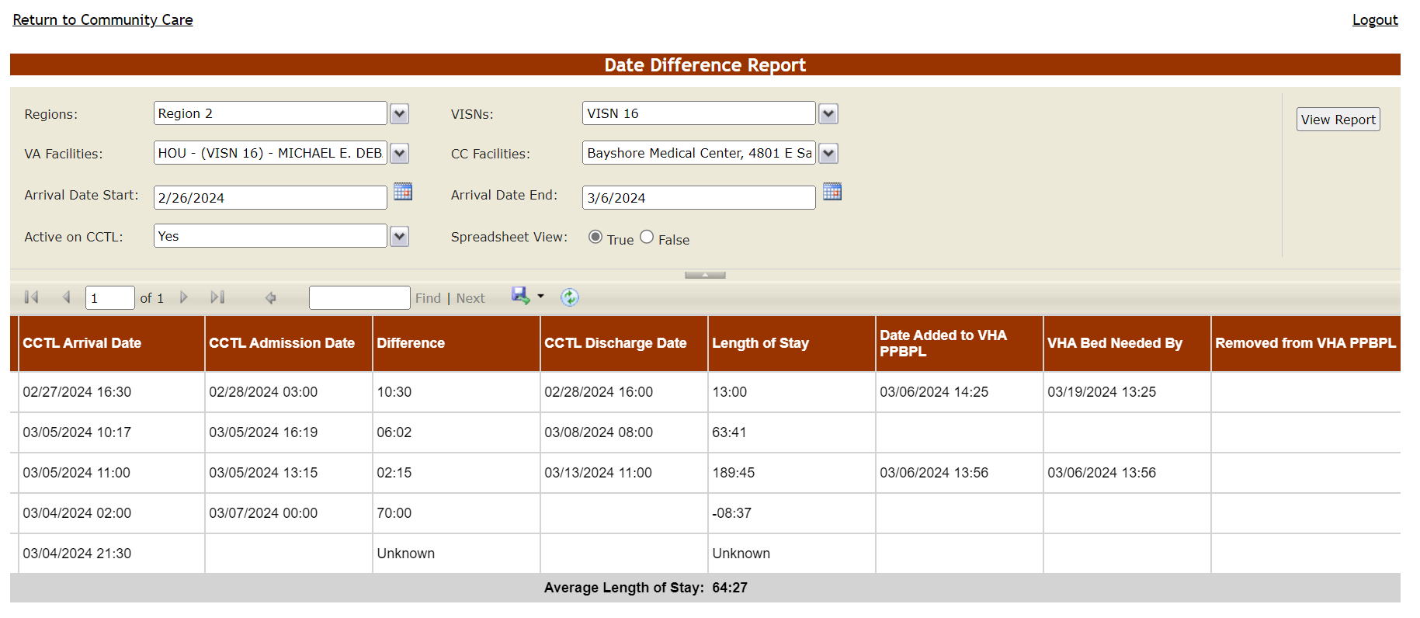

Although the Community Care Tracking List is VAMC-specific, the CCTL reports can be run against any VAMCs’ tracking list data, depending on the BMS login’s site access permissions.

Exit System
To log off the system from the Community Care Tracking List or Community Care Sites pages, click Logout in the upper right-hand corner as show in in the images below:

Figure 16 - Community Care Tracking List Screen Logout
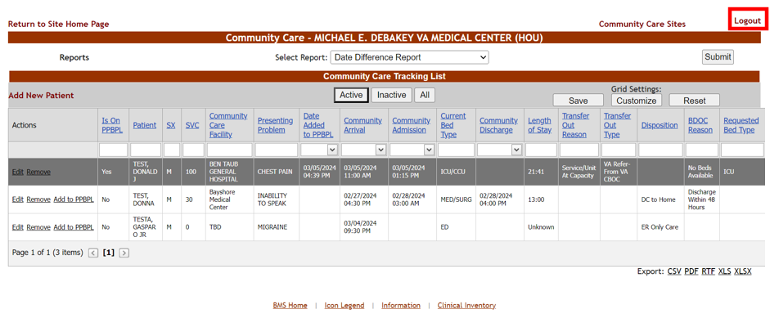
Figure 17 - Community Care Sites Screen Logout
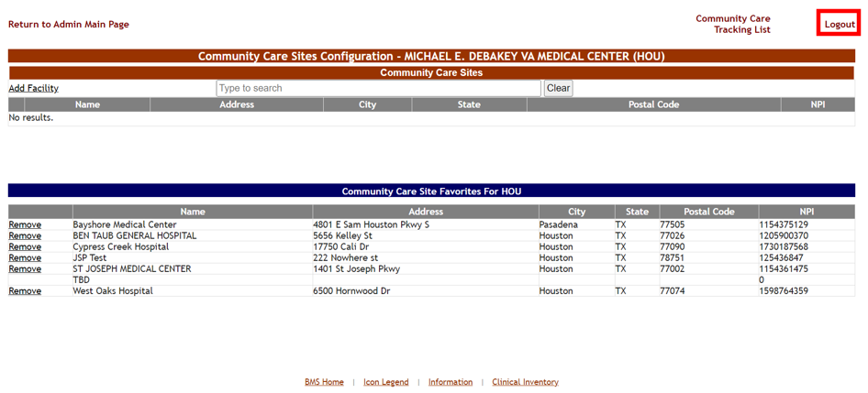

Using the Software
BMS Community Care Tracking List users described in this user guide can be grouped by the following types:
- Community Care Users
- Community Care Transfer Users
- Community Care Admins
- National and Support Users
For general information on user role functionality, see the BMS User Setup and Admin Guide located within the VA Software Document Library.

Community Care Users
Community Care Users have access to the following pages and reports:
- Community Care Tracking List page
- Date Difference Report
- Waiting List Report
- Favorite Facilities List Report
While the Add to PPBPL link is visible to Community Care Users, you will not be able to successfully add a patient to VAMC’s Pending Bed Placement List without the ‘Community Care Transfer User’ role. The message Community Care Users will see when attempting to add a PPBPL record is: “You don’t have permission to access [BMS URL]/Patient/Admission.
Also, while the Facilities to Reactivate and Community Care Historical Reporting reports are visible, Community Care Users will get a “This user does not have sufficient privileges to run this report” message when attempting to run these reports.
Support, National, VISN, Admin and Community Care Transfer User roles all inherit the Community Care User permissions automatically. For more information on roles, refer to the BMS User Setup and Admin Guide located within the VA Software Document Library.

Community Care Tracking List Home Page
After logging in to the BMS application, the home page for Community Care Users will display as in the following image:
Figure 18 - Community Care User Home Page
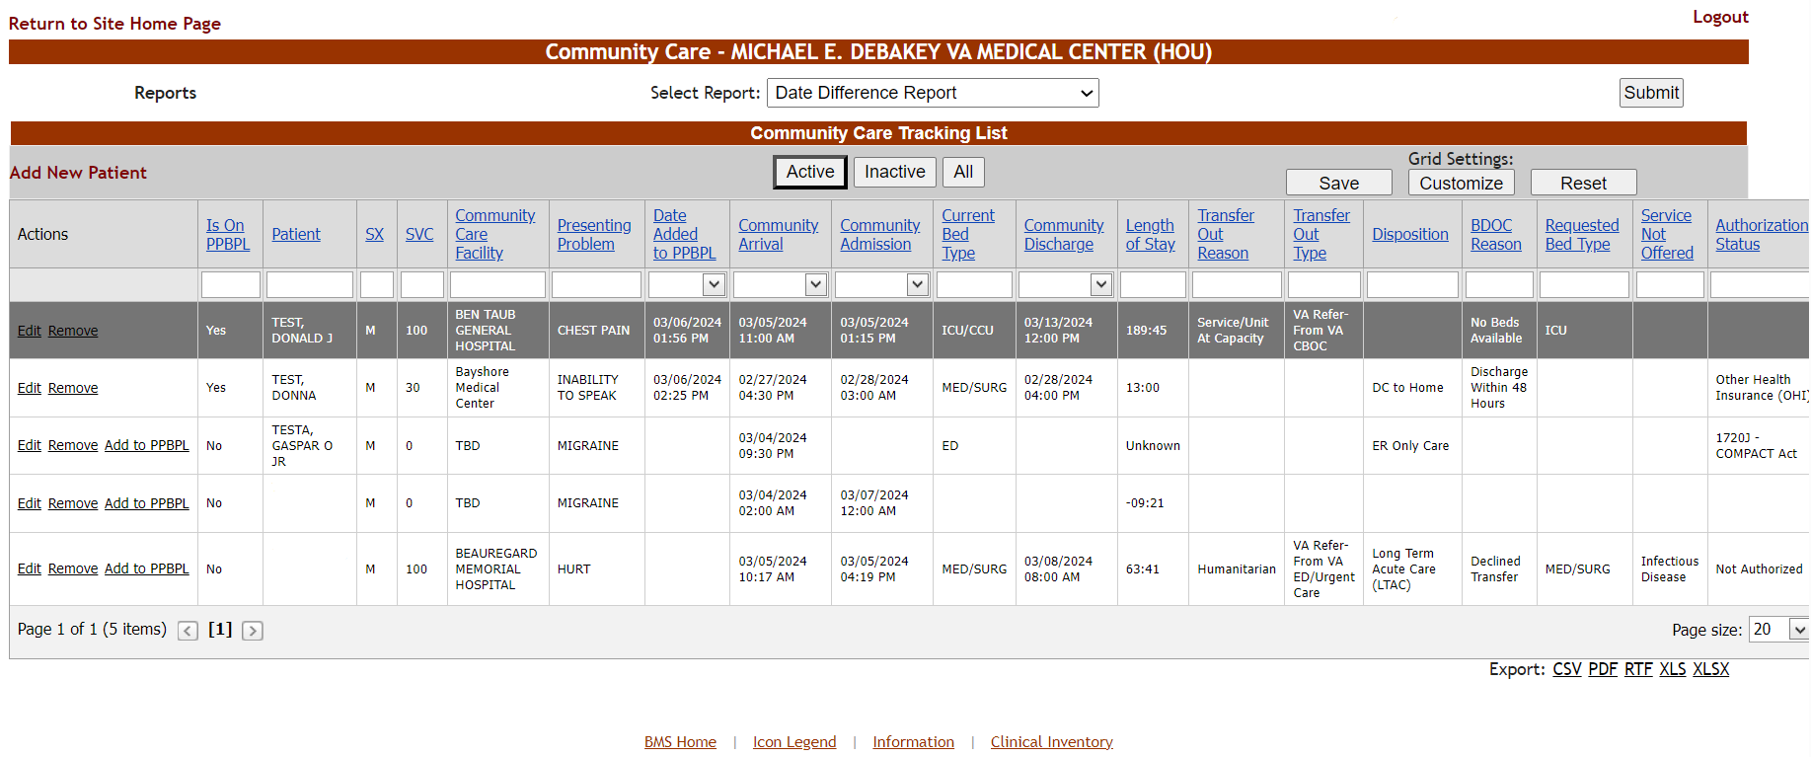

Adding a Veteran to the CCTL

To add a new veteran to your VAMC’s Community Care Tracking List, select the Add New Patient link on the CCTL page:

Figure 19 - Community Care Tracking List Add New Patient
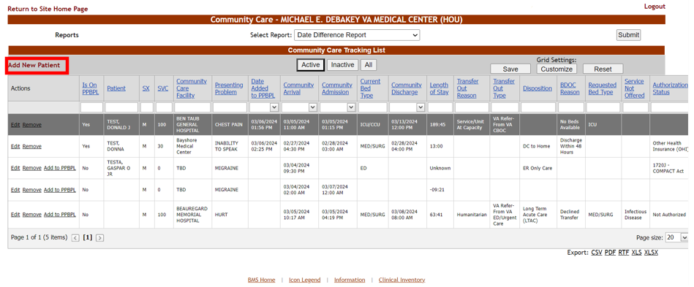
Search for the Veteran by typing a Last Name, full SSN or Last Initial + Last 4 SSN then press Enter. For multiple search results, select the patient record in question then press Select:

Figure 20 - Community Care Tracking List Select Patient
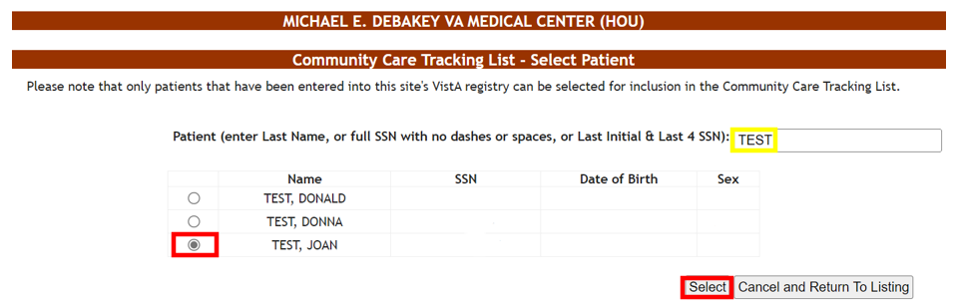
If your patient cannot be found, try searching by full SSN, as the patient’s last name may have changed and is not accounted for in BMS.

If you cannot find your patient at all, check with your local administrative and eligibility support team to verify the patient is registered/enrolled at the VAMC in question. If the patient is in the correct VistA registry, open a ServiceNow ticket for assistance.

From the Add New Item screen, enter values for all required (‘*’) fields using the date picker (‘…’) and drop-down arrow menus:

Figure 21 - Community Care Tracking List Required Fields
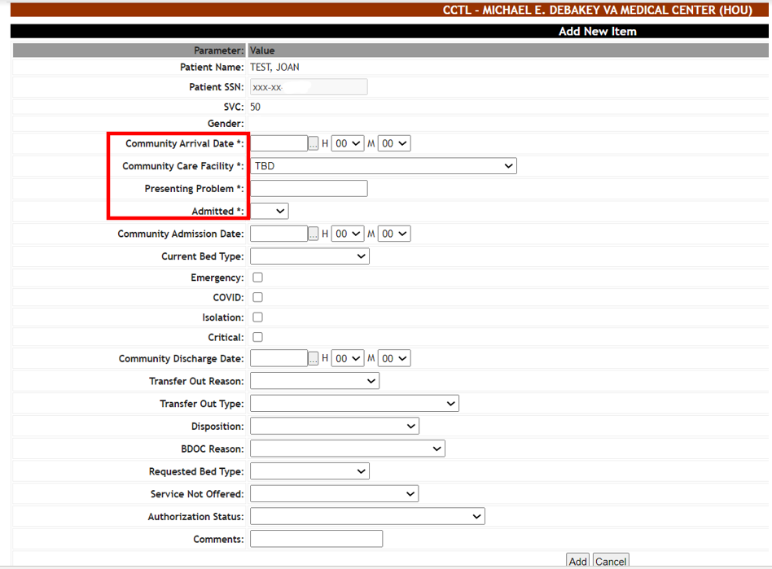
Fill in the Community Arrival Date using the (…) date picker button and Hour (H) and Minute (M) drop-down menus:

Figure 22 - Community Arrival Date
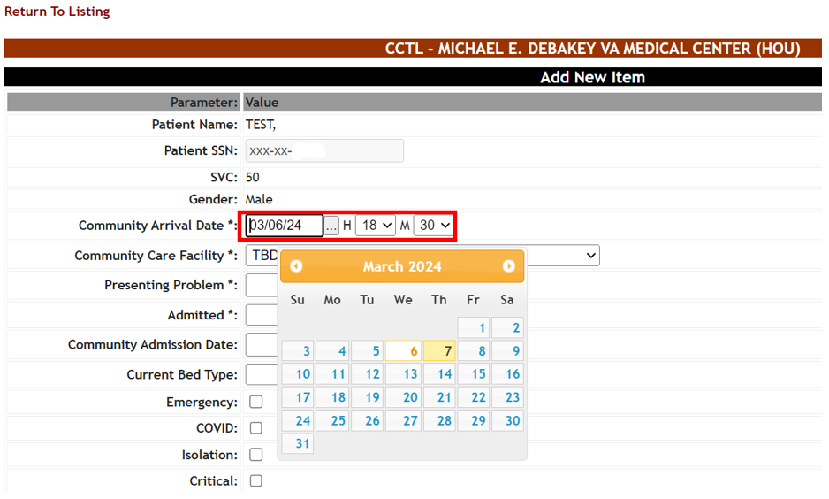
To have accurate date/time calculations, it is highly recommend to fill in the Hour (H) and Minute (M) fields as close as possible to when the patient presented to the community facility.
Now fill in the Community Care Facility using the drop-down menu (Note: “TBD” is the default selection):

Figure 23 - Community Care Facility Field
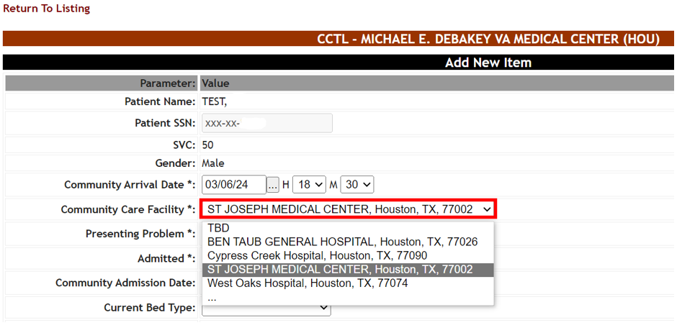
If you cannot find the patient’s community facility among the site favorites, use the ‘…’ selection at the bottom of the list to perform a general search of nearby facilities:

Figure 24 - Community Care Facility General Search Option
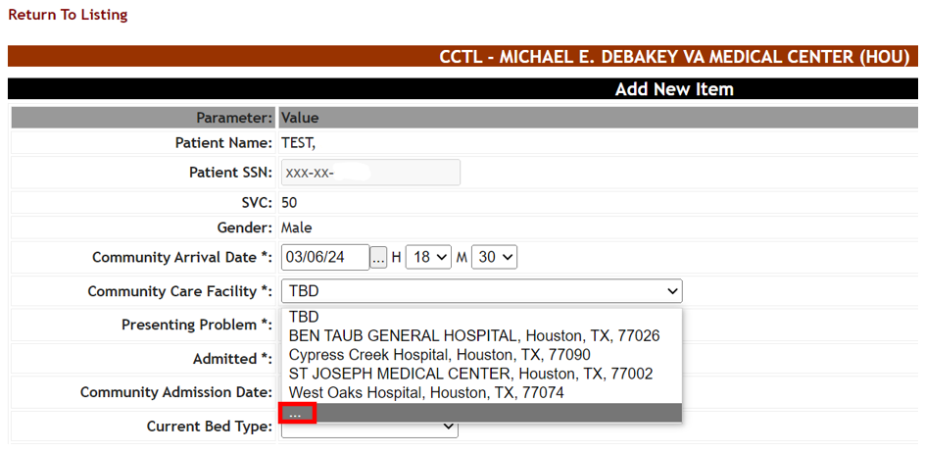
From the Community Care Facility Search window, type a Facility Name, Address, City, State or ZIP code number which brings back search results immediately. Click on a facility then press the Confirm Selection button.

Figure 25 - Community Care Facility Search
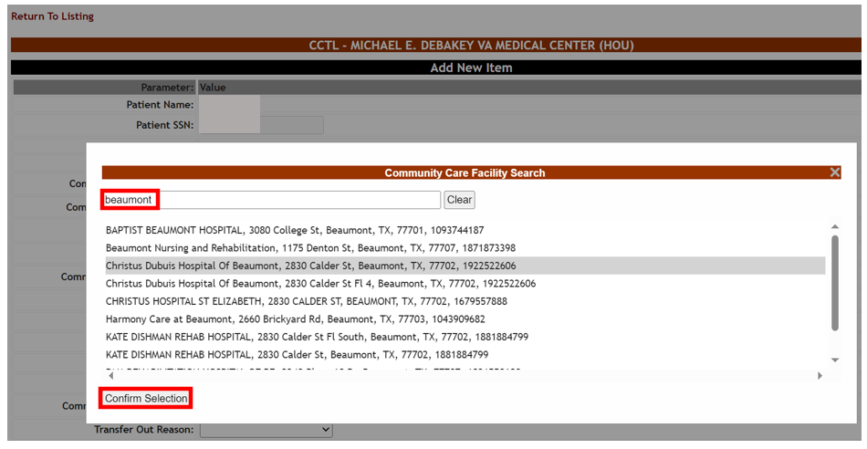
Search results are based on a 300 mile radius of the VAMC’s physical address. Note that multiple VAMCs can have access to the same community facility record based on overlapping radii.
Your search term must be at least 2 characters in length. There is also a limit of 200 results per search. National Provider Identifier (NPI) is not searchable. In addition, multi-term searching (for example, “hospice TX” to find facilities with “Hospice” in the Facility Name and “TX” for the State) is currently unsupported.

Next, enter a free-text Presenting Problem:

Figure 26 - Presenting Problem
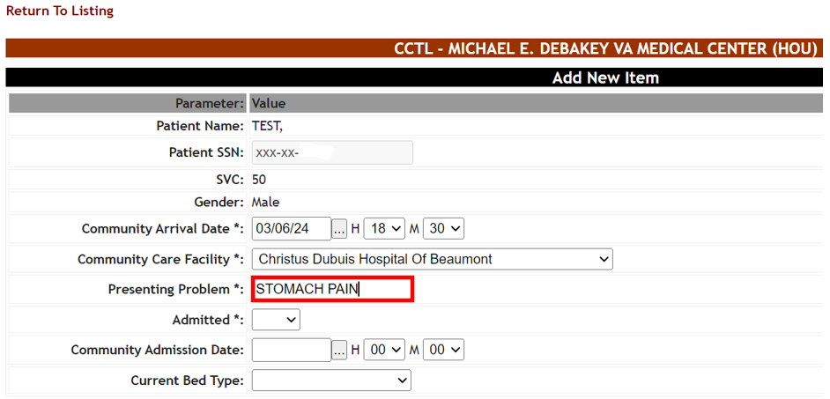
Finally note whether the Veteran has been admitted to the community facility. If you select ‘Yes’ for the Admitted field, Community Admission Date is required.
Figure 27 - Admitted Field and Community Admission Date Entry
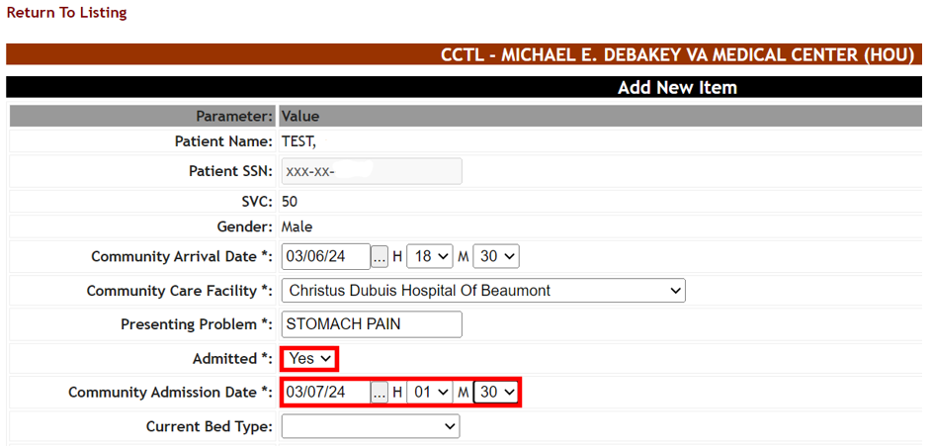

To have accurate date/time calculations, it is highly recommend to fill in the Hour (H) and Minute (M) fields as close as possible to when the patient was admitted to the community facility.

Then enter any other known information about the Veteran before saving the CCTL record.
Table 2 - Community Care Tracking List Fields
COLUMN | DESCRIPTION
Patient Name | The Veteran's Last Name, First Name and Middle Initial.
Patient SSN | The Veteran's Social Security Number.
SVC | The Veteran's service-connected disability percentage.
Gender | The Veteran's gender.
Community Arrival Date | The Veteran's date of presentation at the Community Facility, including Hour (H) and Minute (M).
Community Care Facility | The Community Facility providing care to the Veteran.
Presenting Problem | The reason why the Veteran presented for care/treatment in the community.
Admitted | Whether or not the Veteran has been admitted to the Community Facility.
Community Admission Date | The date the Veteran was admitted to the Community Facility, including Hour (H) and Minute (M). Note: This field is required whenever “Yes” is selected for the Admitted field.
Current Bed Type | The community bed type in use by the Veteran which may reflect level of care and/or acuity.
Emergency | Did the Veteran present at the Community Facility through the Emergency Department (ED)?
COVID | Is the Veteran currently positive for COVID?
Isolation | Does the Veteran require isolation?
Critical | Is the Veteran in critical condition?
Community Discharge Date | The date the Veteran was discharged from the Community Facility, including Hour (H) and Minute (M).
Transfer Out Reason | The reason for VA sending the Veteran to the Community Facility.  Note: this field is only selectable by those with Community Care Transfer Users permissions.
Transfer Out Type | The transfer type associated with the Veteran.  Note: this field is only selectable by those with Community Care Transfer Users permissions.
Disposition | The disposition type associated with the Veteran.
BDOC Reason | The reason (Bed Days of Care) why the Veteran has not been repatriated.
Signed Declined to Transfer Form Status | The status of the Veteran's signed 10-8001 (Refusal of Transfer to VA Medical Facility) form.  Note: This selection only appears when a BDOC Reason of ‘Declined to Transfer’ is chosen.
Requested Bed Type | The type of VA bed needed.  Note: This field is required whenever a BDOC Reason of ‘No Beds Available’ is chosen.
Service Not Offered | The service not available within VA.
Authorization Status | The eligibility for payment of Veteran community care.
Comments | A free text field for entering information such as handoff or clinician notes once the Veteran is repatriated to VA, or care coordination notes and medical record request dates.

Press the Add button to save your new Community Care Tracking List record.

Figure 28 - Community Care Tracking List Add New Patient
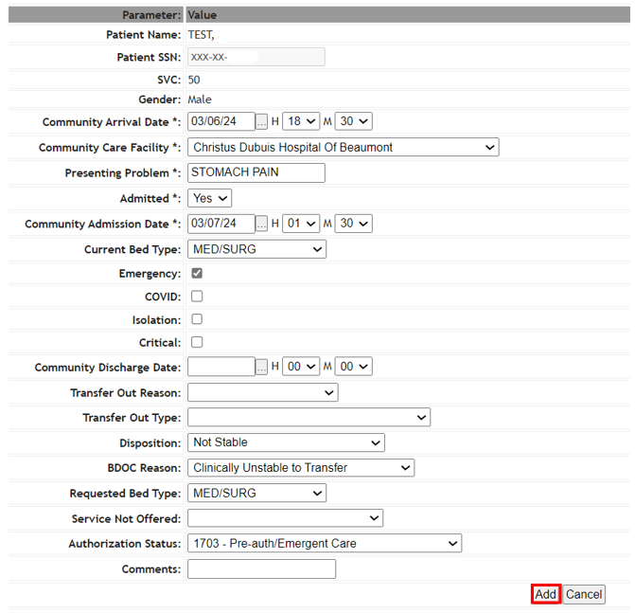
Upon pressing the Add button, you will see a confirmation message, as in the image below:
Figure 29 - Community Care Tracking List Edit Complete
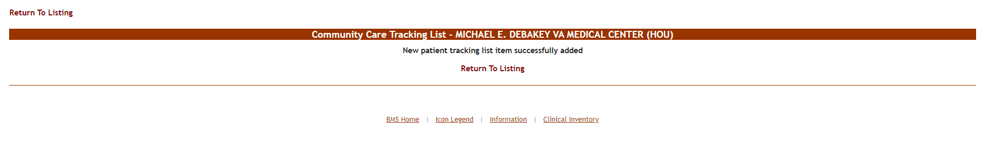
Click on the Return to Listing link to return to the Community Care Tracking List.

Figure 30 - Community Care Tracking List Return to Listing Link
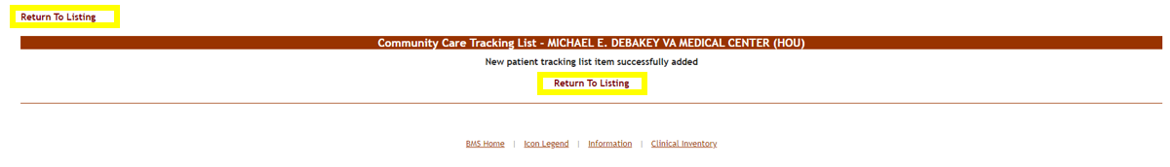
The new Community Care Tracking List record for your VAMC will appear at the bottom of the list.
Figure 31 - Community Care Tracking List Newly Added Record
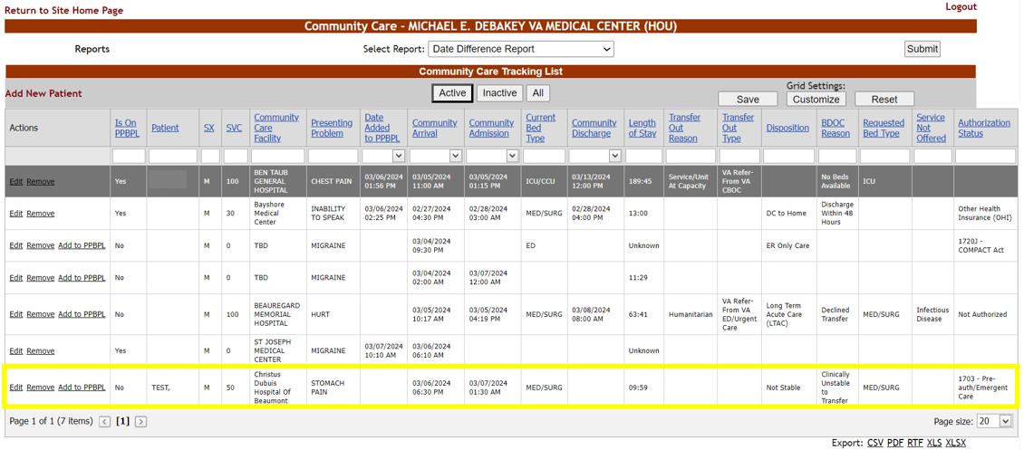
By default the CCTL displays 20 rows on a page, so you may need to use the Page arrow to find your newly created record.
See the CCTL Page Functions section of this document, for information on how to change and save your default Page Size.

Active tracking list records display on the grid by default. Use the Inactive view button to view removed records and default removal-type columns, or All to view both active and inactive records.

Figure 32 - Inactive View with Removal Date and Removal Disposition Columns
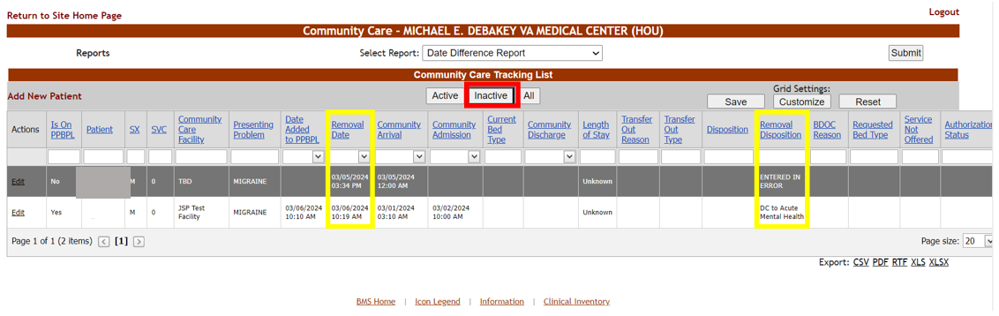

A description for each column of the Community Care Tracking List is listed below:

Table 3 - Community Care Tracking List Grid Columns
COLUMN | DESCRIPTION
Actions | Links for editing or removing (“inactivating”) tracking list records, as well as a link to copy the Veteran to the VAMC’s Patients Pending Bed Placement List (PPBPL).  Note: if the CCTL has been inactivated, the Remove link does not display. If the veteran is on the PPBPL, the Add to PPBPL link does not display.
Is Active | Whether or not the ‘Remove’ link has been selected for the Veteran record on the VAMC's Community Care Tracking List.  Note: This column only displays when selecting the All view.
Is on PPBPL | Whether the Veteran on the VAMC's Community Care Tracking List is also on the VAMC's Patients Pending Bed Placement List.
SX | The Veteran’s gender.
Patient | The Veteran's Last Name, First Name and Middle Initial.
SVC | The Veteran's service-connected disability percentage.
Community Care Facility | The Community Facility providing care to the Veteran.
Presenting Problem | The reason why the Veteran presented for care/treatment in the community.
Date Added to PPBPL | The date and time when the Veteran was copied from the CCTL to the PPBPL.
Removal Date | The date and time when the CCTL record was removed (“inactivated”).
Community Arrival | The Veteran's date of presentation at the Community Facility, including Hour (H) and Minute (M).
Community Admission | The date the Veteran was admitted to the Community Facility, including Hour (H) and Minute (M).
Current Bed Type | The community bed type in use by the Veteran.
Community Discharge | The date the Veteran was discharged from the Community Facility, including Hour (H) and Minute (M).
Length of Stay | The length of time between Community Admission and Community Discharge (or Current Time if no Community Discharge value exists).  Note: If no Community Admission value exists, the Length of Stay will be “Unknown”. Also, if a CCTL record containing a Community Admission Date but no Community Discharge Date is inactivated, the Length of Stay will change from a Current Time-based value to "Unknown".
Transfer Out Reason | The reason for VA sending the Veteran to the Community Facility.  Note: the BMS login will need Community Care Transfer User permissions in order for the Transfer Out Reason field to be editable.
Transfer Out Type | The transfer type associated with the Veteran.  Note: the BMS login will need Community Care Transfer User permissions in order for the Transfer Out Reason field to be editable.
Disposition | The disposition type associated with the Veteran.
Removal Disposition | The disposition type selected when removing (“inactivating”) the CCTL record.
BDOC Reason | The reason (Bed Days of Care) why the Veteran has not been repatriated.
Requested Bed Type | The type of VA bed needed.
Service Not Offered | The service not available within VA.
Authorization Status | The eligibility for payment of Veteran community care.
Admitted* | Whether or not the Veteran has been admitted to the Community Facility.
Comment* | A free text field for entering information such as handoff or clinician notes once the Veteran is repatriated to VA, or care coordination notes and medical record request dates.
COVID* | Is the Veteran currently positive for COVID?
Critical* | Is the Veteran in critical condition?
Emergency* | Did the Veteran present at the Community Facility through the Emergency Department (ED)?
Isolation* | Does the Veteran require isolation?
Modified By* | The BMS user who last edited the CCTL record.
Signed Declined to Transfer Form Status* | The status of the Veteran's signed 10-8001 (Refusal of Transfer to VA Medical Facility) form.
*Column hidden by default.

Displaying Records on the CCTL
The Community Care Tracking List data grid has many features which allow users to filter, sort, customize, export and paginate through the CCTL data grid.

CCTL Column Filtering
Each column within the CCTL list, or “data grid,” is filterable by typing into the test box below the column header. Date-type columns contain a calendar picker for filtering the list.

Figure 33 - CCTL Filtered by Community Care Facility and Community Arrival
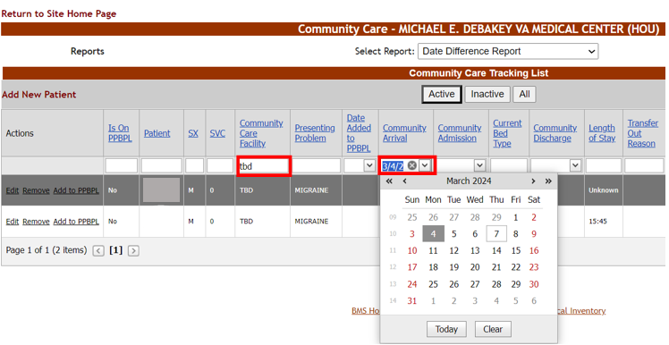

To filter columns successfully, you must enter the first word of the tracking list record’s field value. For example, filtering by “baptist” would successfully display records tied to “Baptist Memorial Hospital” but not records tied to “Regional Baptist Hospital”. In addition, multi-term filtering such as displaying the CCTL by more than one CC facility is not supported.
The list is also sortable by clicking the column header once for an ascending sort (or twice for a descending sort).

Figure 34 - CCTL Sorted by Community Arrival Column (Ascending)
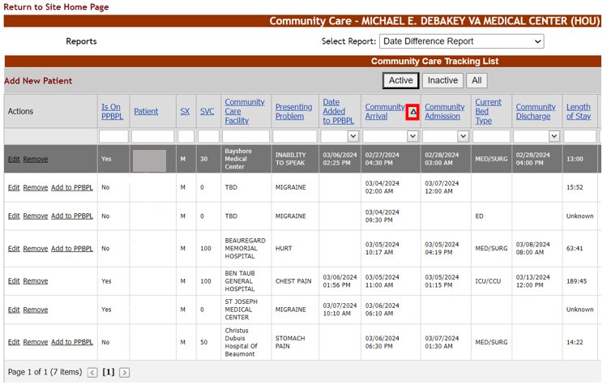

CCTL Column Ordering
The Community Care Tracking List grid allows users to reorder columns. The below screenshots show a user making Community Care Facility the second column on the grid.

Reordering can be done by clicking, holding and dragging the column header to the appropriate location. The highlighted arrow selectors demonstrate the location where the column will be placed upon release of the mouse button.

Figure 35 - CCTL Column Ordering Action
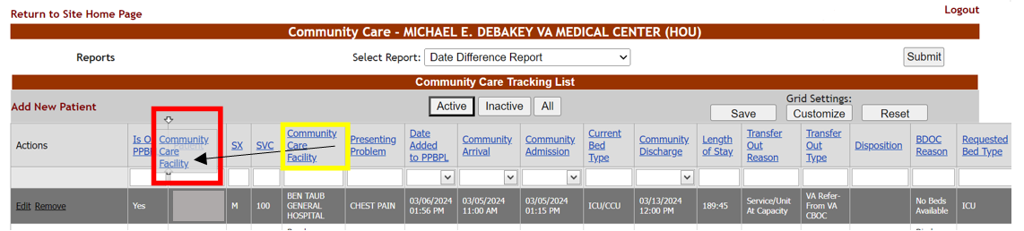

Figure 36 - CCTL Column Ordering Result
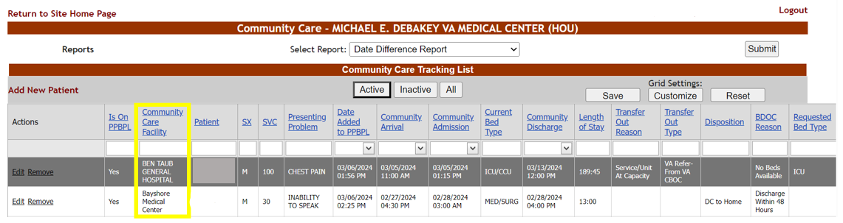

To save this column ordering for future use, press the Save button:
Figure 37 - CCTL Save Button
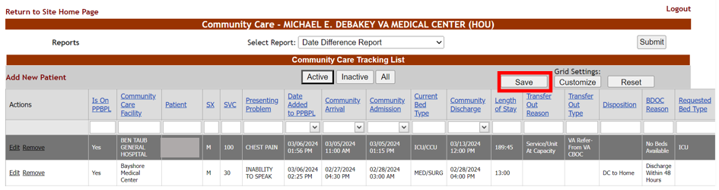

CCTL Customization
Users can further customize their CCTL View by clicking on the Customize button underneath Grid Settings at the top right portion of the screen. Here you will find the CCTL columns hidden by default, as well as any columns you may have hid previously.

Figure 38 - CCTL Customize Button and Hidden Columns Window
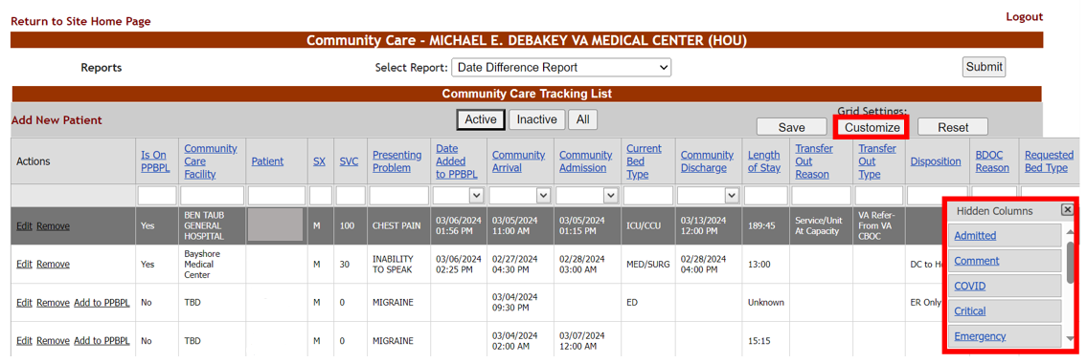

Use this Hidden Columns window both to add and remove columns. For displaying a hidden column, simply click and hold a field in the Hidden Columns window, then drag the selection onto the desired area of the grid and release the mouse button.

Figure 39 - CCTL Customize Column Addition
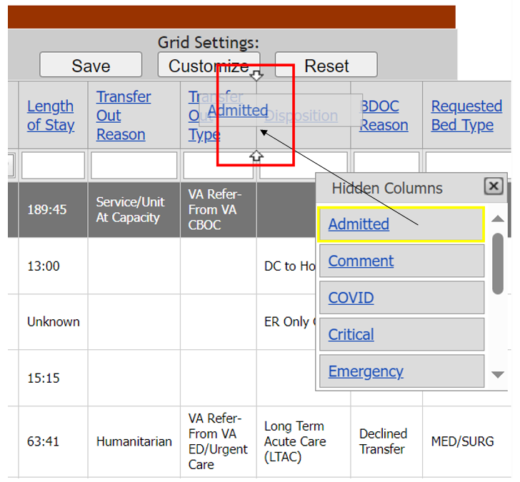

Figure 40 - CCTL Customize Column Addition Result
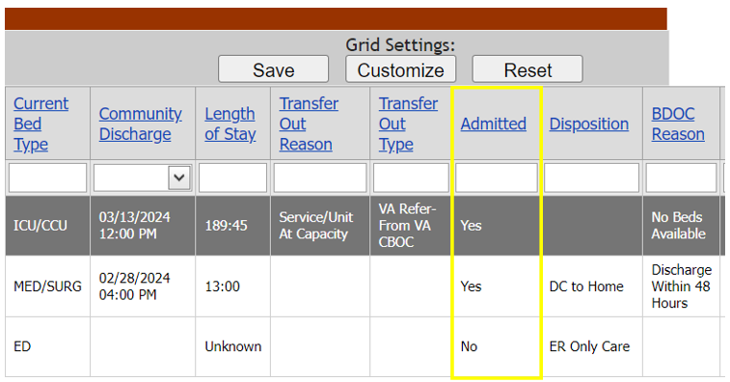
To remove a column from display on the CCTL grid, click and hold with your mouse the column header, drag the selection into the Hidden Columns window and release your mouse.
Figure 41 - CCTL Customize Column Removal
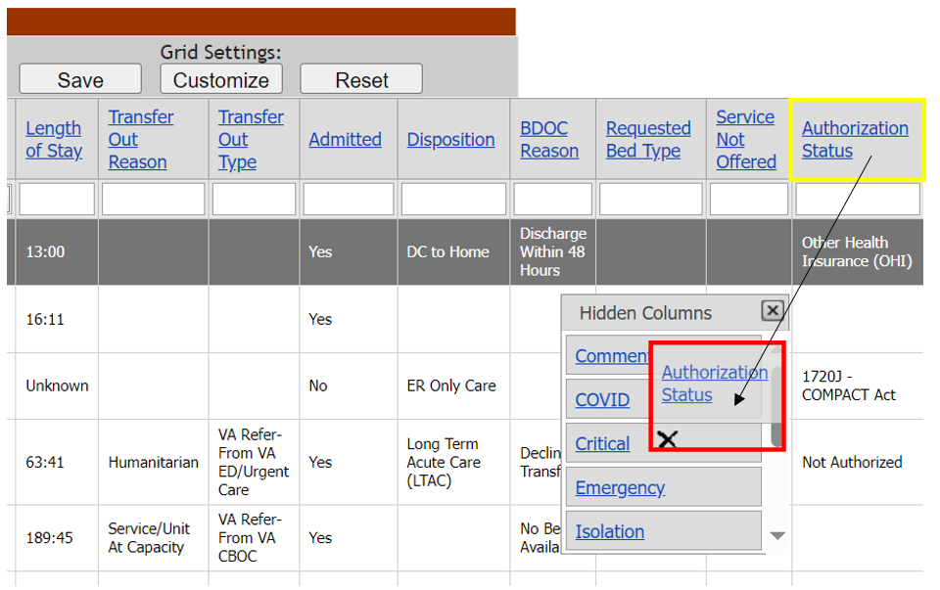

Figure 42 - CCTL Customize Column Removal Result
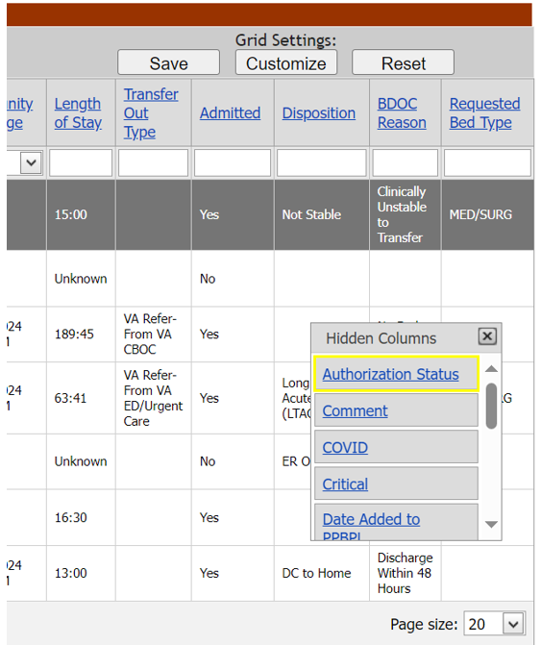

Once a column is removed from the Grid, it can always be re-added by clicking on the Customize button and then dragging it from the column chooser back to the data grid.
To save column additions, column reordering or column removals when logging in later, press the Save button underneath “Grid Settings”.

Clicking on the Reset button resets all selections back to the default. This feature is very useful if users happen to get confused with the combination of customizations they have made and wish to start over with their own customizations. Users can also utilize the Alt + R keyboard shortcut to perform the same function as the Reset button.
Figure 43 - CCTL Reset Button Results
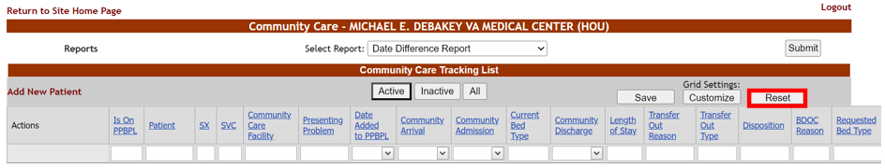

Exporting CCTL Data
Below and right of the CCTL Data Grid are links to allow export to CSV, PDF, RTF, XLS, or XLSX-formatted files. Clicking on any of these links prompts the user to save the onscreen data in the selected format.
Figure 44 - Export of Inactive CCTL Records in XLSX Format
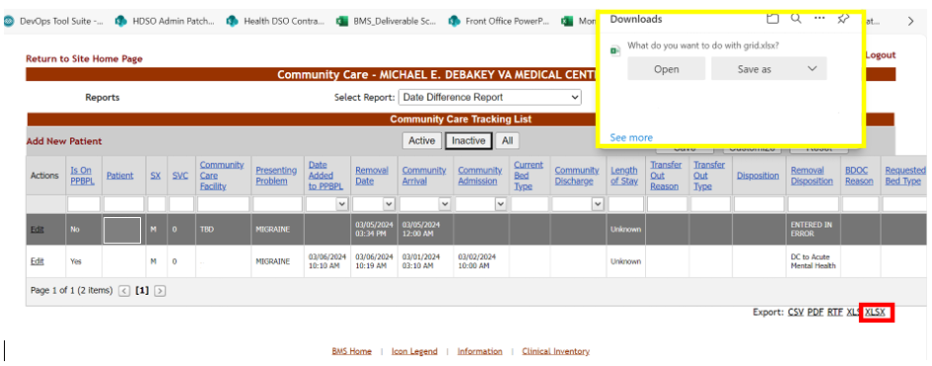
The export options honor the Active, Inactive or All views. That is, if you have selected the Inactive button, only the inactive records will be exported.

CCTL Page Functions
The below screenshot demonstrates pagination functions available on the Community Care Tracking List. These paging functions allow users to move from page to page of results or to select a specific page of results. On the bottom right-hand side of the grid, it is also possible to select how many patient records display per page.
By default 20 rows display on a CCTL page.

Figure 45 - CCTL Paging and Page Size Functions
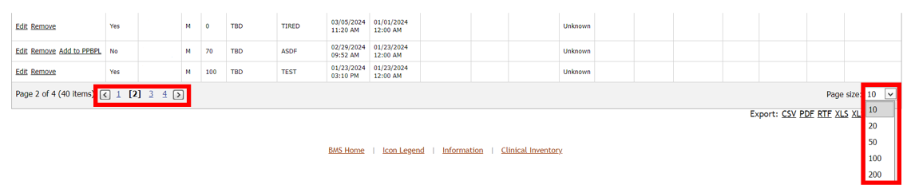

To save the row number default when logging in later, change the Page Size field value then press the Save button underneath “Grid Settings”.

Editing a Record on the CCTL
To edit a veteran record on your VAMC’s Community Care Tracking List, select the Edit link within the Actions column for the Veteran record in question:

Figure 46 - CCTL Edit Link
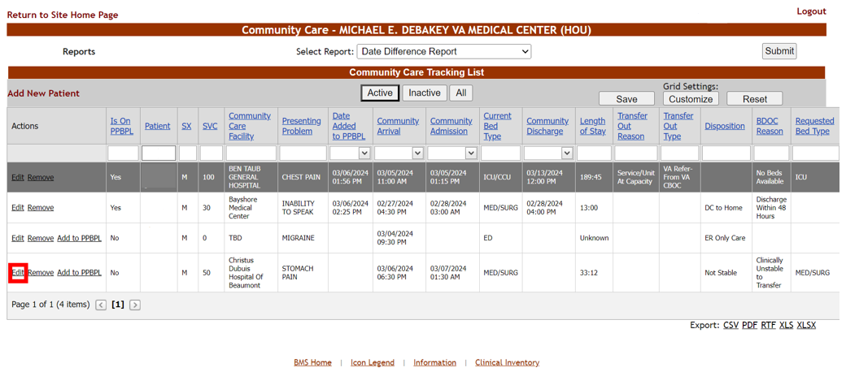
From the EDIT Parameters screen, make any necessary changes to your CCTL record; for example, the date and time when the veteran was discharged from the Community Facility:

Figure 47 - CCTL EDIT Item Screen
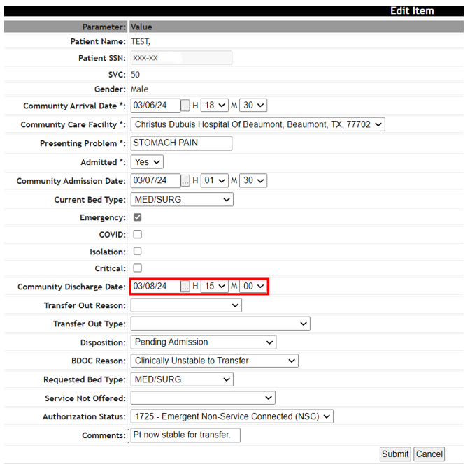
Some field selections require an additional action as noted by an asterisk (‘*’). If you press Submit without filling out the field, a red error message will appear, as in the examples below:

Figure 48 - CCTL Required Field Message when BDOC Reason is ‘Declined Transfer’
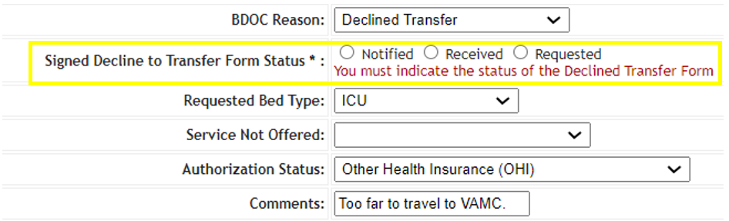

Figure 49 - CCTL Required Field Message when BDOC Reason is ‘No Beds Available’
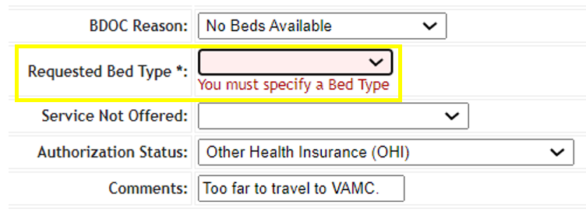

Once you have filled in the necessary CCTL fields, press the Submit button. You will be sent to a Community Care Tracking List Edit Complete screen. Select the Return to Listing link to go back to this VAMC’s Community Care Tracking List.

Figure 50 - CCTL Edit Complete Screen
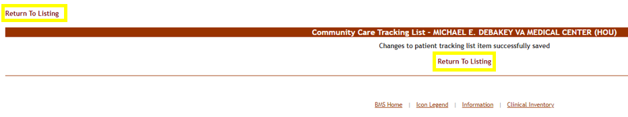

Below are descriptions of specific field values to assist in completing the CCTL record:

Table 4 - Community Care Tracking List Current Bed Type Values
COLUMN | DESCRIPTION
Behavioral Health | Veteran in community Behavioral Health bed.
ED | Veteran in community Emergency Department bed.
Geri-Psych | Veteran in community Geriatric Psychiatric bed.
ICU/CCU | Veteran in community Intensive Care Unit or Critical Care Unit bed.
MED/SURG | Veteran in community Medical-Surgical bed.
Progressive Care Unit | Veteran in community Progressive Care Unit bed.
TELE | Veteran in community Telemetry bed.

Table 5 - Community Care Tracking List Transfer Out Reason Values
COLUMN | DESCRIPTION
CBOC Referral | Veteran referred to Community Facility by VA Community Based Outpatient Clinic.
Diversion | Veteran diverted to Community Facility by VA.
Employee | Veteran is VA employee transferred to Community Facility due to concerns receiving care where employed.
Higher Level of Care | Veteran transferred to Community Facility due to higher level of care.
Humanitarian | Family member, visitor or employee on VA premises transferred to Community Facility for care.
Patient Request | Veteran has requested transfer from VA to Community Facility.
Service/Unit At Capacity | Veteran transferred to Community Facility because VA service or unit at capacity.
Services Not Offered | Veteran transferred to Community Facility because requested service not offered by VA.
The BMS login must have Community Care Transfer User permissions in order to edit the Transfer Out Reason field.
Table 6 - Community Care Tracking List Transfer Out Type Values
COLUMN | DESCRIPTION
SELF Referred | Veteran has not established care in VA and must go through eligibility.
VA Refer-From VA CBOC | Veteran referred by VA Community Based Outpatient Clinic to community for care.
VA Refer-From VA Inpatient to Community | Veteran referred by VA Inpatient facility to community for care.
VA Refer-From VA ED/Urgent Care | Veteran referred by VA Emergency Department to community for care.
VA to VA Refer | Veteran referred by VA to another VA facility.
Veteran Refused Transfer | Veteran refused transfer due to utilizing Medicare or for other reasons.
The BMS login must have Community Care Transfer User permissions in order to edit the Transfer Out Type field.

Table 7 - Community Care Tracking List Disposition Values
COLUMN | DESCRIPTION
Against Medical Advice (AMA) | Veteran left community facility against medical advice.
DC to Acute Mental Health | Veteran discharged to a community acute mental health facility.
DC to Acute Rehab | Veteran discharged to a community acute rehabilitation center.
DC to Home | Veteran discharged to home.
DC to Hospice | Veteran discharged to hospice care.
DC to Inpatient Substance Abuse | Veteran discharged to a community inpatient substance abuse center.
DC to Skilled Nursing Facility | Veteran discharged to a community skilled nursing facility.
ER Only Care | Veteran discharged from the community emergency department.
Long Term Acute Care (LTAC) | Veteran discharged to community long term acute care.
Not Stable | Veteran medically or behaviorally unstable to transfer back to VA.
Pending Admission | Veteran awaiting admission to a VAMC.
Regular Inpatient Discharge | Veteran discharged from the Community Facility.
Repatriated | Veteran has returned to VA acute/CLC/SNF/residential care from the community.
Transfer Out | Veteran transferred out to Community Facility.
Veteran Expired | Veteran expired while in the care of the Community Facility.

Table 8 - Community Care Tracking List BDOC Reason Values
COLUMN | DESCRIPTION
Best Medical Interest | Veteran receiving care in community because of best medical interest.
Clinically Unstable to Transfer | Veteran too unstable for transfer to VA.
Declined Transfer | Veteran or next of kin/guardian has declined transfer to VA. If selected, ‘Signed Declined to Transfer Form Status’ radio buttons will appear onscreen.  Note: See Community Care Tracking List Signed Declined to Transfer Form Status table for more information.
Distance to VA | Veteran receiving care in community due to distance from VAMC.
Discharge Within 48 Hours | Veteran to be discharged from Community Facility within 48 hours.
Late Notification | Veteran length of stay at Community Facility due to late notification to VA.
No Beds Available | VA bed unavailable. Note: If selected, Requested Bed Type is required.
No Response Community Coordination | No response from Community Facility when attempting care coordination.
Service Unavailable | Service unavailable within VA.

Table 9 - Community Care Tracking List Signed Declined to Transfer Form Status Values
COLUMN | DESCRIPTION
Notified | Local VA Community Care office has been requested to obtain signed Refusal of Transfer to VA Medical Facility (10-8001) form.
Received | VA has received signed Refusal of Transfer to VA Medical Facility (10-8001) form.
Requested | Community Facility has been contacted directly regarding need to submit signed Refusal of Transfer to VA Medical Facility (10-8001) form.

Table 10 - Community Care Tracking List Requested Bed Type Values
COLUMN | DESCRIPTION
Acute Mental Health | VA Acute Mental Health bed needed.
Blind Rehab | VA Blind Rehab bed needed.
CLC | VA Community Living Center bed needed.
DOM/RRTP | VA Domiciliary Residential Rehabilitation Treatment Program bed needed.
Geri-Psych | VA Geriatric Psychiatric bed needed.
ICU | VA Intensive Care Unit bed needed.
LTAC | VA Long Term Acute Care bed needed.
MED/SURG | VA Medical-Surgical bed needed.
Progressive Care Unit | VA Progressive Care Unit bed needed.
Rehab Med | VA Physical Medicine & Rehabilitation bed needed.
SCI | VA Spinal Cord Injury bed needed.
Telemetry | VA Telemetry bed needed.

Table 11 - Community Care Tracking List Service Not Offered Values
COLUMN | DESCRIPTION
Burn | Burn service not offered at VA.
Cardiac | Cardiac service not offered at VA.
Cardiac/Interventional | Cardiac/Interventional service not offered at VA.
Cardiothoracic | Cardiothoracic service not offered at VA.
Detox/Drug | Detox (drug) service not offered at VA.
Detox/ETOH | Detox (alcohol) service not offered at VA.
Dialysis | Dialysis service not offered at VA.
ECT (Electroconvulsive Therapy) | ECT service not offered at VA.
EEG | Electroencephalography service not offered at VA.
Electrophoresis | Electrophoresis service not offered at VA.
Endocrinology | Endocrinology service not offered at VA.
ENT | Ear/Nose/Throat service not offered at VA.
Geri-Psych | Geriatric Psychiatric service not offered at VA.
GI | Gastrointestinal service not offered at VA.
Hem/Onc | Hematology/Oncology service not offered at VA.
Infectious Disease | Infectious Disease service not offered at VA.
Interventional Radiology | Interventional Radiology service not offered at VA.
Mental Health | Mental Health service not offered at VA.
Military Sexual Trauma | Military Sexual Trauma service not offered at VA.
Nephrology | Nephrology service not offered at VA.
Neurology/Neurosurgery | Neurology/Neurosurgery service not offered at VA.
OB/GYN | Obstetrics and gynecology service not offered at VA.
Pulmonology | Pulmonology service not offered at VA.
Surgery | Surgery service not offered at VA.
Ophthalmology | Ophthalmology service not offered at VA.
Transplant | Transplant service not offered at VA.
Trauma/Ortho | Orthopedic trauma service not offered at VA.
Urology | Urology service not offered at VA.
Vascular | Vascular service not offered at VA.

Table 12 - Community Care Tracking List Authorization Status Values
COLUMN | DESCRIPTION
1703 - Pre-auth/Emergent Care | Veteran eligible for payment through 38 U.S.C. §1703.
1720J - COMPACT Act | Veteran eligible for payment through 38 U.S.C. §1720J.
1725 - Emergent Non-Service Connected (NSC) | Veteran eligible for payment through 38 U.S.C. §1725.
1728 - Emergent Service Connected (SC) | Veteran eligible for payment through 38 U.S.C. §1728.
Not Authorized | Veteran not authorized for community care payment.
Other Health Insurance (OHI) | Veteran eligible for payment through OHI.
Pending Payment Determination | Veteran eligibility for payment pending.

Removing a Record from the CCTL
Once the VAMC no longer needs to track the Veteran receiving community care, use the Remove link from the Actions column to inactivate the veteran record on the Community Care Tracking list.

Figure 51 - CCTL Remove Link
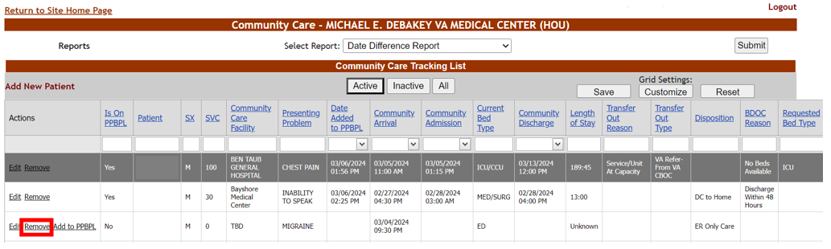
After clicking on the Remove link, you will see a remove confirmation screen. Choose a required Removal Disposition value then press the Remove button to complete the inactivation of the CCTL record.

Figure 52 - CCTL Removal Disposition field and Remove button
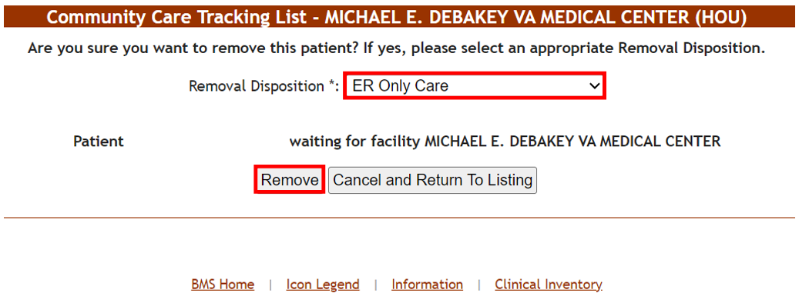
Removal Disposition helps to answer the question why some veterans are not getting repatriated. Below are descriptions for each Removal Disposition:

Table 13 - Community Care Tracking List Removal Disposition Values
COLUMN | DESCRIPTION
Against Medical Advice (AMA) | Veteran left community facility against medical advice.
DC to Acute Mental Health | Veteran discharged to a community acute mental health facility.
DC to Acute Rehab | Veteran discharged to a community acute rehabilitation center.
DC to Home | Veteran discharged to home.
DC to Hospice | Veteran discharged to hospice care.
DC to Inpatient Substance Abuse | Veteran discharged to a community inpatient substance abuse center.
DC to Skilled Nursing Facility | Veteran discharged to a community skilled nursing facility.
ER Only Care | Veteran discharged from the community emergency department.
Long Term Acute Care (LTAC) | Veteran discharged to community long term acute care.
Not Stable | Veteran medically or behaviorally unstable to transfer back to VA.
Pending Admission | Veteran awaiting admission to a VAMC.
Regular Inpatient Discharge | Veteran discharged from the Community Facility.
Repatriated | Veteran has returned to VA acute/CLC/SNF/residential care from the community.
Transfer Out | Veteran transferred out to Community Facility.
Veteran Expired | Veteran expired while in the care of the Community Facility.
ENTERED IN ERROR | Use when removing a record entered on the CCTL accidentally, or in cases where a test record is being removed.
At this point a message will appear stating that the record has been removed. Select the Return to Listing link to go back to the CCTL:

Figure 53 - CCTL Remove Confirmation Success Message
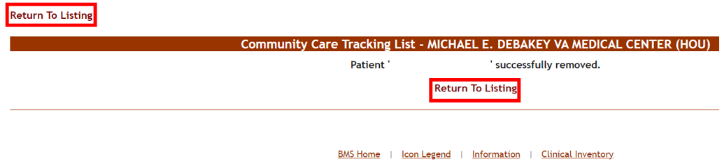
Removed records will still exist in the database for historical purposes, but can be displayed using the Inactive button, as seen in the image below:
Figure 54 - CCTL Inactive Button Selected
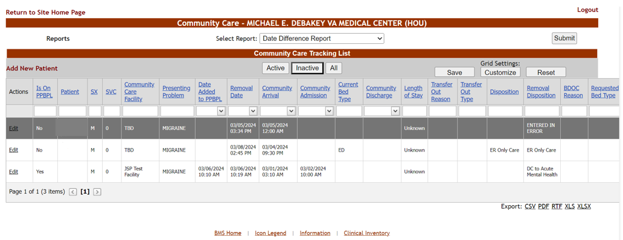
Only active CCTL records from the tracking list can be linked to a PPBPL record; therefore, the Add to PPBPL link will not display for inactive CCTL records.
It is very important for visibility of Veterans that need a VA bed to be added to the BMS PPBP list. Adding the patient to the PPBP list allows VA hospital staff to prioritize a bed for this patient to optimize their access. Request access if needed, if unable to add an active patient to the PPBP list to support repatriation.

Community Care Tracking List Reports
BMS logins with Community Care User permissions have access to three reports for analyzing data: Date Difference Report, Waiting List Report and Favorite Facilities List Report.
Figure 55 - CCTL Reports Accessible with Community Care User Permissions
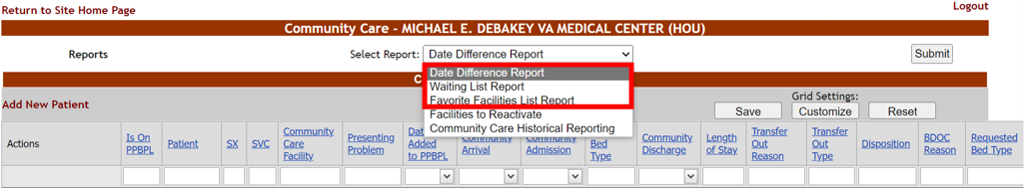

3.1.2.1 Date Difference Report
The Date Difference Report lists the patients on the CCTL with various time difference calculations. To run the Date Difference Report, verify the report in question is selected from the Select Report menu, then press the Submit button on the right-hand side of the screen.

Figure 56 - Date Difference Report and Submit button
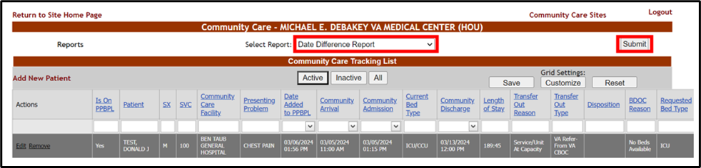

From the Date Difference Report menu, click on the Regions drop-down arrow:
Figure 57 - Date Difference Report Regions Menu
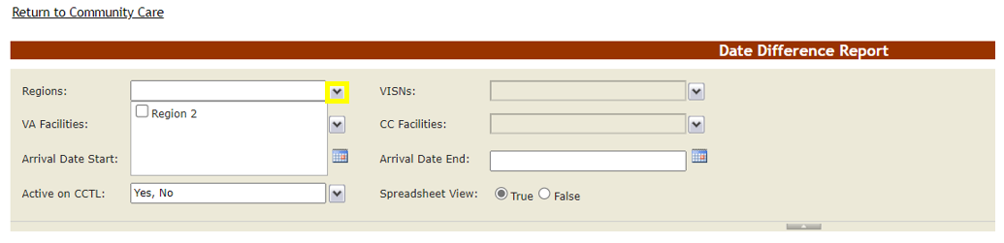
Select the Region your BMS login has access to, by selecting the numbered Region’s checkbox.
Figure 58 - Date Difference Report Region Selection

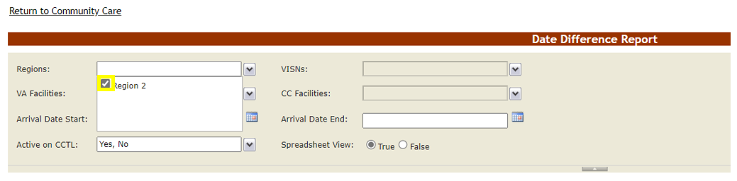

Click away from the Regions field then click on the VISNs drop-down arrow:

Figure 59 - Date Difference Report VISNs Menu
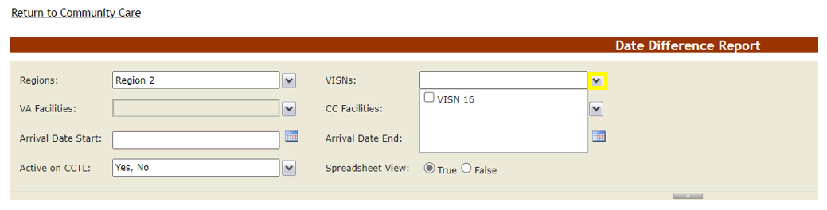

Select the VISN your BMS login has access to, by selecting the numbered VISN’s checkbox.

Figure 60 - Date Difference Report VISN Selection
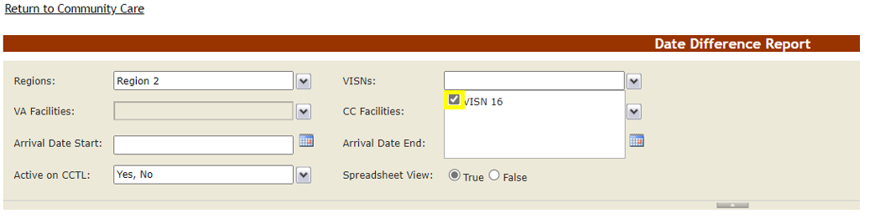
Click away from the VISNs field then click on the VA Facilities drop-down arrow:

Figure 61 - Date Difference Report VA Facilities Menu
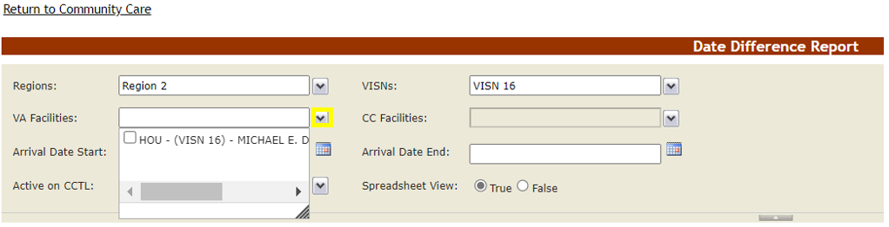
Select the VA Facility (or facilities) your BMS login has access to, by selecting the numbered VA Facility checkbox.

Figure 62 - Date Difference Report VA Facilities Selection
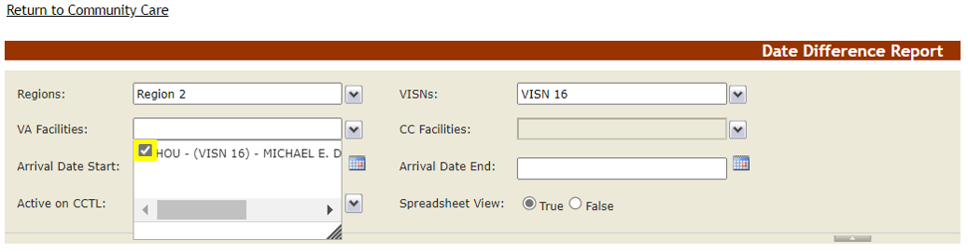
Click away from the VA Facilities field then click on the CC Facilities drop-down arrow:
Figure 63 - Date Difference Report CC Facilities Menu
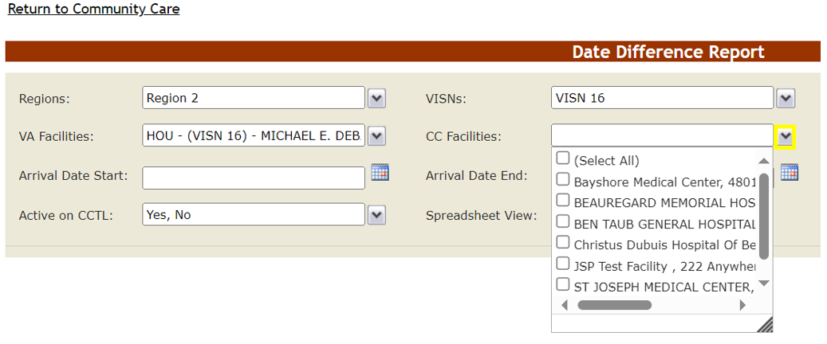

Select the (Select All) checkbox or click on individual CC facilities tied to tracking list records. Also note that you can click and drag the corner of the drop-down menu for increased visibility:

Figure 64 - Date Difference Report CC Facilities Selection plus Stretching Out of Drop-Down List
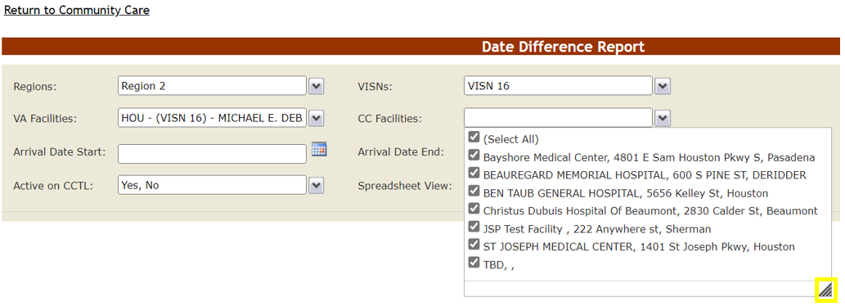

Click away from the CC Facilities field then click on the Arrival Date Start calendar picker:
Figure 65 - Date Difference Report Arrival Date Start Calendar
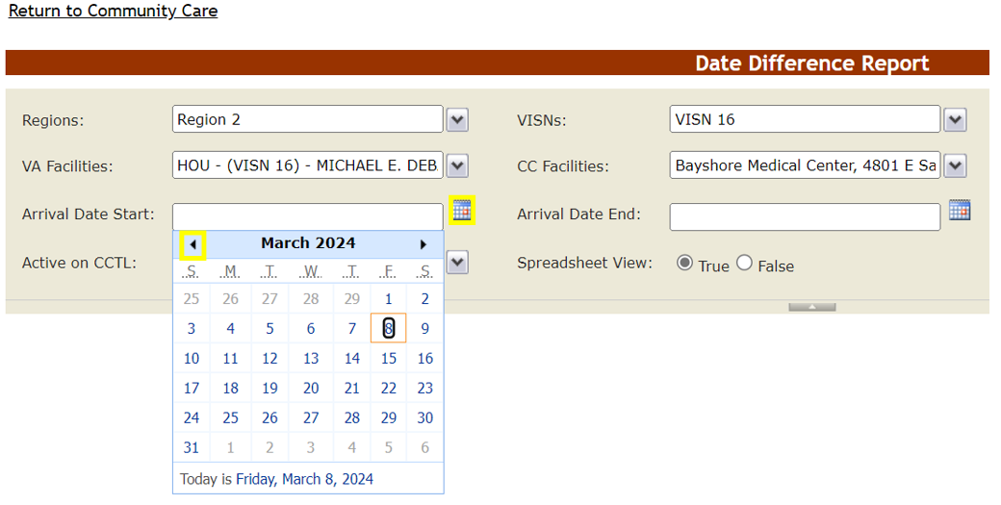
Use the calendar arrows to choose the start date when the Veterans you are tracking in the community presented to the Community Facility:
Figure 66 - Date Difference Report Arrival Date Start Selection
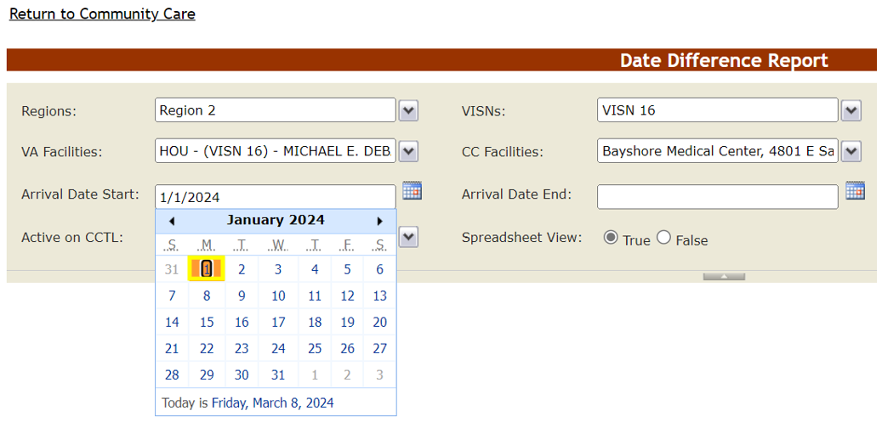
Now click on the Arrival Date End calendar picker:

Figure 67 - Date Difference Report Arrival Date End Menu
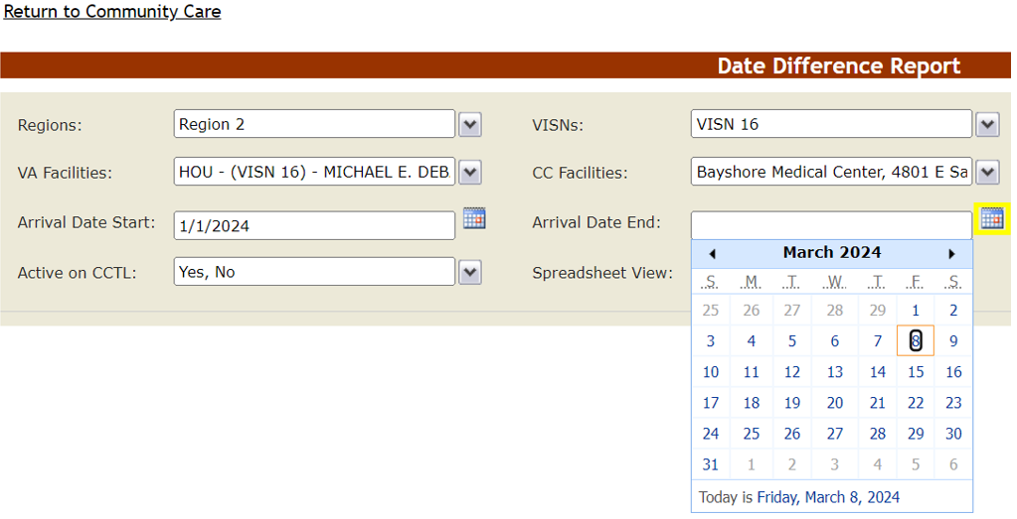
Choose the end date (or the Today is value) when the Veterans you are tracking in the community presented to the Community Facility:
Figure 68 - Date Difference Report Arrival Date End Selection
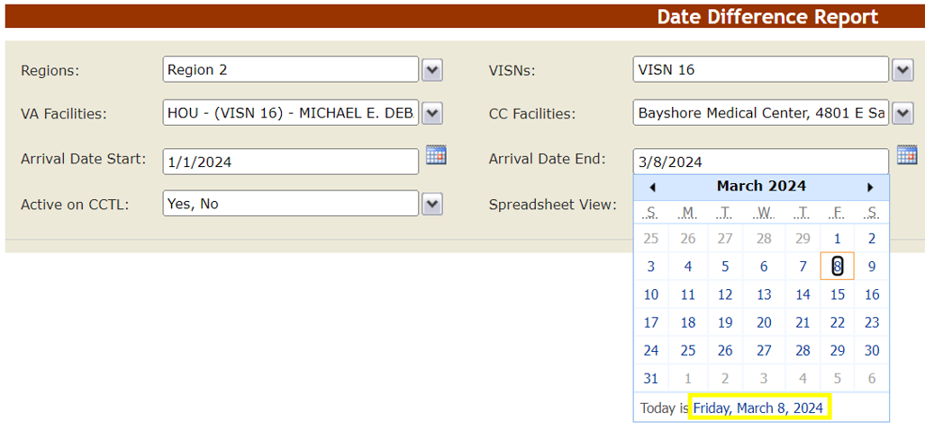
Now click on the Active on CCTL drop-down arrow:

Figure 69 - Date Difference Report Active on CCTL Menu
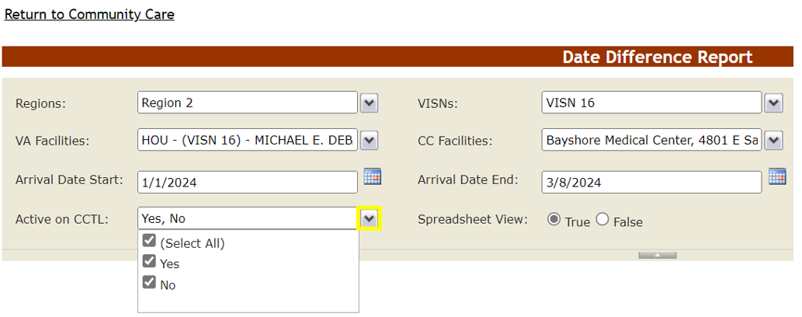
Choose ‘Yes’ for records not removed from the active CCTL, or keep the existing selections to display both Active and Inactive records. Then click away from the Active on CCTL field.

Press the View Report button on the right-hand side of the screen, to run the report:

Figure 70 - Date Difference Report View Report Button
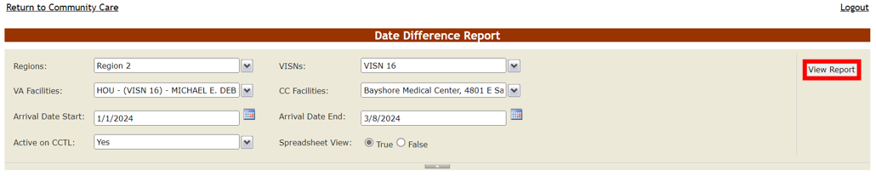

By default the search results appear in a spreadsheet view.

Figure 71 - Date Difference Report Results
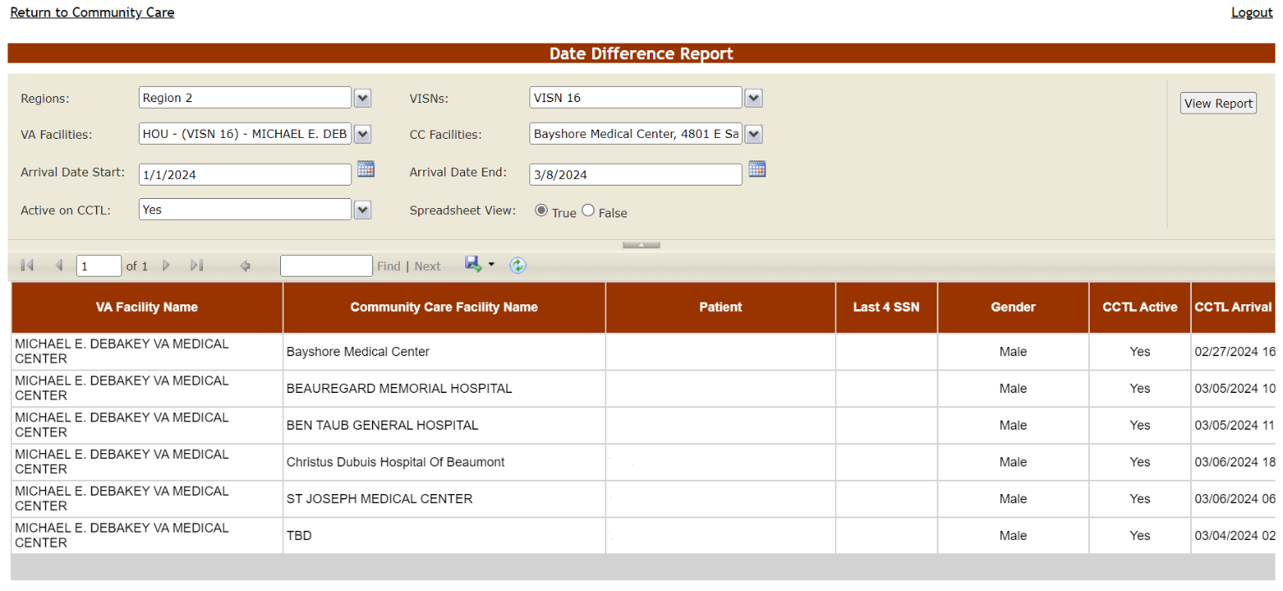

Scrolling to the bottom of the screen reveals a horizontal scroll bar which you can move to the right, to see all the report columns.
Figure 72 - Date Difference Report Scroll Bars
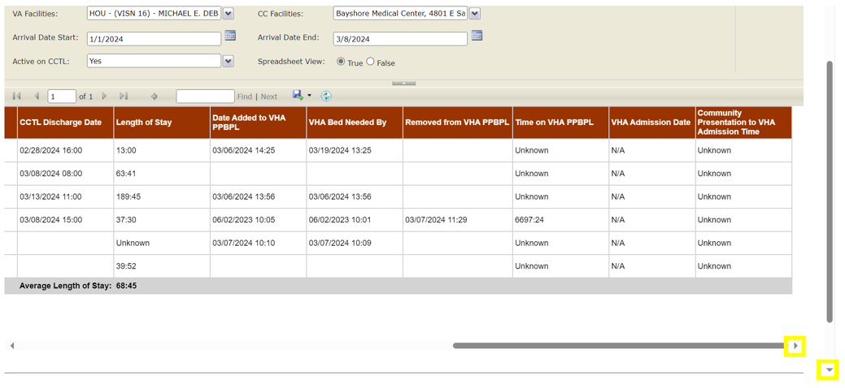
At the bottom of the screen, there is also an overall Average Length of Stay in the community value, which is the cumulative Length of Stay of the report results divided by number of records containing a Length of Stay value:

Figure 73 - Date Difference Report Average Length of Stay

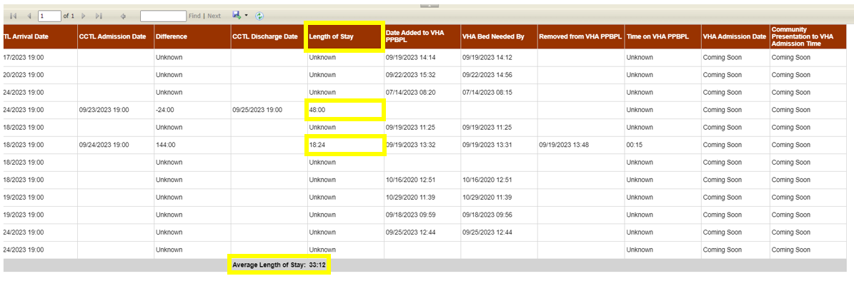

Below are descriptions of the Date Difference Report selections and columns:
Table 14 - Date Difference Report Selections
COLUMN | DESCRIPTION
Regions: | The VA geographical region(s) whose VAMC(s) the BMS User running this report has access to.
VISNs: | The Veteran Integrated Service Network(s) whose VAMC(s) the BMS User running this report has access to.
VA Facilities: | The VAMC(s) the BMS User running this report has access to.
CC Facilities: | The Community Care site(s) tied to the VAMC(s) designated in the report. Note that these CC Facilities are only those tied to specific CCTL records.
Arrival Date Start: | The begin date range for the Community Arrival Date value in the CCTL record.
Arrival Date End: | The end date range for the Community Arrival Date value in the CCTL record.
Active on CCTL: | Yes or No (or both) as to whether the ‘Remove’ link has been selected for the Veteran record on the VAMC's Community Care Tracking List.
Spreadsheet View: | Whether the results should display in one list (True) or broken out by VAMC (False).
Table 15 - Date Difference Report Report Columns
COLUMN | DESCRIPTION
VA Facility Name | The VAMC associated with the CCTL record.
Community Care Facility Name | The Community Facility providing care to the Veteran.
Patient | The Veteran's Last Name, First Name and Middle Name/Initial.
Last 4 SSN | The initial of the Veteran’s Last Name plus last four digits of Social Security Number.
Gender | The Veteran's gender.
CCTL Active | Whether or not the ‘Remove’ link has been selected for the Veteran record on the VAMC's Community Care Tracking List.
CCTL Arrival Date | The Veteran's date/time of presentation at the Community Facility.
CCTL Admission Date | The date/time the Veteran was admitted to the Community Facility.
Difference | The difference in time (HH:MM) between the CCTL Arrival Date and the CCTL Admission Date.
CCTL Discharge Date | The date/time the Veteran was discharged from the Community Facility.
Length of Stay | The difference in time (HH:MM) between the CCTL Admission Date and CCTL Discharge Date.
Date Added to VHA PPBPL | The date/time the Veteran was place on the Patients Pending Bed Placement List using the CCTL’s ‘Add to PPBPL’ function.
VHA Bed Needed By | The date and time on the PPBPL record for when the VA bed is needed.
Removed from VHA PPBPL | The date/time when the patient was removed from the Patients Pending Bed Placement List.
Time on VHA PPBPL | The amount of time (HH:MM) the patient was on the Patients Pending Bed Placement List.
VHA Admission Date | The date/time when the patient was admitted to VA.
Community Presentation to VHA Admission Time | The amount of time (HH:MM) between the CCTL Arrival Date and the VHA Admission Date.

Within the report results, there are also options to page between large numbers of results, keyword search the report output, and export to various file types.

Figure 74 - Community Care Tracking List Reports Paging, Searching and Export Options
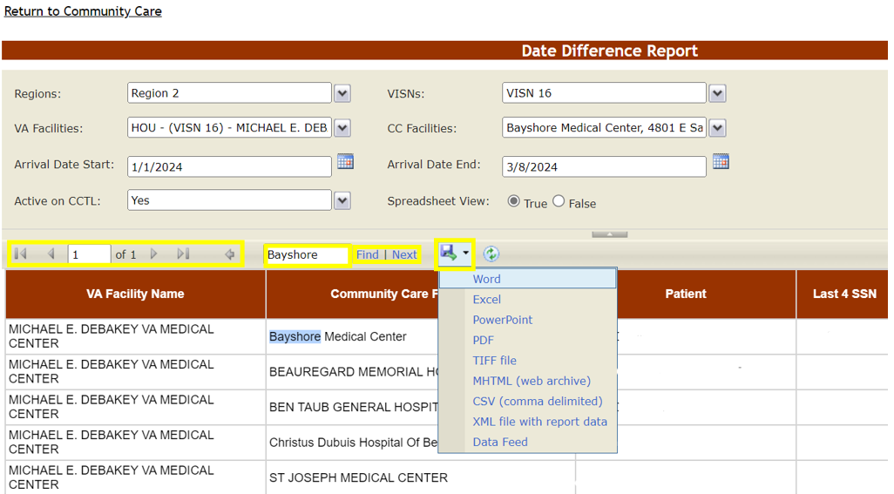
When you wish to return to the Community Care Tracking List, simply select the Return to Community Care link in the upper left-hand corner:
Figure 75 - Return to Community Care Link
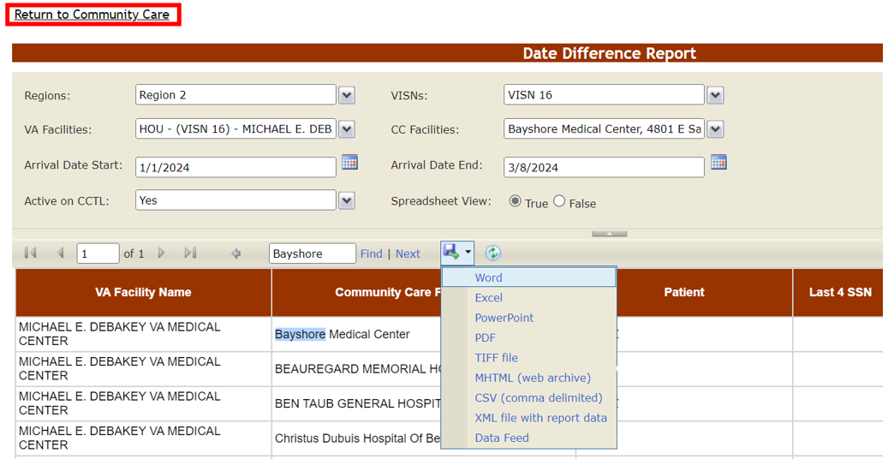

3.1.2.2 Waiting List Report
The Waiting List Report displays general patient information from the CCTL. To run the Waiting List Report, choose Waiting List Report from the Select Report menu, then press the Submit button on the right-hand side of the screen.
Figure 76 - Community Care Tracking List Waiting List Report and Submit Button
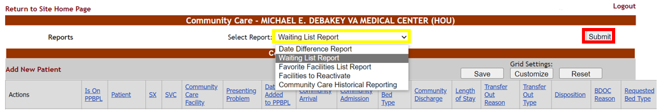

The Waiting List Report selections are the same as the Date Difference Report; however, there are some differences regarding which columns display in the report results.
Figure 77 - Waiting List Report Results
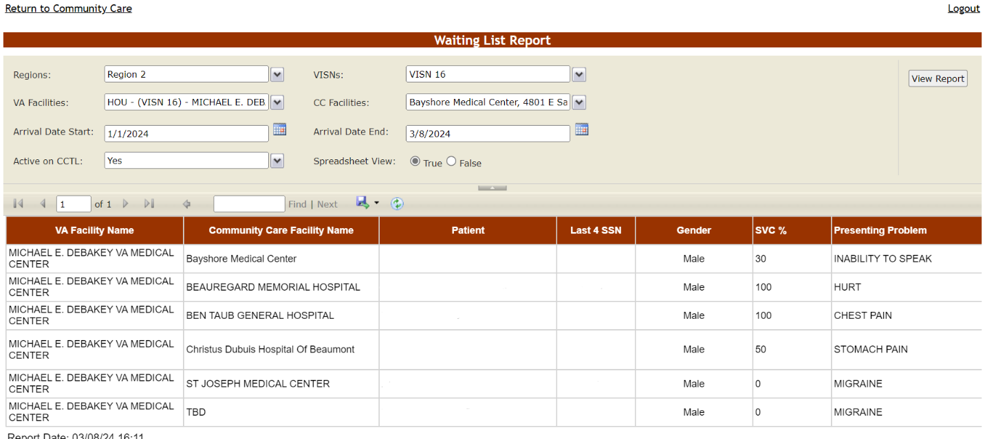

Scrolling to the bottom of the screen reveals a horizontal scroll bar which you can move to the right, to see all the report columns.

Figure 78 - Waiting List Report Scroll Bars
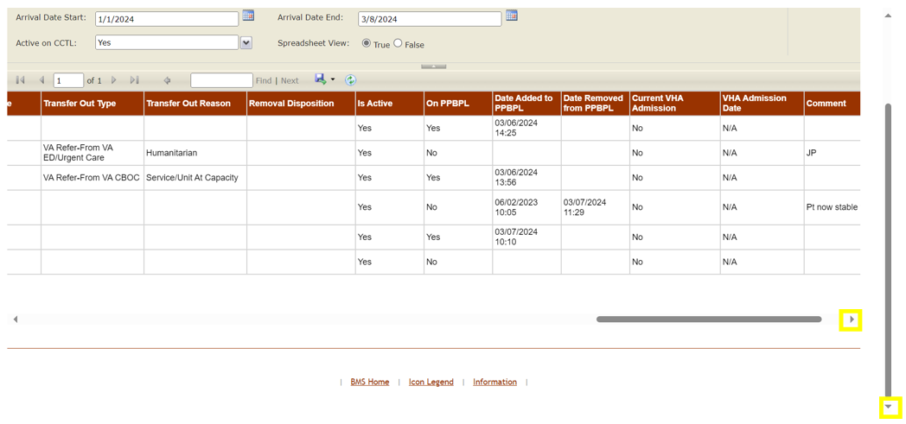

Below are descriptions of the columns that appear within the Waiting List Report:

Table 16 - Waiting List Report Columns
COLUMN | DESCRIPTION
VA Facility Name | The VAMC associated with the CCTL record.
Community Care Facility Name | The Community Facility providing care to the Veteran.
Patient | The Veteran's Last Name, First Name and Middle Name/Initial.
Last 4 SSN | The initial of the Veteran’s Last Name plus last four digits of Social Security Number.
Gender | The Veteran's gender.
SVC % | The Veteran's service-connected disability percentage.
Presenting Problem | The reason why the Veteran presented for care/treatment in the community.
CC Arrival Date | The Veteran's date/time of presentation at the Community Facility.
CC Admission Date | The date/time the Veteran was admitted to the Community Facility.
CC Discharge Date | The date/time the Veteran was discharged from the Community Facility.
CC Removal Date | The date/time when the ‘Remove’ link was selected for the Veteran record on the VAMC's Community Care Tracking List.
Emergency Dept. | Did the Veteran present at the Community Facility through the Emergency Department (ED)?
Admitted | Whether or not the Veteran has been admitted to the Community Facility.
Covid | Is the Veteran currently positive for COVID?
Isolation | Does the Veteran require isolation?
Critical | Is the Veteran in critical condition?
Service Not Offered | The service not available within VA.
Authorization Status | The eligibility for payment of Veteran community care.
Disposition | The disposition type associated with the Veteran.
BDOC Reason | The reason (Bed Days of Care) why the Veteran has not been repatriated.
Signed Declined to Transfer Form | The status of the Veteran's signed 10-8001 (Refusal of Transfer to VA Medical Facility) form.
Bed Type | The type of VA bed needed.
Current Bed Type | The community bed type in use by the Veteran.
Transfer Out Type | The transfer type associated with the Veteran.
Transfer Out Reason | The reason for VA sending the Veteran to the Community Facility.
Removal Disposition | The Disposition selected when removing the patient from the Community Care Tracking List.
Is Active | Whether or not the ‘Remove’ link has been selected for the Veteran record on the VAMC's Community Care Tracking List.
On PPBPL | Whether the Veteran on the VAMC's Community Care Tracking List is also on the VAMC's Patients Pending Bed Placement List.
Date Added to PPBPL | The date/time the Veteran was place on the Patients Pending Bed Placement List using the CCTL’s ‘Add to PPBPL’ function.
Date Removed from PPBPL | The date/time when the patient was removed from the Patients Pending Bed Placement List.
Current VHA Admission | Is there a VA admission record for this CCTL record?
VHA Admission Date | The VA admission date.
Comment | The information from the Comment field for this CCTL record.

Favorite Facilities List Report
The Favorite Facilities List Report lists the Community Facilities mapped to corresponding VA Facilities. To run the Favorite Facilities List Report, choose “Favorite Facilities List Report” from the Select Report menu, then press the Submit button on the right-hand side of the screen.
Figure 79 - Community Care Tracking List Favorite Facilities List Report
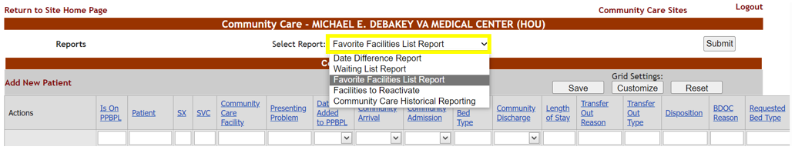

From the Favorite Facilities List Report menu, click on the Regions drop-down arrow:
Figure 80 - Favorite Facilities List Report Regions Menu
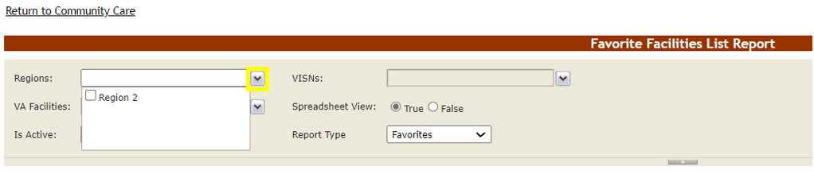
Select the Region your BMS login has access to, by selecting the numbered Region’s checkbox.
Figure 81 - Favorite Facilities List Report Region Selection
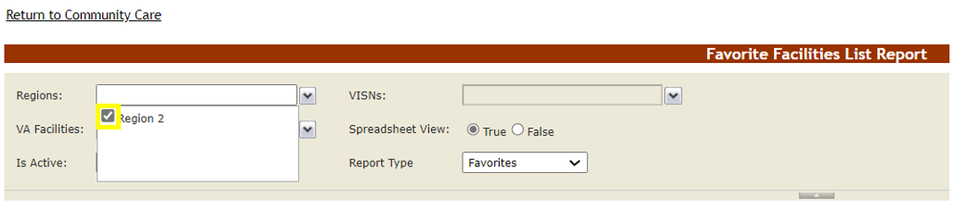

Click away from the Regions field then click on the VISNs drop-down arrow:
Figure 82 - Favorite Facilities List Report VISNs Menu
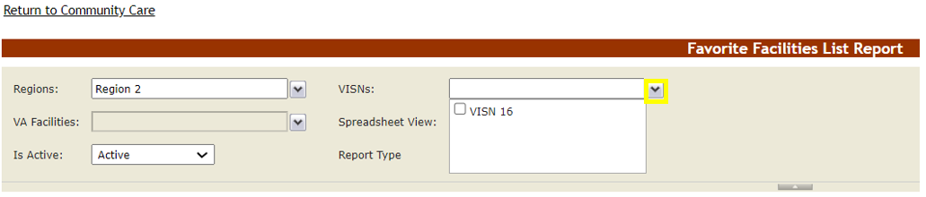

Select the VISN your BMS login has access to, by selecting the numbered VISN’s checkbox.
Figure 83 - Favorite Facilities List Report VISN Selection
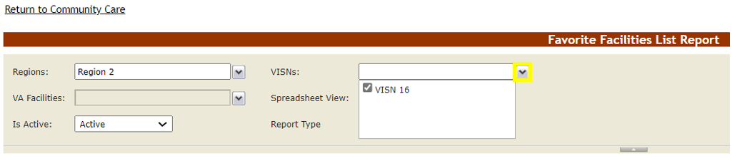
Click away from the VISNs field then click on the VA Facilities drop-down arrow:

Figure 84 - Favorite Facilities List Report VA Facilities Menu

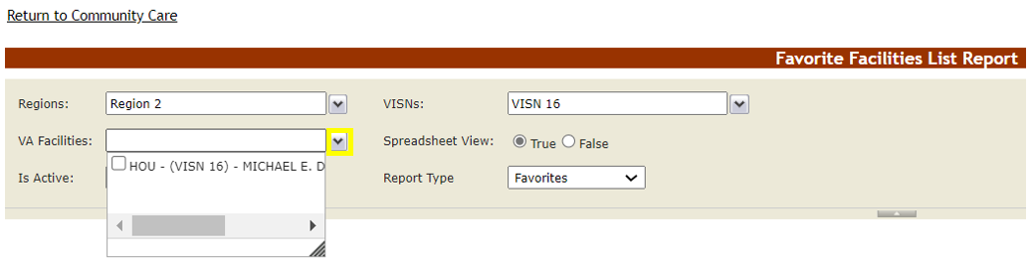
Select the VA Facility (or facilities) your BMS login has access to, by selecting the numbered VA Facility checkbox.
Figure 85 - Favorite Facilities List Report VA Facilities Selection
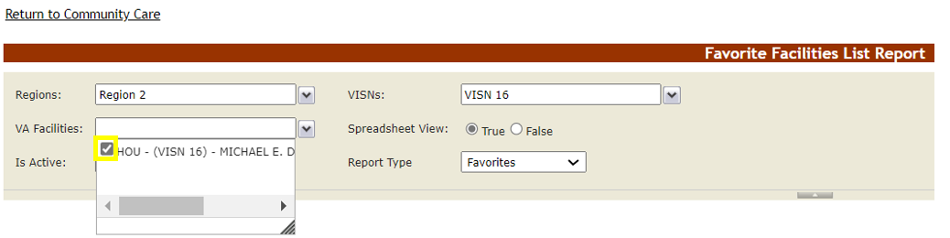
Click away from the VA Facilities field then press the View Report button on the right-hand side of the screen:
Figure 86 - Favorite Facilities List Report View Report Button
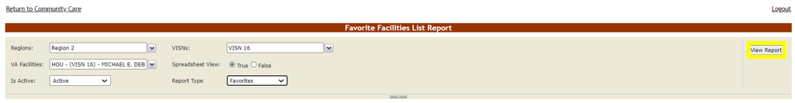

With ‘Favorites’ as the Report Type default, the results will be only Community Care Facilities this VAMC has made its ‘Site Favorites’.

See the section Community Care Admins for more information on setting up a Site Favorites list.

Figure 87 - Favorite Facilities List Report Results

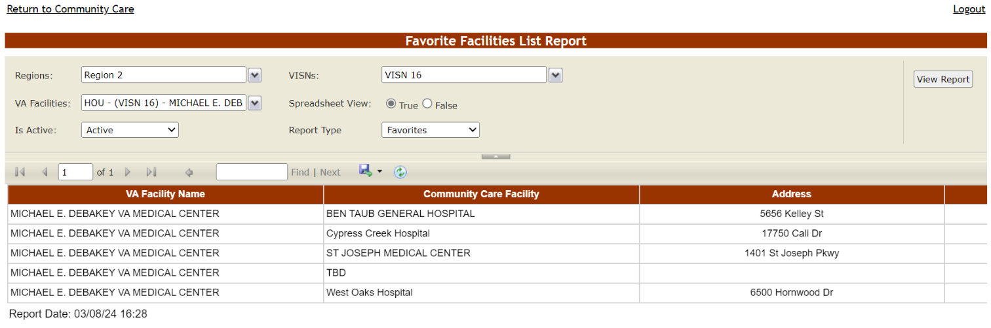

To see all active CC Facilities tied to this VAMC, choose ‘All’ from the Report Type field, then press the View Report button again:
Figure 88 - Favorite Facilities List Report ‘All’ Report Type Results
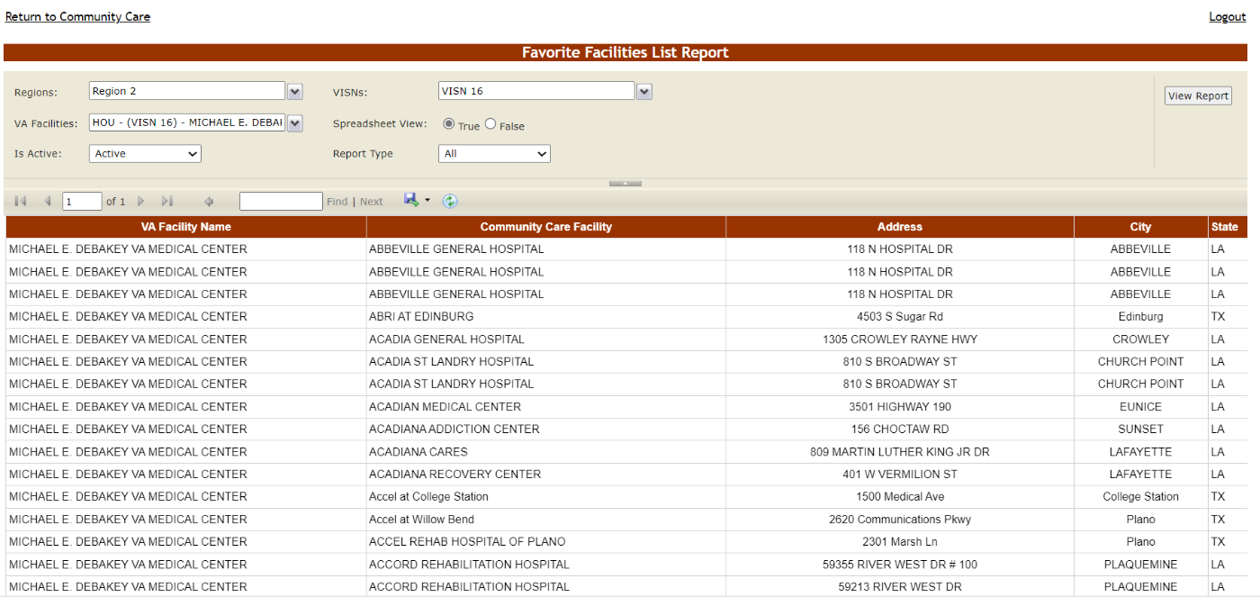

Below are descriptions of the Favorite Facilities List Report selections and columns:
Table 17 - Favorite Facilities List Report Selections
COLUMN | DESCRIPTION
Regions: | The VA geographical region(s) whose VAMC(s) the BMS User running this report has access to.
VISNs: | The Veteran Integrated Service Network(s) whose VAMC(s) the BMS User running this report has access to.
VA Facilities: | The VAMC(s) the BMS User running this report has access to.
Spreadsheet View: | Whether the results should display in one list (True) or broken out by VAMC (False).
Is Active: | If ‘Active’, the CC facility can be actively searched and added to the VAMC favorites list. If ‘Inactive’, the CC facility has been removed within the Community Care Sites screen by an Admin User or higher.  Note: the PPMS background processor that maintains community facility data will automatically inactivate records containing only a street address for the Community Care Facility name.
Report Type: | If ‘Favorites’, lists only the CC Facilities configured for this VAMC’s Site Favorites; if ‘All’, lists all nearby CC Facilities associated with this VAMC.
Table 18 - Favorite Facilities List Report columns
COLUMN | DESCRIPTION
VA Facility Name | The name of the VAMC associated with the Community Facility.
Community Care Facility | The name of the Community Facility.
Address | The physical address of the Community Facility.
City | The city where the Community Facility is located.
State | The state where the Community Facility is located.
Zip Code | The zip code of the Community Facility.
NPI | The National Provider Identifier number of the Community Facility.

Community Care Transfer Users
Community Care Transfer Users have access to these additional CCTL features:
- Add to PPBPL function
- Transfer Out Reason and Transfer Out Type fields
The ‘Community Care Transfer User’ role inherits all the same permissions as the Community Care User role. For information on Community Care Tracking List usage in general, see the previous Community Care Users section of this guide.
For information on BMS logins and user roles, see the Facility Administrator Users chapter of the BMS User Setup and Admin Guide Guide located within the VA Software Document Library.

Adding a CCTL Record to the Patients Pending Bed Placement List
If the Veteran on your VAMC’s Community Care Tracking List is to be repatriated back to VA, there is a convenient Add to PPBPL link on the CCTL that copies the relevant information from the CCTL record to your VAMC’s Patients Pending Bed Placement List.

Click on the Add to PPBPL link to place the Veteran on your VAMC’s PPBPL:

Figure 89 - CCTL Grid Add to PPBPL Link
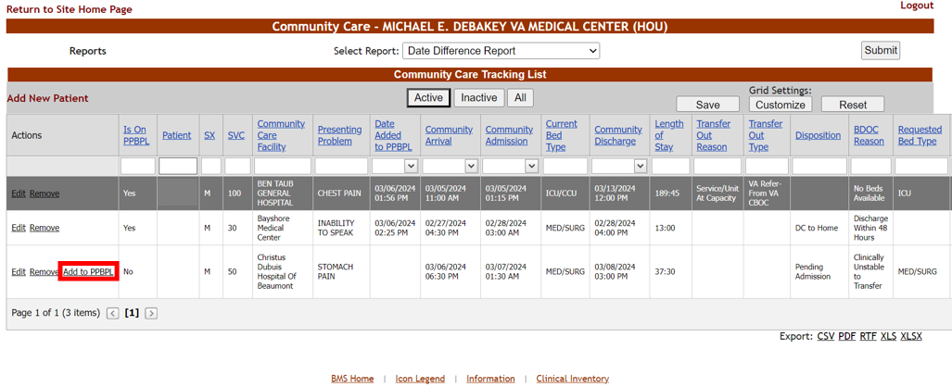
Patients already on the PPBPL won’t display an Add to PPBPL link.
The following fields are populated on the ADD/EDIT Patients Pending Bed Placement screen after selecting the CCTL’s Add to PPBPL link:
- Present Problem – the same value as the CCTL “Presenting Problem”
- Type of Bed/Ward – “TBD” by default
- Did the transfer request or completed transfer originate from the community? – set to ‘Yes’
- Community Care Facility – populated with the same value as the CCTL record
Figure 90 - ADD/EDIT Patients Pending Bed Placement Screen with Copied Values
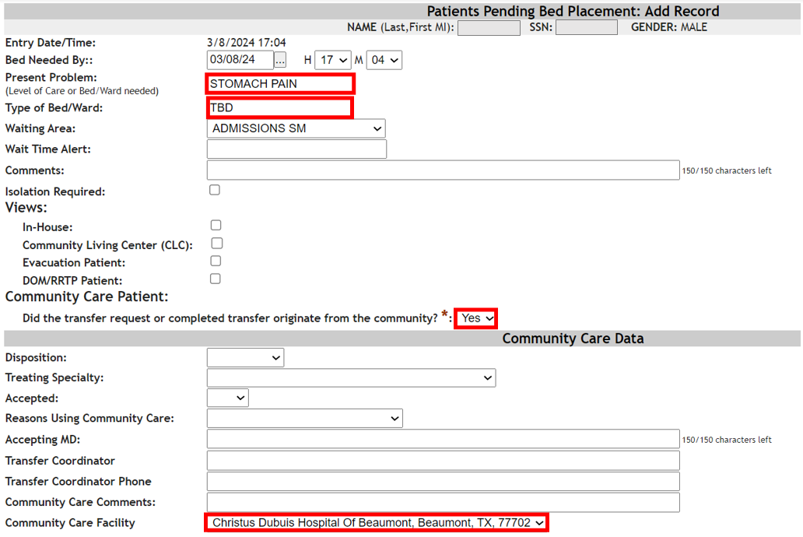
Updating key patient information on the PPBL list is very important to expedite access to the correct VA level of care.

Update the Bed Needed By, Waiting Area and other fields as necessary, then select a required Reasons Using Community Care value:
Figure 91 - Bed Needed By, Waiting Area and Reasons Using Community Care Edits
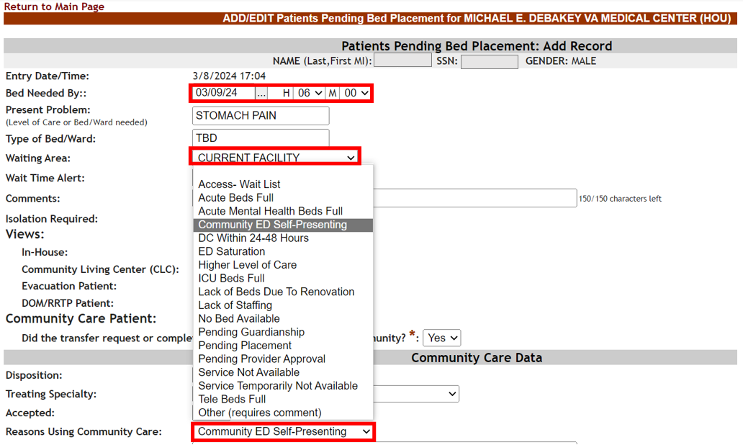
Note that choosing a Reasons Using Community Care value of “No Bed Available” will open a required Bed Type field. The Bed Type selection also populates the Type of Bed/Ward field automatically.
Figure 92 - ADD/EDIT Patients Pending Bed Placement Bed Type and Type of Bed/Ward Fields
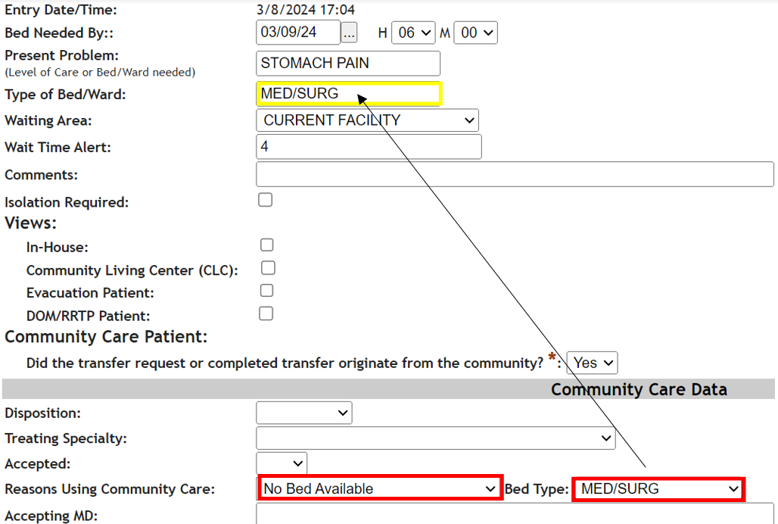
Fill out any other relevant fields then press Submit to add the Veteran to your VAMC’s PPBPL.
Figure 93 - ADD/EDIT Patients Pending Bed Placement Submit Button
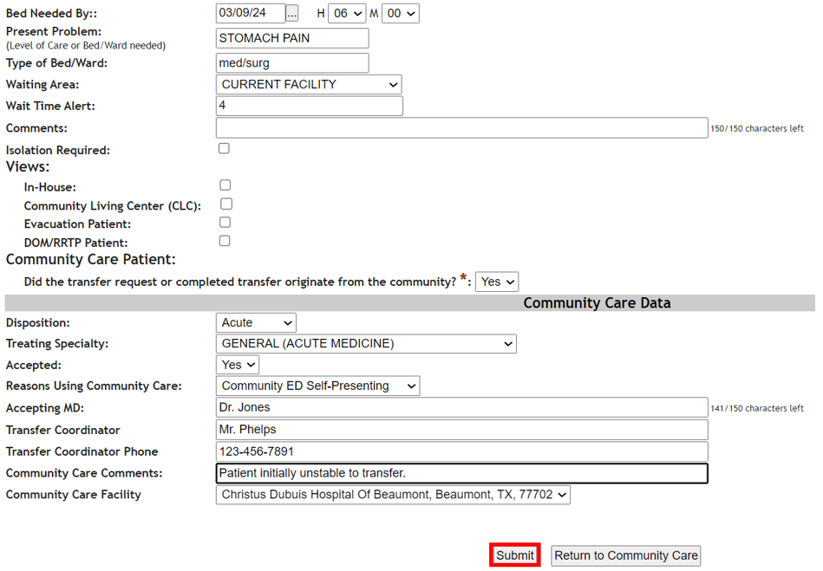
At this point you should see a success message, with options to go to the PPBPL (Return to Listing) or back to the Community Care Tracking List (Return to Community Care).
Figure 94 - ADD/EDIT Patients Pending Bed Placement Facility Parameters Configuration
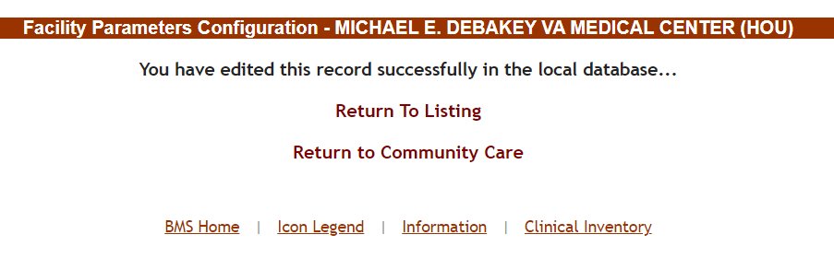

Select Return to Community Care in order to navigate back to the Community Care Tracking List:

Figure 95 - ADD/EDIT Patients Pending Bed Placement Return to Community Care
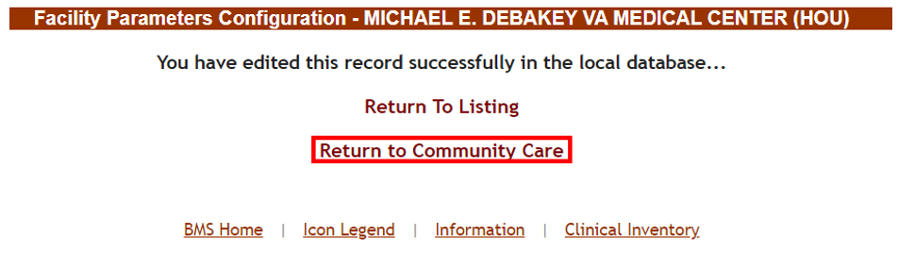
Unless you are a Site User or higher, you will be unable to access the PPBPL in general using the Return to Listing link.

On the Community Care Tracking List the tracking list record added to the PPBPL will display new values for Is On PPBPL and Date Added to PPBPL. In addition, the Add to PPBPL link no longer displays:
Figure 96 - Is On PPBPL and Date Added to PPBPL Updates
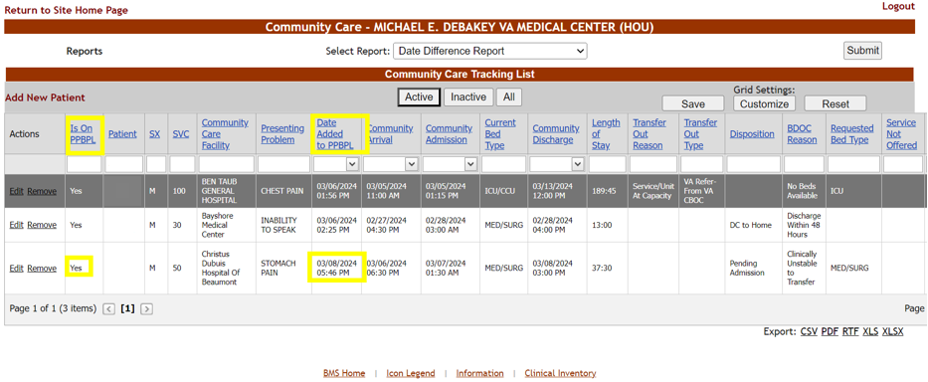
While the Veteran may be on the PPBPL and even have a Community Discharge Date, the CCTL record will remain Active until you remove (that is, “inactivate”) the tracking list record. This will provide the ability to track and monitor these Veterans for continuity of care and follow-up until this is no longer needed.

Transfer Out Reason and Transfer Out Type Fields
BMS logins with Community Care Transfer Users privileges can also edit the Transfer Out Reason and Transfer Out Type fields for a given CCTL record.

For general information on editing CCTL records and specific Transfer Out Reason and Transfer Out Type values, see the Editing a Tracking List Record section of this guide.
Figure 97 - Transfer Out Reason Edit Access
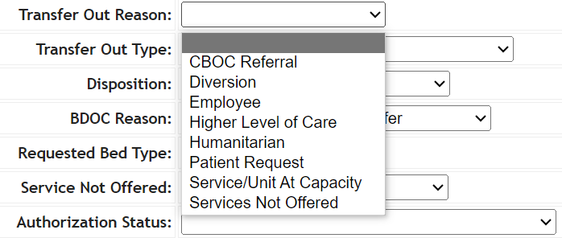
Figure 98 - Transfer Out Type Edit Access
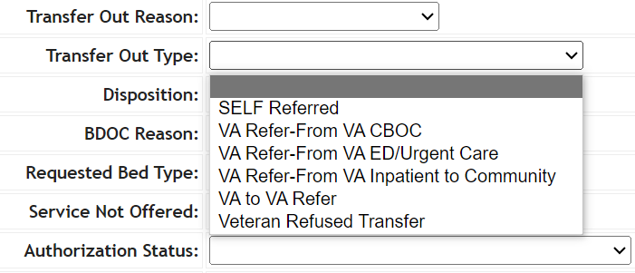

BMS logins with only a Community Care User role won’t be able to edit the Transfer Out Reason and Transfer Out Type fields.

Community Care Admins
Community Care Admins have access to the following page and report:
- Community Care Sites
- Community Care Historical Reporting

Community Care Admins do not automatically inherit Community Care User or Community Care Transfer User role privileges. To have CCTL permission in general, the local administrator must grant either the Community Care User or Community Care Transfer User role, in addition to the Community Care Admin role. For more information refer to the BMS User Setup and Admin Guide located within the VA Software Document Library.
For information on Community Care Tracking List usage in general, see the previous Community Care Users and Community Care Transfer Users sections of this guide.
Support, National, VISN and Admin User roles all inherit the Community Care Admin permissions automatically. For more information refer to the BMS User Setup and Admin Guide located within the VA Software Document Library.

Community Care Sites
To access the Community Care Sites page, BMS users with Community Care Admin privileges will see a Community Care Sites link on the Community Care Tracking List, as in the screenshot below:
Figure 99 - Community Care Sites Link
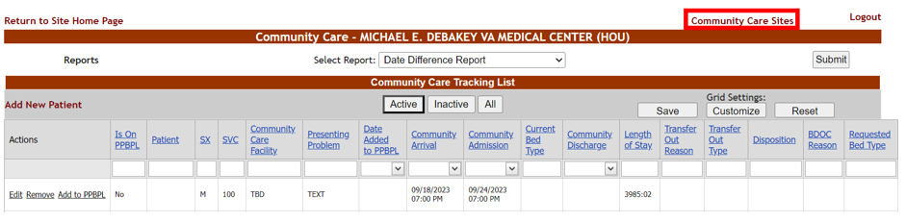
Community Care Users (or Community Care Transfer Users) with the Community Care Admin role will go directly to the Community Care Sites page upon login.

The Community Care Sites page allows BMS users to configure VAMC-specific lists of Community Care Facilities that staff choose from, whenever adding patients to either a VAMC Community Care Tracking List (CCTL) or VAMC Patients Pending Bed Placement List (PPBPL).
Figure 100 - Community Care Sites Configuration Screen
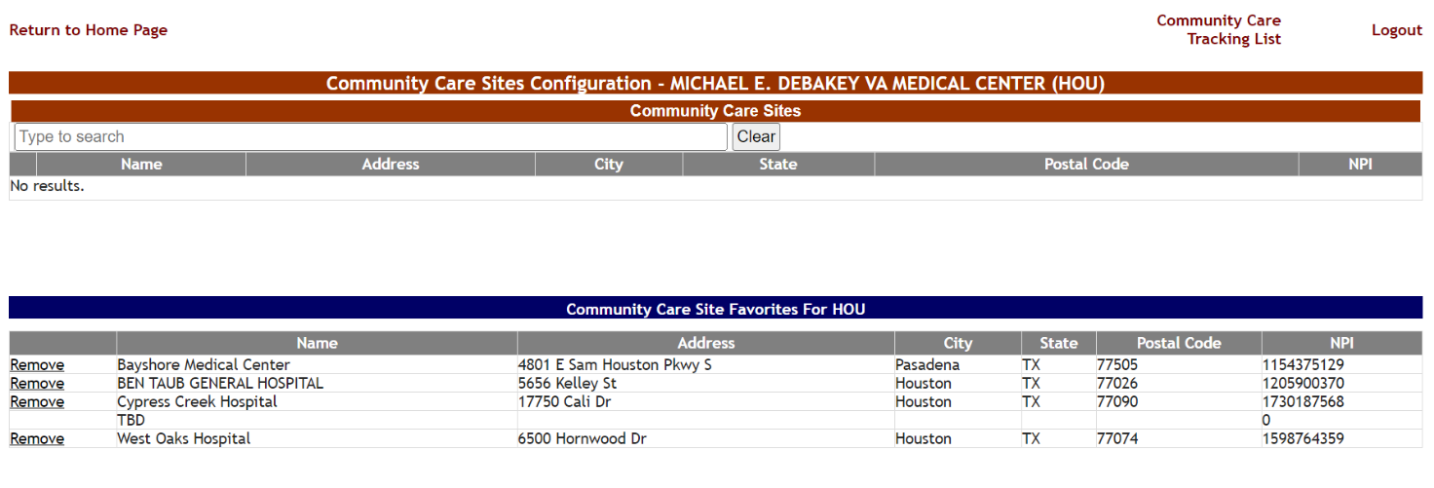

Figure 101 - Community Care Facility Drop-Down List (CCTL)
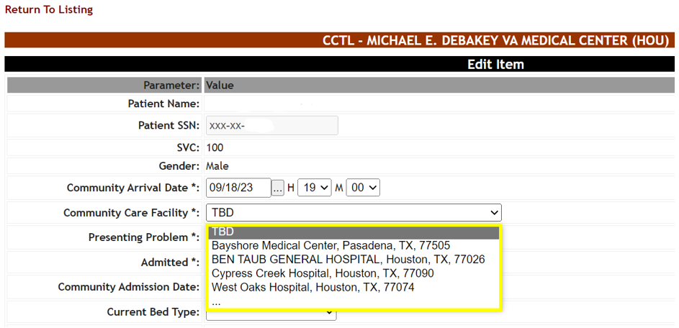

For information on adding, editing and removing Community Care Facilities manually, see the Community Care Sites section of the BMS User Setup and Admin Guide located within the VA Software Document Library.

Adding Community Care Site Favorites
To add or update the drop-down list of community facilities users see when adding patients to this facility’s Community Care Tracking List (CCTL) or Patients Pending Bed Placement List (PPBPL), click in the Type to search field underneath the Community Care Sites header. Then type a Facility Name, Address, City, State or ZIP code number which brings back search results immediately.
Search results are based on a 300 mile radius of the VAMC’s physical address. Note that multiple VAMCs can have access to the same community facility record based on overlapping radii.
Your search term must be at least 2 characters in length. There is also a limit of 200 results per search. National Provider Identifier (NPI) is not searchable. In addition, multi-term searching (for example, “hospice TX” to find facilities with “Hospice” in the Facility Name and “TX” for the State) is currently unsupported.
Figure 102 - Community Care Sites Page Search
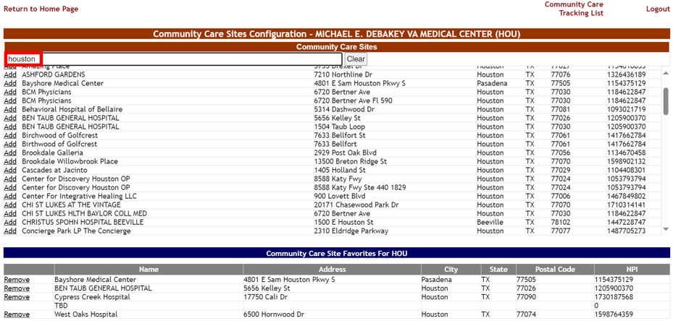

When you find the relevant facility from the search results, select the Add link:
Figure 103 - Community Care Sites Add Link
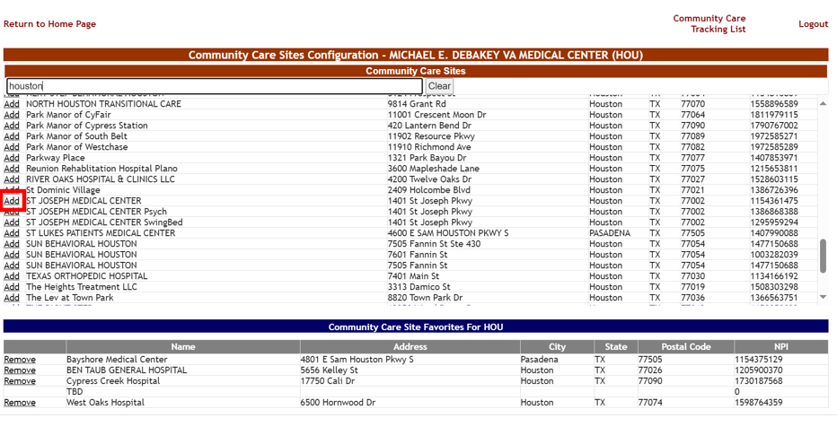

Figure 104 - Community Care Sites Favorite Addition
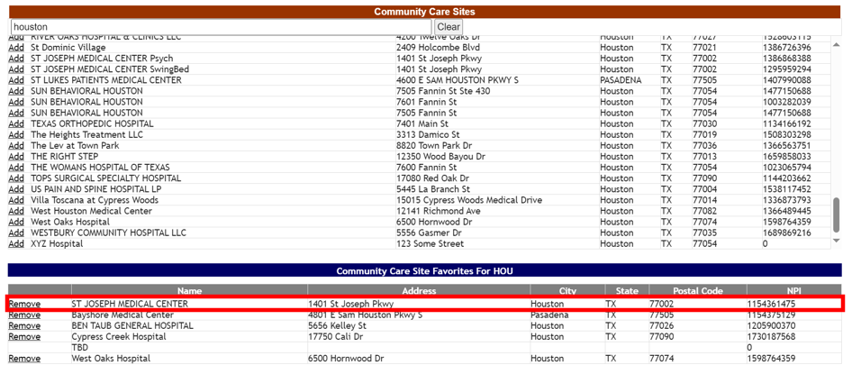
BMS users adding or editing records on the VAMC-specific Community Care Tracking List (or the facility Patients Pending Bed Placement List) will immediately see this community care facility within the Community Care Facility drop-down menu:

Figure 105 - CCTL Community Care Facility Menu New Favorite
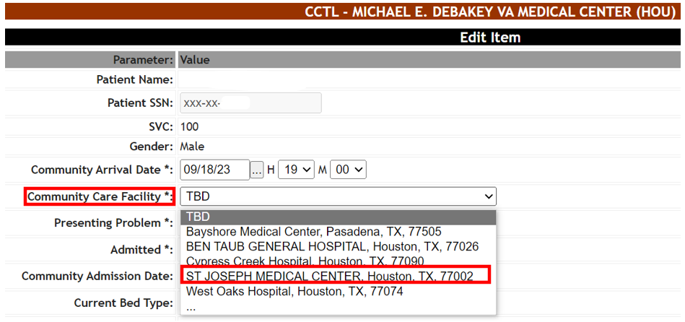

Table 19 - Community Care Sites Parameters
COLUMN | DESCRIPTION
Facility Name | The name of the Community Facility.
Address | The physical address of the Community Facility.
City | The city where the Community Facility is located.
State | The state where the Community Facility is located.
Postal Code | The zip code of the Community Facility.
NPI | The National Provider Identifier number of the Community Facility.

Removing Community Care Site Favorites
To remove one or more Community Care facilities from the ‘Community Care Facility’ drop-down menu, click the Remove link within the Community Care Site Favorites For VAMC table.
Figure 106 - Community Care Sites Configuration Favorite Removal
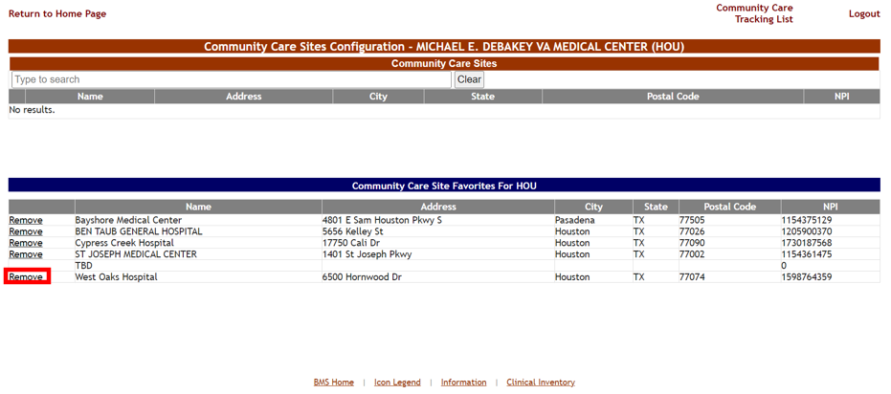

Note that ‘TBD’ will always appear within the Community Care Site Favorites list. This is the default Community Care Facility value when adding someone to the Community Care Tracking List. This should be modified with the correct Community Care Facility.
As with adding community facilities to a VAMC’s favorites list, removing one or more Community facilities from the favorites list is seen immediately by your users.
Figure 107 - CCTL Community Care Facility Menu Removed Favorites
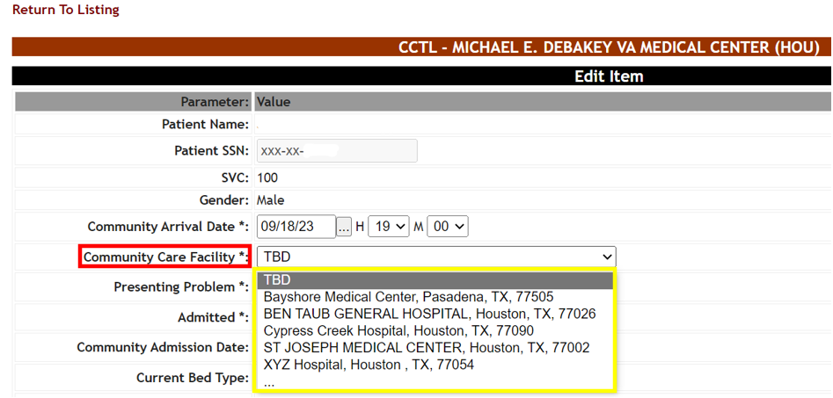

To add, edit or delete Community Care facilities from the Community Care Sites page, an Admin User role is required. For more information refer to the BMS User Setup and Admin Guide located within the VA Software Document Library.
Remember that within the CCTL or PPBPL Community Care Facility field, your users are also able to search the database directly, should the Community Facility they are looking for not be listed as a “favorite”.
Figure 108 - CCTL Community Care Facility Menu Search Option
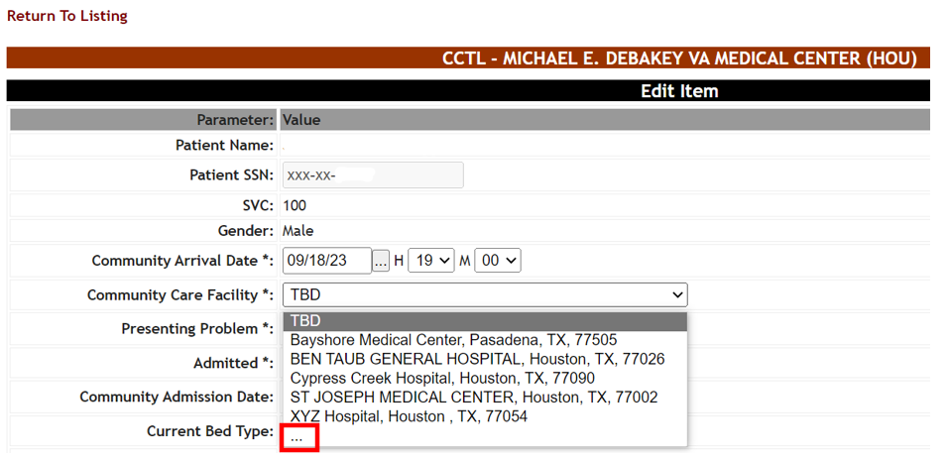
Once the site user selects the ‘…’ option, a new Community Care Facility Search window appears:
Figure 109 - CCTL Community Care Facility Search
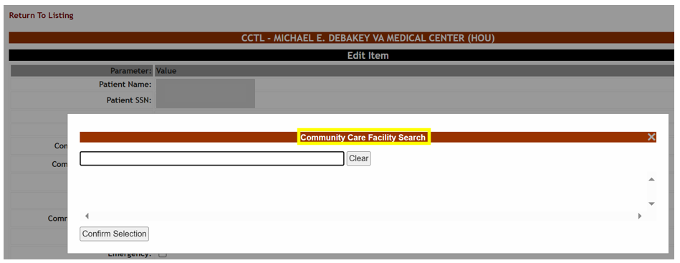

Similar to the Community Care Sites Configuration screen, your user will click in the search bar underneath the Community Care Facility Search header then type a Facility Name, Address, City, State or ZIP code number for your search of community facilities within a 300 mile radius of the VAMC. Note that a search term must be at least 2 characters in length. There is also a limit of 200 results per search; National Provider Identifier (NPI) is not searchable. In addition, multi-term searching (for example, “hospice TX” to find facilities with “Hospice” in the Facility Name and “TX” for the State) is currently unsupported.
Figure 110 - CCTL Community Care Facility Search Results
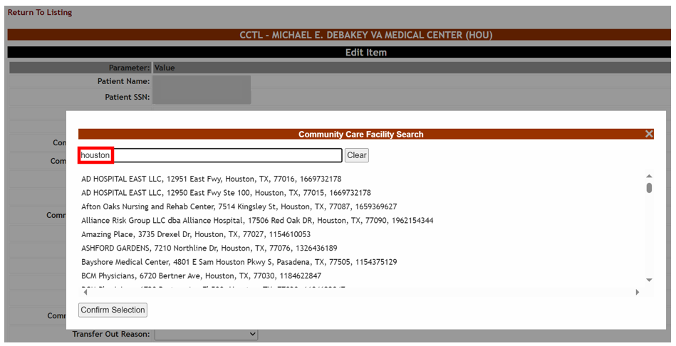
The user will drag the scroll bar if necessary to find the facility in question, then select the record and press the Confirm Selection button.
Figure 111 - CCTL Community Care Facility Search Selection
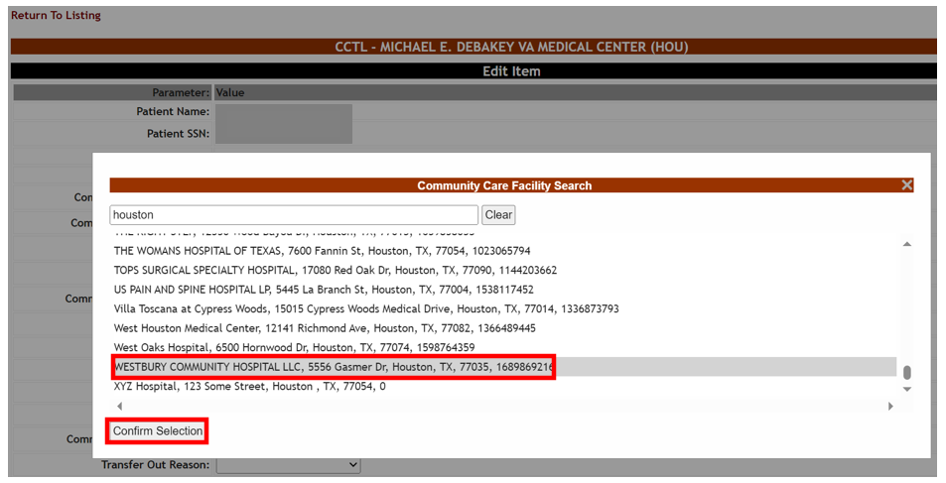
Once the selection is confirmed, the CCTL record’s Community Care Facility field is populated with the facility in question.
Figure 112 - CCTL Community Care Facility Value
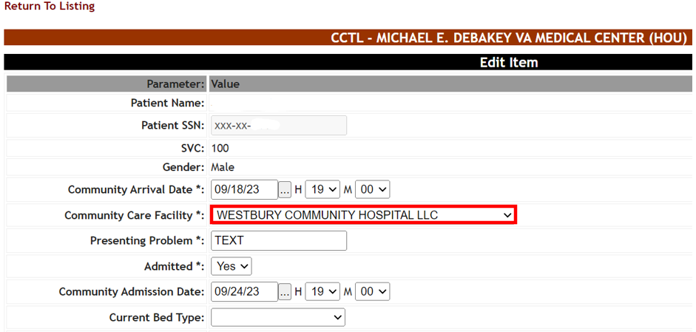

3.3.2 Community Care Historical Reporting
Community Care Historical Reporting displays CCTL activity over an historical timeframe. To access this report, use the Select Report drop down on the CCTL, choose Community Care Historical Reporting then click the Submit button.
Figure 113 - Community Care Historical Reporting
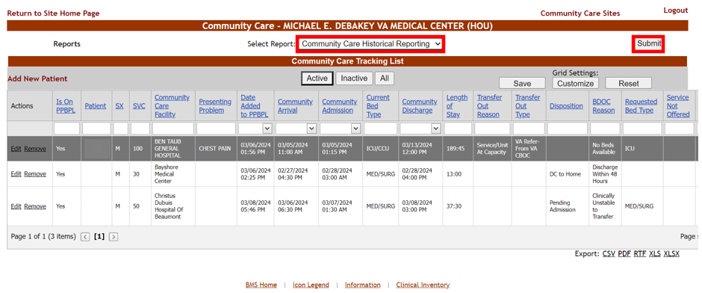
There are three Report Types available within Community Care Historical Reporting:
- Community Care Facilities
- Community Care Favorites
- Community Care Tracking List

3.3.2.1 Community Care Facilities
The Community Care Facilities report type lists historical CC Facility record activity. This report is useful for auditing CC Facility record modifications based on a Provider Profile Management System (PPMS) background processor job or manual CC Facility record editing by an admin user.
For information on the PPMS background processor, see the Background Processors Page section of the BMS User Setup and Admin Guide located within the VA Software Document Library.

From the Report Type field, select the Community Care Facilities option:
Figure 114 - Report Type – Community Care Facilities
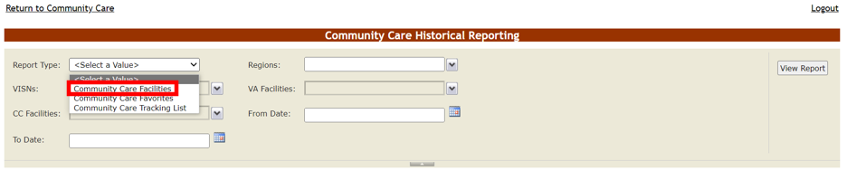

From the Regions field, select the Region(s) your BMS login has access to, by selecting the numbered Region(s) checkbox.
Figure 115 - Community Care Historical Reporting Regions Selection
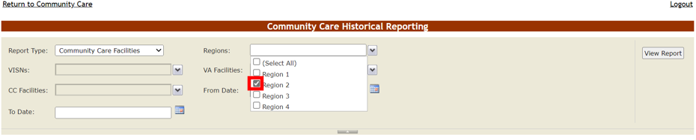

Click away from the Regions field then click on the VISNs drop-down arrow:

Figure 116 - Community Care Historical Reporting VISNs Menu
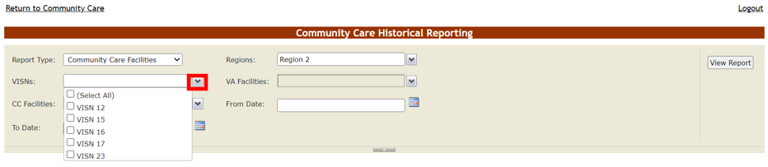

Select the VISN(s) your BMS login has access to, by selecting the numbered VISN(s) checkbox(es).
Figure 117 - Community Care Historical Reporting VISN Selection(s)
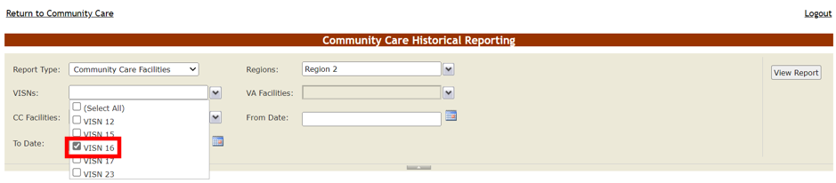
Click away from the VISNs field then click on the VA Facilities drop-down arrow:
Figure 118 - Community Care Historical Reporting VA Facilities Menu
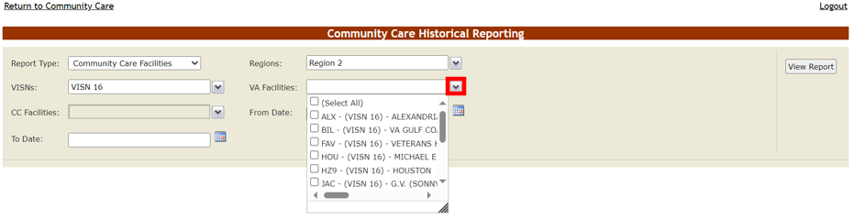
Select the VA Facilit(ies) your BMS login has access to, by selecting the numbered VA Facility checkbox(es).
Figure 119 - Community Care Historical Reporting VA Facilities Selection(s)
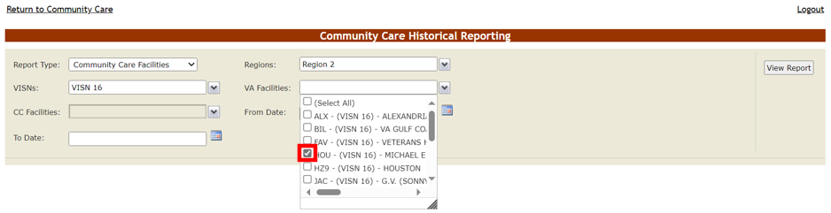
Click away from the VA Facilities field then click on the CC Facilities drop-down arrow:
Figure 120 - Community Care Historical Reporting CC Facilities Menu
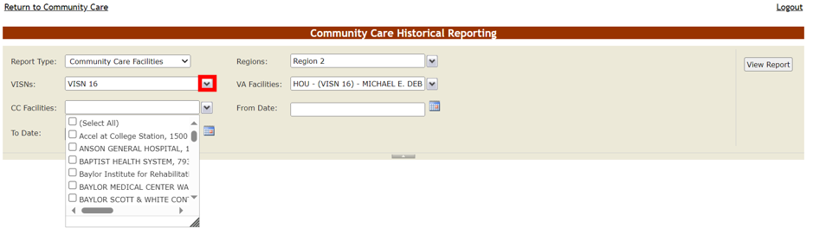

Select the (Select All) checkbox or click on individual CC facilities which have been designated historically as a valid CC Facility for the selected VA Facilities.

Figure 121 - Community Care Historical Reporting CC Facilities Selection
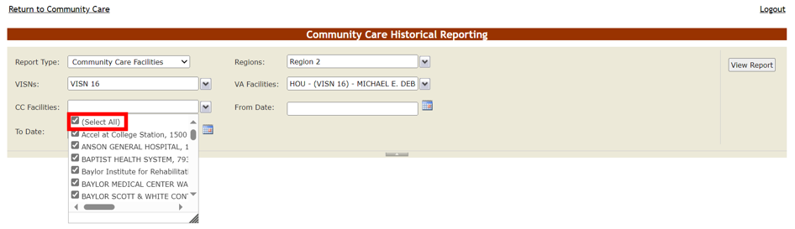

Click away from the CC Facilities field then click on the From Date calendar picker:
Figure 122 - Community Care Historical Reporting From Date Calendar
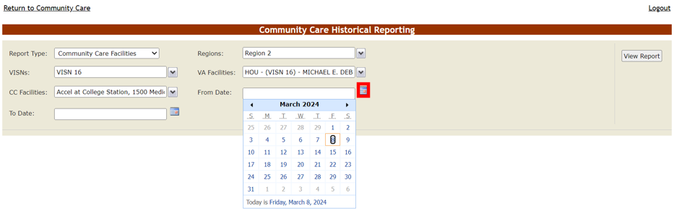
Use the calendar arrows to choose the start date when CC Facility records were created or updated (for example, when the last PPMS background processor job ran).

Now click on the To Date calendar picker and use the calendar to choose the end date when CC Facility records were created or updated.
Figure 123 - Community Care Historical Reporting To Date Calendar
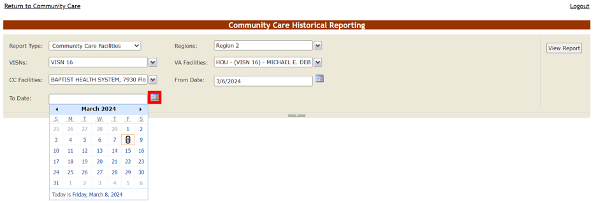

Now press the View Report button on the right-hand side of the screen to run the report:
Figure 124 - Community Care Historical Reporting View Report Button
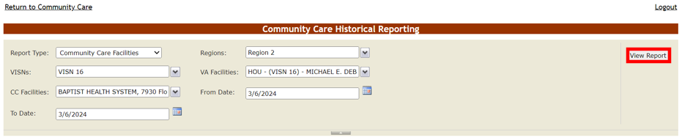

Figure 125 - Community Care Facilties Report Type Results

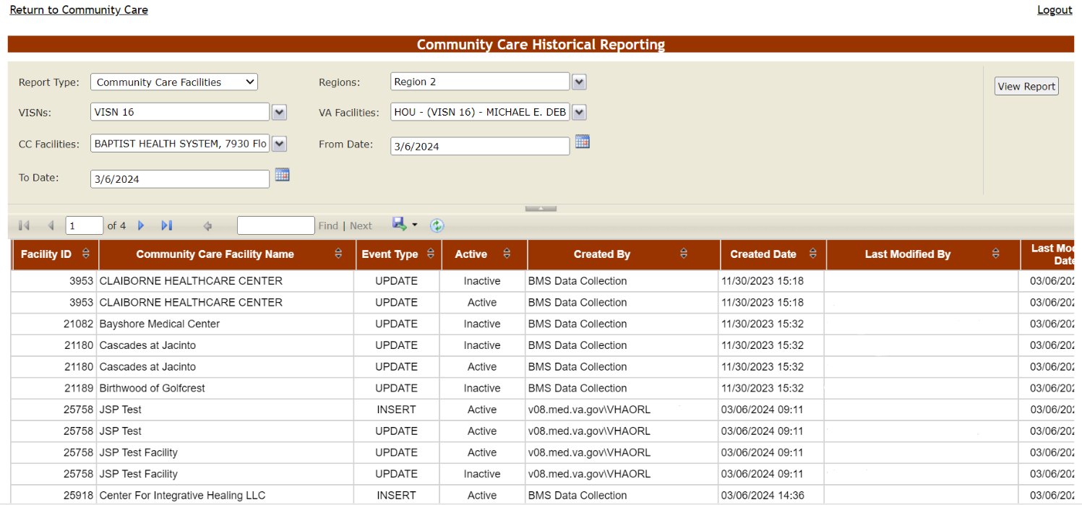

Below are descriptions of the Community Care Facilities report type selections and columns:

Table 20 - Community Care Historical Reporting – Community Care Facilities Selections
COLUMN | DESCRIPTION
Report Type: | The specific Community Care Historical Reporting report type.
Regions: | The VA geographical region(s) whose VAMC(s) the BMS User running this report has access to.
VISNs: | The Veteran Integrated Service Network(s) whose VAMC(s) the BMS User running this report has access to.
VA Facilities: | The VAMC(s) the BMS User running this report has access to.
CC Facilities: | The CC facilities associated historically with this VA Facilities selected.
From Date: | The start date range when the selected CC facility records were edited.  NOTE: this date is technically when the history database was updated, which is usually a few minutes after the CC facility record was created or updated.
To Date: | The end date range when the selected CC facility records were edited.  NOTE: this date is technically when the history database was updated, which is usually a few minutes after the CC facility record was created or updated.

Table 21 - Community Care Facilities report type columns
COLUMN | DESCRIPTION
Facility ID | This is the internal ID of the facility. If the CC Facility name is edited, the ID can be useful to denote when the CC Facility Name changed.
Community Care Facility | The name of the community facility.
Event Type | Whether the CC facility record has been created (“INSERT”), modified (“UPDATE”) or deleted (“UPDATE” + ‘Inactive’ status).
Active | The status (Active or Inactive) of the CC Facility. If inactive, the facility cannot be found when using Community Care Facility Search functionality, depending on whether removal/inactivation was done across all VAMCs for just for a specific VAMC.
Created By | The BMS login that created the CC Facility record. If created by the PPMS background processor, the Created By value is “BMS Data Collection”.
Created Date | The Date/Time the facility record was created.
Last Modified By | The BMS login that created or updated the CC Facility record.
Last Modified Date | The Date/Time the facility record was edited.
Address | The street address of the Community Facility.
City | The city where the Community Facility is located.
State | The state where the Community Facility is located.
Postal Code | The zip code of the Community Facility.
NPI | The National Provider Identifer of the Community Facility.

3.3.2.2 Community Care Favorites
The Community Care Favorites report type lists historical Community Care Site Favorites list activity. This report is useful for auditing the maintenance of a VAMC’s Community Care Facility drop-down list used in CCTL and PPBPL records.

From the Report Type field, select the Community Care Favorites option:
Figure 126 - Report Type – Community Care Favorites
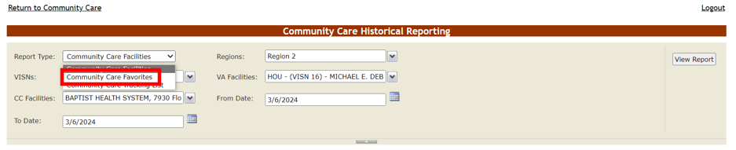

If needed, update the Regions, VISNs and VA Facilities selections. Then from the CC Facilities field, select the (Select All) checkbox or click on individual CC facilities which have been designated historically as Site Favorites for the selected VA Facilities.

Figure 127 - Community Care Historical Reporting CC Facilities Selection
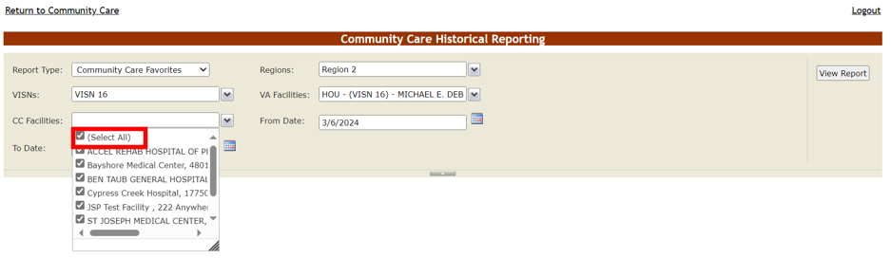

Click away from the CC Facilities field then update the From Date and To Date values, based on the Site Favorite activity date range:
Figure 128 - Community Care Historical Reporting From Date Updated
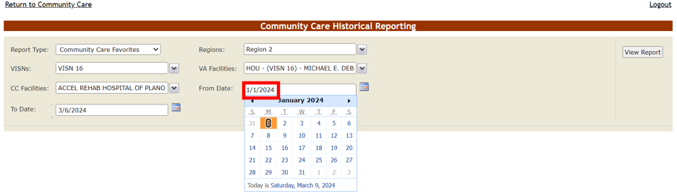
Now press the View Report button on the right-hand side of the screen to run the report:
Figure 129 - Community Care Favorites Report Type Results

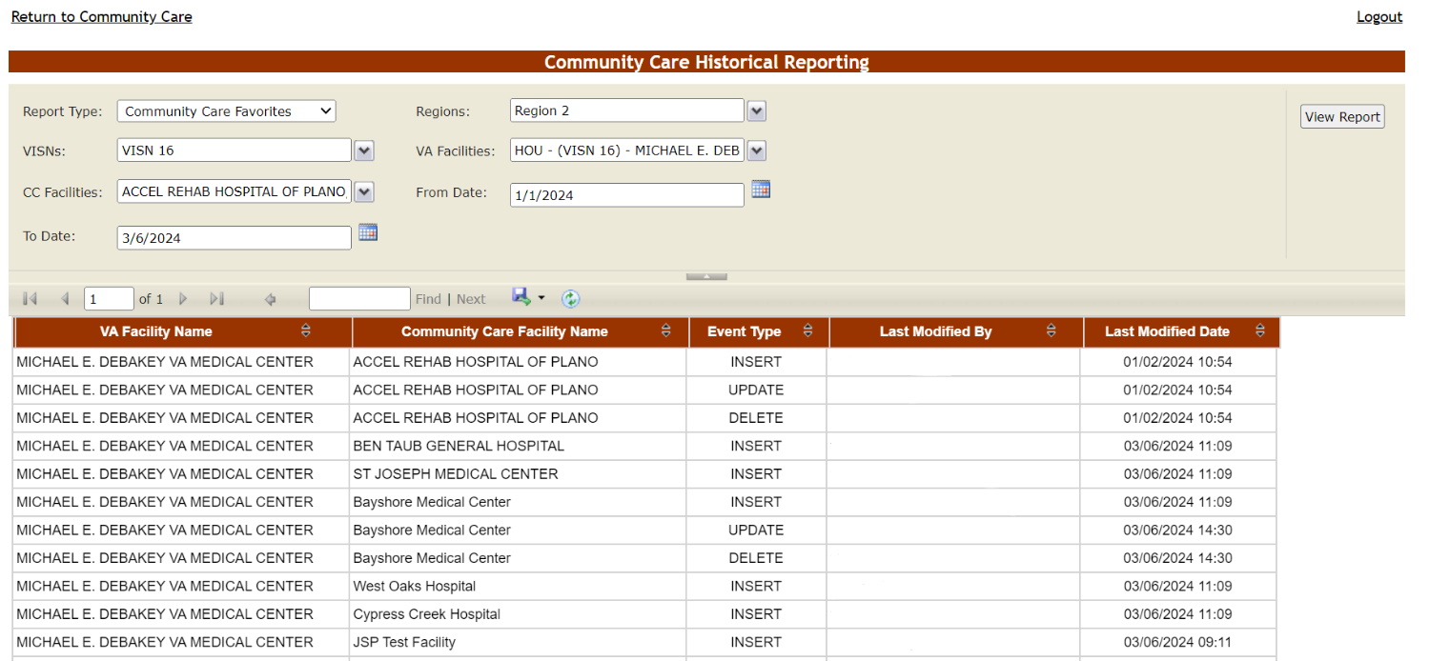

Since site favorites are only added or removed by BMS users, the system will first update the Last Modified Date prior to removal. This is why you see two rows (UPDATE and DELETE) for a given CC Facility that has been removed from a Site Favorites list.

Below are descriptions of the Community Care Favorites report type selections and columns:

Table 22 - Community Care Historical Reporting – Community Care Favorites selections
COLUMN | DESCRIPTION
Report Type: | The specific Community Care Historical Reporting report type.
Regions: | The VA geographical region(s) whose VAMC(s) the BMS User running this report has access to.
VISNs: | The Veteran Integrated Service Network(s) whose VAMC(s) the BMS User running this report has access to.
VA Facilities: | The VAMC(s) the BMS User running this report has access to.
CC Facilities: | The CC Facilities that have ever been part of a Site Favorites list tied to the VA Facilities in the report criteria.
From Date: | The start date range when the selected CC site favorite records were added or removed.  NOTE: this date is technically when the history database was updated, which is usually a few minutes after the CC site favorites record was created or removed.
To Date: | The end date range when the selected CC site favorite records were added or removed.  NOTE: this date is technically when the history database was updated, which is usually a few minutes after the CC site favorites record was created or removed.

Table 23 - Community Care Favorites Report Type Columns
COLUMN | DESCRIPTION
VA Facility Name | The VAMC associated with the CC Facility site favorite.
Community Care Facility Name | The name of the Community Facility.
Event Type | Whether the CC site favorite has been created (“INSERT”), updated (“UPDATE”) or deleted (“DELETE”).  Note: Since site favorites are only added or removed by BMS users, the system will first update the Last Modified Date prior to removal. This is why you see two rows (UPDATE and DELETE) for a given CC Facility that has been removed from a Site Favorites list.
Last Modified By | The BMS login that added, updated or deleted the CC Facility record.
Last Modified Date | The Date/Time the site favorite record was added, updated or deleted.

3.3.2.3 Community Care Tracking List
The Community Care Tracking List report type displays historical Community Care Tracking List activity. This report is useful seeing how staff members are using the CCTL and how a particular patient is being tracked.

From the Report Type field, select the Community Care Tracking List option:
Figure 130 - Report Type – Community Care Tracking List
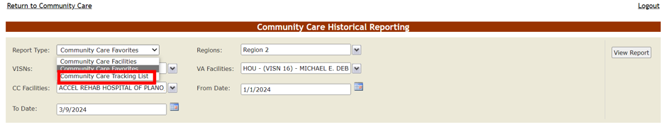

If needed, update the Regions, VISNs and VA Facilities selections. Then from the CC Facilities field, select the Not Applicable.

Figure 131 - Community Care Historical Reporting Not Applicable Selection
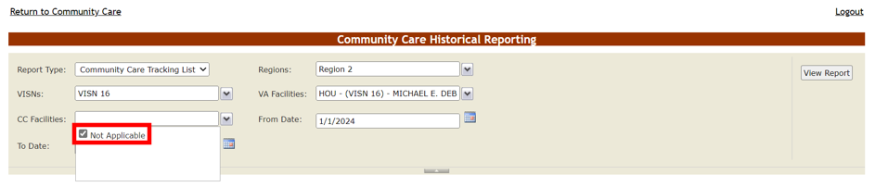

Click away from the CC Facilities field then update the From Date and To Date values, based on the CCTL activity date range. Then press the View Report button on the right-hand side of the screen to run the report:

Figure 132 - Community Care Tracking List Report Type Results

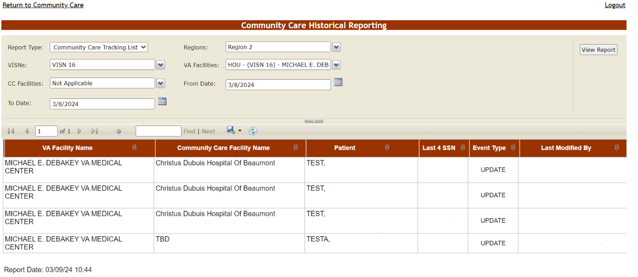
Scrolling to the bottom of the screen reveals a horizontal scroll bar which you can scroll to the right, to see all the report columns.

Figure 133 - Community Care Tracking List Report Type Scroll Bars
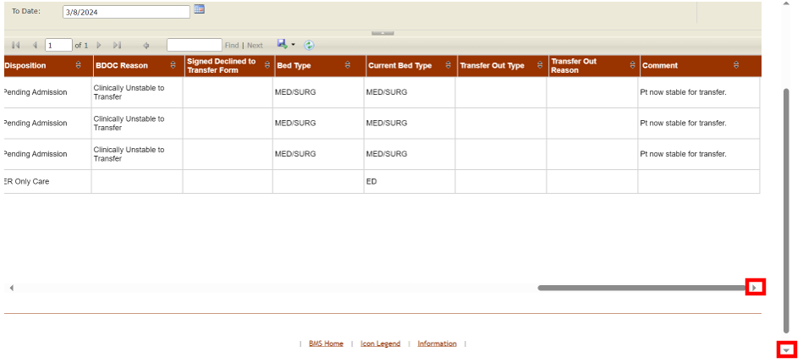

Below are descriptions of the Community Care Tracking List report type selections and columns:

Table 24 - Community Care Historical Reporting – Community Care Tracking List selections
COLUMN | DESCRIPTION
Report Type: | The specific Community Care Historical Reporting report type.
Regions: | The VA geographical region(s) whose VAMC(s) the BMS User running this report has access to.
VISNs: | The Veteran Integrated Service Network(s) whose VAMC(s) the BMS User running this report has access to.
VA Facilities: | The VAMC(s) the BMS User running this report has access to.
CC Facilities: | NOT APPLICABLE
From Date: | The start date range when the selected CCTL activity took place.  NOTE: this date is technically when the history database was updated, which is usually a few minutes after the CCTL record was created, updated or removed.
To Date: | The end date range when the selected CCTL activity took place.  NOTE: this date is technically when the history database was updated, which is usually a few minutes after the CCTL record was created, updated or removed.

Table 25 - Community Care Tracking List Report Type Columns
COLUMN | DESCRIPTION
VA Facility Name | The VAMC associated with the CCTL record.
Community Care Facility Name | The name of the community facility tied to the CCTL record.
Patient | The Veteran associated with the CCTL record.
Last 4 SSN | The Veteran’s Last Initial and Last 4 SSN.
Event Type | Whether the CCTL record has been created (“INSERT”), updated (“UPDATE”) or deleted (“DELETE”).
Last Modified By | The BMS login that added, updated or deleted the CCTL record.
Last Modified Date | The Date/Time the CCTL record was added, updated or deleted.
Is Active | Whether or not the patient was currently active on the CCTL at the time of historical activity.
Presenting Problem | The reason why the Veteran presented for care/treatment in the community.
CC Arrival Date | The Veteran's date of presentation at the Community Facility, including Hour (H) and Minute (M).
CC Admission Date | The date the Veteran was admitted to the Community Facility, including Hour (H) and Minute (M).
CC Discharge Date | The date the Veteran was discharged from the Community Facility, including Hour (H) and Minute (M).
CC Removal Date | The date and time when the CCTL record was removed (“inactivated”).
Removal Disposition | The disposition type selected when removing (“inactivating’) the CCTL record.
Emergency Dept. | Did the Veteran present at the Community Facility through the Emergency Department (ED)?
Admitted | Whether or not the Veteran has been admitted to the Community Facility.
COVID | Is the Veteran currently positive for COVID?
Isolation | Does the Veteran require isolation?
Critical | Is the Veteran in critical condition?
Service Not Offered | The service not available within VA.
Authorization Status | The eligibility for payment of Veteran community care.
Disposition | The disposition type associated with the Veteran.
BDOC Reason | The reason (Bed Days of Care) why the Veteran has not been repatriated.
Signed Declined to Transfer Form Status | The status of the Veteran's signed 10-8001 (Refusal of Transfer to VA Medical Facility) form.
Bed Type | The type of VA bed needed.
Current Bed Type | The community bed type in use by the Veteran.
Transfer Out Type | The transfer type associated with the Veteran.
Transfer Out Reason | The reason for VA sending the Veteran to the Community Facility.
Comment | A free text field for entering information such as handoff or clinician notes once the Veteran is repatriated to VA, or care coordination notes and medical record request dates.

National and Support Users
National and Support Users have access to the following report:
- Facilities to Reactivate

National and Support Users automatically inherit the Community Care User, Community Care Transfer User and Community Care Admin roles’ permissions, including access to reporting. For information on Community Care Tracking List usage in general, see the previous Community Care Users, Community Care Transfer Users and Community Care Admins sections of this guide.

Facilities to Reactivate Report
The Facilities to Reactivate report lets National and Support users reactivate deleted Community Care facilities, whether deleted on the local VAMC level or nationwide.
To run the report, from the CCTL choose Facilities to Reactivate from the Select Report menu, then press the Submit button on the right-hand side of the screen.
Figure 134 - Facilities to Reactivate Report and Submit Button
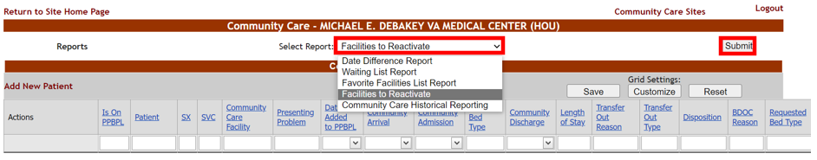
For information on removing CC Facilities manually, see the Editing and Removing Community Care Facilities Manually section of the BMS User Setup and Admin Guide located within the VA Software Document Library.

National Report Type
To view and potentially reactivate any Community Care Facilities inactive across all VAMCs, choose National from the Report Type drop-down arrow:
Figure 135 - Facilities to Reactivate Report Type Menu
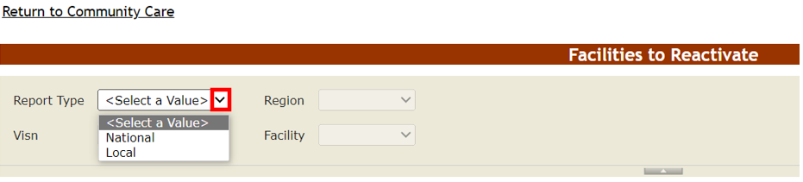

Figure 136 - National Report Type and View Report Button
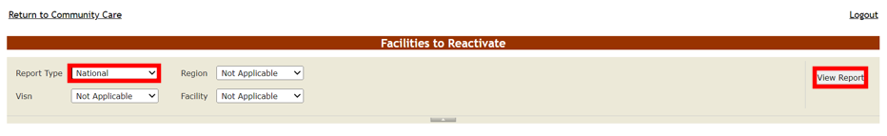

After pressing View Report, you will see a list of all CC Facility records inactive across all VAMCs.
Note that many of these facilities were made inactive automatically through the PPMS background processor, since Name values from Provider Profile Management System (PPMS) can sometimes be invalid.
Figure 137 - Facilities to Reactivate National Report Type Results
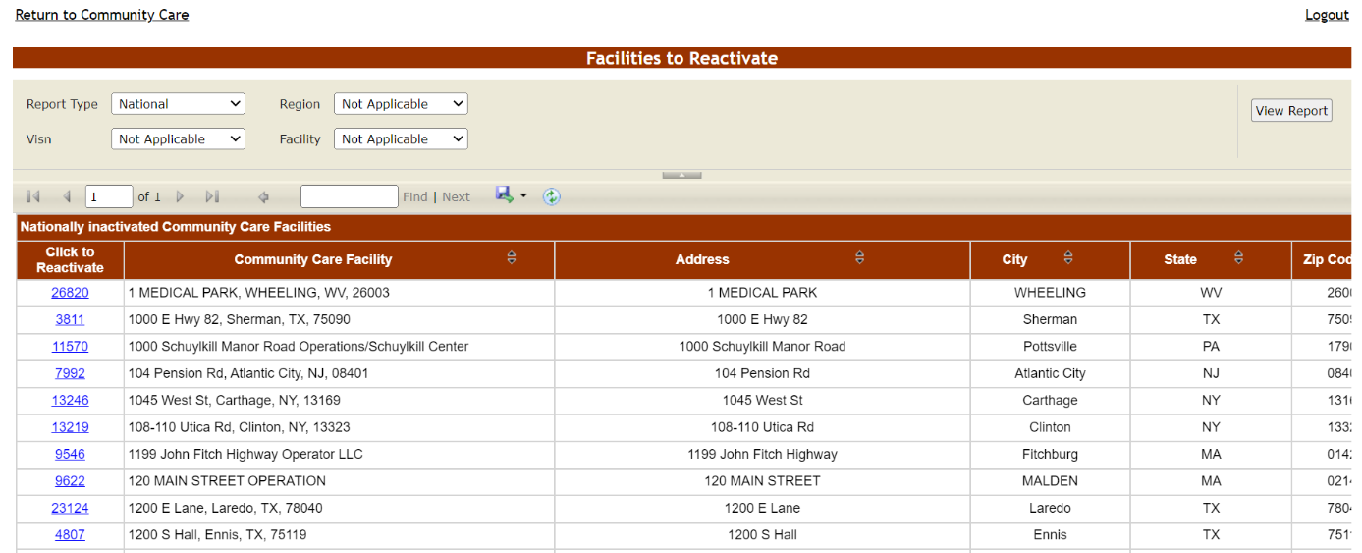

To make a CC facility active again, select the database ID within the Click to Reactivate column.
Figure 138 - Click to Reactivate Link

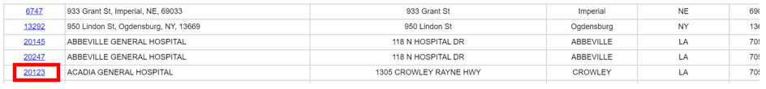

Upon selecting the database ID for the CC facility you wish to reactivate nationally, a “You have successfully reactivated the Community Care Facility. All VAMCs connected to this facility can now select it as a favorite.” confirmation message will appear:
Figure 139 - Facilities to Reactivate Confirmation Message
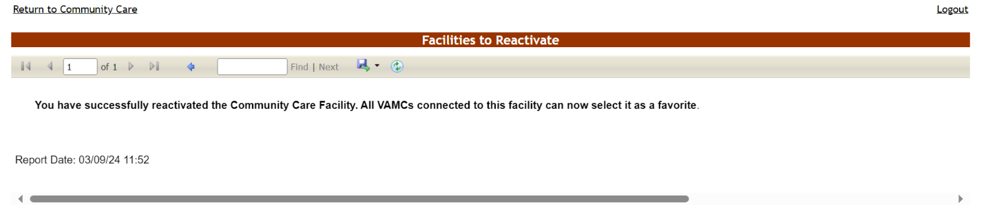

Click on the Return to Community Care link to navigate back to the main Community Care Tracking List screen.

Local Report Type
To view and potentially reactivate any Community Care Facilities inactive for specific VAMCs, choose Local from the Facilities to Reactivate report’s Report Type drop-down arrow:
Figure 140 - Local Report Type Selection
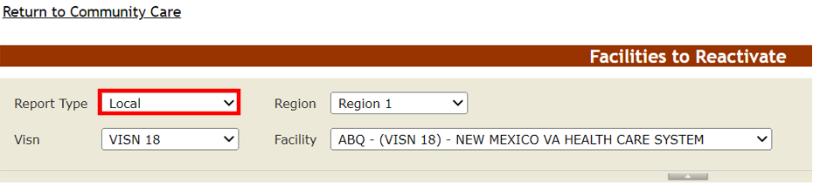

From the Region field, select the Region whose CC Facilities you wish to reactivate.

Figure 141 - Facilities to Reactivate – Region Selection
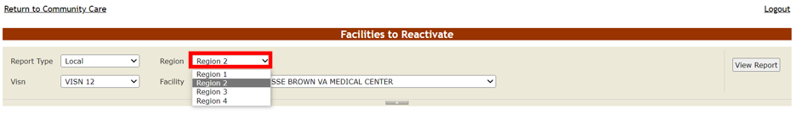

Based on the selected Region, Drill-down further by selecting the VISN and VA Facility whose CC Facilities you wish to reactivate.

Figure 142 - Facilities to Reactivate - Visn and Facility Selections
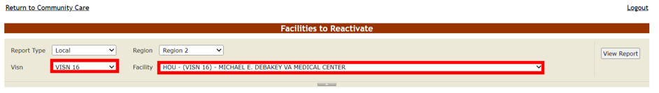

Now press the View Report button on the right-hand side of the screen to run the report. A list of inactive CC Facilities for the selected VAMC will appear.

Figure 143 - Facilities to Reactivate Local Results
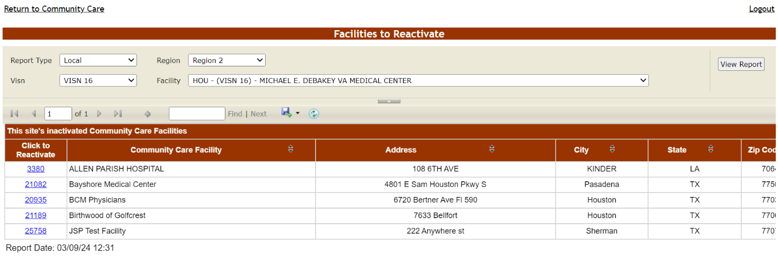

To make a CC facility active again for this VAMC, select the database ID within the Click to Reactivate column.
Figure 144 - Click to Reactivate Link

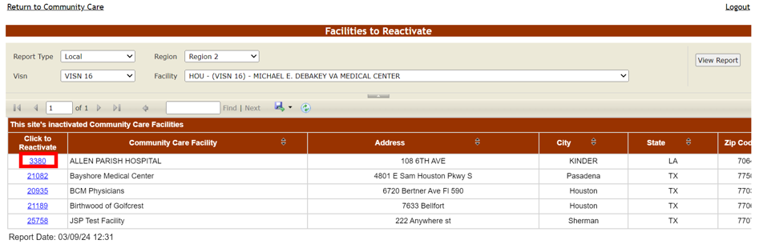

Upon selecting the database ID for the CC facility you wish to reactivate locally, a “You have successfully reactivated the Community Care Facility. This VAMC can now select it as a favorite.” confirmation message will appear:
Figure 145 - Facilities to Reactivate Confirmation Message
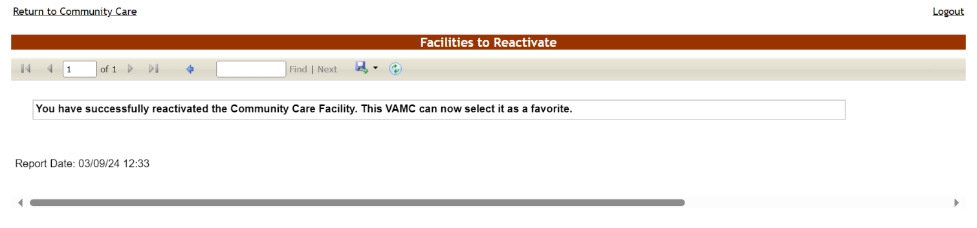

Facilities associated with this VAMC that were inactivated nationally also appear in the report results. If you attempt to reactivate one of these nationally inactivated facilities using the Local report type, a “The Community Care Facility must be active at the National Level in order to activate it locally.” message appears. Use the National report type to inactivate the CC Facility in question.

Figure 146 - Facilities to Reactivate National Level Required Error Message
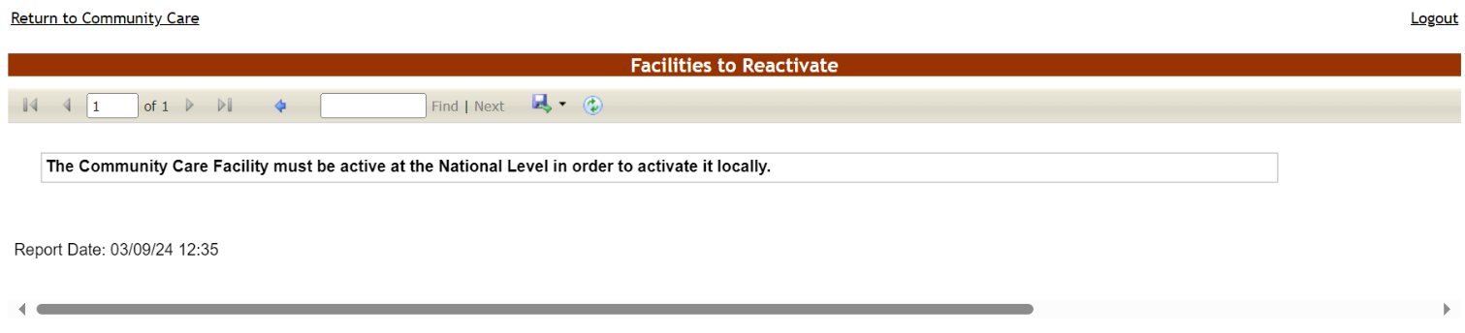

Click on the Return to Community Care link to navigate back to the main Community Care Tracking List screen.

Below are descriptions of the Facilities to Reactivate report selections and columns:
Table 26 - Facilities to Reactivate Report Selections
COLUMN | DESCRIPTION
Report Type | Whether the CC Facilities have been inactivated across all VAMCs (“National”) or for a specific VAMC (“Local”).
Region | The geographic region of the VA Facility associated with the inactive CC Facility.
Visn | The VISN of the VA Facility associated with the inactive CC Facility.
Facility | The VA Facility associated with the inactive CC Facility.

Table 27 - Facilities to Reactivate report columns
COLUMN | DESCRIPTION
Click to Reactivate | The database ID of the inactive CC facility.
Community Care Facility | The name of the Community Facility.
Address | The physical address of the Community Facility.
City | The city where the Community Facility is located.
State | The state where the Community Facility is located.
Zip Code | The zip code of the Community Facility.
NPI | The National Provider Identifier number of the Community Facility.
Created Date (UTC) | The Date/Time when the CC Facility record was created.
Created By | The BMS login that created the CC Facility. If created by the PPMS background processor, “BMS Data Collection” will display.
Last Modified Date (UTC) | The Date/Time when the CC Facility record was last modified.
Last Modified By | The BMS login that last edited the CC Facility.

