# 

# 

**Bed Management Solution (BMS)**

**Technical Manual**

**

**Version 4.0**

**June 2024**

**Department of Veterans Affairs**

**Office of Information and Technology (OIT)**

### Revision History

| **Creation Date** | **Version/Patch No.** | **Description/Comments** | **Author(s)** |
| --- | --- | --- | --- |
| 06/2024 | 4.2 | Updated for BMS patch version 4.2.  The following sections were updated:   * Title Page – Version number * Page Footer – Version number   Note: Version/Patch No. (example: “4.2”) in this document’s Revision History table will represent the specific patch for a version of BMS. | Booz Allen Hamilton |
| 05/2024 | 4.1 | Updated for BMS version 4.1.  The following section was added:   * **PPMS Parameters**   The following table was added:   * **Table 4: GFE Requirements** | Booz Allen Hamilton |
| 01/2024 | 3.8 | Updated for BMS version 3.8.  The following section was updated:   * **7.3** BMS Roles   The following table was updated:   * **Table 3:** Database Server * **Table 13**: BMS Website Files   The following figure was updated:   * **Figure 46**: AuthRoles Table | Booz Allen Hamilton |
| 8/2023 | 3.4 | Updated for BMS version 3.4. The following table was updated:   * **Table 4:** Web Configuration Parameters | Booz Allen Hamilton |
| 6/2023 | 3.7 | Updated for BMS version 3.7. The following figures were updated:   * **Figure 33:** Adding a VistA Site * **Figure 35:** VistA Integration Tab * **Figure 36:** Audit Tab * **Figure 37:** View Audit Results * **Figure 43:** Security Services Architecture (removed)   The following Tables were updated:   * **Table 4**: Updated rows to reflect current configuration parameters * **Table 10**:Removed rows related to Method * **Table 14:** Updated configuration parameters * **Table 16:** Updated acronyms   The following sections were updated:   * 2.7 Removed references to Method for adding VistA site. | Booz Allen Hamilton |
| 04/2023 | 3.10 | -Updated SQL server and service account information in sections 2.1-2.2  - Updated Table 1, Table 2, and Table 3 required hardware  -Updated Contingency Report Setup  -Corrected formatting on Figures throughout manual | Booz Allen Hamilton |
| 03/2023 | 3.3.4 | -Removed BMS.VI.ServiceHost.exe.config and BMS.ServiceHostexe.config references  -Addition of Figure 44- Database Architecture Diagram  -Removed “Stop Microsoft Lync from opening at startup (2.5.3.3)  -Removed section 3.1 Inflow Architectural Removal as well as Figure 45 and Figure 46  -Addition of Figure 58- Class Diagram for Data Contracts in PAP and PDP  -Added “External Relationships” to “External Interfaces” Section and deleted Section 5.  -Updated screenshots and processes to reflect Windows 10  -Removed three unused log files from BMS Log Files  -Updated webconfig parameters/keys  -Updated service files  -Removed references to cache services  -Updated Figure 46 to reflect current verbiage | Booz Allen Hamilton |
| 3/2022 | 2.10 | Updated for Inflow’s EIS database replacement | Liberty IT Solutions |
|  | 2.9 | Updated for Inflow’s EVS database replacement | Liberty IT Solutions |
| 5/1/2021 | 2.8 | Updated for replacement of Inflow’s AUTHZ database | Liberty IT Solutions |
| 12/10/2020 | 2.4.3 | Updated/added several Policy Manager definitions; several reports listings were missing/incorrect | Liberty IT Solutions |
| 10/15/2020 | 2.4.2 | Updated the list of file listings for Web, DB, and App servers | Liberty IT Solutions |
| 07/01/2020 | 2.4.1 | Changed the Revision History to follow BMS Application versioning. Updated for Version 2.4.1 in document. | Redacted |
| 01/13/2020 | 0.12 | Updated for Version 2.4: Minor editing changes to format. Updated release dates on title page and footer. | Redacted |
| 4/23/2019 – 07/24/2019 | 0.11 | Updated document for BMS v2.3.1: Updates to Figure Diagrams to reflect current BMS is using VIA not MDWS, updated parameter tables to include VIA parameters, updated, new service account user to reflect new service account for new server migration. | Redacted |
| 12/19/2016 | 0.10 | Updated for BMS 2.1 merge of VAE MDWS–VIA migration | Redacted |
| 11/29/2016 | 0.9 | Updated for December 2016 Release, added section “CA SiteMinder Web Agent” installation | Redacted |
| 11/2/2016 | 0.8 | Updated document for Public VDA Portal, 508 compliance and removed real servernames and url addresses. | Redacted |
| 8/5/2016 | 0.7 | Updated document for BMS v2.0: Updates to Figure 1 Diagram, SQL Server version, ASP.NET, MVC. | Redacted |
| 3/4/2016 | 0.6 | Removed real URL and server addresses and replaced them with generic address names throughout the document | Redacted |
| 7/15/2015 | 0.5 | Final team review | Redacted |
| 06/05/2015 | 0.5 | Technical edit. Fix issues with table of tables and table of figures. | Redacted |
| 6/05/2015 | 0.5 | Updated the following sections:  2.2 System Requirements  2.3 Configuration Parameters  2.4 Scheduled Windows and SQL Jobs Configuration  2.4.1 BMS Reports Full  2.4.2 BMS Incremental  2.4.3 BMS Reports WMI  2.5 Ward Whiteboard Kiosk Setup  2.6 Whiteboard Snapshot Configuration  2.7 EMS Mobile Defice Configuration  2.9 NUMI Integration  3.3 Database Architecture  3.4 Component Files  7 Software Security | Redacted |
| 07/17/2013 | 0.4 | Updated section 2.3 Configuration Parameters, updated section 2.5 Whiteboard Kiosk Mode, updated section 2.7 EMS Mobile Device Configuration, added Appendix 9.5, | Redacted |
| 07/29/2013 | 0.3 | Updated section 2.8.1.1 to include the MDWS Endpoint. | Redacted |
| 10/07/2013 | 0.2 | Updated section 2.2 with service account information, Renamed and Updated section 2.6.3, Added a note to section 2.6.4, added log files to section 8. | Redacted |
| 06/12/2013 | 0.1 | Initial baseline. | Redacted |

### 

**Table of Contents**

Revision History ii

List of Tables 10

List of Figures 11

1 Introduction 13

1.1 Purpose 13

1.2 BMS Overview 13

1.3 References 14

2 Implementation and Maintenance 15

2.1 BMS Infrastructure Diagram 15

2.2 System Requirements (Hardware and Software) 16

2.3 Configuration Parameters 18

2.4 Ward Whiteboard Kiosk Mode Display Configuration (BMS Whiteboard Kiosk Setup) 20

2.4.1 Create the Ward Whiteboard Kiosk URL 21

2.4.3 Set up the Workstation / Kiosk Machine 25

2.5 Bed Management Solution Contingency Report Setup 35

2.5.1 Create Snapshot Folder 35

2.5.2 Define Network Share 35

2.5.3 Assign Rights to Master BMS Service Account User 38

2.5.4 Assign Snapshot Folder Path to Ward Group 40

2.5.5 Associate Scheduler with Whiteboard Report 41

2.6 EMS Mobile Device Configuration 41

2.6.1 Configure EMS Mobile Device Default Login User 42

2.6.2 Configure EMS Mobile Device URL 43

2.7 VistA Integration 44

2.7.1 Choose VistA Site 44

2.7.3 Define Schedulers 45

2.7.4 Run Scheduler 46

2.7.5 View Audit Results 47

2.8 NUMI Integration 48

2.8.1 Integration Settings 49

2.8.2 Choose VistA Site 49

2.8.3 Define Schedulers 49

2.8.4 Select Scheduler 49

3 Application structure 52

3.1 Application Components 52

3.2 Application Directory Structure 52

3.3 Database Architecture 52

3.4 Component Files 53

4 Archiving 66

5 External Interfaces 67

6 Software Security 69

6.1 Authorization and Authentication 70

6.2 BMS AuthAction table 70

6.3 BMS AuthPermissions table 71

6.4 BMS AuthRoles table 71

6.5 BMS AuthRoleActions 72

6.6 BMS AuthUser table 72

6.7 BMS AuthUserRoles table 73

6.8 BMS AuthActions Listing 73

6.9 Business scenarios and use cases 84

7 Detailed Functional Model on Each Interface 87

7.1 BMS Authentication and Authorization 87

7.1.1 Authentication 87

7.1.2 Authorization 87

7.2 Data contracts 88

7.3 BMS Roles 88

8 Troubleshooting 90

8.1 Symptom 1 90

8.2 Symptom 2 90

8.3 Symptom 3 91

8.4 Symptom 4 91

9 Appendix A – BMS Diagrams 93

9.1 Business Process Diagrams 93

9.2 Activity Diagram 98

9.3 Functional Flow Diagram 99

9.4 Data Flow Diagram 100

9.5 Application Flow Map from APPDYNAMICS 101

10 Appendix B - Terms, Acronyms, and Abbreviations 102

### List of Tables

Table 1-Server for Web Applications 16

Table 2-Application Server 16

Table 3-Database Server 17

Table 4-GFE Requirements 17

Table 5-BMS Web Configuration Parameters 18

Table 6-Ward Whiteboard URL Configuration Parameters 22

Table 7-Facility Settings Page Parameters 42

Table 8-BMS Admin Page Parameters 43

Table 9-Description and Configuration for EMS Mobile Device URL Parameters 44

Table 10-New Scheduler Parameters 46

Table 11-View Audit Results Columns Report 48

Table 12-PPMS Parameters 51

Table 13-BMS Database Files 53

Table 14-BMS Service Files 54

Table 15-BMS Website Files 56

Table 16-Configuration Values 67

Table 17-BMS Operations 73

Table 18-Terms, Acronyms, and Abbreviations 102

### 

### List of Figures

Figure 1-BMS Infrastructure Diagram 15

Figure 2- BMS Ward Whiteboard Screen 20

Figure 3- Facility Settings 24

Figure 4-Whiteboard Kiosk User Role Assignment 25

Figure 5-Screen Saver Option 26

Figure 6-Screen Saver Settings Window 26

Figure 7-System and Security 27

Figure 8- Power Options Settings 28

Figure 9- Change Plan Settings Option 28

Figure 10- Run Window 29

Figure 11- Run Window with Command Entered 29

Figure 12- User Accounts Window 30

Figure 13- User Accounts 30

Figure 14- Settings of Microsoft Edge 31

Figure 15- When Edge Starts 32

Figure 16- Open Option 33

Figure 17- Microsoft Edge Selected 33

Figure 18-Windows Registry Editor 34

Figure 19- Whiteboard Snapshot Folder 35

Figure 20- Whiteboard Snapshot Folder Properties 36

Figure 21- Advanced Sharing Option 36

Figure 22- Share this Folder Option 37

Figure 23- Verify Network Path 37

Figure 24- Permissions for Whiteboard Snapshot 38

Figure 25- Permissions for Whiteboard Snapshot 39

Figure 26- Select Users 39

Figure 27- Remote Desktop Users Properties 40

Figure 28- Contingency Settings Page 41

Figure 29- Add Scheduler for Background Processors 41

Figure 30 - EMS Fields Filled on the Facility Settings Page 42

Figure 31-EMS Fields Filled on the BMS Admin Page 43

Figure 32-EMS Staff Page for Mobile Devices 44

Figure 33-Adding a VistA Site 45

Figure 34-Schedulers Tab 46

Figure 35-VistA Integration Tab 47

Figure 36- Audit Tab 47

Figure 37- View Audit Results 48

Figure 38-NUMI Tab 50

Figure 39- Selecting the VistA Site for NUMI data 50

Figure 40-PPMS page 51

Figure 41-Database Architecture 53

Figure 42-Backup Maintenance Plan 66

Figure 43-BMS External Interfaces 67

Figure 44- New tables added to BMS database for Policy Manager Replacement 70

Figure 45- AuthAction table 71

Figure 46- AuthPermissions table 71

Figure 47- AuthRoles table 72

Figure 48- AuthRoleActions table 72

Figure 49- AuthUser table 73

Figure 50- AuthUserRoles table 73

Figure 51- Authentication Use Cases 84

Figure 52- Authorization Use Cases 84

Figure 53- Authorization Administration Use Cases 85

Figure 54- Class Diagram for Data Contracts in PAP and PDP 88

Figure 55- 500 Server Error 90

Figure 56- Unhandled Exception 90

Figure 57- EMS Bed Status Report is Missing 91

Figure 58- Report Cannot be Found 92

Figure 59- Admit Patient to PPBP Business Process 93

Figure 60- Transfer Patients to PPBP Business Process 93

Figure 61- Display and Update PPBP Business Process 94

Figure 62- Display and Update Bed Status Business Process 94

Figure 63- Manage Bed Cleaning Business Process 95

Figure 64- Create Notification Business Process 95

Figure 65- Create Facility Diversion Business Process 96

Figure 66- Manage Whiteboard Business Process 96

Figure 67- Reports Business Process 97

Figure 68- BMS Overview Activity Diagram 98

Figure 69- BMS Overview Functional Flow Diagram 99

Figure 70- BMS Overview Data Flow Diagram 100

Figure 71- Application Flow map from APPDYNAMICS 101

# Introduction

## Purpose

This document is designed to provide sufficient technical information about the Bed Management Solution (BMS) application to the developers and Information Resources Management (IRM) technical personnel to operate and maintain the software.

## BMS Overview

BMS is a real-time, user-friendly Web-based Veterans Health Information Systems and Technology Architecture (VistA) interface for tracking patient movement, bed status and bed availability. It provides performance information that can be used to improve patient flow within, and between, VA Medical Centers (VAMCs).

BMS allows administrative and clinical staff to record, manage and report on the planning, patient- movement, patient occupancy, and other activities related to management of beds. All patient admission, discharge, and transfer movements are sent directly from VistA to BMS.

BMS offers the following features:

* + - Tracks patient movement through the system;
    - Displays patient and bed occupancy status for all beds in the facility and/or Veterans Integrated Service Networks (VISN);
    - Provides visibility of bed availability within VAMCs to support emergency management;
    - Automates request and assignment of beds;
    - Displays and facilitates timely discharge appointments;
    - Supports and facilitates efficient flow operations and is a catalyst to process improvement and best practices;
    - Provides reports on performance measures associated with bed management and patient flow. BMS provides answers to the following questions:
      * + How many beds do we have?
      * How many empty beds do we have?
      * How many available female beds do we have?
      * How many beds are out of service and why?
      * How long does it take to clean a bed?
      * How many patients are waiting for beds in community hospitals?
      * How many admissions, transfers, and discharges did my unit have yesterday?
      * How many discharges will we have tomorrow?
      * How many scheduled admissions do we have for today?

## References

Requirements Specification Document (CLIN: 0002AA; title: Requirements Specification Document; file: Init8_BMS_RSD)

System Design Document; file: BMS_SDD)

# Implementation and Maintenance

## BMS Infrastructure Diagram

The BMS application has a list of physical components that can be divided on more physical servers according with their roles.

The following diagram represents a possible schema of physical deployment.

Figure -BMS Infrastructure Diagram

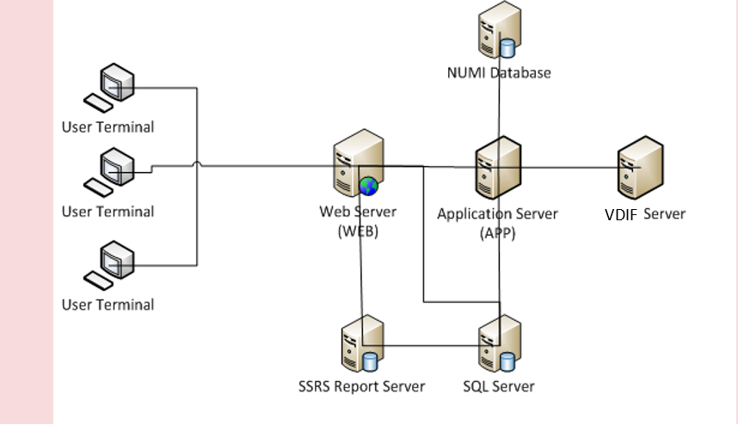

BMS is divided into specific components:

1. Persistence layer: SQL Server 2019 Enterprise database
2. Application server layer: Windows Communication Foundation (WCF) Web Services installed as Windows Services
3. Web server layer: Active Server Pages (ASP) .NET Model-View-Controller (MVC) Web application hosted in Internet Information Services (IIS)
4. Data Exchange Servers:
   1. National Utilization Management Integration (NUMI) SQL Server Database
   2. VistA integration servers (servers that have access to VistA)
5. Client Layer: Web Application client launched from browsers

## System Requirements (Hardware and Software)

BMS requires the creation of a Master Windows Service Account User and numerous facility/Site Service Account Users for execution and operations.

All the BMS Application Services run under a service account.

* + - AITC has created the Windows User (aac\OITAUSBMSPRD) as the master service account that the four BMS Services run under. This can be referred to as the Master BMS Service Account.
    - The <SERVERADDRESS>240 server hosts the BMS.BedManagerService service application.
    - The <ServerAddress>241 server hosts the BMS.VI.ServiceHost service application.

All BMS Facilities/Sites require at least one service account for certain site functionality.

* + - This service account will run the EMS Mobile Page and Whiteboard Kiosk Page functions.
    - Under BMS version 1.xx a single service account can be used for both functions.
    - The service account that runs the EMS Mobile Page and Whiteboard Kiosk Page functions must not have any Policies assigned that restrict its use to specific computers.

BMS minimum hardware and software requirements are presented below:

Table -Server for Web Applications

|  |  |
| --- | --- |
| Basic software: | Microsoft Windows Server 2019 64 bit Standard  IIS 10 ASP.NET MVC5  .NET Framework 4.7.2 |
| Application software: | Dashboards web application |
| Processor(s): | 24 x Intel Xeon E52698v4 or equivalent |
| Memory: | 64 GB |
| Hard disks: | 345 GB |
| Network controller: | Broadcom NetXtreme Gigabit Ethernet, or equivalent |

Table -Application Server

|  |  |
| --- | --- |
| **Server 1** | |
| **Basic software:** | Microsoft Windows Server 2019 64 bit Standard  .NET Framework 4.7.2 |
| **Application software:** | BMS |
| **Processor(s):** | 12 x Intel Xeon E52698v4 or equivalent |
| **Memory:** | 96 GB |
| **Hard disks:** | 280 GB |
| **Network controller:** | Broadcom NetXtreme Gigabit Ethernet, or equivalent |
| **Server 2** | |
| **Basic software:** | Microsoft Windows Server 2019 64 bit Standard  .NET Framework 4.7.2 |
| **Application software:** | BMS |
| **Processor(s):** | 20 x Intel Xeon E52698v4 or equivalent |
| **Memory:** | 64 GB |
| **Hard disks:** | 280 GB |
| **Network controller:** | Broadcom NetXtreme Gigabit Ethernet, or equivalent |

Table -Database Server

|  |  |
| --- | --- |
| **Basic software:** | Microsoft Windows Server 2019 64 bit Standard Microsoft SQL Server 2019 Enterprise  .NET Framework 4.7.2  .NET 6.x – Required to run PPMS Community Care data collection tool from server command prompt |
| **Application software:** | Databases used by the services installed on APP |
| **Processor(s):** | 40 x Intel Xeon E52698v4 or equivalent |
| **Memory:** | 320 GB |
| **Hard disks:** | 2620 GB |
| **Network controller:** | Broadcom NetXtreme Gigabit Ethernet, or equivalent |

Table -GFE Requirements

|  |  |  |  |
| --- | --- | --- | --- |
| Hardware/Software | Component | Minimum requirement | Recommended requirement |
| Hardware | Memory | >=1 GB RAM | >= 2 GB RAM |
| Hardware | CPU | 1.6 GHz | >= 2.8 GHz dual core |
| Hardware | HDD | 40GB | >= SATA 60GB |
| Hardware | Networking | 100 Mbps | 1000 Mbps |
| Hardware | Video | Integrated video card, minimal supported resolution - 1024x768 | Dedicated video card, minimal supported resolution - 1280x800 |
| Hardware | Monitor | 17-inch LCD, CRT | 19-20-inch LCD |
| Hardware | UPS | N/A | 650VA |
| Hardware | Printer ports | LPT or USB for LaserJet or InkJet | LPT or USB for LaserJet or InkJet |
| Hardware | USB ports | N/A | 2 x USB 2.0 |
| Software | Browser | Microsoft Edge (site compatibility turned off) / Firefox 7  Java script enabled | Microsoft Edge (site compatibility turned off) / Firefox (latest version) / Chrome (latest version)  Java script enabled |

## Configuration Parameters

This section describes configuration parameters of the BMS application.

Table 5-BMS Web Configuration Parameters

| **File** | **Section** | **Configuration key** | **Configuration values (ex.)** | **Description** |
| --- | --- | --- | --- | --- |
| Web.config | configuration/ appSettings/ | webpages:Version | 1.0.0.0 | Version of the web site. |
| ClientValidationEnabled | true/false | Gets or sets a value that indicates whether client-side validation is enabled. |
|  | IsWeb | True/false | Indicates if running application is web app |
| key | UnobtrusiveJavaScriptEnabled | true/false | Gets or sets a value that indicates whether unobtrusive JavaScript is  enabled. |
|  | ReportsPath | /BMS | Path of the reports in the reporting services. |
|  | VAURL | <http://vaww.esm.infoshare.va.gov/> PMIC/Projects/BMS/  Implement/default.aspx | BMS Sharepoint Site. |
|  | TICKETURL | <http://vaww.esm.infoshare.va.gov/> PMIC/Projects/BMS/ Implement/HDProcess/  default.aspx | Enter a defect and enhancement ticket. |
|  | WhiteboardRefreshRate | 60 | Time in seconds of refresh rate of the whiteboard page. |
|  | THRESHOLD | 0 | Threshold value used to compare wait time value of the patient, from the Patients Pending Placement List, in order to display an alert on the Patients Pending Placement List. |
|  | aspnet:MaxHttpCollectionKeys | 2000 | Maximum number of aps.net collection keys. |
|  | WhiteboardAjaxRefreshRate | 180 | Time in seconds of AJAX refresh rate of the whiteboard page. |
|  | WhiteboardRealRefreshRate | 60 | Time in minutes of standard refresh rate of the whiteboard page. |
|  | HomePageRefreshRate | 300 | Time in seconds of refresh rate of the home page. |
|  | SmtpHost | VA_MAIL_SERVER | Mail Server host. |
|  | DisplayDetailedErrorMessage | true/false | If set to true displays detailed error message, otherwise displays a generic  message (“Please contact BMS  administrator.”). |
|  |  | Is_IIS_Single_Instance | true/false | If set to true a single IIS instance is used. If set to false multiple IIS instances are  used (web farm scenario). |
|  |  | ProxyPoolMaxCount | 100 | The maximum number of proxies in the pool. |
|  |  | EnableDevExpressContextMenu | true/false | if true, the DevExpress right-click functionality is enabled |
|  | configuration/syste m.serviceModel/ client/endpoint  configuration/syste m.serviceModel/  client/endpoint  configuration/syste m.serviceModel/  client/endpoint  configuration/syste m.serviceModel/  client/endpoint  configuration/syste m.serviceModel/  client/endpoint | address | http://*vaserver*:*17050*/ BMSConfigurationOperations | BMS ConfigurationOperations client endpoint address. |
|  | address | http://*vaserver*:*17050*/ BMSConfigurationOperations | BMS ConfigurationOperations Windows authentication client endpoint address. |
|  | address | http://*vaserver*:*17050*/ BMSQuery | BMS Query client endpoint address. |
|  | address | http://*vaserver*:*17050*/ BMSOperations | BMS Operations client endpoint address. |
|  | address | http://*vaserver*:*17050*/ VistaQuery | VistA Query client endpoint address. |

## 

## Ward Whiteboard Kiosk Mode Display Configuration (BMS Whiteboard Kiosk Setup)

An electronic kiosk (or computer kiosk) houses a computer terminal designed to function while preventing users from accessing system functions. BMS has adopted the use of electronic kiosks to provide sites with the capability to setup Large Screen Displays for the BMS Ward Whiteboard for greater visibility. The Whiteboard Kiosk is a read only access page. It presents an overview of the beds in the current facility (or in the selected ward) and allows the user to assess at a glance the bed availability in their facility (or ward). Kiosk mode locks down the user interface to protect applications from accidental or deliberate misuse. These displays should be placed carefully, considering that confidential patient data (Social Security Number) should not be in view of people who are not authorized to see it.

Figure - BMS Ward Whiteboard Screen

Graphical user interface showing what the BMS white board screen appears as. It is 10 columns across and 10 rows long. 



Setting up for the BMS Whiteboard Kiosk involves a series of steps that most often are performed by IT staff with access to Local Site network configuration and/or staff with authority to request the required Local Site and Active Directory (AD) network configuration changes.

Steps for configuring the BMS Whiteboard Kiosk can be divided into three major categories:

* The Ward Whiteboard Kiosk URL
* The Network User for BMS Kiosk Access
* The Kiosk Workstation for Local Site Use

Each category involves a series of required steps to ensure successful operation of the Kiosk. Following is an outline of the process to setup and configure the BMS Whiteboard Kiosk for a local site.

* *Create the Ward Whiteboard Kiosk URL. See details in* *2.4.1 Create the Ward Whiteboard Kiosk URL*
  + - Determine the BMS Whiteboard Parameters for Kiosk Operation and Setup
    - Test the URL in a browser
  + *Set up a default user for the kiosk. See details in* *2.4.2 Set up a default user for the BMS Kiosk*
    - Set up the Network User for BMS Access
    - Configure the Whiteboard Kiosk Default Login User in BMS
    - Assign a Role to the Whiteboard Kiosk Default User in BMS
  + *Set up the Workstation / Kiosk Machine. See details in* *2.4.3 Set up the Workstation / Kiosk Machine*
    - Disable the Screen Saver
    - Configure the Power Settings to Disable Sleep and Standby Mode
    - Configure Auto Log in Option
    - Set the URL as the Home Page in Microsoft Edge
    - Add <https://vaww.bms.va.gov> to “Trusted Sites” in Microsoft Edge
    - Add to the start-up commands (Windows) the launch of the browser
    - Close ME, and restart to test
    - Set Registry Keys to configure Kiosk for local Site use

### 2.4.1 Create the Ward Whiteboard Kiosk URL

The Ward Whiteboard display uses parameters to determine the behavior of the display. For example, the whiteboard can display a specific ward or ALL wards for a site by setting the parameter **wardName**. Below is a description for each whiteboard display parameter along with available options for each.

Table -Ward Whiteboard URL Configuration Parameters

| **Parameter** | **Short Description** | **Options** |
| --- | --- | --- |
| facilityCode | Code of facility (e.g., BROCKTON = BRK). | Enter the 3 character facility ID. |
| wardName | Name of BMS Ward Name. To see all the wards the value that needs to be configured is ALL. | These are the BMS WARDS as defined in the Facility, Site Options, VistA Ward Add/Edit. The Ward name value should match the "BMS WARD GROUP TEXT". A single ward can be entered or the value "ALL" to display all the wards at the facility. |
| splitScreen | To split the page in two tables enters the value "Yes". | Yes No |
| displayPTCode | How the patient should be displayed under the column "Patient" (full name or 1st+Last 4) or LastName. **LastName is required for Kiosk mode due to Privacy regulations.** | FirstAndLast4 **LastName** |
| genderColorCode | To change the background color for the row according with patient’s gender. | Blue/Pink None |
| displayFooterCensus | To view the footer census. | Yes No |
| displayStaffAttending | What column is displayed in the table? (Staff column, Attending column or both). | Staff and Attending Staff  Attending |
| scrollRate | The timer interval will affect the scrolling speed. This parameter can be absent. (If specified then it represents seconds). | Null or an integer value. |

#### 2.4.1.1 Determine the parameters for the Kiosk, and create the URL

Sample URL to display All Wards for site BRK:

<https://vaww.bms.va.gov/WardWhiteboardUrl?facilityCode=BRK&wardName=ALL&splitScreen=No&displayPTCode=LastName&genderColorCode=Blue/Pink&displayFooterCensus=Yes&displayStaffAttending=Staff%20and%20Attending&scrollRate=20>

#### 2.4.1.2 Test the URL

Once you have the URL, type it into a browser to test. The BMS Ward Whiteboard should come up. Note: a site can have a different URL for each kiosk.

**2.4.2 Set up a default user for the BMS Kiosk**

Create a network service account for accessing the BMS page. Make sure that it is in an Organizational Unit (OU) that will not get the Enterprise System Engineering (ESE) Federal Desktop Core Configuration (FDCC) / US Government Configuration Baseline (USGCB) User Settings. Set the “Log on to” so the account can only log onto the kiosk PC you are setting up.

#### 2.4.2.1 Set up the Network User for BMS Access

* Create AD User with non-expiring password under Service Accounts for the local site. If you are not an AD administrator then provide the following instruction to the AD along with your request for a new service account.

In Active Directory Create a Generic User with a Non-Expiring password in Service Accounts for your location with Access to All Computers.

**NOTE: You will create a single ID, not one for every PC. Also, do not setup auto login with this generic account at this point as PCs will automatically lock at this level.**

* Right click the “Service Accounts” folder (VXX.med.va.gov/VISNxx/Facility(XXX)/Service Accounts) and select New…User.

**NOTE: Do not use the “Service Accounts” folder directly under vXX.med.va.gov.** Under First Name, enter vhaXXX________ (such as vhaSTLBMSUser)

* Enter the same under “User Login Name”
* Enter a password when prompted and select
* Uncheck “User must change password at next logon”
* Check “Password never expires”
* Click “OK” at the warning that the user will not be prompted to change the password.
* Click “Next”
* At the top of the screen the path should read, “vXX.med.va.gov/VISNxx/Facility(XXX)/Service Accounts”
* Uncheck “Create an Exchange Mailbox”
* Click “Next”
* Review confirmation screen for accuracy and click “Finish”.
* Your new account should be available in your “Service Accounts” list. You may have to refresh your list to see it.
* Double-click your new account, in the description field, add
* SERVICE ACCOUNT: VHAxxxxxxxx(YourUserName): BMS DISPLAY
* In the Account tab, ensure “This user can log on to “All computers”. Do not identify any specific computers.
* When you are finished, your new account in the Service Accounts list should only show a Name, Type, and Description. All other fields should be blank.

#### 2.4.2.2 Configure the Whiteboard Kiosk Default Login User in BMS

For the current facility that will display the associated Whiteboard page, a default user needs to be configured in BMS application for the Ward Whiteboard Kiosk.

To configure the Whiteboard Kiosk Default User:

* + - * *Go to the BMS Site Home Page*
      * *Click on the Site Options link*
      * *Click on the Facility Setting link*
      * *Fill the fields “****Whiteboard Kiosk Default User Name:****”, “****Whiteboard Kiosk Password:”*** *and “****Whiteboard Kiosk Password Confirm:”*** *with the BMS Service Account ID*
      * *Click Submit*

Figure - Facility Settings

Graphical user interface, application, table


#### 2.4.2.3 Assign a Role to the Whiteboard Kiosk Default User in BMS

Each facility must assign the BMS “EMS USER” Role to the Service Account ID created to run the Whiteboard Kiosk URL. This assignment can be done from the **BMS Admin Section Add/Edit BMS User** hyperlink or Facility **Site Options BMS User Add/Edit** hyperlink.

* + - * *Click the* ***Select Existing NT User Name*** *button*
      * *Select the correct VISN Domain from the left Drop Down Box*
      * *In the User Name box Enter the BMS Service Account ID created for the BMS EMS/Whiteboard Kiosk. Then click the Find button*
      * *Click the* ***Selected Radio*** *button for the user. Then click the* ***Select*** *button.*
      * *In the* ***EMS User box****, select “****Yes****”. All other roles should be “****No****”*
      * *In the* ***Default Region*** *box, select the correct Region.*
      * *In the* ***Default VISN*** *box, select the correct VISN*
      * *In the* ***Default Site*** *box, select your Site*
      * *In the* ***READ Access*** *box, select “****Yes****”*
      * *In the* ***WRITE Access*** *box, select “****Yes****”*

Figure -Whiteboard Kiosk User Role Assignment

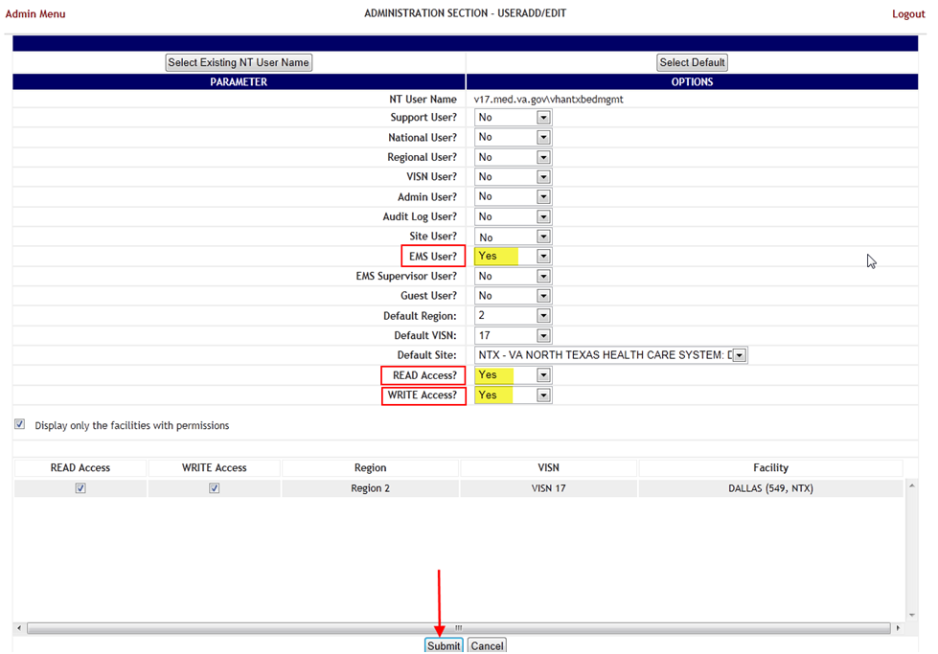

* + - * *Click* ***Submit***

### 2.4.3 Set up the Workstation / Kiosk Machine

After setting up the workstation / Kiosk machine, it will automatically log in to Windows, and automatically login to BMS.

#### 2.4.3.1 Disable Screen Saver

In order to display the Whiteboard page continuously the screen saver needs to be disabled.

NOTE: The Windows menu that allows the disable of the screen saver might be different from one version of Windows to another. For example, for Windows 10 the needed operations are:

* *Right click on the desktop*
  + - * *Click* ***Personalize***
      * *Click on the* ***Lock Screen***
      * *Click on* ***Screen Saver Settings***

Figure -Screen Saver Option

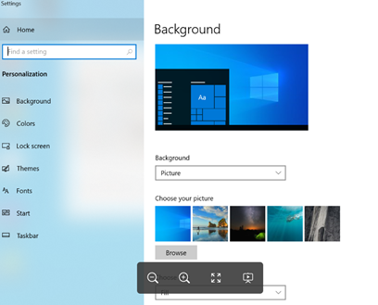

* + - *Select* ***None*** *from the screensaver drop down on the displayed form*

Figure -Screen Saver Settings Window

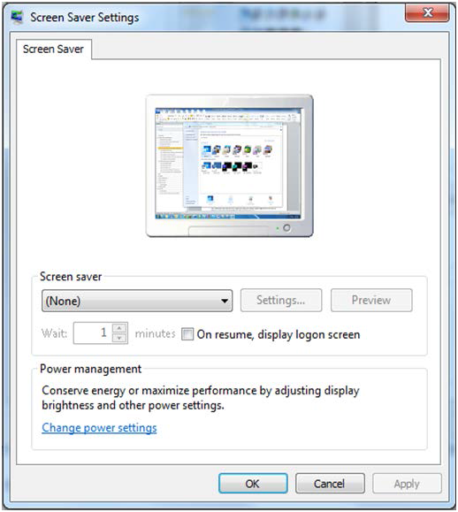

* + - * *Click* ***OK****.*

#### 2.4.3.2 Configure Power Settings: Disable Sleep and Stand-by Mode

In order to display the Whiteboard page continuously the power settings need to be adjusted so that the computer will never enter into hibernate or stand-by and also the screen will never turn off.

**NOTE**: The Windows menu that allows the configuration of the power settings might be different from one version of Windows to another. For example, for Windows 10 the needed operations are:

* + - * *Go To* ***Control Panel***
      * *Select* ***System and Security***
      * *Select* ***Power Options***

Figure -System and Security

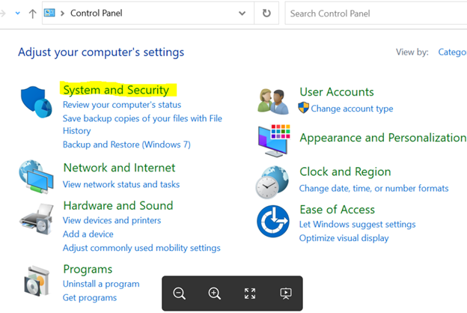

* *Click on “****Change Plan settings****” for the active plan*

Figure - Power Options Settings

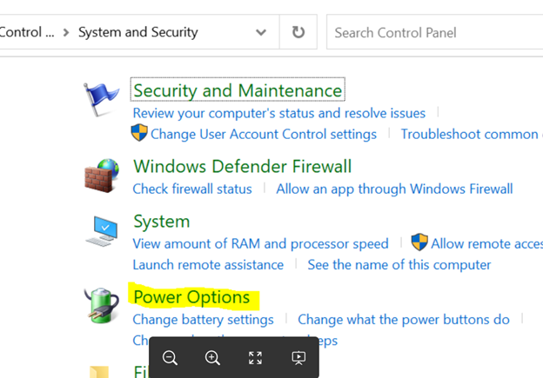

* + - *Select “****Never****” from the drop downs associated with “****Turn off the display****” and “****Put the computer to sleep****”*

Figure - Change Plan Settings Option

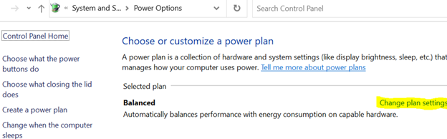

* *Click “****Save changes****”*

#### 2.4.3.3 Configure Auto-login Option

**Configure Auto-Login:** The computer that will display the Whiteboard page needs to have the auto-login configuration set to” true”.

**NOTE**: The Windows menu that allows the configuration of the auto-login settings might be different from one version of Windows to another. For example, for Windows 7 the needed operations are:

* + - * *Press the* ***Windows key + R*** *on your keyboard to launch the “****Run****” dialog box.*

Figure - Run Window

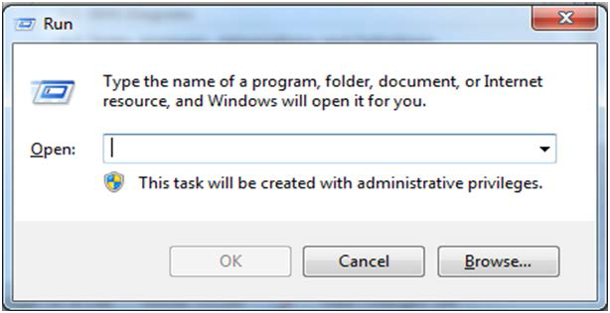

* + - * *Type in “****control userpasswords2****”*

Figure - Run Window with Command Entered

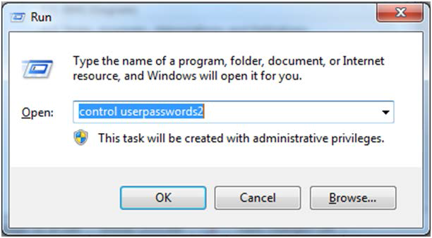

* + - * *Press* ***Enter****. The* ***User Accounts*** *window will display.*

Figure - User Accounts Window

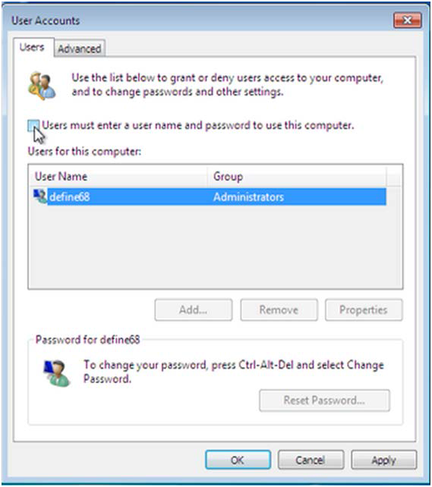

* *Uncheck the option “****Users must enter a user name and password to use this computer****” for the BMS Default Kiosk User Account*

Figure - User Accounts

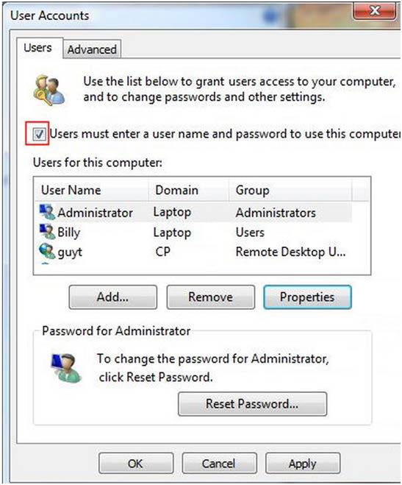

* *Click “****OK****”*

#### 2.4.3.4 Set the URL (from step 2.4.1) as the Home Page in Microsoft Edge

The specific Ward Whiteboard Kiosk URL needs to be configured as the Home-Page for the intended browser. The menu to set the default home-page might differ from one browser to another.

For example, for Microsoft Edge the user needs to:

* + - * *Click the ellipsis …* in the top right of the screen

Figure - Settings of Microsoft Edge

Graphical user interface, text, application
showing the settings menu in Microsoft Edge

* + - * *Select Settings*

Figure - When Edge Starts

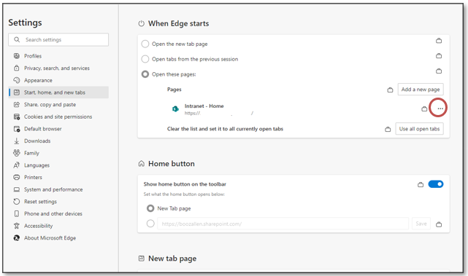

* + - * *On the Start,home, and new tabs, category, under the open these pages: section select the ellipsis …*
      * *Select edit*
      * *enter the URL*
      * *Click Save*

#### 2.4.3.5 Add BMS to the “Trusted Sites”

To add BMS to “Trusted Sites” in Microsoft Edge

* *Type “Internet Options” in the Type Here to Search bar by the start menu*
* *In the “Add this website to the zone:” field, enter https://vaww.bms.va.gov*
* *Click Add, Click OK*

#### 2.4.3.6 Add the launch of the browser to the Windows start up commands.

The next step is to add to the startup commands the launch of the chosen browser.

**NOTE**: This operation might differ from one version of Windows to another. For example, for Windows 10 the steps needed are:

Figure - Open Option

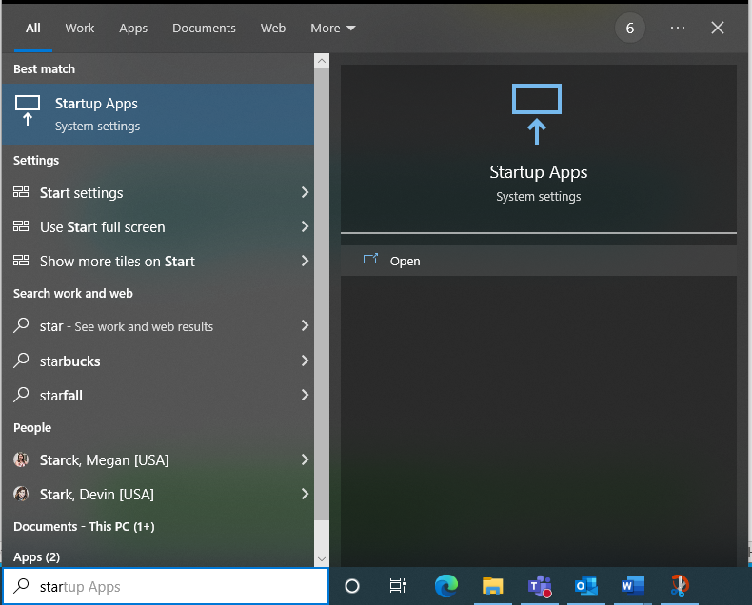

Type “**Startup Apps**” in the Type Here to Search bar ***by the start menu***

Figure - Microsoft Edge Selected

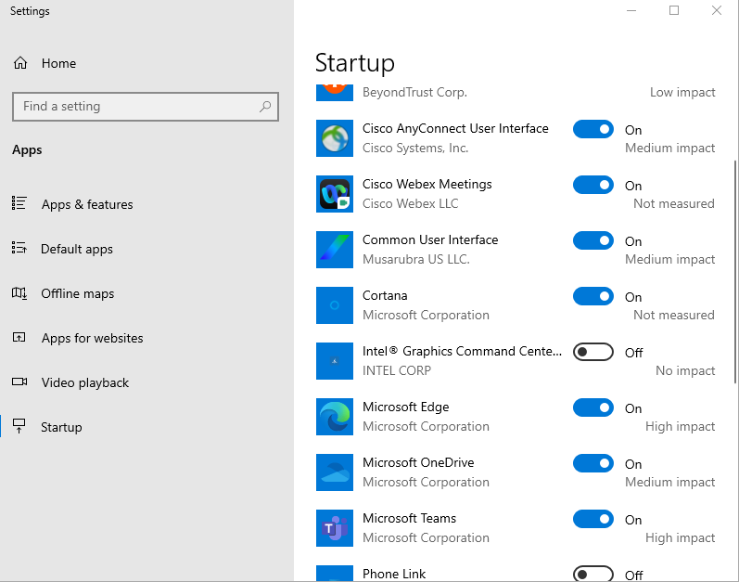

* *Scroll down to Microsoft Edge and toggle to On*

#### 2.4.3.7 Test the Kiosk

Close Microsoft Edge. Restart Microsoft Edge. The BMS Ward Whiteboard for the Kiosk should come up.

#### 2.4.3.8 Set the Registry Keys to configure the Kiosk for local site use.

The purpose of the following steps is to configure Kiosk workstation to serve one function only: BMS Ward Whiteboard display. The following instruction leads you through a series of steps that effectively lock down the workstation for this purpose. Access to workstation software and/or desktop will be prevented after the configuration setup is complete. The Whiteboard Kiosk is read only.

*Note: It is recommended that prior to performing the configuration steps outlined in this section a backup of the existing system be created for rollback / recovery purposes, and that a restoration point be created.

* + Modify Registry Settings

Figure -Windows Registry Editor

**Restriction.reg**

Windows Registry Editor Version 5.00

[HKEY_LOCAL_MACHINE\SOFTWARE\Policies\Microsoft\Internet Explorer\Restrictions]

"NoBrowserContextMenu"=dword:00000001

"NoFileOpen"=dword:00000001

"NoOpenInNewWnd"=dword:00000001

* + Run Restrictions.reg by double-clicking filename from Windows Explorer. Verify settings have been applied.
  + Modify Local Group Policy Settings

For local group policy changes run **gpedit.msc** and make the following changes:

User Configuration\Administrative Templates\System\Ctrl+Alt+Del Options

Remove TaskManager Disable

Remove Lock Computer Enable

Remove Change Password Enable

Remove Logoff Enable

User Configuration\Administrative Templates\Control Panel\Display

* + Password protect the screen saver Disabled

Verify all settings have been applied. The purpose of these settings is to lock down the workstation for one purpose only, BMS Whiteboard Kiosk.

* + Reboot Kiosk Machine to test set up.

*Note: If Kiosk continually “freezes”, please contact the Service Desk to have an IE Refresher script installed.

## Bed Management Solution Contingency Report Setup

The following steps will need to be completed in order to setup the BMS Contingency Report

* + - Create snapshot folder
    - Define network share
    - Assign rights to user
    - Assign snapshot folder path to ward group
    - Associate scheduler with the whiteboard report

### Create Snapshot Folder

To create the Snapshot Folder on Windows 10:

* **Open** File Explorer
* Go to the **C Drive** (or alternate drive letter if appropriate)
* Click **New Folder**
* Enter the Name of the folder, e.g., WhiteBoardSnapshot
  + - Do not use spaces in the folder name

Figure - Whiteboard Snapshot Folder

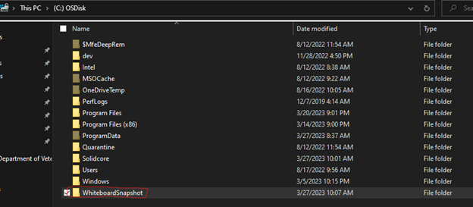

### Define Network Share

Note: Admin rights to the machine are required for this step.

* Navigate to the “**WhiteboardSnapshot**” folder, right-click it and choose **Properties**

Figure - Whiteboard Snapshot Folder Properties

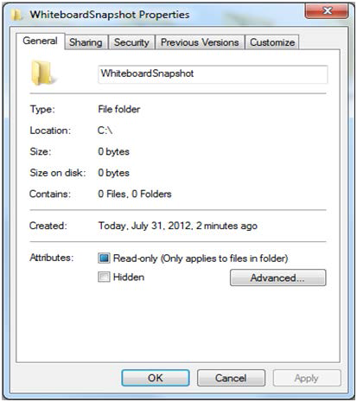

* *Go to* ***Sharing tab*** *and select* ***Advance Sharing*** *option.*

Figure - Advanced Sharing Option

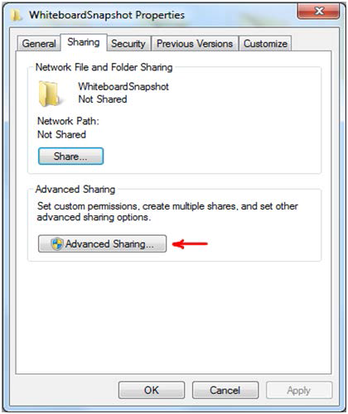

* In **Advanced Sharing** dialog, enable **Share this folder** option. It will automatically add folder’s name as Share name.

Figure - Share this Folder Option

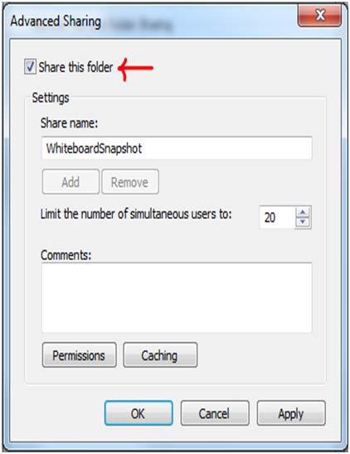

* Click **OK**
* Verify the network path is now populated with the computer name and folder

Figure - Verify Network Path

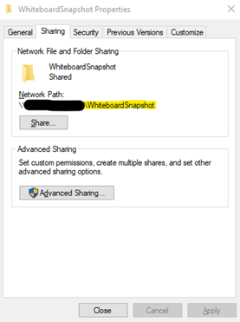

### Assign Rights to Master BMS Service Account User

Note: Admin rights to the machine are required for this step.

The BMS Application runs under a service account. AITC has created the Windows User (**aac\OITAUSBMSPRD**) as the master service account that the BMS Services runs under. The Windows user (**aac\OITAUSBMSPRD**) that is configured to be the Login that runs the four BMS Windows Services needs to have full rights to these shares.

This user must have full control on each facilities file folder that is used to store the Whiteboard Contingency Reports.

*On Windows 10 the needed operations are:*

* Using the Advanced Sharing window (re-open from the previous steps), click Permissions
* Click **Add**
* Type in “**AAC\OITAUSBMSPRD**” and click Check Names

Figure - Permissions for Whiteboard Snapshot

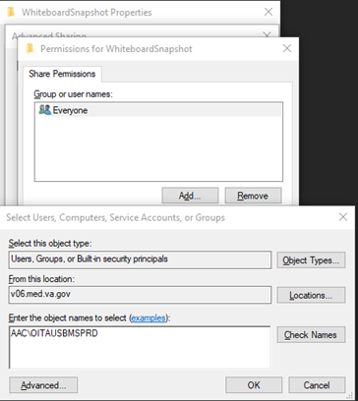

* Click **OK**
* Select the Service Account and check the “**Full Control**” box

Figure - Permissions for Whiteboard Snapshot

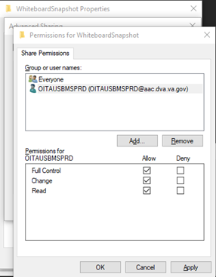

* Click **OK** through the rest of the open Folder Properties windows
* Using the Windows Start button and Search, open “**edit local users and groups**”
  + Make sure to open as Administrator
* Click **Groups**
* Double click the **Remote Desktop Users** group
* Add the BMS Service Account

Figure - Select Users

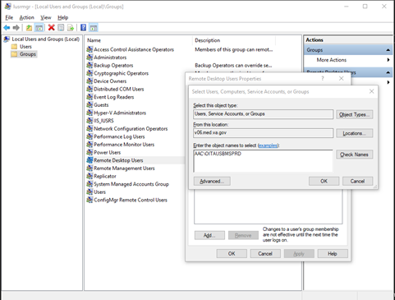

* Click **OK**

Figure - Remote Desktop Users Properties

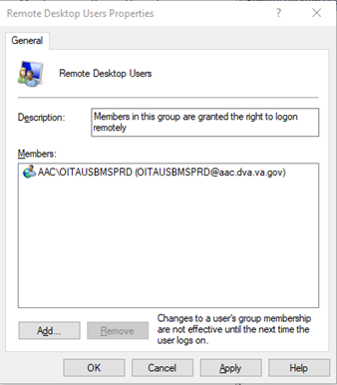

* Click **OK**

### Assign Snapshot Folder Path to Ward Group

* Open BMS and navigate to the **Facility Home Page**
* Click **Site Options**
* Click **Contingency Settings**
* Add the Fully Qualified Domain Name for the configured Whiteboard Snapshot folder
  + **\\XYZ-CMP12345.v06.med.va.gov\WhiteboardSnapshot**
* Click **Save**

Figure - Contingency Settings Page

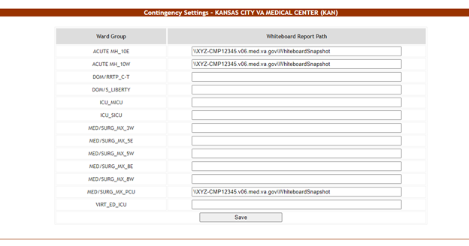

### Associate Scheduler with Whiteboard Report

* Open BMS and navigate to the **Facility Home Page**
* Click **Site Options**
* Click **Background Processors**
* Change the drop-down selection for Add/Update Scheduler to the desired schedule

Figure - Add Scheduler for Background Processors

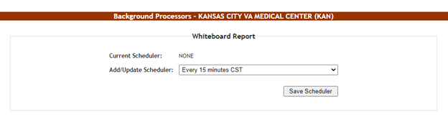

* Click **Save Scheduler**

## EMS Mobile Device Configuration

In order to configure the BMS EMS Mobile Devices, the following steps must be completed:

* + - *The local IS must create a local Service Account with a password that never expires and does not change. This account must not have any kind of policy that restricts its use to specific computers. The EMS Mobile Device will use this account to access the EMS Mobile page. This local Service Account can be the same as the Whiteboard Kiosk Default User Account created in Section 2.5.2.*
    - *Each facility must enter the local Service Account and Password in the EMS Default User and Password fields on the Facilities Settings page.*
    - *Configure the Mobile Device so that when it boots up, it will automatically open IE and go to the specified URL.*

### 

### Configure EMS Mobile Device Default Login User

For the current facility, a default user must be configured in the BMS application for the EMS Mobile Device.

To accomplish this, the Facility Admin User must do the following:

* + - * *Go to the Facility Home Page*
      * *Click on the Site Options link*
      * *Click on the Facility Setting link*
      * *Fill the fields “****EMS Default User Name:”,*** *“****EMS Password:”,*** *and “****EMS Password Confirm:”*** *with the BMS Local Service Account*

Figure - EMS Fields Filled on the Facility Settings Page

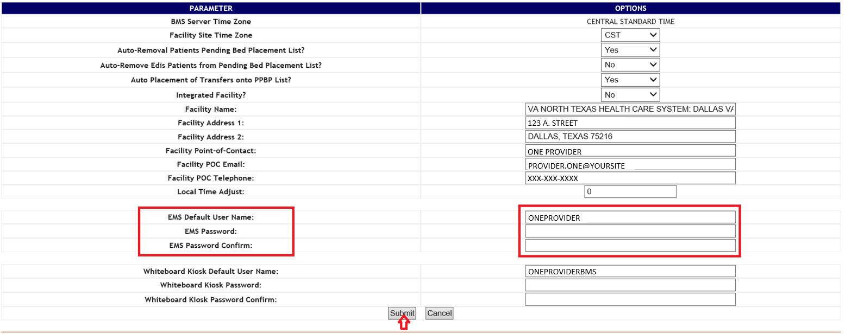

* + - * *Click the Submit button.*

Table 7-Facility Settings Page Parameters

|  |  |
| --- | --- |
| **Column** | **Description** |
| EMS Default User Name: | The BMS Service Account ID needed to load the EMS Mobile Page for Mobile Devices. |
| EMS Password: | The BMS Service Account ID password needed to load the EMS Mobile Page for Mobile Devices. |
| EMS Password confirm: | The confirmation of the password. |

This setup can also be completed by the system Support User:

* + - * + *Go to the BMS Admin Page*
        + *Click on the Edit BMS Facility Settings link*
        + *Click on the Facility Name Drop Down and select the name of the Facility to be configured*
        + *Fill the fields “EMS Default User Name”, “EMS Password” and “EMS Password Confirm” with the BMS Local Service Account*

Figure -EMS Fields Filled on the BMS Admin Page

Graphical user interface, application
 showing EMS fields filled in on BMS admin page

* + - * + *Click the Submit button*

Table 8-BMS Admin Page Parameters

|  |  |
| --- | --- |
| **Column** | **Description** |
| EMS Default User Name: | The BMS Service Account ID needed to load the EMS Mobile Page for Mobile Devices. |
| EMS Password: | The BMS Service Account ID password needed to load the EMS Mobile Page for Mobile Devices. |
| EMS Password confirm: | The confirmation of the password. |

### 

### Configure EMS Mobile Device URL

For the current facility, the EMS Device URL must be configured in the EMS Mobile Device. The URL to be entered has a special format:

[https://vaww.bms.va.gov/EMSMobileLogon?code=BRK.](https://vaww.bms.va.gov/EMSMobileLogon?code=BRK)

Table 9-Description and Configuration for EMS Mobile Device URL Parameters

|  |  |  |
| --- | --- | --- |
| **Parameter** | **Short Description** | **Options** |
| Code | Code of facility (e.g. BROCKTON = BRK) | Enter the 3-character facility ID. |

EMS staff can access the BMS Web page for mobile devices at the URL set up by their local IS staff. Be sure to use the code of the facility for which access is needed.

The following page is displayed:

Figure -EMS Staff Page for Mobile Devices

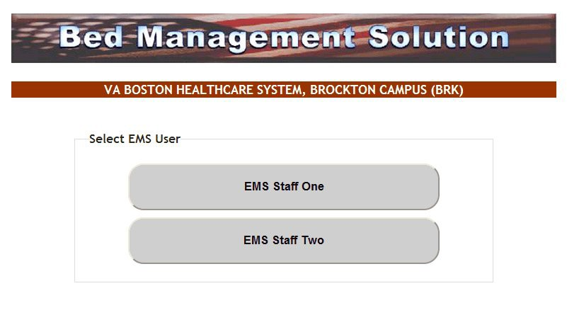

## 2.7 VistA Integration

This chapter describes the process of importing vocabularies, entities, patient admission, transfer, discharge (ADT) and patient pending bed placement information from VistA.

In order to integrate with VistA certain steps should be completed:

* + Choose VistA site
  + Define Schedulers
  + Run Scheduler
  + View Audit Results

### Choose VistA Site

VistA Sites tab from Background Processors page of Admin section allows the user to view the list of VA facility sites sharing the same VistA instance and to add a new VA facility to a VistA instance.

#### Adding a New VistA Site

To add a VA facility site to a VistA instance, follow the steps presented below.

* From the Background Processors page of Admin section select VistA Sites to display the page in the following image. A list of VA facility sites is displayed in the column to the left of the page.

Figure -Adding a VistA Site

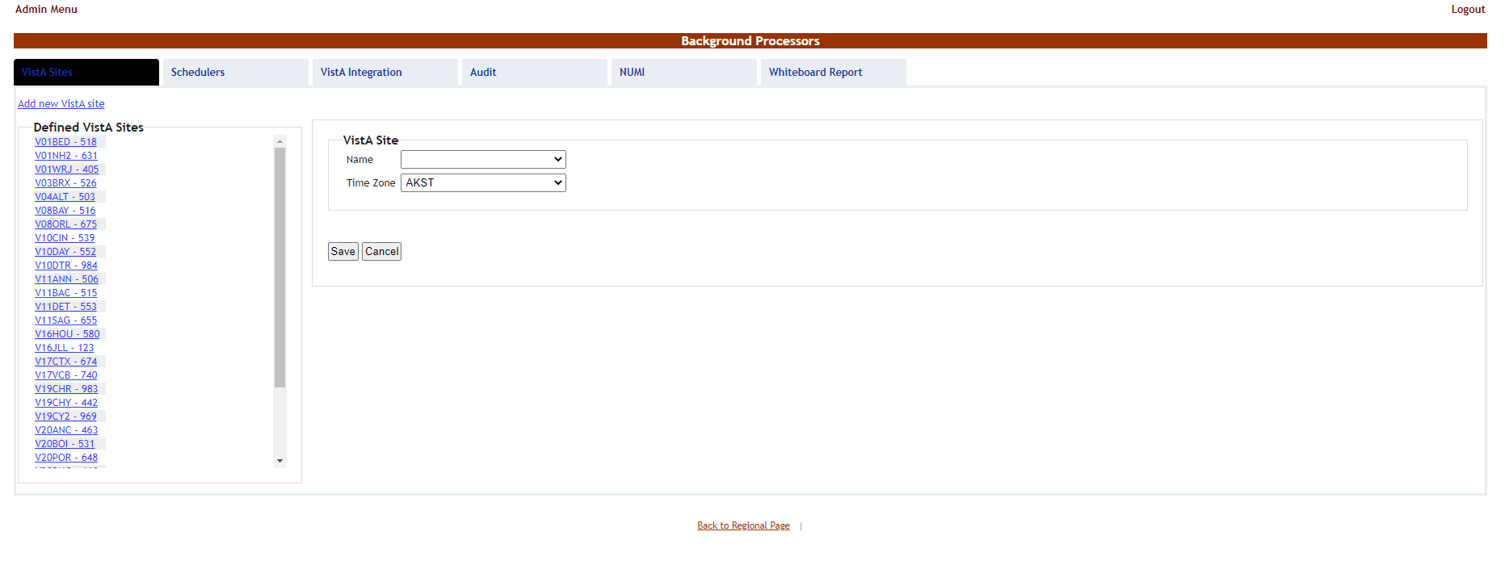

* Click the Add new VistA site link then from the VistA Site area use the Name field to select the code of the site you want to add to the current VistA instance, and then select the Time Zone.
* Press **Save** to enter new data into the system.

The newly added site will be added in the sites list to the left of the screen.

### Define Schedulers

The Schedulers tab from Background Processors page of Admin section displays a list of schedulers defined by user. It allows the user to add new schedulers, edit or remove old schedulers.

NOTE: To run the schedulers, the VistA Integration tab must be used (see next section VistA Integration for details).

The Schedulers tab is displayed as in the following image:

Figure -Schedulers Tab

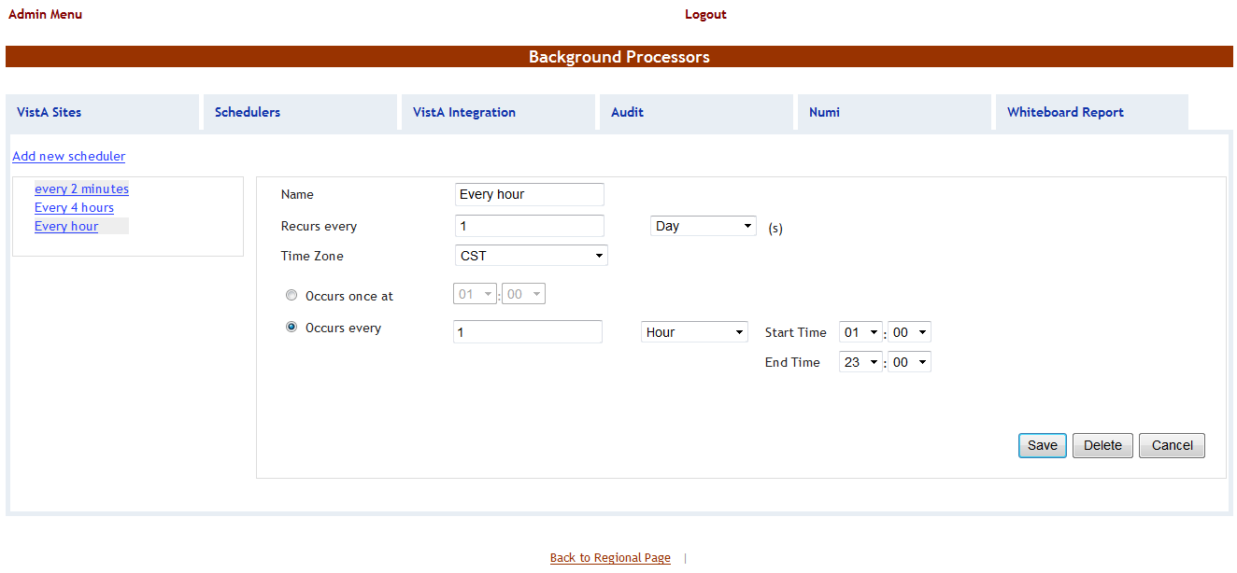

#### Adding a New Scheduler

To add a new scheduler, follow the steps presented below.

* From the Background Processors page select the Schedulers tab.
* In the Schedulers tab fill in the following data:

Table -New Scheduler Parameters

|  |  |
| --- | --- |
| **Column** | **Description** |
| Name | The name of the scheduler. |
| Recurs every | The frequency. |
| Time Zone | Time zone associated with the scheduler. |
| Occurs once at/Occurs every | The frequency values. |

After setting the desired frequency for the new scheduler, do not forget to press the Save button to enter the data into the system.

### Run Scheduler

The VistA Integration tab is used to run (automatically or manually) the defined schedulers and to select which data categories will be affected by a scheduler’s action.

The VistA Integration tab is displayed as in the following image:

Figure -VistA Integration Tab

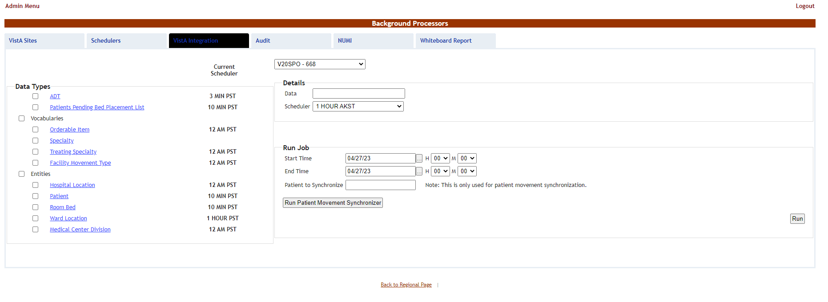

From the field in the upper part of the page select the VistA site where the scheduler(s) will run.

* Either click one data category from the column to the left (its name will appear in the Data field) and then select a scheduler from the Schedulers fields in the Details area: this will cause the selected scheduler to run at the time set for it in the Schedulers tab and to bring data from the selected category.
* Or select several data categories (using the check-boxes) then set the Start time/End time and click the Run button: this will cause the scheduler set to start running now and bring the data from the selected categories.

### View Audit Results

The Audit tab displays the results of the operations performed in the VistA Integration tab.

Figure - Audit Tab

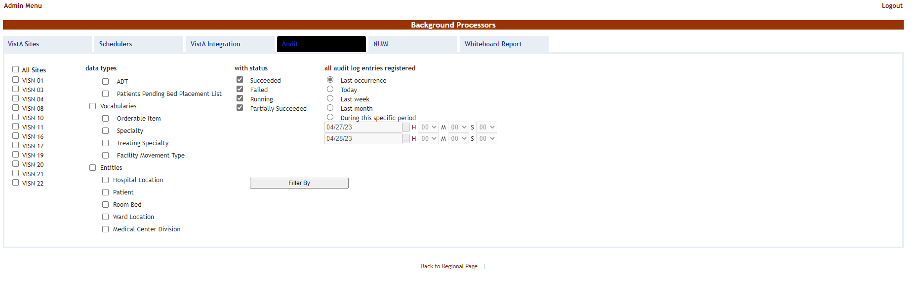

The options to the left of the page allow the user to determine the filter criteria for the generated audit reports. The options to the right of the screen allow the user to select the type of operation to be captured by the audit report as well as the time interval for the audit.

After selecting the desired criteria, click the Filter by button to display the page as in the following image.

Figure - View Audit Results

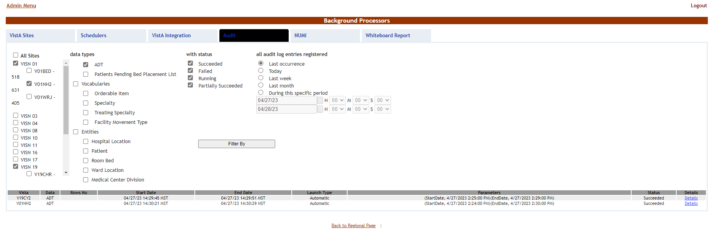

A list of operations is displayed. For each entry the following data is available:

Table 11-View Audit Results Columns Report

|  |  |
| --- | --- |
| **Column** | **Description** |
| VistA | The VistA site where the audit action has been performed. |
| Data | The type of data retrieved by the VistA integration operation. |
| Rows no | The number of operations of the selected type captured by the audit action. |
| Start Date | The start date of the retrieval operation. |
| End Date | The end date of the retrieval operation. |
| Launch Type | The way the audit action has been launched. |
| Parameters | Audit operation start date and time, and end date and time. |
| Status | The status of the VistA integration action. |
| Details | Clicking this link will display the number of entries in the report. |

## NUMI Integration

This chapter describes the process of importing patient level of care information from NUMI.

NUMI connects to VistA for synchronization of patient data using the NUMI Web Service that is part of the Commercial Off the Shelf McKesson product. Authentication to the NUMI Web Service is done by a NUMI supplied secret key.

NUMI Patient Level of Care transaction involves the following steps:

* Change patient level of care in NUMI.
* BMS Reader component will detect the patient level of care in NUMI.
* Patient level of care will be retrieved through a web service method call.
* BMS Writer component will update patient level of care in BMS database.

### Integration Settings

There are a limited number of configuration parameters for NUMI.

* Secret Key
* Number of sites per call
* Path to NUMI web service

These configurations are stored in BMS.Service.Host.exe.config

The current secret key is: <authorization key>

The number of sites per call parameter how many sites will be bundled together in a transaction to NUMI. If this number is increased one should consider the frequency in which the calls are scheduled. Adding more sites will increase the transaction size and length.

Currently all NUMI servers operate on port 100 at the specified endpoint https://<servername>.aac.dva.va.gov/Inpatient.asmx*.*

In order to integrate with NUMI certain steps should be completed:

* Choose VistA site
* Define Schedulers
* Select Scheduler

### Choose VistA Site

This step is the same as the one performed on VistA Integration process and can be referenced from

Section 2.7.1.

### Define Schedulers

The process of defining schedulers can be referenced from Vista Integration process, Section 2.7.2.

### Select Scheduler

The NUMI tab is used to select the scheduler that will connect to the NUMI server and will retrieve data for a certain VistA site.

The NUMI tab is displayed as in the following image.

Figure -NUMI Tab

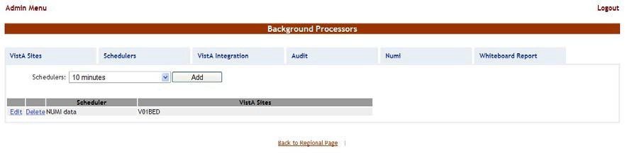

From the Schedulers field select the scheduler created to retrieve the NUMI data then click the Add button. The following page is displayed:

Figure - Selecting the VistA Site for NUMI data

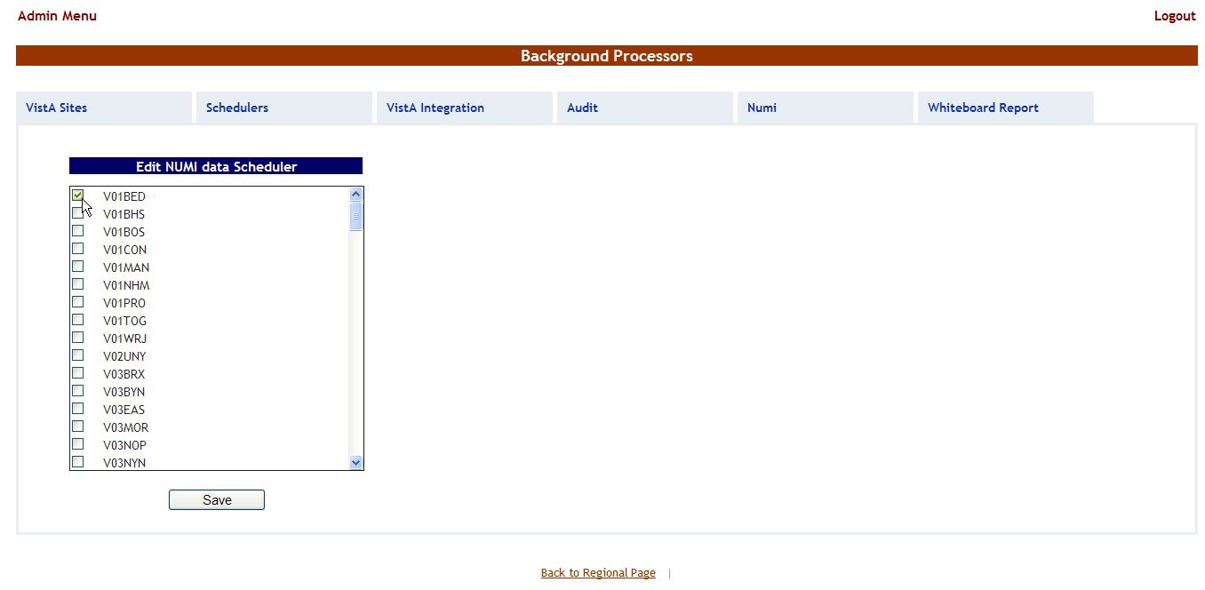

Select the VistA site for which the selected scheduler will retrieve NUMI data then press the Save button. Use the Edit link to select a different site for which the scheduler should retrieve NUMI data.

#### 2.9 PPMS Integration

The **PPMS** tab is for scheduling an extract of in-network Community Care Facilities from an external Provider Profile Management System. These facility records are visible from the Community Care Facility field located in a Patients Pending Bed Placement or Community Care Tracking List record, and can be reviewed via Community Care Sites.

The PPMS job can be scheduled to run as frequently as monthly (or on-demand), but is recommended to run on a quarterly basis.

The **PPMS** tab is displayed as in the following image:

Figure -PPMS page

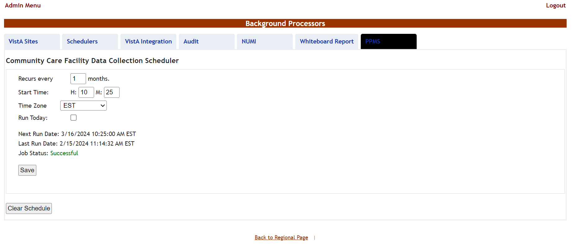

If necessary, make changes to the Recurs every, Start Time and Time Zone fields, then press the **Save** button. If an ad-hoc run of the PPMS job is necessary, select the Run Today checkbox, then press the **Save** button.

Notepad and pencil icon

 The Run Today option kicks off the PPMS job within 5 minutes.

Warning icon image of a triangle with an exclamation mark Pressing the **Clear Schedule** button will remove the Next Run Date and Job Status information.

Table -PPMS Parameters

| Column | Description |
| --- | --- |
| Recurs every | Frequency of PPMS job run by number of months. |
| Start Time | Hour and minute when the next PPMS job is schedule to run. |
| Time Zone | The time zone of the Start Time. |
| Run Today | A checkbox for running the PPMS job one hour after pressing the Save button. |
| Next Run Date | The date and time when the PPMS job is scheduled to run. |
| Last Run Date | The date and time when the PPMS job last ran. |
| Job Status | The status of the previous PPMS job. Possible values are Not Yet Run, Running, Successful and Failed. |

# Application structure

## Application Components

BMS application consists of the following components:

* + - BMS Databases (BMS Database, BMS Authz, BMS EIS, BMS EVS, BMS_DS, BMS_DW, BMS InstanceStore and BMS History)
    - BMS Services (BMS Service and Win ServiceHost)
      * BMS Service
      * Win Service Host (EIS Service, EVS Service, PAP service, PDP service, RS service and STS service)
    - BMS Web Site
    - WMI UserGroup

## Application Directory Structure

BMS application directory is structured as is presented below:

##### +---Consoles

| +---PolicyManager

+---Databases

| \---SQLData

| | \---Job Logs

+---Services

| +---BMS

| | \---DBRepository

| | \---LinqToSql

| | \---LocalReportWhiteboard

| | \---Scripts

+---WebSite

| +---bin

| | \--- LocalReportWhiteboard

| | \--- Scripts

| +---Content

| | \---images

| | +---themes

| | | +---base

| | | | \---images

| +---Reporting

| +---ReportsLocal

| +---Scripts

| \---Views

## Database Architecture

The BMS Database implementation is comprised of three main parts:

* BMS Database
  + BMS (Bed Management database).
  + BMS_History (BMS Transactional History)
  + BMS_InstanceStore (BMS Instances)

Figure -Database Architecture

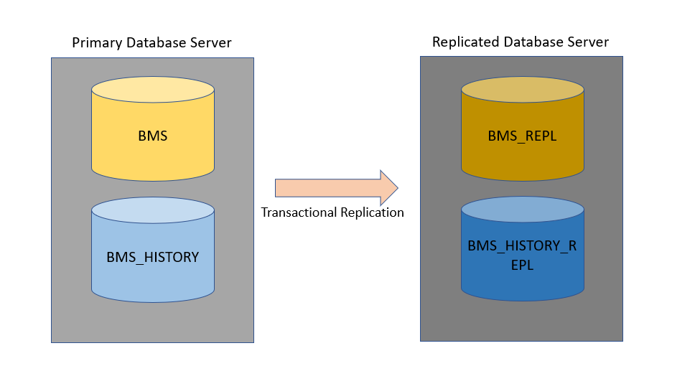



## Component Files

A list with files for each BMS component is presented below:

Table 13-BMS Database Files

| **Relative Path** | **File** | **Description** |
| --- | --- | --- |
| Databases\SQLData  Databases\SQLData2  Databases\SQLLogs | BMS_Data.mdf | Database files |
| BMS_Data_F.ndf |
| BMS_Log.ldf |
| BMS_HISTORY_Data.mdf |
| BMS_HISTORY_Data_F.ndf |
| BMS_HISTORY_Log.ldf |
| BMS_InstanceStore_Data.mdf |
| BMS_InstanceStore_Log.ldf |
| BMS_Reports_Log.txt |
| BMS_Reports_Log_Incremental.txt |
| AdapterRepository.dll |
| Common.dll |
| connectionConfiguration.config |
| Connections.SingleDatabase.dll |
| ContextWriter.dll |
| General.MT.dll |
| Infoworld.Configuration.dll |
| LOOP_IT.bat |
| MessageRequest.bat |
| MiddleTier.dll |
| MS.Common.dll |
| Databases\SQLData\Job_Log s | MS.Configuration.dll |  |
| MS.Connections.dll |

Table 14-BMS Service Files

|  |  |  |
| --- | --- | --- |
| **Relative Path** | **File** | **Description** |
| Services\BMS | AdapterRepository.dll | The binaries of the BMS Service. |
| AuditTrailSender.dll |
| AuthenticationProxy.dll |
| AuthorizationSubscriber.dll |
| BMS.CommonClasses.dll |
| BMS.Contracts.dll |
| BMS.DataAccess.dll |
| BMS.Facade.dll |
| BMS. Facade.Contracts.dll |
| BMS.Host.dll |
| BMS.Numi.dll |
| BMS.Schedulers.dll |
| BMS.ServiceHost.exe |
| BMS.ServiceHost.exe.config |
| BMS.ServiceImplementation.dll |
| BMS.ServicesWrapper.dll |
| BMS.Utils.dll |
| BMS.VistaIntegration.dll |
| BMS.VistaIntegration.Cache.dll |
| BMS.VistaIntegration.Data.dll |
| BMS.VistaIntegration.Mdws.dll |
| BMS.VistaWorker2.Writer.dll |
| BMS.WhiteboardReport.dll |
| Common.dll |
| connectionConfiguration.config |
| Connections.SingleDatabase.dll |
| ContextWriter.dll |
| DataUtil.dll |
| EISContracts.dll |
| General.MT.dll |
| HL7DataTypes.dll |
| IContracts.dll |
| ICTSEdit.dll |
| Infoworld.Configuration.dll |
| InterSystems.Data.CacheClient.dll |
| log4net.dll |
| log4netAsync.dll |
| Mdws2ORM.dll |
| MiddleTier.dll |
| MS.Common.dll |
| MS.Configuration.dll |
| MS.Connections.dll |
| RS.Contracts.dll |
| Saml20.dll |
| SecurityTokenCache.dll |
| Tracing.dll |
| VistASites.xml |
| Xacml2.dll |
| XacmlCore.dll |
| Services\BMS\LocalReportWhiteboard | WardWhiteboard.rdlc | Ward whiteboard report file. |

Table 15-BMS Website Files

| **Relative Path** | **File** | **Description** |
| --- | --- | --- |
| WebSite | BMS_App_Offline.htm | The binaries of the BMS Web Site, web site configuration file. |
| Global.asax |
| Web.config |
| WebTrace.log |
| additional_login_msg.txt |
| WebSite\bin | AntiXSSLibrary.dll |  |
| AuditTrailSender.dll | Dynamic text for main login page |
| AuthenticationProxy.dll | Web site’s binaries. |
| BMS.Contracts.dll |  |
| BMS.Facade.Contracts.dll |  |
| BMS.Facade.dll |  |
| BMS.PAPContracts.dll |  |
| BMS.Security.dll |  |
| BMS.ServicesWrapper.dll |  |
| BMS.Utils.dll |  |
| BMS.Web.dll |  |
| DevExpress.Data.v21.1.dll |  |
| DevExpress.Office.v21.1.Core.dll |  |
| DevExpress.Pdf.v21.1.Core.dll | DevExpress |
| DevExpress.Printing.v21.1.Core.dll | DevExpress |
| DevExpress.RichEdit.v21.1.Core.dll | DevExpress |
| DevExpress.Utils.v21.1.dll | DevExpress |
| DevExpress.Web.Mvc5.v21.1.dll | DevExpress |
| DevExpress.Web.v21.1.dll | DevExpress |
| EISContracts.dll | DevExpress |
| HL7DataTypes.dll | DevExpress |
| HtmlAgilityPack.dll |  |
| HtmlSanitizationLibrary.dll |  |
| IContracts.dll |  |
| ICTSEdit.dll |  |
| Infoworld.Configuration.dll |  |
| log4net.dll |  |
| log4netAsync.dll |  |
| Microsoft.ReportViewer.Common.dll |  |
| Microsoft.ReportViewer.ProcessingObjectModel.dll |  |
| Microsoft.ReportViewer.WebForms.dll |  |
| Microsoft.Web.Infrastructure.dll |  |
| Microsoft.Web.Mvc.dll |  |
| RS.Contracts.dll |  |
| Saml20.dll |  |
| SecurityTokenCache.dll |  |
| System.Web.Helpers.dll |  |
| System.Web.Mvc.dll |  |
| System.Web.Razor.dll |  |
| System.Web.WebPages.Deployment.dll |  |
| System.Web.WebPages.dll |  |
| System.Web.WebPages.Razor.dll |  |
| Tracing.dll |  |
| Web.config |  |
| Xacml2.dll |  |
| XacmlCore.dll |  |
| WebSite\bin\LocalReportWhite board | WardWhitebord.rdlc | Ward Whiteboard report file. |
| WebSite\Content | Controls.css |  |
| LayoutCss.css |  |
| LayoutCSS.css.bundle |  |
| LayoutCss.min.css | Images, themes and styles. |
| LayoutVistaIntegrationCss.css.bundle |  |
| LayoutVistaIntegrationCss.min.css |  |
| Reports.css |  |
| Reports.min.css |  |
| Site.css |  |
| WebSite\Content\images | add_tab_24.png |  |
| arrow_down.png |  |
| arrow_up.png | Images used by site. |
| BMSLogoV6.jpg |  |
| check_inv.png |  |
| edit_staff_cancel.png |  |
| edit_staff_save.png |  |
| FavIcon.ico |  |
| Info.png |  |
| Ladybug.png |  |
| login_logo.png |  |
| logo.png |  |
| order_down.png |  |
| order_up.png |  |
| sort_down.png |  |
| sort_up.png |  |
|  | 30day.png |  |
|  | Ambulatory.png |  |
| WebSite\Content\images\EVS | AnticipatedDischarge.png |  |
| BedCleaned.png |  |
| Bedhold.png |  |
| BedInIsolation.png |  |
| BedNeedsCleaning |  |
| BedOutOfService(BedBoard).png |  |
| BedOutOfService(Vista).png |  |
| Blankroom.png |  |
| Blue Arrow.png |  |
| Blue Arrow_inactive.png |  |
| Blue Box.png |  |
| Blue Box_inactive.png |  |
| Blue Caution.png |  |
| Blue Caution_inactive.png |  |
| Blue Circle.png |  |
| Blue Circle_inactive.png |  |
| Blue Diamond.png |  |
| Blue Diamond_inactive.png |  |
| Blue Heart.png |  |
| Blue Heart_inactive.png |  |
| Blue X.png |  |
| Blue X_inactive.png |  |
| Bluestar.png |  |
| Bluestar_inactive.png |  |
| Browncircle.png |  |
| Browncircle_inactive.png |  |
| Buckle.png |  |
| Choking.png |  |
| CleaningBed.png |  |
| Close Observation (Patient).png |  |
| Convalescent (P).png |  |
| Convalescent (R).png |  |
| Convalescent Icon (P).png |  |
| Convalescent Icon (P)_inactive.png |  |
| Convalescent Icon (R).png |  |
| Convalescent Icon (R)_inactive.png |  |
| Dialysis.png |  |
| DischargeOrdered.png |  |
| DIVERT.png |  |
| DMFS.png |  |
| DMFS_inactive.png |  |
| Electricwc.png |  |
| EMSNotified.png |  |
| Evacuate.png |  |
| Fall.png |  |
| Flu Confirmed.png |  |
| Flu Confirmed_inactive.png |  |
| Flu Confirmed2.png |  |
| Flu Confirmed2_inactive.png |  |
| Flu_Risk2.png |  |
| Green Circle.png |  |
| Green Circle_inactive.png |  |
| Greenstar.png |  |
| Greenstar_inactive.png |  |
| Hearingimpaired.png |  |
| InterwardTransfer.png |  |
| Legal.png |  |
| Lift Equipment (Patient) (EM).png |  |
| Lift Equipment (Room).png |  |
| NegativePressure.png |  |
| Negpres.png |  |
| NumiGreen.png |  |
| NumiRed.png |  |
| NumiYellow1.png |  |
| Observation.png |  |
| Oneto1.png |  |
| Orange Circle.png |  |
| Orange Circle_inactive.png |  |
| Orange Star.png |  |
| Orange Star_inactive.png |  |
| Oxygen (Patient) (EM).png |  |
| PAC Icon 2.png |  |
| PAC Icon 2_inactive.png |  |
| PatientSymbol.png |  |
| PICC.png |  |
| Placementproblem.png |  |
| Privateroompt.png |  |
| PTOptOut.png |  |
| Purplestar.png |  |
| Purplestar_inactive.png |  |
| Red Stop.png |  |
| Red Stop_inactive.png |  |
| Redflag.png |  |
| Redflag_inactive.png |  |
| Redstar.png |  |
| Redstar_inactive.png |  |
| Region.png |  |
| Respitory Therapy (Patient).png |  |
| RoomBedSymbol.png |  |
| Samename.png |  |
| Scripts.png |  |
| Seizure.png |  |
| Serviceanimal.png |  |
| Shared Bathroom (Room).png |  |
| Specmattress.png |  |
| Stretcher (Patient) (EM).png |  |
| Suicide Risk.png |  |
| Telemetry (Patient).png |  |
| Telemetry (Room).png |  |
| Ventilator (Patient) (EM).png |  |
| VirusBlack.png |  |
| VirusRed.png |  |
| VirusRed_inactive.png |  |
| Visuallyimpaired.png |  |
| WBCaution.png |  |
| Wheelchair Bound (Patient) (EM).png |  |
| WomenProgram2.png.png |  |
| Yellowcircle.png |  |
| Yellowcircle_inactive.png |  |
| WebSite\Content\themes\base | Jquery.dynameter.css |  |
| jquery.ui.structure-1.11.4.css |  |
| jquery.ui.structure-1.11.4.min.css | jQuery controls style-sheets files. |
| jquery.ui.theme-1.11.4.css |  |
| jquery.ui.theme-1.11.4.min.css |  |
| jquery-ui-1.11.4.css |  |
| jquery-ui-1.11.4.min.css |  |
| WebSite\Content\themes\base  \images | ui-bg_diagonals-thick_18_b81900_40x40.png |  |
| ui-bg_flat_10_000000_40x100.png |  |
| ui-bg_diagonals-thick_20_666666_40x40.png | Images |
| ui-bg_flat_0_aaaaaa_40x100.png |  |
| ui-bg_flat_75_ffffff_40x100.png |  |
| ui-bg_glass_55_fbf9ee_1x400.png |  |
| ui-bg_glass_65_ffffff_1x400.png |  |
| ui-bg_glass_75_dadada_1x400.png |  |
| ui-bg_glass_75_e6e6e6_1x400.png |  |
| ui-bg_glass_95_fef1ec_1x400.png |  |
| ui-bg_highlight-soft_75_cccccc_1x100.png |  |
| ui-icons_222222_256x240.png |  |
| ui-icons_2e83ff_256x240.png |  |
| ui-icons_454545_256x240.png |  |
| ui-icons_888888_256x240.png |  |
| ui-icons_cd0a0a_256x240.png |  |
| WebSite\Reporting | EvacuationPatientReportViewer.aspx |  |
| EvacuationPatientVISNReportViewer.aspx |  |
| LocalReportViewer.aspx | Report Viewer pages. |
| PPBPReportViewer.aspx |  |
| ReportError.aspx |  |
| ReportViewer.aspx |  |
| WhiteboardReportViewer.aspx |  |
| WebSite\ ReportsLocal | BedStatusReport.rdlc |  |
| FacilityDiversion.rdlc |  |
| WardOccupancy.rdlc | Bed Status Report file. |
| WebSite\Scripts\Elements | CCFacility-DropDown.js | JavaScript File |
| WebSite\Scripts | Ace.js | JavaScript files. |
| antiForgeryToken.js |  |
| conditional-validation.js |  |
| element-change.js |  |
| Ext-language_tools.js |  |
| Globalize.cultures.js |  |
| Globalize.js |  |
| hoverIntent.js |  |
| jquery.autosize.js |  |
| jquery.base64.js |  |
| jquery.base64.min.js |  |
| Jquery.dynameter.js |  |
| jquery.jscrollpane.min.js |  |
| Jquery.limit-textrea.js |  |
| jquery.maskedinput-1.3.min.js |  |
| jquery.mousewheel.js |  |
| jquery.tablescroll.js |  |
| jquery.tablescroll.min.js |  |
| jquery.tablesorter.js |  |
| jquery.tablesorter.min.js |  |
| jquery.unobtrusive-ajax.js |  |
| jquery.unobtrusive-ajax.min.js |  |
| jquery.validate.js |  |
| jquery.validate.min.js |  |
| jquery.validate.unobtrusive.js |  |
| jquery.validate.unobtrusive.min.js |  |
| jquery.validate-vsdoc.js |  |
| jquery-1.11.0.js |  |
| jquery-1.11.0.min.js |  |
| Jquery-1.11.0.min.map |  |
| Jquery-ui-1.11.4.js |  |
| Jquery-ui-1.11.4.min.js |  |
| json2.js |  |
| Knockout-3.3.0.js |  |
| LayoutAdminAutoCompleteAndDatePicker.js |  |
| LayoutAdminScripts.min.js |  |
| LayoutAutoCompleteAndDatePicker.js |  |
| LayoutScripts.min.js |  |
| LayoutVistaIntegrationDatePicker.js |  |
| LayoutVistaIntegrationScripts.min.js |  |
| MicrosoftAjax.debug.js |  |
| MicrosoftAjax.js |  |
| MicrosoftMvcAjax.debug.js |  |
| MicrosoftMvcAjax.js |  |
| MicrosoftMvcValidation.debug.js |  |
| MicrosoftMvcValidation.js |  |
| modernizr-1.7.js |  |
| modernizr-1.7.min.js |  |
| Reports.min.js |  |
| superfish.js |  |
| supersubs.js |  |
| whiteboardReport-script.js |  |
| whiteboard-script.js |  |
| whiteboard-script.min.js |  |
| WebSite\Views | ViewStart.cshtml |  |
| Web.config |  |
| WebSite\Views\Account | LogOff.cshtml | User Interface views. |
| LogOn.cshtml |  |
| WebSite\Views\Admin | AddEditUser.cshtml | Login/Logout user interface views. |
| AddUserOperations.cshtml |  |
| CacheConfirmation.cshtml | Admin section user interface views. |
| ConfirmBulkRevoke.cshtml |  |
| FacilityEdit.cshtml |  |
| FacilityEditSaved.cshtml |  |
| Index.cshtml |  |
| RefreshUsersConfirmation.cshtml |  |
| RemoveUserOperations.cshtml |  |
| SelectUser.cshtml |  |
| SisterSiteAddEdit.cshtml |  |
| SisterSiteEditSaved.cshtml |  |
| UserEditHasSaved.cshtml |  |
| UserOperationsView.cshtml |  |
| WebSite\Views\AdminComments | Index.cshtml |  |
| NotifyChange.cshtml |  |
| WebSite\Views\AdminIcon | Delete.cshtml |  |
| DeleteConfirmation.cshtml |  |
| Edit.cshtml |  |
| Index.cshtml |  |
| SaveConfirmation.cshtml |  |
| Search.cshtml |  |
| SearchResult.cshtml |  |
| WebSite\Views\AdminSpecialt yAssociation | Delete.cshtml |  |
| Index.cshtml |  |
| WebSite\Views\AdminUnavailableReason | AddConfirmation.cshtml | Admin specialty association user interface views. |
| Delete.cshtml |  |
| DeleteConfirmation.cshtml | Admin unavailable reason user interface |
| Edit.cshtml |  |
| EditConfirmation.cshtml |  |
| Index.cshtml |  |
| MissingUnavailableReasonText.cshtml |  |
| UnavailableReasonAlreadyExists.cshtml |  |
| UnavailableReasonList.cshtml |  |
| WebSite\Views\AdminWaitingArea | AddAction.cshtml |  |
| Delete.cshtml |  |
| DeleteAction.cshtml | Admin waiting area user interface views. |
| Edit.cshtml |  |
| EditAction.cshtml |  |
| Index.cshtml |  |
| WebSite\Views\AdminWhiteboardReport | Delete.cshtml |  |
| Edit.cshtml |  |
| Index.cshtml | Admin whiteboard report user interface |
| WebSite\Views\AdtOrderableItems | Confirmation.cshtml |  |
| Delete.cshtml |  |
| Index.cshtml |  |
| OrderableItemsList.cshtml | ADT Orderable Items user interface views. |
| WebSite\Views\ApplicationParameters | Index.cshtml |  |
| Saved.cshtml |  |
| WebSite\Views\BackgroundProcessors | AddEditConfirmation.cshtml |  |
| DeleteConfirmation.cshtml |  |
| Index.cshtml | Background Processors user interface views. |
| WebSite\Views\BedBoard | BedBoardGrid.cshtml |  |
| Index.cshtml |  |
| WebSite\Views\BedBoardModule | Index.cshtml | VISN user interface views. |
| WebSite\Views\BedBulkManagement | _BulkBedGridPartialView.cshtml |  |
| Index.cshtml | Bed Board Module user interface view. |
| WebSite\Views\BedInformation | ClearAll.cshtml |  |
| Index.cshtml |  |
| NotifyChange.cshtml | Bed Information user interface views. |
| WebSite\Views\BedStatusReport | Index.cshtml |  |
| WebSite\Views\CommunityCare | Index.cshtml | Community Care Tracking List Views |
|  | AddEdit.cshtml |  |
|  | EditAction.cshtml |  |
|  | Patient.cshtml |  |
|  | Remove.cshtml |  |
|  | CCTLGrid.cshtml |  |
| WebSite\Views\CommunityCareConfiguration | Index.cshtml | Community Care Facility Management |
| WebSite\Views\ContingencySettings | Confirmation.cshtml |  |
| Index.cshtml | Patients Pending Placement Status report user interface view. |
| WebSite\Views\DischargeClinic | Index.cshtml | Contingency settings user interface views. |
| MessageConfirmation.cshtml |  |
| Delete.cshtml | Discharge clinic user interface views. |
| WebSite\Views\EmsBedStatusAdmin | Edit.cshtml |  |
| EMSBatchAssign.cshtml |  |
| Index.cshtml | EMS bed status user interface views |
| SaveConfirmation.cshtml |  |
| WebSite\Views\EMSMobile | EMSList.cshtml |  |
| Users.cshtml |  |
| WebSite\Views\EMSMobileLogon | Index.cshtml | EMS Mobile user interface views. |
| WebSite\Views\EmsNotification | AddEdit.cshtml |  |
| AddEditAction.cshtml | EMS Mobile Logon user interface view. |
| Delete.cshtml | EMS Notification user interface views. |
| DeleteAction.cshtml |  |
| Index.cshtml |  |
| WebSite\Views\EmsStaff | Delete.cshtml |  |
| Edit.cshtml |  |
| Index.cshtml | EMS Staff user interface views. |
| WebSite\Views\EventNotification | AddConfirmation.cshtml |  |
| AddEdit.cshtml |  |
| Delete.cshtml | Event Notification user interface views |
| DeleteConfirmation.cshtml |  |
| EditConfirmation.cshtml |  |
| Index.cshtml |  |
| WebSite\Views\Exception | Index.cshtml |  |
| WFException.cshtml |  |
| WebSite\Views\FacilityDiversion | Add.cshtml | Exception user interface views. |
| Confirmation.cshtml |  |
| Edit.cshtml | Facility Diversion user interface views. |
| Index.cshtml |  |
| WebSite\Views\FacilitySettings | Index.cshtml |  |
| SaveConfirmation.cshtml |  |
| WebSite\Views\Home | AdmissionList.cshtml | Facility Settings user interface views. |
| AdmissionSuccessRemove.cshtml |  |
| AdmissionSuccessUndoRemove.cshtml | Home user interface views. |
| ChangeIntegratedSiteError.cshtml |  |
| Edit.cshtml |  |
| EmergencyManagementAdmissionGrid.chstml |  |
| FeeUtilizationAdmissionList.cshtml |  |
| Index.cshtml |  |
| MentalHealthAdmissionGrid.cshtml |  |
| PatientFlowAdmissionList.cshtml |  |
| PatientInHouseAdmissionList.cshtml |  |
| PatientInquiry.cshtml |  |
| RemoveAdmission.cshtml |  |
| StandardAdmissionList.cshtml |  |
| UndoRemoveAdmission.cshtml |  |
| WebSite\Views\IconLegend | Index.cshtml |  |
| WebSite\Views\IconLibrary | Edit.cshtml |  |
| Index.cshtml | Icon Legend user interface view. |
| ResetConfirmation.cshtml | Icon Library user interface views. |
| SaveConfirmation.cshtml |  |
| WebSite\Views\Information | Index.cshtml |  |
| WebSite\Views\LogOff | Index.cshtml |  |
| WebSite\Views\MaintainMarquee | Index.cshtml | Information user interface view. |
| Saved.cshtml | LogOff user interface view. |
| WebSite\Views\NationalAndRegional | Index.cshtml | Maintain Marquee user interface view. |
| NationalAndRegionalGrid.cshtml |  |
| PatientListView.cshtml | National user interface views. |
| WebSite\Views\NewEvents | Index.cshtml |  |
| WebSite\Views\Numi | Delete.cshtml |  |
| Edit.cshtml | New events user interface view. |
| Index.cshtml | NUMI user interface views. |
| WebSite\Views\Patient | Admission.cshtml |  |
| Confirmation.cshtml |  |
| EvacuationData.cshtml | Patient user interface views. |
| GenericWfFault.cshtml |  |
| MentalHealthData.cshtml |  |
| PatientWaitingAdd.cshtml |  |
| PatientWaitingEdit.cshtml |  |
| Select.cshtml |  |
| WebSite\Views\Reports | Index.cshtml |  |
| WebSite\Views\Shared | _Layout.cshtml |  |
| _LayoutAdminPages.cshtml | Patient user interface views. |
| _LayoutDevExpress.cshtml | Shared user interface views. |
| _VistaIntegrationLayout.cshtml |  |
| Error.cshtml |  |
| Header.cshtml |  |
| Website\Views\SiteList | Index.cshtml |  |
| WebSite\Views\SiteOptions | EvacuationConfirmation.cshtml |  |
| Index.cshtml | Site list user interface view. |
| WebSite\Views\Transfer | AddEditResult.cshtml | Site options user interface views. |
| AddTranfer.cshtml |  |
| EditTransfer.cshtml |  |
| FinalizeResult.cshtml |  |
| FinalizeTransfer.cshtml |  |
| Index.cshtml |  |
| WebSite\Views\Unauthorized | PermissionAuth.cshtml |  |
| WebSite\Views\UserConfiguration | ConfirmBulkRevoke.cshtml |  |
| Index.cshtml | Unauthorized user interface view. |
| SelectUser.cshtml | User configuration views. |
| UserEditHasSaved.cshtml |  |
| WebSite\Views\UnavailableReason | AddConfirmation.cshtml |  |
| Delete.cshtml |  |
| DeleteConfirmation.cshtml | Unavailable reason user interface views. |
| Edit.cshtml |  |
| EditConfirmation.cshtml |  |
| Index.cshtml |  |
| MissingUnavailableReasonText.cshtml |  |
| UnavailableReasonAlreadyExists.cshtml |  |
| UnavailableReasonList.cshtml |  |
| WebSite\Views\VistaIntegration | Audit.cshtml |  |
| AuditLogEntries.cshtml |  |
| Categories.cshtml | VistA integration user interface views. |
| DeleteScheduler.cshtml |  |
| EditScheduler.cshtml |  |
| EditVistASite.cshtml |  |
| ErrorDetail.cshtml |  |
| Index.cshtml |  |
| Schedulers.cshtml |  |
| VistASites.cshtml |  |
| WebSite\Views\WaitingArea | AddAction.cshtml |  |
| Delete.cshtml |  |
| DeleteAction.cshtml |  |
| Edit.cshtml |  |
| EditAction.cshtml |  |
| Index.cshtml |  |
| WebSite\Views\WardConfiguration | AddEditWardConfirmation.cshtml |  |
| Delete.cshtml |  |
| DeleteConfirmation.cshtml | Ward configuration user interface views. |
| Index.cshtml |  |
| Wards.cshtml |  |
| WebSite\Views\WardOccupancy | Index.cshtml |  |
| WebSite\Views\WardWhiteboard | ClearAll.cshtml |  |
| Edit.cshtml | Ward occupancy user interface view. |
| Index.cshtml | Ward whiteboard user interface views. |
| NotifyChange.cshtml |  |
| WardWhiteBoard.cshtml |  |
| WhiteboardDataOne.cshtml |  |
| WhiteboardDataTwo.cshtml |  |
| WebSite\Views\WardWhiteboardUrl | Index.cshtml | Ward whiteboard url user interface view. |
| WebSite\Views\WhiteboardStaff | Index.cshtml | Whiteboard staff user interface view. |

# Archiving

All the sensitive data in the BMS solution is persisted in a collection of SQL Server Databases. Therefore the archiving process is implying the definition of maintenance plans that will regularly make backups of these databases, backups that can be restored if needed.

The maintenance plan can be defined as detailed in the following pictures:

Figure -Backup Maintenance Plan

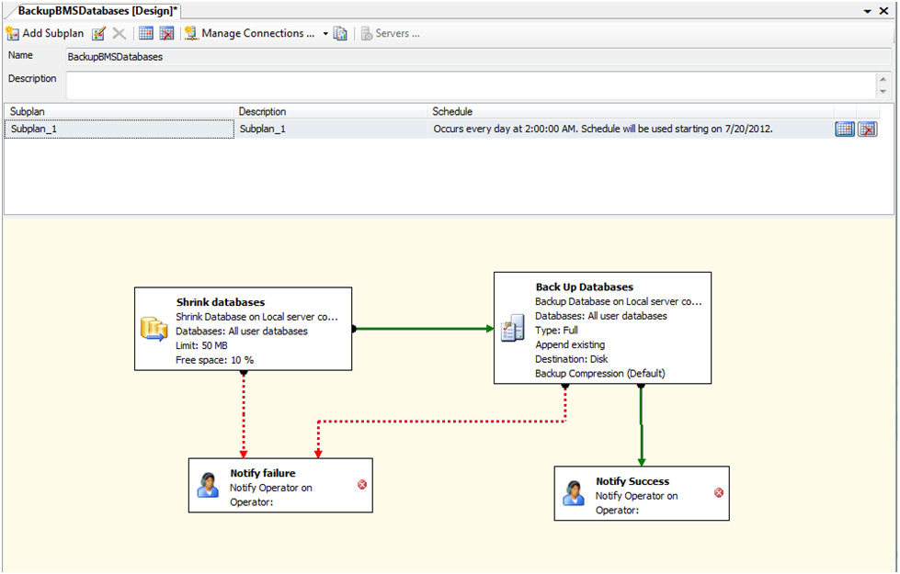

# 5 External Interfaces

*External relationships can be referenced from External Interfaces in this section.

# 

VistA and NUMI are the external interfaces that are connected with the BMS system (see screenshot below):

Figure -BMS External Interfaces

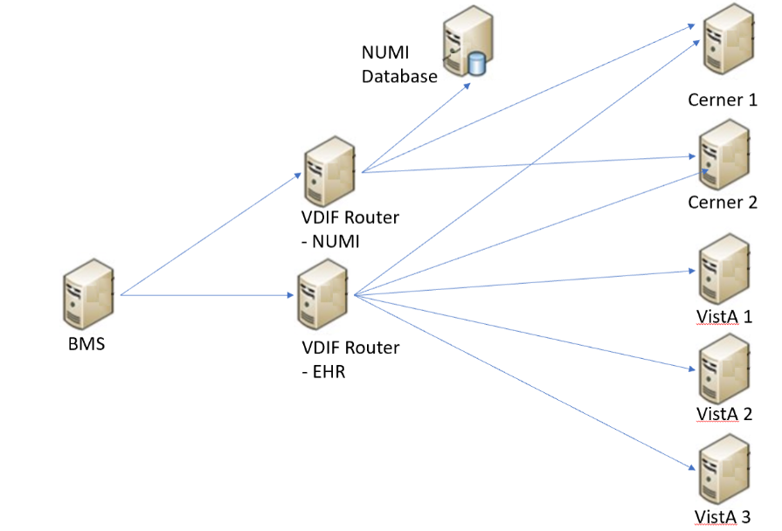

* All the VISTA deployments will be connected through VDIF which has replaced VIA. In order to connect to VDIF, BMS service configuration file (BMS.ServiceHost.exe.config) should be changed as follow, see Table 4 – BMS ServiceHost Configuration Parameter section:

Table 16-Configuration Values

|  |  |
| --- | --- |
| ServiceEndpointUrl | value=”https://vdif-lb-vwsl.va.gov/csp/healthshare/hsaccvdappl/HS.Local.VA.HS.Access.VWSL.Service.BMSRouterService.cls” |
| RequestingApp | value="BMSBatch" |
| WSDLusername | value="BMSB_ID577" |
| WSDLpassword | value=”*****” |
| STSEndpoint | value=”https://services.eauth.va.gov:9301/STS/RequestSecurityToken” |
| STSCertificatePath | value=”D:\\BMS_Services\BMSSYNC.pfx” |
| STSCertificatePassword | value=”******” |
| HostFQDN | value=”BMSAppServer” |
| MinimumFilemanDate | value=”01/01/1992” |

NUMI - A connection string to NUMI database needs to be set in service configuration file (BMS.ServiceHost.exe.config), see ***Table 4 - BMS ServiceHost Configuration Parameters*** section:

*<ConnectionString>Data Source=numiserver;Initial Catalog=NUMI;Integrated Security=True;</ConnectionString>.*

**NOTE**: All the configurations described above are using dummy servers and ports. Real deployment should use appropriate server, port and database connection strings.

# 6 Software Security

BMS Security is implemented at two levels:

* The first level of security consists in deciding which users have access to what pages (National/Regional, VISN, facility, EMS page).
* The second level of security refers to the read/write permissions (which are the pages a user can edit/update).

The security services are based on well-established standards and practices such as:

* LDAP protocol;
* WS-Security specification;
* X509 certificates.

These services are in charge of providing for the following ‘functionalities’:

* CIA:
  + Confidentiality – encrypted message.
  + Integrity – message hasn’t been tampered.
  + Authentication – prove identity.
* Authorization – role based access.
* Accountability – audit trail.
* Policies – mutually agreed by involved parties.

From the client application perspective, the security services are in charge of:

* Authentication:
* Role based authorization:
  + Roles stored in LDAP.
* Record level authorization.
* Audit trail.

The audit services provide the means to address the issues of liability management, asset protection and quality of service. To facilitate a timely response to policy violations, security incidents or infrastructure and application failures, InFlow will support monitoring, logging, analysing, and reporting on every level of its architecture.

## Authorization and Authentication

The Policy Manager has been removed as part of the Inflow-AUTHZ replacement. To perform modifications to Actions, Permissions, Roles, or Users, the BMS database tables below will be used.

Figure - New tables added to BMS database for Policy Manager Replacement

BMS "Auth" tables created in place of the Policy Manager


## BMS AuthAction table

The previously known “Operation Definitions” from using the policy manager have now been mapped to the new AuthAction table. Figure 44 displays the table example. The previous AuthActionUid has now been augmented with an integer primary key, AuthActionID. The AuthActionUid has been retained for backward compatibility, but will likely be phased out by the end of the Inflow project. The original “operation definitions” names have been maintained in the AuthActionName and AuthActionDescription fields, as well as the IsGroup and _ssis_timestamp.

Figure - AuthAction table

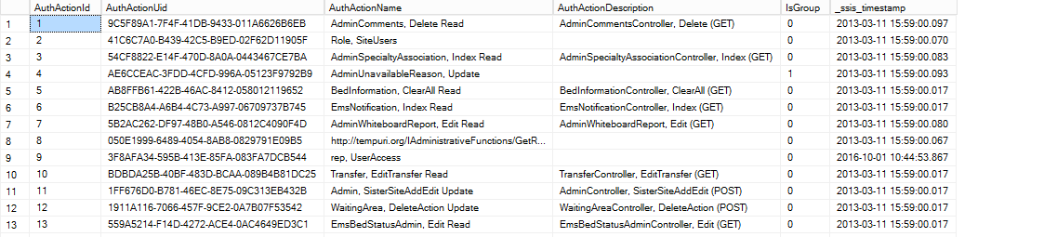

## BMS AuthPermissions table

The AuthPermission table handles the permission mappings between the facility, user, and Permission type. (read or write) utilizing the unique key AuthPermissionsId, AuthUserId, PermissionName, and FacilityId. LastModifiedDate and LastModifiedBy is kept for auditing purposes.

Figure - AuthPermissions table

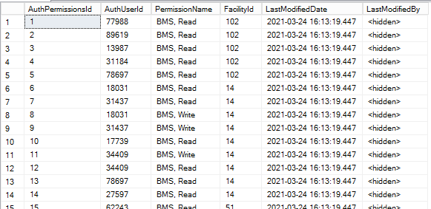

## BMS AuthRoles table

The AuthRoles table handles the Role definitions to be associated to Actions and Users. As noted in AuthAction, we’ve maintained the AuthRoleUid for backward compatibility, but added an integer primary key to quickly associate/join tables. The AuthRoleName, AuthRoleDescription column, AuthRoleAssigned, and _ssis_timestamp were maintained from the previous BMS_AUTHZ database.

Figure - AuthRoles table

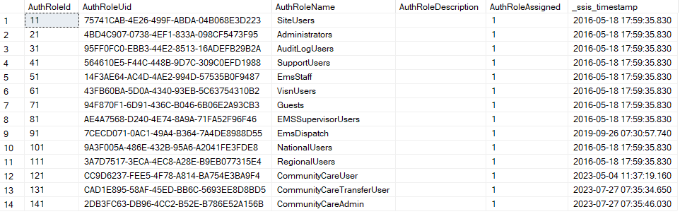

## BMS AuthRoleActions

The AuthRoleActions table associates the AuthActionId from the AuthActions table and the AuthRoleId from the AuthRoles table for purposes of tying the Roles and Actions together.

Figure - AuthRoleActions table

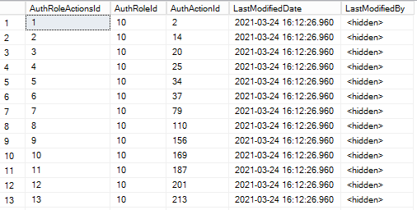

## BMS AuthUser table

The AuthUser table maintains BMS user information, with a new integer primary key, AuthUsername (hidden for security purposes), the previously tracked AuthUserSID and LegacyUserPK (kept for backwards compatibility), IsSuperUser, and _ssis_timestamp.

Figure - AuthUser table

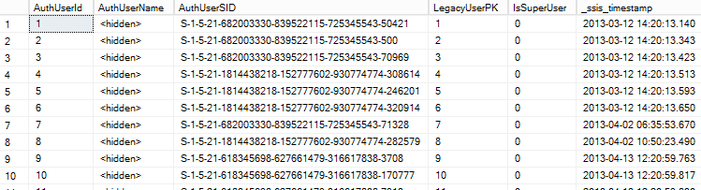

## BMS AuthUserRoles table

The AuthUserRoles table associates the User and the Role they are mapped to, using The AuthUserID and the AuthRoleID. The AuthUserRoles use the integer primary key column named AuthUserRolesId and also maintains the _ssis_timestamp.

Figure - AuthUserRoles table

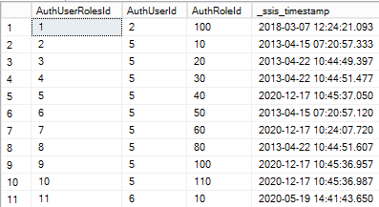

## BMS AuthActions Listing

The entire listing of AuthActions (previously known as Task Definitions) is presented below:

Table 17-BMS Operations

| **Operation Name** | **Operation Description** |
| --- | --- |
| Admin, AddEditUser Read | 'Add/Edit BMS User' hyperlink from the Administration section's menu. |
| Admin, FacilityEdit Read | 'Edit BMS Site' hyperlink from the Administration section's menu. |
| Admin, Index Read | 'BMS Admin' hyperlink from the National And Regional Page. |
| Admin, SelectUser Read | 'Select Existing NT User Name' button from the ADMINISTRATION SECTION - USERADD/EDIT page. |
| Admin, SisterSiteAddEdit Read | 'Edit Sister Sites' hyperlink from the Administration section's menu. |
| Admin, AddUserOperations Read | 'Add User' button from the ADMINISTRATION SECTION  - FACILITY EDIT page (Edit BMS Site submenu). |
| Admin, RemoveUsers Read | 'Remove Selected' button from the ADMINISTRATION SECTION - FACILITY EDIT page (Edit BMS Site  submenu). |
| Admin, SearchUser Read | 'Find' button from the 'Select user' page ('Select Existing NT User Name' button from the Administration Section  menu, 'Add/Edit BMS User' submenu). |
| Admin, SearchUsers Read | 'Find' button from the ADMINISTRATION SECTION - FACILITY EDIT page (Edit BMS Site submenu). |
| Admin, ClearCache Read | 'Clear Cache' link from the Administration section's menu. |
| Admin, AddEditUser Update | 'Submit' button from the ADMINISTRATION SECTION - USERADD/EDIT page. |
| Admin, FacilityEdit Update | 'Submit' button from Administration section's menu 'Edit BMS Site' hyperlink (page ADMINISTRATION SECTION  - FACILITY EDIT). |
| Admin, SisterSiteAddEdit Update | 'Edit Sister Sites' hyperlink from the Administration section's menu, 'Submit' button. |
| Admin, AddUserOperations Update | 'Add' button from Add users page (Add User button from the Facility page). |
| Admin, RemoveUserOperations Update | 'Remove Selected' button from the ADMINISTRATION SECTION - FACILITY EDIT page (Edit BMS Site  submenu). |
| AdminComments, Delete Read | 'Delete' hyperlink from the Common Medical Terms page. |
| AdminComments, Edit Read | 'Edit' hyperlink from the Common Medical Terms page. |
| AdminComments, Index Read | 'Common Medical Terms' hyperlink from the Administration section's menu. |
| AdminComments, Index Update | 'Save' button from the Common Medical Terms page. |
| AdminIcon, Delete Read | 'Delete Icon' button on ADMINISTRATION SECTION - EDIT ICON page (Add/Edit Icon Submenu) |
| AdminIcon, Edit Read | 'Edit' Link on ADMINISTRATION SECTION - ICON  ADD/EDIT page (Add/Edit Icon Submenu) |
| AdminIcon, Index Read | 'Add/Edit Icon' link on ADMINISTRATION SECTION |
| AdminIcon, Search Read | 'Search' Link on ADMINISTRATION SECTION - ICON  ADD/EDIT page (Add/Edit Icon Submenu) |
| AdminIcon, ViewIconReport Read | ''Report' Link on ADMINISTRATION SECTION - ICON  ADD/EDIT page (Add/Edit Icon Submenu) |
| AdminIcon, Delete Update | 'Remove' button on ADMINISTRATION SECTION - DELETE ICON page (Add/Edit Icon Submenu) |
| AdminIcon, Edit Update | 'Save' button on ADMINISTRATION SECTION - EDIT  ICON page (Add/Edit Icon Submenu) |
| AdminIcon, Index Update | 'Up/Down arrow' buttons on ADMINISTRATION SECTION - ICON ADD/EDIT page (Add/Edit Icon  Submenu) |
| AdminSpecialtyAssociation, Delete Read | 'Delete' Link on ADMINISTRATION SECTION - Treating Specialty/NUMA/HAvBED Edit page (Treating  Specialty/NUMA/HAvBED Submenu) |
| AdminSpecialtyAssociation, Index Read | 'Treating Specialty/NUMA/HAvBED' Link on ADMINISTRATION SECTION |
| AdminSpecialtyAssociation, Delete Update | 'Delete' Button on ADMINISTRATION SECTION - Treating Specialty/NUMA/HAvBED Delete page  (Treating Specialty/NUMA/HAvBED Submenu) |
| AdminSpecialtyAssociation, Index Update | 'Save' Button on ADMINISTRATION SECTION - Treating Specialty/NUMA/HAvBED Edit page (Treating  Specialty/NUMA/HAvBED Submenu) |
| AdminUnavailableReason, Delete Read | 'Delete' link on ADMINISTRATION SECTION - National Unavailable Reason page (National Unavailable Reason  Submenu) |
| AdminUnavailableReason, Edit Read | 'Edit' link on ADMINISTRATION SECTION - National Unavailable Reason page (National Unavailable Reason  Submenu) |
| AdminUnavailableReason, Index Read | 'National Unavailable Reason' Link on ADMINISTRATION SECTION |
| AdminUnavailableReason, Delete Update | 'Delete Record' button on ADMINISTRATION SECTION  - National Unavailable Reason Delete page (National Unavailable Reason Submenu) |
| AdminUnavailableReason, Edit Update | 'Submit' button on ADMINISTRATION SECTION - National Unavailable Reason Edit page (National Unavailable Reason Submenu) |
| AdminUnavailableReason, Index Update | 'Add' button on ADMINISTRATION SECTION - National Unavailable Reason page (National Unavailable Reason Submenu) |
| AdminWaitingArea, Delete Read | 'Delete' link on ADMINISTRATION SECTION - National Waiting Areas Parameter page (National Waiting Area Submenu) |
| AdminWaitingArea, Edit Read | 'Edit' link on ADMINISTRATION SECTION - National Waiting Areas Parameter page (National Waiting Area Submenu) |
| AdminWaitingArea, Index Read | 'National Waiting Area' Link on ADMINISTRATION SECTION |
| AdminWaitingArea, DeleteAction Update | 'Delete Record' button on ADMINISTRATION SECTION  - National Waiting Area Parameter Delete page (National Waiting Area Submenu) |
| AdminWaitingArea, Edit Update | 'Submit' button on ADMINISTRATION SECTION - National Waiting Area Parameter Edit page (National Waiting Area Submenu) |
| AdminWaitingArea, Index Update | 'Add' button on ADMINISTRATION SECTION - National Waiting Area Parameter page (National Waiting Area  Submenu) |
| AdminWhiteboardReport, Delete Read | 'Delete' link on ADMINISTRATION SECTION - Whiteboard Report page (Background Processor  Submenu) |
| AdminWhiteboardReport, Edit Read | 'Edit' link on ADMINISTRATION SECTION - Whiteboard Report page (Background Processor Submenu) |
| AdminWhiteboardReport, Index Read | 'Whiteboard Report' tab on ADMINISTRATION SECTION - Background Processor page |
| AdminWhiteboardReport, Delete Update | 'Delete Record' button on ADMINISTRATION SECTION  - Whiteboard Report Delete page (Background Processor Submenu) |
| AdminWhiteboardReport, Edit Update | 'Save' button on ADMINISTRATION SECTION - Whiteboard Report Edit page (Background Processor Submenu) |
| AdtOrderableItems, Index Read | Site Options, ADT Orderable Items Add/Delete hyperlink |
| AdtOrderableItems, Delete Update | 'Delete' hyperlink from the list of orderable items. |
| AdtOrderableItems, Index Update | 'Add' button from the Bed Board ADT Orderable Items Configuration. |
| BackgroundProcessors, Index Read | 'Backgroung Processors' hyperlink from Site Options page. |
| BackgroundProcessors, Index Update | 'Save Scheduler' button from Background Processors page within Site Options. |
| AuditLogReport, Index Read | 'View audit log' link on ADMINISTRATION SECTION |
| rep, Audit Log Report | Access the Audit Log Report. |
| BedBoard, ChangeFacility Read | Click on a facility link from the VISN Network Bed Boards list. |
| BedBoard, Index Read | 'Return to VISN Network' hyperlink from the home page. |
| BedBoard, ShowFacilityBedSummaryReport Read | Click on a Facility Summary Report on VISN Network Bed Boards list |
| BedBoard, ShowVISNBedSummaryReport Read | Click on a VISN Summary Report on VISN Network Bed Boards list |
| BedBoardModule, Index Read | Site Options, Bed Board Module Enable/Disable link. |
| BedBoardModule, Index Update | 'Submit' button from the Bed Board Module Activation and Configuration page. |
| BedInformation, Index Read | Ward Occupancy, click on a hyperlink from the BED column. |
| BedInformation, ClearAll Read | Click on button 'Clear ALL Comments For ALL Wards Associate To This Bed…'. |
| BedInformation, NotifyChange Read | 'Submit' button from the Add/Edit Bed Unavailable Reason page. |
| BedInformation, Index Update | Click on buttons 'Submit' and/or 'Update Reason and Comments'. |
| ContingencySettings, Index Read | 'Contingency Settings" link on Site Settings pages. |
| ContingencySettings, Index Update | 'Save' button on Contingency Settings page on Site Settings pages. |
| DischargeClinic, Index Read | Site Options, 'Discharge Appt Clinics Add/Delete' hyperlink. |
| DischargeClinic, Delete Update | Site Options, 'Discharge Appt Clinics Add/Delete' hyperlink, 'Delete' button. |
| DischargeClinic, Index Update | Site Options, 'Discharge Appt Clinics Add/Delete' hyperlink, 'Add' button. |
| EmsBedStatusAdmin, EMS Supervisor Read/Update | 'Assigned To' drop down on EMS Bed Edit page |
| EmsBedStatusAdmin, EMSBatchAssign Read | 'Batch Assign' button on Ems Bed Status Admin page |
| EmsBedStatusAdmin, EMSBatchAssign Update | 'Submit' button on EMS Bed Edit page on EMS Bed Status Admin page |
| EmsBedStatusAdmin, Edit Read | RoomBed column link click. |
| EmsBedStatusAdmin, Index Read | 'Return to VISN Network' link from the home page, 'Return to Regional Page' link, 'Go To Facility Bed  Cleaning Page (EMS Staff Only) button. |
| EmsBedStatusAdmin, SaveConfirmation Read | 'Submit' button click in the Environmental Management Service Bed Status page. |
| EmsBedStatusAdmin, Edit Update | 'Submit' button click in the Environmental Management Service Bed Status page. |
| EMSMobile, EMSList Read | Load Bed Clean Requests on EMS Mobile Pages |
| EMSMobile, Users Read | Click on a User button on EMS Mobile Pages |
| EMSMobile, EMSList Update | Click on a Bed Clean Request button on EMS Mobile Pages |
| EMSMobile, Users Update | Click on Submit button after entering a PIN on EMS Mobile Pages |
| EmsNotification, AddEdit Read | 'Edit' link from the Current Locations table (EMS Bed Notification). |
| EmsNotification, AddEditAction Read | 'Submit' button from the EMS Bed Notification Edit page. |
| EmsNotification, Delete Read | 'Delete' link from the Current Locations table (EMS Bed Notification). |
| EmsNotification, Index Read | Site Options, 'EMS Notification Add/Edit' link |
| EmsNotification, DeleteAction Update | 'Delete Record' button from the EMS Bed Status Notification Delete page. |
| EmsNotification, Index Update | 'Submit' button from the EMS Bed Notification Edit page or Notifications Add page. |
| EmsStaff, Delete Read | 'Delete' link on EMS Staff page on Site Options pages |
| EmsStaff, Edit Read | 'Edit' link on EMS Staff page on Site Options pages |
| EmsStaff, Index Read | EMS Staff link on Site Options page |
| EmsStaff, Delete Update | 'Delete Record' button on Ems Staff Delete page on Site Options pages |
| EmsStaff, Edit Update | 'Submit' button on Ems Staff Edit page on Site Options pages |
| EventNotification, AddConfirmation Read | 'Submit' button from the Event Notification Add page. |
| EventNotification, AddEdit Read | 'Add' button or 'Edit' link from the Event Notifications page. |
| EventNotification, EditConfirmation Read | 'Submit' button from the Event Notifications Edit page. |
| EventNotification, Index Read | Site Options, 'Event Notification Add/Edit' hyperlink. |
| EventNotification, Index Update | 'Submit' button from the Event Notification Add page. |
| Exception, Index Read | Appears when an exception occurs. |
| FacilityDiversion, Add Read | 'Add' button from the Facility Diversion page. |
| FacilityDiversion, AddConfirmation Read | 'Add' button from the Add New Diversion Status page. |
| FacilityDiversion, Edit Read | 'Edit' link from the Facility Diversion page. |
| FacilityDiversion, EditConfirmation Read | 'Save' button from the Diversion Status edit page. |
| FacilityDiversion, FilterDiversions Read | 'Current Diversions' or 'All Diversions' button from the main Facility Diversions page. |
| FacilityDiversion, Index Read | 'Facility Diversion' hyperlink from the home page. |
| FacilityDiversion, Index Update | 'Add' button or 'Edit' link from the Facility Diversion page. |
| FacilitySettings, Index Read | Site Options, Facility Settings link |
| FacilitySettings, Index Update | Site Options, Facility Settings link, Submit button |
| Home, Index Read | Home page. |
| Home, Index2 Read | Current, Past 30-Days, Past 60-Days, Past 90-Days home page's buttons. |
| Home, PatientInquiry Read | Click on the patient link from the Patients Pending Placement list (Home page). |
| Home, RemoveAdmission Read | Remove link from the Patients Pending Placement list (Home page). |
| Home, UndoRemoveAdmission Read | Undo link from the Patients Pending Placement list (Home page). |
| Home, RemoveAdmissionPost Update | Remove link from the Patients Pending Placement list (Home page), Remove button from the confirmation  page. |
| Home, UndoRemoveAdmissionPost Update | 'Undo' button on Undo Remove Admission Page on Facility HomePage |
| IconLegend, Index Read | 'Icon Legend' link from the bottom of the Home page or Site Options, BMS Icon Legend link. |
| IconLibrary, Edit Read | 'Edit' Link on Site Options - Site Configurable Icons page. |
| IconLibrary, Index Read | Site Options, Site Configurable Icons link. |
| IconLibrary, ResetConfirmation Read | 'Reset' button on Edit Site Configurable Icon page. |
| IconLibrary, Edit Update | 'Save' button on Site Options - Site Configurable Icons page. |
| IconLibrary, Index Update | 'Up/Down arrow' buttons on Site Options - Site Configurable Icons page. |
| IconLibrary, ResetConfirmation Update | 'Reset' button on Reset Site Configurable Icon page. |
| Information, Index Read | 'Information' link from the bottom of the Home page. |
| MaintainMarquee, Index Read | 'Maintain Marquee Text' link from the Administration Section's menu. |
| MaintainMarquee, ChangeMarquee Update | 'Submit' button from the ADMINISTRATION SECTION - MAINTAIN MARQUEE TEXT page. |
| NationalAndRegional, Index Read | Home page, Return to VISN Network link, Return to Regional Page link. |
| NewEvents, Index Read | Home page, New Events link. |
| Numi, Add Read | 'Add' button on ADMINISTRATION SECTION -  Background Processors page (Background Processors Submenu). |
| Numi, Delete Read | 'Delete' Link on ADMINISTRATION SECTION -  Background Processors page (Background Processors Submenu). |
| Numi, Edit Read | 'Edit' Link on ADMINISTRATION SECTION -  Background Processors page (Background Processors Submenu). |
| Numi, Index Read | 'Numi' tab on ADMINISTRATION SECTION -  Background Processors page (Background Processors Submenu). |
| Numi, Delete Update | 'Delete Record' button on ADMINISTRATION SECTION  - Background Processors Delete page (Background Processors Submenu). |
| Numi, Edit Update | 'Save' button on ADMINISTRATION SECTION - Background Processors Add/Edit page (Background  Processors Submenu). |
| <http://tempuri.org/IAdministrativeFunctions/GetDomain> s |  |
| <http://tempuri.org/IAdministrativeFunctions/GetCurrent> Domain |  |
| <http://tempuri.org/IAdministrativeFunctions/GetRoles> |  |
| <http://tempuri.org/IAdministrativeFunctions/GetBulkPoli> cies |  |
| <http://tempuri.org/IAdministrativeFunctions/GrantPermi> ssion |  |
| <http://tempuri.org/IAdministrativeFunctions/RevokePer> mission |  |
| <http://tempuri.org/IAdministrativeFunctions/GetRoleBy> Name | Functions used in the Administration Section, Add/Edit BMS User and Edit BMS Site submenus. |
| <http://tempuri.org/IAdministrativeFunctions/GetPermiss> ionsByResourceType |  |
| <http://tempuri.org/IAdministrativeFunctions/GetAllUser> sAndDomain |  |
| <http://tempuri.org/IAdministrativeFunctions/GetAllUser> Roles |  |
| <http://tempuri.org/IAdministrativeFunctions/AssignUser> |  |
| <http://tempuri.org/IAdministrativeFunctions/DeassignU> ser |  |
| <http://tempuri.org/IAdministrativeFunctions/GetPolicy> |  |
| <http://tempuri.org/IAdministrativeFunctions/ClearPermi> ssionsForResource |  |
| <http://tempuri.org/IAdministrativeFunctions/AddActionE> ntityType |  |
| <http://tempuri.org/IAdministrativeFunctions/AddOperati> on |  |
| <http://tempuri.org/IAdministrativeFunctions/AddRole> |  |
| <http://tempuri.org/IAdministrativeFunctions/AddTask> |  |
| <http://tempuri.org/IAdministrativeFunctions/AssignOper> ations |  |
| <http://tempuri.org/IAdministrativeFunctions/AssignRole> |  |
| <http://tempuri.org/IAdministrativeFunctions/ChangeUse> rPassword |  |
| <http://tempuri.org/IAdministrativeFunctions/DeassignO> perations |  |
| <http://tempuri.org/IAdministrativeFunctions/DeassignR> ole |  |
| <http://tempuri.org/IAdministrativeFunctions/DeleteActio> nEntityType |  |
| <http://tempuri.org/IAdministrativeFunctions/DeleteOper> ation |  |
| <http://tempuri.org/IAdministrativeFunctions/DeletePerm> issionForResourceAndOperation |  |
| <http://tempuri.org/IAdministrativeFunctions/DeletePerm> issionsForResourcesAndOperations |  |
| <http://tempuri.org/IAdministrativeFunctions/DeleteRole> | Functions used in the Administration Section, Add/Edit BMS User and Edit BMS Site submenus. |
| <http://tempuri.org/IAdministrativeFunctions/DeleteTask> |  |
| <http://tempuri.org/IAdministrativeFunctions/GetActionE> ntityTypes |  |
| <http://tempuri.org/IAdministrativeFunctions/GetAvailabl> eDomains |  |
| <http://tempuri.org/IAdministrativeFunctions/GetCallerIs> SuperUser |  |
| <http://tempuri.org/IAdministrativeFunctions/GetConnec> tedRolesAndOperations |  |
| <http://tempuri.org/IAdministrativeFunctions/GetEntityTy> pes |  |
| <http://tempuri.org/IAdministrativeFunctions/GetOperati> onByName |  |
| <http://tempuri.org/IAdministrativeFunctions/GetOperati> onByNameExcludingId |  |
| <http://tempuri.org/IAdministrativeFunctions/GetOperati> ons |  |
| <http://tempuri.org/IAdministrativeFunctions/GetRoleBy> NameExcludingId |  |
| <http://tempuri.org/IAdministrativeFunctions/GetRoleDef> inition |  |
| <http://tempuri.org/IAdministrativeFunctions/GetRolesD> efinitionIntersect |  |
| <http://tempuri.org/IAdministrativeFunctions/GetRoleUs> ers |  |
| <http://tempuri.org/IAdministrativeFunctions/GetSubscri> ptions |  |
| <http://tempuri.org/IAdministrativeFunctions/GetTaskBy> Name |  |
| <http://tempuri.org/IAdministrativeFunctions/GetTaskBy> NameExcludingId |  |
| <http://tempuri.org/IAdministrativeFunctions/GetTaskDe> finition |  |
| <http://tempuri.org/IAdministrativeFunctions/GetTasks> |  |
| <http://tempuri.org/IAdministrativeFunctions/GetUserBy> Sid |  |
| <http://tempuri.org/IAdministrativeFunctions/GetUserBy> UserName |  |
| <http://tempuri.org/IAdministrativeFunctions/GetUserDef> inedRoles |  |
| <http://tempuri.org/IAdministrativeFunctions/GetUserGr> oupId |  |
| <http://tempuri.org/IAdministrativeFunctions/GetUserRol> es |  |
| <http://tempuri.org/IAdministrativeFunctions/InsertPermi> ssionForResourceAndOperation |  |
| <http://tempuri.org/IAdministrativeFunctions/InsertPermi> ssionsForResourcesAndOperations | Functions used in the Administration Section, Add/Edit BMS User and Edit BMS Site submenus. |
| <http://tempuri.org/IAdministrativeFunctions/InsertReso> urce |  |
| <http://tempuri.org/IAdministrativeFunctions/IsChild> |  |
| <http://tempuri.org/IAdministrativeFunctions/RefreshCac> he |  |
| <http://tempuri.org/IAdministrativeFunctions/SearchUser> s |  |
| <http://tempuri.org/IAdministrativeFunctions/SetCurrent> Domain |  |
| <http://tempuri.org/IAdministrativeFunctions/Syncronize> AllSubscribers |  |
| <http://tempuri.org/IAdministrativeFunctions/UpdateOpe> ration |  |
| <http://tempuri.org/IAdministrativeFunctions/UpdateRole> |  |
| <http://tempuri.org/IAdministrativeFunctions/UpdateTas>k |  |
| Patient, Admission Read | 'Edit' link from the Home page, Patients Pending Placement list. |
| Patient, Select Read | 'Add New Patient' link from the Home page, Patients Pending Placement section. |
| Patient, Admission Update | 'Submit' button from ADD/EDIT Patients Pending Placement page. |
| rep, Active Admission Orders Report | Access the Active Admission Orders Report. |
| rep, Active Discharge Orders Report | Access the Active Discharge Orders Report. |
| rep, Active Transfer Orders Report | Access the Active Transfer Orders Report. |
| rep, Antic Discharge Orders Report | Access the Antic Discharge Orders Report. |
| rep, Audit Log Report | Access the Audit Log Report |
| rep, BED AVAILABILITY STATUS REPORTQu | Access the BED AVAILABILITY STATUS REPORT. |
| rep, Bed Specialty Report | Access the Bed Specialty Report. |
| rep, Bed Specialty Roster | Access the Bed Specialty Roster. |
| rep, Bed Summary Report | Access the Bed Summary Report. |
| rep, Bed Turnaround Time Report | Access the Bed Turnaround Time Report. |
| rep, Beds Out of Service Report (All) | Access the Beds Out of Service Report (All). |
| rep, Beds Out of Service Report (By Date) | Access the Beds Out of Service Report (By Date). |
| rep, Discharge Order Difference Report | Access the Discharge Order Difference Report |
| rep, Discharges In Progress | Access the Discharges In Progress. |
| rep, Emergency Management Report | Access Emergency Management Report |
| rep, EMS Bed Status Report (Admin) | Access the EMS Bed Status Report |
| rep, Facility Diversion Report | Access the Facility Diversion Report |
| rep, Icon Usage Report | Access the Icon Usage Report |
| rep, Patient Inquiry | Access the Patient Inquiry report. |
| rep, Patient Movement Report | Access the Patient Movement Report. |
| rep, Patient Movements by Date | Access the Patient Movements by Date. |
| rep, Patients w Discharge Appointments | Access the Patients w Discharge Appointments. |
| Rep, PPBP by Date Range Report | Access the PPBP By Date Range Report |
| rep, Scheduled Admissions by Date | Access the Scheduled Admissions by Date. |
| rep, Scheduled Admissions Report | Access the Scheduled Admissions Report. |
| rep, UserAccess | Access the UserAccess Report |
| rep, VISN Bed Summary Report | Access VISN Bed Summary Report |
| rep, VISN Emergency Management Report | Access the VISN Emergency Management Report |
| rep, VISN Diversion Report | Access the VISN Diversion Report |
| rep, VISN Network Active Report | Access the VISN Network Active Report. |
| rep, VISN Network Audit Report | Access the VISN Network Audit Report. |
| rep, VISN Network Contract Report | Access the VISN Network Contract Report. |
| rep, VISN Network Disposition Report | Access the VISN Network Disposition Report. |
| rep, Wait List Status Report | Access the Patients Pending Placement Status Report. |
| Reports, Index Read | 'Submit' buttons from the Home page corresponding to the reports. |
| SiteOptions, Index Read | Home page, Site Options link. |
| SiteOptions, EvacuationConfirmation Read | Access to Evacuation Confirmation page. |
| SiteOptions, Index Update | 'Submit' button from Site Options page. |
| SiteOptions, EvacuationConfirmation Update | 'Save' button from Evacuation Confirmation page. |
| Transfer, AddTransfer Read | VISN page, Add New Patient button, Submit button from the Select Patient page. |
| Transfer, EditTransfer Read | 'Edit' link from the VISN page, Patients in Community Hospitals list. |
| Transfer, FinalizeTransfer Read | 'Finalize' link from the VISN page, Patients in Community Hospitals list. |
| Transfer, Index Read | VISN page, Add New Patient button. |
| Transfer, AddTransfer Update | VISN page, Add New Patient button, Submit button from the Select Patient page, and Submit button from the Enter Patient Data page. |
| Transfer, EditTransfer Update | 'Edit' link from the VISN page's Patients in Community Hospitals list and then Submit button. |
| Transfer, FinalizeTransfer Update | 'Finalize' link from the VISN page's Patients in Community Hospitals list and then Submit button from the Finalize Patient Data page. |
| UnavailableReason, Delete Read | 'Delete' link from the Bed Board Site Unavailable Reason page's list. |
| UnavailableReason, Edit Read | 'Edit' link from the Bed Board Site Unavailable Reason page's list. |
| UnavailableReason, Index Read | Site Options, Unavailable Reason Add/Edit link. |
| UnavailableReason, Delete Update | 'Delete' link from the Bed Board Site Unavailable Reason page's list and then 'Delete Record' button. |
| UnavailableReason, Edit Update | 'Edit' link from the Bed Board Site Unavailable Reason page's list and then Submit button. |
| UnavailableReason, Index Update | 'Add' button from the Bed Board Site Unavailable Reason page. |
| UserConfiguration, Index Read | Site Options, Add/Edit BMS User link. |
| UserConfiguration, SearchUser Read | 'Find and Save' buttons from the 'Select user' page ('Select Existing NT User Name' button from the Site  Options, 'Add/Edit BMS User' link ). |
| UserConfiguration, SelectUser Read | 'Select Existing NT User Name' button from the Site Options - Add/Edit BMS User page. |
| UserConfiguration, Index Update | 'Submit' button from the Site Options - Add/Edit BMS User page. |
| VistaIntegration, Audit Read | 'Audit' tab on ADMINISTRATION SECTION -  Background Processors page (Background Processors Submenu) and 'Filter By' button from the 'Audit' tab. |
| VistaIntegration, Categories Read | 'VistA Integration' tab on ADMINISTRATION SECTION - Background Processors page (Background Processors Submenu). |
| VistaIntegration, DeleteScheduler Read | 'Add new scheduler' link and select a scheduled name from the 'Scheduled' tab. |
| VistaIntegration, Index Read | 'Background Processors' link on ADMINISTRATION SECTION. |
| VistaIntegration, Schedulers Read | 'Schedulers' tab on ADMINISTRATION SECTION - Background Processors page (Background Processors  Submenu). |
| VistaIntegration, TestMDWSConnection Read | 'TestMDWSConnection' button from the 'VistA Sites' tab. |
| VistaIntegration, TestODBCConnection Read | 'TestODBCConnection' button from the 'VistA Sites' tab. |
| VistaIntegration, VistASites Read | 'VistA Sites' tab on ADMINISTRATION SECTION - Background Processors page (Background Processors  Submenu). |
| VistaIntegration, Categories Update | 'Save and Run' buttons from the 'VistA Integration' tab. |
| VistaIntegration, DeleteScheduler Update | 'Delete' link from the 'Scheduled' tab and then 'Delete Record' button. |
| VistaIntegration, Schedulers Update | 'Save' button from the 'Scheduled' tab. |
| VistaIntegration, VistASites Update | 'Save' button from the 'VistA Sites' tab. |
| WaitingArea, Delete Read | 'Delete' link from the Patient Waiting Areas page's list of Current Waiting Areas. |
| WaitingArea, Edit Read | 'Edit' link from the Patient Waiting Areas page's list of Current Waiting Areas. |
| WaitingArea, Index Read | Site Options, Waiting Area Add/Delete link. |
| WaitingArea, DeleteAction Update | 'Delete' link from the Patient Waiting Areas page's list of Current Waiting Areas and then 'Delete Record button. |
| WaitingArea, Edit Update | 'Edit' link from the Patient Waiting Areas page's list of Current Waiting Areas and then Submit button. |
| WaitingArea, Index Update | 'Add' button from the Patient Waiting Areas page. |
| WardConfiguration, Delete Read | 'Delete' link from the Bed Board Ward Configuration, Current Vista Wards list. |
| WardConfiguration, Index Read | Site Options, Vista Ward Add/Edit link. |
| WardConfiguration, Index Update | Site Options, Vista Ward Add/Edit link, Save button. |
| WardConfiguration, DeleteWard Update | Site Options, Vista Ward Add/Edit link, Delete operation. |
| WardOccupancy, Index Read | 'Submit' button from the Home page corresponding to the Ward Occupancy. |
| WardWhiteboard, Edit Read | Click on a link from the BED column from WARD Whiteboard Report. |
| WardWhiteboard, EditPT Read | Click on a link from the PT column from the WARD Whiteboard Report. |
| WardWhiteboard, Index Read | Home page, 'Ward Whiteboard' link. |
| WardWhiteboard, NotifyChange Read | Click on a link from the BED column from WARD Whiteboard Report and then on the Submit button. |
| WhiteboardStaff, Index Read | Click on the checkbox from the STAFF column from the WARD Whiteboard Home. |
| WardWhiteboard, ShowReport Read | 'Export Report' link from the right of the WARD Whiteboard Home page or WARD Whiteboard Report page, Export Report. |
| WardWhiteboard, Submit Read | 'Submit' button from the WARD Whiteboard Home page. |
| WardWhiteBoard, WardWhiteBoard Read | Home page, 'Ward Whiteboard' link, Submit button from the WARD Whiteboard Home. |
| WardWhiteboard, ClearAll Read | Click on a link from the BED column from WARD Whiteboard Report and then click on the button 'Clear ALL Comments For ALL Wards Associate To This  Bed…'. |
| WardWhiteBoard, WardWhiteBoard Update | Click on a staff name from the STAFF column from the WARD WhiteBoard Report and then click on the image  'Save Staff'. |
| WhiteboardStaff, Index Update | Click on the checkbox from the STAFF column from WARD Whiteboard Report and then on the 'Save' button. |
| WardWhiteboard, Edit Update | Click on a link from the BED column from WARD Whiteboard Report and then on the Submit button. |

## Business scenarios and use cases

**Authentication**

Figure - Authentication Use Cases

Authentication Use Cases

| ***Section*** | ***Description*** |
| --- | --- |
| **Use Case Name** | User authentication |
| **Summary** | In the above diagram it is represented the methods that a client application can use to authenticate their users. |
| **Preconditions** | The users, that will use the client application, need to be defined in an Active Directory |
| **Triggers** | External |
| **Basic course of events** | 1. The client application will validate through SSOi 2. SSOi verifies the login information and BMS verifies the user has a role. 3. The system returns the result of the verification to the client application. |
|  |  |

**Authorization**

Figure - Authorization Use Cases

Authorization Use Cases

| ***Section*** | ***Description*** |
| --- | --- |
| **Use Case Name** | User authorization |
| **Summary** | In the above diagram it is represented the methods that a client application can use to check if an authenticated user has access to a specified action on a resource. |
| **Preconditions** | The users, actions and resources must be defined in an Active Directory structure that the Security Service is using. |
| **Triggers** | External |
| **Basic course of events** | 1. The client application will invoke a check access method for a specified action on a specific resource 2. The system will find the actions that the requesting users has access 3. The system returns true/false if the action requested is among the users defined actions   Figure - Authorization Administration Use Cases |

Authorization Administration Use Cases

|  |  |
| --- | --- |
| ***Section*** | ***Description*** |
| **Use Case Name** | Action and resource management |
| **Summary** | Administrative console can define actions and resources and associate an action with a resource type. |
| **Preconditions** | The association method mandates that the action and the resource type should already be defined |
| **Triggers** | External |
| **Basic course of events** | 1. The client application will invoke a create action 2. The system will try to create requested action. 3. The system will fail if the specified action name already exists, or specified id already exists. |

| ***Section*** | ***Description*** |
| --- | --- |
| **Use Case Name** | Role management |
| **Summary** | Administrative console can define user roles and associate users/user groups with roles. |
| **Preconditions** | The association method mandates that the role should already be defined |
| **Triggers** | External |
| **Basic course of events** | 1. The client application will invoke a create role 2. The system will try to create requested role. 3. The system will fail if the specified role name already exists, or specified id already exists. |

| ***Section*** | ***Description*** |
| --- | --- |
| **Use Case Name** | Security policy management |
| **Summary** | Administrative console can associate users (groups of users) with roles. These roles are then associated with and action (operation). |
| **Preconditions** | The association method mandates that the action and the resource type should already be defined. |
| **Triggers** | External |

# Detailed Functional Model on Each Interface

## BMS Authentication and Authorization

### Authentication

BMS connects with single sign-on (SSOi) and the user inputs their PIV pin. The SSOi headers are supplied by the SSOi service validating their user credentials to the BMS Application. Their user credentials are parsed from the SSOi headers in order to verify that the user is authenticated and has a role in the BMS application. If the user does NOT have a role in BMS, the login is rejected.

### Authorization

Authorization occurs within the BMS Service layer. The application utilizes the Security Wrapper to Check Action and Check Permission for the user’s account. The Security Wrapper queries the BMS database and the new Auth tables defined beginning in section 7.1.

* Check Action

Check Action queries the BMS database via the Security Wrapper for User Roles (BMS.AuthRole and BMS.AuthUserRoles) against the defined Actions (BMS.AuthAction and BMS.AuthRoleActions).

* Check Permission

The BMS Application validates the user’s permission via the Security Wrapper by calling the CheckPermission to determine Read or Write access to a specific facility. This functionality is primarily reading the BMS.AuthUser and BMS.AuthPermissions tables.

## Data contracts

Figure - Class Diagram for Data Contracts in PAP and PDP

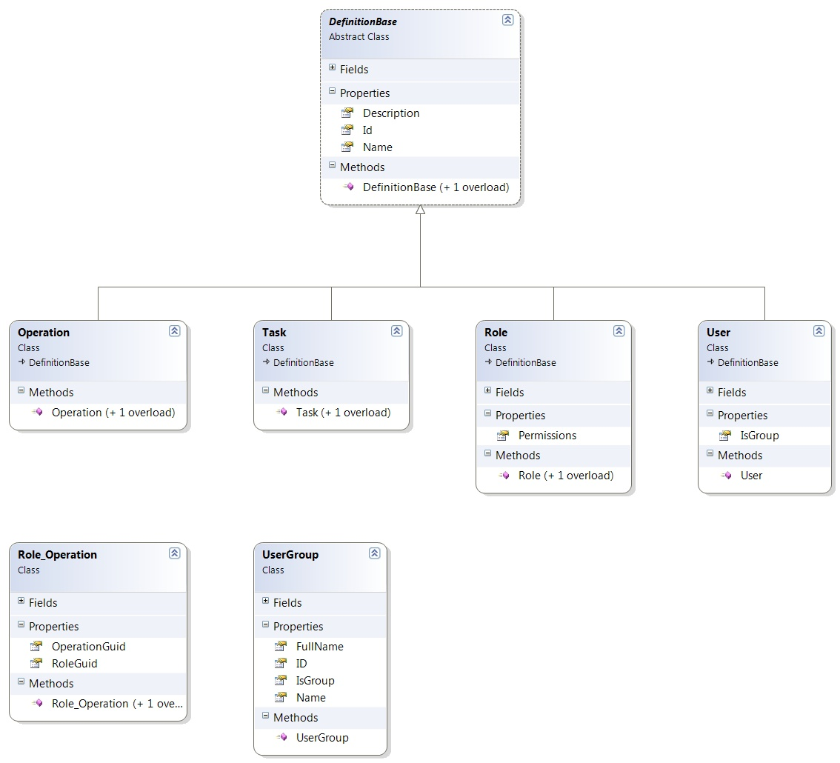

## BMS Roles

BMS users fall under the following categories:

**Administrators**: This type of user will customize the BMS settings according to the needs of a facility. They will have access to the Site Options pages. This role refers to a group of users whose members are the person(s) responsible for setting up BMS options for the current facility.

**AuditLogUsers:** This type of user will have access to Audit Log Report. This role cannot be used alone, only together with another role.

**CommunityCareUser:** This type of user will have access to the Community Care Tracking List page. Note that Admin User role or higher will always have this role’s permissions.

**CommunityCareTransferUser:** This type of user will have access to both the Community Care Tracking List page and Add to PPBPL function. Note that Admin User role or higher will always have this role’s permissions. In addition, the Community Care Transfer User role will always have Community Care User role permissions automatically.

**CommunityCareAdmin:** This type of user will have access to the Community Care Sites page. Note that Admin User role or higher will always have this role’s permissions.

**EmsStaff**: The EMS group of users will be allowed to edit and update the bed cleaning process but not the other parts of the bed board. Any member of your EMS staff that will be interacting with BMS must be in this group.

**EMSSupervisorUsers:** The EMS supervisor group of users will be allowed to view the requests for bed clean operations, to filter existing requests by different criteria and to select requests in order to assign them to EMS staff. This role cannot be used alone, only together with EmsStaff role.

**Guests**: The guest user will be allowed to generate the National Bed Availability report from National/Regional page.

**National Users/Regional Users**: This type of user will have access to the National/Regional page only.

**Site Users**: This type of user only has access to the BMS facility page.

**Support Users**: This type of user will have access to the Administrative page of the BMS solution. They configure the sites for the BMS facilities and grant access and read/write rights to the users.

**VISN Users**: This type of user will have access to the pages of different facilities within the VISN where they have been granted access.

# Troubleshooting

This section contains information on common issues with using BMS solution and how those may be resolved.

## Symptom 1

When you try to load the BMS application, one of the following error messages appear:

Figure - 500 Server Error

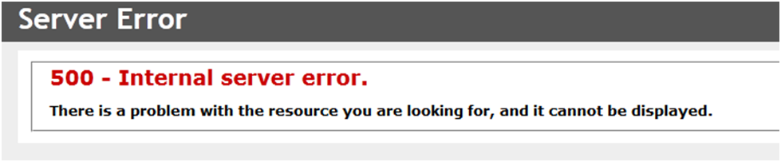

**Problem**

IIS is not started/running.

**Diagnoses and Solutions**

Start the IIS Manager and check if the Application Pool Identity is set to the correct service account. (). Verify the BMS pool is started, If stopped right click on the BMS, Select ‘Start’.

Verify the Site ‘BMS’ is started. If not select ‘BMS’ under the Site folder in IIS Manager, select ‘Start’ from the ‘Manage Web Site’ panel on the right side of the IIS Manager.

## Symptom 2

When trying to load the BMS application, one of the following error messages appears:

Figure - Unhandled Exception

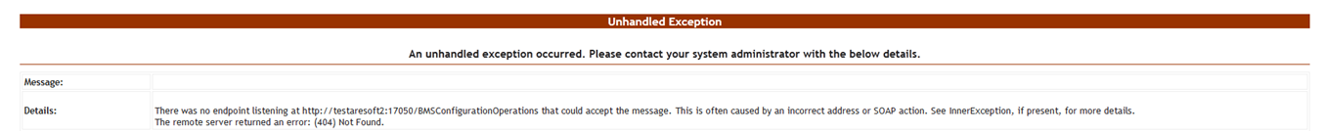

**Diagnoses and Solutions**

* Check if BMS.BMService service is stopped or SQL Server might also have stopped.
* Go to the SQL Server machine and start the SQL Server from the SQL Server Configuration Manager. Verify if the connection string to the database server is set properly.
* Then go to the services’ machine, start the services.msc console and start the BMS.BMService service.

## Symptom 3

A report is missing from Other Reports section on the Facility Home Page (e.g. *EMS Bed Status Report (Admin)*).

Figure - EMS Bed Status Report is Missing

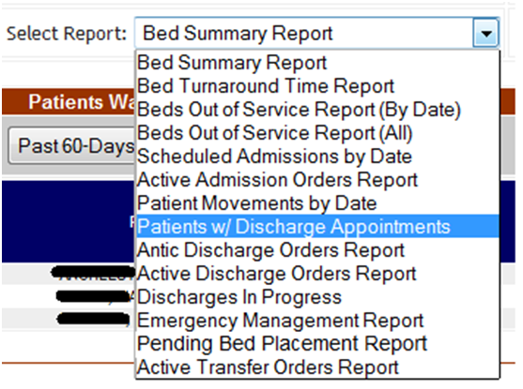

**Diagnoses and Solutions**

Check if the report is missing from the SQL Server Reporting Services. Go to the management web page and add the missing report (Upload File).

## Symptom 4

When trying to view one of the reports (other than the *Other Reports*) the following error appears:

Figure - Report Cannot be Found

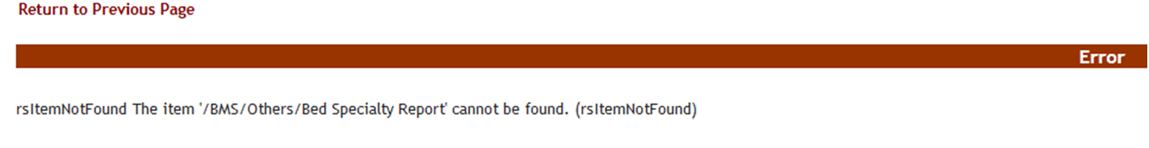

**Diagnoses and Solutions**

Check if the mentioned report is missing from the Reporting Services. Go to the management web page and add the specified report.

###### BMS Log Files

There are two log files available to anyone supporting the BMS system, the

**BMS.VI.ServiceHost** and the **WebTrace log**.

* The BMS.VI.ServiceHost logfile is named BMS.VI.trace.log and its location is on the application server (vaausbmsmulx6) at D:\BMS\Bin\BMS.
* The Web trace log is named WebTrace.log and its location is on the web server (vaausbmswebx5) at D:\BMS\BMS.Web.

These logs contain various types of information (informational, warnings, and errors) with the exception of the web trace log, which only contains error messages.

# Appendix A – BMS Diagrams

## Business Process Diagrams

Figure - Admit Patient to PPBP Business Process

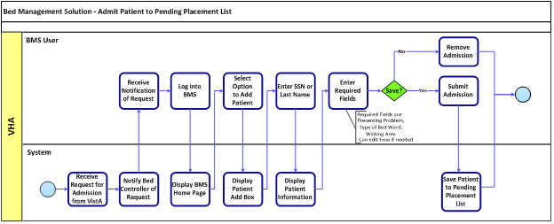

Figure - Transfer Patients to PPBP Business Process

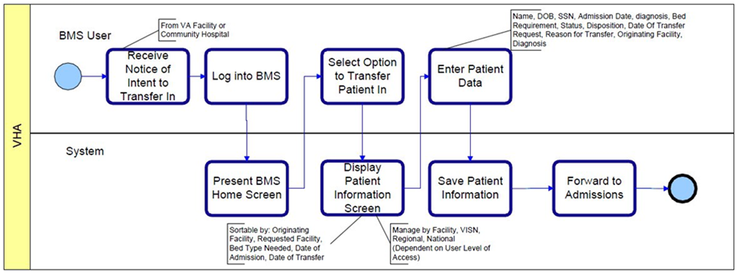

Figure - Display and Update PPBP Business Process

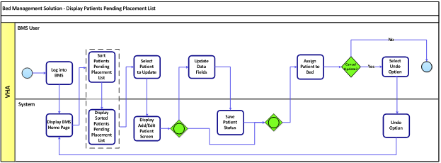

Figure - Display and Update Bed Status Business Process

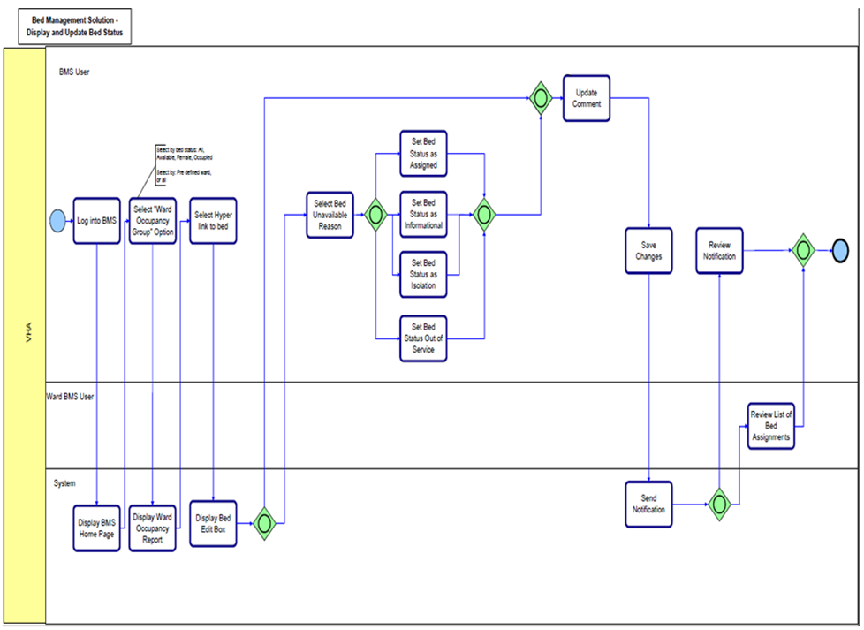

Figure - Manage Bed Cleaning Business Process

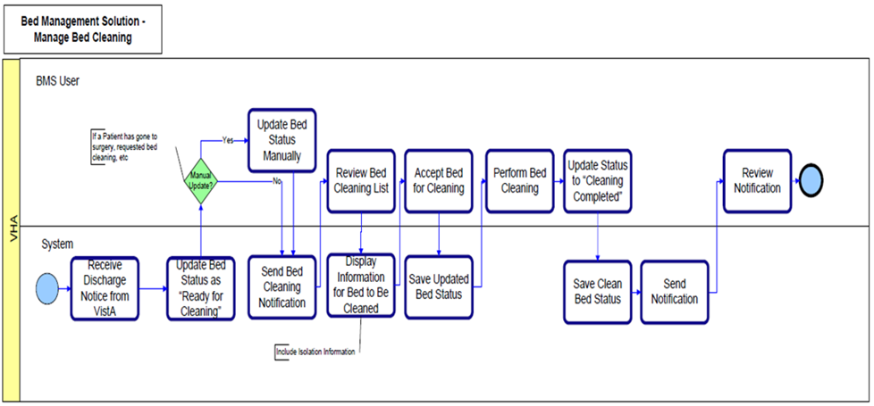

Figure - Create Notification Business Process

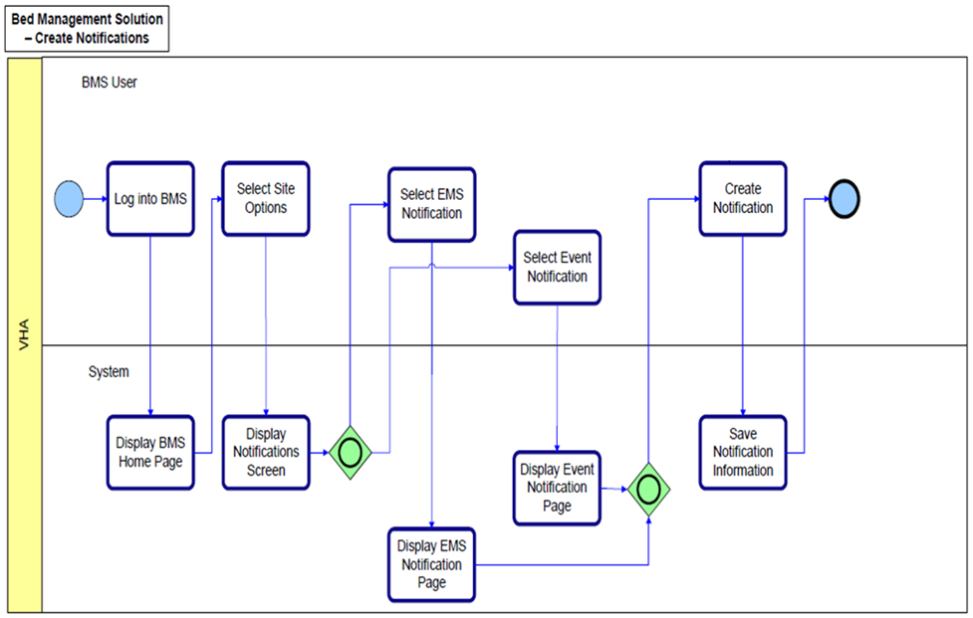

Figure - Create Facility Diversion Business Process

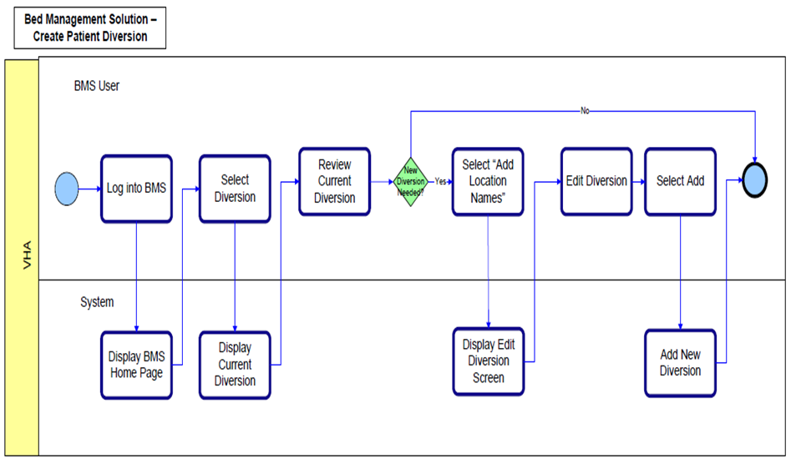

Figure - Manage Whiteboard Business Process

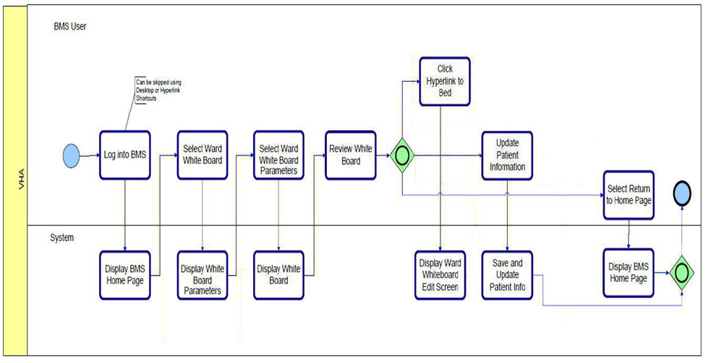

Figure - Reports Business Process

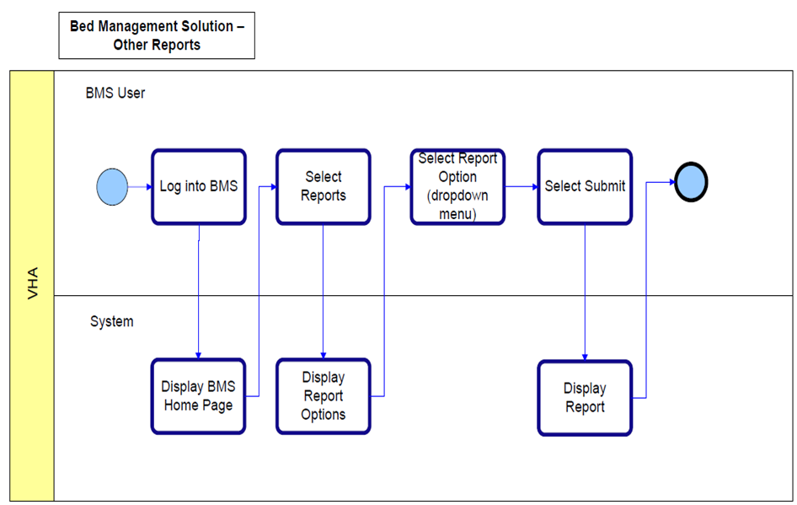

## Activity Diagram

Figure - BMS Overview Activity Diagram

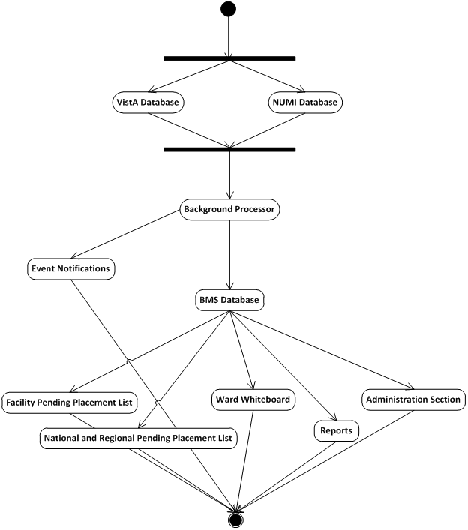

## Functional Flow Diagram

Figure - BMS Overview Functional Flow Diagram

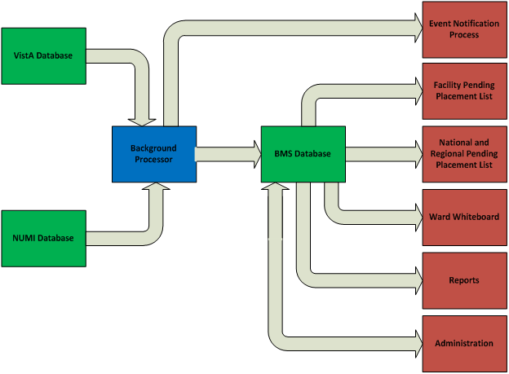

## Data Flow Diagram

Figure - BMS Overview Data Flow Diagram

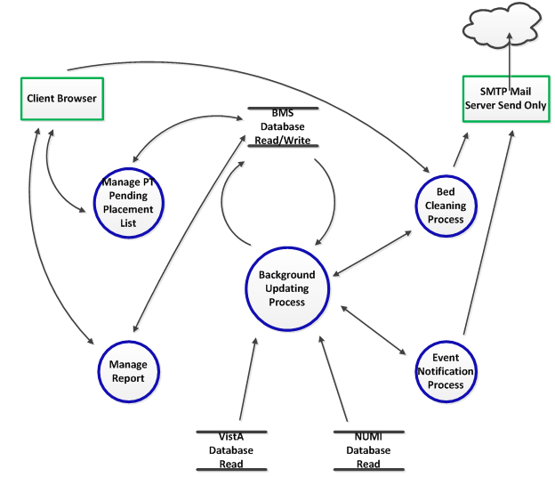



## Application Flow Map from APPDYNAMICS

Figure - Application Flow map from APPDYNAMICS

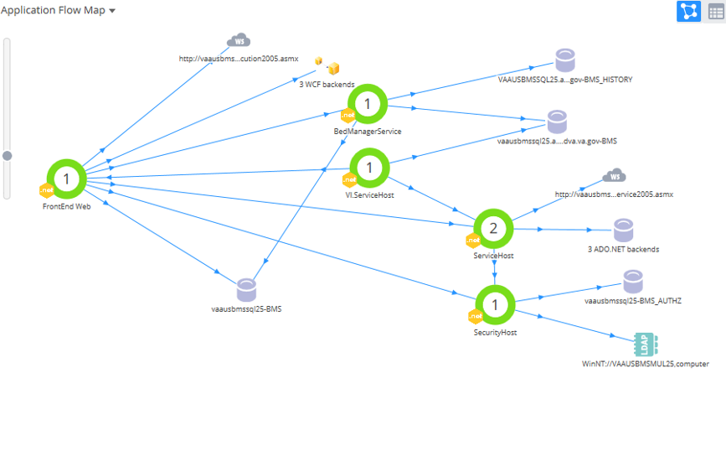

# 10 Appendix B - Terms, Acronyms, and Abbreviations

Table 18-Terms, Acronyms, and Abbreviations

|  |  |
| --- | --- |
| **Terms, Acronyms, Abbreviations** | **Definitions** |
| ASP | Active Server Pages |
| BMS | Bed Management Solution |
| CRUD | Create, Read, Update, Delete |
| EIS | Entity Identification Service |
| EMS | Environmental Management Service |
| ETL | Extract Transform Load |
| EVS | Enterprise Vocabulary Service |
| IE | Microsoft Edge |
| IIS | Internet Information Services |
| IRM | Information Resources Management |
| MDO | Medical Domain Objects |
| MDWS | Medical Domain Web Services |
| MVC | Model-View-Controller |
| NUMI | National Utilization Management Integration |
| ODBC | Open Database Connectivity |
| PAP | Policy Administration Point |
| PPBPL | Patients Pending Bed Placement List . A list of patients in need of beds at VA facilities |
| PPMS | Provider Profile Management System |
| PDP | Policy Decision Point |
| RS | Reporting Services |
| SOA | Service Oriented Architecture |
| SQL | Structured Query Language |
| STS | Secure Token Service |
| URI | Uniform Resource Identifier |
| URL | Uniform Resource Locator |
| VA | Department of Veterans Affairs |
| VAMC | VA Medical Center |
| VDIF | Veterans Data Integration and Federation |
| VIA | Vista Integration Adapter |
| VISN | Veterans Integrated Service Network |
| VistA | Veterans Health Information Systems and Technology Architecture |
| WCF | Windows Communication Foundation |
| XAML | Extensible Application Markup Language |
| XML | eXtensible Markup Language |
| WMI | Windows Management Instrumentation |