Bed Management Solution (BMS)

User Guide
Version 4.0
June 2024
Department of Veterans Affairs
Office of Information and Technology (OIT)

Revision History

Date | Revision | Description | Author
06/2024 | 4.2 | Updated for BMS patch version 4.2.  The following figure was updated:  Figure 47 - Remove Patient from the Pending Bed Placement List Confirmation | Booz Allen Hamilton
05/2024 | 4.1 | Updated for BMS patch version 4.1.  The following sections were removed:  2.x System Summary  3.4.4 Bed Board Site Configuration Page  3.4.8 Administration Section  4.1 Facility Administrator Users  4.6 Support Users  5.x Troubleshooting  The following sections were updated:  1.1 Purpose  1.2 Intended Audience  1.3.5 Documentation Conventions  1.4 Continuity of Operation  1.5 Microsoft Edge Settings  2. Getting Started  3. Using the Software  3.1.1.3 Adding a Patient to the Patients Pending Bed Placement List  3.1.1.6 Removing Patient from the Patient Pending Bed Placement List  3.1.1.9 Ward Occupancy Report  3.1.1.17 Bed Occupancy Summary Report  3.1.1.30 Facility Diversion Report  3.4 VISN Users  3.4.6 VISN Audit Log Reports  The following sections were added:  3.4.7 VISN Emergency Management Report  The following figures were added:  Figure 21 - New Events  Figure 29 - Patients Pending Bed Placement List  Figure 30 - Patients Pending Bed Placement List – View drop-down menu and Save button  Figure 44 – Confirmation of edited record on Patient Pending Bed Placement List  Figure 55 – Bulk Remove Patients from the Patient Pending Bed Placement List Removal Disposition  Figure 64 - VISN Interfacility Transfer Sheet – successful confirmation  Figure 101: PPBP By Date Range Report – Community Care View and Reasons Using Community Care requirement  Figure 114 – Ward Whiteboard button  Figure 116 - Ward Whiteboard Home – Footer Census  Figure 217 –Interfacility Transfer Patient confirmation screen  Figure 219 - VISN Bed Summary Report link  Figure 221 - VISN Bed Boards Page – Summary Reports  Figure 224 - VISN Bed Boards Page – Select Report: ACTIVE  Figure 226 - VISN Bed Boards Page – Select Report: CONTRACT  Figure 228 - VISN Bed Boards Page – Select Report: DATE AUDIT  Figure 230 - VISN Bed Boards Page – Select Report: DISPOSITIONS  Figure 248 – National Bed Availability link  Figure 249 – BMS National/Regional Home Page VISN link example  The following figures were updated:  Figure 31 - PPBP Column Grouping Action  Figure 32 - PPBP Column Grouping Result  Figure 35 - PPBP Customize button and removing Presenting Problem example  Figure 36 – Reset button  Figure 43 - Edit Details of the Patient Pending Bed Placement List  Figure 50 – Isolation Required checkbox  Figure 53 - Remove Patient from the Pending Bed Placement List Confirmation  Figure 56 - Patients Pending Bed Placement: Past 30-Days  Figure 62 - VISN Interfacility Transfer Sheet – Enter Patient Data  Figure 63 - VISN Interfacility Transfer Sheet – Enter Patient Data  Figure 100: PPBP By Date Range Report  Figure 110 – New Events link  Figure 112 - New Events Page Export Report link  Figure 123 - Selecting a Bed from the Ward Whiteboard Page  Figure 125 – Out of Service Reason and required Expected OOS End Date  Figure 128 - Selecting a Bed from the Ward Whiteboard Page  Figure 200 - Select Diversion Report Type  Figure 201 - Select Diversion Report Specialty  Figure 202 - Select Diversion Report Date Ranges and Active value  Figure 203 - VISN Diversion Report Results  Figure 213 - VISN Interfacility Transfer Sheet – Enter Patient Data  Figure 216 - Finalize a Patient’s Stay in Community Hospital  Figure 218 - VISN Bed Boards Page – Summary Reports  The following tables were updated:  Table 2 - VA Facility Standard View  Table 3 - VA Facility Community Care View Parameters  Table 4 - VA Facility Patient Flow View Parameters  Table 5 - VA Facility In-House View Parameters  Table 6 - VA Facility DOM/RRTP View Parameters  Table 7 - VA Facility Emergency Mgmt View Parameters  Table 8 - Add/Edit Patients Pending Bed Placement – Parameters  Table 30 - PPBP By Date Range Report Parameters  Table 56 - National Patients Pending Bed Placement - Parameters | Booz Allen Hamilton
01/2024 | 3.8 | Updated for BMS patch version 3.8.  The following figures were updated:  Figure 10 - BMS Bed Board Site Configuration/Site Options Screen  Figure 19 - Bed Board Site Configuration Page  Figure 22 - Selecting VistA Ward Add/Edit Page  Figure 25 - Selecting VistA Ward Add/Edit Page  Figure 29 - Selecting VistA Ward Add/Edit Page  Figure 32 - Selecting BMS Orderable Items Add/Delete  Figure 35 - Selecting BMS Orderable Items Add/Delete  Figure 41 - Selecting EMS Notification Add/Edit  Figure 46 - Selecting EMS Notification Add/Edit  Figure 50 - Selecting EMS Notification Add/Edit  Figure 54 - Selecting Facility Settings  Figure 59 - Selecting EMS Portal Access  Figure 63 - Selecting EMS Portal Access  Figure 67 - Selecting EMS Portal Access  Figure 70 - Selecting Unavailable Reason Add/Edit  Figure 73 - Selecting Unavailable Reason Add/Edit  Figure 76 - Selecting Unavailable Reason Add/Edit  Figure 80 - Selecting Unavailable Reason Add/Edit  Figure 83 - Selecting Discharge Appt Clinics Add/Delete  Figure 86 - Selecting Discharge Appointment Clinics Add/Delete  Figure 88 - Selecting Event Notification Add/Edit  Figure 91 - Selecting Event Notification Add/Edit  Figure 95 - Selecting Event Notification Add/Edit  Figure 99 - Selecting Event Notification Add/Edit  Figure 102 - Selecting Site Configurable Icons  Figure 105 - Selecting BMS User Add/Edit  Figure 108 - Selecting BMS User Add/Edit  Figure 111 - Customize BMS Facility Site User Rights  Figure 113 - Selecting BMS User Add/Edit  Figure 116 - Customize BMS Facility Site User Rights  Figure 118 - Selecting BMS User Add/Ed  Figure 121 - Customize BMS Facility Site User Rights  Figure 122 - Selecting Background Processors  Figure 126 - Selecting Waiting Area Add/Delete  Figure 129- Selecting Waiting Area Add/Delete  Figure 133 - Selecting Waiting Area Add/Delete  Figure 138 - Selecting Waiting Area Add/Delete  Figure 142 - Selecting Icon Usage Report  Figure 145 - BMS Bed Board Site Configuration BMS Icon Legend Screen  Figure 147 - BMS Bed Board Site Configuration / View Audit Log Screen  Figure 162 - Bed Board Site Configuration Page Contingency Settings  Figure 164 - Evacuation On/Off  Figure 209 - Edit Details of the Patient Pending Bed Placement List  Figure 388 - Customize BMS user rights  Figure 390 - Edit BMS user rights  Figure 393 - Customize BMS user rights  Figure 411 - Facility Site Options Page  Figure 415 - Facility Site Options Page  The following tables were updated:  Table 12 - BMS Facility Site User Parameters  Table 26 - VA Facility Community Care View Parameters  Table 31 - Add/Edit Patients Pending Bed Placement – Parameters  Table 53 - PPBP By Date Range Report Parameters  Table 71 - BMS User Parameters  The following sections were updated:  1.3 Document Orientation  2.4 User Level Access  3 Getting Started  4 Using the Software  4.1 Facility Administrator Users  The following sections were added:  4.2 Community Care Sites  The following tables were updated:  Table 78 - Acronyms/Abbreviations | Booz Allen Hamilton
8/2023 | 3.4 | Updated for BMS version 3.4. The following figures were updated:  Figure 172 – BMS Facility Patients Pending Bed Placement List- Stnadard View  Figure 173 – Patients Pending Bed Placement List – Community Care View  Figure 189 – Edit Details of the Patient Pending Bed Placement List  Figure 39 - Isolation Required Checkbox  The following tables were updated:  Table 30 - Add/Edit Patients Pending Bed Placement – Parameters | Booz Allen Hamilton
7/2023 | 3.7.2 | Updated for BMS RFC June 2023. The following figures were updated:  Figure 242 PPBP By Date Range Report  The following figures were added:  Figure 243: Community Care Comments  Figure 354: Network Active Report  The following tables were updated:  Table 64 Network Active Report  Added note to 4.2.1.32 below Table 52  Added description of community care comments | Booz Allen Hamilton
6/2023 | 3.7 | Updated for BMS version 3.7. The following figures were updated:  Figure 123 Facility Background Processors  Figure 124 Facility Background Processors  Figure 426 Background Processors Page  Figure 427 Background Processors Page – Adding a VistA Site  Figure 429 VistA Integration Tab  Figure 430 Audit Page  Figure 431 View Audit Results  The following tables were updated:  Table 75 -Removed and all subsequent table numbers were updated  Table 76 -Removed references to method for operations  Table 78 -Added VDIF acronym  The following sections were updated:  4.1.12 Removed references to Add/Update Method from background processors  4.9.12.1 Added save information  4.9.12.4 Removed references to configuration Method for background processors on VistA site | Booz Allen Hamilton
3/7/2023 | 3.3 | Updated for BMS version 3.3. The following figures were updated:  Figure 188 Add/Edit Patients Pending Bed Placement in the VA Facility - Details  Figure 189 Edit Details of the Patient Pending Bed Placement List  Figure 190 Isolation Required Checkbox  Figure 194 Add/Edit Patients Pending Bed Placement  Figure 205 VISN Interfacility Transfer Sheet – Enter Patient Data  Figure 206 VISN Interfacility Transfer Sheet – Enter Patient Data  The following tables were updated:  Table 30 Add/Edit Patients Pending Bed Placement – Parameters  Table 31 Interfacility Transfer Parameters  Redactions of patient/provider names were updated on all images to keep with VA redaction formatting (Lastname. Firstname written as One, Provider; Two, Provider; etc) | Booz Allen Hamilton
4/7/2022 | 2.11 |  | Booz Allen Hamilton
9/28/2021 | 2.9 | Updated for BMS version 2.9. The following figure was updated:  - to reflect use of fully qualified domain name in Whiteboard Kiosk Default User Name field  The following tables were updated:  - : to reflect use of fully qualified domain name in Whiteboard Kiosk Default User Name field
9/1/2021 | 2.9 | - Updated for BMS version 2.9. The following figures were updated:Error! Not a valid bookmark self-reference. and Error! Not a valid bookmark self-reference.– to reflect new fields for Auto-Remove Edis Patients from PPBP list and Auto Placement of Transfers onto PPBP list  - Figure 89 - Patient Pending Bed Placement List Status Report Criteria - to reflect field name change from “Community Services” to “Community Specialty”  The following table was updated:  - Error! Not a valid bookmark self-reference. - to reflect new fields for Auto-Remove Edis Patients from PPBP list and Auto Placement of Transfers onto PPBP list and Integrated Sites  Removed Bed Board Module Enable/Disable Configuration page information from Section 4.1- | Liberty ITS
4/12/2021 | 2.8 | Updated for BMS version 2.8. The following figure was added:  The following Table was added:  The following figure was updated:  - Figure 107 - Patient Movement Report - to reflect change in title “Patient Movements – All Wards” to “Patient Movement (PM) – All Wards” and “IEN” to “PM IEN”. | Liberty ITS
3/10/2021 | 2.8 | Updated for BMS version 2.8. The following figure was updated:  - Figure 171 - Select Bed Clean Request for Assignation | Liberty ITS
2/15/2021 | 2.8 | Updated for BMS version 2.8. The following section was added:  - 4.1.16.5 Error! Not a valid bookmark self-reference.  The following figures were updated:  - Figure 87 - Patient Movement Report by Date Range - to reflect change to reflect change in title “Patient Movements – All Wards” to “Patient Movement (PM) – All Wards”, “IEN” to “PM IEN”.  - Figure 213 - Network Audit Report and Figure 215 - Network Disposition Report - to reflect added column “Event Entered Date”  The following tables were updated:  - Table 28 - Patient Movement Report by Date Parameters - to reflect change “IEN” to “PM IEN” and D(ate)/T(ime) being changed to D/T as shown in report.  - Table 45 - Network Audit Report and Table 46 – Network Disposition Report – to reflect added column “Event Entered Date”  - Table 17 - Active Admission Orders Parameters, Table 18 - Active Discharge Orders Parameters, Table 19 - Anticipated Discharge Orders Parameters, Table 25 - Discharges in Progress Parameters, Table 27 - Future Discharge Report Parameters, Table 31 – Bed Switch Report Parameters - to reflect D(ate)/T(ime) being changed to D/T as shown in report | Liberty ITS
12/9/2020 | 2.6 | Updated for BMS version 2.6. The following figures were updated:  - Figure 7 - Facility Home Screen Logout, Figure 125, Figure 9 - VA Facility Homepage, Figure 12 - Census Category Selection, Figure 13 - Census Category Percentage, Figure 14 - Ward Census, Figure 17 - BMS Facility Patients Pending Bed Placement List – Standard View, Figure 18 - Patients Pending Bed Placement List – Community Care View, Figure 19 - Patients Pending Bed Placement List – Patient Flow View, Figure 20 - Patients Pending Bed Placement List – In-House Patients View, Figure 21 - Patients Pending Bed Placement List – DOM/RRTP Patients View, Figure 22 - Patients Pending Bed Placement List – Emergency Mgmt Patients View, Figure 25 - PPBP Column Grouping Action, Figure 26 - PPBP Column Grouping Result, Figure 27 - PPBP Column Ordering Action, Figure 28 - PPBP Column Ordering Result, Figure 29 - PPBP Customize, Figure 33 - Adding a Patient to the Patients Pending Bed Placement List, Figure 40 - Add New Patient in Patient Pending Bed Placement List, Figure 45 - Patients Pending Bed Placement List Showing Isolation Icon,  - Figure 46 - Remove Patient from the Pending Bed Placement List, Figure 50 - Patients Pending Bed Placement: , Figure 51 - Undo Remove Patient from the Patient Pending Bed , Figure 59 - Report Page Navigation, Figure 99 - Selecting Facility Diversion,  - Figure 127 - Standard View of Patient Pending Bed Placement List, Figure 128 - Emergency Management View of Patient Pending Bed Placement List, Figure 136 - Selecting Ward Whiteboard, Figure 144 - Selecting Ward Whiteboard, Figure 151 - Selecting Ward Whiteboard, Figure 156 - Selecting Ward Whiteboard, Figure 299, Figure 163 - Edit Details of the Patient, Figure 242 - BMS National/Regional Home Page, - to reflect added columns “SVC” and “Standard Icons” and Emergency Icons”.  The following tables were updated:  - Table 2 - VA Facility Standard View Parameters, Table 3 - VA Facility Community Care View Parameters, Table 4 - VA Facility Patient Flow View Parameters, Table 5 - VA Facility In-House View Parameters, Table 6 - VA Facility DOM/RRTP View Parameters and Table 7 - VA Facility Emergency Mgmt View Parameters - to reflect added columns “SVC” and “Standard Icons” and Emergency Icons”. | Liberty ITS
11/17/2020 | 2.6 | Updated for BMS version 2.6. Added the following Sections:  - Section 1.2 Purpose  - Section 1.3 Document Orientation  - Section 2.2  - Section 2.3  - Section 2.4  - Section 2.5 Continuity of Operation  - Section 3.5 Exit System  - Section 4.2.1.4 .  - Section 4.9.4.1 .  - Section 4.9.4.2  The following Figures were updated:  - Figure 127 - Standard View of Patient Pending Bed Placement List, Figure 128 - Emergency Management View of Patient Pending Bed Placement List  The following Tables were updated:  - to change the wording “Virtual” Ward to “Combined” Ward | Liberty ITS
10/06/2020 | 2.5 | Updated for BMS version 2.5. Updated Index. Updated Section 4.5.1 to include the VISN Diversion Reports and the VISN Emergency Management Reports. The following Figures were added:  - The View Emergency Mgmt. Report link provides access to the various Emergency Reports, for details on the Emergency Mgmt. reports see the section Emergency Management Report Page  - Figure 236 - VISN Bed Board Page, Figure 237 - Select Emergency Management Report Type and Facility, Figure 238 - VISN Emergency Management Report – Roster, Figure 239 - VISN Emergency Management Report – Regulate, Figure 240 - VISN Emergency Management Report – Manifest, Figure 241 - VISN Emergency Management Report – Patient Transfer  The following Tables were added:  Table 58 - VISN Emergency Management Reports Parameters | Liberty ITS
09/29/2020 | 2.5 | Updated for BMS version 2.5.  - Inserted Section 4.1.16.7 in Audit Log Report  - Inserted Section 4.2.4.7 Updating Multiple Beds in the Ward Whiteboard.  - Inserted Section 4.2.4.8 Returning Multiple Beds to Service in the Ward Whiteboard  - Inserted Section 4.2.4.9 Updating Multiple Patients with the Evacuation Icon in the Ward Whiteboard  - Inserted Section 4.1.16.7 in the Audit Log Report  - Inserted Section 4.1.16.8 in the Audit Log Report  - Updated Section 4.2.1 to include Census Category updates and Figure 12 - Census Category Selection, Figure 13 - Census Category Percentage, and Figure 14 - Ward Census  Inserted Section 4.2.4.10 Adding/Removing the Evacuation Icon in the Ward Whiteboard Home Page. | Liberty ITS
09/17/2020 | 2.5 | Updated for BMS version 2.5. The following Figures were updated:  - Figure 112 - Patient Information Display - the hover ability has been implemented to quickly view patient’s last name and last 4 digits of the SSN, if they have opted out of being displayed. | Liberty ITS
08/21/2020 | 2.5 | Updated for BMS version 2.5. The following Figures were updated:  - Figure 17 - BMS Facility Patients Pending Bed Placement List – Standard View – to reflect added columns “Presenting Problem”, “Community Care”, “Comments”, “Wait Time (h:m)” and deleted columns “Fee” and “Fee Comments”.  - Figure 19 - Patients Pending Bed Placement List – Patient Flow View - to reflect added columns “Presenting Problem” and “Wait Time (h:m)”.  - Figure 20 - Patients Pending Bed Placement List – In-House Patients View– to reflect deleted column “Removed”.  - Figure 21 - Patients Pending Bed Placement List – DOM/RRTP Patients View- to reflect added columns “Presenting Problem” and “Wait Time (h:m)”.  - Figure 22 - Patients Pending Bed Placement List – Emergency Mgmt Patients View - to reflect added column “Wait Time (h:m)”.  - – to reflect column “Removed”.  - Figure 118 - Taking a Bed Out of Service, Figure 121 - Ward Whiteboard Home – Return Bed to In Service and  - Figure 123 - Ward Whiteboard – No Patient Assigned - to reflect new button “Warning: Clears ALL Comments and Icons”  - Figure 168 - The Ward Whiteboard Page - to reflect new button “Warning: Clears ALL Comments and Icons”  The following Tables were updated:  - Table 3 - VA Facility Community Care View Parameters– to reflect added rows “Presenting Problem”, “Community Care”, “Comments” “Wait Time (h:m) and deleted columns “Fee” and Fee Comments”.  - Table 4 - VA Facility Patient Flow View Parameters - to reflect added rows “Presenting Problem” and “Wait Time (h:m)”.Table 6 - VA Facility DOM/RRTP View Parameters- to reflect added rows “Presenting Problem” and “Wait Time (h:m)”.  - Table 7 - VA Facility Emergency Mgmt View Parameters - to reflect added row “Wait Time (h:m)”.  Table 33 - PPBP By Date Range Report Parameters – to reflect column “Removed” | Liberty ITS
08/12/2020 | 2.5 | Updated for BMS version 2.5. The following Figures were updated:  - Figure 80 - Emergency Management Report – Roster – to reflect sort capability in “Current/Needed Bed Type”  - Figure 81 - Emergency Management Report – Regulate - to reflect sort capability in “Current/Needed Bed Type”  - Figure 82 - Emergency Management Report – Manifest - to reflect sort capability in “Current/Needed Bed Type”  Updated all Figure numbers and Table numbers. Updated Document Standards and Style. | Liberty ITS
07/23/2020 | 2.5 | Updated for BMS version 2.5.  The following Figure was updated:  – to reflect added ability to multiple users | Liberty ITS
07/17/2020 | 2.5 | Updated for BMS version 2.5. The following Figures were updated:  - Figure 77 - ALL Current Beds Out of Service Report– to reflect ‘Out of Service’ wording from red to black standard font  - – to reflect added columns “Created By”, “Created Date”, “Edited By” and “Edited Date”  The following Tables were updated:  - Table 22 - Beds Out of Service (All) Parameters– to reflect added column “Reason” and remove column “User Clearing Data”  - .- to reflect added columns “Created By”, “Created Date”, “Edited By” and “Edited Date” and remove “Transaction Updates” | Liberty ITS
07/01/2020 | 2.4.1 | - Updated Section 4.2.2 Facility Diversion which allows for an Empty End Date while the Diversion is active.  - Removed section referring to Staff Assignment Report content in Section 4. | Redacted
06/13/2020 | 2.4 | Updated Section 4.1.7 to clarify that the Add/Edit Unavailable Reason is now only available for users with the Support Role and section 4.2.4.1 to indicate that out of service types except activate on demand will require a return service date selection to allow the bed to be taken out of service. | Redacted
04/20/2020 | 2.4 | User Bulk Add / Edit feature is removed from the admin and facility user/edit sections. | Redacted
01/13/2020 | 2.4 | Inserted Section 4.9.6.4 Configuring Auto-Icons for use in BMS. P249.  Added guidance for the use of Keyboard Shortcuts on the Patients Pending Bed Placement (PPBP) screen. Pages 45 and 136.  Updated screenshots for Whiteboard, added reference to the latest RTM for tracking back to the appropriate User guide sections/pages in Section 6.  Added Section 3.2.4 Utilization of Color and 508 Standards Compliance, updated Images.  Replaced 4.1.14, added additional content.  Updated Section 4.1.8 with the following text, “In addition, the defining of Discharge Appointment Clinic will allow the automated assignment of the Anticipated Discharge, “A”, icon on the facility’s Whiteboard.”  Updated p.191, under section 4.2.4 with the following text, “or by finding a current appointment in a previously identified Discharge Appointment Clinic.” | Technatomy
10/17/2019 | 2.3.3 | Added BMS Self-Help Troubleshooting Guide | Redacted
05/09/2018 | 2.3.2 | Updated with 2.3 changes | Redacted
12/19/2016 | 2.3.1 | Updated with VAE MDWS-VIA migration changes | Redacted
11/22/2016 | 2.3 | Added/removed screenshots and descriptions for the SSO (Single Sign On) PIV login pages. | Redacted
11/3/2016 | 2.2 | Address 508 conformance | Redacted
9/15/2016 | 2.1 | Updated TOC | Redacted
06/07/2016 | 2.0 | Updated screenshots and additional functionality done through BMS 2.0 | Redacted
04/05/2016 | 1.6 | Added missing 1.3 update from 10/14/2013 | Redacted
03/18/2016 | 1.6 | Updated for accessibility | Redacted
03/04/2016 | 1.6 | Updated for BMS version 1.6. The following Figures were updated:  - Figure 10 – BMS VISN Network Bed Boards Screen  - Figure 11 – BMS National/Regional Screen  - Figure 241 – VISN Bed Boards Page  - Figure 242 – Adding a Patient to Patients Pending Bed Placement List  - Figure 248 – VISN Bed Boards Page – Summary Reports  - Figure 255 – BMS National / Regional Home Page  Figure 258 – Accessing Administration Section Page from National/Regional page | Redacted
8/11/2015 | 0.6 | Updated for BMS version 1.5 and fixes to document formatting. The following sections were modified:  - 3.2.1 – Obtain BMS Access – pages 17-18  - 3.2.3 – Log in – pages 18-19  - 4.1.5.1 – Ward Whiteboard Kiosk URL Settings – pages 48-49  - 4.1.5.2 – EMS Mobile URL Settings – page 49  - Figure 166 – Scheduled Admissions Report – page 129  - Table 24 – Scheduled Admissions Parameters – page 130  - Figure 187 – Scheduled Admissions by Date – page 148  - Table 38 – Scheduled Admissions Parameters – Page 149  - 4.2.4.1 – Taking a Bed out of Service – Last paragraph – Page 162  - 4.9.6.5 – Generating an icon usage report – Pages 213-214  Figure 277 – Administration Section – Icon Usage Report – Page 214 | Redacted
04/01/2015 | 0.5 | Updated ADT description in section 4.9.12.3. | Redacted
03/30/2015 | 0.4 | Technical edit. | Redacted
07/18/2013 | 0.3 | Updated section 4.1.5 Facility Settings, section 4.1.5.1 Ward Whiteboard Kiosk URL Settings, section4.4.2 EMS Staff Page for Mobile Devices, section 4.9.4 Edit BMS Facility Settings Page, section 4.9.12.5 NUMI, section 4.9.13 Clear Cache confirmation Page, and added Figure 316. | Redacted
10/14/2013 | (1.3) | Updated tables 22 and 42 DISCH STATUS description. | Redacted
7/29/2013 | 0.2 | Updated section 4.9.12.1 to add the MDWS Endpoint. | Redacted
06/18/2013 | 0.1 | Initial baseline. | Redacted
Table of Contents
1. Introduction 37
1.1 Purpose 37
1.2 Intended Audience 37
1.3 Document Orientation 37
1.3.1 Organization of the Manual 37
1.3.2 Assumptions 37
1.3.3 Coordination 38
1.3.4 Disclaimers 38
1.3.4.1 Software Disclaimer 38
1.3.4.2 Documentation Disclaimer 38
1.3.5 Documentation Conventions 38
1.3.6 References and Resources 39
1.4 Continuity of Operation 39
1.5 Microsoft Edge Settings 39
2. Getting Started 41
2.1 Launch BMS 42
2.2 Obtain BMS Access 42
2.3 Logging On 42
2.4 Exit System 45
2.5 BMS Utilization of Color and 508 Standards Compliance 46
2.6 Working with Data Grids 47
2.6.1 Sort Information within Columns 47
3. Using the Software 48
3.1 Site Users 48
3.1.1 The Facility Home Page 48
3.1.1.1 Patient Pending Bed Placement (PPBP) View Preference 63
3.1.1.2 Patient Pending Bed Placement (PPBP) Features 63
3.1.1.2.1 PPBP Column Grouping 64
3.1.1.2.2 PPBP Column Ordering 65
3.1.1.2.3 PPBP Customization 65
3.1.1.2.4 Exporting PPBP Data 66
3.1.1.2.5 PPBP Page Functions 67
3.1.1.3 Adding a Patient to the Patients Pending Bed Placement List 67
3.1.1.4 Editing the Details of an Entry in the Patients Pending Bed Placement List 73
3.1.1.5 Adding Isolation Status to a Patient in the Patient Pending Bed Placement List 75
3.1.1.6 Removing Patient from the Patient Pending Bed Placement List 77
3.1.1.7 Undo Remove Patient from Patients Pending Bed Placement List 79
3.1.1.8 Adding an Interfacility Transfer 80
3.1.1.9 Reports 84
3.1.1.9.1 Ward Occupancy Report 84
3.1.1.9.2 Bed Groupings Report 87
3.1.1.9.3 Scheduled Admissions Report 89
3.1.1.9.4 Patient Movement Report 90
3.1.1.9.5 Other Reports 92
3.1.1.9.6 Active Admission Order Report 92
3.1.1.9.7 Active Discharge Orders Report 94
3.1.1.9.8 Anticipated Discharge Orders Report 95
3.1.1.9.9 Bed Occupancy Summary Report 96
3.1.1.9.10 Bed Turnaround Time Report 98
3.1.1.9.11 Beds Out of Service Report – All 99
3.1.1.9.12 Historical Beds Out of Service Report - By Date 101
3.1.1.9.13 Emergency Management Report 102
3.1.1.9.14 Discharges in Progress Report 106
3.1.1.9.15 EMS Bed Status Report – Admin 107
3.1.1.9.16 Patients with Discharge Appointments Report 108
3.1.1.9.17 Patient Movements by Date 110
3.1.1.9.18 Scheduled Admissions by Date 111
3.1.1.9.19 Patients Pending Bed Placement List Status Report 112
3.1.1.9.20 Active Transfer Orders Report 114
3.1.1.9.21 Bed Switch Report 115
3.1.1.9.22 Facility Diversion Report 116
3.1.1.9.23 PPBP By Date Range Report 117
3.1.1.9.24 Discharge Order Difference Report 119
3.1.2 The Facility Diversion Page 121
3.1.2.1 Setting a Facility Area/Ward or ED to Diversion Status 122
3.1.2.2 Edit an Existing Facility Diversion Entry 124
3.1.3 The Events Page 124
3.1.3.1 View/Generate Patient Movement Report 125
3.1.4 The Ward Whiteboard Home Page 126
3.1.4.1 Taking a Bed out of Service 132
3.1.4.2 Flagging a Bed/Patient with Different Icons 136
3.1.4.3 Assigning a Bed to a Nurse 139
3.1.4.4 Editing the Nurse Assignment for a Bed 140
3.1.4.5 Assigning Several Beds to Medical Staff 141
3.1.4.6 Display the Patient Details 142
3.1.4.7 Updating Multiple Beds 143
3.1.4.8 Returning Multiple Beds to Service 146
3.1.4.9 Updating Multiple Patients with the Evacuation Icon 148
3.1.4.10 Adding/Removing the Evacuation Icon 150
3.1.4.11 Generate the Ward Whiteboard Report for the Selected Wards 155
3.1.5 The Ward Whiteboard Page 156
3.1.5.1 Request Cleaning/EMS Services for a Bed 158
3.2 EMS Supervisors 159
3.2.1 Environmental Management Service Bed Status Page 159
3.2.1.1 Assigning a bed clean request 161
3.2.1.2 Assigning a batch of bed clean requests 163
3.2.1.3 Commenting a Bed Clean Request 164
3.2.1.4 New Comment on a Bed after it has been Marked Clean 165
3.3 EMS Users 166
3.3.1 Environmental Management Service Bed Status Page 166
3.3.1.1 Assigning a bed clean request 168
3.3.1.2 Mark a Bed Clean Request as Completed 170
3.3.2 EMS Staff Page for Mobile Devices 171
3.4 VISN Users 174
3.4.1 VISN Network Bed Boards Page 174
3.4.1 Editing the Details of a Patient in the Patients Pending Bed Placement List 176
3.4.2 VISN PPBL Screen 177
3.4.3 Adding a Patient to the Patients Pending Bed Placement List 178
3.4.4 Finalizing a Patient’s Stay in the Community Hospital 181
3.4.5 VISN Bed Boards Reports 183
3.4.5.1 VISN Bed Summary Report 184
3.4.5.2 Network Active Report 186
3.4.5.3 Network Contract Report 189
3.4.5.4 Network Audit Report 190
3.4.5.5 Network Disposition Report 192
3.4.6 VISN Audit Log Reports 193
3.4.6.1 Site Configurable Icons Report 194
3.4.6.2 Facility Patient Pending Bed Placement List Report 196
3.4.6.3 VISN Patient Pending Bed Placement List Report 197
3.4.6.4 Staff Assignment Report 199
3.4.6.5 Bed History Report 200
3.4.6.6 PPBP Usage (VISN) Report 201
3.4.6.7 PPBP Usage (Facility) Report 202
3.4.6.8 Whiteboard Patient Icon Usage Report 203
3.4.6.9 Whiteboard Bed Icon Usage Report 204
3.4.6.10 Whiteboard Comments Usage Report 206
3.4.7 VISN Diversion Report 207
3.4.8 VISN Emergency Management Report 209
3.4.9 National Users 213
3.4.10 National Bed Availability Report 217
3.2 Regional Users 218
3.3 Guest Users 218
4. Troubleshooting 219
5. Appendix A. Acronyms and Abbreviations 220
List of Figures
Figure 1 – Microsoft Edge Settings 40
Figure 2 - VA Single Sign-On Screen 43
Figure 3 - VA Single Sign-On Page 43
Figure 4 - Other Sign-In Options 44
Figure 5 - Regional/National Home Screen Logout 45
Figure 6 - VISN Home Screen Logout 46
Figure 7 - Facility Home Screen Logout 46
Figure 8 - Sort Information Within Columns by Clicking on Column Headers 47
Figure 9 - VA Facility Homepage 49
Figure 10 - Selecting from the Available Integrated Sites 49
Figure 11- Facility Diversion Hover 50
Figure 12 - Census Category Selection 51
Figure 13 - Census Category Percentage 51
Figure 14 - Ward Census 52
Figure 15 – New Events 52
Figure 16 – Add New Patient, Add Interfacility links and Today +24 hours, Current, Today -24 hours, Past 30-days buttons 53
Figure 17 - BMS Facility Patients Pending Bed Placement List – Standard View 54
Figure 18 - Patients Pending Bed Placement List – Community Care View 55
Figure 19 - Patients Pending Bed Placement List – Patient Flow View 57
Figure 20 - Patients Pending Bed Placement List – In-House Patients View 58
Figure 21 - Patients Pending Bed Placement List – DOM/RRTP Patients View 59
Figure 22 - Patients Pending Bed Placement List – Emergency Mgmt Patients View 61
Figure 23 - Patients Pending Bed Placement List – Edit and Remove links 62
Figure 24 - Patients Pending Bed Placement List – View drop-down menu and Save button 63
Figure 25 - PPBP Column Grouping Action 64
Figure 26 - PPBP Column Grouping Result 64
Figure 27 - PPBP Column Ordering Action 65
Figure 28 - PPBP Column Ordering Result 65
Figure 29 - PPBP Customize button and removing Presenting Problem example 66
Figure 30 – Reset button 66
Figure 31 - Exporting PPBP Data 67
Figure 32 - PPBP Page Functions 67
Figure 33 - Adding a Patient to the Patients Pending Bed Placement List 68
Figure 34 - Add/Edit Patients to the Patients Pending Bed Placement in the VA Facility 68
Figure 35 - Add/Edit Patients Pending Bed Placement – Select Patient 69
Figure 36 - Add/Edit Patients Pending Bed Placement in the VA Facility - Details 69
Figure 37 - Edit Details of the Patient Pending Bed Placement List 74
Figure 38 – Confirmation of edited record on Patient Pending Bed Placement List 74
Figure 39 - Isolation Required Checkbox 75
Figure 40 - Add New Patient in Patient Pending Bed Placement List 75
Figure 41 - Enter Patient Lookup Information 76
Figure 42 - Select Patient 76
Figure 43 - Add/Edit Patients Pending Bed Placement 76
Figure 44 – Isolation Required checkbox 77
Figure 45 - Patients Pending Bed Placement List Showing Isolation Icon 77
Figure 46 - Remove Patient from the Pending Bed Placement List 78
Figure 47 - Remove Patient from the Pending Bed Placement List Confirmation 78
Figure 48 – Bulk Remove Patients from the Patient Pending Bed Placement List 79
Figure 49 – Bulk Remove Patients from the Patient Pending Bed Placement List Removal Disposition 79
Figure 50 - Patients Pending Bed Placement: Past 30-Days 80
Figure 51 - Undo Remove Patient from the Patient Pending Bed Placement List 80
Figure 52 - Undo Remove Patient from the Pending Bed Placement List Confirmation 80
Figure 53 – Selecting Bulk Patients for VISN Interfacility Transfer 81
Figure 54 - VISN Interfacility Transfer Sheet – Select Patient 81
Figure 55 - VISN Interfacility Transfer Sheet – Select Patient 82
Figure 56 - VISN Interfacility Transfer Sheet – Enter Patient Data 82
Figure 57 - VISN Interfacility Transfer Sheet – Enter Patient Data 83
Figure 58 - VISN Interfacility Transfer Sheet – successful confirmation 84
Figure 59 - Report Page Navigation 85
Figure 60 - Selecting Parameters for Ward Occupancy Report 85
Figure 61 - Ward Occupancy Report 86
Figure 62 - Selecting Parameters for Bed Groupings Report 87
Figure 63 - Bed Specialty Report 87
Figure 64 - Bed Specialty Report – Roster View 88
Figure 65 - Selecting Parameters for Scheduled Admissions Report 89
Figure 66 - Scheduled Admissions Report 89
Figure 67 - Selecting Parameters for Patient Movement Report 90
Figure 68 - Patient Movement Report 91
Figure 69 - Other Reports 92
Figure 70 - Active Admission Orders Report 93
Figure 71 - Active Discharge Orders Report 94
Figure 72 - Anticipated Discharge Report 95
Figure 73 - Bed Occupancy Summary Report – BMS Wards 96
Figure 74 - Bed Occupancy Summary Report – NUMA Wards 97
Figure 75 - Bed Occupancy Summary Report – HAvBED Wards 97
Figure 76 - Bed Turnaround Time Report 98
Figure 77 - ALL Current Beds Out of Service Report 100
Figure 78 - Historical Beds Out of Service Report - By Date 101
Figure 79 - Patients Pending Bed Placement- Evacuation Patient 103
Figure 80 - Emergency Management Report – Roster 103
Figure 81 - Emergency Management Report – Regulate 104
Figure 82 - Emergency Management Report – Manifest 104
Figure 83 - Emergency Management Report – Patient Transfer 104
Figure 84 - Discharges in Progress Report 106
Figure 85 - EMS Bed Status Report 107
Figure 86 - Inpatients with Future Discharge Report Appointments 109
Figure 87 - Patient Movement Report by Date Range 110
Figure 88 - Scheduled Admissions by Date 111
Figure 89 - Patient Pending Bed Placement List Status Report Criteria 113
Figure 90 - Patient Pending Bed Placement List Status Report 113
Figure 91 - Active Transfer Orders Report 114
Figure 92 – Bed Switch Report 115
Figure 93 - Facility Diversion Report 116
Figure 94: PPBP By Date Range Report 117
Figure 95: PPBP By Date Range Report – Community Care View and Reasons Using Community Care requirement 118
Figure 96: Community Care Comments 119
Figure 97 - Discharge Order Difference Report 120
Figure 98 - Facility Diversion Page 121
Figure 99 - Selecting Facility Diversion 123
Figure 100 - Adding/Editing Details of Facility Diversion 123
Figure 101 - Add New Diversion Status 123
Figure 102 - Edit Diversion Status Details 124
Figure 103 - Edit Diversion Status Details 124
Figure 104 – New Events link 124
Figure 105 - New Events Page 125
Figure 106 - New Events Page Export Report link 126
Figure 107 - Patient Movement Report 126
Figure 108 – Ward Whiteboard button 126
Figure 109 - Ward Whiteboard Home – Select Display Criteria 127
Figure 110 - Ward Whiteboard Home – Footer Census 127
Figure 111 - Ward Whiteboard Home 128
Figure 112 - Patient Information Display 129
Figure 113 - Ward Whiteboard Home – Evacuation Status 129
Figure 114 - Ward Whiteboard Home - Ward Census Field 130
Figure 115 - Selecting Ward Whiteboard 132
Figure 116 - Selecting Parameters for Ward Whiteboard 133
Figure 117 - Selecting a Bed from the Ward Whiteboard Page 133
Figure 118 - Taking a Bed Out of Service 134
Figure 119 – Out of Service Reason and required Expected OOS End Date 134
Figure 120 - Ward Whiteboard Home - Bed Out of Service 135
Figure 121 - Ward Whiteboard Home – Return Bed to In Service 135
Figure 122 - Selecting a Bed from the Ward Whiteboard Page 136
Figure 123 - Ward Whiteboard – No Patient Assigned 136
Figure 124 - Ward Whiteboard – Patient Assigned 137
Figure 125 - Incompatible Patient Icon Warning 138
Figure 126 - Ward Whiteboard Home – Bed/Patient Flagged 138
Figure 127 - Standard View of Patient Pending Bed Placement List 139
Figure 128 - Emergency Management View of Patient Pending Bed Placement List 139
Figure 129 - Ward Whiteboard Home – Select Bed to Assign to a Nurse 140
Figure 130 - Ward Whiteboard Home – Select Nurse 140
Figure 131 - Ward Whiteboard Home – Change Nurse Assignment for Bed 141
Figure 132 - Selecting a Batch Assign Button 141
Figure 133 - Batch Assign Beds to Staff 141
Figure 134 - Beds Assigned 142
Figure 135 - Patient Details – Bed Control Pt Inquiry 143
Figure 136 - Selecting Ward Whiteboard 143
Figure 137 - Selecting Parameters for Ward Whiteboard 144
Figure 138 - Selecting Bulk Bed Management 144
Figure 139 - Selecting Bed Out of Service Reason 144
Figure 140 - Selecting Expected Completed Date 145
Figure 141 - Making Comments on Bed Out of Service Reason 145
Figure 142 - Saving Changes 145
Figure 143 - Expected Completed Date Required 145
Figure 144 - Selecting Ward Whiteboard 146
Figure 145 – Selecting Parameters for Ward Whiteboard 146
Figure 146 - Selecting Bulk Bed Management 147
Figure 147 - Selecting Return to Service 147
Figure 148 - Selecting Return to Service Date 147
Figure 149 - Making Comments on Return to Service Date 148
Figure 150 - Saving Changes 148
Figure 151 - Selecting Ward Whiteboard 148
Figure 152 - Selecting Parameters for Ward Whiteboard 149
Figure 153 - Selecting Bulk Bed Management 149
Figure 154 - Selecting Evacuation 149
Figure 155 - Saving Changes 150
Figure 156 - Selecting Ward Whiteboard 150
Figure 157 - Selecting Parameters for Ward Whiteboard 151
Figure 158 - Selecting a Bed/Patient from the Ward Whiteboard Page 151
Figure 159 - Add/Remove Evacuate Patient Icon 152
Figure 160 - Ward Whiteboard Home – Bed/Patient Flagged 152
Figure 161 - Bulk Bed Management Page 153
Figure 162 - Select Patient in Patient Pending Bed Placement List 153
Figure 163 - Edit Details of the Patient 154
Figure 164 - Editing Patients Pending Bed Placement View 154
Figure 165 - Ward Whiteboard Home Page 155
Figure 166 - Bulk Bed Management Page 155
Figure 167 - Ward Whiteboard Report 156
Figure 168 - The Ward Whiteboard Page 157
Figure 169 - Request Manual Cleaning Area 159
Figure 170 - EMS Bed Status Page 160
Figure 171 - Select Bed Clean Request for Assignation 162
Figure 172 - EMS Bed Status Page – Assign Cleaning 162
Figure 173 - Ward Whiteboard – Cleaning Bed 163
Figure 174 - Select Several Bed Clean Requests 163
Figure 175 - Assign Several Bed Clean Requests 164
Figure 176-Select a Bed Clean Request for Comment 164
Figure 177 - EMS Bed Status Page – Comment Bed Clean Request 165
Figure 178 - Select a Bed for a New Comment 165
Figure 179 - EMS Bed Status Page – New Comment on Clean Bed 166
Figure 180 - EMS Bed Status Page – Showing Multiple Comments on a Bed 166
Figure 181 - EMS Bed Status Page – EMS User 167
Figure 182 - EMS Bed Status Page – Select Bed Clean Request for Assigning 169
Figure 183 - EMS Bed Status Page – Assign Cleaning 169
Figure 184 - Ward Whiteboard – Cleaning Bed 170
Figure 185 - Select Bed Clean Request to Mark as Completed 170
Figure 186 - EMS Bed Status Page – Completed Cleaning 171
Figure 187 - Ward Whiteboard – Clean Bed 171
Figure 188 - EMS Staff Page for Mobile Devices 172
Figure 189 - EMS Staff Page for Mobile Devices – User Login 172
Figure 190 - EMS Staff Page for Mobile Devices – User Home Page 173
Figure 191 - EMS Staff Page for Mobile Devices – Pending to Assigned 174
Figure 192 - VISN Bed Boards Page 175
Figure 193 - Editing the Details of a Patient in the VISN Patients Pending Bed Placement List 176
Figure 194 – Interfacility Edit Action confirmation on VISN Patients Pending Bed Placement List 177
Figure 195 - Adding a Patient to Patients Pending Bed Placement List 179
Figure 196 - VISN Interfacility Transfer Sheet – Select Patient 179
Figure 197 - VISN Interfacility Transfer Sheet – Select Patient from List 180
Figure 198 - VISN Interfacility Transfer Sheet – Enter Patient Data 180
Figure 199 - Finalize a Patient’s Stay in Community Hospital 181
Figure 200 - Finalize a Patient’s Stay in Community Hospital 182
Figure 201 –Interfacility Transfer Patient confirmation screen 183
Figure 202 - VISN Bed Boards Page – Summary Reports 184
Figure 203 - VISN Bed Summary Report link 184
Figure 204 - VISN Bed Boards Page – Summary Reports 185
Figure 205 - VISN Bed Boards Page – Summary Reports 186
Figure 206 - Bed Occupancy Summary Report 186
Figure 207 - Network Active Report 187
Figure 208 - VISN Bed Boards Page – Select Report: ACTIVE 187
Figure 209 - Network Active Report 187
Figure 210 - VISN Bed Boards Page – Select Report: CONTRACT 189
Figure 211 - Network Contract Report 189
Figure 212 - VISN Bed Boards Page – Select Report: DATE AUDIT 190
Figure 213 - Network Audit Report 191
Figure 214 - VISN Bed Boards Page – Select Report: DISPOSITIONS 192
Figure 215 - Network Disposition Report 192
Figure 216 - Selecting Audit Log from VISN home page 193
Figure 217 - VISN Users – Audit Log Report Types 194
Figure 218 - Site Configurable Icons Report 195
Figure 219 - Facility Patient Pending Bed Placement List Report 196
Figure 220 - VISN Patient Pending Bed Placement List Report 198
Figure 221 - Staff Assignment Report 199
Figure 222 - Bed History Report 200
Figure 223 - PPBP Usage (VISN) Report 201
Figure 224 - PPBP Usage (Facility) Report 202
Figure 225 - Selecting Whiteboard Patient Icon Usage Report 203
Figure 226 - Whiteboard Patient Icon Usage Report 204
Figure 227 - Selecting Whiteboard Bed Icon Usage Report 205
Figure 228 - Whiteboard Bed Icon Usage Report 205
Figure 229 - Whiteboard Comments Usage Report 206
Figure 230 - VISN Bed Board Page 207
Figure 231 - Select Diversion Report Type 207
Figure 232 - Select Diversion Report Specialty 208
Figure 233 - Select Diversion Report Date Ranges and Active value 208
Figure 234 - VISN Diversion Report Results 208
Figure 235 – VISN Emergency Management Report 210
Figure 236 - VISN Bed Board Page 210
Figure 237 - Select Emergency Management Report Type and Facility 210
Figure 238 - VISN Emergency Management Report – Roster 211
Figure 239 - VISN Emergency Management Report – Regulate 211
Figure 240 - VISN Emergency Management Report – Manifest 212
Figure 241 - VISN Emergency Management Report – Patient Transfer 212
Figure 242 - BMS National/Regional Home Page 214
Figure 243 – National Bed Availability link 214
Figure 244 – BMS National/Regional Home Page VISN link example 215
Figure 245 – Date Audit and Past 30-Days views, plus filtering by Region (R) and VISN (V) 215
Figure 246 - National Bed Availability Report – Select Criteria 217
Figure 247 - National Bed Availability 217

List of Tables
Table 1 - Documentation Symbols and Descriptions 38
Table 2 - VA Facility Standard View Parameters 54
Table 3 - VA Facility Community Care View Parameters 55
Table 4 - VA Facility Patient Flow View Parameters 57
Table 5 - VA Facility In-House View Parameters 58
Table 6 - VA Facility DOM/RRTP View Parameters 60
Table 7 - VA Facility Emergency Mgmt View Parameters 61
Table 8 - Add/Edit Patients Pending Bed Placement – Parameters 70
Table 9- Originate from the community is set to “Yes” 71
Table 10-Evacuation Patient is selected 71
Table 11-DOM/RRTP Patient is selected 73
Table 12 - Interfacility Transfer Parameters 83
Table 13 - Ward Status Parameters 86
Table 14 - Bed Specialty Parameters 88
Table 15 - Scheduled Admissions Parameters 90
Table 16 - Patient Movement Parameters 91
Table 17 - Active Admission Orders Parameters 93
Table 18 - Active Discharge Orders Parameters 95
Table 19 - Anticipated Discharge Orders Parameters 96
Table 20 - Bed Summary Parameters 98
Table 21 - Bed Turnaround Time Parameters 99
Table 22 - Beds Out of Service (All) Parameters 100
Table 23 - Historical Beds Out of Service (by Date) Parameters 102
Table 24 - Emergency Management Reports Parameters 105
Table 25 - Discharges in Progress Parameters 106
Table 26 - EMS Bed Status Parameters 108
Table 27 - Future Discharge Report Parameters 109
Table 28 - Patient Movement Report by Date Parameters 110
Table 29 - Scheduled Admissions Parameters 112
Table 30 - Active Transfer Orders Report Parameters 114
Table 31 – Bed Switch Report Parameters 115
Table 32 - Facility Diversion Report Parameters 117
Table 33 - PPBP By Date Range Report Parameters (Community Care View) 118
Table 34 - Discharge Order Difference Report Parameters 120
Table 35 - Current Diversions Parameters 121
Table 36 - All Diversions Parameters 122
Table 37 - Beds Parameters 130
Table 38 - Bed Parameters 158
Table 39 - EMS Bed Status Parameters 160
Table 40 - EMS Bed Status Parameters 167
Table 41 - Patients Pending Bed Placement - Parameters 177
Table 42 - Interfacility Transfer Parameters 181
Table 43 - Network Active Report 188
Table 44 - Patients in Community Hospitals - Contract Report 190
Table 45 - Network Audit Report 191
Table 46 – Network Disposition Report 192
Table 47 - Site Configurable Icons Report Parameters 195
Table 48 - Facility Patient Pending Bed Placement List Report Parameters 197
Table 49 - VISN Patient Pending Bed Placement List Report Parameters 198
Table 50 - Staff Assignment Report Parameters 199
Table 51– Bed History Report Parameters 200
Table 52 - PPBP Usage (VISN) Report Parameters 201
Table 53 - PPBP Usage (Facility) Report Parameters 203
Table 54 - Whiteboard Patient Icon Usage Report Parameters 204
Table 55 - Whiteboard Bed Icon Usage Report Parameters 206
Table 56 - Whiteboard Comments Usage Report Parameters 207
Table 57 - VISN Diversion Report Parameters 209
Table 58 - VISN Emergency Management Reports Parameters 212
Table 59 - National Patients Pending Bed Placement - Parameters 215
Table 60 - National Beds Availability 217
Table 61 - Acronyms/Abbreviations 220

Introduction

Purpose
This document is designed to provide sufficient information about the Bed Management Solution (BMS) application to non-support users so that they can operate the software.

Intended Audience
This guide provides instructions on how to use the Bed Management Solution (BMS) software. Typical audience for this manual will be clinical and administrative staff working in Veterans Affairs (VA) facilities. For additional technical information, refer to the Bed Management Solution User Setup and Admin Guide, the Bed Management Solution Technical Manual or the Bed Management Solution Community Care Tracking List Guide.

Document Orientation

Organization of the Manual
- Introduction – Explains BMS software and how it is used.
- Getting Started - Provides a general walkthrough of the system from initiation through exit.
- Using the Software - Categorizes information and chapter titles by function and role of the software.
- Acronyms and Abbreviations - Provides a list of the acronyms and abbreviations used in this document and the meaning of each.
- Index – A directory of the User Guide

Assumptions
This guide was written with the following assumed experience/skills of the audience:
- User has basic knowledge of the operating system (such as the use of commands, menu options, and navigation tools).
- User has been provided the appropriate active roles, required for the BMS.
For more information, refer to the BMS User Setup and Admin Guide.
- User has validated access to BMS.
- User has completed any prerequisite training.

Coordination
- The Bed Management Solutions business team will have two calls per month with end users and one call per month with the VISN teams to discuss upcoming changes and new functionality.
- OIT SPM HSP VFO HDSO BMS– T3 Sustainment Team, OIT EPMO HPS BMS Tier 2 – T2 Support Team, BMS OERHM Project Lead and the BMS Cloud Migration Project Manager will be notified of all upcoming enhancements and release dates.

Disclaimers

Software Disclaimer
This software was developed at the Department of Veterans Affairs (VA) by employees of the Federal Government in the course of their official duties. Pursuant to title 17 Section 105 of the United States Code this software is not subject to copyright protection and is in the public domain. VA assumes no responsibility whatsoever for its use by other parties, and makes no guarantees, expressed or implied, about its quality, reliability, or any other characteristic. We would appreciate acknowledgement if the software is used. This software can be redistributed and/or modified freely if any derivative works bear some notice that they are derived from it, and any modified versions bear some notice that they have been modified.

Documentation Disclaimer
The appearance of external hyperlink references in this manual does not constitute endorsement by the Department of Veterans Affairs (VA) of this Web site or the information, products, or services contained therein. The VA does not exercise any editorial control over the information you may find at these locations. Such links are provided and are consistent with the stated purpose of the VA.

Documentation Conventions
This manual uses several methods to highlight different aspects of the material.
- Various symbols are used throughout the documentation to alert the reader to special information. The following table gives a description of each of these symbols:
Table 1 - Documentation Symbols and Descriptions
Symbol | Description
 | The notepad icon emphasizes noteworthy information.
 | The warning icon indicates items of or critical importance.
 | The information icon refers the reader to additional documentation.
- Bold type indicates application elements (views, panes, links, buttons, and text boxes, for example) and key names.
- Italicized text indicates special emphasis.

References and Resources
There is no COTS Product documentation required.

Continuity of Operation
Each facility using the BMS software application will develop a local contingency plan to be used in the event of application problems in a live environment. The facility contingency plan must identify procedures used for maintaining the functionality provided by the software in the event of a system outage.
- Contingency Planning instructions can be found HERE.

Microsoft Edge Settings
Microsoft Edge Privacy must be set to “Medium High” or lower to login. Tools> Internet Options> Privacy Tab, Settings must be set to “Medium High” or lower.
Figure 1 – Microsoft Edge Settings
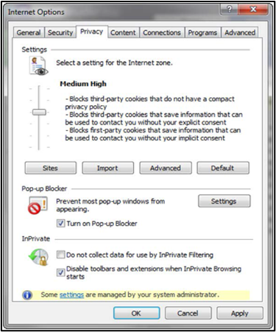

Getting Started
Bed Management Solution (BMS) is a real-time, user-friendly web-based Veterans Health Information Systems and Technology Architecture (VistA) interface for tracking patient movement, bed status and bed availability within the VA system. It provides performance information that can be used to measure and improve patient flow as it occurs within and between VAMCs.
BMS enhances safety, quality of care, patient/staff satisfaction and improves patient flow for process and outcome improvements. BMS, the automated Bed Management Solution, allows administrative and clinical staff to record, manage and report on the planning, patient-movement, patient occupancy, and other activities related to management of beds. All patient admission, discharge, and transfer movements are pulled directly from VistA to BMS resulting in minimal manual data entry.
BMS offers the following features:
- Tracks patient movement into, through and out of the hospital;
- Displays patient and bed occupancy status for all beds in the facility, Veterans Integrated Service Networks (VISN), Regional and National;
- Provides visibility of bed availability within VAMC’s to support emergency management;
- Automates request and assignment of beds;
- Displays and facilitates discharge appointments;
- Supports and facilitates efficient flow operations and is a catalyst to process improvement and best practices;
- Provides reports on performance measures associated with bed management and patient flow.
- Supplies a standardized list of Community Care Facilities applicable to tracking Veterans receiving care in the community
BMS provides answers to the following questions:
- How many beds do we have?
- How many empty beds do we have?
- How many available female beds do we have?
- How many beds are out of service and why?
- How long does it take to clean a bed?
- How many patients have been pending bed placement within the VA facility and in the community hospitals?
- How many admissions, transfers, and discharges did my unit have yesterday?
- How many discharges will we have tomorrow?
- How many scheduled admissions do we have for today?
- What is the length of time between addition to pending bed placement list and VA admission?
- Why was the patient not admitted to VA?

Launch BMS
If your support staff has not provided a desktop shortcut or another way to access BMS, you can access BMS by pointing your browser to [BMS Web URL], the application’s Uniform Resource Locator (URL).
When you access this URL, the application's security system automatically redirects you to the login page. As it does this, the security system begins its authentication process.

Obtain BMS Access
Your manager or BMS Site Coordinator must authorize and provide you access to BMS before you can log in. Your level of access will be dependent upon your role.

Logging On
When you launch BMS, the application displays the VA Single Sign-On page that will present a few different options to authenticate to the BMS application.
Figure 2 - VA Single Sign-On Screen
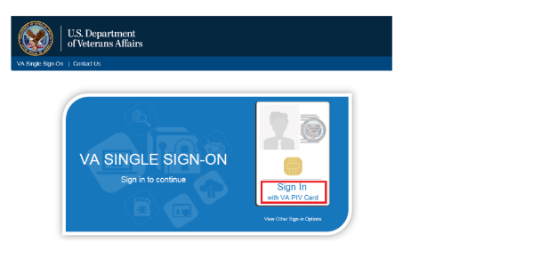
To log in, there are 3 different options available to the user to authenticate to the BMS application, though the majority will utilize option #1 if they have a PIV Card:
- Click on the “Sign In with VA PIV Card”
Upon clicking the “Sign In with VA PIV Card”, the user will see the next screen, prompting them for the PIV PIN from the ActivClient Login dialog box, as below:

Figure 3 - VA Single Sign-On Page
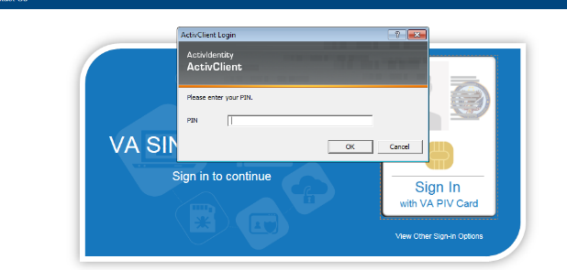
The user will enter their PIV PIN and click OK.
-OR-
By clicking on the “View Other Sign-in Options” below the “Sign In with VA PIV Card”, the user is presented with another screen (below), allowing them to select either “Sign in with Windows Authentication” or “Sign in with VA Network ID”. Both are viable options to the user if they have a PIV Exemption (new employee or lost PIV badge are common examples).
Figure 4 - Other Sign-In Options
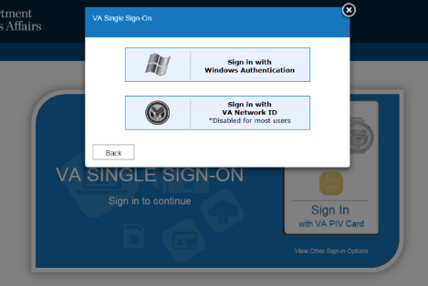

- Other Sign-In Options
In cases where users have not yet obtained their PIV card (new employee) or have lost their PIV card, they must request a PIV exemption by contacting the NSD and requesting a 2-week exemption. The user’s manager needs to follow up with a call or email to NSD to make the exemption permanent.
Without a valid PIV card and/or PIV Exemption, neither of the below options will allow the user to sign into the BMS application.
Sign In with Windows Authentication - Clicking this button will utilize the security token issued to the user’s computer upon signing in to the VA network.
Sign In with VA Network ID - Clicking this button will display a prompt for the user’s VA username and password to authenticate with Active Directory.
Note: The most common reasons for BMS access issues are:
- No BMS access granted by supervisor / site coordinator
- Incorrect Username or Password entered (this may be due to trying to use another User ID and password combination than the Windows User ID and password).
- Windows password expired (Windows passwords expire every 90 days). If your windows password has expired, you will need to contact the National Service Desk (NSD) to request a password reset. This is NOT a BMS password reset, but a reset of your Windows password.
- No PIV badge/exemption. In cases where BMS users do not have their PIV card or have lost their PIV card, they must request a PIV exemption by contacting the NSD and requesting a 2-week exemption. User’s manager needs to follow up with a call or email to NSD to make the exemption permanent

Exit System
To log off the system from the Regional/National Page, click Logout in the upper right corner as show in in the figure below:
Figure 5 - Regional/National Home Screen Logout
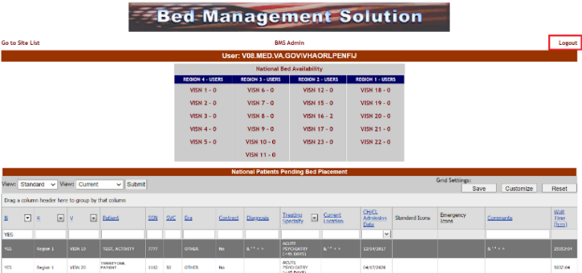
To log off the system from the VISN Page, click Logout in the upper right corner as show in in the figure below:
Figure 6 - VISN Home Screen Logout
To log off the system from the Facility Page, click Logout in the upper right corner as show in in the figure below:
Figure 7 - Facility Home Screen Logout
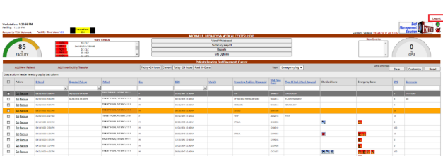

BMS Utilization of Color and 508 Standards Compliance
The BMS Application uses color as an indicator of importance throughout the application. There have been issues flagged by the 508 office via their audits about color representations, but it has been explained and accepted that while we utilize color to indicate importance, we also indicate this with text such as 90%, 50%, etc., to aid those who may be visually impaired. The 508 office will likely report this going forward, but it has also been an accepted response. The BMS Business Line would rather continue to utilize both color and numerical representations instead of removing the colors, as they are a strong indicator for our end users.

Working with Data Grids
BMS commonly displays information using a tabular—or grid—format. The application’s data grids allow you to sort within columns.

Sort Information within Columns
You can sort the information within most columns.
- Click the column header link to sort the information within the grid by that column.
- Click the column header again to sort the column’s contents in descending order.
Figure 8 - Sort Information Within Columns by Clicking on Column Headers
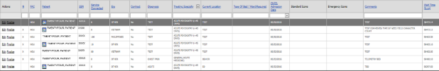

Using the Software
BMS users described in this user guide can be grouped in the following types:
- Site Users
- EMS Supervisor Users
- EMS Users
- VISN Users
- Regional Users
- National Users
- Guest Users
The following sections present the BMS actions that can be performed by users listed above, with a step-by-step description of each action.
For information on Admin User and Support User functionality, see the BMS User Setup and Admin Guide.
For information on Community Care User, Community Care Transfer User and Community Care Admin functionality, see the BMS Community Care Tracking List Guide.

Site Users
The site users have access to the following pages:
- Facility Home page
- Facility Diversion page
- Events page
- Ward Whiteboard Home page
- Ward Whiteboard page
- Reports page

The Facility Home Page
After logging in the BMS application the home page of the current facility is displayed as in the following image.
Figure 9 - VA Facility Homepage
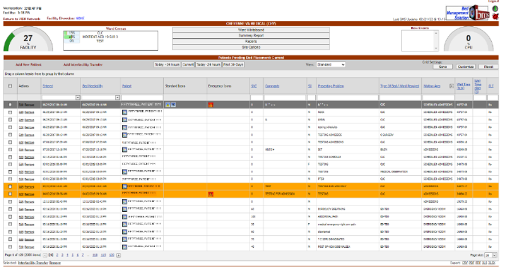

The home page allows the administrator user to organize their admission/ discharge operations for the day by presenting the list of patients pending bed placement for a bed and a set of reports offering information about the status of the beds in the current facility.
The Integrated Sites dropdown field shown below will only be available for sites for which sister sites have been defined. The Integrated Sites field allows the user to switch between sister sites.
For details on how to define sister sites see the sections Edit Sister Sites and Edit BMS Facility Settings Page sections within the BMS User Setup and Admin guide.
Figure 10 - Selecting from the Available Integrated Sites
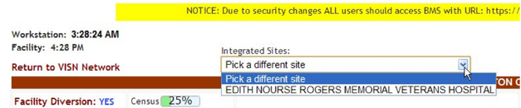

The Facility Diversion link in the upper left corner of the page allows the user setup a list of facilities or Emergency Departments (ED) that are not accepting patients due to insufficient resources or facility issues. For details on the Diversion screen and the available options see the Facility Diversion Page.
Also note that the Figure below demonstrates the Facility Diversion Hover functionality.
Figure 11- Facility Diversion Hover
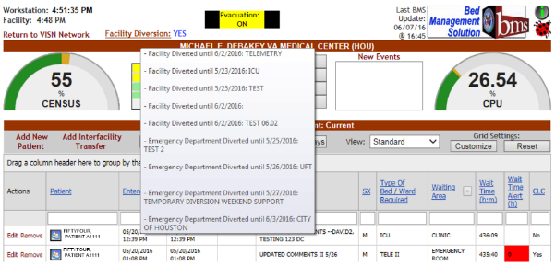

When a user hovers over the Facility Diversion hyperlink, a hover area is displayed showing the Facility Diversion History with the appropriate comments.
The Census graph provides information on the percentage of occupied beds out of the total beds available. Also note that the Figure below demonstrates the Census category selection. Right click on the Gauge to see all Census categories.
Figure 12 - Census Category Selection
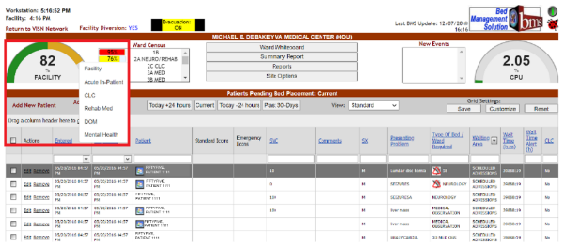

Click on your selection to see the percentage of occupied beds out of total beds available per Census category, or N/A if there are no beds in the ward, as displayed in the following image.
Figure 13 - Census Category Percentage
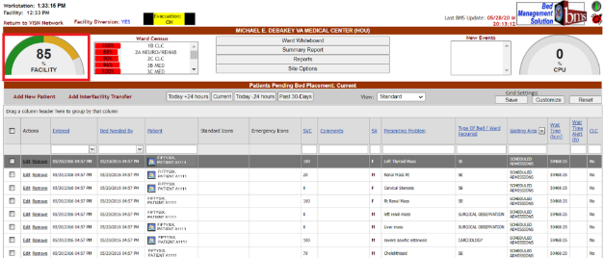

The Ward Census scroll list provides a breakdown of percentage of occupied beds out of total beds available per ward, as shown in the image below.
Figure 14 - Ward Census
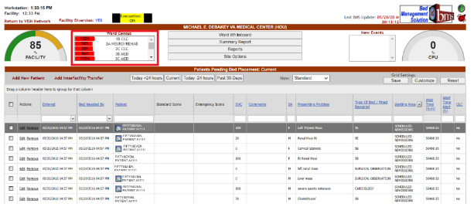

The ladybug button in the upper right corner of the page is a link to an internet site that will provide information regarding the help desk process.
The green information button in the upper right corner of the home page: This Icon links the user to VA's SharePoint System which has available information related to the project consisting of but not limited to point of contact information, sample documents, FAQs, and training instructions.
The name of the current facility is displayed in the header along with its three letter abbreviation.
The middle top of the page provides four navigation buttons: Ward Whiteboard, Summary Report, Reports, and Site Options.
Unless you have the Admin User role, you will not be able to access the Site Options menu.
The New Events list box shows New Event Type categories which can be clicked on for individual reporting.
Figure 15 – New Events
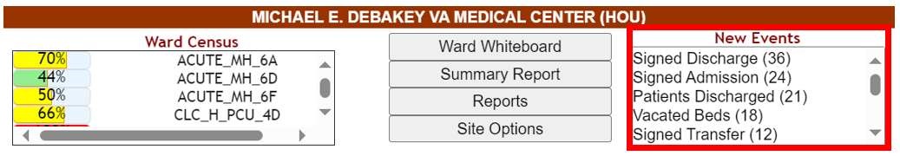

The lower part of the screen displays a data grid containing patients pending bed placement.
The Add New Patient link allows the site user to add a new patient to the pending bed placement list. The Add Interfacility Transfer link allows the site user to register an interfacility transfer.
The buttons Today +24 hours, Current, Today -24 hours, Past 30-Days allow the site user to filter the patient list according to waiting time but will also include patients who have been removed from the list. Clicking the Current button will display a list of patients entered in the pending bed placement list and who have not been removed.
Figure 16 – Add New Patient, Add Interfacility links and Today +24 hours, Current, Today -24 hours, Past 30-days buttons
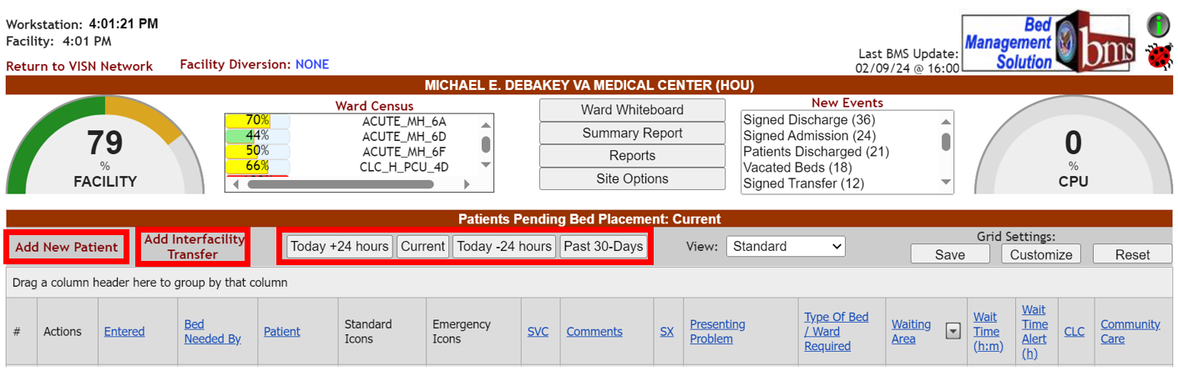
The display of the list can be customized from the View drop-down field according to the following criteria:
- Community Care
- DOM/RRTP
- Emergency Management
- In-House
- Patient Flow
- Standard

Figure 17 - BMS Facility Patients Pending Bed Placement List – Standard View
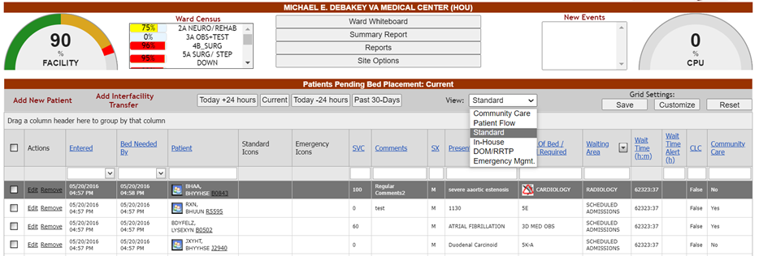
In the Standard view (image above), the following data is available for each patient in the list:
Table 2 - VA Facility Standard View Parameters
COLUMN | DESCRIPTION
Entered | The date and time when the request for a bed was entered.
Bed Needed By | The date and time when the bed is needed.
Removed | The date and time when the patient was removed from the list. (This column displays whenever the Today -24 hours or Past 30-Days button is selected.)
Removal Disposition | The disposition applied to the patient record when removed from the Patients Pending Bed Placement List. (This column displays whenever the Today -24 hours or Past 30-Days button is selected.)
Patient | The name of the patient.
Standard Icons | Icons associated with this patient.
Emergency Icons | Emergency icons associated with this patient.
SVC | The patient’s percent service-connected disability (default of NULL, this is an integer % value)
Comment | Comments regarding the patient.
SX | The gender of the patient.
Presenting Problem | The main reason a patient is seeking medical care.
Type of Bed/Ward Required | The type of bed/ ward required according to the patient’s problem.
Waiting Area | The waiting area where the patient is registered.
Wait Time (h:m) | The estimated waiting time.
Wait Time Alert (h) | The time interval after which an alert is raised. When the patient is added to the waiting list, the user can enter in this field any value between 1-99. After saving the patient to the waiting list the system begins the countdown: when the value in this field is less than the value select (ex. 5 hours) then it will be displayed against a red background and the operator will know they have to urgently find a bed for that patient.
Community Living Center (CLC) | If the patient is a resident in a Community Living Center or in house waiting for a bed at the Community Living Center.
Community Care | Whether or not the patient is in Community Care.
When selecting the Community Care view, the patient pending bed placement list is displayed as in the following image:
Figure 18 - Patients Pending Bed Placement List – Community Care View
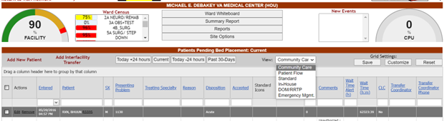

In the Community Care view, the following data is available for each patient in the list:
Table 3 - VA Facility Community Care View Parameters
COLUMN | DESCRIPTION
Entered | The date and time when the patient was added to the list of Patients Pending Bed Placement for a Bed.
Removed | The date and time when the patient was removed from the list. (This column displays whenever the Today -24 hours or Past 30-Days button is selected.)
Removal Disposition | The disposition applied to the patient record when removed from the Patients Pending Bed Placement List. (This column displays whenever the Today -24 hours or Past 30-Days button is selected.)
Patient | The Name of the patient.
SX | The gender of the patient.
Presenting Problem | The main reason a patient is seeking medical care.
Treating Specialty | The treating specialty selected when the patient was added to the pending bed placement list.
Reason | The reason why a certain fee was used for the generation of the bill.
Disposition | The disposition with which the patient is added to the pending bed placement list.  List of available choices to select from:  - Acute  - Non-Acute  - CLC
Bed Type | The VA bed type not available currently. This field displays and is required only when a Reasons Using Community Care value of “No Bed Available” is selected.
Accepted | The date the patient was accepted.
Standard Icons | Icons associated with this patient.
Emergency Icons | Emergency icons associated with this patient.
SVC | The patient’s percent service-connected disability (default of NULL, this is an integer % value)
Comments | Comments regarding the patient.
Wait Time Alert (h) | The time interval after which an alert is raised. When the patient is added to the waiting list, the user can enter in this field any value between 1-99. After saving the patient to the waiting list the system begins the countdown: when the value in this field is less than the value select (ex. 5 hours) then it will be displayed against a red background and the operator will know they have to urgently find a bed for that patient.
Wait time (h:m) | The estimated waiting time.
CLC | If the patient is a resident in a Community Living Center or in house waiting for a bed at the Community Living Center.
Community Care Hospital? | (THIS FIELD IS NO LONGER AVAILABLE WHEN ADDING OR EDITING A PATIENT ON THE PENDING BED PLACEMENT LIST.)
Transfer Coordinator | The name of the Transfer Coordinator.
Transfer Coordinator Phone | The phone number of the Transfer Coordinator.
Bed Needed By | The date and time when the bed is needed.
Type of Bed/Ward Required | The type of bed/ ward required according to the patient’s problem.
Waiting Area | The waiting area where the patient is registered.
Community Care Facility | The non-VA facility where the patient is receiving care.
When selecting the Patient Flow view, the patient pending bed placement list is displayed as in the following image.
Figure 19 - Patients Pending Bed Placement List – Patient Flow View
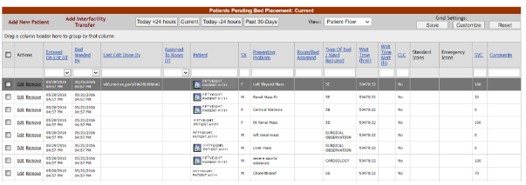
In the Patient Flow view, the following data is available for each patient in the list:
Table 4 - VA Facility Patient Flow View Parameters
COLUMN | DESCRIPTION
Entered on List DT | The date and time when the patient was added to the list.
Bed Needed By | The date and time when the bed is needed.
Removed From List DT | The date and time when the patient was removed from the list. (This column displays whenever the Today -24 hours or Past 30-Days button is selected.)
Removal Disposition | The disposition applied to the patient record when removed from the Patients Pending Bed Placement List. (This column displays whenever the Today -24 hours or Past 30-Days button is selected.)
Last Edit Done By | The name of the user who last edited the entry.
Assigned to Room DT | The date and time when the patient has been assigned a room.
Patient | The name of the patient.
SX | The gender of the patient.
Presenting Problem | The main reason a patient is seeking medical care.
Room/Bed Assigned | The number of the room and of the bed that has been assigned to the patient.
Type of Bed/Ward Required | The type of bed/ward required for the particular ailment of that patient.
Wait Time (h:m) | The estimated waiting time.
Wait Time Alert (h) | The time interval after which an alert is raised. When the patient is added to the waiting list, the user can enter in this field any value between 1-99. After saving the patient to the waiting list the system begins the countdown: when the value in this field is less than the value select (ex. 5 hours) then it will be displayed against a red background and the operator will know they have to urgently find a bed for that patient.
CLC | If the patient is a resident in a Community Living Center or in house waiting for a bed at the Community Living Center.
Standard Icons | Icons associated with this patient.
Emergency Icons | Emergency icons associated with this patient.
SVC | The patient’s percent service-connected disability (default of NULL, this is an integer % value)
Comments | Comments regarding the patient.
When selecting the In-House view, the Patients Pending Bed Placement list is displayed as in the following image.
Figure 20 - Patients Pending Bed Placement List – In-House Patients View
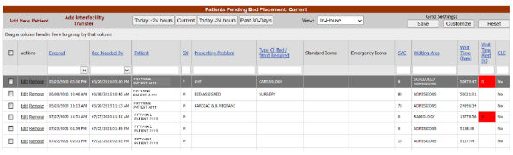

The In-House view presents the patients for whom the In-House option has been selected when the patient was added to the pending bed placement list. This is used for those patients already admitted to a ward/bed/room but in need of a different level of care. For details see the section Adding a Patient to the Patients Pending Bed Placement List. In the In-House view the data available for each patient is the same as in the standard view. For details see the previous paragraphs.
In the In-House view, the following data is available for each patient in the list:
Table 5 - VA Facility In-House View Parameters
COLUMN | DESCRIPTION
Entered | The date and time when the request for a bed was entered.
Bed Needed By | The date and time when the bed is needed.
Removed | The date and time when the patient was removed from the list. (This column displays whenever the Today -24 hours or Past 30-Days button is selected.)
Removal Disposition | The disposition applied to the patient record when removed from the Patients Pending Bed Placement List. (This column displays whenever the Today -24 hours or Past 30-Days button is selected.)
Patient | The name of the patient.
SX | The gender of the patient.
Presenting Problem | The main reason a patient is seeking medical care.
Type of Bed/Ward Required | The type of bed/ ward required according to the patient’s problem.
Standard Icons | Icons associated with this patient.
Emergency Icons | Emergency icons associated with this patient.
SVC | The patient’s percent service-connected disability (default of NULL, this is an integer % value)
Waiting Area | The waiting area where the patient is registered.
Wait Time (h:m) | The estimated waiting time.
Wait Time Alert (h) | The time interval after which an alert is raised. When the patient is added to the waiting list, the user can enter in this field any value between 1-99. After saving the patient to the waiting list the system begins the countdown: when the value in this field is less than the value select (ex. 5 hours) then it will be displayed against a red background and the operator will know they have to urgently find a bed for that patient.
CLC | If the patient is a resident in a Community Living Center or in house waiting for a bed at the Community Living Center

When selecting the DOM/RRTP view, the patient pending bed placement list is displayed as in the following image:
Figure 21 - Patients Pending Bed Placement List – DOM/RRTP Patients View
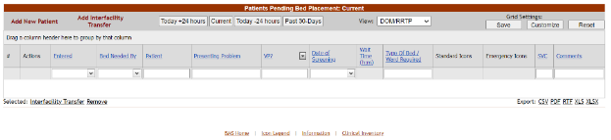

In the DOM/RRTP view, the following data is available for each patient in the list:
Table 6 - VA Facility DOM/RRTP View Parameters
COLUMN | DESCRIPTION
Entered | The date and time when the patient was added to the list.
Bed Needed By | The date and time when the bed is needed.
Removed | The date and time when the patient was removed from the list. (This column displays whenever the Today -24 hours or Past 30-Days button is selected.)
Removal Disposition | The disposition applied to the patient record when removed from the Patients Pending Bed Placement List. (This column displays whenever the Today -24 hours or Past 30-Days button is selected.)
Patient | The name of the patient.
Presenting Problem | The main reason a patient is seeking medical care.
VP? | The Veteran Preference value (YES, NO, or UNKNOWN) for this patient.
Date of Screening | The date and time of the screening.
Wait Time (h:m) | The estimated waiting time.
Type of Bed/Ward Required | The type of bed/ward required for the particular ailment of that patient.
Standard Icons | Icons associated with this patient.
Emergency Icons | Emergency icons associated with this patient.
SVC | The patient’s percent service-connected disability (default of NULL, this is an integer % value)
Comments | Pertinent comments.

When selecting the Emergency Mgmt view, the patient pending bed placement list is displayed as in the following image:
Figure 22 - Patients Pending Bed Placement List – Emergency Mgmt Patients View
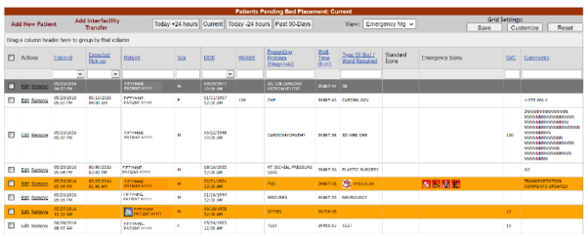
In the Emergency Mgmt view, the following data is available for each patient in the list:
Table 7 - VA Facility Emergency Mgmt View Parameters
Column | Description
Entered | The date and time when the patient was added to the list.
Expected pick-up | The date and time when the patient is expected to be picked up.
Patient | The name of the patient.
Removed | The date and time when the patient was removed from the list. (This column displays whenever the Today -24 hours or Past 30-Days button is selected.)
Removal Disposition | The disposition applied to the patient record when removed from the Patients Pending Bed Placement List. (This column displays whenever the Today -24 hours or Past 30-Days button is selected.)
Sex | Patient gender.
DOB | Patient date of birth.
Weight | Patient weight.
Presenting Problem | Patient diagnosis.
Wait Time (h:m) | The estimated waiting time.
Type of Bed/Ward Required | The type of bed/ward required for the particular ailment of that patient.
Standard Icons | Icons associated with this patient.
Emergency Icons | Emergency icons associated with this patient.
SVC | The patient’s percent service-connected disability (default of NULL, this is an integer % value)
Comments | Pertinent comments.

The Edit and Remove links to the left of a patient line from the list, allow the site user to either edit the details, or remove the entry from the list. Once a patient has been removed from the list an Undo link will become available allowing the user to cancel the remove operation.
Figure 23 - Patients Pending Bed Placement List – Edit and Remove links
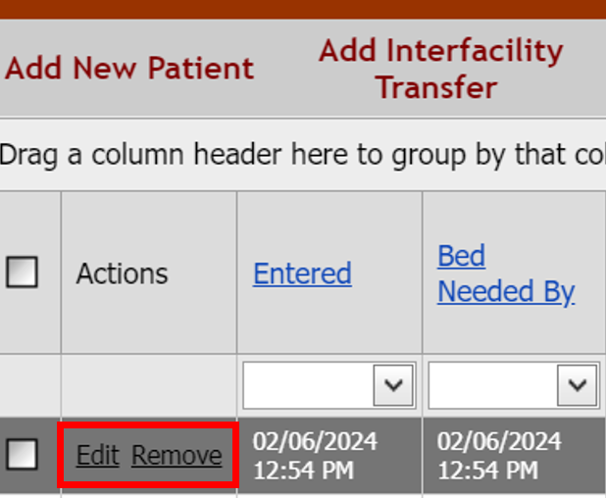
When adding a patient to the Patients Pending Bed Placement list, BMS will create an Admission Request for the selected patient. In order to check if an Admission Order has been issued for a patient, access the New Events page and click the corresponding link to display the reports.
Once a patient has been added to the Patients Pending Bed Placement list, he/she can be assigned a bed in a ward and receive the appropriate treatment. The bed assignment is done from VistA. When the patient is admitted to the VA facility he/she can be removed from the list Patients Pending Bed Placement for a Bed in two ways: manually, by clicking the associated Remove link or automatically (when he/she is assigned a bed), if the option Auto-Removal Pending Bed Placement List option has been selected in the Facility Setting page from Site Options.
For more information see the BMS User Setup and Admin guide.
After being admitted to a VA facility the patient can be either transferred to another VA facility (to a different ward of different bed) or discharged. For a transfer operation a Transfer Order or a Patient Movement of Type Transfer has to be registered in VistA. For the Discharge operation the following have to be registered in VistA: Patient Appointment, Discharge Order and Patient Movement of Type Discharge.
The actions that the site user can perform in the facility home page are as follows: adding, editing the details of an entry and removing entries from the Patients Pending Bed Placement list. In addition, the user can also add an Interfacility Transfer and generate different types of reports.

Patient Pending Bed Placement (PPBP) View Preference

The PPBP can be customized from the View drop-down field to allow the user to save their preferred PPBP list view so that if they navigate to other pages of BMS and return to the Facility home page, the PPBP list view they have selected is automatically displayed. User will select their preferred View from View dropdown field and then click Save.
Figure 24 - Patients Pending Bed Placement List – View drop-down menu and Save button
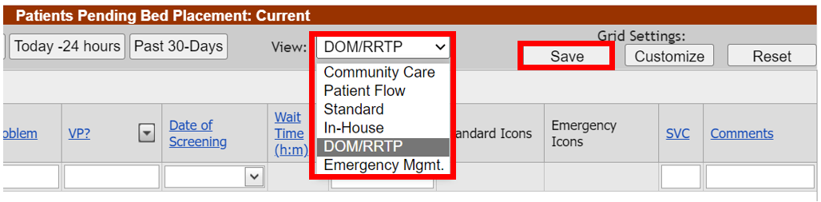

Patient Pending Bed Placement (PPBP) Features
The PPBP data grid has many features which allow users to customize, sort, filter, group, export, and paginate through the PPBP data grid.
Each column within the PPBP list, or “data grid”, is filterable by typing into the text box below the column header. The list is also sortable by selecting the arrow next to the column header (where applicable). The PPBP is heavily customizable by allowing users to perform grouping, re-ordering, and adding/removing columns. The Waiting Area Column allows users to select which Waiting Areas they would see, “unchecking” a Waiting Area allows users to “filter out” what they don’t want/need to see. Customizing the user’s Grid Settings allowing the user to customize their own preferred layout, as well as save their customizations for future use, and also reset to the default setting. The modified layout is saved each time the user changes their own Grid Settings, Groupings, Filters, or Ordering of columns. Below and left of the PPBP Data Grid are links to allow export to CSV, PDF, RTF, XLS, or XLSX.
Each of these features are explained in the following screenshots.

PPBP Column Grouping

Figure 25 - PPBP Column Grouping Action
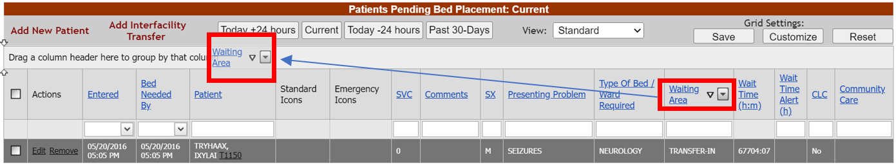
For users who wish to group the PPBP data in different ways, the user will click in the header they wish to group by in the grey area (not on the link which orders the columns) and drag that header to the row above where it states “Drag a column header here to group by that column”. This will group the data by that column header. In the top screen example, we have grouped by the Waiting Area.
Figure 26 - PPBP Column Grouping Result
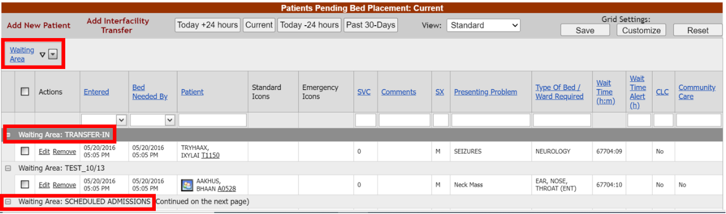

As indicated above, this is the result of the column grouping drag and drop action. We are now grouping by the Waiting Area. Users can add additional column headers to group by or remove them by dragging them from the column header grouping area and placing them back into the header area in the order of their choosing. Note that this action forces a reload of the data indicated by a small “Loading” image in the center of the user’s screen. The BMS application is reloading the data for the user based on the new view selected.
The column headers that you group by are also sortable by ascending and descending order. Clicking this arrow sorts the data either in ascending order (up arrow) or descending order (down arrow).
The column header grouping data is also collapse/expandable allowing users to show/hide data groupings at their choosing. Clicking the “-” button collapses a grouping, and “+” expands a grouping.

PPBP Column Ordering

Users are able to further customize their own PPBP View by ordering their columns however they choose. The below screenshots show a user making the second column become “Patient” name. This can be done by clicking and dragging the column header to the appropriate location. The circled arrow selectors demonstrate the location that the column will be placed upon release of the mouse button.
The second screenshot shows the result of the new column ordering.
Figure 27 - PPBP Column Ordering Action
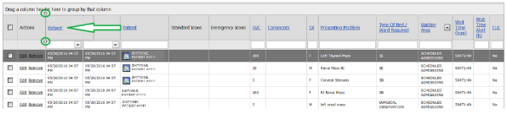

Figure 28 - PPBP Column Ordering Result
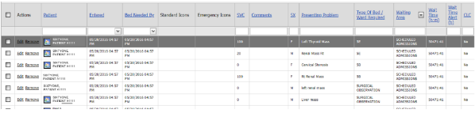

PPBP Customization

Users can further customize their PPBP View by clicking on the Customize button underneath “Grid Settings”, which presents the Column Chooser. In the screenshot below, we can see that Presenting Problem has been removed from the column selections and placed in the Column Chooser. Users can drag into and out of the Column Chooser to add/remove the columns they wish to see. Once a column is removed from the Grid, it can always be re-added by clicking on the Customize button and then dragging it from the column chooser to the data grid.
Figure 29 - PPBP Customize button and removing Presenting Problem example
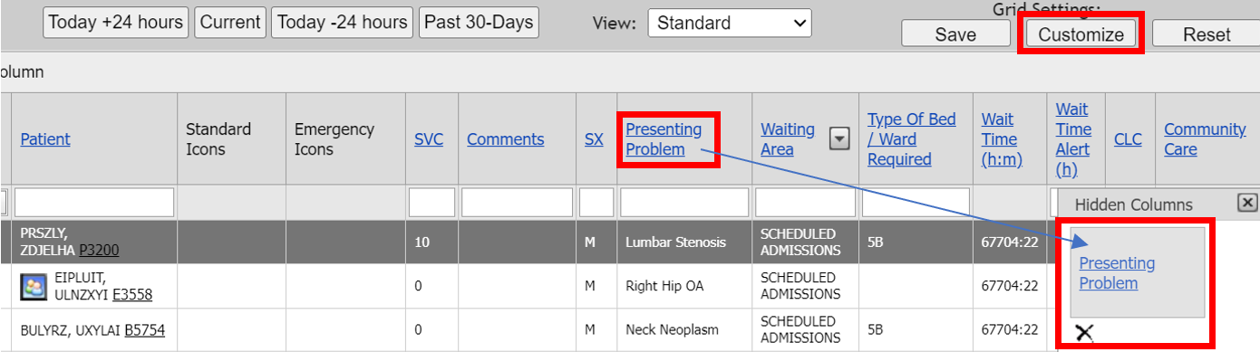
Clicking on the Reset button resets all selections back to the default. This feature is very useful if users happen to get confused with the combination of customizations they have made and wish to start over with their own customizations. Users can also utilize the Alt + R keyboard shortcut to perform the same functions as the Reset button.
Figure 30 – Reset button
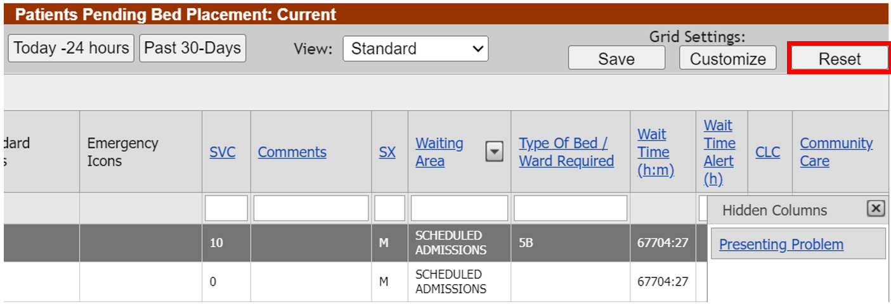

Exporting PPBP Data
Below and right of the PPBP Data Grid are links to allow export to CSV, PDF, RTF, XLS, or XLSX file types.
Figure 31 - Exporting PPBP Data
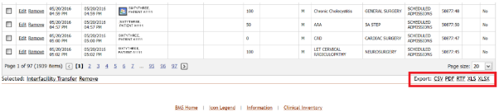

PPBP Page Functions
Figure 32 - PPBP Page Functions
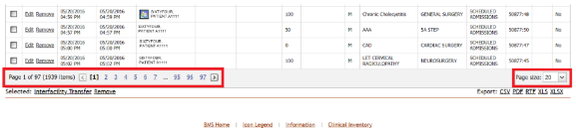

The above screenshot demonstrates pagination functions available from the PPBP View. The view allows users to select specific pages quickly by clicking on a specific page # for the view. It is also possible to select how many patient records display per page, on the bottom left of the grid.

Adding a Patient to the Patients Pending Bed Placement List

To add a patient to the pending bed placement list, follow the steps presented below.
From the facility home page, click the Add New Patient link in the Patients Pending Bed Placement area.
Figure 33 - Adding a Patient to the Patients Pending Bed Placement List
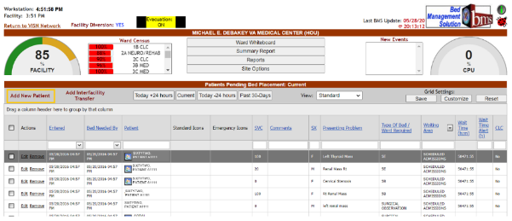

Clicking the Add New Patient link will cause the following page to be displayed.
Figure 34 - Add/Edit Patients to the Patients Pending Bed Placement in the VA Facility
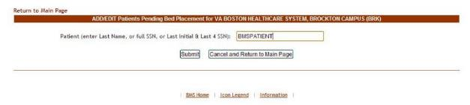

Enter the patient’s last name, or the full SSN, or the last initial and last 4 SSN digits then click the Submit button.
If there are several patients with the same last name, the following page is displayed:
Figure 35 - Add/Edit Patients Pending Bed Placement – Select Patient
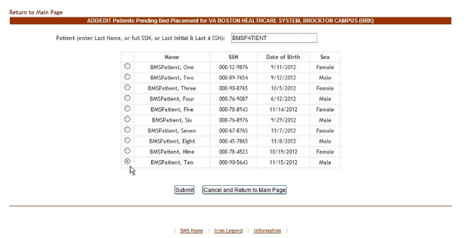

A list of all the patients with the last name entered is displayed. Select the patient you want to add then press the Submit button to display the following page:
Figure 36 - Add/Edit Patients Pending Bed Placement in the VA Facility - Details
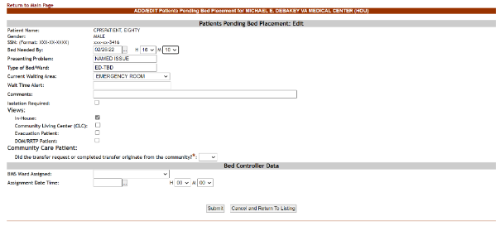

If the SSN exists in the system, the associated data will be retrieved (from VistA) and the NAME (Last, First, MI) of the patient will be displayed in the upper part of the screen.
If the SSN is not found in the system, an error message is displayed.

Table 8 - Add/Edit Patients Pending Bed Placement – Parameters
Field | Enter
Entry Date/Time | This field is automatically filled in with the current date and time.
Bed Needed By | Fill in these fields according to the instructions on screen. This is the time that the patient will need the bed. Use “projected Decision to Admit Time”.
Presenting Problem | What reason is the patient being admitted? (For example: CHF, DM, Surgery)
Type of Bed/Ward | The type of bed/ward needed according to the patient’s problem.
Waiting Area | Select the corresponding waiting area. There is a pre-defined list of waiting areas
Wait Time Alert | The time interval after which an alert is raised. When the patient is added to the pending bed placement list, the user can enter in this field any value between1-99. After saving the patient to the pending bed placement list the system begins the countdown: when the value in this field is less than the value select (example: 5 hours) then it will be displayed against a red background and the site user will know they have to urgently find a bed for that patient.
Isolation Required | If box is checked for isolation, precautions are taken to prevent the spread of infectious disease. When checked, the isolation icon appears on the patients pending bed placement list.
Views | A series of checkboxes that when selected display a particular group of patient fields.
In-House | If the patient is already admitted to VA but needs only to be moved into another ward.
CLC | If the patient is a resident in a Community Living Center or in-house pending bed placement at the Community Living Center.
Evacuation Patient | If the patient has to be evacuated in case of emergency.
DOM/RRTP | If the patient is in Domiciliary/Residential Rehab Treatment Program.
Did the transfer request or completed transfer originate from the community? | If the patient is designated as Community Care. Formerly labeled “Community Care.” This field is now required.

The following fields will only be displayed if the option “Did the transfer request or completed transfer originate from the community?” is set to “Yes.”
Table 9- Originate from the community is set to “Yes”
Field | Enter
Disposition | The disposition with which the patient is added to the pending bed placement list. Within the Fee Utilization data, it is the determination of Acute, Non-Acute or CLC.
Treating Specialty | The treating specialty required.
Accepted | Flag to designate whether or not the patient is accepted.
Reasons Using Community Care | The reason justifying fee usage.  (This field is now required.)
Bed Type | The VA bed type not available currently. This field displays and is required only when a Reasons Using Community Care value of “No Bed Available” is selected.
Accepting MD | Name of the Accepting Physician.
Transfer Coordinator | Name of the Transfer Coordinator.
Transfer Coordinator Phone | Phone number of the Transfer Coordinator.
Community Care Comments | Any relevant additional information about the fee utilization. Note this field is required if using a Reasons Using Community Care selection of “Other (requires comment)”
Community Care Facility | The non-VA facility where the patient is receiving community care. This drop-down menu will contain a list of nearby CC facilities as created by admins with the Community Care Admin role (or Admin User role and higher). If the facility cannot be located within the drop-down list, use the “…” search option to open a Community Care Facility Search window for locating a nearby community facility by Name, Street, City, State or ZIP/Postal code number.

The following fields will only be displayed if the option Evacuation Patient is selected.
Table 10-Evacuation Patient is selected
Field | Enter
Current Ward | The name/code of the ward where the patient is currently.
Current Bed | The code of the bed where the patient is currently.
Admitting Diagnosis | The admitting diagnosis.
Evac Disposition Status | The disposition status in case of evacuation.
Expected pick-up | The date and time when the patient is expected to be picked up in case of evacuation.
Actual pick-up | The actual date and time when the patient has been picked during evacuation.
Arrival Time | The time the patient arrived at the facility.
Reason for Delay | The reason for the delay, if applicable.
Equip/Supply Requirements | Equipment or Supply requirements for the patient in case of evacuation.
Transportation Care Level | The level of the transportation care for the patient in case of evacuation.
Enroute Medical Attendant | The number, qualification and name of the enroute medical attendant.
MA Telephone | The Enroute Medical Attendant telephone number.
Enroute Non-Medical Attendant (NMA) | The number and the name of the enroute non-medical attendant.
NMA Telephone | The Enroute Non-Medical Attendant telephone number.
Operator Name | The vehicle operator name.
Operator Telephone | The vehicle operator telephone number.
Vehicle ID | The identifying number of the transportation vehicle.
Seat Position | The patient’s seat position on the vehicle.
Transportation Type | The type of transportation required for the patient in case of evacuation.
Transportation Provider | The provider of transportation.
Transportation Comments | Any relevant comments regarding transportation.
Transfer/Evacuate To | The location name of the place the patient is evacuated to.
Destination Address | The address of the facility where the patient is evacuated to.
Destination City, State | The city and state where the patient is evacuated to.
Destination POC Telephone | The telephone of the Point-of-Contact of the facility where the patient is evacuated to.
Originating Facility | The facility the patient is being evacuated from.
Originating POC | The name of the Point-of-Contact of the facility where the patient is evacuated from.
Originating Address | The address of the location the patient is being evacuated from.
Originating City, State | The city and state of the location the patient is being evacuated from.
Originating POC Telephone | The telephone of the facility from where the patients are evacuated.
Evacuation Comments | Any relevant evacuation comments.

The following fields will only be displayed if the option DOM/RRTP Patient is selected.
Table 11-DOM/RRTP Patient is selected
Field | Enter
Date of Screening | The date of the screening.
Contact Phone Number | Phone number of the person who performed the screening.
Veteran Preference (VP) | Flag to indicate the Veteran Preference.
Comments | Any pertinent comments.

After filling in all the data required click the Submit button to enter the data into the system.
The newly added patient will be displayed in the area Patients Pending Bed Placement from the home page.

Editing the Details of an Entry in the Patients Pending Bed Placement List
To edit the details of an entry from the Patients Pending Bed Placement list click the corresponding Edit link. The following page is displayed.
Figure 37 - Edit Details of the Patient Pending Bed Placement List
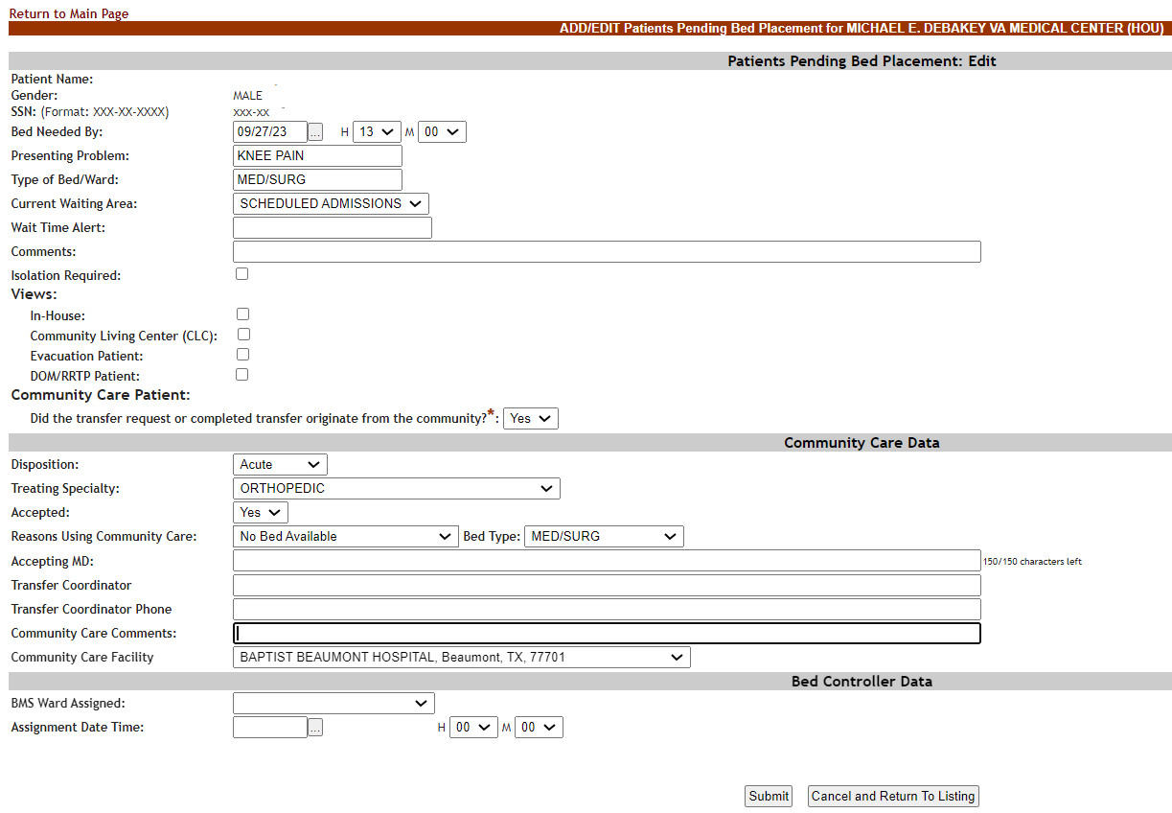

In the Bed Controller Data area, select the BMS Ward Assigned and the Assignment Date Time. Modify the existing data then press the Submit button to enter it into the system.
A screen is displayed confirming the modification of the record in the database.
Figure 38 – Confirmation of edited record on Patient Pending Bed Placement List
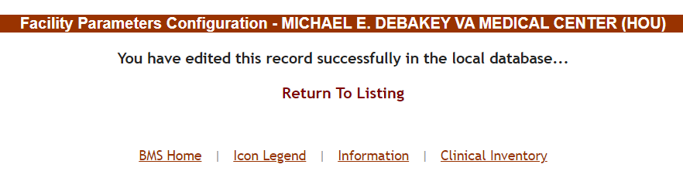

Adding Isolation Status to a Patient in the Patient Pending Bed Placement List
To add an Isolation Status icon to a patient from the Patients Pending Bed Placement list click the corresponding Edit link. The following page is displayed. Click on the Isolation Required checkbox and then press the Submit button to enter it into the system.
Figure 39 - Isolation Required Checkbox
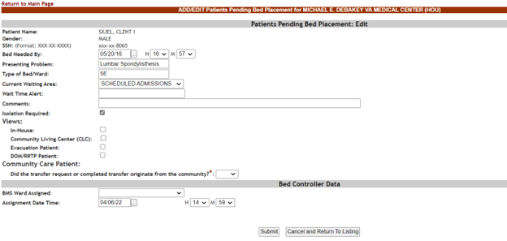

A screen is displayed confirming the modification of the record in the database.
You can also add an Isolation Required icon from the facility page by clicking Add New Patient in the upper left in the row below the Census gauge.
Figure 40 - Add New Patient in Patient Pending Bed Placement List
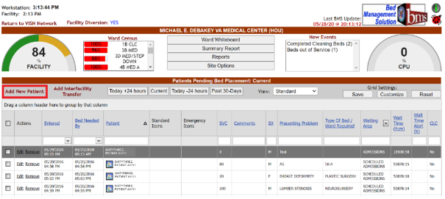
The following page is displayed:
Figure 41 - Enter Patient Lookup Information
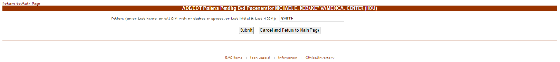

Look up the patient you would like to edit by typing their last name, full SSN or Last Initial & Last 4 of the SSN in the Patient search box. The following page is displayed:
Figure 42 - Select Patient
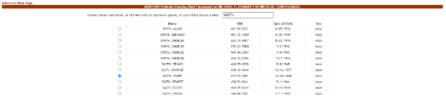
Select the radial button in front of the patient you would like to choose, then press Submit. The following page is displayed:
Figure 43 - Add/Edit Patients Pending Bed Placement
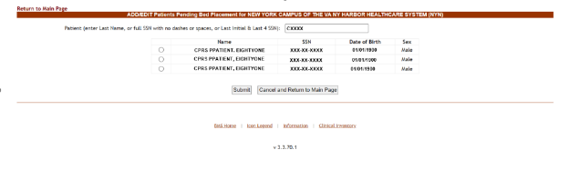
To add Isolation status, select the checkbox next to Isolation Required.
Figure 44 – Isolation Required checkbox
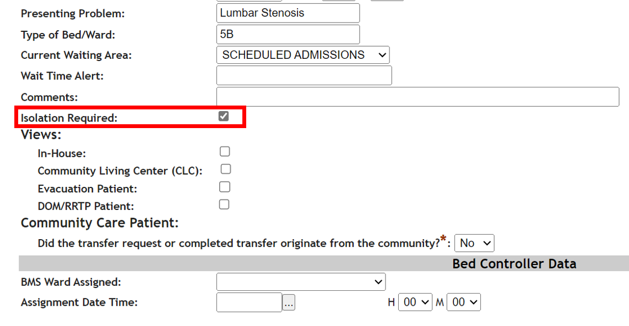
Click Submit at the bottom of the page to save changes. A screen is displayed confirming the modification of the record in the database.
Figure 45 - Patients Pending Bed Placement List Showing Isolation Icon
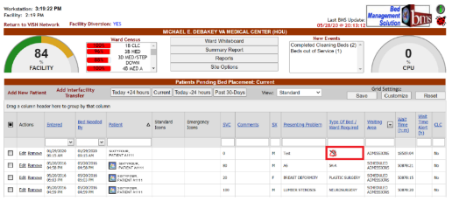
The Isolation Required icon will show in the Patients Pending Bed Placement list in Type of Bed/Ward Required.

Removing Patient from the Patient Pending Bed Placement List
In the facility home page, in the area Patients Pending Bed Placement click the corresponding Remove link.
Figure 46 - Remove Patient from the Pending Bed Placement List
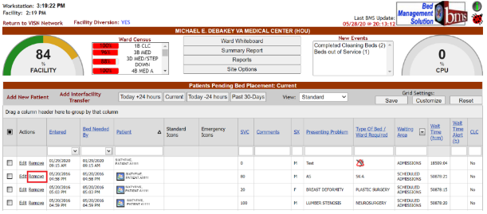

Before actually removing the patient from the pending bed placement list, you will be asked to confirm the operation. There will be a required Removal Disposition value that must be filled in. This can help answer why a Veteran was not admitted to VA care.
Figure 47 - Remove Patient from the Pending Bed Placement List Confirmation
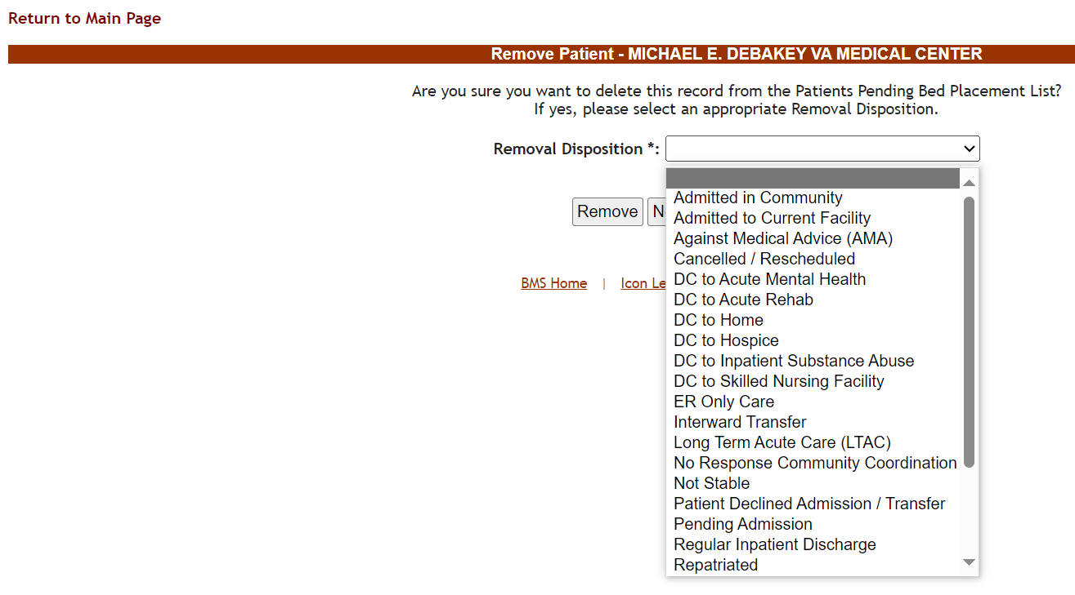

Select a Removal Disposition from the list, then press the Remove button. Or if you do not wish to remove the patient, select the Never Mind and Return to Listing button.
To add remove multiple patients, select one or more patients by clicking the checkbox to the left of their name in the Patient Pending Bed Placement list. Then click the Remove link at the bottom left of the PPBP grid as displayed in the image below:

Figure 48 – Bulk Remove Patients from the Patient Pending Bed Placement List
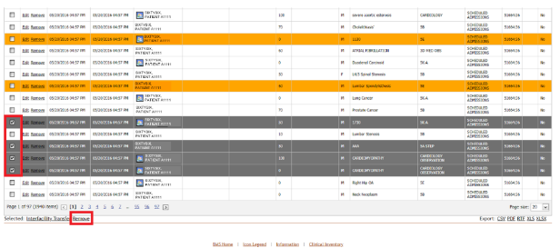

Select a Removal Disposition from the list, then press the Remove button. Or if you do not wish to remove the patient, select the Never Mind and Return to Listing button.

Figure 49 – Bulk Remove Patients from the Patient Pending Bed Placement List Removal Disposition
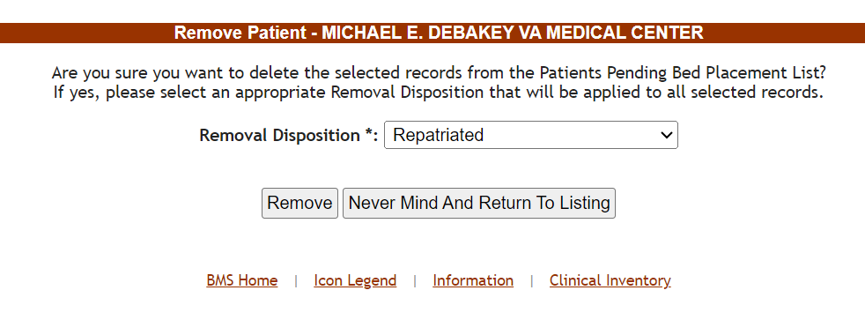

Undo Remove Patient from Patients Pending Bed Placement List
After removing a patient from the pending bed placement list an Undo link will become available. Select Today -24 hours or Past 30-Days to show current removed patients.
Figure 50 - Patients Pending Bed Placement: Past 30-Days
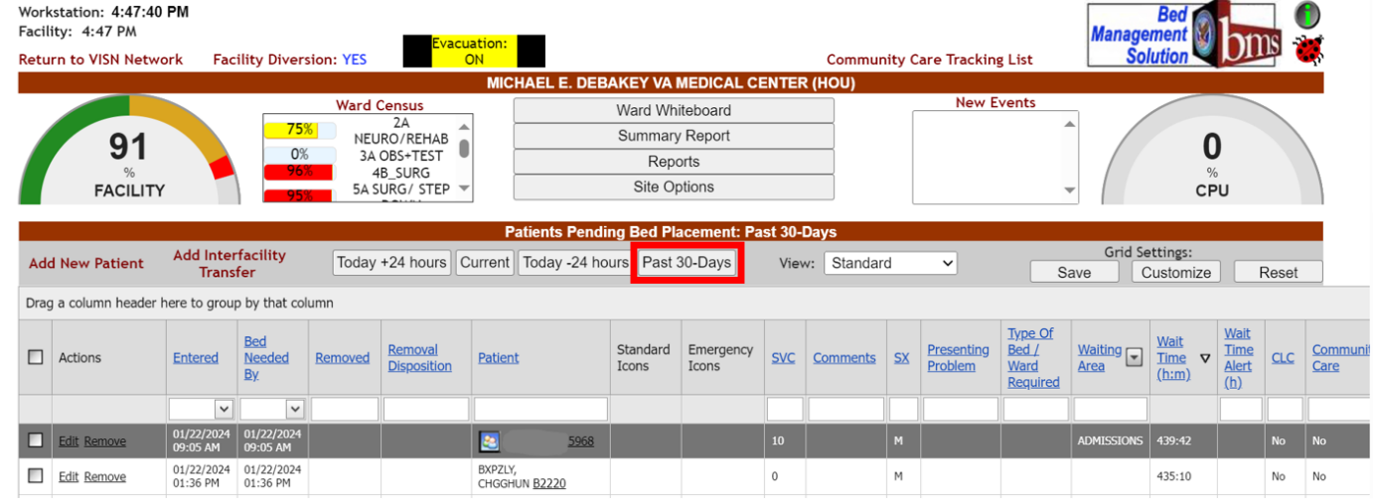
Use the Undo link to cancel the Remove operation.
Figure 51 - Undo Remove Patient from the Patient Pending Bed Placement List
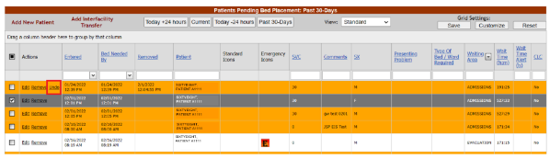
Before actually undoing the removal of the patient from the pending bed placement list, you will be asked to confirm the operation.
Figure 52 - Undo Remove Patient from the Pending Bed Placement List Confirmation
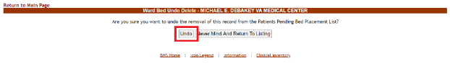

Adding an Interfacility Transfer
Adding interfacility transfers will place the patient information on the VISN Patients Pending Bed Placement list to assist with the transfer needs of the patient.
To add interfacility transfers in the facility home page for multiple patients, select one or more patients by clicking the checkbox to the left of their name in the Patient Pending Bed Placement list. Then click the Interfacility Transfer link at the bottom left of the PPBP grid as displayed in the image below:
Figure 53 – Selecting Bulk Patients for VISN Interfacility Transfer
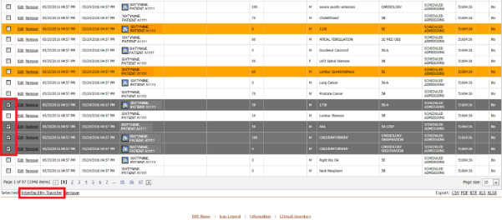

To add an interfacility transfer in the facility home page click the Add Interfacility Transfer link to display the following page:
Figure 54 - VISN Interfacility Transfer Sheet – Select Patient
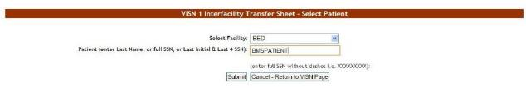
From the Select Facility field, select the name of the VA facility that the patient is associated with or the requesting facility. In the Patient field, enter either the patient name or the patient SSN number following the instructions on screen, then press the Submit button.
If there are several patients in the system with the same name, the system presents a list with details of the patients so that you can identify the patient you need.
Figure 55 - VISN Interfacility Transfer Sheet – Select Patient
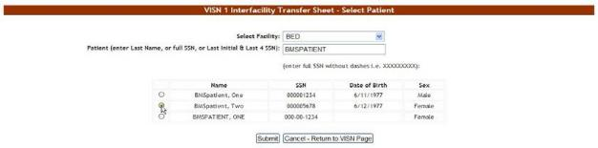
If you entered the patient SSN and the patient is registered in the VistA system, the associated information (patient full name, gender, service connected) will be retrieved and presented as in the following image.
Figure 56 - VISN Interfacility Transfer Sheet – Enter Patient Data
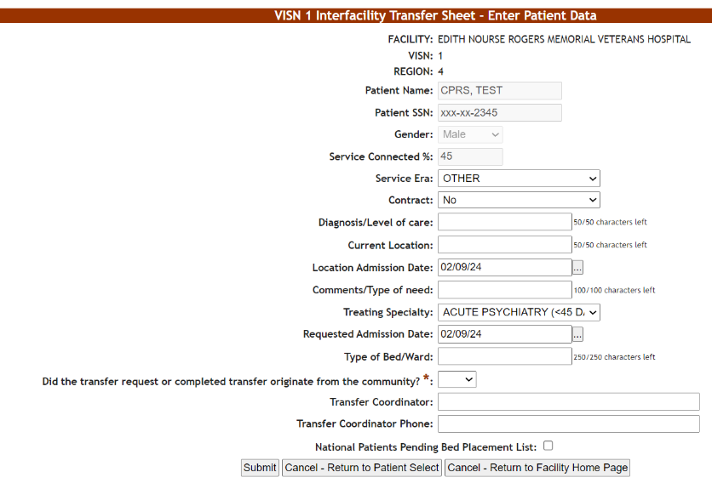

If you entered the patient SSN but that patient has not been added yet to the VistA system you will have to fill in the associated information (patient full name, gender, service connected) as in the following image. (The verification will eventually be done by the system when using the Finalize option and if the patient is still not found in the VistA system the finalize operation cannot be completed.)
Figure 57 - VISN Interfacility Transfer Sheet – Enter Patient Data
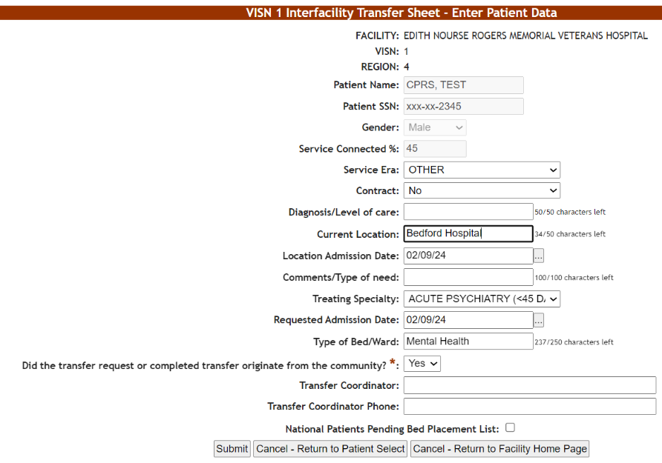

In the VISN Interfacility Transfer Sheet – Enter Patient Data page the name of the current facility, the VISN it belongs to and the Region are displayed.
Enter the following data:
Table 12 - Interfacility Transfer Parameters
FIELD | ENTER
Service Era | The period of service that the patient served.
Contract: | Whether or not the VA facility has a contract with the community hospital.
Diagnosis/Level of care | The diagnosis for which the patient requests admission to the community hospital.
Current Location | The name of the location where the patient is currently being treated.
Location Admission Date | The date when the patient has been admitted to the current location.
Comments/Type of need | The type of need for which the patient is being transferred to the community hospital.
Treating Specialty | The treating specialty corresponding to the type of need.
Requested Admission Date | The date when the patient should be able to be admitted to the VA facility.
Type of Bed/Ward | The Type of Bed/Ward that the patient requires.
Did the transfer request or completed transfer originate from the community? | Designates the patient as Community Care. Formerly labeled “Community Care Patient.” This field is now required.
Transfer Coordinator | Name of the Transfer Coordinator.
Transfer Coordinator Phone | Phone number of the Transfer Coordinator.
National Patients Pending Bed Placement List | If the patient is to be included or not in the National Patients Pending Bed Placement list.

Click the Submit button to enter the data into the system. A screen is displayed confirming the successful registration of the record in the database.

Figure 58 - VISN Interfacility Transfer Sheet – successful confirmation
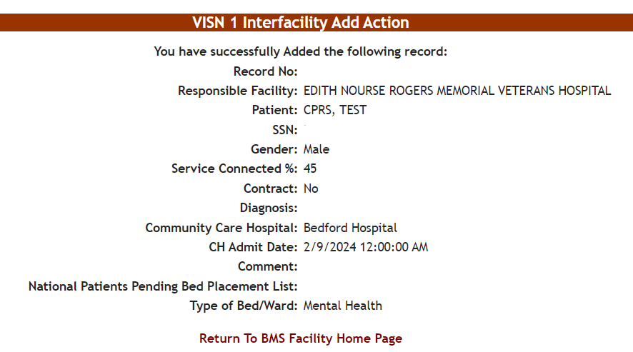

Reports

Ward Occupancy Report
To generate the Ward Occupancy report, follow the instructions below.
From the Facility Home page, the user will need to navigate to the Reports page by clicking the Reports button as highlighted below:
Figure 59 - Report Page Navigation
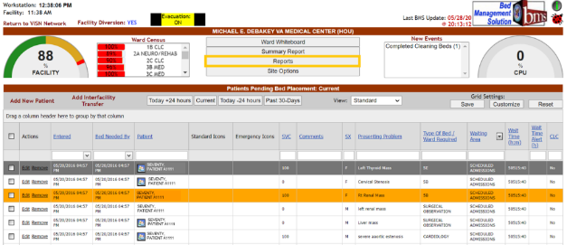
In the Reports area, from the Select Ward Group field, click the arrow button to display a list of ward groups defined in the system and select the ward group for which you want to generate the report. Then, from the Bed Status field select one of the available options (All, Available, Female, Occupied).
Figure 60 - Selecting Parameters for Ward Occupancy Report
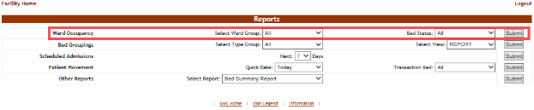
After you have selected the desired criteria press the Submit button. The report is displayed as in the following image:
Figure 61 - Ward Occupancy Report
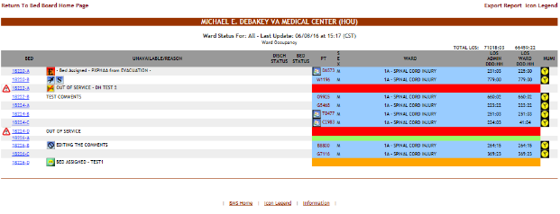
The following data is available for each entry:
Table 13 - Ward Status Parameters
COLUMN | DESCRIPTION
Bed | The room/bed number.
Unavailable/reason | The reason why it has been marked as unavailable.
Discharge status | The bed will be vacated for one of the following reasons: “Anticipated Discharge or Discharge Appointment”, “Discharge Ordered”, or “Interward Transfer”. See Table 37 - Beds Parameters for more information.
Bed status | The bed cleaning status. See the Icon Legend for the meaning of the icon.
PT (patient) | The name of the patient occupying the bed.
Sex | The gender of the patient.
Ward | The ward where the bed is.
LOS ADMIN (Length of stay) | The patient’s length of stay in the facility.
LOS WARD (Length of stay) | The patient’s length of stay on the ward.
NUMI | The National Utilization Management Integration (NUMI) automates utilization review assessment and outcomes. The Utilization Management (UM) Process is a tool used to help verify that patients are receiving the right care, at the right time, and in the right place. UM is both a quality and efficiency tool, as it is used to move patients efficiently through the VA system to maximize use of resources. UM reviewers assess patient admissions and hospital stay days using standardized objective evidence-based clinical criteria to determine whether patients meet criteria for acute hospital care. Refer to the NUMI icons for the different levels of care.

Bed Groupings Report
To generate the Bed Groupings report, follow the instructions below.
On the Reports page, from the Bed Groupings row, click the arrow button of the Select Type Group field to display a list of available wards and select the ward for which you want to generate the report. From the Select View field choose a type of view (“report” or “roster” are the available options).
The bed grouping report allows you to see the usage of beds for a specific BMS type group such as Medical/Surgical, CLC or ICU. Using the report view will display the information by BMS type group where the roster will display the beds in order. The roster view shows each bed once while the report views displays the beds by VistA ward/specialty.
Figure 62 - Selecting Parameters for Bed Groupings Report
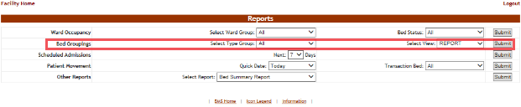
Click the Submit button.The report is displayed as in the following image:
Figure 63 - Bed Specialty Report
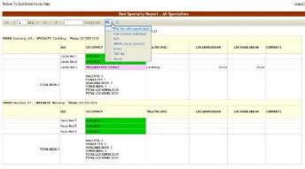
Note: The view depends on the option chosen from the Select View field: “REPORT” or “ROSTER”. In the image above the REPORT option has been chosen.
The same report in the ROSTER view is displayed in the image below.
Figure 64 - Bed Specialty Report – Roster View
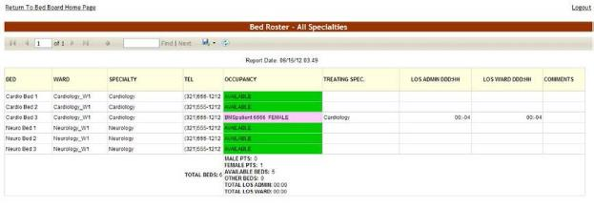

The title of the report is displayed in the upper part of the page. Navigation and display tools are available in the toolbar displayed across the screen. Place the mouse cursor over a button to display the corresponding tooltip.
The report can be exported to a series of formats available when clicking the Save button (see image above).
Once exported, the Print button allows the site user to send the generated report to a printer.
The header of the report displays the criteria used to generate the report, the selected ward and the specialty.
The following data is available in the report:
Table 14 - Bed Specialty Parameters
COLUMN | DESCRIPTION
Bed | The room/bed number.
Ward | The name of the ward.
Specialty | The ward specialty.
Tel | The telephone number of the ward POC.
Occupancy | The status of the bed: AVAILABLE, ASSIGNED or OCCUPIED. (Colors are assigned to each status so that they are easily identifiable.)
Treating Specialty | The medical specialty to which the bed is assigned.
LOS ADMIN | The patient’s length of stay in the facility.
LOS WARD | The patient’s length of stay on the ward.
Comments | Any relevant additional info entered by the site user.

Scheduled Admissions Report
To generate the Scheduled Admissions report, follow the instructions below.
On the Reports page, from the Scheduled Admissions report select for how many days you want to generate the report. You can look ahead up to seven days or back from five days. You can also look at those patients scheduled for admission today.
Figure 65 - Selecting Parameters for Scheduled Admissions Report
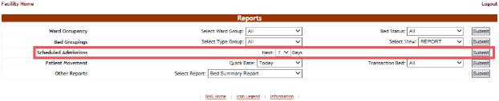
After selecting the number of days, click the Submit button to display the report as in the following image:
Figure 66 - Scheduled Admissions Report
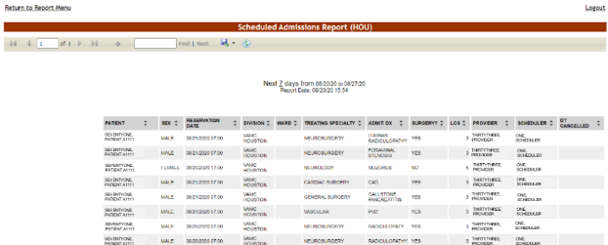
The title of the report is displayed in the upper part of the page. Navigation and display tools are available in the toolbar displayed across the screen. Place the mouse cursor over a button to display the corresponding tooltip.
The report can be exported to a series of formats available when clicking the Save button. Once exported, the Print button allows the site user to send the generated report to a printer.
The following data is available for each entry:
Table 15 - Scheduled Admissions Parameters
COLUMN | DESCRIPTION
Patient | The name of the patient displayed as Last Name plus first letter of last name and last 4 of SSN in parentheses. Example: Brown (B1234)
Sex | The gender of the patient.
Reservation Date | The date for which the admission is scheduled.
Division | The division where the admission has been made.
Ward | The ward name.
Treating Specialty | The treating specialty indicated when admission scheduled in VistA. This field is a preexisting field in the site’s VistA instance and BMS is just pulling this field in from VistA.
Admit. Dx. | Reason for admission entered in VistA. This field is a preexisting field in the site’s VistA instance and BMS is just pulling this field in from VistA.
Surgery? | Indicates if the admitted patient is scheduled for surgery.
LOS | Anticipated Length of Stay. This field is a preexisting field in the site’s VistA instance and BMS is just pulling this field in from VistA.
Provider | The physician arranging the admission. This field is a pre-existing field in the site’s VistA instance and BMS is just pulling this field in from VistA.
Scheduler | VA person that scheduled the admission. This filed is a preexisting field in the site’s VistA instance and BMS is just pulling this field in from VistA.
DT Cancelled | If the admission was cancelled, the date and time of the cancellation.

Patient Movement Report
To generate the Patient Movement report, follow the instructions below.
On the facility home page, click the Reports button. On the Reports page, the fourth row is the Patient Movement report. Choose the number of days you want to generate the report using the Quick Date field. From the Transaction Bed field select the type of movement/transaction you want to include in the report (Admissions, Discharges, Inter Ward Transfers, Intra Ward Transfers, Specialty Transfers, or All).
Figure 67 - Selecting Parameters for Patient Movement Report
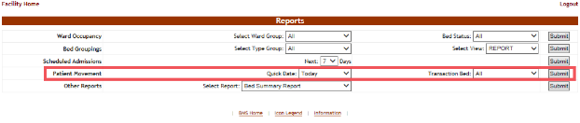
After selecting the desired number of days and the type of transaction you want to include in the report, click the Submit button. The Patient Movement report is displayed as in the following image:
Figure 68 - Patient Movement Report
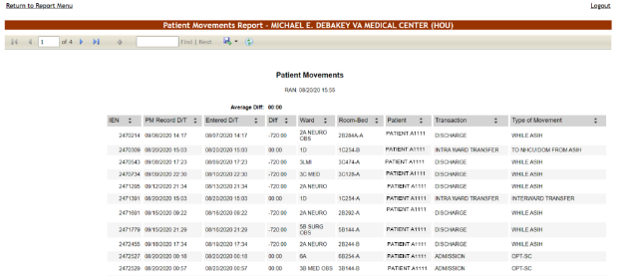
The title of the report is displayed in the upper part of the page. Navigation and display tools are available in the toolbar displayed across the screen. Place the mouse cursor over a button to display the corresponding tooltip.
The report can be exported to a series of formats available when clicking the Save button. Once exported, the Print button allows the site user to send the generated report to a printer.
The following data is available for each entry:
Table 16 - Patient Movement Parameters
COLUMN | DESCRIPTION
IEN | The VistA Internal Entry Number for the primary lookup key in the Patient Movement file.
PM Record D/T | The date and time when the patient movement has been recorded.
Entered D/T | The date and time when the movement has been registered in the system.
Diff | The time lapse between the date/time when the movement occurred and when it has been registered.
Ward | The name of the ward.
Room-Bed | The name of the room/bed.
Patient | The patient name/last 4 of SSN.
Transaction | The type of transaction.
Type of Movement | The type of movement.

Other Reports
Use the arrow button of the field Select Report to display a list of reports that can be generated. Select the desired report then press the Submit button.
Figure 69 - Other Reports
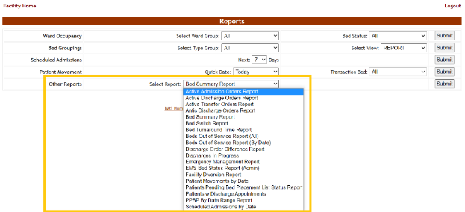

The following sections present each of the additional reports that can be generated.

Active Admission Order Report
This report shows the patients with admission orders as defined by the orderable items in the Site Options page. This report shows the IEN (internal entry number) of the order, the date and time it was written, the patient name, the date/time the order was signed, the provider writing the order and the date/time the order was released.
To generate the Active Admission Orders report, follow the instructions below.
On the Reports page, from the Other Reports field select Active Admission Orders Report then press the Submit button. The report is displayed as in the following image:
Figure 70 - Active Admission Orders Report
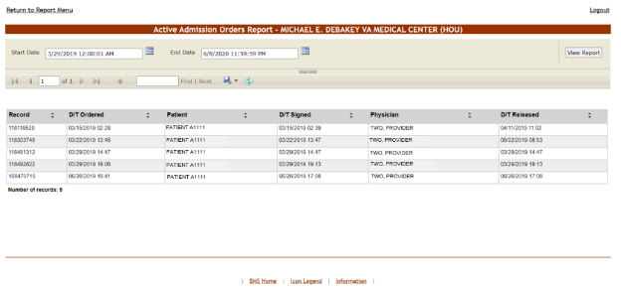
From the upper part of the page, you can select the time interval for which you want to generate the report: after selecting a Start Date and an End Date click the View Report button to generate the report for the selected time period.
The title of the report is displayed in the upper part of the page. Navigation and display tools are available in the toolbar displayed across the screen. Place the mouse cursor over a button to display the corresponding tooltip.
The report can be exported to a series of formats available when clicking the Save button. Once exported, the Print button allows the site user to send the generated report to a printer.
For each admission order in the report, the following data is available:
Table 17 - Active Admission Orders Parameters
Column | Description
Record (Internal entry number - IEN) | The VistA Internal Entry Number for the primary lookup key in the Order file.
D/T Ordered | The date and time of the admission order.
Patient | The name of the patient being admitted.
D/T Signed | The date and time when the admission order was signed.
Physician | The name of the physician signing the admission order.
D/T Released | The date and time of the actual release.

Active Discharge Orders Report
This report shows the patients with discharge orders as defined by the orderable items in the Site Options page. This report shows the IEN (internal entry number) of the order, the date and time it was written, the patient name, the date/time the order was signed, the provider writing the order and the date/time the order was released.
To generate the Active Discharge Orders report, follow the instructions below.
On the Reports page, from the Other Reports field select Active Discharge Orders Report then press the Submit button. The report is displayed as in the following image:
Figure 71 - Active Discharge Orders Report
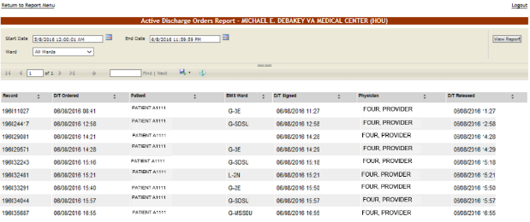
From the upper part of the page, you can select the time interval for which you want to generate the report. After selecting a Start Date and an End Date, use the Ward field to select the ward(s) for which you want to generate the report then click the View Report button to generate the report for the selected time period.
The title of the report is displayed in the upper part of the page. Navigation and display tools are available in the toolbar displayed across the screen. Place the mouse cursor over a button to display the corresponding tooltip.
The report can be exported to a series of formats available when clicking the Save button. Once exported, the Print button allows the site user to send the generated report to a printer.
For each discharge order in the report, the following data is available:
Table 18 - Active Discharge Orders Parameters
COLUMN | DESCRIPTION
Record | This is a unique ID automatically generated by the system identifying the patients’ discharge order.
D/T Ordered | The date and time of the discharge order.
Patient | The name of the patient being discharged.
BMS Ward | The BMS ward where the patient has been treated.
D/T Signed | The date and time when the discharge order was signed.
Physician | The name of the physician signing the discharge order.
D/T Released | The date and time of the actual discharge/release.

Anticipated Discharge Orders Report
To generate the Anticipated Discharge report, follow the instructions below.
On the Reports Page, from the Other Reports field select Antic Discharge Orders Report then press the Submit button. The report is displayed as in the following image:
Figure 72 - Anticipated Discharge Report
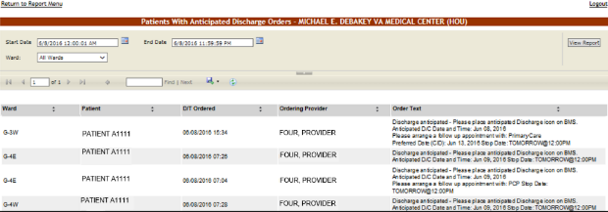
Using the Start Date and End Date fields, you can define the time interval for which you want to generate the report. From the Ward field select the ward for which you want to generate the report. After selecting the desired parameters click the View Report button to generate the report for the selected time period.
The title of the report is displayed in the upper part of the page. Navigation and display tools are available in the toolbar displayed across the screen. Place the mouse cursor over a button to display the corresponding tooltip.
The report can be exported to a series of formats available when clicking the Save button. Once exported, the Print button allows the site user to send the generated report to a printer.
For each anticipated discharge order in the report, the following data is available:
Table 19 - Anticipated Discharge Orders Parameters
Column | Description
Ward | The name of the ward from where the anticipated discharge operation is being performed.
Patient | The name of the patient being discharged with anticipation.
D/T Ordered | The date and time of the anticipated discharge order.
Ordering Provider | The full name of the clinician ordering the patient’s discharge.
Order Text | The text of the anticipated discharge order.

Bed Occupancy Summary Report
This report is high-level and gives a quick overall view on bed occupancy and therefore availability in the entire facility.
To generate the Bed Occupancy Summary report, follow the instructions below.
On the Reports page, from the Other Reports field select Bed Summary Report then press the Submit button. The report is displayed as in the following image:
Figure 73 - Bed Occupancy Summary Report – BMS Wards
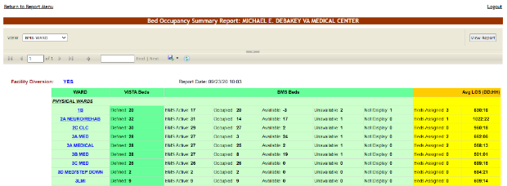
From the VIEW field select one of the available options (BMS WARD, NUMA or HAvBED) and click the View Report button.
- BMS view shows the bed summary by BMS ward group text.
- NUMA shows the bed summary report by NUMA specialties such as acute-medical, acute-surgical or mental health /chronic.
- HAvBed will convert the specialties above to a more specific group of beds used in evacuation and placement of patients.
The image above presents the report for the BMS wards. Below is an example of a report for the Nursing Unit Mapping Application (NUMA) specialty.
Figure 74 - Bed Occupancy Summary Report – NUMA Wards
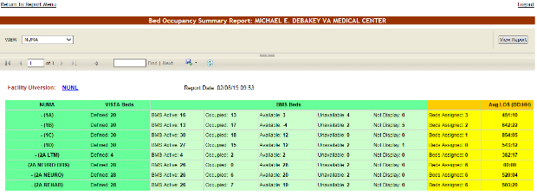
The Hospital Available Beds for Emergencies and Disasters (HAvBED) bed summary report is displayed as in the following image:
Figure 75 - Bed Occupancy Summary Report – HAvBED Wards
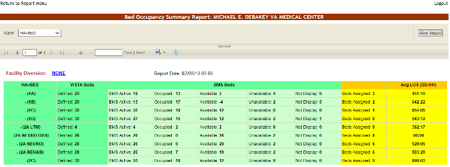
The title of the report is displayed in the upper part of the page. Navigation and display tools are available in the toolbar displayed across the screen. Place the mouse cursor over a button to display the corresponding tooltip.
The report can be exported to a series of formats available when clicking the Save button. Once exported, the Print button allows the site user to send the generated report to a printer.
The following data is available:
Table 20 - Bed Summary Parameters
COLUMN | DESCRIPTION
Ward/NUMA/HAvBED | The name of the BMS ward group or the NUMA/HAvBED associated.
VistA Beds | The number of active VistA Beds in the ward.
BMS Beds | The number of beds in the ward grouped by their corresponding status (Active, Occupied, Available, Unavailable, Not Displayed).
Beds Assigned | The number of beds which have already been assigned to a patient.
Avg LOS (DD:HH) | The average length of stay (days + hours) for all patients on that wardcombined.
Other Information | This area presents the number of Scheduled Admissions for the facility as well as the number of patients pending bed placement.

Bed Turnaround Time Report
This report shows how long it takes from discharge of one patient until the bed is ready for the next. To generate the Bed Turnaround Time report, follow the instructions below.
On the Reports page, from the Other Reports field select Bed Turnaround Report then press the Submit button. The report is displayed as in the following image:
Figure 76 - Bed Turnaround Time Report
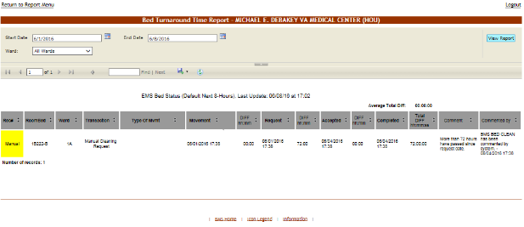
From the Ward field the site user can select the ward for which to generate the report. Using the Start Date and End Date fields a time interval for the report can be defined. After selecting the desired parameters click the View Report button to generate the report.
The title of the report is displayed in the upper part of the page. Navigation and display tools are available in the toolbar displayed across the screen. Place the mouse cursor over a button to display the corresponding tooltip.
The report can be exported to a series of formats available when clicking the Save button. Once exported, the Print button allows the site user to send the generated report to a printer.
The following data is available for each entry:
Table 21 - Bed Turnaround Time Parameters
COLUMN | DESCRIPTION
Rec# | The record number automatically assigned in the system to any request. This is the discharge entry number in the patient movement file. Manual bed cleaning requests will not display a record number but the word “manual”.
RoomBed | The code/number of the room/bed requested.
Ward | The code/name of the ward.
Transaction | The type of transaction that caused a bed cleaning. Usually transfer or discharge.
Type of Mvmt | The type of movement.
Movement | The date and time when the movement has occurred. (The icon indicates that the EMS notification has been sent by BMS.)
DIFF | The time lapse between the date/time when the movement occurred and when it was requested.
Request | The date and time when a request has been issued.
DIFF | The time lapse between the date/time when the request is submitted and when the cleaning is accepted by the bed cleaner.
Accepted | The date and time when the request was accepted.
DIFF | The time lapse between the date/time when the request was accepted and when it was completed.
Completed | The date and time when the movement was completed.
Total DIFF | The accumulated total of time lapse between the date/time when the request is submitted and when the cleaning is completed by the bed cleaner.
Comment | Any comments added in the Comments field.
Commented by | The user who entered the comments.

Beds Out of Service Report – All
This report shows which beds are or were unavailable and the time they are expected to be back in service.
To generate the Beds Out of Service (All) report, follow the instructions below.
On the Reports page, from the Other Reports field select Beds Out of Service (All) report then press the Submit button. The report is displayed as in the following image:
Figure 77 - ALL Current Beds Out of Service Report
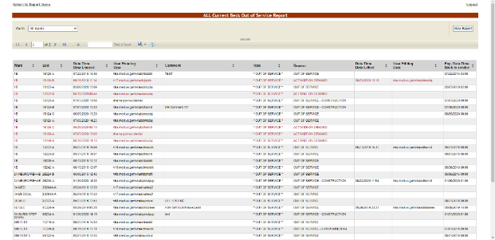
From the Ward field the site user can select the ward for which to generate the report. After selecting the ward(s), click the View Report button to generate the report.
The title of the report is displayed in the upper part of the page. Navigation and display tools are available in the toolbar displayed across the screen. Place the mouse cursor over a button to display the corresponding tooltip. Use the scroll bar to display all the data available.
The report can be exported to a series of formats available when clicking the Save button. Once exported, the Print button allows the site user to send the generated report to a printer.
The following data is available for each entry:
Table 22 - Beds Out of Service (All) Parameters
COLUMN | DESCRIPTION
Ward | The ward where the bed is located.
Bed | The bed’s facility assigned number.
Date Time Data Entered | The date and time when the bed was marked as “out of service.”
User Entering Data | The user who has taken the bed out of service.
Comment | The comment entered by the user when taking the bed out of service.
Type | The type of reason for which the bed was taken out of service.
Reason | Additional description of the type of reason the bed was taken out of service.
Data Time Data Edited | The date and time when the bed has been taken out of service.
User Editing Data | The name of the user who has taken the bed out of service.
Date Time Data Cleared | The date and time when the data has been cleared.
Exp. Date Time Back in service | The date when the bed is expected to be back in service.

Historical Beds Out of Service Report - By Date
This Report shows the beds set to Out of Service during the time frame of the report, and the date they are expected back in service.
To generate the Beds Out of Service (by Date) report, follow the instructions below.
On the Reports page, from the Other Reports field select Beds Out of Service (by Date) report then press the Submit button. The report is displayed as in the following image:
Figure 78 - Historical Beds Out of Service Report - By Date
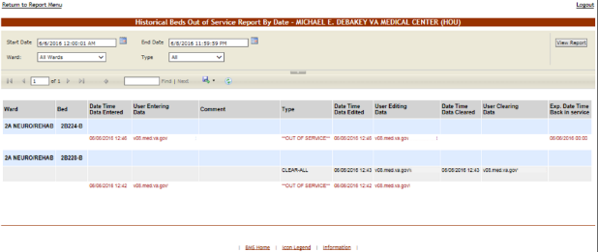
From the Ward field the user can select the desired ward or All Wards to generate the report. From the Type field the site user can select the type of reason (Information or Out of Service) for the bed being out of service. Using the Start Date and End Date fields a time interval for the report can be defined. After selecting the desired parameters, click the View Report button to generate the report.
The title of the report is displayed in the upper part of the page. Navigation and display tools are available in the toolbar displayed across the screen. Place the mouse cursor over a button to display the corresponding tooltip.
The report can be exported to a series of formats available when clicking the Save button. Once exported, the Print button allows the site user to send the generated report to a printer.
The following data is available for each entry:
Table 23 - Historical Beds Out of Service (by Date) Parameters
COLUMN | DESCRIPTION
Ward | The ward where the bed is located.
Bed | The code of the bed.
Date Time Data Entered | The date and time when the bed was marked “Out of Service.”
User Entering Data | The user who has taken the bed out of service.
Comment | The comment entered by the user when taking the bed out of service.
Type | The Bed Out of Service Reason.
Data Time Data Edited | The type of reason for which the bed was taken out of service, can be either Information or Out of Service.
User Editing Data | The date and time when the bed has been taken out of service.
Date Time Data Cleared | The name of the user who has taken the bed out of service.
User Clearing Data | The explanation of the date when the bed was placed back in service.
Exp. Date Time Back in service | The ward where the bed is located.

Emergency Management Report
This report provides information that can be printed and used in case of an emergency.
- Roster report is a listing of those patients needing to be evacuated and transported out of the facility;
- Regulate report provides a worksheet that can be used with some prefilled information such as admitting diagnosis;
- Manifest report can be used by those actually evacuating the patient such as the driver/attendant of the bus or vehicle;
- Transfer report is a report listing patients transferred and the facility or ward from which the patient was transferred.
The Emergency Management report presents a list with all the patients that need to be evacuated in case of emergency: all the patients currently admitted in the facility as shown in the Ward Whiteboard Home page.
The report presents the data entered in the Evacuation Data fields, which become available when selecting the option Evacuation patient in the ADD/EDIT Patients Pending Bed Placement for (facility name) page. Some data fields are designed to be filled out once the reports have been printed for use in the actual transport of those patients being evacuated.
Figure 79 - Patients Pending Bed Placement- Evacuation Patient
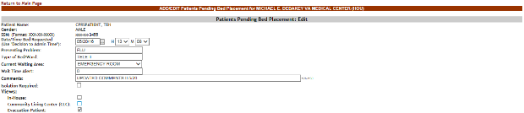
To generate the Emergency Management report, follow the instructions below.
On the Reports page from the Other Reports field select the Emergency Management Report. The following page is displayed:
Figure 80 - Emergency Management Report – Roster
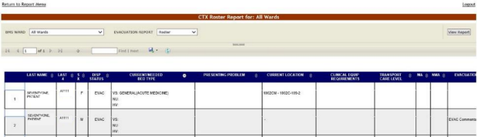
From the BMS Ward field select the ward(s) for which you want to generate the report. From the EVACUATION REPORT field select one of the display options for the report: Roster, Regulate, Manifest or Patient Transfer.
Below is an example of a report displayed with the Regulate display option:

Figure 81 - Emergency Management Report – Regulate
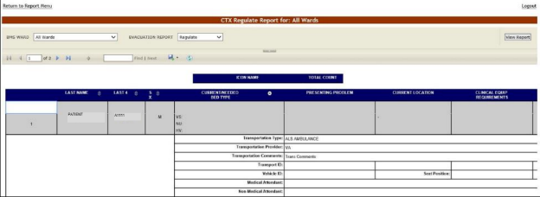
Below is an example of a report displayed with the Manifest display option:
Figure 82 - Emergency Management Report – Manifest
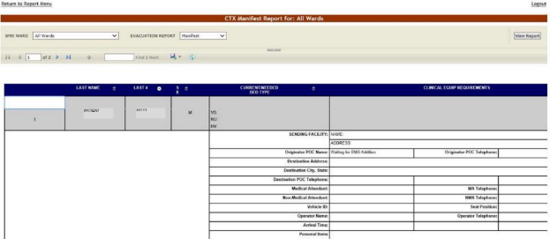
Below is an example of a report displayed with the Patient Transfer display option:
Figure 83 - Emergency Management Report – Patient Transfer
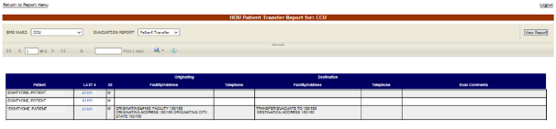

The title of the report is displayed in the upper part of the page. Navigation and display tools are available in the toolbar displayed across the screen. Place the mouse cursor over a button to display the corresponding tooltip.
The report can be exported to a series of formats available when clicking the Save button. Once exported, the Print button allows the site user to send the generated report to a printer.
The following data is available for each entry:
Table 24 - Emergency Management Reports Parameters
COLUMN | DESCRIPTION
Last Name | Last name of the patient who needs to be evacuated.
Last 4 | First Initial of last name and last four digits of the patient SSN.
SX | The gender of the patient.
Disp. Status | The disposition with which the patient is added to the patient pending bed placement list.
Current/Needed Bed Type | The type of bed needed for the patient who is being evacuated.
Presenting Problem | The problem for which the patient has been admitted. Pulls in admitting Diagnosis for inpatients.
Current Location | The current location of the patient. Pulls in current ward/room/bed.
Clinical Equipment Requirements | The clinical equipment requirements for the patient.
Transport Care Level | The transport care level.
Originator POC Telephone | The telephone of the facility from where the patients are evacuated.
Destination Address | The address of the facility where the patient is evacuated to.
Destination City, State | The city and state where the patient is evacuated to.
Destination POC Telephone | The telephone of the Point-of-Contact of the facility where the patient is evacuated to.
Medical Attendant | The name of the Medical Attendant assigned for the patient.
MA Telephone | The phone number of the Medical Attendant assigned for the patient.
Non-Medical Attendant | The name of the non-Medical Attendant accompanying the patient or of the family member that may be transported with the patient.
NMA Telephone | The phone number of the non-Medical Attendant accompanying the patient or of the family member that may be transported with the patient.
Vehicle ID | The identifying number of the transportation vehicle.
Seat Position | The seat position of the patient for the transportation vehicle.
Operator Telephone | The telephone of the facility from where the patients are evacuated.
Evacuation Comments: | Any relevant evacuation comments.

Discharges in Progress Report
To generate the Discharges in Progress report, follow the instructions below.
On the Reports page, from the Other Reports field select Discharges in Progress Report then press the Submit button. The report is displayed as in the following image:
Figure 84 - Discharges in Progress Report
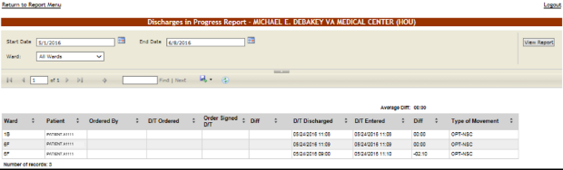
From the Ward field select the ward for which you want to generate the report. Using the Start Date and End Date fields, define the time interval for which you want to generate the report. After selecting the desired parameters, click the View Report button to generate the report for the selected time period.
The title of the report is displayed in the upper part of the page. Navigation and display tools are available in the toolbar displayed across the screen. Place the mouse cursor over a button to display the corresponding tooltip.
The report can be exported to a series of formats available when clicking the Save button. The Print button allows the site user to send the generated report to a printer.
The following data is available for each entry:
Table 25 - Discharges in Progress Parameters
COLUMN | DESCRIPTION
Ward | The name of the ward where the bed is.
Patient | The patient code of the patient who is being discharged.
Ordered by | The name of the clinician writing the discharge order.
D/T Ordered | The date and time when the discharge order has been issued.
Order Signed D/T | The date and time the discharge order was signed.
Diff | The time lapse between the date/time when the discharge was ordered and the date/time that the discharge order was signed.
D/T Discharged | The date and time when the actual discharge was performed.
D/T Entered | The date and time when the discharge was registered in the system.
Diff | The time lapse between the date/time when the discharge was performed and the date/time it was registered in the system.
Type of Movement: | The type of movement.

EMS Bed Status Report – Admin
To generate the EMS Bed Status report, follow the instructions below.
On the Reports page, from the Other Reports field select EMS Bed Status Report (Admin) then press the Submit button. The report is displayed as in the following image:
Figure 85 - EMS Bed Status Report
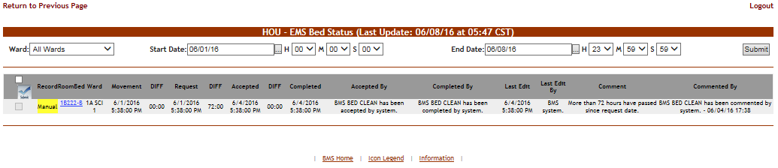
From the Ward field select the ward for which you want to generate the report. Using the Start Date and End Date fields, define the time interval for which you want to generate the report. After selecting the desired parameters, click the Submit button to generate the report for the selected time period.
The title of the report is displayed in the upper part of the page. Navigation and display tools are available in the toolbar displayed across the screen. Place the mouse cursor over a button to display the corresponding tooltip.
The report can be exported to a series of formats available when clicking the Save button. Once exported, the Print button allows the site user to send the generated report to a printer.
The following data is available for each entry:
Table 26 - EMS Bed Status Parameters
COLUMN | DESCRIPTION
Record | The number automatically assigned in the system to the record. This is the discharge entry number in the patient movement file.
RoomBed | The room and bed number.
Ward | The ward number.
Movement | The date and time when the movement has been registered.
DIFF | The time lapse between the date/time when the movement occurred and when it was requested.
Request | The date and time of the request.
DIFF | The time lapse between the date/time when the request occurred and when it was accepted.
Accepted | The date and time when the request was accepted.
DIFF | The time lapse between the date/time when the request was accepted and the date/time when the request was completed.
Completed | The date and time when the movement has been completed.
Accepted By | The name of the person who accepted the request.
Completed By | The name of the person who completed the operation.
Last Edit | The date and time when the record was last edited.
Last Edit By | The name of the person who last edited the record.
Comment | The comments entered in the Comments field.
Commented By | The user who entered the comments.

Patients with Discharge Appointments Report
To generate the Inpatients with Future Discharge Appointments report, follow the instructions below.
On the Reports page, from the Other Reports field select Patients w Discharge Appointment Report then press the Submit button. The report is displayed as in the following image:
Figure 86 - Inpatients with Future Discharge Report Appointments
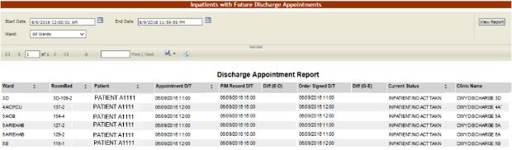
Using the Start Date and End Date fields, define the time interval for the report. From the Ward field select the ward for the report. After selecting the desired parameters, click the View Report button to generate the report for the selected time period.
The title of the report is displayed in the upper part of the page. Navigation and display tools are available in the toolbar displayed across the screen. Place the mouse cursor over a button to display the corresponding tooltip.
The report can be exported to a series of formats available when clicking the Save button. Once exported, the Print button allows the site user to send the generated report to a printer.
The following data is available for each entry:
Table 27 - Future Discharge Report Parameters
COLUMN | DESCRIPTION
Ward | The code/name of the ward where the bed is.
RoomBed | The bed where the discharge is being performed.
Patient | The name of the patient being discharged.
Appointment Date/Time | The scheduled date and time of the discharge.
P/M (Patient Movement) Record D/T | The date and time of the last patient movement.
Diff (E-D) | The time difference between the Appointment Date/Time and the Patient Movement Record Date/Time.
Order Signed Date/Time | The date and time of the time the Discharge Order was signed.
Diff (G-E) | The time difference between the Appointment Date/Time and the Order Signed Date/Time.
Current Status | The current status of the discharge operation.
Clinic Name | The name of the Clinic where the patient has the discharge appointment.

Patient Movements by Date
To generate the Patient Movements by Date report, follow the instructions below.
On the Reports page, from the Other Reports field select Patient Movements by Date then press the Submit button. The report is displayed as in the following image:
Figure 87 - Patient Movement Report by Date Range
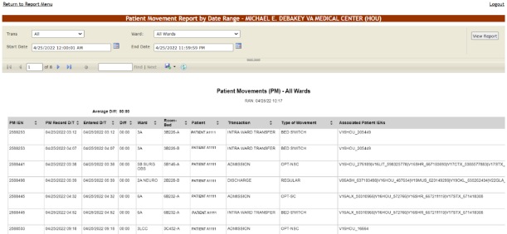
From the Trans field select the type of movement (All, Admissions, Discharges, Inter Ward Transfers, Intra Ward Transfers, Specialty Transfers) you want to include in the report. Using the Start Date and End Date fields, define the time interval for the report. From the Ward field select the ward(s) for which you want to generate the report. After selecting the desired parameters, click the View Report button to generate the report for the selected time period.
The title of the report is displayed in the upper part of the page. Navigation and display tools are available in the toolbar displayed across the screen. Place the mouse cursor over a button to display the corresponding tooltip.
The report can be exported to a series of formats available when clicking the Save button. Once exported, the Print button allows the site user to send the generated report to a printer.
The following data is available for each entry:
Table 28 - Patient Movement Report by Date Parameters
COLUMN | DESCRIPTION
PM IEN (Internal Entry Number) | The VistA Patient Movement Internal Entry Number for the primary lookup key in the Patient Movement file
PM Record D/T | The date and time when the patient movement has been registered in the system.
Entered D/T | The data and time the patient movement was entered in the system.
Diff | The time lapse between the PM Record D/T and the Entered D/T.
Ward | The code/name of the ward.
Room-Bed | The code of the room/bed.
Patient | The code/name of the patient.
Transaction | The type of transaction.
Type of Movement | The type of the movement.
Associated Patient IENs | Patient Internal Entry Number

Scheduled Admissions by Date
To generate the Scheduled Admissions by Date report, follow the instructions below.
On the Reports page, from the Other Reports field select the Scheduled Admissions by Date then press the Submit button. The report is displayed as in the following image:
Figure 88 - Scheduled Admissions by Date
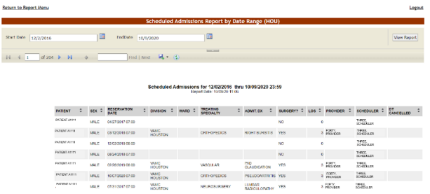

Using the Start Date and End Date fields, define the time interval for which you want to generate the report. After selecting the desired parameters, click the View Report button to generate the report for the selected time period.
The title of the report is displayed in the upper part of the page. Navigation and display tools are available in the toolbar displayed across the screen. Place the mouse cursor over a button to display the corresponding tooltip.
The report can be exported to a series of formats available when clicking the Save button. Once exported, the Print button allows the site user to send the generated report to a printer.
The following data is available for each entry:
Table 29 - Scheduled Admissions Parameters
COLUMN | DESCRIPTION
Patient | The name of the patient displayed as Last Name plus first letter of last name and last 4 of SSN in parentheses. Example: Brown (B1234)
Sex | The gender of the patient.
Reservation Date | The date of admission.
Division | The Division where patient will be admitted.
Ward | The ward where is the bed for which the admission has been made.
Treating Specialty | The medical specialty to which the patient has been assigned.
Admit. Dx | Diagnosis on admission.
Surgery? | Indicates if the patient is scheduled for surgery.
LOS | Length of stay.
Provider | The primary care clinician for the patient.
Scheduler | The name of the person scheduling the admission.
DT Cancelled | If the scheduled admission was cancelled, the date and time of the cancellation.

Patients Pending Bed Placement List Status Report
To generate the Patients Pending Bed Placement List Status report, follow the instructions below.
On the Reports page, from the Other Reports field select the Patients Pending Bed Placement List Status report then press the Submit button. The report is displayed as in the following image:
Figure 89 - Patient Pending Bed Placement List Status Report Criteria
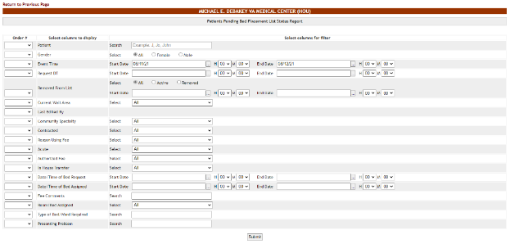
The user can select the data to be included in report.
From the Order # column select the order in which the columns of the report will be arranged. If you do not select a number in this column the associated column will not be included in the report.
From the Select columns for filter area select the filter criteria for the report entries.
Make your selections then press the Submit button to display the report as in the following image:
Figure 90 - Patient Pending Bed Placement List Status Report
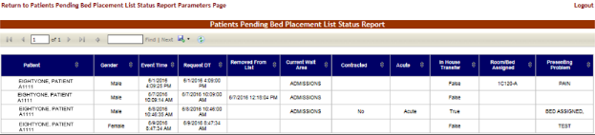
The title of the report is displayed in the upper part of the page. Navigation and display tools are available in the toolbar displayed across the screen. Place the mouse cursor over a button to display the corresponding tooltip.
The report can be exported to a series of formats available when clicking the Save button. Once exported, the Print button allows the site user to send the generated report to a printer.

Active Transfer Orders Report
This report presents the list of active transfer orders for the current facility. To generate the Active Transfer Orders report, follow the instructions below.
On the Reports page, from the Other Reports field select the Active Transfer Orders then press the Submit button. The report is displayed as in the following image:
Figure 91 - Active Transfer Orders Report
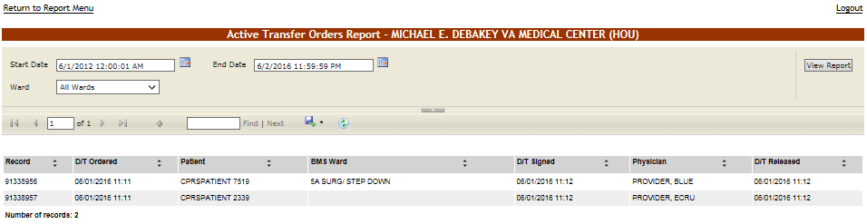
Using the Start Date and End Date fields, define the time interval for which you want to generate the report. Using the Ward field, select the ward or all wards. After selecting the desired parameters, click the View Report button to generate the report for the selected time period.
The title of the report is displayed in the upper part of the page. Navigation and display tools are available in the toolbar displayed across the screen. Place the mouse cursor over a button to display the corresponding tooltip.
The report can be exported to a series of formats available when clicking the Save button. Once exported, he Print button allows the site user to send the generated report to a printer.
The following data is available for each entry:
Table 30 - Active Transfer Orders Report Parameters
COLUMN | DESCRIPTION
Record | The number automatically assigned in the system to the record. This is the transfer entry number in the patient movement file.
D/T Ordered | The date and time when the transfer has been ordered.
Patient | The patient’s last name and the last 4 digits of their SSN.
BMS Ward | The BMS ward where the patient is being transferred to.
D/T Signed | The date and time when the transfer order has been signed.
Physician | The name of the physician who signed the transfer order.
D/T Released | The date and time when the patient has been released.

Bed Switch Report
This report presents the list of active transfer orders for the current facility. To generate the Bed Switch report, follow the instructions below.
On the Reports page, from the Other Reports field select the Bed Switch Report then press the Submit button. The report is displayed as in the following image:
Figure 92 – Bed Switch Report
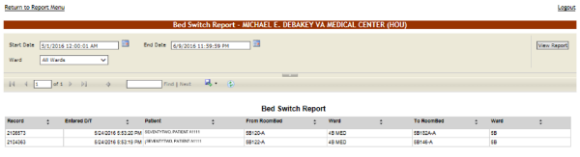
Using the Start Date and End Date fields, define the time interval for which you want to generate the report. Using the Ward field, select the desired ward or All Wards. After selecting the desired parameters, click the View Report button to generate the report.
The title of the report is displayed in the upper part of the page. Navigation and display tools are available in the toolbar displayed across the screen. Place the mouse cursor over a button to display the corresponding tooltip.
The report can be exported to a series of formats available when clicking the Save button. Once exported, the Print button allows the site user to send the generated report to a printer.
The following data is available for each entry:
Table 31 – Bed Switch Report Parameters
COLUMN | DESCRIPTION
Record | The number automatically assigned in the system to the record. This is the transfer entry number in the patient movement file.
Entered D/T | The date and time when the bed switch was entered.
Patient | The patient’s last name and the last 4 digits of their SSN.
From RoomBed | The room/bed which the patient was switched from.
(From) Ward | The BMS ward where the patient was switched from.
To RoomBed | The room/bed which the patient was switched to.
(To) Ward | The BMS ward where the patient was switched to.

Facility Diversion Report
This report presents the list of facility diversions for the current facility. To generate the Facility Diversion report, follow the instructions below.
On the Reports page, from the Other Reports field select the Facility Diversion Report then press the Submit button. The report is displayed as in the following image:
Figure 93 - Facility Diversion Report
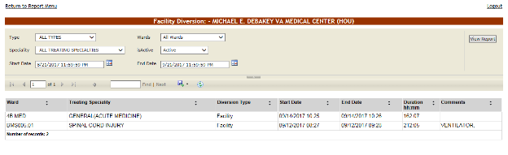
Using the Start Date and End Date fields, define the time interval for which you want to generate the report. Facility Type, Wards, Specialty, and Active status can also be selected. After selecting the desired parameters, click the View Report button to generate the report for the selected time period. (Only diversions that started during the time interval selected will display).
Active Diversions will display an empty End Date value.
The title of the report is displayed in the upper part of the page. Navigation and display tools are available in the toolbar displayed across the screen. Place the mouse cursor over a button to display the corresponding tooltip.
The report can be exported to a series of formats available when clicking the Save button. The Print button allows the site user to send the generated report to a printer.
The following data is available for each entry:
Table 32 - Facility Diversion Report Parameters
COLUMN | DESCRIPTION
Ward | The Ward.
Treating Specialty | The treating specialty.
Diversion Type | The diversion type either Facility or Emergency Department.
Start Date | Start date of diversion.
End Date | End date of diversion.
Duration hh:mm | Duration of diversion hours & minutes.
Comments | Any pertinent comments.

PPBP By Date Range Report
This report presents the list of PPBP entries by date range for the current facility. To generate the Facility PPBP By Date Range report, follow the instructions below.
On the Reports page, from the Other Reports field select the PPBP By Date Range Report then press the Submit button. The report is displayed as in the following image:
Figure 94: PPBP By Date Range Report
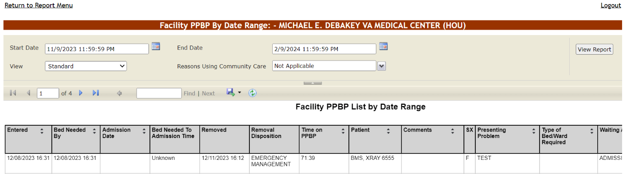
Using the Start Date and End Date fields, define the time interval for which you want to generate the report. By default, the date range is set to 30 days. After selecting the desired parameters, click the View Report button to generate the report for the selected time period.
The title of the report is displayed in the upper part of the page. Navigation and display tools are available in the toolbar displayed across the screen. Place the mouse cursor over a button to display the corresponding tooltip.
The report can be exported to a series of formats available when clicking the Save button. Once exported, the Print button allows the site user to send the generated report to a printer.
When using the Community Care view, user must choose a selection from the Reasons Using Community Care drop down menu. If no selection is made, the following error message will be displayed: “Please enter a value for the parameter ‘Reasons Using Community Care’. The parameter cannot be blank.” Choose a selection from the dropdown box to clear this error.
Figure 95: PPBP By Date Range Report – Community Care View and Reasons Using Community Care requirement

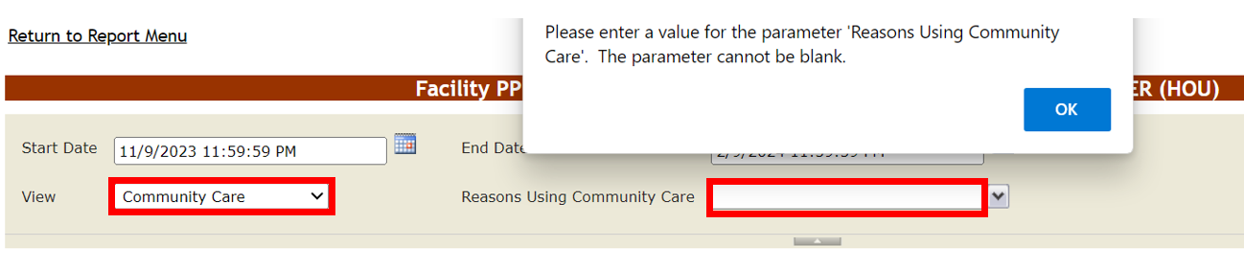
Table 33 - PPBP By Date Range Report Parameters (Community Care View)
COLUMN | DESCRIPTION
Entered | Date of entry on Patients Pending Bed Placement List.
Bed Needed By | The date and time when the bed is needed.
Admission Date | The date the patient was admitted to VA.
Bed Needed To Admission Time | The difference between the Bed Needed By and Admission Date values.
Removed | Date the entry on the PPBPL was removed.
Removal Disposition | The disposition applied to the patient record when removed from the Patients Pending Bed Placement List.
Time on PPBP | The difference between the Entered and Admission Date. If the patient wasn’t admitted, Time on PPBP is calculated as 'Entered' date – 'Removed' date. If the patient is not yet admitted and has not been removed from the PPBPL, Time on PPBP is calculated as 'Entered' date - Current Time.
Patient | The last name, first name and last 4 digits of the SSN.
Comments | Pertinent comments.
SX | Patient gender.
Presenting Problem | Patient’s initial complaint.
Type of Bed/Ward Required | Ward/Bed required.
Waiting Area | Facility waiting area.
Wait Time (h:m) | Wait time in hours & minutes.
Wait Time Alert Date | Alerts, if any.
CLC | If the patient is a resident in a Community Living Center or in-house waiting for a bed at the Community Living Center.
Community Care Facility Name | The non-VA facility where the patient is receiving community care.
Bed Type | The VA bed type not available currently.
Definitions for other report views may be found in Tables 3 – 7.
If text appears in the Community Care Comments like the image below, open a support ticket for Tier 3 Support to retrieve the prior comment text for you.
Figure 96: Community Care Comments
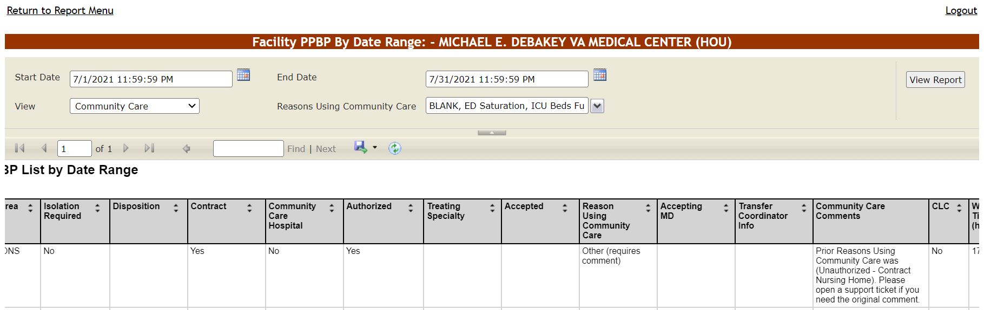

Discharge Order Difference Report
This report presents the list of discharge order differences for the current facility. To generate a Discharge Order Difference report, follow the instructions below.
On the Reports page, from the Other Reports field select the Discharge Order Difference Report then press the Submit button. The report is displayed as in the following image:
Figure 97 - Discharge Order Difference Report
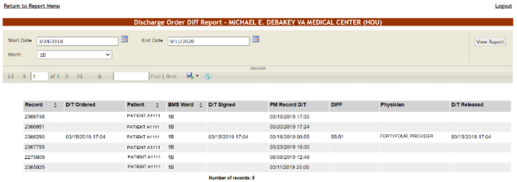
Using the Start Date and End Date fields, define the time interval for the report. Using the Ward field, select the desired ward or All Wards for the report. After selecting the desired parameters, click the View Report button to generate the report for the selected time period.
The title of the report is displayed in the upper part of the page. Navigation and display tools are available in the toolbar displayed across the screen. Place the mouse cursor over a button to display the corresponding tooltip.
The report can be exported to a series of formats available when clicking the Save button. Once exported, the Print button allows the site user to send the generated report to a printer.
The following data is available for each patient in the report:
Table 34 - Discharge Order Difference Report Parameters
COLUMN | DESCRIPTION
Record | The number automatically assigned in the system to the record. This is the transfer entry number in the patient movement file.
D/T Ordered | The date and time the transfer has been ordered.
Patient | The patient’s last name and the last 4 digits of their SSN.
BMS Ward | The BMS ward the patient is being transferred to.
D/T Signed | The date and time the transfer order has been signed.
PM Record D/T | The date and time when the patient movement has been recorded.
DIFF | The time lapse between the date/time when the movement occurred and when it has been registered.
Physician | The name of the physician who signed the transfer order.
D/T Released | The date and time the order has been released.

The Facility Diversion Page
This page is accessed by clicking the Facility Diversion link in the upper left corner of the facility home page.
Figure 98 - Facility Diversion Page
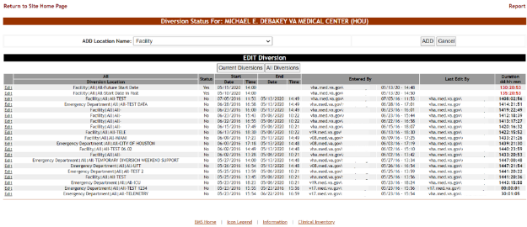
This page presents a list of facility areas/wards or Emergency Departments (ED) that are not accepting patients due to insufficient resources or facility issues.
In the Facility Diversion page, the user can perform the following actions: add a Facility Diversion entry and edit an existing Facility Diversion entry.
The user can add one of the locations available in the field ADD Location Name (populated from the VistA system).
The diversion list can be filtered to see only the Current Diversions or All Diversions. All Diversions gives the user historical diversion information for the facility or ED.
The following data is available for each entry in the list when the Current Diversions button is pressed:
Table 35 - Current Diversions Parameters
COLUMN | DESCRIPTION
Edit | Allows the user to update diversion information.
Current Diversion Location | The name of the facility that is in Diversion Status.
Status | Yes / No.
Start Date/Time | The date and time when the diversion operation has been registered.
Entered By | The name of the person who has registered the diversion.
Last Edit By | The name of the person who last modified the details of the diversion.
Duration dd:hh:mm | The length of time for which the facility has been on Diversion Status
The following data is available for each entry in the list when the All Diversions button is pressed:
Table 36 - All Diversions Parameters
COLUMN | DESCRIPTION
Edit | Allows the user to update diversion information.
All Diversion Location | The name of the facility that is in Diversion Status.
Status | Yes / No.
Start Date/Time | The date and time when the diversion operation has been registered.
End Date/Time (EST) | The date and time when the diversion operation ended.
Entered By | The name of the person who has registered the diversion.
Last Edit By | The name of the person who last modified the details of the diversion.
Duration dd:hh:mm | The length of time for which the facility has been on Diversion Status.
To change the details of a diversion the user can use the Edit link to the left of an entry.

Setting a Facility Area/Ward or ED to Diversion Status
To register a Facility or ED to Diversion Status, follow the instructions below.
From the home page, click the Facility Diversion link in from the upper left corner of the screen.
Figure 99 - Selecting Facility Diversion
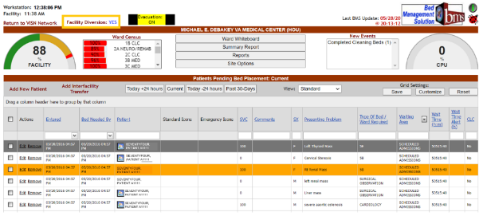
The Diversion page is displayed as in the following image:
Figure 100 - Adding/Editing Details of Facility Diversion
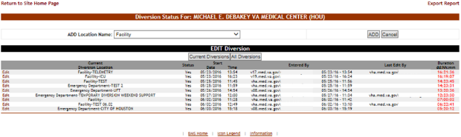
From the field ADD Location Name select the facility or ED you want to divert then press the ADD button.The following screen is displayed:
Figure 101 - Add New Diversion Status
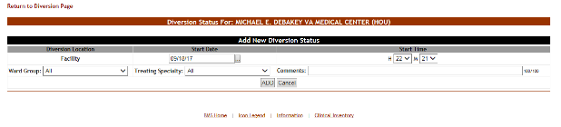
The name of the facility selected in the previous screen is displayed in the Diversion Location column. The user enters the Date and Time that the Facility or ED will Start Diversion Status. In addition, the facility can be assigned to a specific Ward Group or Treating Specialty, as needed.
In the Comments field, enter any comments that you consider relevant then press the ADD button to enter the data into the system.
If facility diversion is selected in the comments field indicate which ward/area is being diverted. For example, select Facility and in the comments section indicate Intensive Care Unit (ICU)-No beds available. The newly registered diversion will be displayed in the Current Diversions list in the main Diversion screen.

Edit an Existing Facility Diversion Entry
To edit the details of the diversion status set for a Facility or ED: in the Diversion Status for… (facility name) page, click the Edit link to the left of the diversion status you want to modify. The following page is displayed:
Figure 102 - Edit Diversion Status Details
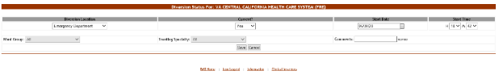
Modify any of the existing parameters then press the Save button to enter the data into the system.
Change the “Current?” Dropdown selection to No for the End Date and End Time fields to appear.
Figure 103 - Edit Diversion Status Details
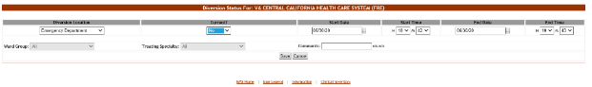

The Events Page
This page is accessed by clicking the New Events link above the New Events List box on the right side of the screen, beside the CPU% graph.
Figure 104 – New Events link
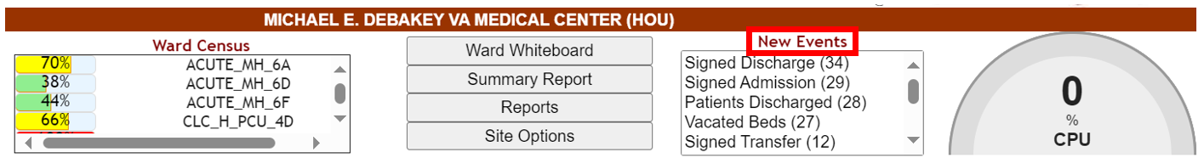
Figure 105 - New Events Page
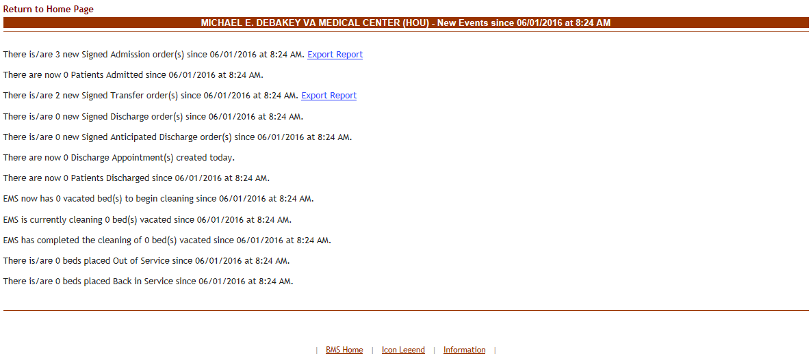
This page presents the latest events occurring in VistA and which have an impact on the activity of the current facility as well as events occurred in the current facility during the last 8 hours. A View Report link is available for displaying details on the events of a certain type.
In the Events Page the user can perform a single type of action: generating a report.

View/Generate Patient Movement Report
To generate a report in the New Events page, click the Export Report link. The following page is displayed. (In the image below the Patient Movement Report by Date Range is presented).
Figure 106 - New Events Page Export Report link
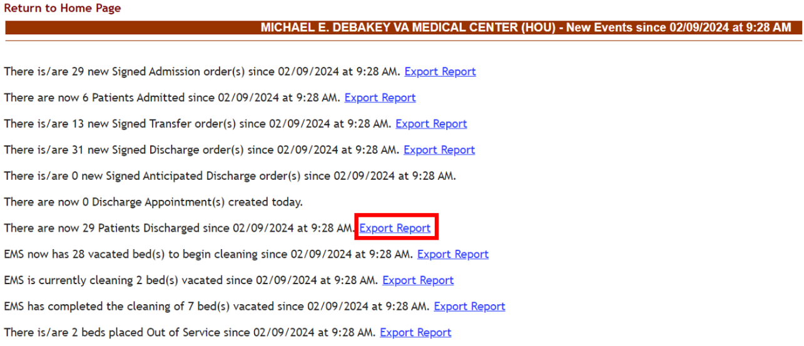
Figure 107 - Patient Movement Report
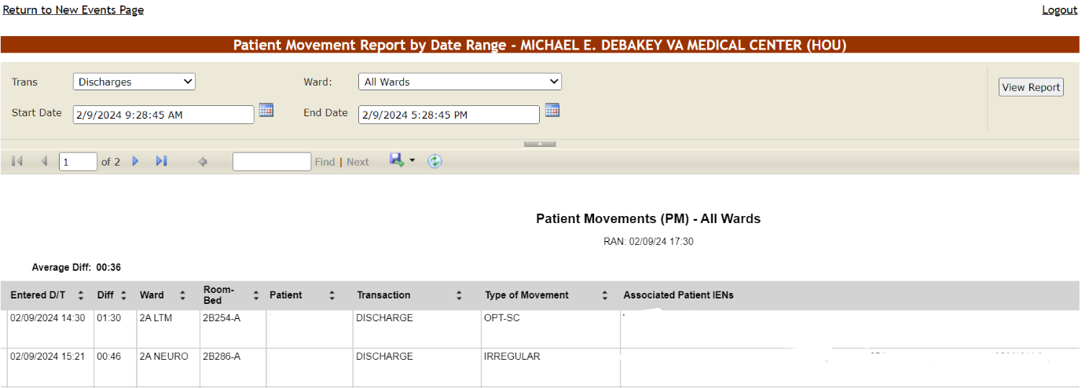

The Ward Whiteboard Home Page
This page is accessed by clicking the Ward Whiteboard button in the middle/top section of the facility home page.
Figure 108 – Ward Whiteboard button
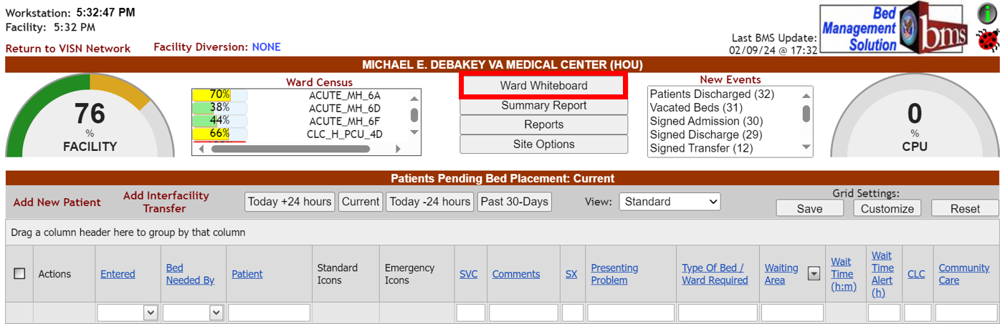
Note: Users are discouraged from using the words DNR/DNI in the comment of the Ward Whiteboard or using any icon to represent DNR/DNI on the Ward Whiteboard.
Figure 109 - Ward Whiteboard Home – Select Display Criteria
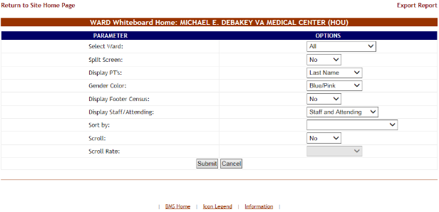
The following display criteria are available:
Select Ward: Use the arrow button of this field to display a list of wards defined for the current facility and select the ward for which you want to display the whiteboard. Selecting ‘All’ will allow all wards to be displayed on one screen.
Split Screen: Use the Yes/No options in this field to decide whether to display the info in one or two columns. This could be helpful if the ward to be displayed has a large number of beds associated to it.
Display PTs: Use the arrow button of this field to select display options for the patient name. You can choose between the full name and a code made up of the first letter of the name of the patient + 4 last digits in their SSN. The default on a public whiteboard is the full last name.
Gender Color: Use the arrow button of this field to determine the color-coding for the patient gender. If set to None all rooms will be displayed in shades of gray.
Display Footer Census: If detailed census values should be displayed at the bottom of the bed list. If set to Yes, the whiteboard will be displayed with the information seen for that ward on the Bed Summary Report.
Figure 110 - Ward Whiteboard Home – Footer Census
Display Staff/Attending: The options for this field is Staff/Attending, Staff only, or Attending only This will create the appropriate column(s) on the whiteboard, The Attending will be populated from VistA with the Attending physicians last name.
Sort by: if the list should be sorted according to the available criteria. The available criteria is staff/attending in ascending or descending order or by ward in ascending or descending order. This would be useful for staff assignment or end of shift reporting.
Scroll: if the scroll function should be enabled (for long lists).
Scroll Rate: This option will only be available if you select “Yes” for the Scroll field. You can select a scroll rate of 2 seconds, 5 seconds, 10 seconds, 20 seconds or 30 seconds.
Select the desired display criteria from the drop-down fields, then press the Submit button to order the patient list according to the selected criteria. Below is an example of All wards selected with the footer census:

Figure 111 - Ward Whiteboard Home
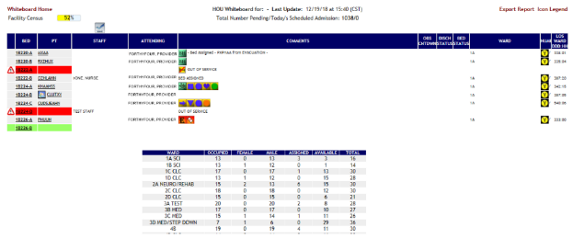
NOTE: If the patient has opted-out of having their name displayed, the PT column will show “x x x x”.
To view the patient’s information quickly, hover over the “x x x x” and the patient’s last name and last 4 digits of their SSN will display, as in the screenshot below:
Figure 112 - Patient Information Display
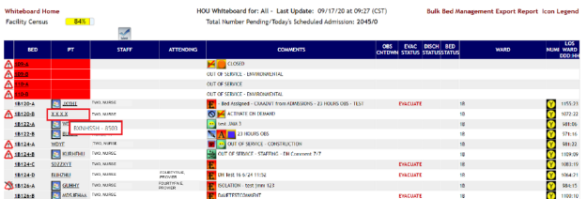
If a facility is set to Evacuation mode, the Whiteboard displays an extra EVAC STATUS column and an indicator for each patient regarding their evacuation status, as in the screenshot below:
Figure 113 - Ward Whiteboard Home – Evacuation Status
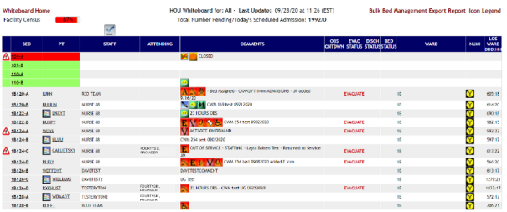
NOTE: if you select only a ward group instead of the entire facility in the upper right corner of the screen a Ward Census field will display the percentage of occupancy for the selected ward.
Figure 114 - Ward Whiteboard Home - Ward Census Field
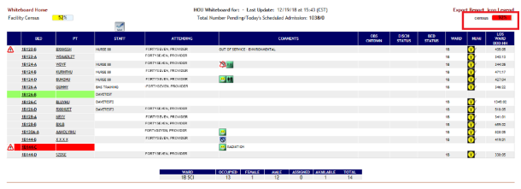
The Ward Whiteboard Home page displays the list of beds in the selected ward(s). For each bed, the following data is available:
Table 37 - Beds Parameters
COLUMN | DESCRIPTION
BED | The number assigned to the bed in the ward. The site user can click this link to view and/or edit bed information.
PT | The patient code of the patient occupying the bed. (The format of this code can be selected from the Display PTs field at the top of the beds list). Clicking the patient code link will display the Edit Patient page where you can see details of the selected patient. An icon indicating the same or similar name may appear next to the patient name if another patient on the ward has been identified.
STAFF | Name of Nursing personnel assigned to the bed.
ATTENDING | The name of the attending physician in charge of care of the patient.
COMMENTS | Helpful information entered by the site user when changing the bed status. Includes Patient Risk information conveyed by means of specific icons (Flight Risk, Slip, and/or Fall Risk). For details on the patient risk icons available, click the Icon Legend link in the top-right corner of the beds list.
OBS CNTDWN | This is the observation countdown.
EVAC STATUS | When a facility is on Evacuation Status, this column displays patients which have been designated for evacuation.
DISCH STATUS | The DSC column displays the Discharge status of the bed. Three possible statuses are available:  Anticipated Discharge  Discharge Ordered  Interward Transfer  These icons are all triggered by Orderable Items and will continue to display until the Orderable Item is completed or the patient is discharged from the room.  Discharge Icons are triggered when a patient is assigned an Orderable Item that has been defined in Site Options, BMS Orderable Items Add/Delete, as Type of “DISCHARGE”.  Interward Transfer Icons are triggered when a patient is assigned an Orderable Item that has been defined in Site Options, BMS Orderable Items Add/Delete, as Type of “TRANSFER”.  NOTE: Discharge Orders override Anticipated Discharge Orders.  Anticipated Discharge Icons are triggered off the Order Text when it contains the text “Anticipated Discharge” or “Planned Discharge”, or by finding a current appointment in a previously identified Discharge Appointment Clinic.  For more information, refer to the BMS User Setup and Admin guide.
BED STATUS | The BED column displays information about the bed cleaning status. Three statuses are available:  Bed Cleaned  Bed Needs Cleaning  Cleaning Bed
WARD | The ward where the bed is located.
NUMI | NUMI automates utilization review assessment and outcomes. The Utilization Management (UM) Process is a tool used to help verify that patients are receiving the right care, at the right time, and in the right place. UM is both a quality and efficiency tool, as it is used to move patients efficiently through the VA system to maximize use of resources. UM reviewers assess patient admissions and hospital stay days using standardized objective evidence-based clinical criteria to determine whether patients meet criteria for acute hospital care. Refer to the NUMI icons for the different levels of care.
LOS WARD DDD:HH | Length of stay on a ward.
In this page the user can perform the following actions: take a bed out of service, flag a bed with different icons, display the patient details and generate the ward whiteboard report for the selected wards.

Taking a Bed out of Service
To take a bed out of service, follow the instructions below. You must have privileges that will allow you to do this action.
From the home page, click the Ward Whiteboard link.
Figure 115 - Selecting Ward Whiteboard
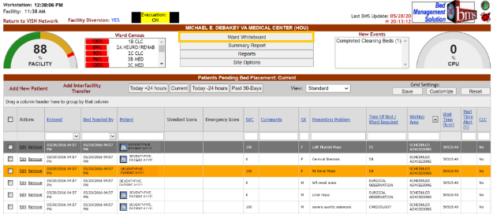
The Ward Whiteboard page is displayed as in the following image:
Figure 116 - Selecting Parameters for Ward Whiteboard
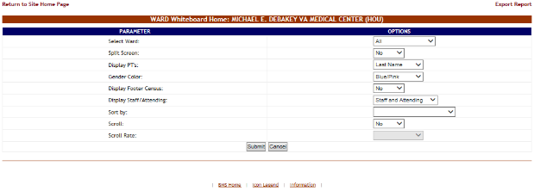
Click the arrow button of the Select Ward field to display a list of wards defined in the system and select the ward where the bed is located that you want to take out of service, then press the Submit button. The list of the beds in the selected ward is displayed as in the following image:
Figure 117 - Selecting a Bed from the Ward Whiteboard Page
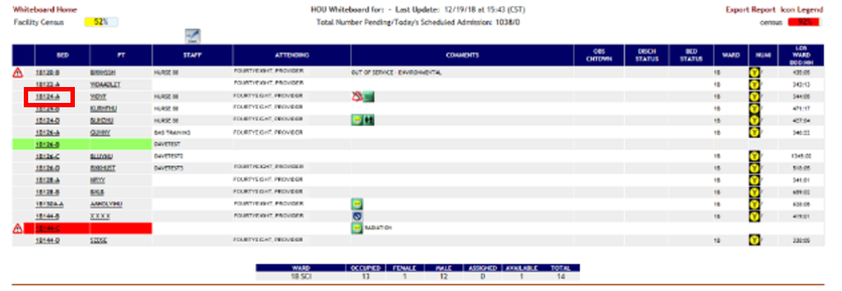
Click the bed code link of the bed you want to take out of service. The WARD Whiteboard page is displayed as in the following image:
Figure 118 - Taking a Bed Out of Service
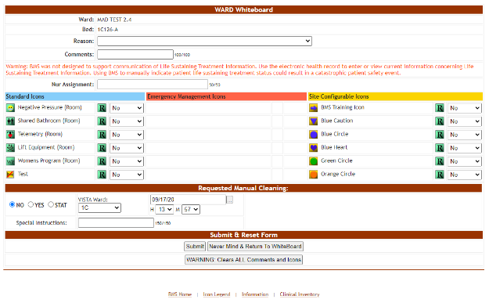
Click the arrow button of the Reason field to display a list of available options then select an OUT OF SERVICE reason. Enter the date and time the bed is expected to be returned to service if it is known. Note that the date will be a required selection for all Out of Service selections except ‘ACTIVATE ON DEMAND’. The date is not required for this reason, as the bed is immediately available pending patient demand. When all the data has been entered, press the Submit button. This information is displayed in Beds Out of Service reports.
Figure 119 – Out of Service Reason and required Expected OOS End Date
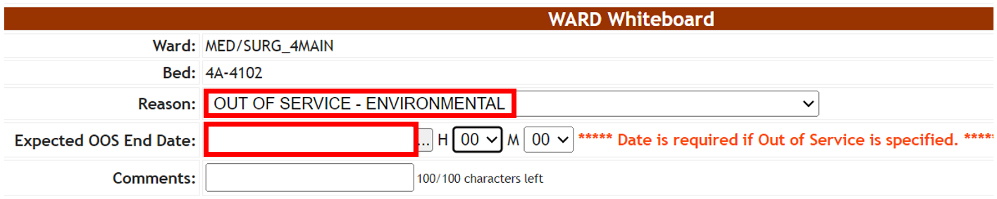
When displaying the Ward Whiteboard Home page, the selected bed will be marked with an icon “Out of service” and the color will be changed to Red.
If you choose a Do Not Display Reason, the bed will not be displayed on the Whiteboard.
Figure 120 - Ward Whiteboard Home - Bed Out of Service
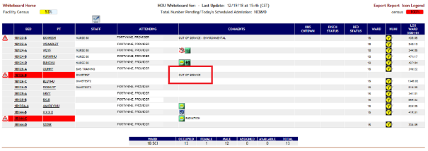
To return the bed to In Service Status, click the arrow button of the Reason field to display a list of available options then select DELETE THIS REASON and press the Submit button or click the WARNING: Clears ALL Comments and Icons button. Clicking the clear all comments button will remove all icons associated to the room as well as comments.
Figure 121 - Ward Whiteboard Home – Return Bed to In Service
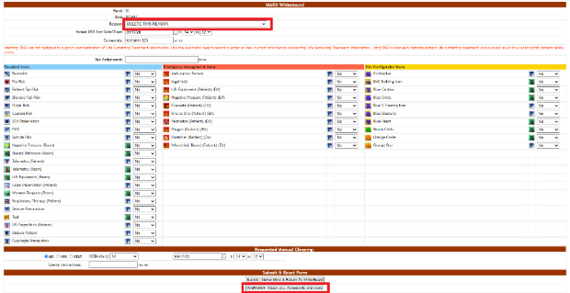
If you have changed the status of a bed to a Do Not Display Reason and want to return the bed to service, you will have to go to the either the Bed Summary Report or the Ward Occupancy Report since you cannot see the bed on the Whiteboard. These reports will show the Do Not Display beds which you can put back in service by selecting DELETE THIS REASON and pressing the Submit button, or by clicking the WARNING: Clears ALL Comments and Icons button. Clicking the clear all comments will remove all icons associated to the room as well as comments.

Flagging a Bed/Patient with Different Icons
In the Ward Whiteboard Home page click the bed code of the bed you want to flag:
Figure 122 - Selecting a Bed from the Ward Whiteboard Page
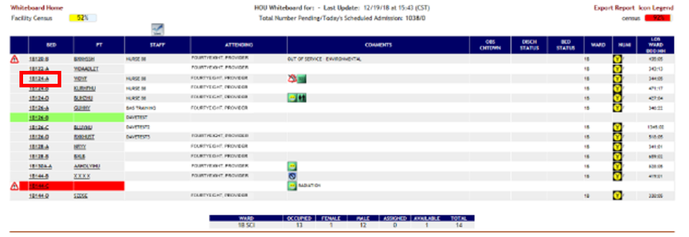

If the selected bed is empty (no patient assigned) then the Ward Whiteboard page is displayed as in the following image:
Figure 123 - Ward Whiteboard – No Patient Assigned
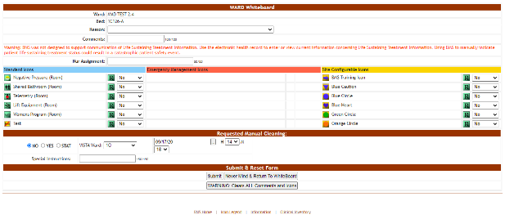
Note: Only icons that can be assigned to a room/bed will be available.
If the selected bed is assigned to a patient, then the Ward Whiteboard page is displayed as in the following image:
Figure 124 - Ward Whiteboard – Patient Assigned
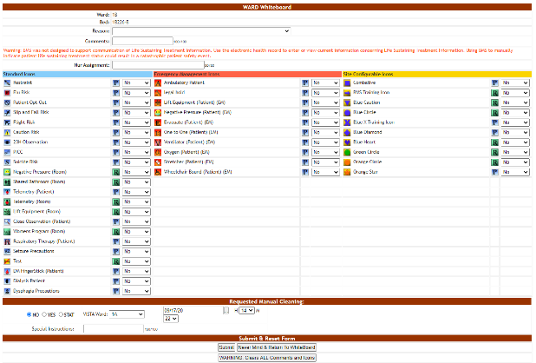
The image to the right of an icon indicates that it can be used to flag a person and those icons appear on a blue background. The image to the right of an icon indicates that it can be used to flag a room or a bed and those icons appear on a green background.
To add an icon to the selected bed, select Yes from the field to the right of the icon then press the Submit button. To add an icon regarding the patient occupying the bed select Yes from the field to the right of the icon then press the Submit button.
Figure 125 - Incompatible Patient Icon Warning
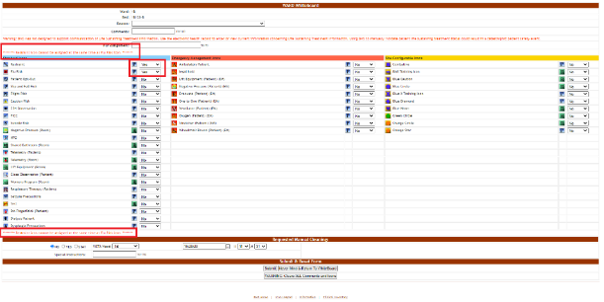
If you select conflicting icons on the patient record, such as Flu Risk and Restraint, a warning will appear above and below the icons that says, “Restraint icon cannot be assigned at the same time as the Flu Risk icon.” Uncheck one of the boxes and then press the Submit button. A screen is displayed confirming the modification of the record in the database.
Figure 126 - Ward Whiteboard Home – Bed/Patient Flagged
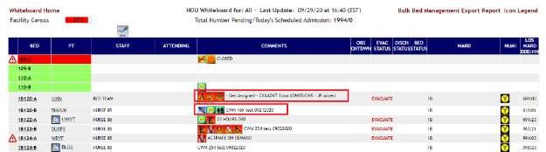
The icons for which you selected Yes will be displayed in the Comments column of the selected bed.
Click Whiteboard Home in the upper left corner to take you back to the Ward Whiteboard home page and then click Return to Site Home page in the upper left corner to return to the Patients Pending Bed Placement List. Or you can click BMS Home at the bottom of the Ward Whiteboard page to return directly to the Patients Pending Bed Placement List.
Figure 127 - Standard View of Patient Pending Bed Placement List
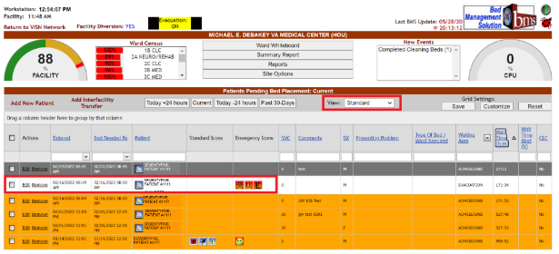
Look up the patient you would like to edit by typing their last name in the Patient search box or select the patient from the list in Standard view. The Standard and Emergency Icons will show in the appropriate columns.
When selecting the Emergency Mgmt view, the Patients Pending Bed Placement list is displayed as in the following image:
Figure 128 - Emergency Management View of Patient Pending Bed Placement List
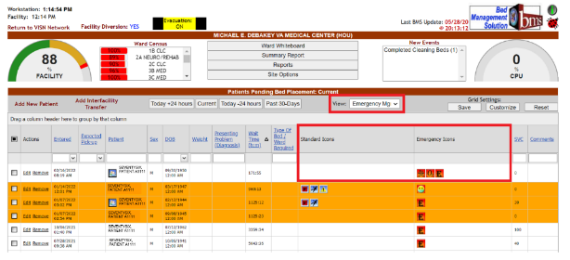

Assigning a Bed to a Nurse
To assign a bed to a nurse follow the instructions below.
In the Ward Whiteboard Home page click the field to the right of a bed in the STAFF column.
Figure 129 - Ward Whiteboard Home – Select Bed to Assign to a Nurse
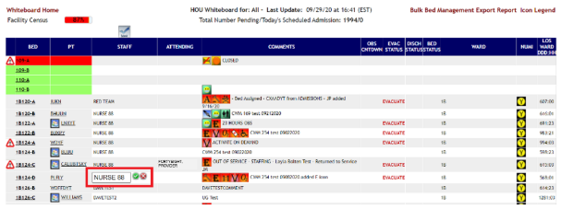
In the field that becomes available enter the name of the nurse to whom you want to assign the bed then press the Green Checkmark button to the right of the field to enter the data into the system. To cancel the operation, click the Red X button.

Editing the Nurse Assignment for a Bed
To change the nurse assignment for a bed, follow the instructions below.
In the Ward Whiteboard Home page click the field to the right of a bed in the STAFF column where the name of the current nurse is displayed.
Figure 130 - Ward Whiteboard Home – Select Nurse
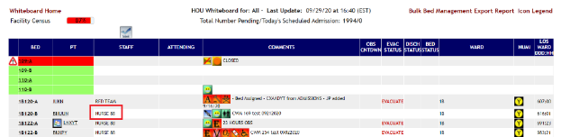
The field will become editable as in the following image.
Figure 131 - Ward Whiteboard Home – Change Nurse Assignment for Bed
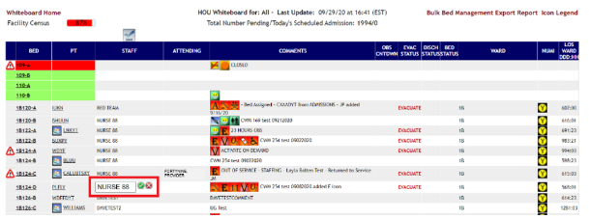
Change the name of the nurse then press the green checkmark button to enter the data into the system or the red X button to cancel the operation.

Assigning Several Beds to Medical Staff
Users can assign several beds to medical personnel from the Ward Whiteboard page.
Figure 132 - Selecting a Batch Assign Button
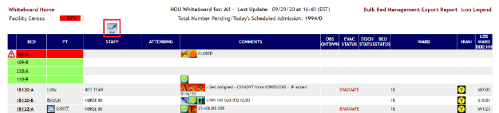
Click the Batch Assign Staff button at the top of the Staff column. The following page is displayed:
Figure 133 - Batch Assign Beds to Staff
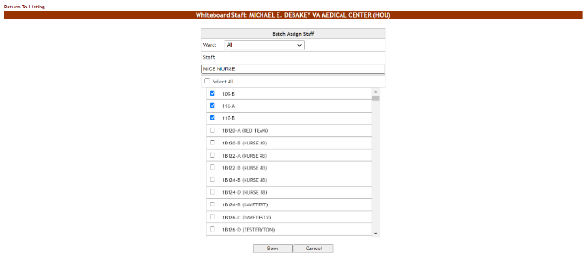
A list of beds is displayed: use the Ward field at the top of the page to filter the bed list according to wards.
In the Staff field enter the name of the nurse (or other personnel) that you want to assign for the selected bed.
Use the selection box to select the beds which you want to assign to the selected nurse (or other personnel). If a nurse (or other personnel) has already been assigned to a bed their name will be displayed next to the bed name in the list.
Click the Save button to enter the data into the system. The name of the nurse (or other medical personnel) will be displayed in the STAFF column in the Ward Whiteboard homepage as in the following image:
Figure 134 - Beds Assigned
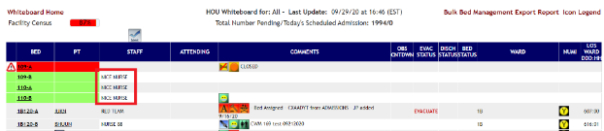

Display the Patient Details
In the Ward Whiteboard home page click the patient name link. The following page is displayed:
Figure 135 - Patient Details – Bed Control Pt Inquiry
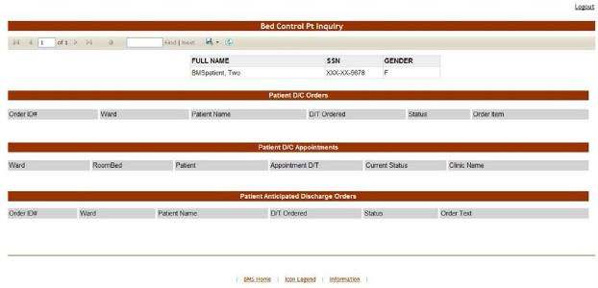
A list with all the operations registered in the system for the selected patient is displayed.

Updating Multiple Beds
To update multiple beds at one time with out of service reasons, follow the instructions below.
From the home page, click the Ward Whiteboard link.
Figure 136 - Selecting Ward Whiteboard
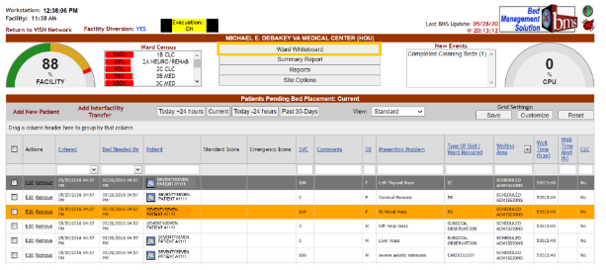
The Ward Whiteboard page is displayed as in the following image:
Figure 137 - Selecting Parameters for Ward Whiteboard
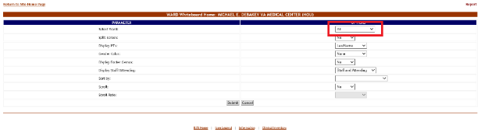
Click the arrow button of the Select Ward field to display a list of wards defined in the system. Select the ward where the bed is located that you want to take out of service or select All, then press the Submit button. The list of the beds in the selected ward is displayed as in the following image:
Figure 138 - Selecting Bulk Bed Management
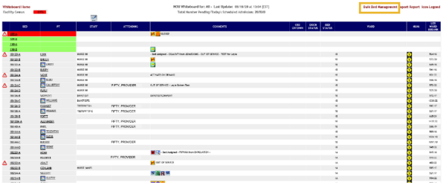
In the upper right corner of the screen, click on the Bulk Bed Management link.
Figure 139 - Selecting Bed Out of Service Reason
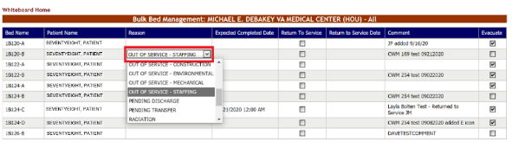
Double-click on the Bed Reason for the beds you would like to make changes on and make your selection from the drop-down menu.
Figure 140 - Selecting Expected Completed Date
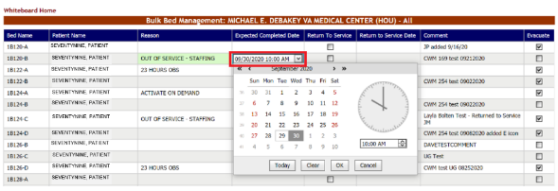
Double click on Expected Completed Date and click on the drop-down menu to select the date and time. When you have chosen the date and time, click OK.

Figure 141 - Making Comments on Bed Out of Service Reason
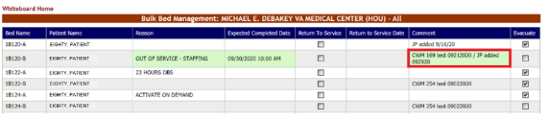
Click on Comment and type in your comments, if any.
Figure 142 - Saving Changes
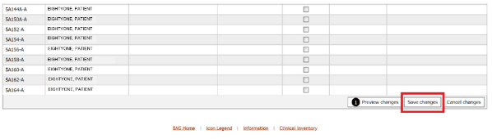
Scroll down to the bottom of the page and click on Save Changes.
Figure 143 - Expected Completed Date Required
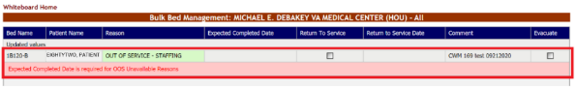
If you did not enter an Expected Completed Date for OOS Unavailable Reasons, the screen will prompt you to enter one.

Returning Multiple Beds to Service
To return multiple beds to service at one time, follow the instructions below.
From the home page, click the Ward Whiteboard link.
Figure 144 - Selecting Ward Whiteboard
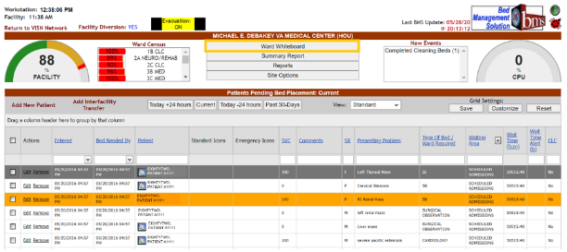
The Ward Whiteboard page is displayed as in the following image:
Figure 145 – Selecting Parameters for Ward Whiteboard
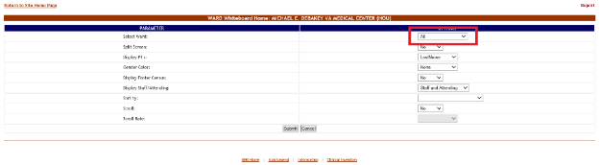
Click the arrow button of the Select Ward field to display a list of wards defined in the system. Select the ward where the bed is located that you want to take out of service or select All, then press the Submit button. The list of the beds in the selected ward is displayed as in the following image:
Figure 146 - Selecting Bulk Bed Management
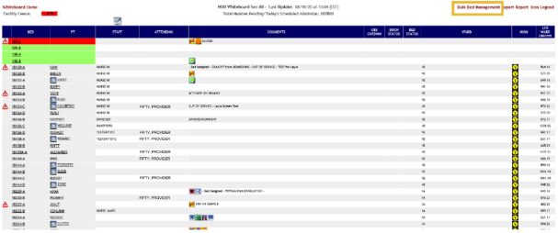
In the upper right corner of the screen, click on the Bulk Bed Management link.
Figure 147 - Selecting Return to Service
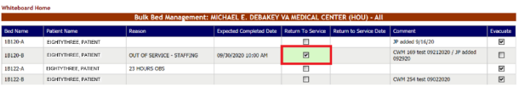
Double-click on the Return to Service column for the beds that are currently marked Out of Service and check those that you would like to return to service. If a bed is not out of service, you will not be able to select the checkbox in the Return to Service column.
Figure 148 - Selecting Return to Service Date
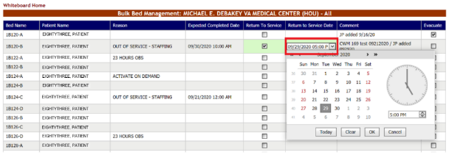
Double click on Return to Service Date and click on the drop-down menu to select the date and time. When you have chosen the date and time, click OK.
Figure 149 - Making Comments on Return to Service Date
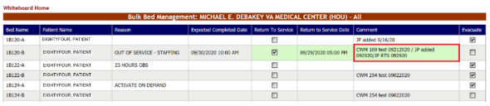
Click on Comment and type in your comments, if any.
Figure 150 - Saving Changes
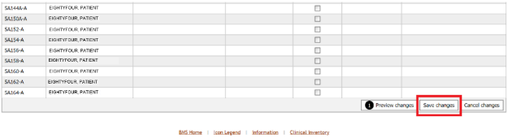
Scroll down to the bottom of the page and click on Save Changes.

Updating Multiple Patients with the Evacuation Icon
To update multiple patients with the Evacuation Icon at one time, follow the instructions below.
From the home page, click the Ward Whiteboard link.
Figure 151 - Selecting Ward Whiteboard
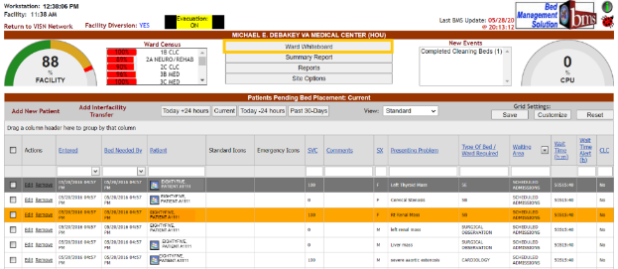
The Ward Whiteboard page is displayed as in the following image:
Figure 152 - Selecting Parameters for Ward Whiteboard
Click the arrow button of the Select Ward field to display a list of wards defined in the system. Select the ward where the bed is located that you want to take out of service or select All, then press the Submit button. The list of the beds in the selected ward is displayed as in the following image:
Figure 153 - Selecting Bulk Bed Management
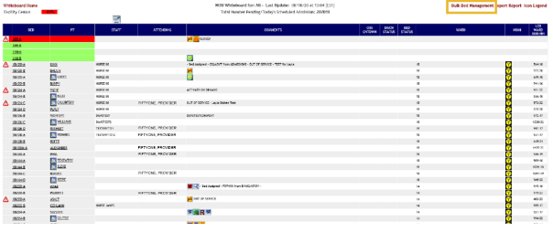
In the upper right corner of the screen, click on the Bulk Bed Management link.
Figure 154 - Selecting Evacuation
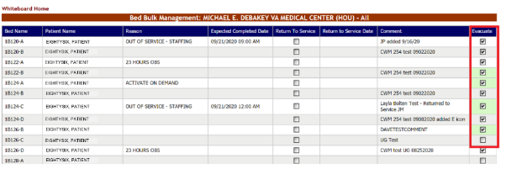
Double-click on all the beds you would like to evacuate.
Figure 155 - Saving Changes
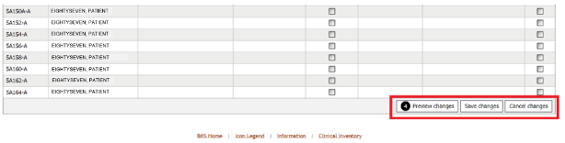
Scroll down to the bottom of the page and click on Save changes.

Adding/Removing the Evacuation Icon
To Add or Remove the Evacuation Icon from a patient, follow the instructions below.
From the home page, click the Ward Whiteboard link.
Figure 156 - Selecting Ward Whiteboard
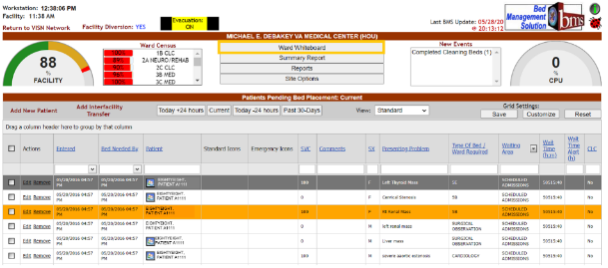
The Ward Whiteboard page is displayed as in the following image:
Figure 157 - Selecting Parameters for Ward Whiteboard
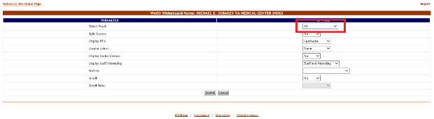
Click the arrow button of the Select Ward field to display a list of wards defined in the system. Select the ward where the bed is located that you want to take out of service or select All, then press the Submit button. The list of the beds in the selected ward is displayed as in the following image:
Figure 158 - Selecting a Bed/Patient from the Ward Whiteboard Page
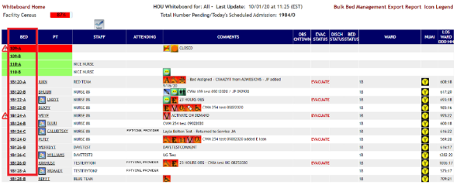
Click the bed code link of the bed you want to take out of service. The WARD Whiteboard page is displayed as in the following image:
Figure 159 - Add/Remove Evacuate Patient Icon
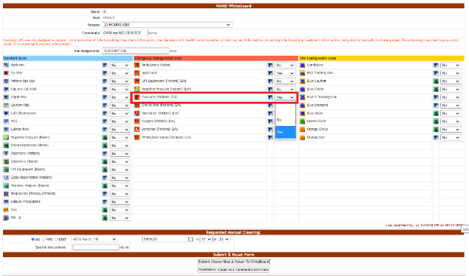
To edit the Evacuate Patient icon on the selected bed, choose Yes or No from the field to the right of the icon then press the Submit button. A screen is displayed confirming the modification of the record in the database.
Figure 160 - Ward Whiteboard Home – Bed/Patient Flagged
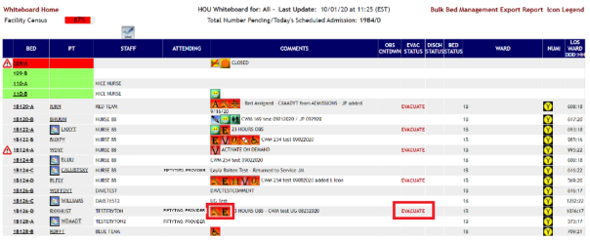
If “Yes” was selected, the Evacuate Patient icon will be displayed in the Comments column of the selected bed, and EVACUATE will appear in the EVAC STATUS column. If “No” was selected, the Evacuate Patient icon will be removed.
Figure 161 - Bulk Bed Management Page
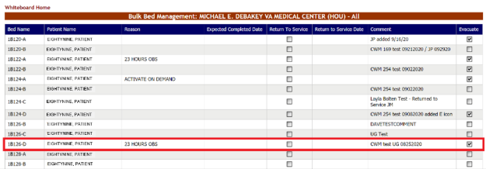
Then click on the Bulk Bed Management link on the Ward Whiteboard home page to verify that the Evacuation icon has been added/removed on that page. (You can also remove the Evacuation Patient Icon from the patient by checking/unchecking the box in the Evacuate column on this page).
Figure 162 - Select Patient in Patient Pending Bed Placement List
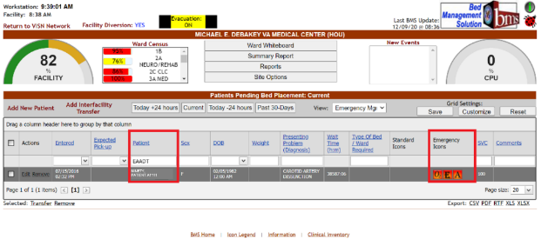
Look up the patient you would like to edit by typing their last name in the Patient search box or select a patient from the list.
Figure 163 - Edit Details of the Patient
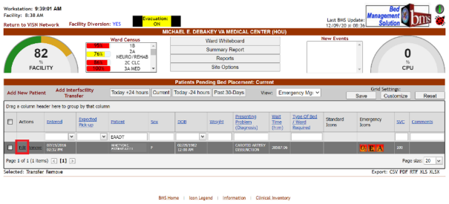
To edit the details of an entry from the Patients Pending Bed Placement list click the corresponding Edit link. The following page is displayed:
Figure 164 - Editing Patients Pending Bed Placement View
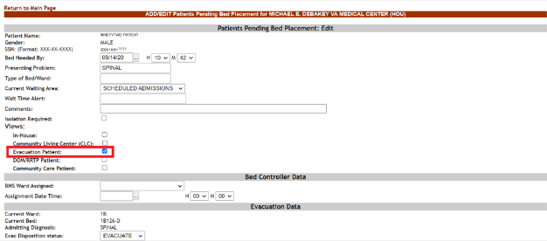
To Add/Remove Evacuation Patient status select the checkbox next to Evacuation Patient in Views.
Click Submit at the bottom of the page to save changes. A screen is displayed confirming the modification of the record in the database.
Figure 165 - Ward Whiteboard Home Page
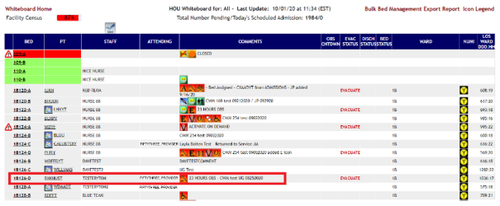
To verify that the Evacuation icon has been added/removed, go the Whiteboard Home page. The patient record shows that the Evacuation Icon has been added/removed.
Figure 166 - Bulk Bed Management Page
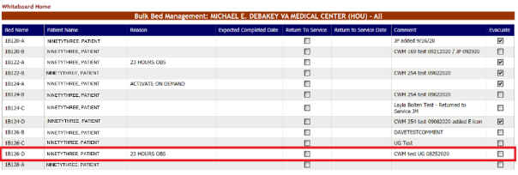
Then click on the Bulk Bed Management link on the Ward Whiteboard home page to verify that the Evacuation icon has been added/removed on that page.

Generate the Ward Whiteboard Report for the Selected Wards
In the Ward Whiteboard Home page click the Export Report link in the upper right corner of the page. The report is presented as in the following image:
Figure 167 - Ward Whiteboard Report
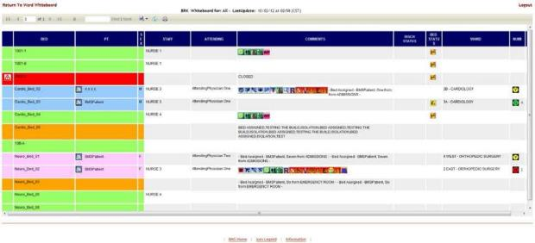

The Ward Whiteboard Page
The Ward Whiteboard page is accessible from the Ward Whiteboard Home page by clicking the corresponding bed code link in the BED column.
Figure 168 - The Ward Whiteboard Page
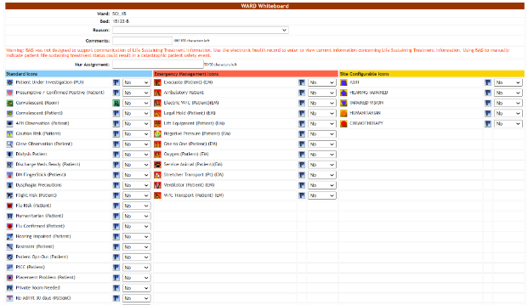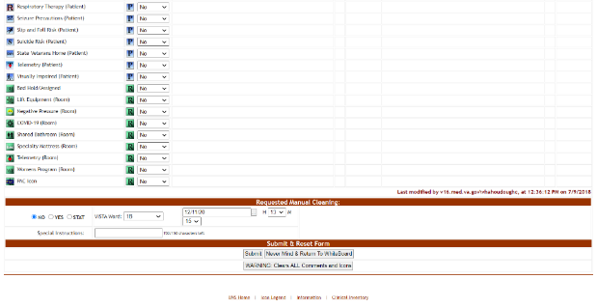
The Ward Whiteboard page presents information about the selected bed and allows the user to perform various operations such as taking the bed out of use, enabling/disabling patient risk flags, requesting manual cleaning.
Note: Users are discouraged from using the words DNR/DNI in the comment of the Ward Whiteboard or using any icon to represent DNR/DNI on the Ward Whiteboard.
The following data is available for each bed:
Table 38 - Bed Parameters
COLUMN | DESCRIPTION
Ward | The ward where the selected bed is.
Bed | The code assigned in the system to the bed.
Reason | The site user can use this field to enter a reason why the selected bed is unavailable. Clicking the arrow button will display a list of available reasons.  For details on how to add a reason to this list, see the BMS User Setup and Admin guide.
Comments | The site user can enter any comments that he/she considers necessary.
Nur Assignment | Displays the name of the nurse in charge of the selected bed.
PT RiskFlags | The patient risk flags can be displayed to indicate the risks associated to the patient currently occupying the selected bed.
Requested Manual Cleaning | The options available in this area allow the user to determine when the current bed will be cleaned.  STAT - urgent/emergent situation  YES – bed clean request at the date and time selected from the associated fields. NO - no bed clean request is generated.
VistA Ward | This field displays the VistA Wards with which the bed is associated. When entering a bed clean request this field allows you to determine for which of the associated VistA wards you register the bed clean request.
Special Instructions | Enter any special instructions regarding the cleaning operation.
Submit and Reset Form | The buttons available in this area allow the user to enter the data into the system, reset the existing selections, or return to the main screen without making any changes.

Request Cleaning/EMS Services for a Bed
In the Ward Whiteboard page, in the Request Manual Cleaning Area select “Yes” then enter the date and time when the bed needs to be clean. Enter all relevant comments in the Special Instructions field then press the Submit button.
Alternatively, from the Request Manual Cleaning Area you can select the STAT option to request an urgent bed clean operation.
Once a cleaning operation has been requested for a bed, the Requested Manual Cleaning area is displayed as in the following image:
Figure 169 - Request Manual Cleaning Area
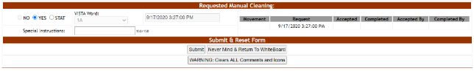
All the fields in the Requested Manual Cleaning area are disabled and the fields to the left of the area present the following data:
Movement: the date and time of the movement that generated the request.
Request: the date and time when the bed clean request was entered in the system.
Accepted: the date and time when the bed clean request has been accepted by the EMS personnel.
Accepted By: the name of the EMS user who accepted the request.
NOTE: A manual stat clean or new bed clean request can only be created after the existing bed clean request has been completed.

EMS Supervisors
The EMS supervisor users can access the following pages:
- EMS Bed Status page
- Environmental Management Service Bed Status page
- Environmental Management Service Bed Status – Batch Assign EMS Staff page.

Environmental Management Service Bed Status Page
This page is accessed by pressing the button Go To Facility Bed Cleaning Page (EMS Staff Only) from the BMS User Login page. The EMS Bed Status page is displayed as in the following image:

Figure 170 - EMS Bed Status Page
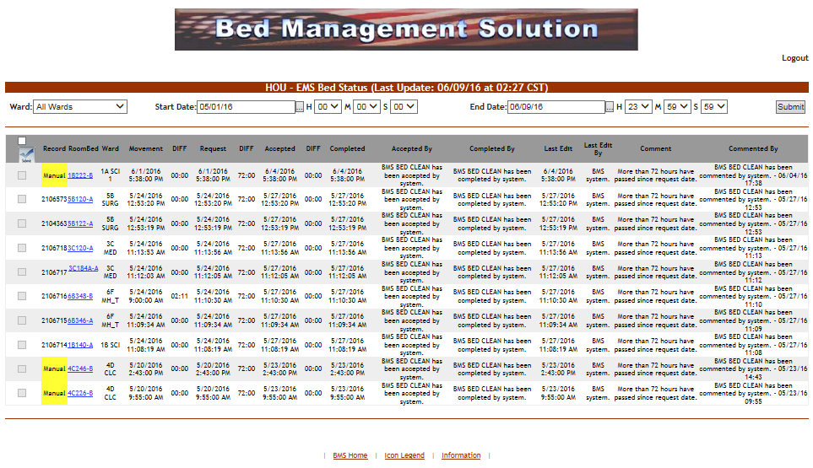
This page allows the EMS supervisor to view the requests for bed clean operations, to filter existing requests by different criteria and to select requests in order to assign them to EMS staff.
In the upper part of the page the filter criteria are available: Ward – to filter the bed clean requests by the ward for which they have been requested; Start Date/Time and End Date/Time – to filter the requests by time interval when they have been requested (the Requested column).
The following data is available for each request in the list:
Table 39 - EMS Bed Status Parameters
Column | Description
Select batch | Allows the selection of several requests in the list.
(selection box) | Allows the selection of the entry.
Record | For automatic requests, displays the record number of the movement that generated the request.  For manual urgent requests, the “Manual/STAT” is displayed against a red background. For manual requests, the word “Manual” is displayed against a yellow background.
RoomBed | Displays the name/code of the bed.
Ward | Displays the name of the ward where the bed is.
Movement | Displays the date and time of the movement that generated the request.
DIFF | The difference between the date and time of the movement and the date and time of the request.
Request | The date and time when the cleaning operation was requested.
DIFF | The difference between the time when the request for cleaning the bed was sent and the time when the request was accepted.
Accepted | The date and time when the request for the cleaning operation has been accepted.
DIFF | The difference between the time when the cleaning operation has been accepted and the time when the cleaning operation has been completed.
Completed | The date and time when the cleaning operation has been completed.
Accepted by | The name of the person who has accepted the request for the cleaning operation.
Completed by | The name of the person who has completed the cleaning operation.
Last Edit | The date and time when the record was last edited.
Last Edit by | The name of the person who last edited the record.
Comment | Any comments entered regarding the bed clean operation.
Commented by | The name of the person who entered the comment.

In this page the user can perform the following operations: select a bed clean request in order to assign it, select several bed clean requests in order to assign them and comment a request.

Assigning a bed clean request
To assign a bed clean request follow the instructions below.
In the (facility name) EMS Bed Status page click the bed code link as in the following image.
Figure 171 - Select Bed Clean Request for Assignation
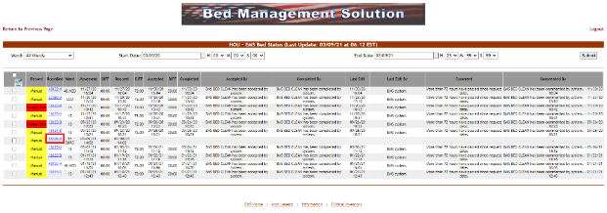 NOTE: you can only select a request which has not been yet assigned. The selection box of a request already assigned will be disabled.
Upon selection the following screen is displayed:
Figure 172 - EMS Bed Status Page – Assign Cleaning
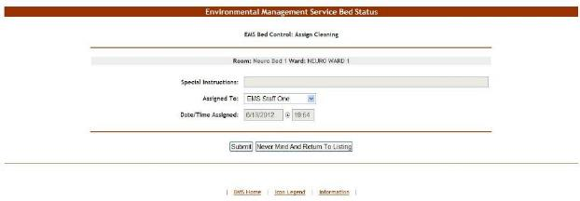At the top of the screen the name of the current operation is presented: Assign Cleaning. The Special Instructions field displays any comments or instructions entered by the person who requested the cleaning.
From the Assign to field select the EMS person to whom the cleaning operation will be assigned then press the Submit button. The EMS Bed Status page will then be displayed.
The Accepted by column will present the name of the user who has accepted the request. Also, the bed will be displayed in the report “EMS is currently cleaning (x) beds” in the New Events screen.
In the Ward Whiteboard Home page, the “cleaning bed” icon will be displayed next to the bed name as in the following image:

Figure 173 - Ward Whiteboard – Cleaning Bed
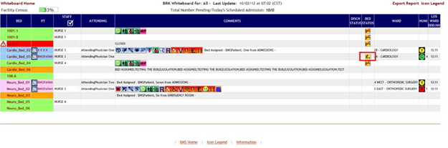

Assigning a batch of bed clean requests
To assign a batch of bed clean requests follow the instructions below.
In the (facility name) EMS Bed Status page click the selection box of all the bed clean requests you want to assign as in the following image.
Figure 174 - Select Several Bed Clean Requests
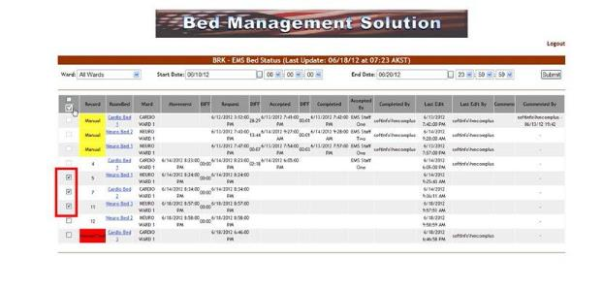
NOTE: you can only select a request which has not been yet assigned. The selection box of a request already assigned will be disabled.
Then click the Batch Assign EMS staff button at the top of the column. Upon selection the following screen is displayed:

Figure 175 - Assign Several Bed Clean Requests
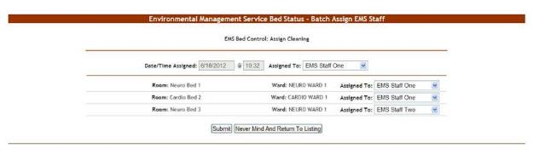A list of the selected requests is displayed. You can assign all the requests to the same person or you can assign each request to a different person. Use the arrow button of the Assigned To: fields drop down box to display the available personnel. Click the Submit button to enter the data into the system.

Commenting a Bed Clean Request
To enter comments for a bed clean request, follow the instructions below.
In the (facility name) EMS Bed Status page click the bed code link as in the following image.
Figure 176-Select a Bed Clean Request for Comment
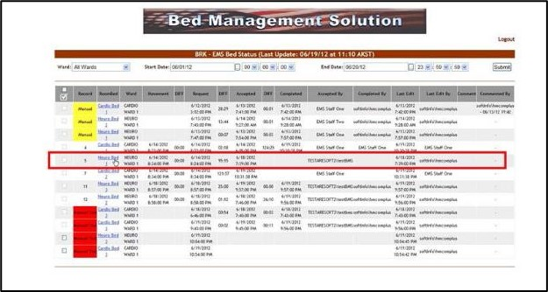
NOTE: you can only enter comments for a request which has been assigned.
Upon selection the following screen is displayed:
Figure 177 - EMS Bed Status Page – Comment Bed Clean Request
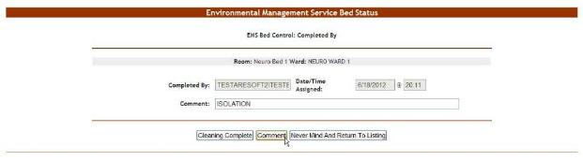In the Comment field enter any relevant comments. Click the Comment button to save the comment.

New Comment on a Bed after it has been Marked Clean
To enter a new comment on a bed that has already been marked clean, follow the instructions below.
In the (facility name) EMS Bed Status page click the bed code link as in the following image:
Figure 178 - Select a Bed for a New Comment
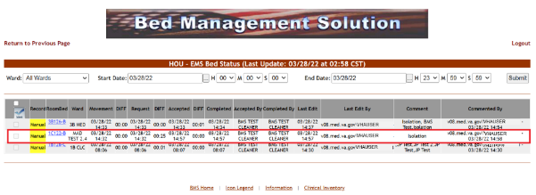In the Comment field, clear the old comment and enter a new comment. Click the Comment button to save the comment.
Figure 179 - EMS Bed Status Page – New Comment on Clean Bed
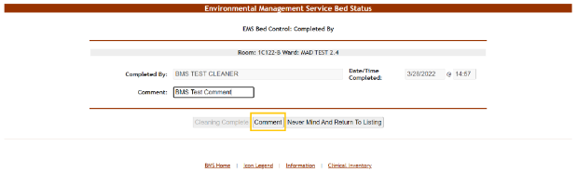Upon saving, the following screen is displayed showing multiple comments on the bed:
Figure 180 - EMS Bed Status Page – Showing Multiple Comments on a Bed

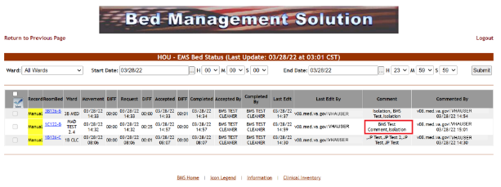

EMS Users
The EMS users can access the following pages:
- The (facility name) EMS Bed Status page
- The Environmental Management Service Bed Status page

Environmental Management Service Bed Status Page
This page is accessed by pressing the button Go To Facility Bed Cleaning Page (EMS Staff Only) from the BMS User Login page. The EMS Bed Status page is displayed as in the following image:
Figure 181 - EMS Bed Status Page – EMS User
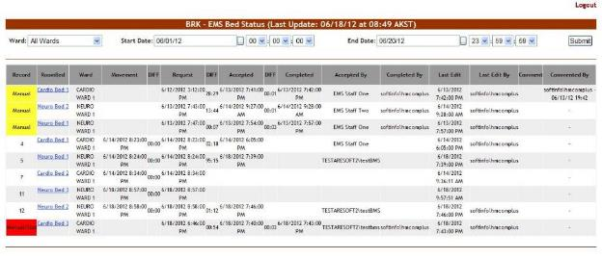This page allows the EMS user to view the requests for bed clean operations, to filter existing requests by different criteria and to select requests in order mark them as completed or to enter comments.
In the upper part of the page the filter criteria are available:
Ward – to filter the bed clean requests by the ward for which they have been requested;
Start Date/Time – to filter the requests by the date/time when they have been requested (the Requested column).
End Date/Time – to filter the requests by the date/time when they have been requested (the Requested column).
The following data is available for each request in the list:
Table 40 - EMS Bed Status Parameters
COLUMN | DESCRIPTION
Record | For automatic requests, displays the record number of the movement that generated the request.  For manual urgent requests the “Manual/STAT” is displayed against a red background. For manual requests the word “Manual” is displayed against a yellow background.
RoomBed | Displays the name/code of the bed.
Ward | Displays the name of the ward where the bed is.
Movement | Displays the date and time of the movement that generated the request.
DIFF | The difference between the date and time of the movement and the date and time of the request.
Request | The date and time when the cleaning operation was requested.
DIFF | The difference between the time when the request for cleaning the bed was sent and the time when the request was accepted.
Accepted | The date and time when the request for the cleaning operation has been accepted.
DIFF | The difference between the time when the cleaning operation has been accepted and the time when the cleaning operation has been completed.
Completed | The date and time when the cleaning operation has been completed.
Accepted by | The name of the person who has accepted the request for the cleaning operation.
Completed by | The name of the person who has completed the cleaning operation.
Last Edit | The date and time when the record was last edited.
Last Edit by | The name of the person who last edited the record.
Comment | Any comments entered regarding the bed clean operation.
Commented by | The name of the person who entered the comment.
In this page the user can perform the following operations: select a bed clean request(s) in order to mark it as completed and comment a request.

Assigning a bed clean request
To assign a bed clean request follow the instructions below.
In the (facility name) EMS Bed Status page click the bed code link as in the following image. NOTE: you can only select a request which has not been yet assigned.
Figure 182 - EMS Bed Status Page – Select Bed Clean Request for Assigning
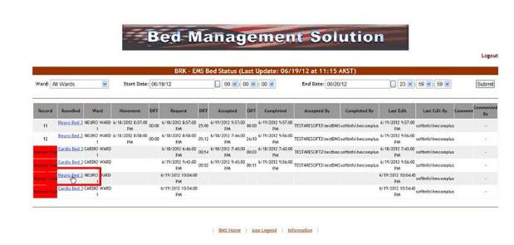Upon selection the following screen is displayed:
Figure 183 - EMS Bed Status Page – Assign Cleaning
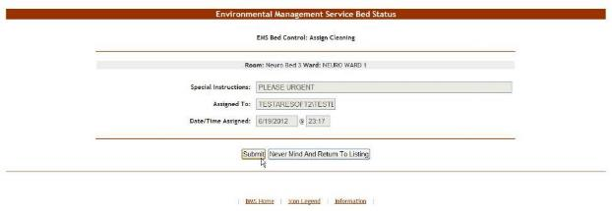At the top of the screen the name of the current operation is presented: Assign Cleaning.
The Special Instructions field displays any comments or instructions entered by the person who requested the cleaning.
The field Assign to displays the name of the current EMS user who is assigning a bed request to him/herself.
The Date/Time Assigned field displays the current date and time.
Press the Submit button. The EMS Bed Status page will be displayed. The Accepted by column will present the name of the user who has accepted the request. Also, the bed will be displayed in the report “EMS is currently cleaning (x) beds” in the New Events screen.
In the Ward Whiteboard Home page, the “cleaning bed” icon will be displayed next to the bed name as in the following image:
Figure 184 - Ward Whiteboard – Cleaning Bed

Mark a Bed Clean Request as Completed
To mark a bed clean operation as completed follow the instructions below.
In the (facility name) EMS Bed Status page click the bed code link as in the following image:
Figure 185 - Select Bed Clean Request to Mark as Completed
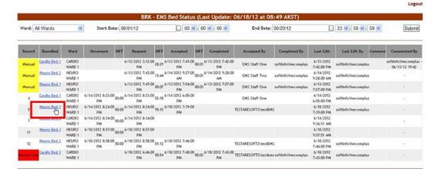Upon selection the following screen is displayed:
Figure 186 - EMS Bed Status Page – Completed Cleaning
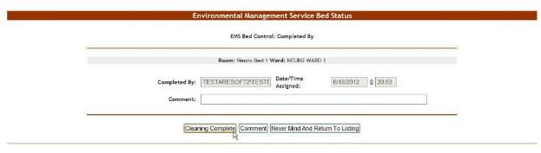At the top of the screen the name of the current operation is presented: Completed by. Click the Cleaning Completed button to mark the bed as “cleaned”.
In the Ward Whiteboard Home page, the “cleaned” icon will be displayed next to the bed name as in the following image:
Figure 187 - Ward Whiteboard – Clean Bed
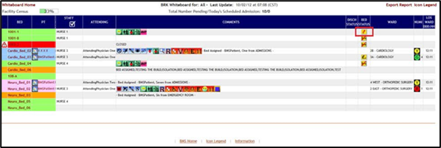

EMS Staff Page for Mobile Devices
EMS staff can access the BMS Web page for mobile devices at the URL setup by their local IS staff. The URL is setup like this link: https://<servername>.gov/EMSMobileLogon?code=BRK.

The “BRK” is the 3-digit facility code. Make sure you use the code of the facility you want to access. The following page is displayed:
Figure 188 - EMS Staff Page for Mobile Devices
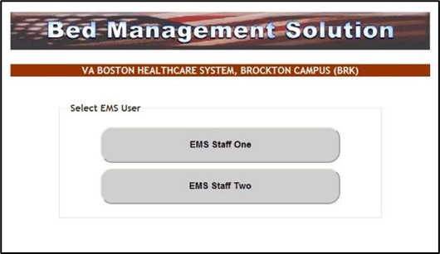
Select the EMS user name. The following page is displayed:
Figure 189 - EMS Staff Page for Mobile Devices – User Login
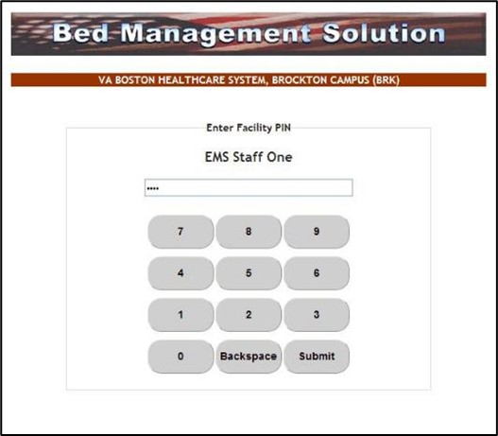
Enter the PIN associated to your EMS user name then press the Submit button. The following page is displayed:
Figure 190 - EMS Staff Page for Mobile Devices – User Home Page
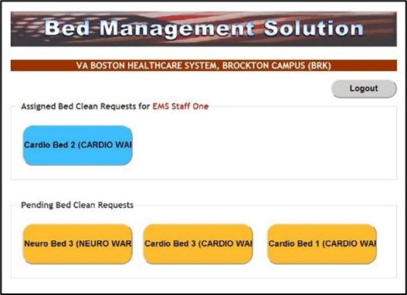
The blue buttons in the upper part of the screen represent bed clean requests which have been assigned to the current EMS user. Clicking a blue button will mark the request as “completed” and will cause the button to disappear.
The yellow buttons in the lower part of the screen represent bed clean requests which have not yet been assigned to any EMS personnel. Clicking a yellow button will assign the pending request to the current user and will cause the yellow button to be displayed as a blue button in the upper part of the screen.
Figure 191 - EMS Staff Page for Mobile Devices – Pending to Assigned
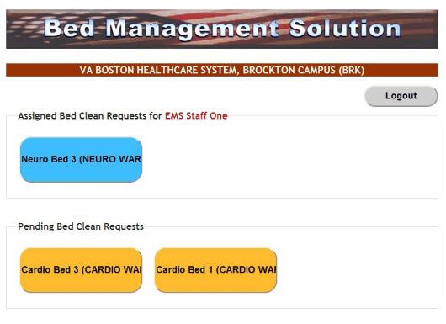

VISN Users
VISN User can access the VISN Network Bed Boards Page.
VISN Users----Please Note: This page allows the user to keep track of Veteran Patients who are currently being treated in community hospitals on Fee Basis or requiring a service that the current facility does not provide or cannot accommodate the patient. In other words, this is a list of patients that could not be admitted to a VA facility or in need of care not available at the facility they currently are admitted.
See the BMS Community Care Tracking List Guide for additional methods of tracking patients receiving community care.

VISN Network Bed Boards Page
The VISN Bed Boards page is displayed after logging in the BMS system.
From the current facility home page, the VISN Bed Boards page is accessible by clicking the link Return to VISN Network.
From the National/Regional BMS home page the VISN Bed Boards page is accessible by the clicking the corresponding VISN link.
The VISN Bed Boards page is displayed as in the following image:
Figure 192 - VISN Bed Boards Page
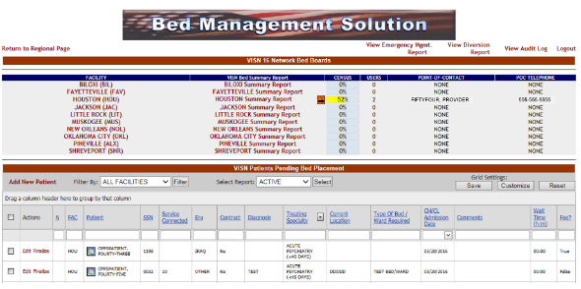
This page allows the user to keep track of Veteran Patients who are currently being treated in community hospitals on Fee Basis or requiring a service that the current facility does not provide or cannot accommodate the patient. In other words, this is a list of patients that could not be admitted to a VA facility or in need of care not available at the facility they currently are admitted.
The upper part of the page presents a list of VISN facilities. Clicking one of the links in the Facility column will display the corresponding home page of the selected facility.
The VISN Bed Summary Report link (the column title) will generate a bed summary report for all the facilities in the current VISN. (See VISN Bed Summary Report for details). The links in the VISN Bed Summary Report column will display the bed summary report for the corresponding facility.
The Census fields display the bed occupancy percentage of the facility. The Users column displays the number of users currently logged on the facility site.
The links in the Point of Contact column will automatically connect to your default email client (such as Outlook for example) and will open a New Message window that can be used to send an email to the corresponding facility. The POC Telephone column displays the telephone number for the facility.
The View Audit Log link provides access to the Audit reports, for details on the Audit reports see the section Audit Log Report Page.
The View Diversion Report link provides access to the Facility Diversion reports, for details on the Diversion reports see the section View Diversion Report.
The View Emergency Mgmt. Report link provides access to the various Emergency Reports, for details on the Emergency Mgmt. reports see the section Emergency Management Report Page

Editing the Details of a Patient in the Patients Pending Bed Placement List
To edit the details of a patient from the list Patients Pending Bed Placement click the corresponding Edit link. The VISN Interfacility Transfer Sheet – Select Patient screen is displayed as in the following image:
Figure 193 - Editing the Details of a Patient in the VISN Patients Pending Bed Placement List
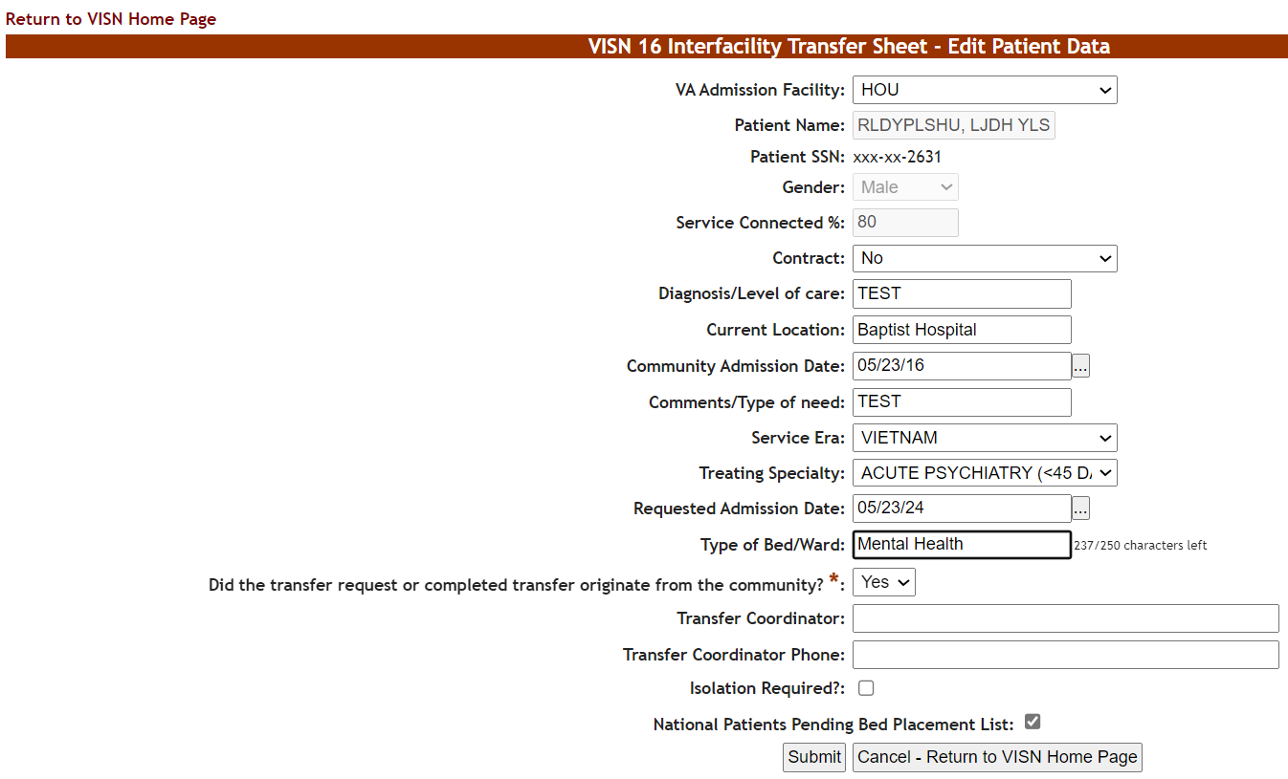
Modify existing data as necessary then click the Submit button to enter it into the system. A screen is displayed confirming the modification of the record in the database.
Figure 194 – Interfacility Edit Action confirmation on VISN Patients Pending Bed Placement List
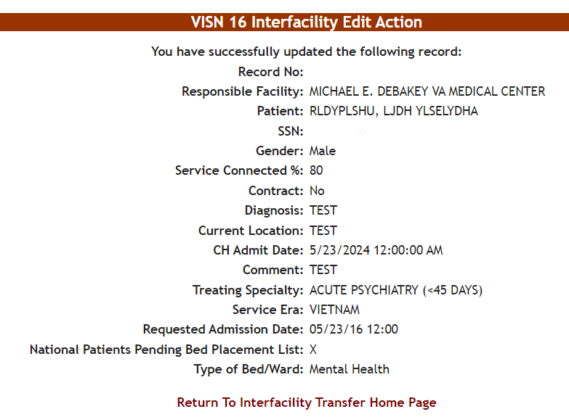

VISN PPBL Screen
The lower part of the page presents the list of patients currently in community hospitals, who are benefitting from VA coverage, and who might be admitted to a VA facility.
At the top of the list, the following filter/order options are available:
Filter by: this field allows the user to select the facility for which he/she wants to display the patients pending bed placement.
Select report: this drop-down field allows the user to organize the list of Patients in Community Hospitals according to the following criteria:
- Active
- Contract
- Date audit
- Dispositions
For each entry in the list, the following data is available:
Table 41 - Patients Pending Bed Placement - Parameters
COLUMN | DESCRIPTION
N | If the patient is to be included or not in the National Patients Pending Bed Placement list.
Facility | The facility associated with the Community Hospital the patient was admitted to.
Patient | The patient name.
SSN | The social security number of the patient.
Service Connected | The patient’s percent service-connected disability (default of NULL, this is an integer % value).
Era | The period of service that the patient served.
Contract: | Whether or not the VA facility has a contract with the selected community hospital.
Diagnosis | The diagnosis for which the patient was admitted to the community hospital.
Treating Specialty | The medical specialty dealing with the diagnosis.
Current Location | The name of the community hospital where the patient has been admitted.
Type of Bed/Ward Required | The type of bed/ward requested for the patient.
CH/CL (Community Hospital/Current Location) Admission Date | The date when the patient was admitted to the community hospital.
Comments | Any relevant info entered by VISN user.
Wait time | Patient wait time in hours and minutes.
The Add New link allows the VISN user to add a new patient to the list.
The Edit link allows the VISN user to modify/update some of the patient data as per communications with community hospital staff.
The Finalize link allows the VISN user to finalize the patient’s stay in the community hospital: after being discharged from the community hospital, the patient might be admitted to the VA facility or go home.
The Toggle National link (After selecting one or more patients) will toggle multiple patients to the National board. An “X” will appear in the National (“N”) column.

Adding a Patient to the Patients Pending Bed Placement List
From the home page of your facility, click the link Return to VISN Network to display the page in the following image:
Figure 195 - Adding a Patient to Patients Pending Bed Placement List
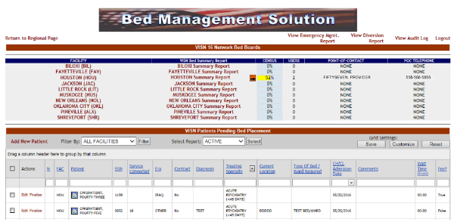
When adding a patient to the VISN Patients Pending Bed Placement list BMS will verify if the patient SSN exists in the system (if the patient is registered in VistA or if the patient has been admitted before to a VA facility).
In the area VISN Patients Pending Bed Placement, click the Add New Patient link. The following page is displayed:
Figure 196 - VISN Interfacility Transfer Sheet – Select Patient
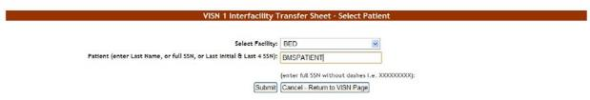
From the Select Facility field select the name of the VA facility that the patient is associated with. In the Patient field, enter either the patient SSN number or the patient name following the instructions on screen, then press the Submit button. The following page is displayed:
Figure 197 - VISN Interfacility Transfer Sheet – Select Patient from List
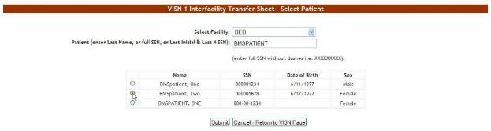
If there are several patients in the system with the same name, the system presents a list with details of the patients so that you can identify the patient you need.
If the patient SSN is not found in the system a warning is displayed on screen. Press the Submit button to register the patient in the system. The following screen is displayed:
Figure 198 - VISN Interfacility Transfer Sheet – Enter Patient Data
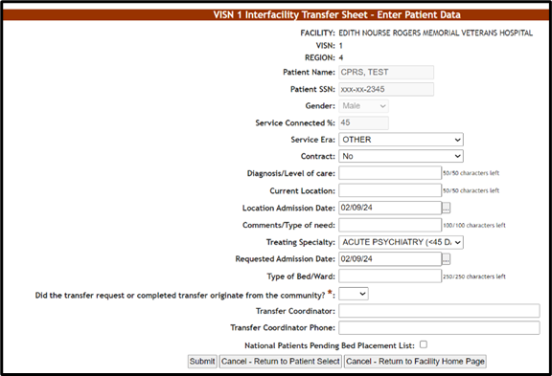
The name of the current facility, the VISN it belongs to, the Region, the patient SSN and full name are displayed.
Enter the following data:
Table 42 - Interfacility Transfer Parameters
FIELD | ENTER
Service Era | The period of service that the patient served.
Contract | Whether or not the VA facility has a contract with the selected community hospital.
Diagnosis/Level of care | The diagnosis for which the patient requests admission to the community hospital.
Current Location | The name of the location where the patient is currently being treated
Location Admission Date | The date when the patient has been admitted in the selected location.
Comments/Type of need | The type of need for which the patient is being transferred to the community hospital.
Treating Specialty | The treating specialty corresponding to the type of need.
Requested Admission Date | The date when the patient should be able to be admitted to the VA facility.
National Patients Pending Bed Placement | If the patient is to be included or not in the National Patients Pending Bed Placement list.
Click the Submit button to enter the data into the system.
A screen is displayed confirming the successful registration of the record in the database.

Finalizing a Patient’s Stay in the Community Hospital
To register the end of a patient’s stay in a community hospital, from the list Patients Pending Bed Placement click the corresponding Finalize link. The Finalize Patient Data page is displayed as in the following image:
Figure 199 - Finalize a Patient’s Stay in Community Hospital
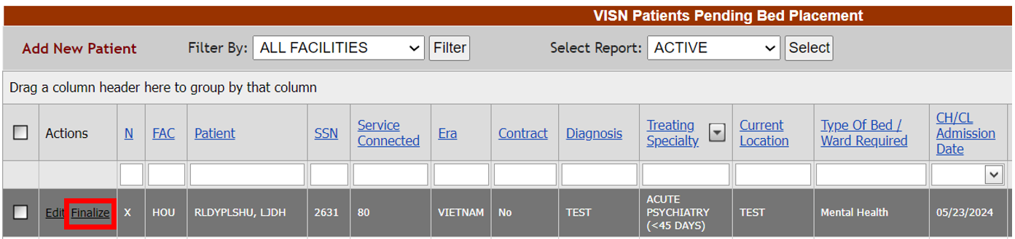

Figure 200 - Finalize a Patient’s Stay in Community Hospital
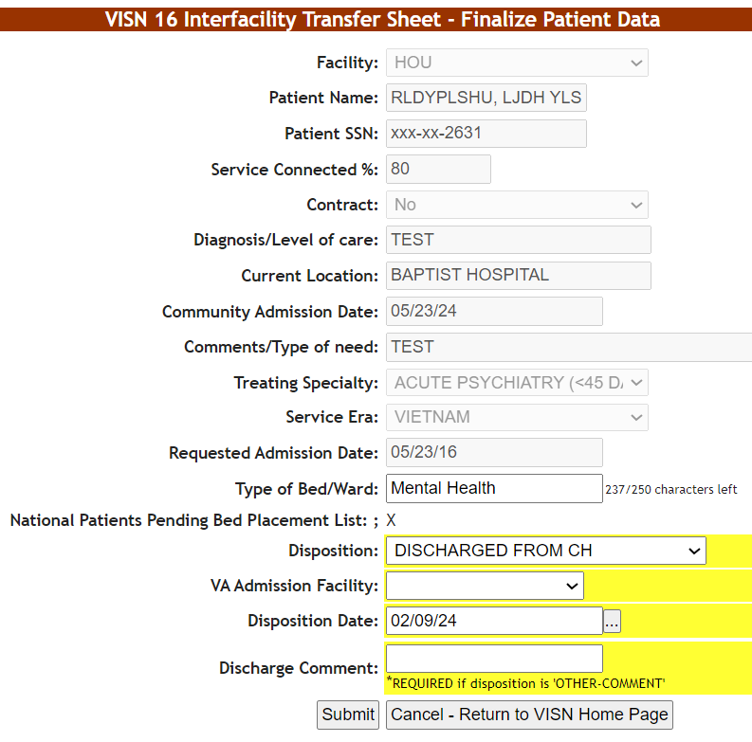
The following additional fields are available:
Disposition: the disposition with which the patient’s stay in the community hospital has ended. The following options are available in this field:
- VA ADMISSION-MOVE TO SITE
- REFUSED VA CARE
- EXPIRED
- DISCHARGED FROM COMMUNITY HOSPITAL
- OTHER-COMMENT
VA Admission Facility: from the available options, select the VA facility where the patient will be (re-) admitted.
Disposition Date: the current date is displayed, to change it, use the available options.
Discharge Comment: the VISN user can enter any comments relevant for the operation. If the option Other has been selected from the Disposition field the VISN user will be required to fill in a comment in this field.
A screen is displayed confirming the modification of the record in the database.
Figure 201 –Interfacility Transfer Patient confirmation screen
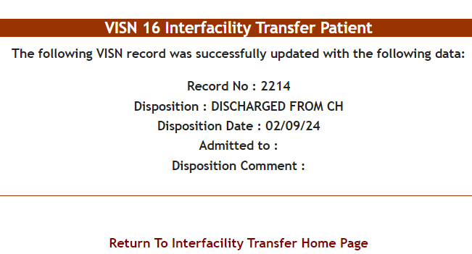
When pressing the Finalize link attached to a transfer in the VISN Patients Pending Bed Placement list the VISN user registers the end of a patient’s stay in a community hospital and the patient’s name will no longer appear in the list Patients Pending Bed Placement. An admission to a VA facility will follow.

VISN Bed Boards Reports
In the VISN Bed Boards page several reports are available as shown in the image below:
Figure 202 - VISN Bed Boards Page – Summary Reports
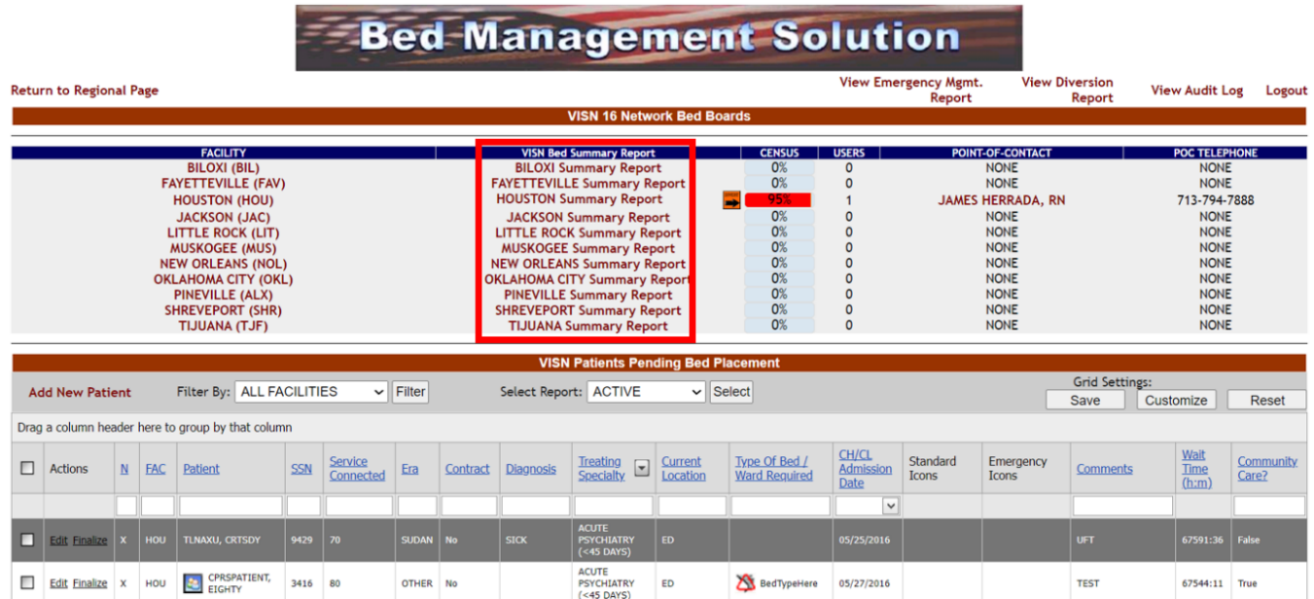
The available reports are the VISN Bed Summary Report, the Summary Report corresponding to each facility in the VISN and the reports related to the Patients Pending Bed Placement list. Details about these reports are available in the following sections.

VISN Bed Summary Report
The VISN Bed Summary Report link (the column title) will generate a bed summary report for all the facilities in the current VISN. On the VISN Bed Boards Page, select the Facility for which you would like a Summary Report.
Figure 203 - VISN Bed Summary Report link
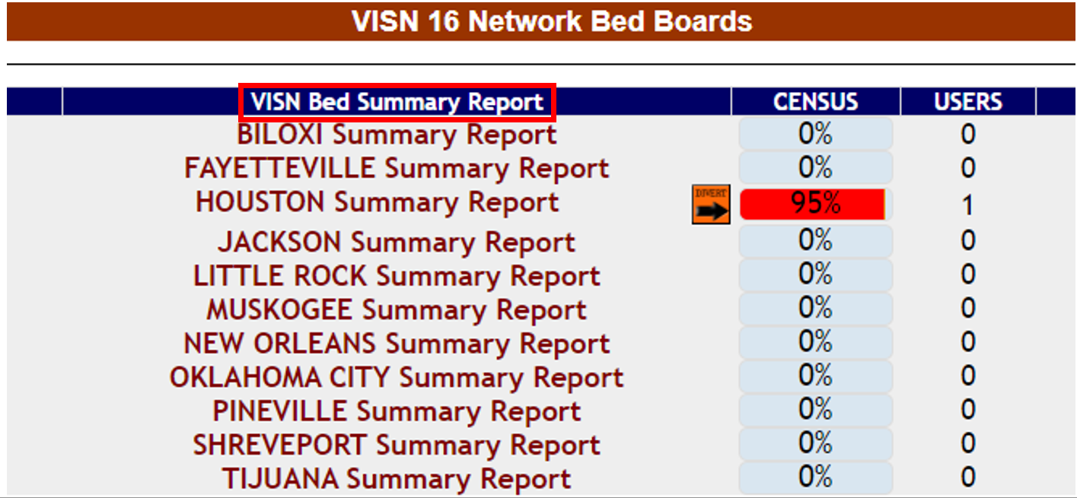
The image below presents an example of a VISN Bed Summary Report.
Figure 204 - VISN Bed Boards Page – Summary Reports
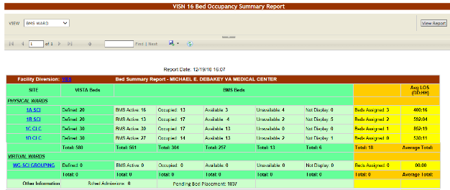
The title of the report is displayed in the upper part of the page. Navigation and display tools are available in the toolbar displayed across the screen. Place the mouse cursor over a button to display the corresponding tooltip.
The report can be exported to a series of formats available when clicking the Save button. Once exported, the Print button allows the site user to send the generated report to a printer.
For details on the type of data available in this report see the section Bed Occupancy Summary Report.
The VISN Network Bed Boards page displays a list of facility sites in the current VISN and allows the user to view bed summary reports for each facility in the list. Access to this page is determined by the VISN/Facilities.
Figure 205 - VISN Bed Boards Page – Summary Reports
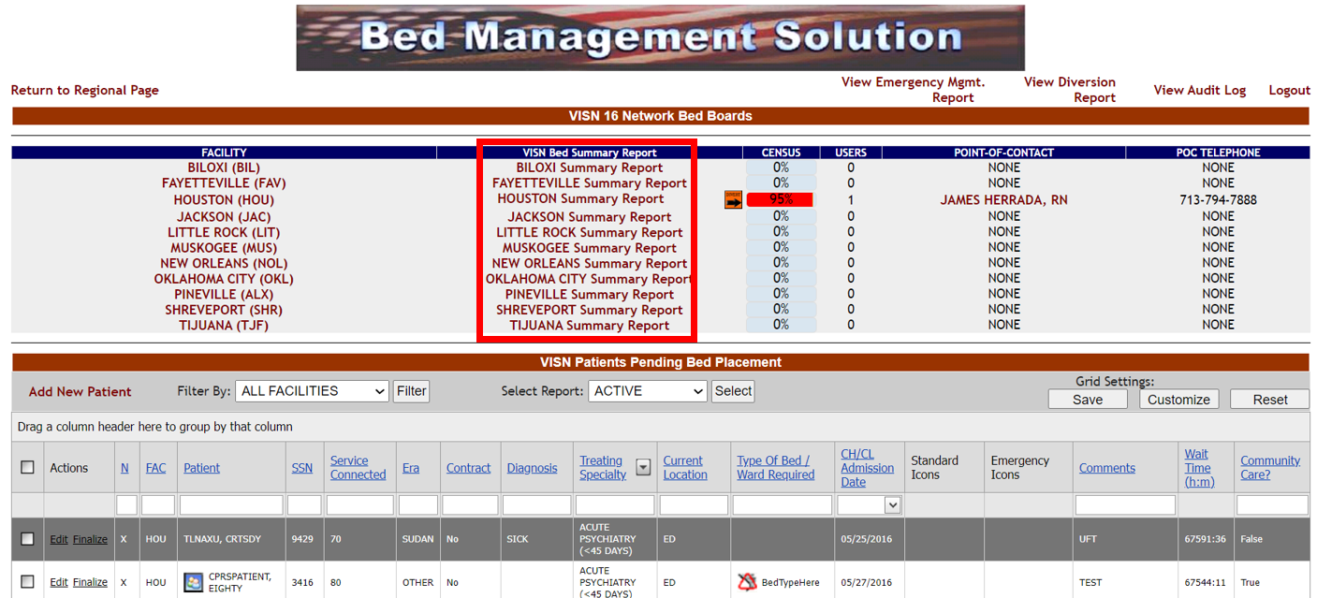
These reports offer information about the bed occupancy situation in a facility. Simply click the link adjacent to the facility name. The report is displayed as in the following image:
Figure 206 - Bed Occupancy Summary Report
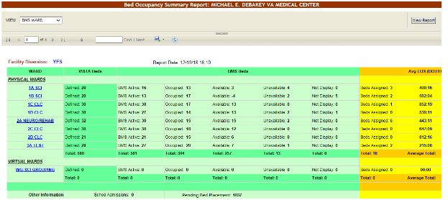
For details on the type of data available in this report see the section Bed Occupancy Summary Report.

Network Active Report
The Network Active report presents the list of patients who are currently in Community Hospitals with or without a contract. The image below presents a report of patients in community hospitals according to the active status.
Figure 207 - Network Active Report
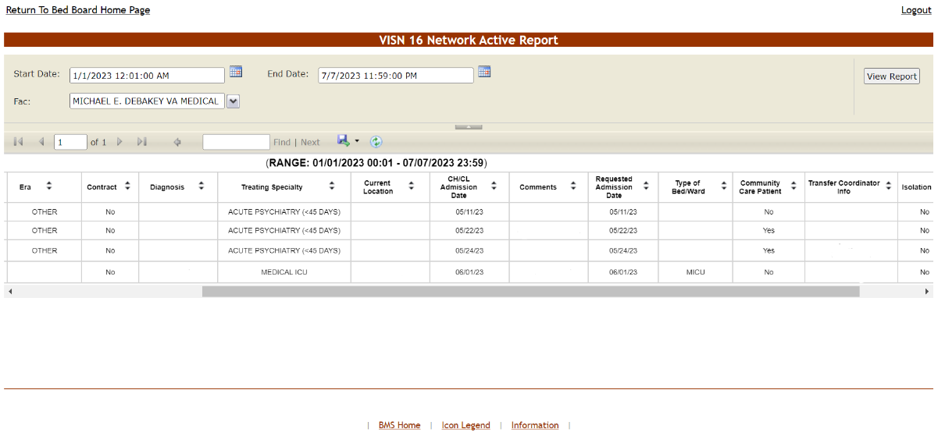
From the Select Report field in the VISN Patients Pending Bed Placement area select Active and press the Select button to display the report as in the following image:
Figure 208 - VISN Bed Boards Page – Select Report: ACTIVE
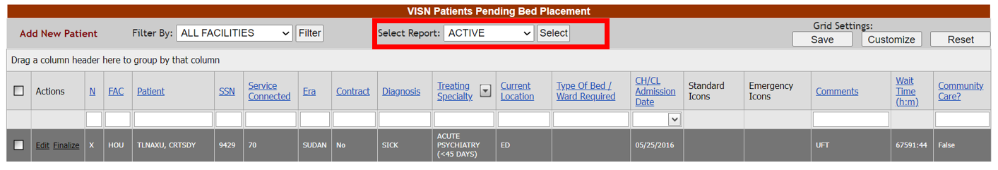
Select the facility from the Fac drop-down menu and select Using the Start Date and End Date fields, define the time interval for the report. After selecting the desired parameters, click the View Report button to generate the report.
The report is displayed as in the following image:
Figure 209 - Network Active Report
The title of the report is displayed in the upper part of the page. Navigation and display tools are available in the toolbar displayed across the screen. Place the mouse cursor over a button to display the corresponding tooltip.
The report can be exported to a series of formats available when clicking the Save button. Once exported, the Print button allows the site user to send the generated report to a printer.
The following data is available for each patient in the report:
Table 43 - Network Active Report
COLUMN | DESCRIPTION
N(ational) | Indicator of whether the patient is on the National PPBP.
FAC(ility) | The Facility from the patient has been transferred.
Patient | The patient’s first and last name.
SSN | The Social Security Number of the patient.
Service Connected | The patient’s percent service-connected disability (default of NULL, this is an integer % value).
Era | Location/Time period of where/when the patient served.
Contract | Whether or not the VA facility has a contract with the selected community hospital.
Diagnosis | The diagnosis for which the patient is sent to the community hospital.
Treating Specialty | The treating specialty for the diagnosis
Current Location | The current location of the patient.
CH/CK Admission Date | The date when the patient has been admitted in the Community Hospital.
Comments | Comments entered in the Comments field.
Wait Time (h:m) | The length of time the patient has been awaiting placement in hours:minutes.
SX | The gender of the patient.
Requested Admission Date | The date when the patient should be able to be admitted to the VA facility.
Type of Bed/Ward | The type of bed/ward requested for the patient.
Community Care Patient | Whether the transfer request or completed transfer originated from the community.
Transfer Coordinator Info | Information pertaining to the Transfer Coordinator.
Isolation | If box is checked for isolation, precautions are taken to prevent the spread of infectious disease.

Network Contract Report
Network Contract Report presents the list of patients who are currently in Community Hospitals and/or who have been in the past in Community Hospitals, with or without a contract.
From the Select Report field in the VISN Patients Pending Bed Placement area select Contract and press the Select button to display the report as in the following image.
Figure 210 - VISN Bed Boards Page – Select Report: CONTRACT
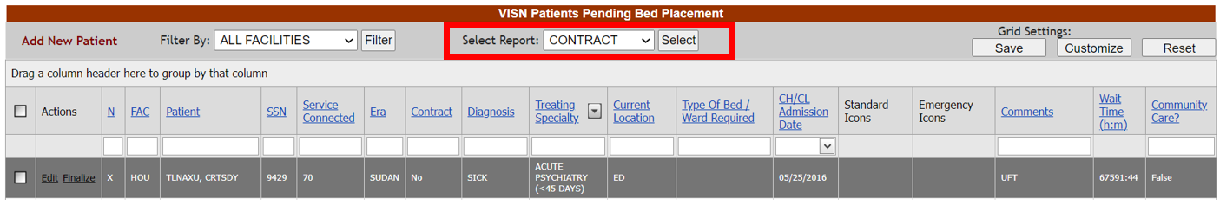
Select the facility from the Fac drop-down menu. Select the contract from the Contract drop-down menu. Using the Start Date and End Date fields, define the time interval for the report. After selecting the desired parameters, click the View Report button to generate the report.
The report is displayed as in the following image:
Figure 211 - Network Contract Report
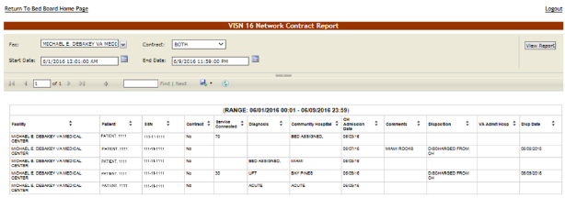
The title of the report is displayed in the upper part of the page. Navigation and display tools are available in the toolbar displayed across the screen. Place the mouse cursor over a button to display the corresponding tooltip.
The report can be exported to a series of formats available when clicking the Save button. Once exported, the Print button allows the site user to send the generated report to a printer.
The following data is available for each patient in the report:
Table 44 - Patients in Community Hospitals - Contract Report
COLUMN | DESCRIPTION
Facility | The Facility from the patient has been transferred.
Patient | The patient’s last name and the last 4 digits of their SSN.
SSN | The last 4 digits of the patient’s Social Security Number.
Contract | Whether or not the VA facility has a contract with the selected community hospital.
Service Connected | The patient’s percent service-connected disability (default of NULL, this is an integer % value)
Diagnosis | The diagnosis for which the patient is sent to the community hospital.
Community Hospital | The Community Hospital where the patient is currently admitted.
CH Adm Date | The date when the patient has been admitted in the Community Hospital.
Comments | Comments entered in the Comments field.
Disposition | The disposition with which the patient had been added to the patient pending bed placement list.
VA Admit. Hosp. | The VA Hospital where the patient has been admitted.
Disp. Date | The date when the disposition was entered.

Network Audit Report
The Network Audit Report presents a list of patients who are currently in Community Hospitals and/or who have been in the past in Community Hospitals and the user who has entered this data in the system as well as the date and time when he/she did so.
From the Select Report field in the VISN Patients Pending Bed Placement area select Date Audit and press the Select button to display the report as in the following image:
Figure 212 - VISN Bed Boards Page – Select Report: DATE AUDIT
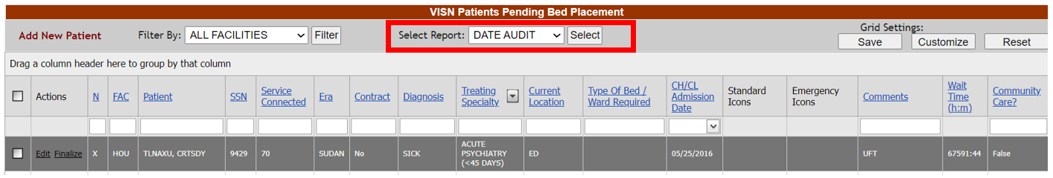
Select the facility from the Fac drop-down menu, select the Status or All Status from the Status drop-down menu. Using the Start Date and End Date fields, define the time interval for the report. After selecting the desired parameters, click the View Report button to generate the report.
The report is displayed as in the following image:
Figure 213 - Network Audit Report
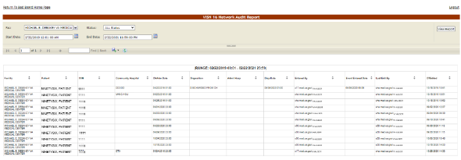
The title of the report is displayed in the upper part of the page. Navigation and display tools are available in the toolbar displayed across the screen. Place the mouse cursor over a button to display the corresponding tooltip.
The report can be exported to a series of formats available when clicking the Save button. Once exported, the Print button allows the site user to send the generated report to a printer.
The following data is available for each patient in the report:
Table 45 - Network Audit Report
COLUMN | DESCRIPTION
Facility | The Facility from the patient has been transferred.
Patient | The patient’s last name and the last 4 digits of their SSN.
SSN | The last 4 digits of the patient’s Social Security Number.
Community Hospital | The Community Hospital where the patient is currently admitted.
CH Adm Date | The date when the patient has been admitted in the Community Hospital.
Disposition | The disposition with which the patient had been added to the patient pending bed placement list.
Admit. Hosp. | The hospital where the patient has been admitted.
Disp. Date | The date when the disposition was entered.
Entered by | The name of the user who added the patient to the pending bed placement list.
Event Entered Date | The time the requested order was released or signed.
Last Edit by | The name of the user who last edited the entry.
DT Edited | The date and time when the entry was last edited.

Network Disposition Report
Network Disposition Report presents a list of patients who have been in Community Hospitals, have been discharged and have orders according to the discharge disposition.
From the Select Report field in the VISN Patients Pending Bed Placement area select Dispositions and press the Select button to display the report.
Figure 214 - VISN Bed Boards Page – Select Report: DISPOSITIONS
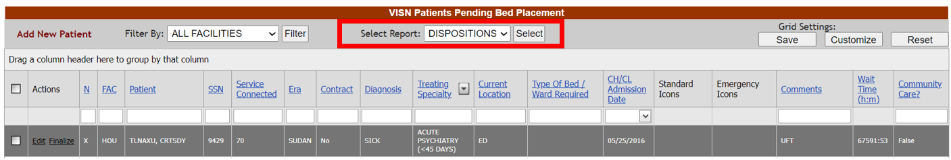
Select the facility from the Fac drop-down menu, select the Disposition or All Dispositions. Using the Start Date and End Date fields, define the time interval for the report. After selecting the desired parameters, click the View Report button to generate the report.
The report is displayed as in the following image:
Figure 215 - Network Disposition Report
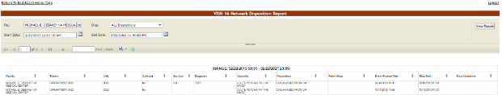
The title of the report is displayed in the upper part of the page. Navigation and display tools are available in the toolbar displayed across the screen. Place the mouse cursor over a button to display the corresponding tooltip.
The report can be exported to a series of formats available when clicking the Save button. Once exported, the Print button allows the site user to send the generated report to a printer.
The following data is available for each entry in the report:
Table 46 – Network Disposition Report
COLUMN | DESCRIPTION
Facility | The Facility which the patient has been transferred from.
Patient | The patient’s last name and the last 4 digits of their SSN.
SSN | The last 4 digits of the patient’s Social Security Number.
Contract | Whether or not the VA facility has a contract with the selected community hospital.
Service Connected | The patient’s percent service-connected disability (default of NULL, this is an integer % value).
Diagnosis | The diagnosis for which the patient is sent to the community hospital.
Specialty | The treating specialty required for the patient’s problem.
Disposition | The disposition with which the patient had been added to the patient pending bed placement list.
Admit Hosp | The hospital where the patient has been admitted.
Event Entered Date | The time the requested order was released or signed.
Disp Date | The date when the disposition was entered.
Disp Comments | The comments entered for the selected disposition.

VISN Audit Log Reports
VISN Users have access to Audit Log reports if granted an additional Audit Log role. They will click the View Audit Log link to access the page as in the following image:
Figure 216 - Selecting Audit Log from VISN home page
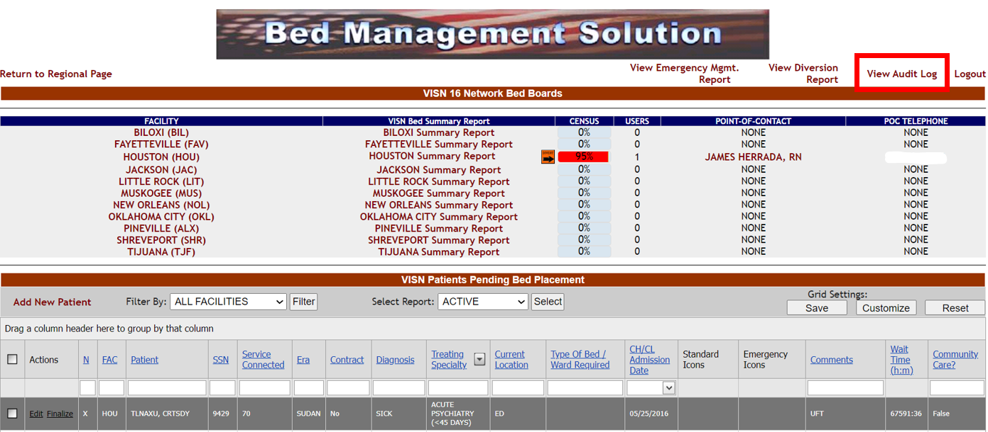
For more information on granting the Audit Log User role to a BMS login, refer to the BMS User Setup and Admin Guide.
When the View Audit Log button is clicked, users are presented with the report options available via the “Select Report” parameter. Select which Reports you would like to display, as shown in the screenshot below:
Figure 217 - VISN Users – Audit Log Report Types
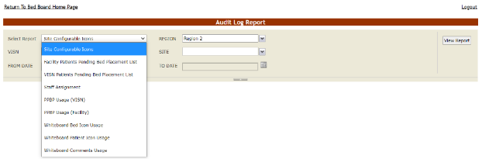
Note: You cannot change the VISN or Region Selection and the user must have the VISN User role as well as Audit Log to access this report.
The Audit Log reports present information about what users have performed what actions in different areas of the application (such as icons, pending bed placements, staff assignment or whiteboard usage). See the following sections for details on each report.
The reports available from the VISN Audit Log Page follow below:

Site Configurable Icons Report
The Site Configurable Icons Report presents information about the usage of the site configurable icons within the system.
In the Audit Log Report page use the Select Report field to select the Site Icons report, then select Date from/Date to determine the time interval for the report, the Region, VISN and Site and press the View Report button. The image below presents an example of a Site Configurable Icons Report:
Figure 218 - Site Configurable Icons Report
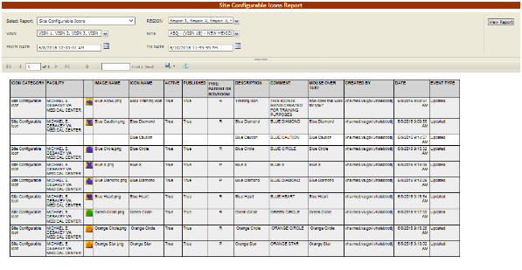

The title of the report is displayed in the upper part of the page. Navigation and display tools are available in the toolbar displayed across the screen. Place the mouse cursor over a button to display the corresponding tooltip.
The report can be exported to a series of formats available when clicking the Save button. Once exported, the Print button allows the site user to send the generated report to a printer.
For each entry the following data is available:
Table 47 - Site Configurable Icons Report Parameters
Column | Description
Icon Category | The type of icon: can only be Site Configurable Icon.
Facility | The name of the facility for which the icon has been configured and used.
(Icon image) | The icon image.
Image Name | The name of the image entered in the Image Name field in the Edit Icon page.
Icon Name | The name assigned to the icon.
Active | If the icon is active.
Published | If the icon has been published.
Type: Patient or RoomBed | If the icon is used to flag a patient or a room or a bed.
Description | The description of the icon as entered in the Icon Description field in the Edit Icon page.
Comment | Any comment entered in the Comments field in the Edit Icon page.
Mouse Over Text | The text entered in the Mouse Over Text field in the Edit Icon page.
Created By | The name of the user who performed the current operation on the icon.
Date | The date and time when the current operation has been performed on the icon.
Event Type | The type of operation that has been performed on the icon.

Facility Patient Pending Bed Placement List Report
The Facility Patient Pending Bed Placement List Report presents information about what users have performed what actions on a facility pending bed placement list.
In the Audit Log Report page use the Select Report field to select the Facility Pending Bed Placement List report, then select Date from/Date to determine the time interval for the report, the Region, VISN and Site and press the View Report button. The image below presents an example of a Facility Patient Pending Bed Placement List Report.
Figure 219 - Facility Patient Pending Bed Placement List Report
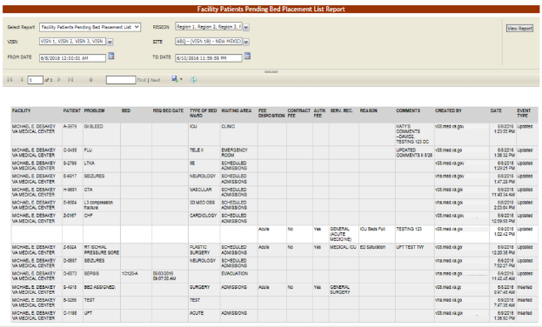

The title of the report is displayed in the upper part of the page. Navigation and display tools are available in the toolbar displayed across the screen. Place the mouse cursor over a button to display the corresponding tooltip.
The report can be exported to a series of formats available when clicking the Save button. Once exported, the Print button allows the site user to send the generated report to a printer.
For each entry the following data is available:
Table 48 - Facility Patient Pending Bed Placement List Report Parameters
COLUMN | DESCRIPTION
Facility | The name of the VA facility.
Patient | The code of the patient.
Problem | The problem for which the patient needed treatment.
Bed | The bed assigned to the patient.
Req Bed Date | The date when the bed was requested for the patient.
Type of Bed Ward | The type of bed/ward requested for the patient.
Waiting Area | The waiting area where the patient has been placed.
Fee Disposition | The fee disposition associated to the patient.
Contract Fee | The contract fee.
Auth. Fee | The authorization to use the fee.
Serv. Rec. | The type of service requested according to the patient’s problem.
Reason | The reason for using the fee.
Comments | Any comments entered in the Comments field.
Created by | The user who created the event.
Date | The date and time when the event was created.
Event Type | The type of event.

VISN Patient Pending Bed Placement List Report
The VISN Patient Pending Bed Placement List Report presents information about what users have performed what actions on a VISN pending bed placement list.
In the Audit Log Report page use the Select Report field to select the VISN Patient Pending Bed Placement List report, then select Date from/Date to determine the time interval for the report, the Region, VISN and Site and press the View Report button. The image below presents an example of a VISN Patient Pending Bed Placement List Report:
Figure 220 - VISN Patient Pending Bed Placement List Report
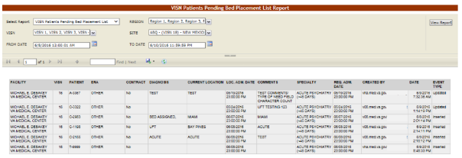

The title of the report is displayed in the upper part of the page. Navigation and display tools are available in the toolbar displayed across the screen. Place the mouse cursor over a button to display the corresponding tooltip.
The report can be exported to a series of formats available when clicking the Save button. Once exported, the Print button allows the site user to send the generated report to a printer.
For each entry the following data is available:
Table 49 - VISN Patient Pending Bed Placement List Report Parameters
COLUMN | DESCRIPTION
Facility | The name of the VA facility.
VISN | The VISN where the VA facility is located.
Patient | The code of the patient.
ERA | The period of service that the patient served.
Contract | Whether or not the VA facility has a contract with the selected community hospital.
Diagnosis | The diagnosis for which the patient requests admission to the community hospital.
Current location | The name of the community hospital where the patient is currently being treated
Location Adm. Date | The date when the patient has been admitted in the selected location.
Comments | Any comments entered in the Comments field.
Specialty | The treating specialty corresponding to the type of need.
Req. Adm. Date | The date when the patient should be able to be admitted to the VA facility.
Created by | The name of the user who created the event.
Date | The date and time when the event has been created.
Event Type | The type of the event.

Staff Assignment Report
The Staff Assignment Report presents information about what users have assigned staff personnel to the beds in the wards of a facility.
In the Audit Log Report page use the Select Report field to select the Staff Assignment report, then select Date from/Date to determine the time interval for the report, the Region, VISN and Site and press the View Report button. The image below presents an example of a Staff Assignment Report:
Figure 221 - Staff Assignment Report
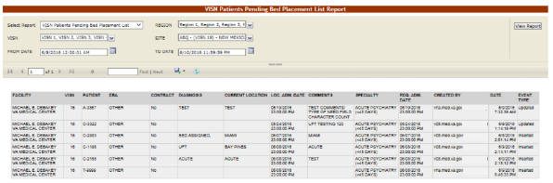

For each entry the following data is available:
Table 50 - Staff Assignment Report Parameters
COLUMN | DESCRIPTION
Ward | The ward where the bed is.
Bed | The code of the bed.
Staff | The name of the person assigned to the bed.
Patient | The code of the patient occupying the bed.
Created by | The name of the user who created the event.
Date | The date and time when the event has been created.
Event Type | The type of the event.

Bed History Report
The Bed History Report presents information about what users have performed what actions on a bed.
In the Audit Log Report page use the Select Report field to select the Bed History Report, then Region, VISN, Site, and then select From Date/To Date determine the time interval for the report and press the View Report button. The image below presents an example of a Bed History Report:
Figure 222 - Bed History Report
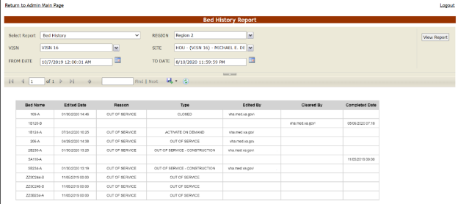

The title of the report is displayed in the upper part of the page. Navigation and display tools are available in the toolbar displayed across the screen. Place the mouse cursor over a button to display the corresponding tooltip.
The report can be exported to a series of formats available when clicking the Save button. Once exported, the Print button allows the site user to send the generated report to a printer.
For each entry the following data is available:
Table 51– Bed History Report Parameters
COLUMN | DESCRIPTION
Bed Name | The bed number.
Edited Date | The date and time the bed was edited.
Reason | The reason the bed is being edited.
Type | The type of edit reason.
Edited By | The name of the user editing the bed.
Cleared By | The name of the user who cleared the edits.
Completed Date | The date the bed was cleared of all edits.

PPBP Usage (VISN) Report
The PPBP Usage (VISN) Report presents information about any and all modifications users have made from the Patient Pending Bed Placement (PPBP) view.
In the Audit Log Report page use the Select Report field to select the PPBP Usage (VISN) report, then select Date from/Date to determine the time interval for the report, the Region, VISN and Site and press the View Report button. The image below presents an example of the PPBP Usage (VISN) Report:
Figure 223 - PPBP Usage (VISN) Report
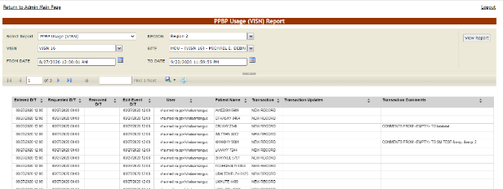

The title of the report is displayed in the upper part of the page. Navigation and display tools are available in the toolbar displayed across the screen. Place the mouse cursor over a button to display the corresponding tooltip.
The report can be exported to a series of formats available when clicking the Save button. Once exported, the Print button allows the site user to send the generated report to a printer.
For each entry the following data is available:
Table 52 - PPBP Usage (VISN) Report Parameters
COLUMN | DESCRIPTION
Entered D/T | The Date/Time of the modification to the Whiteboard.
Requested D/T | The Date/Time the placement on the board was requested.
Removed D/T | The Date/Time the entry was removed.
Edit Event D/T | The Date/Time the event was deleted.
User | The BMS User who made the modification.
Patient Name | The patient’s last name and last 4 digits of the SSN.
Transaction | The type of operation performed on the record, such as Update, New Record, or Delete.
Transaction Updates | The updates made to the Whiteboard, not including comments
Transaction Comments | Any comments made for the transaction performed by the user.

PPBP Usage (Facility) Report
The PPBP Usage (Facility) Report presents information about any and all modifications users have made from the Patient Pending Bed Placement (PPBP) view.
In the Audit Log Report page use the Select Report field to select the Whiteboard Usage report, then select Date from/Date to determine the time interval for the report, the Region, VISN and Site and press the View Report button. The image below presents an example of the PPBP Usage (Facility) Report:
Figure 224 - PPBP Usage (Facility) Report
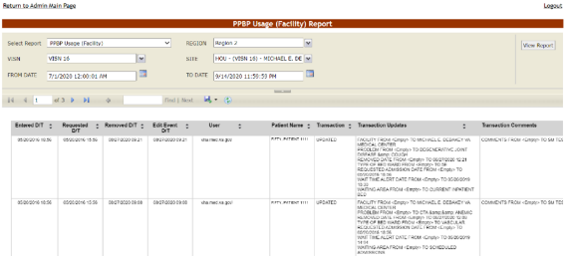

The title of the report is displayed in the upper part of the page. Navigation and display tools are available in the toolbar displayed across the screen. Place the mouse cursor over a button to display the corresponding tooltip.
The report can be exported to a series of formats available when clicking the Save button. Once exported, the Print button allows the site user to send the generated report to a printer.
For each entry the following data is available:
Table 53 - PPBP Usage (Facility) Report Parameters
COLUMN | DESCRIPTION
Entered D/T | The Date/Time of the modification to the Whiteboard
Requested D/T | The Date/Time the placement on the board was requested.
Removed D/T | The Date/Time the entry was removed.
Edit Event D/T | The Date/Time the event was deleted.
User | The BMS User who made the modification.
Patient Name | The patient’s last name and last 4 digits of the SSN.
Transaction | The type of operation performed on the record, such as Update, New Record, or Delete.
Transaction Updates | The updates made to the Whiteboard, not including comments
Transaction Comments | Any comments made for the transaction performed by the user.

Whiteboard Patient Icon Usage Report
The Whiteboard Patient Icon Usage Report presents information about modifications users have made to Patients from the Whiteboard.
In the Audit Log Report page use the Select Report field to select the Whiteboard Patient Icon Usage report, then select the Region, VISN and Site, then the From Date/To Date to determine the time interval for the report and press the View Report button.
Figure 225 - Selecting Whiteboard Patient Icon Usage Report
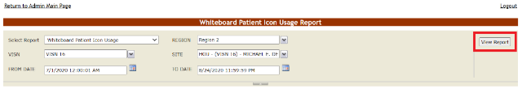
The image below presents an example of the Whiteboard Patient Icon Usage Report:
Figure 226 - Whiteboard Patient Icon Usage Report
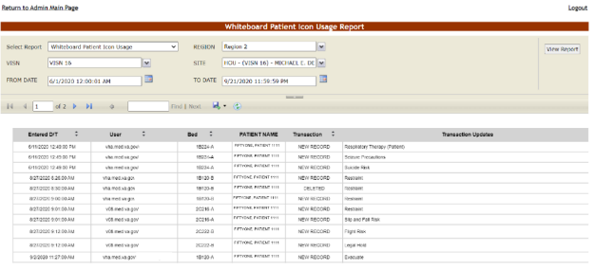
The title of the report is displayed in the upper part of the page. Navigation and display tools are available in the toolbar displayed across the screen. Place the mouse cursor over a button to display the corresponding tooltip.
The report can be exported to a series of formats available when clicking the Save button. Once exported, the Print button allows the site user to send the generated report to a printer.
For each entry the following data is available:
Table 54 - Whiteboard Patient Icon Usage Report Parameters
COLUMN | DESCRIPTION
Entered D/T | The Date/Time the entry was created.
User | The BMS User who made the entry.
Bed | The bed assigned to the patient.
Patient Name | The last name, first name and last 4 digits of the patient’s SSN.
Transaction | The type of operation performed on the record, such as Update, New Record, or Delete.
Transaction Updates | Any updates made for the transaction performed by the user.

Whiteboard Bed Icon Usage Report
The Whiteboard Bed Icon Usage Report presents information about modifications users have made to Icons from the Whiteboard.
In the Audit Log Report page use the Select Report field to select the Whiteboard Bed Icon Usage report, then select the Region, VISN and Site, then the From Date/To Date to determine the time interval for the report and press the View Report button.

Figure 227 - Selecting Whiteboard Bed Icon Usage Report
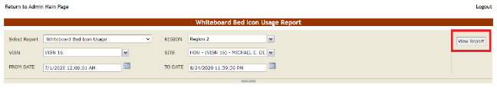

The image below presents an example of the Whiteboard Bed Icon Usage Report:
Figure 228 - Whiteboard Bed Icon Usage Report
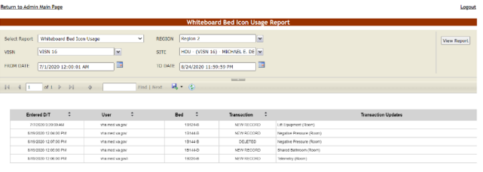

The title of the report is displayed in the upper part of the page. Navigation and display tools are available in the toolbar displayed across the screen. Place the mouse cursor over a button to display the corresponding tooltip.
The report can be exported to a series of formats available when clicking the Save button. Once exported, the Print button allows the site user to send the generated report to a printer.
For each entry the following data is available:
Table 55 - Whiteboard Bed Icon Usage Report Parameters
COLUMN | DESCRIPTION
Entered D/T | The Date/Time the entry was created.
User | The BMS User who made the entry.
Bed | The bed assigned to the patient.
Transaction | The type of operation performed on the record, such as Update, New Record, or Deleted.
Transaction Updates | Any updates made for the transaction performed by the user.

Whiteboard Comments Usage Report
The Whiteboard Comments Usage Report presents information about any and all modifications users have made from the Whiteboard.
In the Audit Log Report page use the Select Report field to select the Whiteboard Comments Usage report, then select Date from/Date to determine the time interval for the report, the Region, VISN and Site and press the View Report button. The image below presents an example of the Whiteboard Usage Report:
Figure 229 - Whiteboard Comments Usage Report
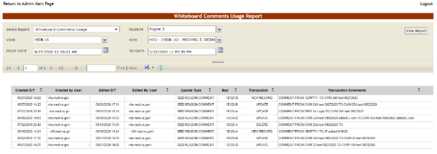

The title of the report is displayed in the upper part of the page. Navigation and display tools are available in the toolbar displayed across the screen. Place the mouse cursor over a button to display the corresponding tooltip.
The report can be exported to a series of formats available when clicking the Save button. Once exported, the Print button allows the site user to send the generated report to a printer.
For each entry the following data is available:
Table 56 - Whiteboard Comments Usage Report Parameters
COLUMN | DESCRIPTION
Created D/T | The Date/Time the comment was created.
Created by User | The BMS User who created the comment.
Edited D/T | The Date/Time of the modification to the Whiteboard.
Edited by User | The BMS User who made the modification.
Update Type | The type of update made to the Whiteboard, such as Bed Reason Comment, Bed Unavailable, Icon Assignment, or Bed Staff Assignment.
Bed | The bed record affected by the modification.
Transaction | The type of operation performed on the record, such as Update, New Record, or Delete.
Transaction Comments | Any comments made for the transaction performed by the user.

VISN Diversion Report
Figure 230 - VISN Bed Board Page
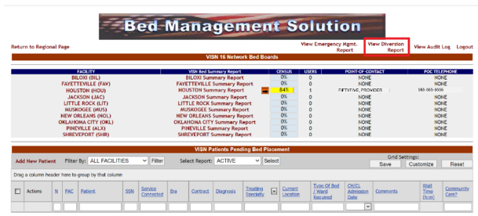

Figure 231 - Select Diversion Report Type
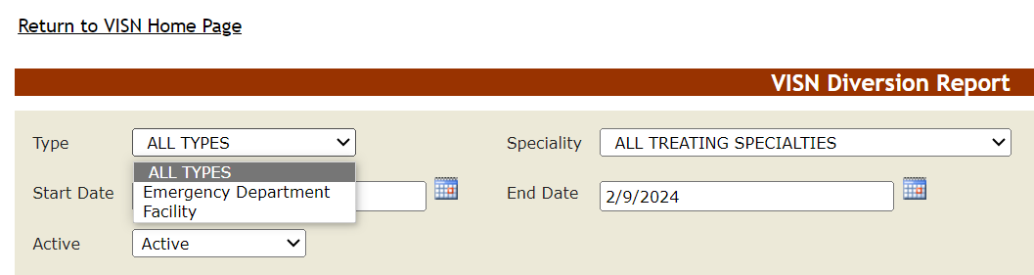

Figure 232 - Select Diversion Report Specialty
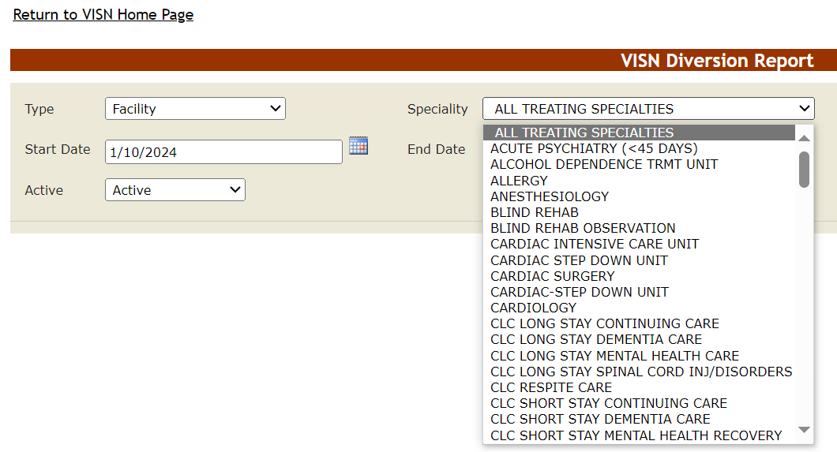
Figure 233 - Select Diversion Report Date Ranges and Active value
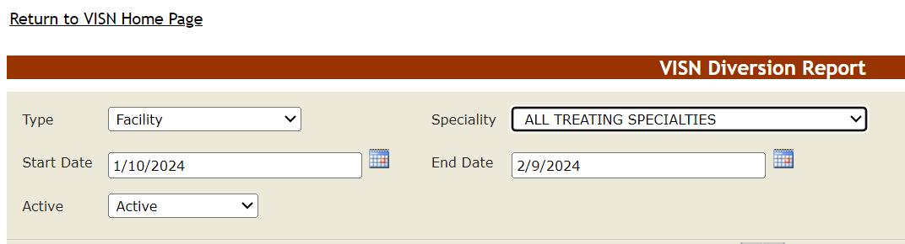

Figure 234 - VISN Diversion Report Results
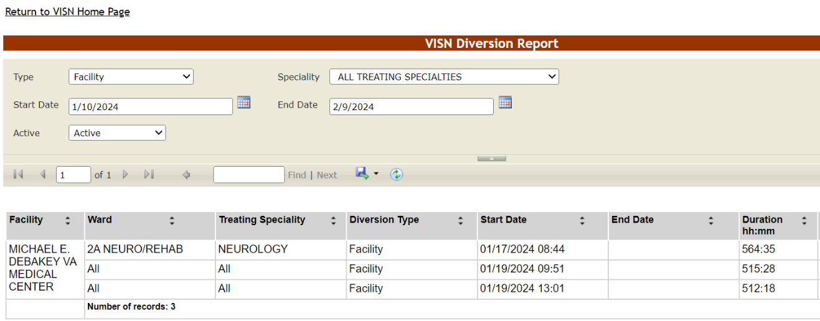
For active diversions the End Date value will be blank (i.e., no end date).
The title of the report is displayed in the upper part of the page. Navigation and display tools are available in the toolbar displayed across the screen. Place the mouse cursor over a button to display the corresponding tooltip.
The report can be exported to a series of formats available when clicking the Save button. Once exported, the Print button allows the site user to send the generated report to a printer.
The following data is available for each entry:
Table 57 - VISN Diversion Report Parameters
COLUMN | DESCRIPTION
Facility | The name of the Facility.
Ward | The Ward.
Treating Specialty | The treating specialty.
Diversion Type | The diversion type.
Start Date | Start date of diversion.
End Date | End date of diversion.
Duration | Duration of diversion hours & minutes.
Comments | Any pertinent comments.

VISN Emergency Management Report
The View Emergency Mgmt. Report link provides access to the various Emergency reports. This report provides information that can be printed and used in case of an emergency:
- Roster report is a listing of those patients needing to be evacuated and transported out of the facility;
- Regulate report provides a worksheet that can be used with some prefilled information such as admitting diagnosis;
- Manifest report can be used by those actually evacuating the patient such as the driver/attendant of the bus or vehicle;
- Patient Transfer report is a report listing patients transferred and the facility or ward from which the patient was transferred.
The emergency management report presents a list with all the patients that need to be evacuated in case of emergency.
To generate the emergency management report, follow the instructions below.
The VISN Emergency Mgmt. Report link is on the upper right of the VISN Bed Board page.

Figure 235 – VISN Emergency Management Report
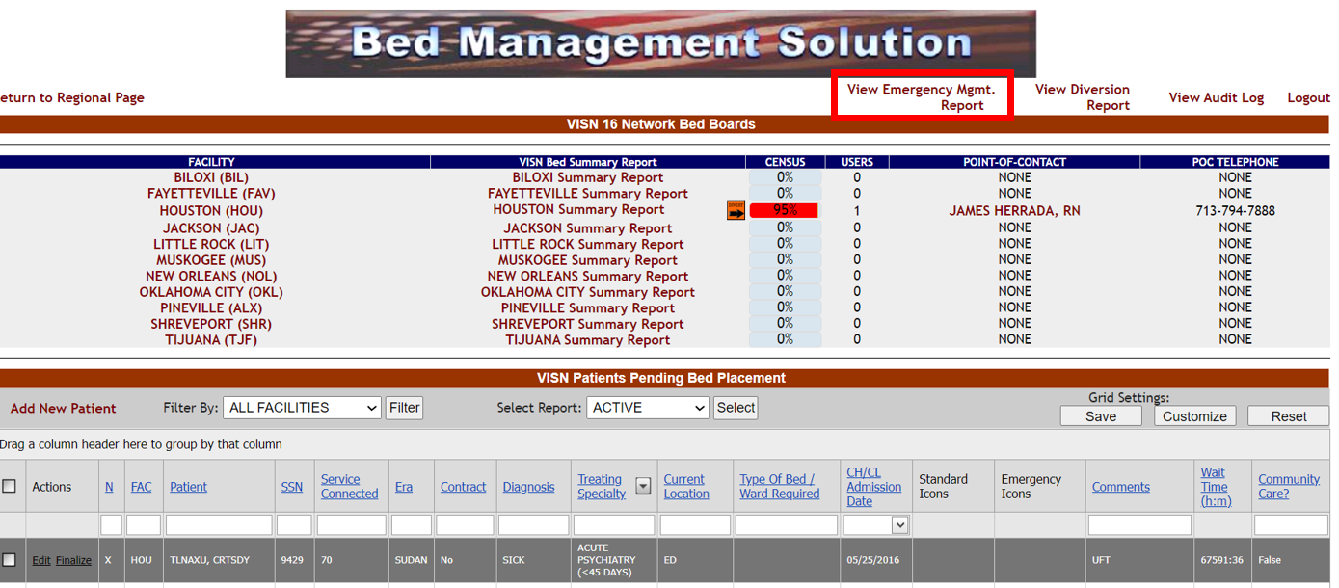
Select View Emergency Mgmt. Report.
Figure 236 - VISN Bed Board Page
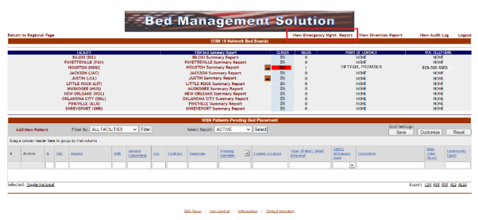
The following page is displayed:
Figure 237 - Select Emergency Management Report Type and Facility
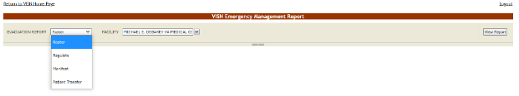
From the EVACUATION REPORT field select one of the display options for the report: Roster, Regulate or Manifest. From the Facility field select the facility or all facilities for which you want to generate the report. Below is an example of a report displayed with the Roster display option:
Figure 238 - VISN Emergency Management Report – Roster
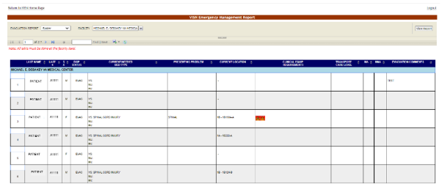
Below is an example of a report displayed with the Regulate display option:
Figure 239 - VISN Emergency Management Report – Regulate
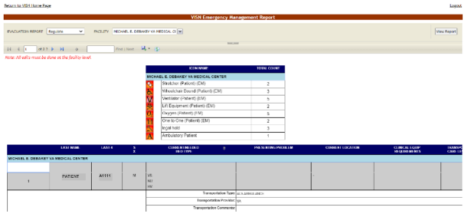
Below is an example of a report displayed with the Manifest display option:
Figure 240 - VISN Emergency Management Report – Manifest
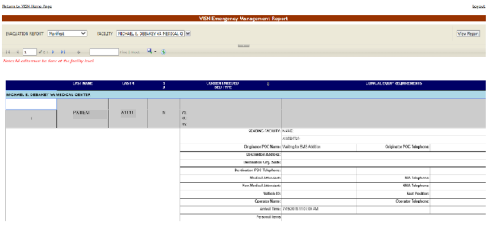
Below is an example of a report displayed with the Patient Transfer display option:
Figure 241 - VISN Emergency Management Report – Patient Transfer
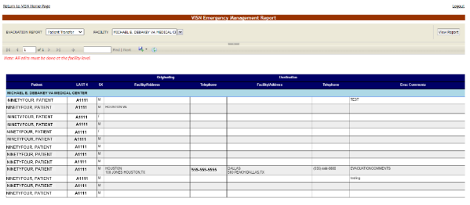
The following data is available for the reports:
Table 58 - VISN Emergency Management Reports Parameters
Column | Description
Last Name | Last name of the patient who needs to be evacuated.
Last 4 | Last four digits of the patient SSN.
SX | The gender of the patient.
Disp. Status | The disposition with which the patient is added to the patient pending bed placement list.
Current/Needed Bed Type | The type of bed needed for the patient who is being evacuated.
Presenting Problem | The problem for which the patient has been admitted. Pulls in admitting Diagnosis for inpatients
Current Location | The current location of the patient. Pulls in current ward/room/bed
Clinical Equipment Requirements | The clinical equipment requirements for the patient.
Transport Care Level | The transport care level.
Originator POC Telephone | The telephone of the facility from where the patients are evacuated.
Destination Address | The address of the facility where the patient is evacuated to.
Destination City, State | The city and state where the patient is evacuated to.
Destination POC Telephone | The telephone of the Point-of-Contact of the facility where the patient is evacuated to.
Medical Attendant | The name of the Medical Attendant assigned for the patient.
MA Telephone | The phone number of the Medical Attendant assigned for the patient.
Non-Medical Attendant | The name of the non-Medical Attendant accompanying the patient or of the family member that may be transported with the patient
NMA Telephone | The phone number of the non-Medical Attendant accompanying the patient or of the family member that may be transported with the patient
Vehicle ID | The identifying number of the transportation vehicle.
Seat Position | The seat position of the patient for the transportation vehicle.
Operator Telephone | The telephone of the facility from where the patients are evacuated.
Evacuation Comments: | Any relevant evacuation comments.

National Users
National users can access the National/Regional page displayed as in the following image:
Figure 242 - BMS National/Regional Home Page
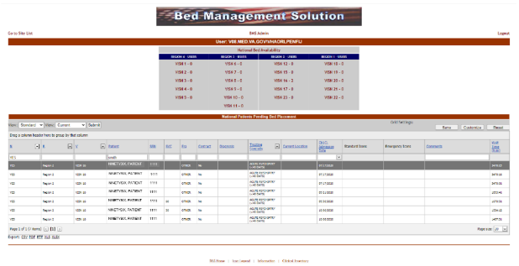
The National Bed Availability link at the center of the page generates the National Bed Availability Report. For details, see the section National Bed Availability Report.
Figure 243 – National Bed Availability link
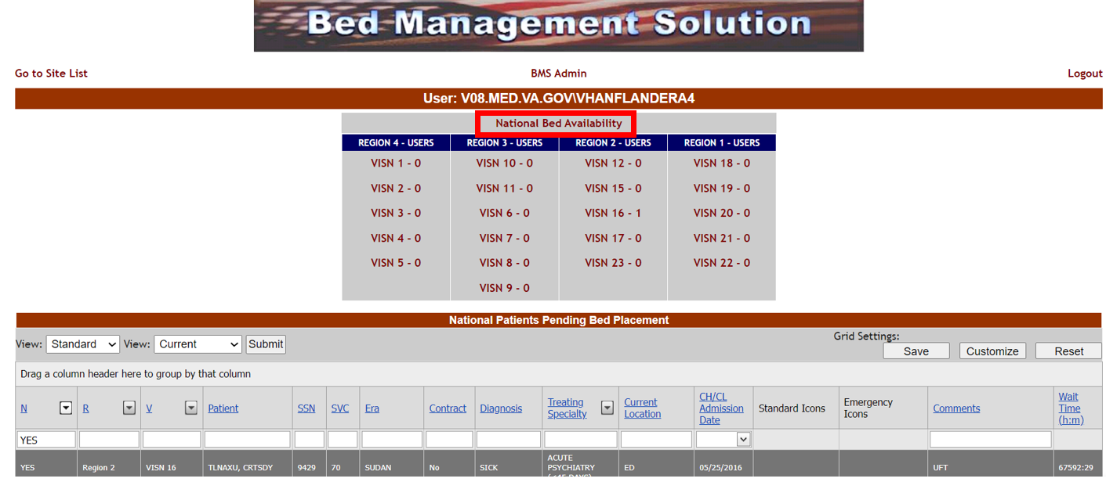
A list of VISN networks grouped by regions is displayed. To display the homepage of a VISN click the corresponding link.
Figure 244 – BMS National/Regional Home Page VISN link example
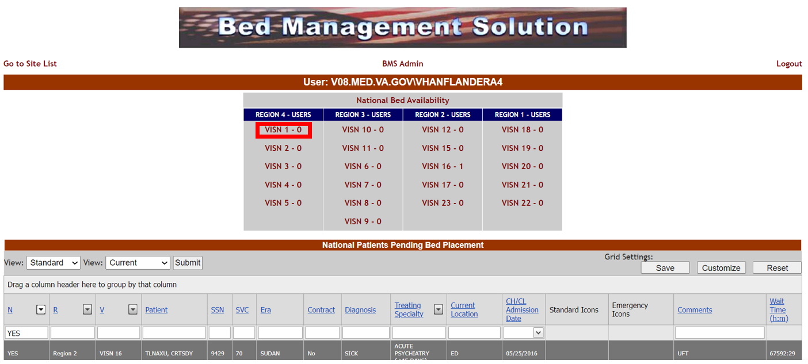
In the lower part of the screen, a National Patients Pending Bed Placement List is displayed.
The first View drop-down menu (Standard, Date Audit) is for determining specific column displays. There is also a second View drop-down for displaying records by date range (Current, Past 30-Days, Past 60-Days, Past 90-Days). In addition, the list can be filtered using the following criteria: REGION, VISN, and TREATING SPECIALTY.
Figure 245 – Date Audit and Past 30-Days views, plus filtering by Region (R) and VISN (V)
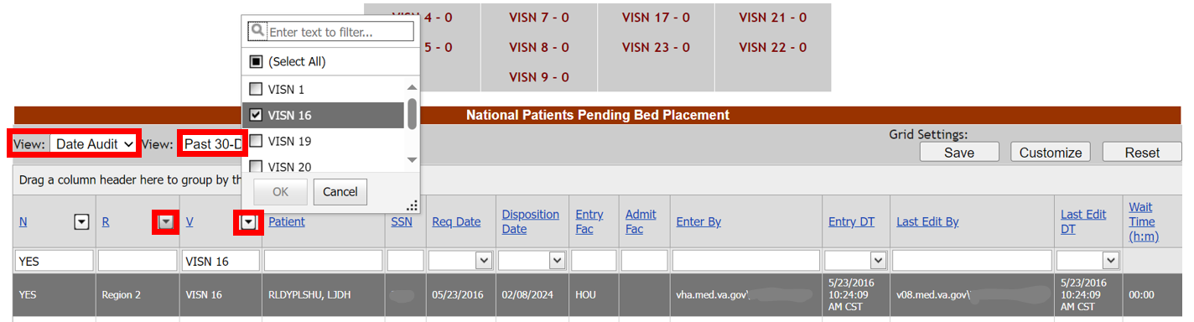

For each patient in the list the following data is available:
Table 59 - National Patients Pending Bed Placement - Parameters
COLUMN | DESCRIPTION
N | If the patient was flagged to be included in the National Patients Pending Bed Placement list.
R | The region of the facility
V | The VISN of the facility
Patient | The name of the patient.
SSN | The social security number of the patient.
Req Date | The requested admission date.
Disposition Date | The disposition date used when the patient is finalized from the VISN Patients Pending Bed Placement List.
Entry Fac | The facility chosen when entering the patient on the VISN Patients Pending Bed Placement List.
Admit Fac | The admission facility chosen when the patient is finalized from the VISN Patients Pending Bed Placement List.
Enter By | The BMS login that entered the patient on the National Patients Pending Bed Placement List.
Entry DT | The date and time the patient was entered on the National Patients Pending Bed Placement List.
Last Edit By | The BMS login that last edited the patient record on the National Patients Pending Bed Placement List.
Last Edit DT | The date and time the patient record was last edited on the National Patients Pending Bed Placement List.
SVC | The patient’s percent service-connected disability (default of NULL, this is an integer % value)
Era | The period of service that the patient served.
Contract | Whether or not the VA facility has a contract with the defined community hospital.
Diagnosis | The diagnosis for which the patient is sent to the community hospital.
Treating Specialty | The medical specialty which treats the selected diagnosis.
Current Location | The name of the community hospital where the patient has been admitted.
CH/CL Admission Date | The date when the patient has been admitted to the community hospital.
Standard Icons | Icons associated with this patient.
Emergency Icons | Emergency icons associated with this patient.
Comments | Any relevant information entered by the Regional user.
Wait Time (h:m) | The time lapse between the request and the actual admission of the patient to the community hospital.

National Bed Availability Report
In the National/Regional Page click the National Bed Availability link to display the corresponding report as in the following image.
Figure 246 - National Bed Availability Report – Select Criteria
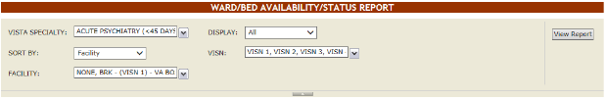
Select the VistA Specialty, the Sort and Display criteria then the Facilities and VISNs you want to include in the report then press the View Report button to display the report as in the following image.
Figure 247 - National Bed Availability
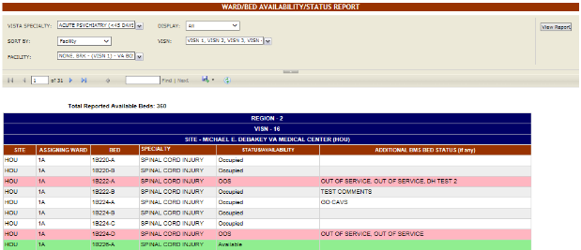
The title of the report is displayed in the upper part of the page. Navigation and display tools are available in the toolbar displayed across the screen. Place the mouse cursor over a button to display the corresponding tooltip.
The report can be exported to a series of formats available when clicking the Save button. Once exported, the Print button allows the site user to send the generated report to a printer.
The following data is available for each entry:
Table 60 - National Beds Availability
COLUMN | DESCRIPTION
Site | The code of the facility.
Assigning Ward | The ward where the available bed is located.
Bed | The code of the available bed.
Specialty | The treating specialty.
Status/Availability | The status of the bed.
Additional BMS Bed Status (if any) | Additional status if defined by the facility site administrator.

Regional Users
Regional users can also access the National/Regional page.
See the previous section for details on the National/Regional page.

Guest Users
The guest user can only access the National/Regional page and the only action he/she can perform is to generate the National Bed Availability report.
For details see the section National Bed Availability Report.

Troubleshooting
The BMS project team is working to develop a frequently asked questions (FAQs) section for this User Guide, which will contain user-related troubleshooting tips, known issues, and anomalies. This section will be made available as those items are realized and documented.
BMS Self-Help Troubleshooting Guide
The BMS Self-Help Troubleshooting Guide is an online resource for BMS application users. This system provides troubleshooting assistance to help end users determine if they are able to resolve their issues independently or if they need to enter a ticket to reach the BMS Sustainment Team or another group. Content will be added and updated as needed to suit the needs of BMS application users at all levels. To use, select an issue category and choose a listed issue to see potential solutions. If a YourIT helpdesk request is required, wording for the specific issue is listed.
BMS Self-Help Troubleshooting Guide
User Guide for BMS Self-Help Troubleshooting Guide

Appendix A. Acronyms and Abbreviations
In addition to the acronyms defined below, more definitions can be found on the OI&T Master Glossary.
Table 61 - Acronyms/Abbreviations
TERM | DEFINITION
ADT | Admission, Discharge, and Transfer
BMS | Bed Management Solution
BN | Business Need
BRD | Business Requirements Document
CCTL | Community Care Tracking List
CFM | Comprehensive Flow Management
CH/CL | Community Hospital / Current Location
CHF | Congestive Heart Failure
CLC | Community Living Center
COW | Computer on Wheels
CPRS | Computerized Patient Record System
D/C | Discharge
DM | Diabetes Mellitus
DOB | Date of Birth
DOM | Domiciliary
DRG | Diagnostic Related Group
DUSH | Deputy Under Secretary for Health
ED | Emergency Department
EMS | Environmental Management Service
EMSHG | Emergency Management Strategic Healthcare Group
ERR | Enterprise Requirements Repository
FAQs | Frequently Asked Questions
FIPS | Federal Information Processing Standard
GUI | Graphical User Interface
HAvBED | Hospital Available Beds for Emergencies & Disasters
HVAC | House Veterans Affairs Committee
ICU | Intensive Care Unit
IEN | Internal Entry Number. The primary keys for VistA files.
IT | Information Technology
LOS | Length of Stay
MDWS | Medical Domain Web Service
M (MUMPS) | Massachusetts General Hospital Utility Multi-Programming System
NIST | National Institute of Standards and Technology
NUMA | Nursing Unit Mapping Application
NUMI | National Utilization Management Integration
ODBC | Open Database Connectivity
OED | Office of Enterprise Development
OOS | Out of Service
OI&T | Office of Information and Technology
PICC | Peripherally Inserted Central Catheter
PPMS | Provider Profile Management System
PT | Patient
SSN | Social Security Number
Service Era or ERA | The period of service that the patient served.
STAT | Indicates an emergent or extremely urgent situation
TAG | Flow Improvement Technical Advisory Group
UM | Utilization Management
VA | Department of Veterans Affairs
VAMC | VA Medical Center
VHA | Veterans Health Administration
VDIF | Veterans Data Integration and Federation
VIA | VistA Integration Adapter
VISN | Veterans Integrated Service Network
VistA | Veterans Health Information Systems and Technology Architecture

