Veterans Data Integration and Federation Enterprise Platform (VDIF-EP):
InterSystems Application Programming Interface (API) Manager
Technical Guide
June 2024
Department of Veterans Affairs (VA)
Office of Information and Technology (OIT)

Revision History
Date | Revision | Description | Author
06/14/2024 | 1.0 | Initial Veterans Data Integration and Federation Enterprise Platform (VDIF-EP) InterSystems Application Programming Interface (API) Manager Technical Guide document. | VDIF-EP API Manager Development Team

Table of Contents
Revision History ii
List of Figures iii
List of Tables iv
1. Introduction 1
1.1. Purpose 1
2. System Summary 2
3. Getting Started 2
3.1. Registering Account 3
3.2. Logging In 4
3.3. Exit System 5
4. Testing API Key 5
4.1. Navigation 5
4.2. Registering Application 5
4.3. Activate Registration 7
4.4. Authentication 8
4.5. Testing through Postman 9
5. Troubleshooting 9
6. Acronyms and Abbreviations 10

List of Figures
Figure 1: API Manager Overview 1
Figure 2: API Manager Developers’ Portal 2
Figure 3: Registering API Manager Account Screen 3
Figure 4: API Manager Popup Message 4
Figure 5: Logging into API Manager Screen 4
Figure 6: VDIF-EP API Manager Application Screen 6
Figure 7: Create Application Screen 7
Figure 8: Approval Status Screens (1 of 2) 7
Figure 9: Approval Status Screens (2 of 2) 8
Figure 10: Generate Credential Screen 8
Figure 11: Postman API Testing Page 9

List of Tables
Table 1: Acronyms and Abbreviations 10

Introduction
The Application Programming Interface (API) Manager is an application that resides on an InterSystems IRIS for Health data platform and serves as a gateway between applications and the intended API. This allows organizations to securely access, manage, and analyze their APIs.
This guide focuses on the Developers’ portal, which displays information necessary for a developer to code against an API and incorporate that API into application code.

Purpose
The Veterans Data Integration and Federation Enterprise Platform (VDIF-EP) API Manager is a commercial-off-the-shelf (COTS) product from InterSystems that provides a way to route API traffic through a centralized gateway, which then forwards requests to the correct target endpoints. It is an application that resides on an InterSystems IRIS for Health data platform. API Manager serves as a gateway between applications (such as Fast Healthcare Interoperability Resources [FHIR] R4 a subset of Health Level Seven [HL7]) and the intended API.
NOTE: The process for project teams to request an application be added is currently under development.
Figure 1: API Manager Overview
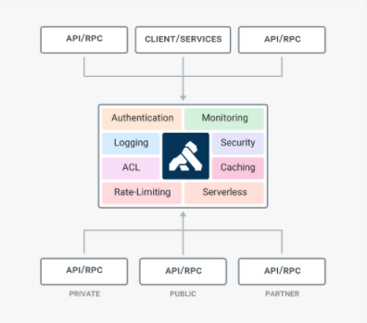

System Summary
The VDIF-EP API Manager application is hosted on Amazon Web Service (AWS). The system is only accessible within the VA intranet. The Developers’ portal is intended for internal VA users to discover existing APIs available for use through self-service.

Getting Started
The Developers’ portal (Figure 2) is available to all VA users from the VA intranet.
REF: For general login and use of the Developer’s portal, see the VDIF-EP InterSystems API Manager User Guide.
Figure 2: API Manager Developers’ Portal
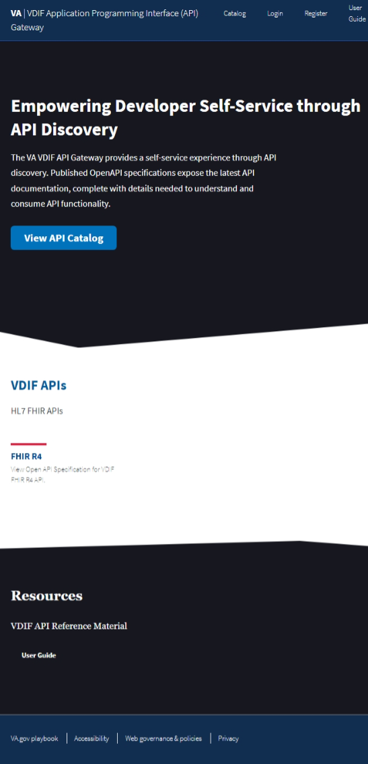

Registering Account
To register an account for the Developers’ portal, do the following:
- Open a browser (such as Microsoft© Edge or Google© Chrome).
- Navigate to the API Manager Developers’ portal.
- Select Register.
- Enter values in the following fields (Figure 3):
Full Name
Email
Password

- Select Create Account (Figure 3).
- Select OK in the “Thank you Registering…” popup message (Figure 4).
Figure 3: Registering API Manager Account Screen
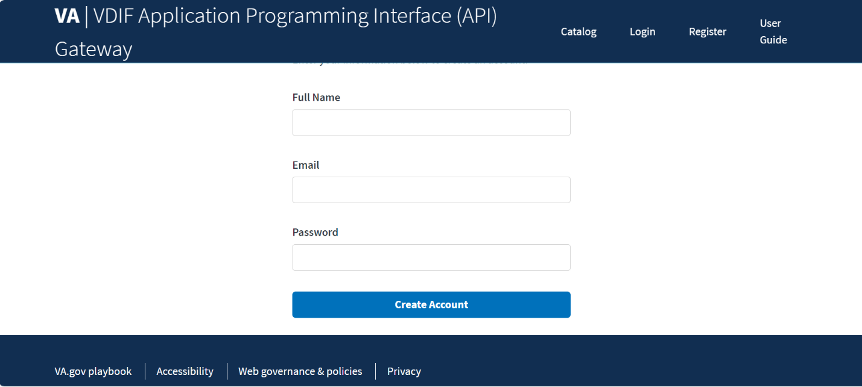

Figure 4: API Manager Popup Message
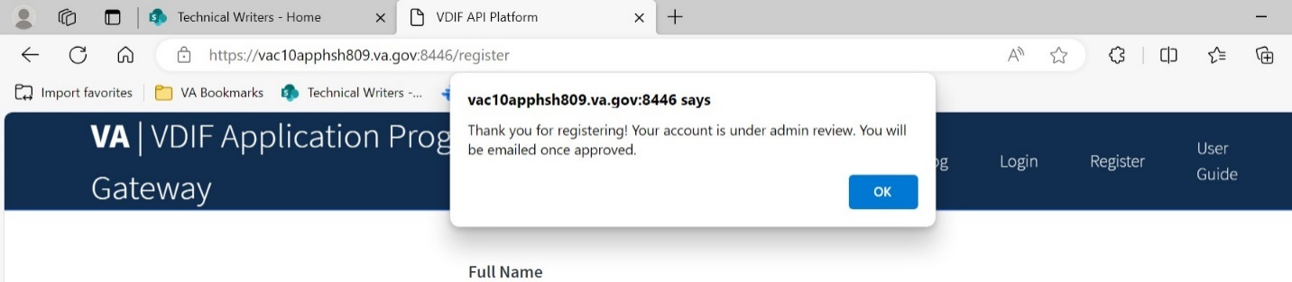

- An admin will then approve your application registration.

Logging In
To log onto the Developers’ portal, do the following:
- Open a browser (such as Microsoft© Edge or Google© Chrome).
- Navigate to the API Manager Developers’ portal.
- Select Login in the top dashboard (Figure 5).
- Enter:
Email
Password

- Select Login.
Figure 5: Logging into API Manager Screen
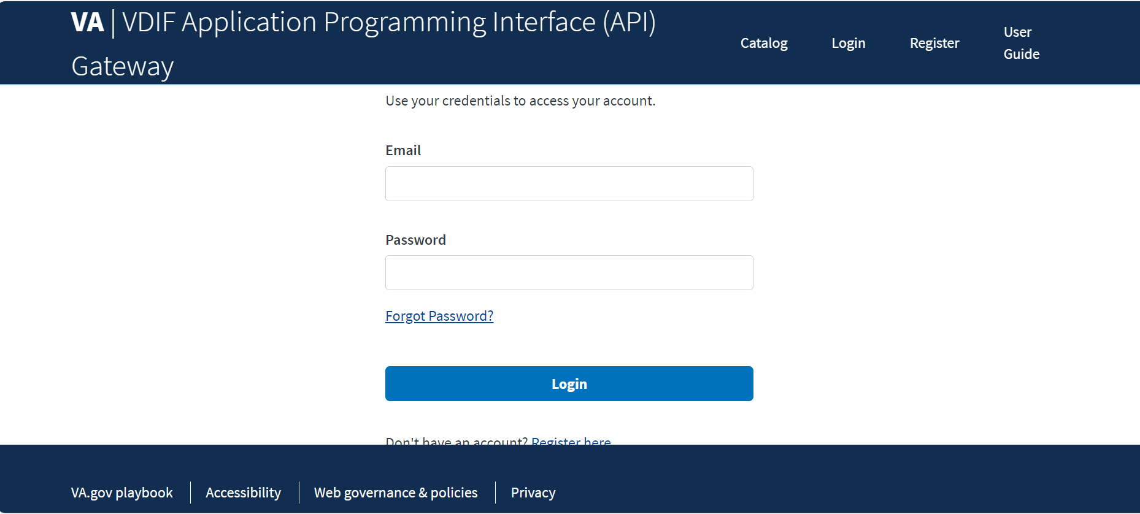

Exit System
To exit the Developers’ portal, close the browser. Logout is not necessary.

Testing API Key

Navigation
Navigation of the Developers’ portal is accomplished by:
- Pressing buttons.
- Selecting links.
- Using built-in browser features, such as a link to go back to the previous page.

Registering Application
To use an application outside of the Try It Out feature and directly access the Sandbox, a developer must register an application and receive an API key.
To register for an application:
- Open a browser (such as Microsoft© Edge or Google© Chrome).
- Navigate to the API Manager Developers’ portal.
- Select My Applications in the top menu (Figure 6).
- Select +New Application (Figure 6).
Figure 6: VDIF-EP API Manager Application Screen
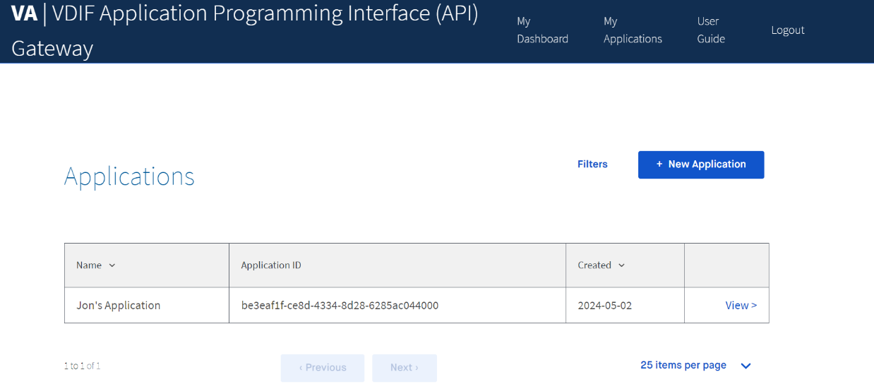

- Enter the following fields in the “Create Applications“ screen (Figure 7):
Application Name.
Redirect URI.
NOTE: This can be any valid URI, such as http://www.google.com.
Description—This is optional and can be filled in with any detail you would like API Manager to know.

- Select Create.
- A green success popup message appears and redirects you to the My Applications page.
Figure 7: Create Application Screen
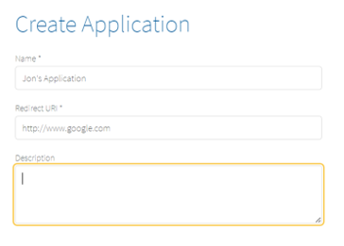
- An admin will then approve your application registration.

Activate Registration
You need to activate and get your application approved before using your API key.
From your application home page in Figure 6:
- Select View on the Application you are wanting to approve.
- Scroll down to Services (Figure 8).
- Select Activate (Figure 8).
- Application status will appear as Pending Approval until approved (Figure 9).
Figure 8: Approval Status Screens (1 of 2)
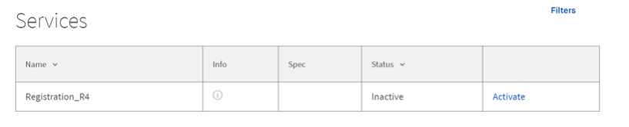

Figure 9: Approval Status Screens (2 of 2)
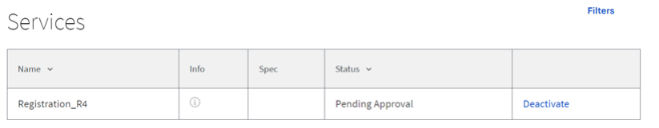

Authentication
While waiting for application approval, you can generate an API key for your API Requests. After you login, from the home page:
- Select My Applications in the top menu.
- Select View on your Application.
- Select +Generate Credential (Figure 10).
- Copy the Client ID to save it in your buffer(Figure 10).
Figure 10: Generate Credential Screen
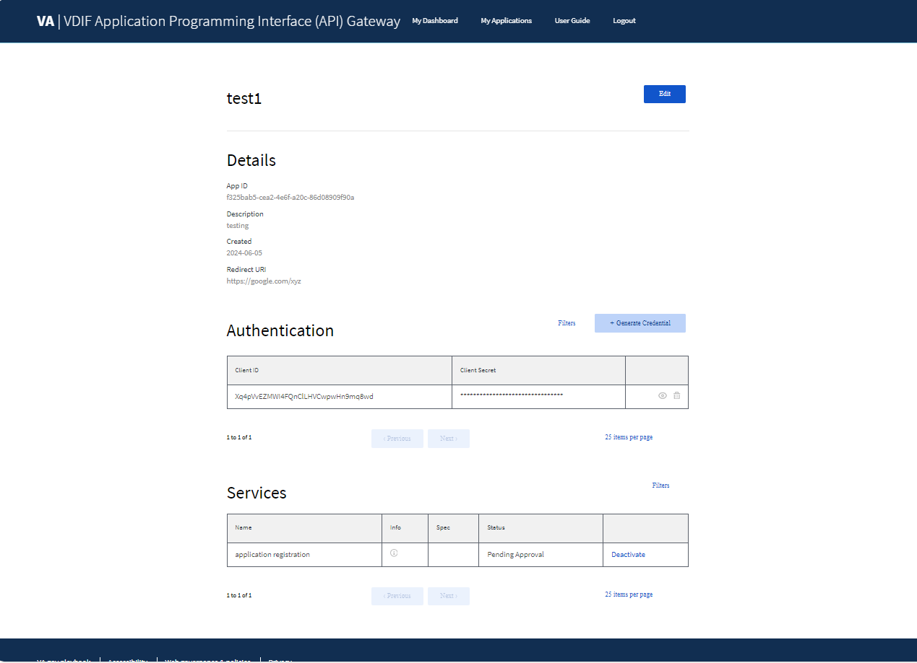

Testing through Postman
After you have generated your credential, you can now test through the Postman API Platform.
In the Postman Authorization tab:
- Enter the following (Figure 11):
Key (apikey)
Value (Client ID copied in Section 4.4, Step 4)

- From the Add to drop-down, select where you want your API key to be shown (Figure 11).
Figure 11: Postman API Testing Page
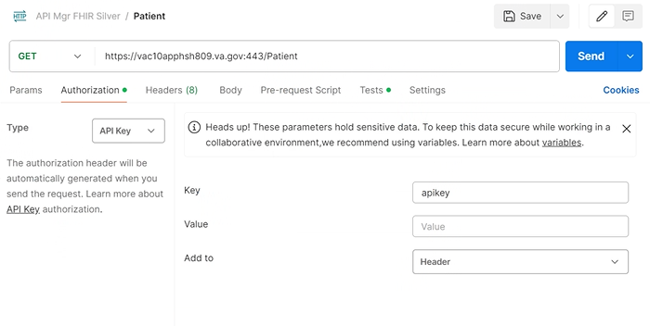

Troubleshooting
Getting access is manually approved through the admin’s developer portal. From the developer portal, admins can view the requested access and approve the request. Admins can also revoke access.
Be sure to reach out directly to the admin via email, so that they may manually approve your access.

Acronyms and Abbreviations
Table 1: Acronyms and Abbreviations
Term | Definition
API | Application Programming Interface
AWS | Amazon Web Service
CD2 | Critical Decision Point #2
COTS | Commercial-Off-the-Shelf
FHIR | Fast Healthcare Interoperability Resources
HL7 | Health Level Seven
OIT | Office of Information and Technology
SSOi | Single Sign On internal
VA | Department of Veterans Affairs
VDIF-EP | Veterans Data Integration and Federation Enterprise Platform
VIP | Veteran-focused Integrated Process

