Veterans Health Administration (VHA) Enrollment System (VES) 6.10

Quick Start User Guide
June 2024
Department of Veterans Affairs
Office of Information and Technology (OIT)

Revision History
Date | Revision | Description | Author
6/10/2024 | 49.0 | VES 6.10 added the following:  - Project References updated, pg. 2  - Vietnam Service Episode Dates  - Person Search Tabs → Military Service → Period of Service pgs. 10-11  - Change Rejected Enrollment Status to Deferred  - Person Search Tabs → Eligibility→ Enrollment→ Current Enrollment pgs. 11-12  - Enable Confidential Address  - Person Search Tabs → Demographics → Addresses →Confidential Mailing Address pg. 12  - TERA Updates for 10-10EZ, UI, VOA and Work Items  - Person Search Tabs → Financials pg. 13  - Person Search Tabs → Enrollment → Veteran’s Online Application pgs. 13-14  - Person Search Tabs → Military Service pgs. 14-17 | BAHSW

Artifact Rationale
Per the Veteran-focused Integrated Process (VIP) Guide, the Quick Start User Guide is required to be completed prior to Critical Decision Point #2 (CD2), with the expectation that it will be updated as needed. A Quick Start User Guide is a technical communication document intended to give assistance to people using a particular system, such as the Veterans Health Administration (VHA) Enrollment System (VES). Technical writers generally compose, update, and maintain the Quick Start User Guide; however, programmers, product and project managers, or other technical staff can also compose, update, and maintain the Quick Start User Guide. Most quick start guides contain both a written guide and the associated images. In the case of computer applications, it is usual to include screenshots of the human-machine interfaces, and hardware manuals often include clear, simplified diagrams. The language used is matched to the intended audience, with jargon kept to a minimum or explained thoroughly. The Quick Start User Guide is a mandatory, build-level document, and should be updated to reflect the contents of the most recently deployed build. The sections documented herein are required if applicable to your product.
Table of Contents
1. Introduction 1
1.1. Purpose 1
1.2. Overview 1
1.2.1. Release Updates and Enhancements 1
1.2.2. Organization of the Manual 1
1.2.3. Assumptions 2
1.2.4. Installation, Maintenance, & Monitoring 2
1.2.5. Software Disclaimer 2
1.2.6. User Guide Disclaimer 2
1.2.7. Project References 2
2. System Summary 3
2.1. System Design Document 3
2.2. User Access Levels 3
2.3. ESM Application Information System Contingency Plan 3
2.4. ESM Project Artifacts (VDL) 3
3. Getting Started 3
3.1. VES Layout 3
3.2. VES Online Help 5
3.3. 508 Compliance & Accessibility 8
3.3.1. Accessibility Software 9
3.4. Standard Data Service (SDS) Lookup Tables 9
3.5. Exiting VES 10
3.6. Caveats and Exceptions 10
4. Significant Additions and Updates to VES Version 6.10 10
4.1. VES Vietnam Service Episode Dates 10
4.1.1. Person Search Tabs → Military Service → Period of Service 10
4.2. VES Change Rejected Enrollment Status to Deferred 12
4.2.1. Person Search Tabs → Eligibility→ Enrollment→ Current Enrollment 12
4.3. ESM Enable Confidential Address 12
4.3.1. Person Search Tabs → Demographics → Addresses →Confidential Mailing Address 12
4.4. TERA Updates for 10-10EZ, UI, VOA and Work Items 13
4.4.1. Person Search Tabs → Financials 13
4.4.2. Person Search Tabs → Enrollment → Veteran’s Online Application 14
4.4.3. Person Search Tabs → Military Service 14
Table of Figures
Figure 1: Menu Bar 4
Figure 2: Summary with a Sensitive Record 4
Figure 3: Person Search Tabs 4
Figure 4: Summary and Main Screen on VES 5
Figure 5: Sorting Columns 5
Figure 6: System Help and Screen Help 6
Figure 7: SDS Lookup Table 10
Figure 8: Automatic HEC Period of Service List 11
Figure 9: HEC Period of Service List 11
Figure 10: Enrollment Statuses 12
Figure 11: Current Confidential Communication Types 13
Figure 12: Print 1010EZ & Print 1010EZR 13
Figure 13: Veteran's Online Application (VOA) 14
Figure 14: Agent Orange Exposure Location 15
Figure 15: TERA Indicator 15
Figure 16: TERA Indicator - Cohort 1-3 16
Figure 17: Military Service Tab Screenshot 17

List of Tables
Table 1: Accessibility Software 9

Introduction
The Veterans Health Administration (VHA) Enrollment System (VES) is the primary Veterans Affairs (VA) system used to manage VA health benefits.
VES allows staff at the Health Eligibility Center (HEC), located in Atlanta, Georgia, to work more efficiently and determine patient eligibility in a timelier manner. Messaging with the VAMC (Department of Veterans Affairs Medical Center) allows for the adding and updating of beneficiary records to the enterprise enrollment system to be shared with the field.
VES is one component of the "system of systems" needed to implement the VistA/GUI Hybrids (formerly HealtheVet) REE (Registration, Eligibility & Enrollment) environment.
VES’s two main functions are:
- Expert System (Messaging) provides a seamless bi-directional interface with external Veterans Health Administration (VHA) and non-VHA systems for data exchange of Veterans’ information.
- Workflow (Case Management) that provides authorized VHA case representatives at the HEC and VAMC with a web interface to easily track, maintain, and manage cases associated with Veteran benefits. HEC and VAMC staff utilize VES to manage these "cases" to completion so that verified Eligibility & Enrollment can be determined.

Purpose
The purpose of this user guide is to familiarize users with important features and navigational elements of the VES application.

Overview
President George W. Bush established a task force for returning Global War on Terror (GWOT) heroes who resulted in enhancements that improved delivery of Federal services and benefits to GWOT service members and Veterans. Among recommendations associated with task force was to focus on enhancing delivery of services and information to GWOT service members and Veterans within existing authority and resource levels.

Release Updates and Enhancements
Click the link to view current and past VES release updates and enhancements on the Online Help.

Organization of the Manual
This Quick Start User Guide contains the following:
- Introduction
- System Summary
- Getting Started

- Significant Additions and Updates to VES Version
- Troubleshooting

Assumptions
This quick start was written with the following assumed experience/skills of the audience:
- User has basic knowledge of VES (such as the use of commands, menu options, and navigation tools).
- User has been provided the appropriate active roles, menus, and security keys required for VES.
- User is using VES to do their job.
- User has validated access to VES.
- User has completed any prerequisite training.

Installation, Maintenance, & Monitoring
Installation, maintenance, and monitoring of VES updates are performed at the Austin Information Technology Center (AITC) on the third Saturday of each month.

Software Disclaimer
This software was developed at the Department of Veterans Affairs (VA) by employees of the federal government in the course of their official duties. Pursuant to title 17 Section 105 of the United States Code this software is not subject to copyright protection and is in the public domain. VA assumes no responsibility whatsoever for its use by other parties, and makes no guarantees, expressed or implied, about its quality, reliability, or any other characteristic. We would appreciate acknowledgement if the software is used. This software can be redistributed and/or modified freely if any derivative works bear some notice that they are derived from it, and any modified versions bear some notice that they have been modified.

User Guide Disclaimer
The appearance of external hyperlink references in this User Guide does not constitute endorsement by VA of this Web site or the information, products, or services contained therein. The VA does not exercise any editorial control over the information you may find at these locations. Such links are provided and are consistent with the stated purpose of the VA.

Project References
Refer to the following VES references:
- VES 6.10 Release Notes
- VES 6.10 Online Help

System Summary
Users require group membership to access SharePoint and Teams’ links. To request access, contact the E&E Program Management Office (PMO) or use the request access option at the SharePoint site and specify group membership.

System Design Document
Please refer the System Design Document (SDD). Please submit a ServiceNow ticket to the NTL MNT EDB/ESR group for access to the SDD.

User Access Levels
See the Buttons/Admin section where User Accounts, Profiles, Roles and Capability Sets explain the different user access levels of the VES.

ESM Application Information System Contingency Plan
The Enrollment System Modernization (ESM) Application Information System Contingency Plan is stored in eMASS and is available upon request. Please submit a ServiceNow ticket to the NTL MNT EDB/ESR group for access.

ESM Project Artifacts (VDL)
Click the following link to access the ESM Project Artifacts located in the VA Software Document Library (VDL). Scroll down to VA Enrollment System (VES) to access VES artifacts.

Getting Started

VES Layout
VES displays a beneficiary's record data. The "Menu Bar" and the "Person Search Tabs" provide access to various screens for viewing, updating, adding, and deleting information on VES.

Menu Bar
Menu Bar is where utility buttons for VES are located.

From the Menu Bar, users view Worklists, perform Veteran Merges, perform Health Level 7 (HL7), Community Care Network (CCN), Third-Party Administrator (TPA) and Military Service Data Sharing (MSDS) Message Searches, Load Registries, do an Undeliverable Mail Search, Generate/View Reports, Reference Thresholds/Enrollment Group Threshold (EGT) Settings, view Veterans Online Application (VOA) Re-submissions, Search and Add a New Person, and perform general Administrative functions such as enable or disable Veterans Community Care Eligibility (VCE) parameters.

Figure 1: Menu Bar

Summary
The Summary displays the beneficiary's Name, social security number (SSN), date of birth (DOB), date of death (DOD), Enrollment Status, Member ID (if available), and any other important information such as Open Work Items, Pending Merges, Sensitive Records, etc.

Sensitive Record information, if disclosed to the individual, may have serious adverse effects on the individual's mental or physical health. Such information may require explanation or interpretation by an intermediary or assistance in the information's acceptance and assimilation in order to preclude adverse impacts on the individual's mental or physical health.

Figure 2: Summary with a Sensitive Record

Person Search Tabs
Person Search Tabs are the area of the screen where the user may access the various kinds of information on record for the beneficiary to aid in determining his or her eligibility for enrollment in the VA healthcare system.

Figure 3: Person Search Tabs
The terms Veteran, beneficiary, patient, and applicant are used interchangeably throughout VES. While not all applicants are Veterans or patients, not all applicants are beneficiaries either. Whether they are a Veteran, patient or beneficiary is determined AFTER the application for benefits is received and processed.

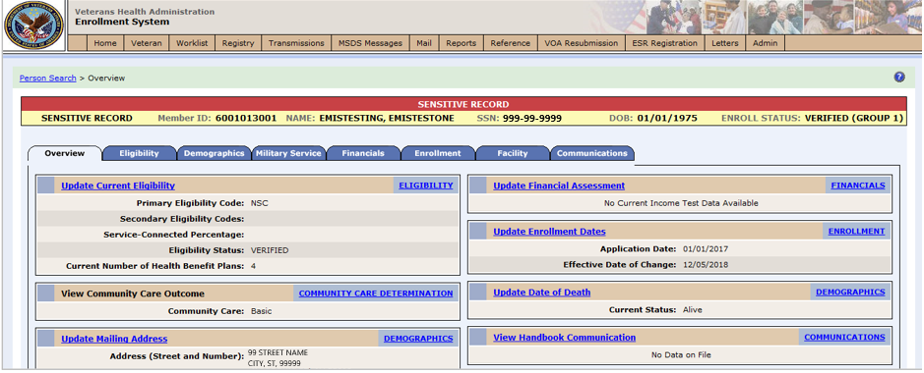
Figure 4: Summary and Main Screen on VES

Sorting Columns
For screens that contain listed data, ascending and descending sorting may be performed for any category by clicking on the category name or on the symbol . Re-clicking the category name or symbol re-sorts the previous sort.

Figure 5: Sorting Columns
VES Online Help is an Online Help system built in Adobe RoboHelp, an authoring and publishing tool. The VES Online Help delivers an output to VES users when clicking the context-sensitive help buttons, System Help or Screen Help.

VES Online Help
In VES, you can obtain information about windows or dialogs clicking the context-sensitive help button available VES in the upper right-hand corner of the “System Help” and “Screen Help”.

System Help:
System Help is the top upper-right context-sensitive help button .

Screen Help:
Screen Help is the lower upper-right context-sensitive help button .
If you roll over the Help icons in VES, screen tips will appear distinguishing between “System Help” and “Screen Help”.

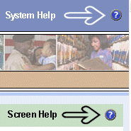
Figure 6: System Help and Screen Help

VES Online Help Tool Bar
To the left of the VES Online Help, above the table of contents pane, a tool bar contains Contents, Index, Search and Glossary links.

Table of Contents:
Contents displays an expanded table of contents.
- Collapse / Expand (, )
- Topics () are categories of information in the VES Online Help. Clicking, you can view the contents of topic in the main screen located to the right.

Index:
Index displays a multi-level list of keywords and keyword phrases. These terms are associated with topics in the VES Online Help, and the keywords are intended to direct you to specific topics within the VES Online Help. Click the keyword to launch a topic from the TOC to the main screen. If the keyword is used with more than one topic, a list of topics displays under the keyword or keyword phrase in which the keyword or keyword phrase appears.

Search:
Search provides a way to explore the content of the VES Online Help and find matches to VES-defined words. Unlike Index that lists author-defined keywords such as terms, synonyms, and cross-references, Search lists words used within the content of topics. To find a topic in which the word appears, click the letter link to display the words that begin with the letter being searched for. Words that appear once are in bold. Words that appear in multiple topics are listed with numbers. Click on a number to display the topic in the right-hand pane in which the word appears.

Glossary:
Glossary provides a list of terms and definitions related to the subject-matter in VES. Click a letter in the top pane and see corresponding definitions that begin with the letter clicked in the lower pane.

The VES Online Help uses Adobe RoboHelp’s 2017 WebHelp as its output and is 508-compliant. The Online Help opens in your web browser as a new window.

Other buttons and functions
Hide/Show the left pane
Provides a larger viewing area of the open topic and hides the left pane.
- Click the Hide link in the upper left side of the right pane to hide the left pane.
- Click the Show link in the upper left side of the pane to show the left pane.

Browser Toolbar
Since there is not a browser toolbar at the top of the VES Online Help window, right-click within VES Online Help window and select either Back or Forward to go back and forward through the history of visited topics, print a topic, or perform other tasks available within the Windows context-sensitive commands.

The Forward command is only available if the Back command has been used first. At that point the Forward command becomes available.

The TOC on the left side of the VES Online Help can also be used to navigate throughout the VES Online Help.

WebHelp Build Date
Click the Systems Parameters topic to view the WebHelp Build Date. The build date is next to the topic title.

Adjusting the main screen and TOC size
Adjust the width and height of the main screen window by dragging the edges of the window in or out.
Adjust the width of the table of contents pane by pointing to the right edge of the left pane until the mouse pointer turns into a line with arrows on each end: Drag the pane to the right or left with the left mouse button held down.

Navigating Help Topics

The following navigational techniques generally refer to the Online Help, where indicated, and not the written documentation:

Links (Online Help)
* symbol indicates a required field in the Online Help.
symbol indicates a required field in the user guide.
symbol is displayed when a submitted field has an error.
symbol ("data changed") is displayed when a type of data has changed on the History, Veteran Merge, and user-related confirmation windows.
Indicates a note or item of special interest.

508 Compliance & Accessibility
With every release, the Department of Veterans Affairs strives to improve accessibility in VES through the World Wide Web Consortium (W3C)’s Web Content Accessibility Guidelines (WCAG) 2.0, Levels A and AA.
It's important to mention that because Adobe RoboHelp displays a leveled hierarchy of contents through expanded and collapsed icons. VES users must click the collapsed icon to display contentsfor that section and re-click the expanded icon to close the contents of that section.
Simple interface patterns that allow you to expand and collapse content can be helpful accessibility aids as they give users the choice of revealing content to read it, or bypassing the content, making page navigation more efficient for screen-reader users and people using the keyboard or alternative input devices.

Accessibility Software
The table below lists accessibility software used to assist disabled users with VES.
Table 1: Accessibility Software
Accessibility Software | Description | Keyboard Shortcuts
Jaws (Job Access with Speech) | Assists blind and visually impaired Veterans with reading screens on VES either with a text-to-speech output or a Braille display. | JAWS Keystrokes
ZoomText Magnifier / Reader | Magnifies VES screens to varying levels and assists Veterans with screen reading. | ZoomText Tutorial
Dragon Naturally Speaking | Through dictating VES functions, assists disabled Veterans with VES document downloads  and exports. | Dragon NaturallySpeaking User Documentation

If you have questions or comments regarding Adobe RoboHelp 2017 accessibility, please contact the Adobe Accessibility Team and provide feedback on their feedback form. For further information on Adobe accessibility, please refer to the following link:
https://www.adobe.com/accessibility/508standards.html

Standard Data Service (SDS) Lookup Tables
The SDS is a repository of enterprise-level reference tables. The SDS Lookup Tables contain information needed to define requirements and research the E&E process. The SDS Lookup Tables page enables a user to view information about a specific table (for example, table name, code, description, active status, date when a code became inactive). VES uses SDS tables in several of its applications.
Users access the SDS Lookup Tables screen by clicking the Reference Tables link at the top right of any VES screen.
To display the SDS Lookup Tables:
- Click the Reference Tables link and the SDS Lookup Tables page displays. SDS table and SDS History table names are listed in alphabetical order in the Navigation Bar.
- Select an SDS table name from the navigation bar. The right panel displays the first five columns in the selected table and the Table Name contains a link for downloading the whole table as an Excel spreadsheet. The Excel spreadsheet will display all the columns in the table.

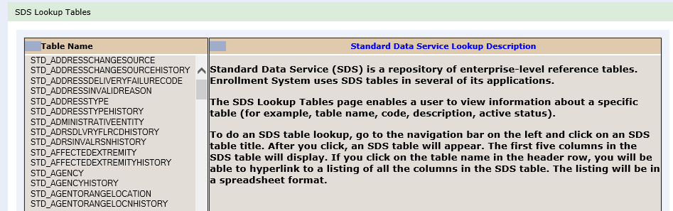
Figure 7: SDS Lookup Table
No data found for the selected table displays if there is no data in an SDS Lookup Table.

Exiting VES
To exit VES, click on the Sign Out link at the top of any page.

Caveats and Exceptions
None.

Significant Additions and Updates to VES Version 6.10
Please refer to VES 6.10 additions below in the Online Help.

VES Vietnam Service Episode Dates

Person Search Tabs → Military Service → Period of Service
Confirm the following Online Help updates.
Step | Action
1 | Click the Person Search Tabs section on the table of contents on the Online Help
2 | Click the Military Service section.
3 | Click the Period of Service section
4 | Confirm the following information was modified:  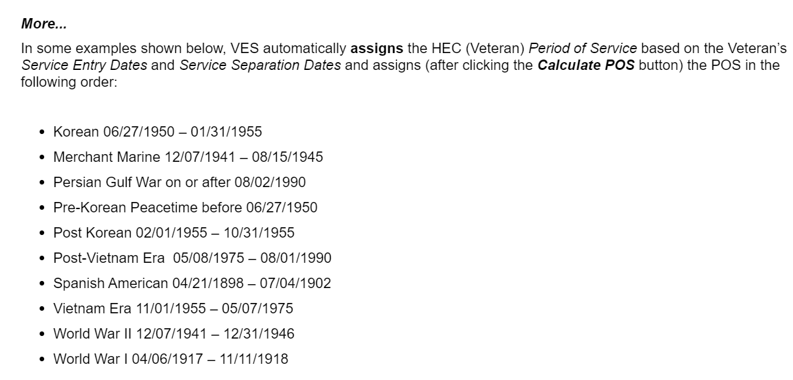  Figure 8: Automatic HEC Period of Service List  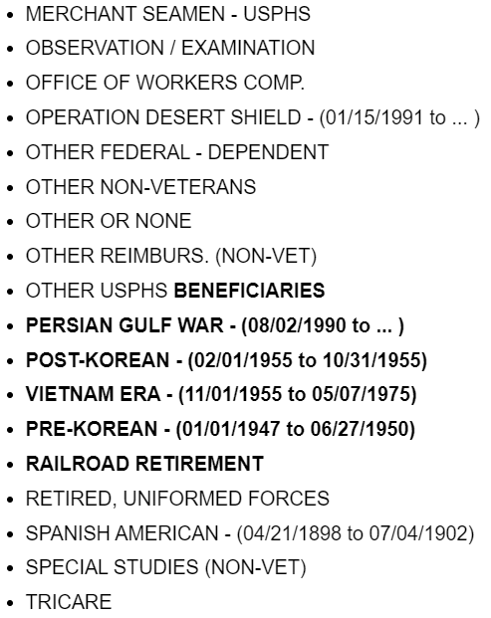  Figure 9: HEC Period of Service List

VES Change Rejected Enrollment Status to Deferred

Person Search Tabs → Eligibility→ Enrollment→ Current Enrollment

Confirm the following Online Help updates.

Step | Action
1 | Click the Person Search Tabs section on the table of contents on the Online Help.
2 | Click the Eligibility section.
3 | Click the Enrollment section.
4 | Click the Current Enrollment section.
5 | Confirm the following information has been added:  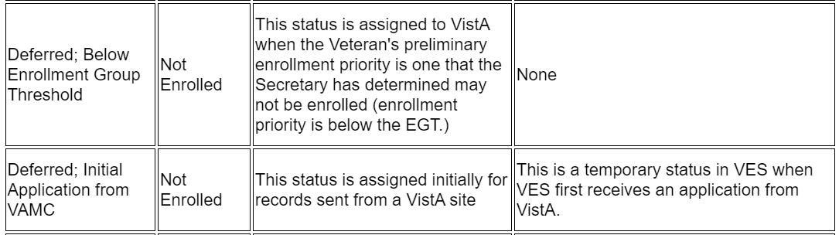  Figure 10: Enrollment Statuses

ESM Enable Confidential Address

Person Search Tabs → Demographics → Addresses →Confidential Mailing Address

Confirm the following Online Help updates.

Step | Action
1 | Click the Person Search Tabs section on the table of contents on the Online Help.
2 | Click the Demographics section.
3 | Click the Addresses section.
4 | Click the Confidential Mailing Address section.
5 | Confirm the following information has been added:  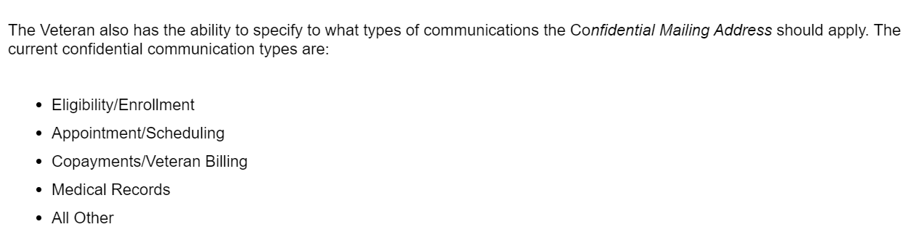  Figure 11: Current Confidential Communication Types

TERA Updates for 10-10EZ, UI, VOA and Work Items

Person Search Tabs → Financials

Confirm the following Online Help updates.

Step | Action
1 | Click the Person Search Tabs section on the table of contents on the Online Help.
2 | Click the Financials section.
3 | Confirm the following information has been added:  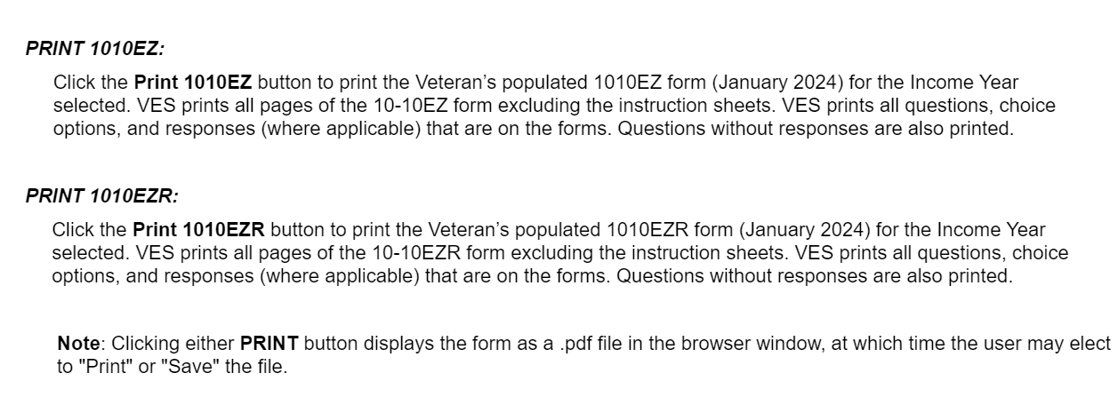  Figure 12: Print 1010EZ & Print 1010EZR

Person Search Tabs → Enrollment → Veteran’s Online Application

Confirm the following Online Help updates.

Step | Action
1 | Click the Person Search Tabs section on the table of contents on the Online Help.
2 | Click the Enrollment section.
3 | Click the Veteran’s Online Application section.
4 | Confirm the following information has been added:  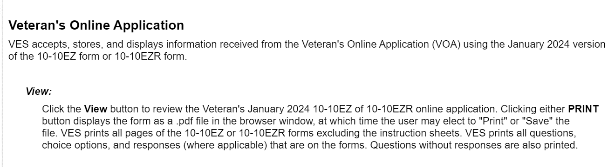  Figure 13: Veteran's Online Application (VOA)

Person Search Tabs → Military Service

Confirm the following Online Help updates.

Step | Action
1 | Click the Person Search Tabs section on the table of contents on the Online Help.
2 | Click the Military Service section.
3 | Confirm the following information has been added:  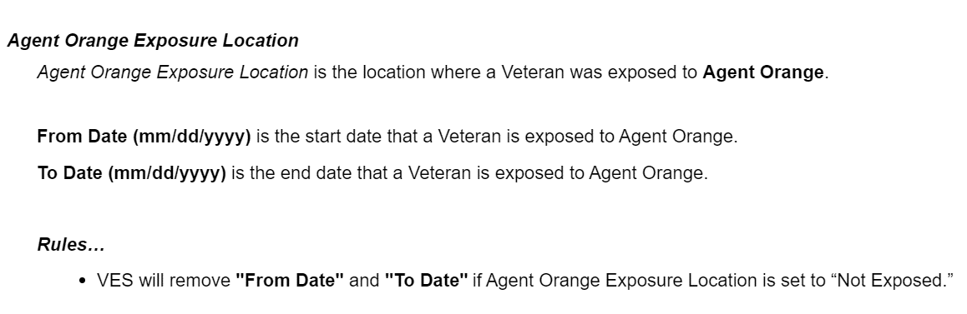  Figure 14: Agent Orange Exposure Location  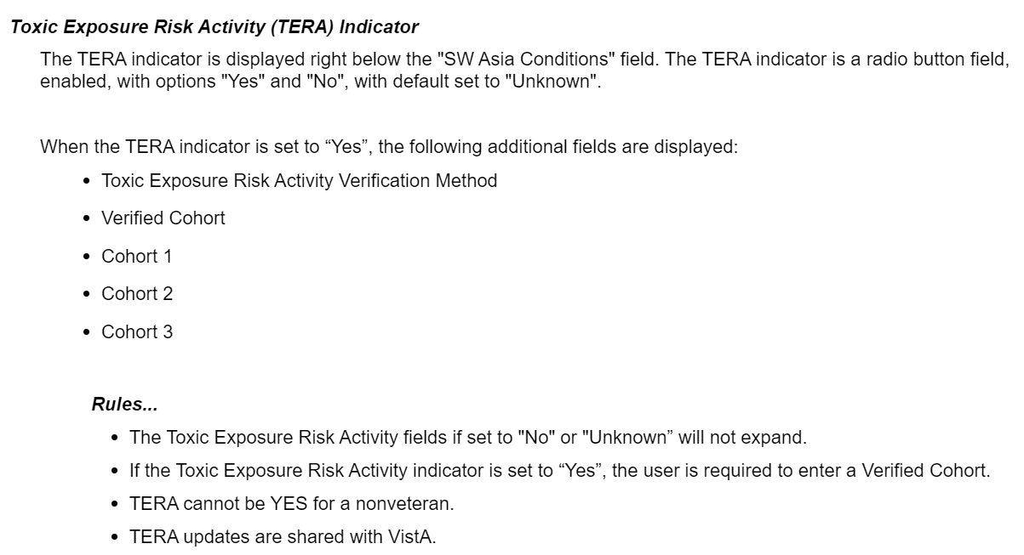  Figure 15: TERA Indicator  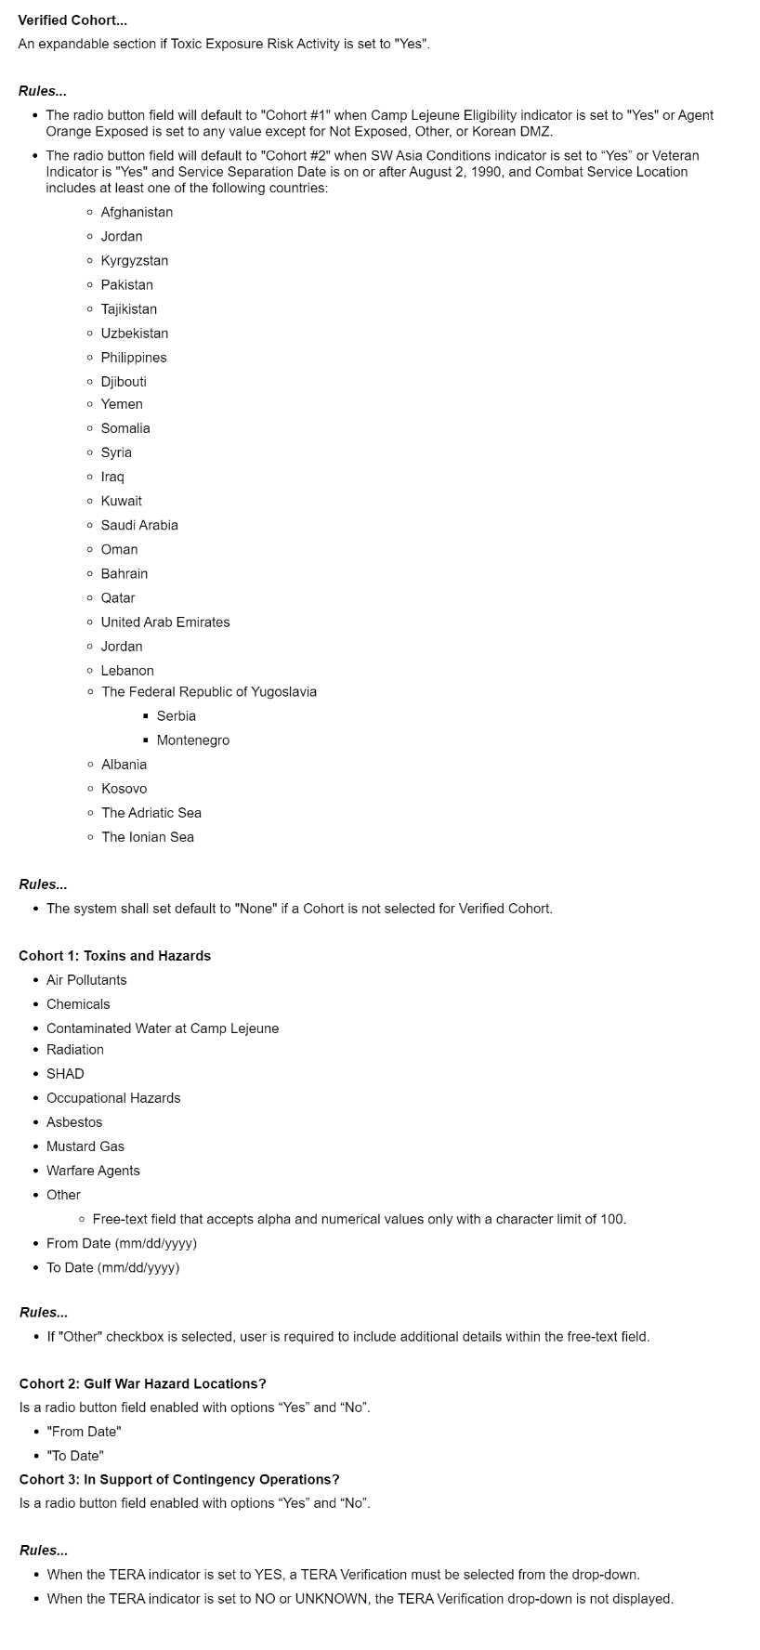  Figure 16: TERA Indicator - Cohort 1-3  Confirm the screenshot has been updated (found at the bottom of the Military Service section):  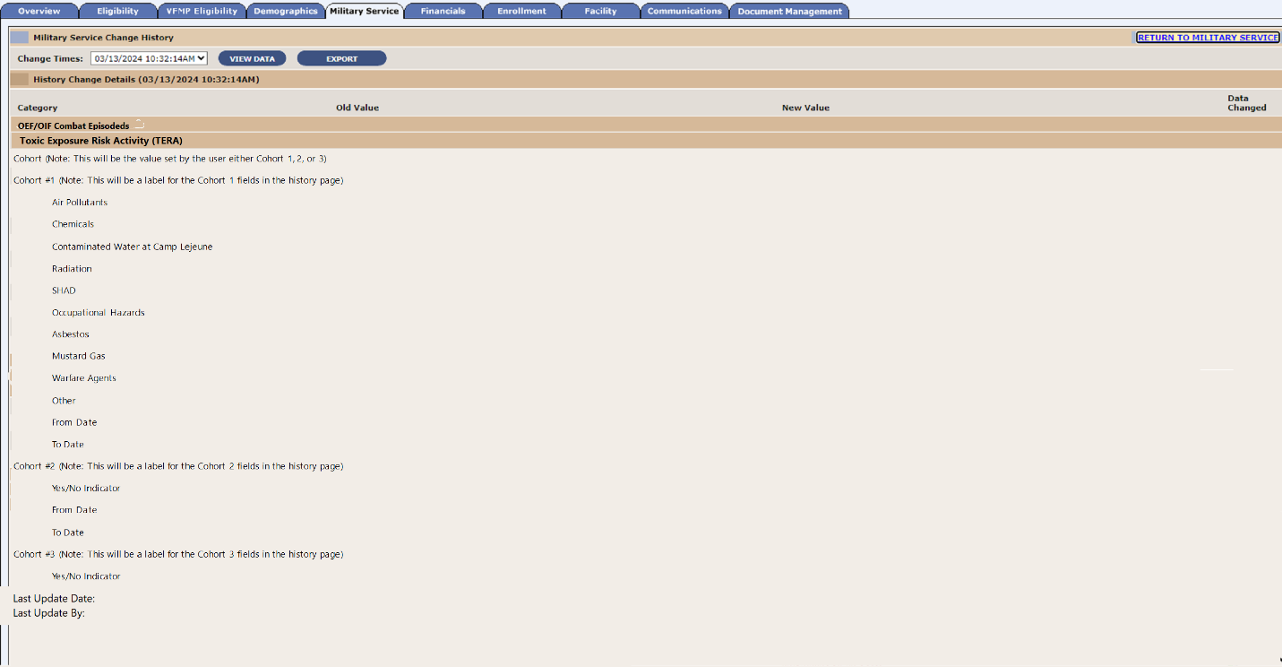  Figure 17: Military Service Tab Screenshot

