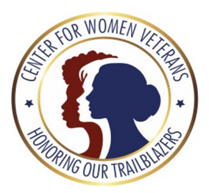
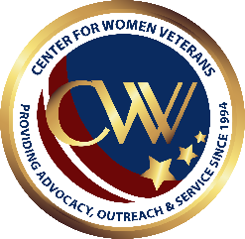
DEPARTMENT OF VETERANS AFFAIRS
CENTER FOR WOMEN VETERANS TRAILBAZERS
CODE OF CONDUCT

As a Woman Veteran Trailblazer:
I agree to promote the use of all Department of Veterans Affairs benefits and services available for women Veterans.
I agree to support the Department of Veterans Affairs strategic goals and core values: Integrity, Commitment, Advocacy, Respect, and Excellence (I CARE).
I agree to be an advocate for the Department of Veterans Affairs, Center for Women Veterans in raising awareness of the responsibility to treat women Veterans with dignity and respect.
I agree to be an advocate for the Department of Veterans Affairs, Center for Women Veterans to promote positive messaging and cultural transformation in the general public by encouraging women Veterans to share their stories.
I agree to participate in two Department of Veterans Affairs, Center for Women Veterans outreach and innovative strategies to provide positive women Veterans experiences, to include pilot programs, outreach opportunities, and updates to VA programs and services.
I agree to once a quarter participate in Department of Veterans Affairs focus groups to identify and share best practices that can be adopted to improve women Veterans’ programs, benefits, and services.
I agree to share and promote outreach communication provided by the Department of Veterans Affairs, Center for Women Veterans through websites and social media platforms monthly. (Ex. Webinars, roundtables, FB Live, Women Veterans Survey, CWV initiatives and campaigns, etc.)
I agree once a quarter to assist with increased communication between the Department of Veterans Affairs, Center for Women Veterans and women Veterans within my region, state, and network.
I agree to foster a culture of partnership with the Department of Veterans Affairs, Center for Women Veterans and my organization by extending an invitation once a quarter to meetings and/or conferences that my organization host to discuss and improve the quality of life for women Veterans and their eligible family members.

Agreement and Signature:
I have read and understand the above Code of Conduct, and I agree to abide by this code during my participation as a Woman Veteran Trailblazer for the Department of Veterans Affairs Center for Women Veterans.

Signature _____________________________
Date _____________________________

